# Appendix

**Table 6** *Change of labels in Self-efficacy items*

|  |  |  |
| --- | --- | --- |
| Item | Original label | Summarised label |
| General Self-efficacy | | |
| is2g27a | Edit digital photographs or other graphic images | Edit graphic images |
| is2g27c | Write or edit text for a school assignment | Write or edit text |
| is2g27d | Search for and find relevant information for a school project on the Internet | Search and find information on internet |
| is2g27i | Create a multi-media presentation (with sound, pictures, or video) | Create multi-media presentation |
| is2g27j | Upload text, images, or video to an online profile | Upload multimedia to an online profile |
| is2g27k | Insert an image into a document or message | Insert an image into a document/message |
| is2g27l | Install a program or [app] | Install a program/app |
| is2g27m | Judge whether you can trust information you find on the Internet | Judge internet information veracity |
| Specialized Self-efficacy | | |
| is2g27b | Create a database (e.g. using [Microsoft Access ®]) | Create a database |
| is2g27e | Build or edit a webpage | Build a webpage |
| is2g27g | Create a computer program, macro, or [app] | Create a computer program/app |
| is2g27h | Set up a local area network of computers or other ICT | Set up a local area network |

**Table 7** *Correlation matrix assuming continuous*

|  |  |  |  |  |  |  |  |  |  |  |  |  |
| --- | --- | --- | --- | --- | --- | --- | --- | --- | --- | --- | --- | --- |
|  | (A) | (B) | (C) | (D) | (E) | (F) | (G) | (H) | (I) | (J) | (K) | (L) |
| A. Create a database |  | 0.339 | 0.385 | 0.316 | 0.279 | 0.21 | 0.187 | 0.268 | 0.166 | 0.18 | 0.163 | 0.234 |
| B. Build a webpage |  |  | 0.501 | 0.386 | 0.26 | 0.168 | 0.132 | 0.311 | 0.177 | 0.206 | 0.182 | 0.23 |
| C. Create a computer program/app |  |  |  | 0.512 | 0.185 | 0.091 | 0.06 | 0.254 | 0.119 | 0.136 | 0.094 | 0.2 |
| D. Set up a local area network |  |  |  |  | 0.201 | 0.12 | 0.122 | 0.281 | 0.161 | 0.157 | 0.141 | 0.224 |
| E. Edit graphic images |  |  |  |  |  | 0.346 | 0.295 | 0.346 | 0.307 | 0.313 | 0.262 | 0.242 |
| F. Write or edit text |  |  |  |  |  |  | 0.505 | 0.29 | 0.35 | 0.431 | 0.358 | 0.306 |
| G. Search and find information on internet |  |  |  |  |  |  |  | 0.263 | 0.344 | 0.393 | 0.341 | 0.323 |
| H. Create multi-media presentation |  |  |  |  |  |  |  |  | 0.344 | 0.36 | 0.309 | 0.304 |
| I. Upload multimedia to an online profile |  |  |  |  |  |  |  |  |  | 0.459 | 0.393 | 0.323 |
| J. Insert an image into a document/message |  |  |  |  |  |  |  |  |  |  | 0.431 | 0.338 |
| K. Install a program/app |  |  |  |  |  |  |  |  |  |  |  | 0.364 |
| L. Judge internet information veracity |  |  |  |  |  |  |  |  |  |  |  |  |

**Table 8** *Correlation matrix assuming categorical*

|  |  |  |  |  |  |  |  |  |  |  |  |  |
| --- | --- | --- | --- | --- | --- | --- | --- | --- | --- | --- | --- | --- |
|  | (A) | (B) | (C) | (D) | (E) | (F) | (G) | (H) | (I) | (J) | (K) | (L) |
| A. Create a database |  | 0.423 | 0.487 | 0.394 | 0.404 | 0.363 | 0.315 | 0.349 | 0.236 | 0.287 | 0.248 | 0.315 |
| B. Build a webpage |  |  | 0.624 | 0.48 | 0.385 | 0.273 | 0.221 | 0.417 | 0.255 | 0.295 | 0.266 | 0.309 |
| C. Create a computer program/app |  |  |  | 0.624 | 0.275 | 0.155 | 0.093 | 0.36 | 0.169 | 0.191 | 0.149 | 0.28 |
| D. Set up a local area network |  |  |  |  | 0.305 | 0.206 | 0.211 | 0.379 | 0.252 | 0.249 | 0.215 | 0.318 |
| E. Edit graphic images |  |  |  |  |  | 0.541 | 0.49 | 0.496 | 0.471 | 0.476 | 0.422 | 0.335 |
| F. Write or edit text |  |  |  |  |  |  | 0.743 | 0.472 | 0.559 | 0.658 | 0.58 | 0.495 |
| G. Search and find information on internet |  |  |  |  |  |  |  | 0.43 | 0.579 | 0.637 | 0.572 | 0.522 |
| H. Create multi-media presentation |  |  |  |  |  |  |  |  | 0.507 | 0.537 | 0.459 | 0.399 |
| I. Upload multimedia to an online profile |  |  |  |  |  |  |  |  |  | 0.678 | 0.596 | 0.475 |
| J. Insert an image into a document/message |  |  |  |  |  |  |  |  |  |  | 0.634 | 0.506 |
| K. Install a program/app |  |  |  |  |  |  |  |  |  |  |  | 0.524 |
| L. Judge internet information veracity |  |  |  |  |  |  |  |  |  |  |  |  |

**Table 9** *Factorial Analysis ICT Self-efficacy Results*

|  |  |  |  |  |  |
| --- | --- | --- | --- | --- | --- |
|  | Three factors model | | | Two factors model | |
|  | Factor 1 | Factor 2 | Factor 3 | Factor 1 | Factor 2 |
| Suggested as Specialized Self-efficacy | | | | | |
| A. Create a database | -0.20 | **0.49** | 0.47 | 0.23 | **0.49** |
| B. Build a webpage | 0.09 | **0.66** | 0.07 | 0.13 | **0.67** |
| C. Create a computer program/app | 0.00 | **0.91** | -0.07 | -0.10 | **0.93** |
| D. Set up a local area network | 0.14 | **0.66** | -0.04 | 0.08 | **0.66** |
| Suggested as General Self-efficacy | | | | | |
| E. Edit graphic images | 0.15 | 0.23 | **0.44** | **0.54** | 0.23 |
| F. Write or edit text | 0.11 | -0.04 | **0.80** | **0.83** | -0.03 |
| G. Search and find information on internet | 0.24 | -0.09 | **0.66** | **0.84** | -0.09 |
| H. Create multi-media presentation | **0.46** | 0.32 | 0.09 | **0.52** | 0.30 |
| I. Upload multimedia to an online profile | **0.82** | 0.02 | -0.02 | **0.76** | -0.01 |
| J. Insert an image into a document/message | **0.72** | 0.02 | 0.14 | **0.83** | 0.01 |
| K. Install a program/app | **0.67** | 0.00 | 0.11 | **0.75** | 0.02 |
| L. Judge internet information veracity | **0.41** | 0.17 | 0.19 | **0.57** | 0.16 |

**Table 10** *Table of gender indexes differences*

|  |  |  |  |  |  |
| --- | --- | --- | --- | --- | --- |
| Variables | N | Overall, N = 3,092 | Boy, N = 1,519 | Girl, N = 1,573 | p-value |
| Computer and Information Literacy Score | 3,092 | 48 (9) | 48 (9) | 49 (9) | <0.001 |
| ICT self-efficacy regarding the use of general applications | 2,999 | 52 (9) | 51 (9) | 52 (9) | 0.019 |
| ICT self-efficacy regarding the use of specialist applications | 2,996 | 51 (9) | 52 (9) | 50 (9) | <0.001 |

*¹ Mean (SD)*

*² Welch Two Sample t-test*

**Table 11** *Gender composition differences*

|  |  |  |  |  |
| --- | --- | --- | --- | --- |
| Characteristic | Masculinized school, N = 10 | Mixed school, N = 134 | Feminized school, N = 19 | p-value |
| Computer Literacy | 46.8 (7.1) | 48.2 (5.7) | 48.2 (6.0) | >0.9 |
| ICT General Self Efficacy | 50.92 (3.16) | 51.43 (3.13) | 52.86 (3.28) | 0.13 |
| ICT Specialized Self Efficacy | 49.83 (4.84) | 51.42 (3.14) | 51.05 (3.61) | 0.4 |

*¹ Mean (SD)*

*² Kruskal-Wallis rank sum test*

**Figure 5** *Corrplot principal variables*

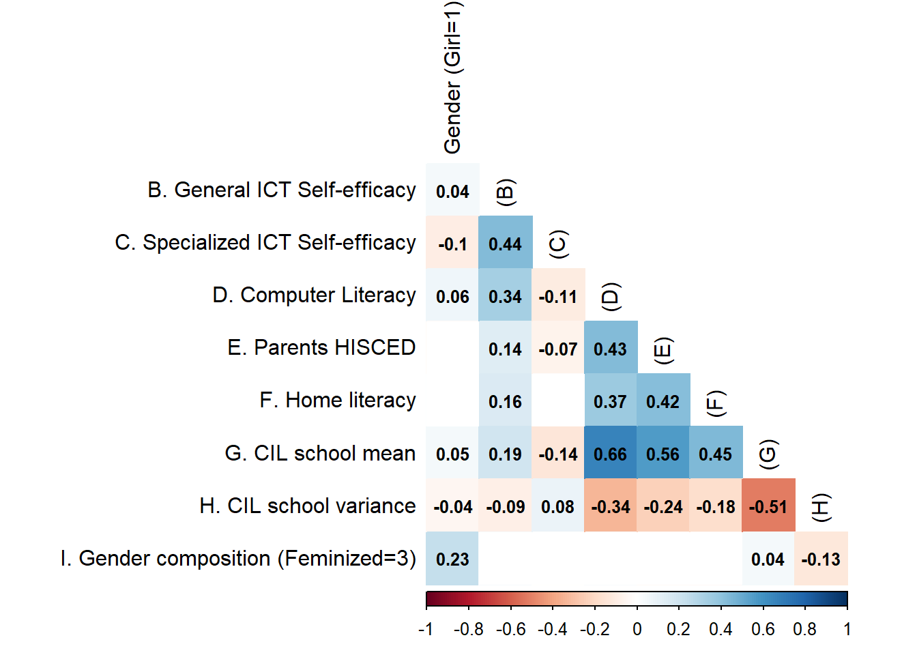

**Table 12** *Gender CIL correlation differences*

|  |  |  |
| --- | --- | --- |
| Sex | General self-efficacy | Specialized self-efficacy |
| Boy | 0.36 | -0.08 |
| Girl | 0.31 | -0.12 |