# JavaScript for Front-End – DOM Manipulations

Your task is to write the Front-End part of an application which renders information into HTML.

There are a few simple tasks. Those little tasks will ultimately combine into the functionality you need for the application itself.

## Rendering Data in HTML – 20 pts

In order for the HTML to look tidy and well formed, CSS needs to be applied, which suggests some specific element hierarchy and classes. Check the template and make sure your function renders the object correctly. You can see input and output below.

Create your functions for this task inside the jquery-data.js file, and implement them so that they render the data inside the jquery-data.html file.

### Render Elements in HTML – 20 pts

#### Input

|  |
| --- |
| jquery-data.html |
| <!DOCTYPE **html**> <**html lang="en"**> <**head**>  <**meta charset="UTF-8"**>  <**title**>Title</**title**>  <**link rel="stylesheet" href="https://stackpath.bootstrapcdn.com/font-awesome/4.7.0/css/font-awesome.min.css"**>  <**script src="https://ajax.googleapis.com/ajax/libs/jquery/3.2.1/jquery.min.js"**></**script**>  <**link rel="stylesheet" href="style.css"**> </**head**> <**body**>  <**form**></**form**> <**script src="winamp.js"**></**script**> </**body**> </**html**> |
|  |

#### Output

|  |
| --- |
| jquery-data.html |
| <!DOCTYPE **html**> <**html lang="en"**> <**head**>  <**meta charset="UTF-8"**>  <**title**>Title</**title**>  <**link rel="stylesheet" href="https://stackpath.bootstrapcdn.com/font-awesome/4.7.0/css/font-awesome.min.css"**>  <**script src="https://ajax.googleapis.com/ajax/libs/jquery/3.2.1/jquery.min.js"**></**script**>  <**link rel="stylesheet" href="style.css"**> </**head**> <**body**> <**form**>  <**h1 class="heading"**>Front-End-Player</**h1**>  <**div class="img-ctr"**>  <**img src="love-music.png" alt="music"**>  </**div**>  <**div class="container"**>  <**i id="prev" class="fa fa-step-backward" aria-hidden="true"**></**i**>  <**i id="play" class="fa fa-play-circle" aria-hidden="true"**></**i**>  <**i id="pause" class="fa fa-pause-circle hidden" aria-hidden="true"**></**i**>  <**i id="next" class="fa fa-step-forward" aria-hidden="true"**></**i**>  </**div**>  <**div class="input-ctr"**>  <**input type="text" class="result" disabled value="Play me !"**>  </**div**> </**form**> <**script src="winamp.js"**></**script**> </**body**> </**html**> |

If you do everything correctly, you should see this:

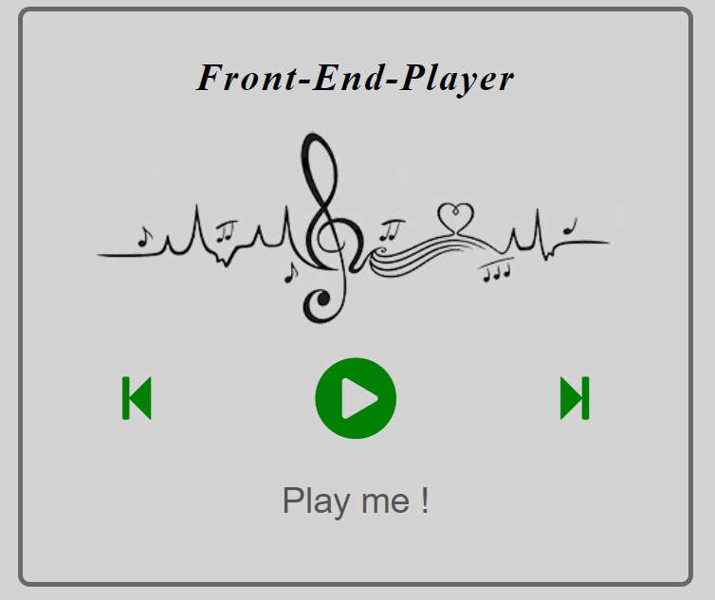

## Capture Click Events – 80 pts

Now let’s complete some tasks of handling click events. Write your code in events.js.

### Play and Pause Click Event – 40 pts

Your task is to **attach** a click event to **#play** which hides play icon and show pause icon in the same position and change the content under the icon.

This is vizualization before click:



After click on **play** symbol you shoud see this:

: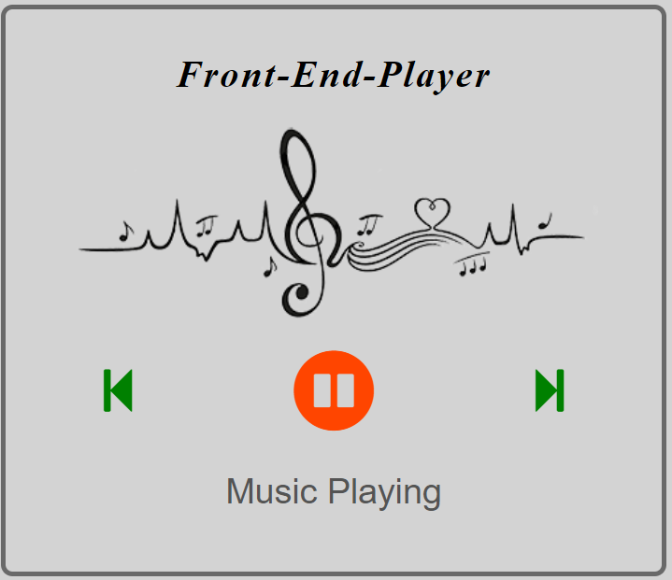

After click on **pause** icon you shoud see this:

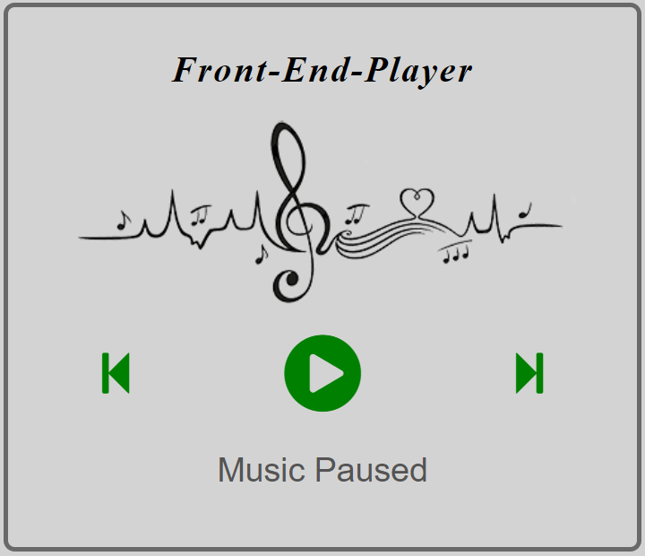

Here we have agane PLAY icon and the text under the PLAY simbol is different, that’s it ☺

### Previous and Next Click Event – 40 pts

Your task is to **attach** a click event to **#prev and #next** and after click event you should change the content under the player like following.

Click on **#prev:**

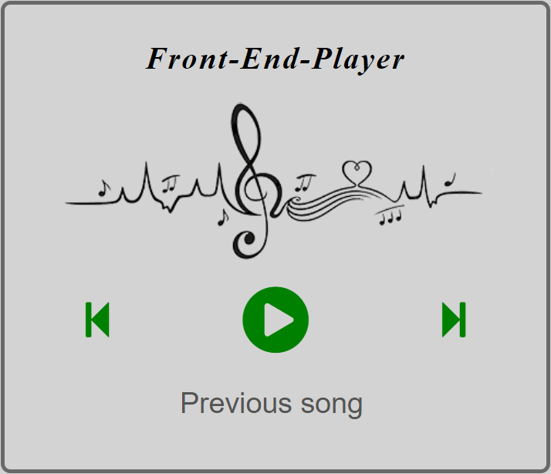

Click on **#next:**

