# Homework M6: Prometheus and Grafana

## Solution:

1st Part:

Vagrant file - 1 virtual instance with Docker with:

* 1 Prometheus container
* 1 Grafana container
* 2 Goprom containers

Prometheus.yml – for defining and configuring the jobs to scrape for metrics

Daemon.json – for allowing docker metrics



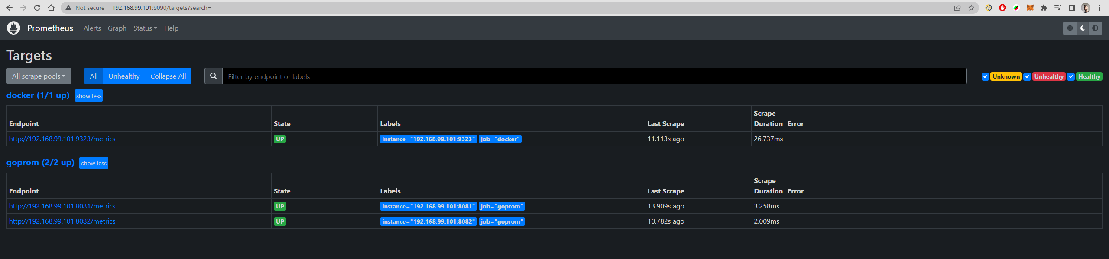

2nd Part (Grafana):

Dashboard with panel for:

* + -which shows how many containers are on the host (in all states)
  + which shows how many jobs are processed by each **goprom** application (all result types)

