

Using the Models of Teaching Resource
This resource should be used within the wider context of the planning, implementation and evaluation cycle.

Page four of the resource identifies Models of Teaching as “a set of related practices which teachers can adopt in order to help achieve particular learning objectives (similar terms – approach, strategy, method, learning design)”

As an introduction to what makes for ‘effective teaching’, it is worth considering what makes an ‘effective teacher’. Students will enter Higher Education from a variety of backgrounds and with different experiences of education. The preliminary activities will provide a good starting point from which to discuss why they have chosen a career in teaching; what qualities they think make for effective teaching and what makes an effective teacher. Activity one could be undertaken individually, in small groups or as a whole class exercise, mind mapping the ideas on a flip chart or whiteboard. The second activity provides a case study of two students with similar entry profiles. A suggestion for using this activity would be to discuss/debate the chapter through the discussion board of your VLE. The third activity provides an opportunity for the students to think about their own learning style by undertaking the online audit.

Used in the wider context of the planning, implementation, evaluation cycle, students should be encouraged to plan lessons using (for example) the inclusive framework below. Once lessons have been planned in context, students can begin to consider approaches to teaching, using the video resource (see Using the Video Resource guide). In considering the different approaches to teaching, students should be guided on why learning theories are important in helping develop their own models of teaching.

It is envisaged that Higher Education Institutions will encourage students to film their own teaching and invite peer feedback on those teaching episodes. This resource provides some strategies that students may consider on their journey to becoming an NQT.

Planning an Inclusive lesson:

Consider
- Lesson Context – class; theme; concept; unit; background (where the lesson fits in)
- Lesson Content – syllabus; lesson goal; content differentiation; specific objectives.
- Lesson Product – varied ways in which students can demonstrate their learning
- Lesson Process – room arrangement; student arrangement; teaching strategies
- Lesson Outline – sequence of lesson; materials and assistive technologies;
- Reflection – student learning (what was learnt); student engagement – what will I change for next time? Iterative process leading to planning, implementation, evaluation cycle for next time. Education theories that guided the decision making process for all of the above.

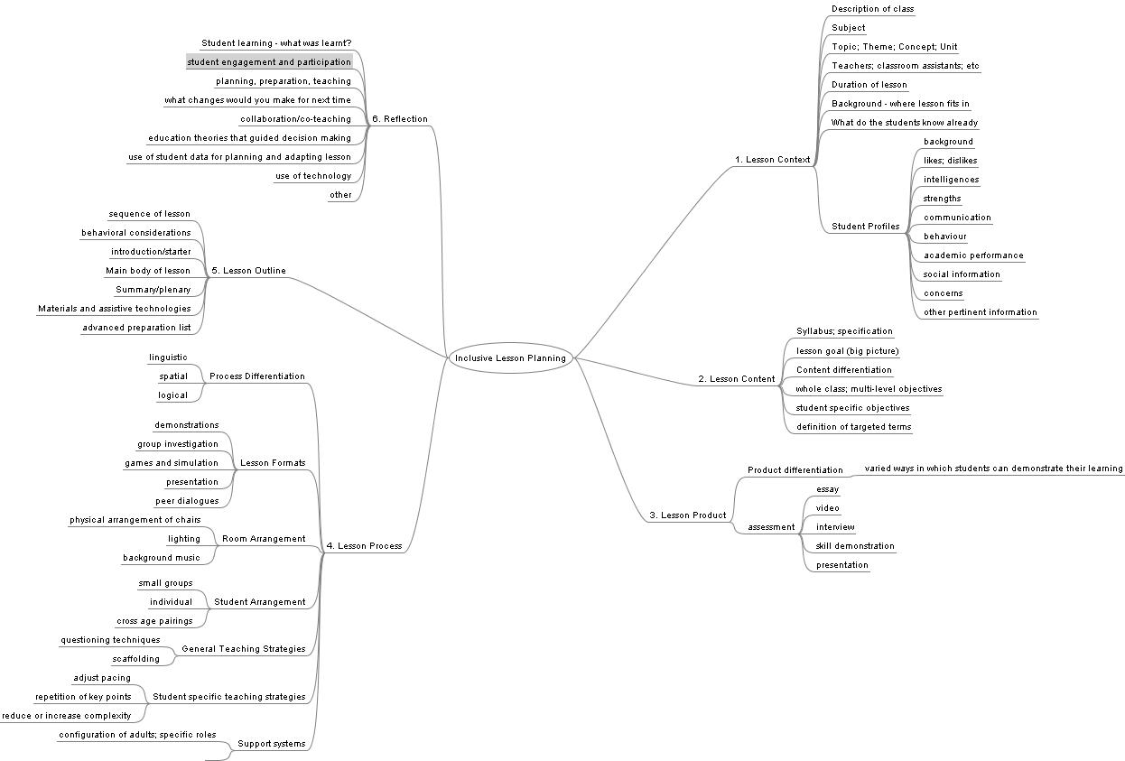
Mind map constructed from text source:-
Causton-Theoharis, Julie N., Theoharis, George T. and Trezek, Beverly J.(2008)'Teaching pre-service teachers to
design inclusive instruction: a lesson planning template',International Journal of Inclusive Education,12:4,381 — 399

