**COVER PAGE**

# **CS323 Programming Assignments**

**Fill out all entries 1 - 7. If not, there will be deductions!**

1. Names [ 1. Miles Chao ]

[ 2. Jose Jimenez ]

2. Assignment Number [ 1 ]

3. Due Date [ 03/03/2023 ]

4. Submission Date [ 03/03/2023 ]

5. Executable File name [ lexer.exe ]

(**A file that can be executed without compilation by the instructor, such as .exe, .jar, etc** - **NOT** a source file such as .cpp )

6. Names of the test case files - input test file output test file

test 1. [ test1.txt ] [ ]

test 2. [ test2.txt ] [ ]

test 3. [ test3.txt ] [ ]

Output test files

test1 test2 test3 test3

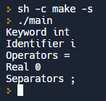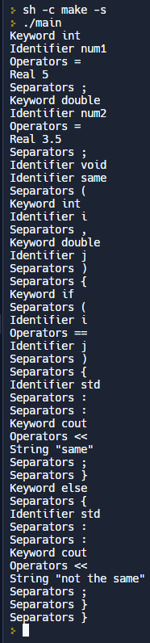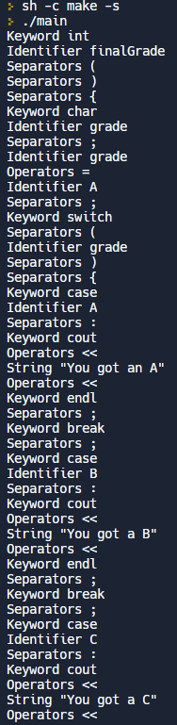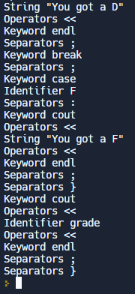

7. Operating System [ Windows ]

(Window or Unix/Linux but Window preferred)

**To be filled out by the Instructor:**

Comments and Grade: