Aid for Non-aggression
Miles D. Williams
2025-05-01
Abstract
Theory holds that non-aggression pacts are unique among military alliances in that their purpose is not to ensure cooperation between signatories but to signal commitment to peace for the benefit of third-parties. This study tests whether foreign aid is a mechanism that makes this third-party signal credible. Foreign aid is argued to be a form of costly cooperation that signals that the commitment to non-aggression is more than just cheap talk. Consistent with this argument, an analysis of aid commitments in the post-Cold War period shows that donors reward non-aggression partners with greater aid, and that third parties adjust their behavior toward non-aggression aid recipients, expressed in the form of greater bilateral trade and foreign direct investment.
keywords: Foreign Aid, Non-aggression, Donor Strategy, Alliances, Signaling

Introduction
What role does foreign aid play in the context of non-aggression treaties? These security pacts have become increasingly common since the end of the Cold War – in fact, far more common than any other kind of treaty type according to the Alliance and Treaty Obligations and Provisions (ATOP) dataset (Leeds et al. 2002). Despite their prevalence, they remain less studied compared to other kinds of alliances, like defensive treaties. Zhang (2024) recently showed that the latter are linked with the foreign aid allocation decisions of traditional donor countries. This finding is important given the hefty military commitment defensive treaties demand of their signatories, but they are actually quite rare among aid donor-recipient dyads. Non-aggression pledges are far more proliferate by comparison, but no research has explored the linkage between them and foreign aid. Figure 1 shows the disparity between these two alliance types among donor-recipient pairs according to the ATOP dataset. There are reasons to suspect that non-aggression pacts in particular might be correlated with donor giving, but for very different reasons than aid is linked to defensive treaties. Their widespread adoption suggests far more sweeping implications for foreign aid.
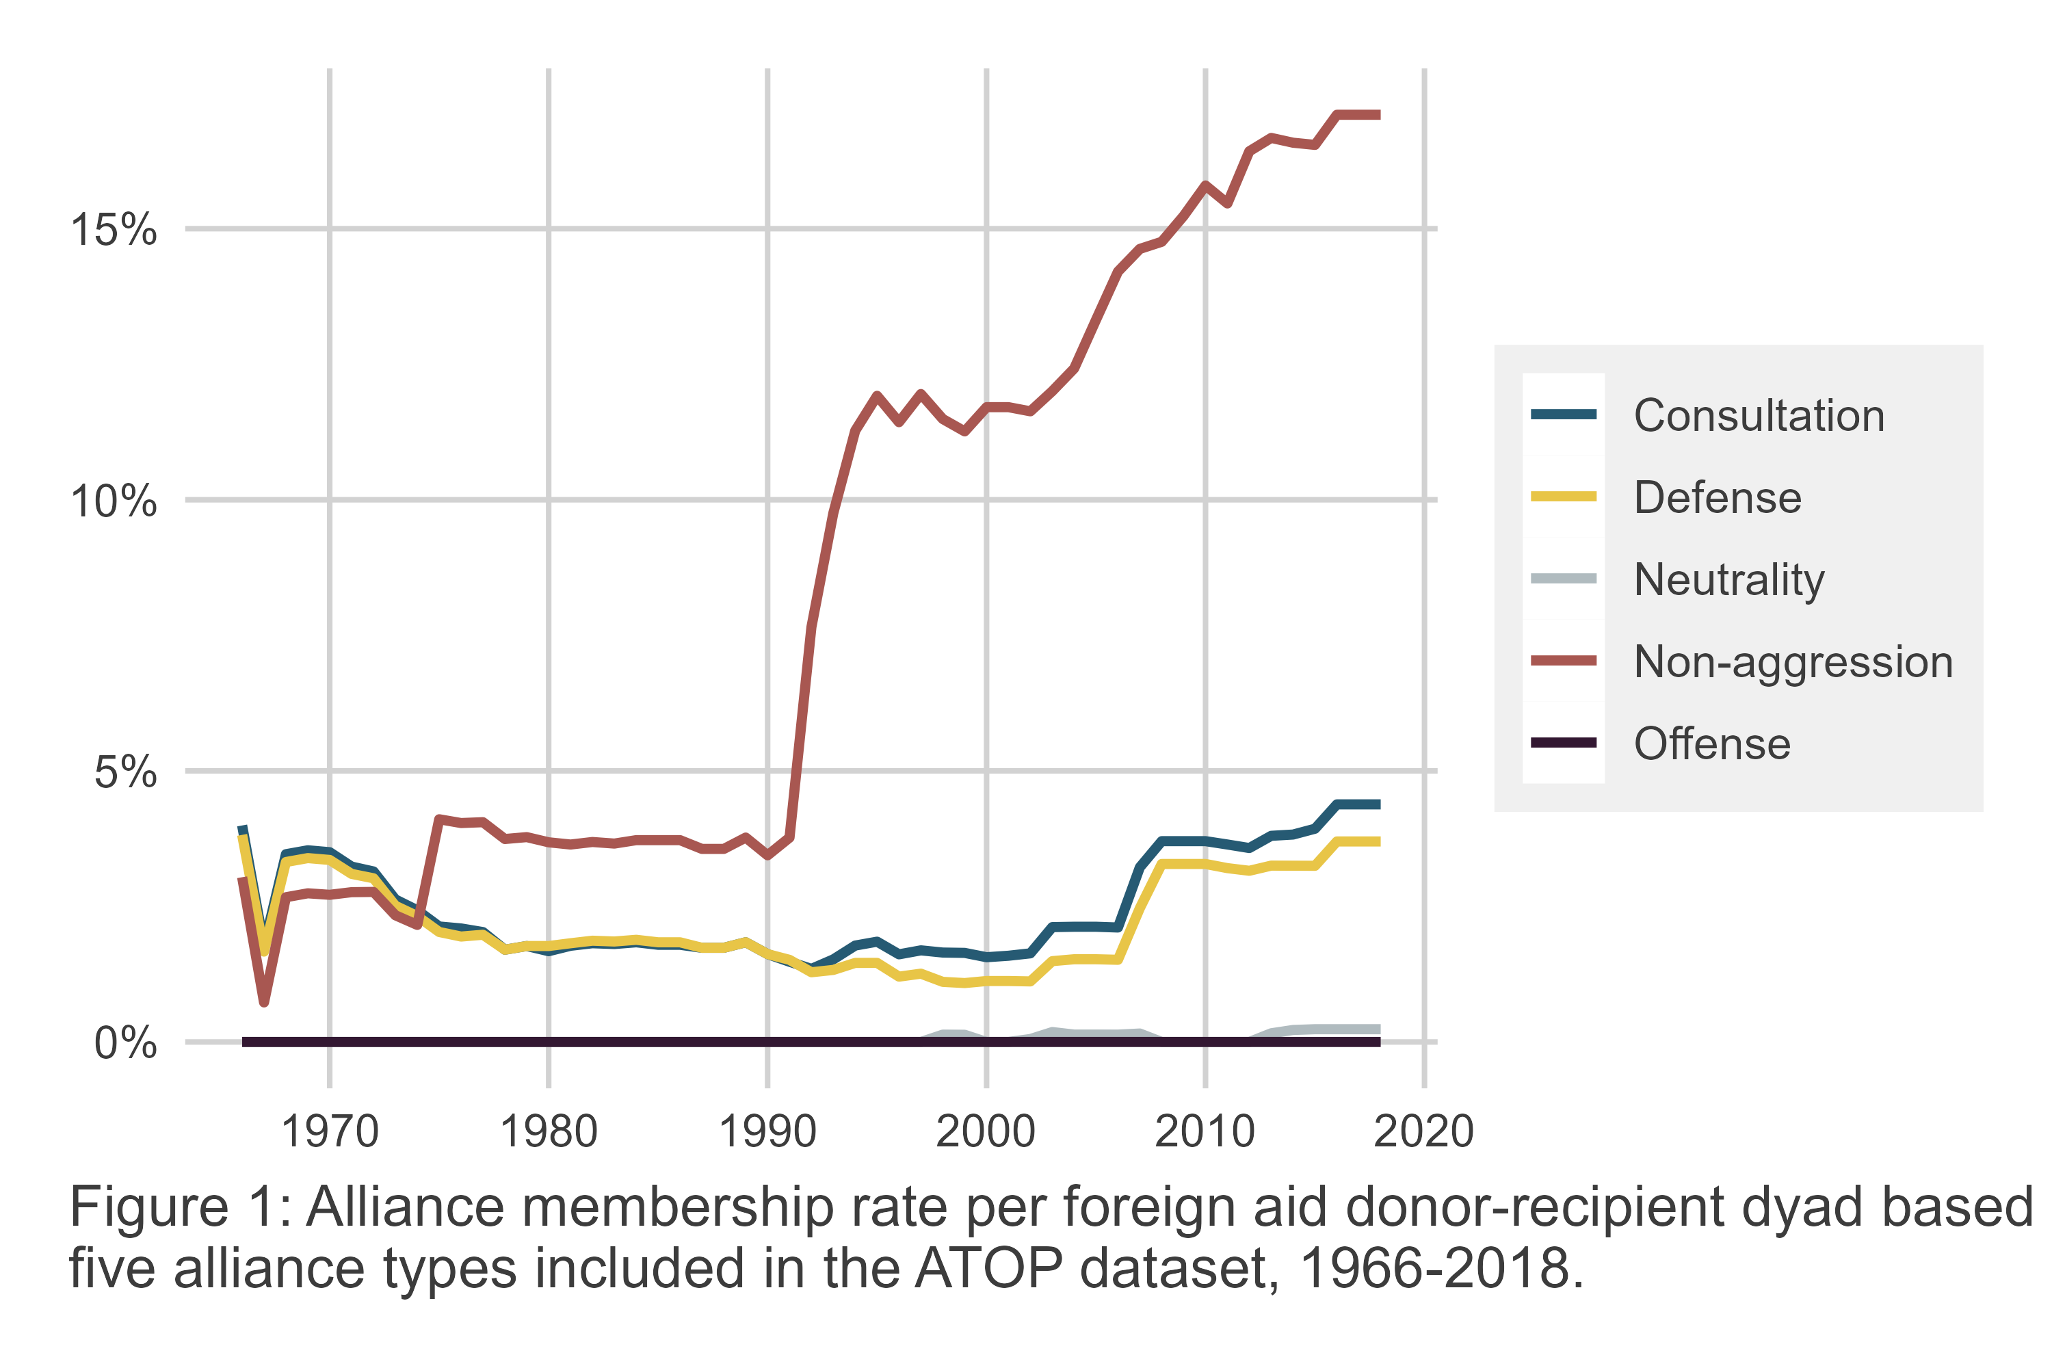
Mattes and Vonnahme (2010) found that non-aggression pacts predict greater peace among signatories, which makes sense, given that these agreements commit members against using force on one another. But more recently, Lupu and Poast (2016) proposed and tested a different argument about the function of non-aggression pacts – one that might imply a special role for foreign aid. Lupu and Poast (2016) make the case that non-aggression treaties are much less about ensuring peace among signatories than they are about signaling peace to third parties. Their argument is that countries that wish to cease hostilities toward each other know that this is their intention. So why sign a non-aggression pact? The reason is that this information held by the former rivals is private and may not be obvious to other actors. Signing a non-aggression treaty is for the benefit of onlookers, providing assurances that the threat of conflict between the signatories is abated.
This study seeks to probe possible implications that follow from this theory. If non-aggression pacts signal peace for the benefit of third parties, might this signal be enhanced by credible commitments like foreign aid? Furthermore, if non-aggression pledges truly signal peace, will third parties adjust their behavior toward the alliance partners in predictable ways?
Aid has long served as a tool of foreign policy for donor countries, allowing them to buy votes in the United Nations General Assembly, gain access to foreign markets for their exports, and build goodwill and soft power (Dreher, Lang, and Reinsberg 2024). As Zhang (2024) recently showed, aid also plays a complex role in the context of defensive treaties, serving as either a complement or a substitute for military commitments depending on the security environment. Given aid’s flexibility to perform a wide range of functions, it would be a natural tool for donor countries to turn to if they need a way to ensure the credibility of a non-aggression treaty. Furthermore, if aid does this job well, it ought to predict changes in third party behavior toward non-aggression partners.
These ideas are put to the test in this study using a dyadic panel dataset of 30 Development Assistance Committee (DAC) aid donor countries and 156 non-DAC aid recipient countries from 1991 to 2014. Analysis of the data supports the argument that donor countries reward non-aggression partners with greater aid to enhance the signal of mutual peace communicated to third parties by the alliance. Further analysis shows that third parties respond to this signal in two materially important ways that are consistent with this signal. First, non-aggression pledges between a donor-recipient pair predict an increase in trade with third party countries for both donors and recipients conditional on the level of aid given by the former to the latter. Second, aid from non-aggression donor partners predicts greater net foreign direct investment (FDI) going to non-aggression aid recipients from private investors.
These findings matter for two reasons. The first is that they support Lupu and Poast’s (2016) theory that non-aggression pledges function as signals of peace for third parties rather than as institutions that merely serve to reinforce an existing peace. But, second, these results go further than Lupu and Poast (2016) by showing that non-aggression pledges on their own may be insufficient for making this signal credible and that other commitments, such as foreign aid, are required.
These findings have special relevance in the wake of recent disruptions to the status quo in foreign aid. As of this writing, the United States has frozen nearly all foreign assistance and eliminated its preeminent aid agency – the United States Agency for International Development (USAID). Accusations of rampant corruption and a disconnect between U.S. foreign assistance and its national interests were the pretext for this policy move. Many other traditional DAC donors are also set to slash their aid budgets this year. While this study cannot speak to the impact of foreign aid on recipients, or its abuses, it does offer an important refutation of the claim that aid is not given in ways consistent with U.S. interests or those of other donors. The results of this study contribute to a large body of literature on the links between donor country objectives and the way they distribute foreign aid across developing countries. This scholarship shows overwhelmingly that aid dollars are distributed according donor countries’ security and economic goals – see Dreher, Lang, and Reinsberg (2024) for a comprehensive survey of relevant studies. Consistent with this body of work, this study shows that aid is given in ways that are consistent with donor objectives to signal credible commitments to non-aggression, which can be incredibly important for maintaining stability and reducing uncertainty about the health of the relationship between signatories. Documenting the role of foreign aid in facilitating this, and a wide range of security and soft power goals, is a necessary step if the breach between reality and recent political rhetoric is to filled.
The paper proceeds as follows. First, the theoretical function of non-aggression pacts is discussed, and the argument for the role of aid in the context of these treaties is laid out. Data and methods for testing this argument are then summarized, followed by a presentation of the results. The paper concludes with a discussion of the findings, limitations, and suggestions for ways future research might build on the work presented here.

Aid and a Multilateral Theory of Non-aggression
Non-aggression pledges commit members against taking military action against each other. Some have argued that these pledges act as institutions that allow members to solve cooperation problems (Long, Nordstrom, and Baek 2007; Mattes and Vonnahme 2010), particularly to reduce the odds of future conflict (Long, Nordstrom, and Baek 2007; Mattes and Vonnahme 2010; Warren 2016). Lupu and Poast (2016) recently questioned this view, noting that formal agreements are far from necessary for cooperation (Smith 1995; Morrow 2000). Indeed, many countries that maintain peaceful relations do not make formal non-aggression pledges.
Instead, Lupu and Poast (2016) propose an alternative theory of non-aggression pacts centered on the role of private information. They make the observation that “[l]eaders of states emerging from a rivalry know something other actors may not: that the future likelihood of conflict among the former rivals has significantly decreased” (Lupu and Poast 2016, 345). Non-aggression pledges are argued to solve this problem because they are a visible act that can assure third parties that countries with a once high propensity to fight now are less likely to do so.
If true, this argument bears on even the most significant non-aggression pledge in recent history signed by the U.S. and Russia on June 17, 1992. Known as the “Nunn-Lugar Cooperative Threat Reduction Umbrella Agreement,” this pact emphasized non-proliferation of nuclear weapons, but also contained clear language associated with non-aggression. The third paragraph of the agreement reads: “(The parties) confirm their commitments to settle disputes between them by peaceful means and to refrain form the threat or use of force against the territorial integrity and political independence of each other.” Among many provisions were several non-military forms of cooperation, including trade, investment, and technology exchange. While the conventional view holds that this agreement was intended to promote peace between these former Cold War rivals, Lupu and Poast (2016) would contend that even this agreement ought to be understood as an effort to signal peace for the benefit of onlookers – a peace that policymakers in both Washington and Moscow already knew they were committed to.
Lupu and Poast (2016) hypothesize that, if their argument is true, groups of two or more states with a recently ended rivalry are more likely to make non-aggression pledges. They test this theory using a $k$-adic research design where a $k$-ad is a unit of observation with $k≥2$ members, and they predict that $k$-ads with a higher density of ended rivalries (in the last 10 years) are more likely to form non-aggression pacts. This is exactly what they find in their data. Using a Cox proportional hazard model and controlling for a number of factors, Lupu and Poast (2016) find that “going from no rivalry cessations to a Rivalry cessation density of 1 will result in a 416% increase in the probability of non-aggression pact formation” (354). Their Rivalry cessation density measure is the ratio of rivalries that have ended in a $k$-ad to the total number of possible dyads (pairs of countries that could potentially have a rivalry) in the group.
In this paper, the goal is to assess whether additional predictions consistent with Lupu and Poast’s (Lupu and Poast 2016) theory are supported by the data. If they are, this only bolsters the credibility of their argument. If not, this may generate new questions about the signalling function of non-aggression pledges.
The additional predictions that are the focus of this paper center on the role that foreign aid may play in non-aggression pact formation. The logic of the argument follows naturally from the basic assertions made by Lupu and Poast (2016), namely, that the goal of non-aggression pacts is to signal peaceful relations among members to third parties. However, here the argument is taken further to consider whether non-aggression pledges alone are sufficient to signal peace, and whether third-parties respond to this signal.
The subject of credible signals has concerned international relations scholars for some time. In their summary of the vast literature on foreign policy signals, Gartzke et al. (2017) note that signalling is usually studied in the context of the bargaining theory of war – that is, zero-sum bilateral conflict. But the theory Lupu and Poast (2016) put forward is multilateral and positive sum. The actors involved in signing a non-aggression pledge have intentions to maintain bilateral peace, but they need to assure other actors that this is the case. This signalling is relevant for other actors because whether former rivals are still rivals or not will shape other countries’ policies toward them. For example, trade or military cooperation with a pair of former rivals will have different expected payoffs for other actors if the pair of countries in question are at peace or on the brink of war. This was certainly true for the U.S. and Russia when they formally committed to non-aggression in 1992.
As Gartzke et al. (2017) further explain, signals must be both purposive and strategic. In the first case, this implies that recipients of the signal interpret a massage from it. In the second case, the message should change the expected payoffs of the actors receiving the message. Thus, if a signal neither communicates a message to other actors, nor changes their expected payoffs, then it is not a signal at all.
The concepts of “cheap talk” and “costly signals” are relevant for understanding when the intention to signal actually produces one. If other countries interpret an action as cheap talk, then the attempted signal has failed to convince them that anything has changed. Costly signals, however, provide a more powerful way to send a signal. These usually involve material commitments made by the signalling actor.
In the context of non-aggression pacts, the goal is to send a message to third parties that also is of material consequence to them about the likelihood of conflict between the pair of countries signing the agreement. However, a non-aggression pledge alone might be interpreted as cheap talk. Foreign aid could help solve this problem.
Other research has recently explored the role of foreign aid in cementing alliance commitments – defensive alliances in particular (Zhang 2024). While this research suggests aid serves a nuanced role with respect to defensive pledges, in certain situations aid is a costly signal of the donor’s commitment to assist an ally if they are attacked. It is a means of “sinking costs,” akin to mobilizing forces in a situation where a country seeks to make a credible threat to attack another country.
Foreign aid is a reasonable foreign policy instrument that countries might turn to in the context of non-aggression pledges as well. Aid, after all, is an expression of bilateral cooperation and exchange between the aid donor and the aid recipient. In their well cited study of foreign aid allocation, Bueno de Mesquita and Smith (2009) make the case that foreign aid is part of a positive sum exchange between donors and recipients – donors offer a recipient aid, and in exchange the recipient makes policy concessions aligned with the interests of the donor. If a pair of countries are willing to make this exchange, which has material costs if the exchange isn’t fulfilled, this implies mutual trust.
For this reason, foreign aid allocation provides non-aggression partners a way to send a costly signal of their commitment to cooperation and peace. Such logic may have operated in the minds of policymakers in Washington and Moscow. In addition to their non-aggression pact in 1992, U.S. foreign aid to Russia went from zero to well over 1 billion U.S. dollars (2011 values) on a yearly basis beginning in the early 1990s. Thought this aid served many functions, if the argument presented here is true, it also served to reaffirm the former rivals’ commitment to cooperation. If this argument applies more broadly, this implies the following hypothesis:
- Hypothesis 1: All else equal, foreign aid donors will give more foreign aid to recipients with whom they make non-aggression pledges.
The above hypothesis captures the idea that a donor will purposely use aid to signal a credible commitment to non-aggression, but this is only half of the equation. As Gartzke et al. (2017) note, a signal is only a true signal if the target sees it and adjusts its behavior. In this case, the theory implies that third parties (actors beyond the donor-recipient dyad sharing a non-aggression pledge) will get the signal that non-aggression partners are at peace and, therefore, change their behavior. The most likely desired response on the part of non-aggression partners is greater willingness to cooperate. This might manifest in a number of ways, but two materially significant ones are tested here.
The first centers on bilateral trade between the non-aggression dyad and other countries. Specifically:
- Hypothesis 2a: All else equal, third parties will engage in more bilateral trade with non-aggression aid recipients conditional on aid from that recipient’s non-aggression donor partner.
- Hypothesis 2b: All else equal, third parties will engage in more bilateral trade with non-aggression aid donors conditional on the aid it gives to its non-aggression partner.
These hypotheses reflect a conditional relationship between non-aggression and trade given foreign aid. With respect to the first, the more aid that a donor gives to a non-aggression partner, the more third parties are predicted to engage in commerce with the aid recipient. The second implies a similar relationship with respect to third party trade with the donor.
Of these two, the second is more tenuous. Donors have stronger economies that make them appealing markets for international trade. A non-aggression pledge coupled with foreign aid may have a negligible effect on third parties in their behavior toward a donor. Even so, the possibility that a donor might enjoy a marginal boost in trade by virtue of signalling peace with a non-aggression aid recipient is worth testing.
Trade certainly was a concern for the U.S. and Russia in their 1992 non-aggression pact. Page 12 of their agreement says so explicitly. Even though this likely applied to bilateral trade between the former rivals, other countries would certainly have opened their economies to trade with Russia as well on the heels of this agreement, and former Soviet satellites or other former Soviet allies might have responded in kind to the U.S.
The second material implication of a successful signal of peace might manifest in the behavior of non-state actors, namely, private investors. The idea that the security relationship between countries influences the behavior of private investors is not a new idea. In fact, it has long been argued, and shown, that private investors pay close attention to potential geostrategic risks in their foreign investments (Wang and Youn 2018). As a result, dyadic foreign direct investment, or FDI, tends to have a positive correlation with factors like defensive alliances (Wang and Youn 2018). Other research shows that dyadic FDI also has a positive correlation with dyadic foreign aid flows (Selaya and Sunesen 2012). It is possible that private investors also consider aid from a non-aggression donor a signal of lower geostrategic risk. Turning again to the 1992 U.S.-Russia non-aggression pact, investment and business promotion are explicit goals of cooperation. Ergo:
- Hypothesis 3: All else equal, foreign aid from non-aggression donors will lead to an increase in total net recipient FDI inflows.
Unlike the trade hypotheses, this one is unique to the aid recipient and it is monadic in nature. The unit of analysis implied is the recipient-year, and the outcome is all FDI going to a recipient, rather than FDI exclusively from the aid donor. The reason to focus on just recipients is that geostrategic risk, if it is a concern to investors, will more likely be a risk in an aid recipient than a donor. Any potential conflict between a donor-recipient dyad would most likely take place in the recipient’s territory or region rather than in the donor’s. While not all donor countries are major powers capable of power projection beyond their immediate neighborhood, no aid recipients have this status (with the exception of China and Russia).
The reason to focus on total FDI rather than FDI exclusively from the donor is two fold. First, from a theoretical perspective, any foreign investors globally might be sensitive to the signal of peace communicated by aid from a donor to a recipient non-aggression partner. There’s no special reason to assume that investors in the donor are the only ones who are relevant. Second, as a practical matter, data coverage for FDI is much better for total inflows than for bilateral inflows. Reporting on bilateral flows to organizations like the International Monetary Fund or OECD is voluntary, yielding haphazard coverage. The World Bank, however, maintains a much more comprehensive dataset of net FDI inflows at the country level.
The next section introduces the data and research design used to test these hypotheses.

Data and Design
To test the argument that aid recipients get more foreign aid from aid donors with which they share a non-aggression pledge, an original dataset of donor-recipient pairs was constructed covering the years 1991 to 2018. Donor countries included in the sample are the 30 Development Assistance Committee (DAC) members of the Organization for Economic Cooperation and Development (OECD), and recipient countries include up to 154 low- and middle-income countries recorded as aid recipients in the OECD’s database.
One of the main variables of interest is aid flows between donors and recipients, measured in 2021 constant U.S. dollars and reflecting total bilateral commitments of official development assistance (ODA) promised by donors to recipients in a given year. Commitments are used instead of disbursements since the former are an up-to-date reflection of donor policy while the latter may lag behind commitments by several years. The data was pulled from OECD.stat, table DAC3a.
Non-aggression pledges between donors and recipients is another variable of interest. It is coded as a “0” or a “1” depending on whether, according to the ATOP dataset, a donor-recipient pair had at least one non-aggression pact in force in a given year (Leeds et al. 2002).
To model the relationship between aid and non-aggression, the following Poisson model is estimated:
$${\text{ODA}}_{ijt}=exp\{α_{ij}+s\left(t\right)+β{\text{Nonagg}}_{ijt}+γ^{⊤}X_{ijt}\} \left(1\right)$$
The expected value of ODA commitments from a donor $i$ to recipient $j$ in year $t$ is modeled as a function of whether there is a non-aggression pledge in force between $i$ and $j$ along with random donor-recipient intercepts ($α_{ij}$) to adjust for between-dyad heterogeneity and within-dyad dependence in aid flows, a non-linear time trend ($s\left(t\right)$), and a vector of control variables ($X_{ijt}$). A Poisson model is used as a convenient way to handle censoring in aid commitments which are restricted to non-negative values, and the pseudo-Poisson maximum likelihood (PPML) estimator is used, which is robust to distributional assumptions about the variance of the outcome (Silva and Tenreyro 2006).
The model includes a vector of control variables. These are intended to adjust for potential confounders and to improve precision. They include ATOP coded defensive pledges between donors and recipients (Leeds et al. 2002), World Bank estimates of aid recipient GDP and population, whether there is an ongoing armed conflict involving an aid recipient (Gleditsch et al. 2002; Pettersson, Högbladh, and Öberg 2019), the minimum distance between a donor and recipient (Schvitz et al. 2022; Weidmann and Gleditsch 2010), bilateral imports and exports (Barbieri, Keshk, and Pollins 2009), foreign policy similarity based on United Nations voting data (Bailey, Strezhnev, and Voeten 2017), and recipient quality of democracy as measured by the Varieties of Democracy Project (Coppedge et al. 2020). GDP, population, trade, and distance were normalized using the inverse hyperbolic sine. This was done instead of the natural log to preserve zero values in trade and distance. While GDP and population have no zero values, the inverse hyperbolic sine was used for these as well to maintain consistency. This makes very little difference since for very large values, the inverse hyperbolic sine is approximately equivalent to the natural log (Bellemare and Wichman 2020).
Many of these variables (including alliance data) were accessed and incorporated into the final dataset using the {peacesciencer} R package (Miller 2022). While aid and alliance data cover the whole time-series from 1991 to 2018, trade data stops in 2014. So, once control variables are included in the analysis, coverage only runs up to 2014.
To test hypotheses 2a and 2b, the following additional model specifications are considered. Both are estimated using PPML as well. The first models bilateral trade (imports plus exports) to a donor $i$ with third parties—all possible trade partners not the recipient $j$:
$${\text{Trade}}_{i−jt}=exp\{α_{ij}+s\left(t\right)+δ_{1}{\text{Nonagg}}_{ijt}+δ_{2}\text{asinh}\left({\text{ODA}}_{ijt}\right)+δ_{3}{\text{Nonagg}}_{ijt}×\text{asinh}\left({\text{ODA}}_{ijt}\right)+γ^{⊤}X_{ijt}\} \left(2\right)$$
The second models bilateral trade (imports plus exports) to a recipient $j$ with third parties—all possible trade partners not the donor $i$:
$${\text{Trade}}_{−ijt}=exp\{α_{ij}+s\left(t\right)+δ_{1}{\text{Nonagg}}_{ijt}+δ_{2}\text{asinh}\left({\text{ODA}}_{ijt}\right)+δ_{3}{\text{Nonagg}}_{ijt}×\text{asinh}\left({\text{ODA}}_{ijt}\right)+γ^{⊤}X_{ijt}\} \left(3\right)$$
In each model, there is a non-aggression term and a measure of bilateral ODA transformed using the inverse hyperbolic sine, along with their interaction, on the right-hand side of the equation. For the results to be consistent with hypotheses 2a and 2b, in both models the interaction term should be positive and the level of third party trade predicted by the existence of a non-aggression pledge increasing in bilateral ODA.
To test hypothesis 3, the final model predicts net foreign direct investment (FDI) to an aid recipient in a given year. Unlike the previous models, this is done at the recipient-year level of analysis and it is a linear regression model with net FDI transformed using the inverse hyperbolic sine to normalize values and to accommodate negative values. Unlike the previous models, this one drops the non-aggression term and instead includes total ODA from non-aggression donors and total ODA from all other donors as seperate predictors. If the data is consistent with hypothesis 3, non-aggression ODA specifically should positively predict greater net FDI going to an aid recipient. This ODA is separated from all remaining ODA to tease out the unique role of aid from non-aggression partners in predicting the behavior of private investors as opposed to the role of ODA in general.
$$\text{asinh}\left({\text{FDI}}_{jt}\right)=α_{j}+s\left(t\right)+η_{1}\text{asinh}\left({\text{nODA}}_{jt}\right)+η_{2}\text{asinh}\left({\text{oODA}}_{jt}\right)+γ^{⊤}X_{jt}+ϵ_{jt} \left(4\right)$$
In models 2 and 3, third-party trade is computed using the Correlates of War trade dataset (Barbieri, Keshk, and Pollins 2009), and in model 4 net FDI flows are from the World Bank. Models 2 and 3 have the same control variables as model 1, but in model 4 the vector of control variables is modified since the analysis is at the recipient level of analysis. Dyadic measures of defensive alliances and distance from donors are dropped, and imports and exports now reflect total flows with all donors in the sample.

Analysis
The first hypothesis holds that aid recipients should receive more foreign aid from donors that they share a non-aggression pact with, all else equal. This hypothesis is supported by the data, as shown in Table 1. Column 1 shows the results for the relevant model. The non-aggression term equals 0.114 and is statistically significant at the $p<0.01$ level.
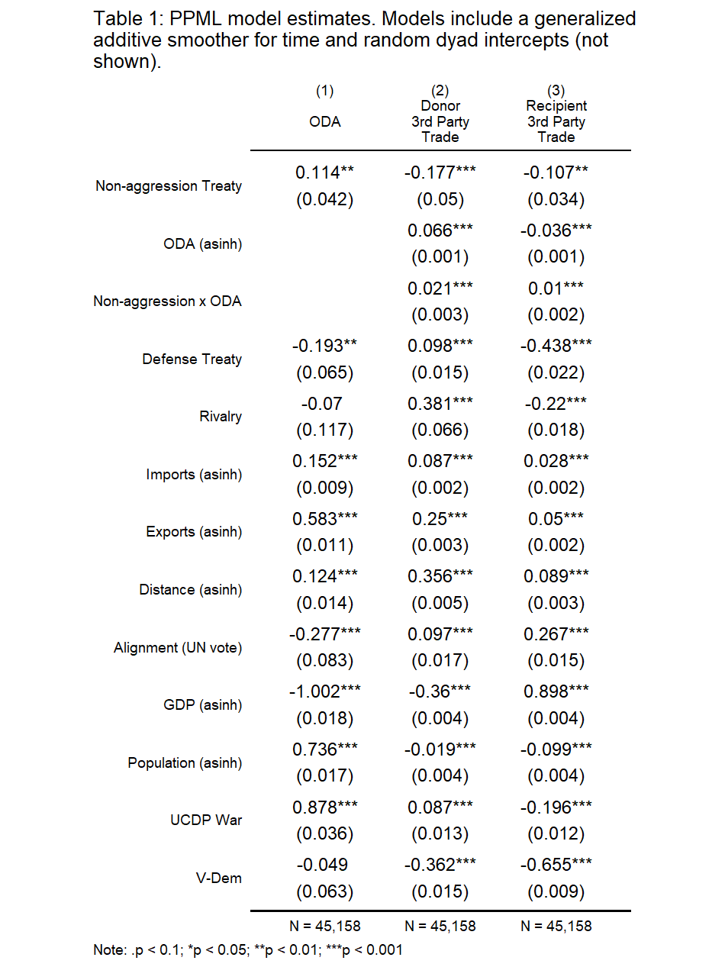
Since the model is non-linear, it will help to compute a representative estimate of the predicted change to bilateral ODA predicted by a non-aggression pledge. Holding all the predictors constant at their mean, the model predicts a 12.1% increase in bilateral ODA (95% CI = [9.4%; 14.9%]) when a donor and recipient come to share a non-aggression pledge. That is a substantial increase to bilateral ODA.
Columns 2 and 3 of Table 1 report the estimates for models 2 and 3 described in the previous section. Here the main coefficients of interest are those for the non-aggression and ODA terms, along with their interaction. Because of the multiplicative nature of the model, it is wise to avoid directly interpreting the coefficients on the main terms, but note the interaction term. It is both positive and statistically significant in models 2 and 3, consistent with hypotheses 2a and 2b respectively.
Figure 4 shows what this implies for predicted third party trade conditional on non-aggression. In the absence of bilateral ODA, a non-aggression pledge between a donor and recipient predicts a 16.2% decline in third party trade with the former and 10.2% decline with the latter. But when bilateral ODA is $1 million, a non-aggression pledge predicts a 13.5% increase in third party trade with donors and a 3.6% increase with recipients. And when bilateral ODA is $1 billion, a non-aggression pledge predicts a 31.2% increase in third party trade with donors and a 10.9% increase with recipients. These results are clearly consistent with the argument that third parties are sensitive to the signal communicated by ODA between non-aggression partners as shown by their greater willingness to access donor and recipient markets, and allow access to their own.
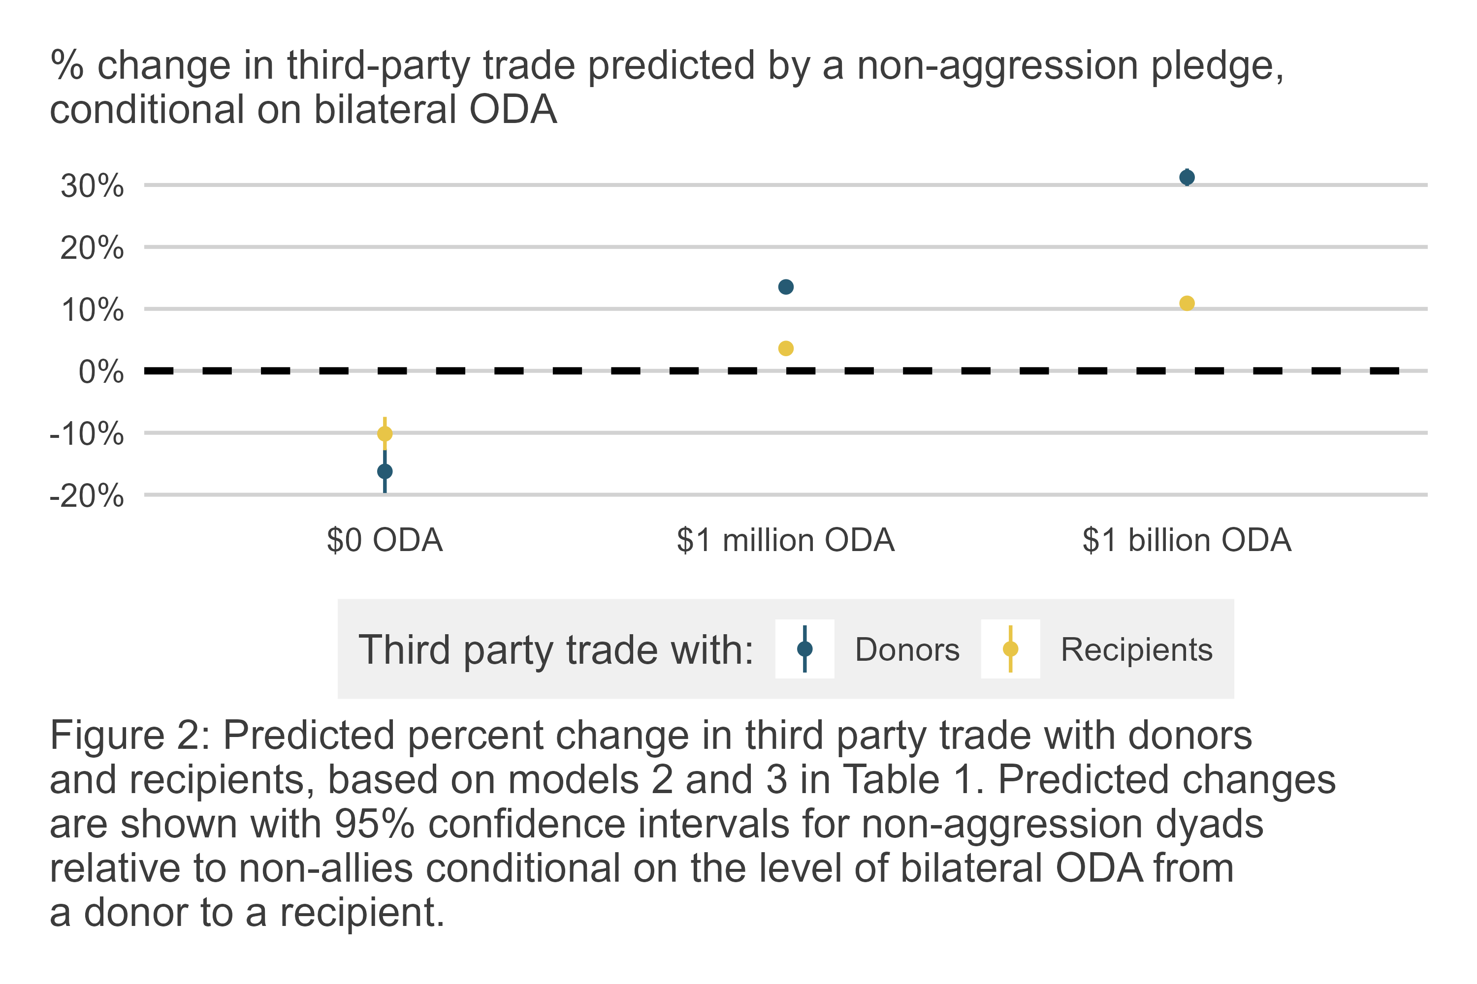
Table 2 reports OLS estimates for the linear model predicting net FDI (transformed with the inverse hyperbolic sine) to aid recipients as a function of ODA from non-aggression partners and ODA from all other donors. Consistent with hypothesis 3, the estimate for non-aggression ODA is both positive and statistically significant. Because both the outcome and the predictor have been transformed with the inverse hyperbolic sine, the coefficient can be approximately interpreted as an elasticity, or percent change in the outcome given a percent change in the predictor. According to the model, all else equal, a 1% increase in ODA from non-aggression partners predicts a 0.088% increase in net FDI. This is consistent with the idea that aid from non-aggression partners signals peace and, therefore, better return on investment.
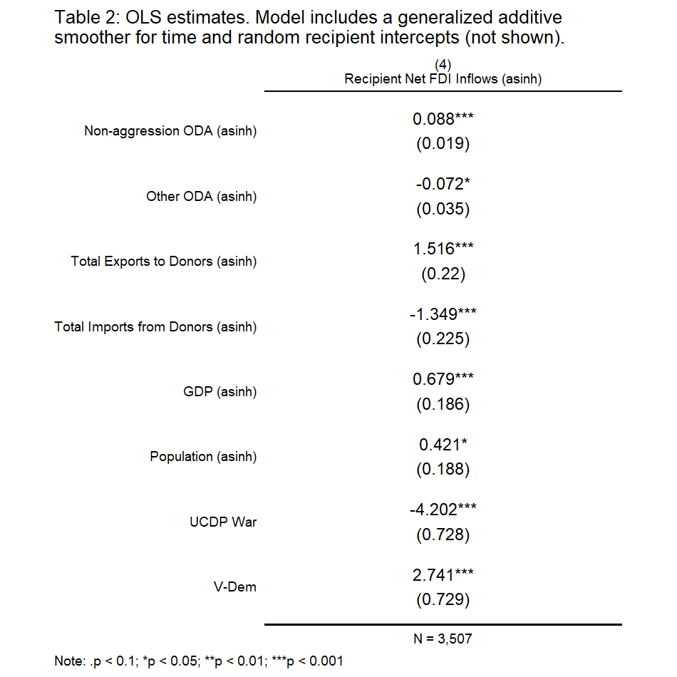
It is important to note that this predicted change is quite modest when compared with predictors like imports, exports, and GDP. As a practical matter, this implies that private investors, if they really do pay attention to the signal communicated by ODA that the chance of conflict between a donor and recipient has declined, they ultimately are far more swayed by mainstay macro economic indicators. They also are more swayed by recipient institutions and political stability, as implied by the coefficient for recipient V-Dem score and the coefficient for civil war. Nonetheless, controlling for these other factors, the model is consistent with the idea that private investors are marginally sensitive to the signal of peace communicated by ODA from non-aggression partners.
It further is interesting that ODA from donors that do not share a non-aggression pledge with a recipient predicts a statistically significant change in FDI, but in the opposite direction predicted by ODA from non-aggression partners. A 1% increase in ODA from non-allies predicts a 0.072% decline in net FDI. The theoretical argument underpinning hypothesis 3 has little direct implications for how private investors should respond to foreign aid in general, or to the aid given by non-allies in particular. However, the fact that there is such a contrast between the predictive power of aid from non-aggression partners and all other donors offers some unexpected face validity for the argument that ODA from non-aggression partners enhances the signal of peace communicated by non-aggression pledges. This finding does raise the question of why investors might invest less in recipients that get more aid from non-allies. Perhaps in contrast to aid from non-aggression partners, they interpret aid from other donors as a signal of recipient need and, therefore, lower return on investment.

Conclusion
Understanding the role that aid plays in alliance formation and effectiveness has more relevance than ever as the world’s leading bilateral donor, the United States, engages in unprecedented cuts to its foreign aid budget and the dismantling of its foremost aid agency, the United States Agency for International Development. Many other traditional donors in Europe and elsewhere are also cutting their aid budgets in parallel. The ripple effects of these changes for non-aggression pledges, other alliances, and additional foreign policies is not yet clear. In the interim, IR scholars are well situated to document the strategic importance of foreign aid, as this study does in the context of non-aggression pledges, so that policymakers in top donor countries understand the potential costs of dispensing with this versatile foreign policy tool.
This study contributes to this effort by demonstrating the important role that foreign aid plays in the context of non-aggression treaties. Analysis of a donor-recipient-year dataset covering the years 1991 to 2014 shows that foreign aid is used to complement non-aggression pledges. All else equal, a recipient country can expect a 12.1% boost in foreign aid from a donor country with which it shares a non-aggression pledge. The analysis also supports the argument that third parties register the signal of peace communicated by non-aggression pledges and foreign aid. Both donors and recipients that share a non-aggression pledge enjoy increases in total trade with third party countries, conditional on the amount of ODA given by donors to recipients. Furthermore, aid from non-aggression partners predicts a significant, if modest, increase in net FDI flows going to aid recipients.
These results support the multilateral theory of non-aggression pledges proposed by Lupu and Poast (2016), but also go further, first by demonstrating foreign aid’s role in enabling non-aggression partners to communicate their intentions for peace to third parties, and, second, by showing that third parties recognize this signal and respond accordingly.
But unanswered questions still remain. What other kinds of material concessions might non-aggression partners bundle together to make their commitment to cooperation appear credible? Aside from aid, countries might consider bilateral investment treaties or preferential trade agreements. It also is possible that alternative concessions might substitute for aid. These possibilities would speak to other areas of research important to IR scholars, such as theories of foreign policy substitutability (Morgan and Palmer 2003; Palmer, Wohlander, and Morgan 2002; Palmer and Morgan 2006).
Furthermore, what factors might condition when non-aggression partners see foreign aid or other concessions as necessary to make their commitment to cooperate credible? It is possible that the boost in aid to non-aggression partners is non-constant. Results not reported in the manuscript, but included in the Online Appendix, show that non-aggression pledges predict changes to ODA that are time variant. This suggests that certain periods or geostrategic contexts might necessitate material concessions beyond formal non-aggression pledges more so than others. The idea that systemic factors condition the link between aid and other kinds of alliances, like defensive pledges, has been proposed by others (Zhang 2024), so it is certainly plausible for this to be the case with non-aggression pledges as well.
Any of these questions would be worth pursuing in subsequent studies. Indeed, as the future of foreign aid remains in doubt, documenting the costs of losing this important policy lever, and identifying alternatives, will only grow in importance.

Replication Materials
Analysis for this study was done using R version 4.2.1. R code and data to replicate this analysis are saved on the corresponding author’s GitHub: [link to be provided upon acceptance].

References
Bailey, Michael A, Anton Strezhnev, and Erik Voeten. 2017. “Estimating Dynamic State Preferences from United Nations Voting Data.” Journal of Conflict Resolution 61 (2): 430–56.
Barbieri, Katherine, Omar MG Keshk, and Brian M Pollins. 2009. “Trading Data: Evaluating Our Assumptions and Coding Rules.” Conflict Management and Peace Science 26 (5): 471–91.
Bellemare, Marc F., and Casey J. Wichman. 2020. “Elasticities and the Inverse Hyperbolic Sine Transformation.” Oxford Bulletin of Economics and Statistics 82(1): 50–61.
Bueno de Mesquita, Bruce, and Alastair Smith. 2009. “A Political Economy of Aid.” International Organization 63 (2): 309–40.
Coppedge, Michael, John Gerring, Carl Henrik Knutsen, Staffan I Lindberg, Jan Teorell, David Altman, Michael Bernhard, et al. 2020. “V-Dem Codebook V10, Varieties of Democracy (v-Dem) Project.” Retrieved June 20: 2019.
Dreher, Axel, Valentin Lang, and Bernhard Reinsberg. 2024. “Aid Effectiveness and Donor Motives.” World Development 176: 106501.
Gartzke, Erik A, Shannon Carcelli, J Andres Gannon, and Jiakun Jack Zhang. 2017. “Signaling in Foreign Policy.” In Oxford Research Encyclopedia of Politics.
Gleditsch, Nils Petter, Peter Wallensteen, Mikael Eriksson, Margareta Sollenberg, and Havard Strand. 2002. “Armed Conflict 1946-2001: A New Dataset.” Journal of Peace Research 39 (5): 615–37.
Leeds, Brett Ashley, Jeffrey M. Ritter, Sarah McLaughlin Mitchell, and Andrew G. Long. 2002. “Alliance Treaty Obligations and Provisions, 1815-1944.” International Interactions 28: 237–60.
Long, Andrew G, Timothy Nordstrom, and Kyeonghi Baek. 2007. “Allying for Peace: Treaty Obligations and Conflict Between Allies.” The Journal of Politics 69 (4): 1103–17.
Lupu, Yonatan, and Paul Poast. 2016. “Team of Former Rivals: A Multi-Lateral Theory of Non-Aggression Pacts.” Journal of Peace Research 53(3): 344–58.
Mattes, Michaela, and Greg Vonnahme. 2010. “Contracting for Peace: Do Nonaggression Pacts Reduce Conflict?” The Journal of Politics 72 (4): 925–38.
Miller, Steven V. 2022. “$\{$Peacesciencer$\}$: An r Package for Quantitative Peace Science Research.” Conflict Management and Peace Science 39 (6): 755–79.
Morgan, Clifton T., and Glenn Palmer. 2003. “To Protect and to Serve: Alliances and Foreign Policy Portfolios.” Journal of Conflict Resolution 47 (2): 180–203.
Morrow, James D. 2000. “Alliances: Why Write Them Down?” Annual Review of Political Science 3 (1): 63–83.
Palmer, Glenn, and T. Clifton Morgan. 2006. A Theory of Foreign Policy. Princeton: Princeton University Press.
Palmer, Glenn, Scott B. Wohlander, and T. Clifton Morgan. 2002. “Give or Take: Foreign Aid and Foreign Policy Substitutability.” Journal of Peace Research 39 (1): 5–26.
Pettersson, Therése, Stina Högbladh, and Magnus Öberg. 2019. “Organized Violence, 1989-2018 and Peace Agreements.” Journal of Peace Research 56 (4): 589–603.
Schvitz, Guy, Seraina Rüegger, Luc Girardin, Lars-Erik Cederman, Nils Weidmann, and Kristian Skrede Gleditsch. 2022. “Mapping the International System, 1886-2017: The CShapes 2.0 Dataset.” Journal of Conflict Resolution 66 (1): 144–61. https://doi.org/10.1177/00220027211013563.
Selaya, Pablo, and Eva Rytter Sunesen. 2012. “Does Foreign Aid Increase Foreign Direct Investment?” World Development 40 (11): 2155–76.
Silva, J.M.C. Santos, and Silvana Tenreyro. 2006. “The Log of Gravity.” The Review of Economics and Statistics 88 (4): 641–58.
Smith, Alastair. 1995. “Alliance Formation and War.” International Studies Quarterly 39 (4): 405–25.
Wang, Zhiyuan, and Hyunjin Youn. 2018. “Locating the External Source of Enforceability: Alliances, Bilateral Investment Treaties, and Foreign Direct Investment.” Social Science Quarterly 99 (1): 80–96.
Warren, T Camber. 2016. “Modeling the Coevolution of International and Domestic Institutions: Alliances, Democracy, and the Complex Path to Peace.” Journal of Peace Research 53 (3): 424–41.
Weidmann, Nils B., and Kristian Skrede Gleditsch. 2010. “Mapping and Measuring Country Shapes: The Cshapes Package.” R Journal 2 (1): 18–24.
Zhang, Qi. 2024. “When Does Security Cooperation Increase Foreign Aid Allocation?” Journal of Conflict Resolution 68 (5): 875–902.

Denison University, Granville, OH USA. Contact at mdwilliams@denison.edu. The author is grateful for feedback from panel participants at the 2024 annual meeting of the American Political Science Association and the 2025 annual meeting of the Midwest Political Science Association.
See “Burden-shedding: the unraveling of the OECD aid consensus,” published March 7, 2025 (accessed March 8, 2025): https://devpolicy.org/burden-shedding-the-unravelling-of-the-oecd-aid-consensus-20250307/.
See ATOP documentation for treaty #4265.
See ATOP documentation for treaty #4265.
See ATOP documentation for treaty #4265.

