Here is a document
Miles D. Williams
2024-05-20
Abstract: Something abstract, like an abstract, seems rather…abstract.

1 Quarto
Quarto enables you to weave together content and executable code into a finished document. To learn more about Quarto see https://quarto.org.
One of the kinds of documents you can create is a .docx document. While these are not the most beautiful documents, they are editable and most academic journals will accept .docx files of manuscripts. They won't always accommodate .pdf files (especially upon final submission.)

2 Running Code
When you click the Render button a document will be generated that includes both content and the output of embedded code. You can embed code like this:
1 + 1
[1] 2
You can add options to executable code like this
[1] 4
The echo: false option disables the printing of code (only output is displayed).
You can also make data visualizations and control the dpi.
plot(
x = mtcars$wt,
y = mtcars$mpg,
pch = 19,
col = "gray",
xlab = "Weight",
ylab = "MGP"
)
abline(
lm(mpg ~ wt, mtcars),
col = "steelblue",
lwd = 2
)
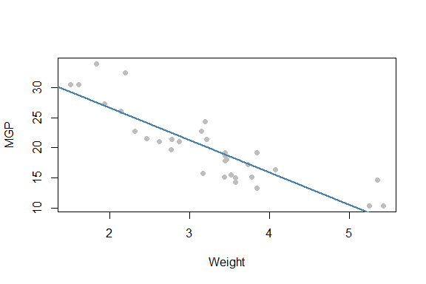
Figure 1: Here is a scatter plot
You can also make regression tables using {modelsummary}.
library(modelsummary)
list(
"Model 1" = lm(mpg ~ wt, mtcars),
"Model 2" = lm(mpg ~ hp, mtcars),
"Model 3" = lm(mpg ~ wt + hp, mtcars)
) -> fits
modelsummary(
models = fits,
estimate = "{estimate}{stars} ({std.error})",
statistic = NULL,
align = "lccc",
vcov = "stata",
coef_map = c(
"wt" = "Weight",
"hp" = "Horse Power",
"(Intercept)" = "Control"
),
gof_map = list(
list(raw = "nobs",
clean = "$N$",
fmt = \(x) format(x, big.mark = ",")),
list(raw = "r.squared",
clean = "$R^2$",
fmt = \(x) round(x, 2))
),
title = "Table 1: Here is a regression table",
notes = c(
paste(
"Regression tables are easy enough to produce in",
"word documents, but be careful about certain",
"formating choices---they don't always play nice",
"with the rendered .docx file."
),
"*** p < 0.001; ** p < 0.01; * p < 0.05; + p < 0.1"
)
)
Table 1: Here is a regression table
 | Model 1 | Model 2 | Model 3
Weight | -5.344*** (0.654) |  | -3.878*** (0.651)
Horse Power |  | -0.068*** (0.014) | -0.032*** (0.007)
Control | 37.285*** (2.195) | 30.099*** (2.077) | 37.227*** (2.037)
$$N$$ | 32 | 32 | 32
$$R^{2}$$ | 0.75 | 0.6 | 0.83
Regression tables are easy enough to produce in word documents, but be careful about certain formatting choices—they don’t always play nice with the rendered .docx file.
*** p < 0.001; ** p < 0.01; * p < 0.05; + p < 0.1

