Data Viz for Faculty Attitudes toward a DPR Major for Political Science Students

2024-06-13

This document contains some data visualizations and the code used to produce them. The data viz are in the first section, and the code appears after.

## 1 The Data Visualiations

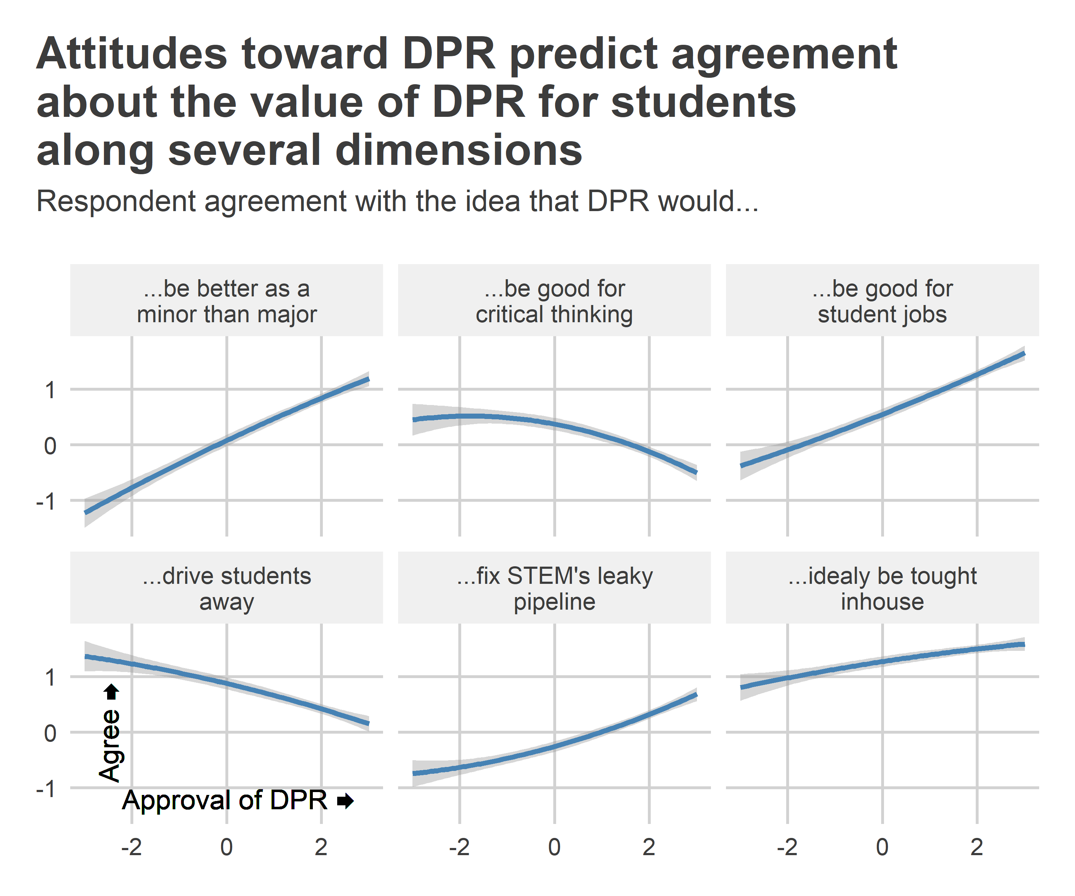

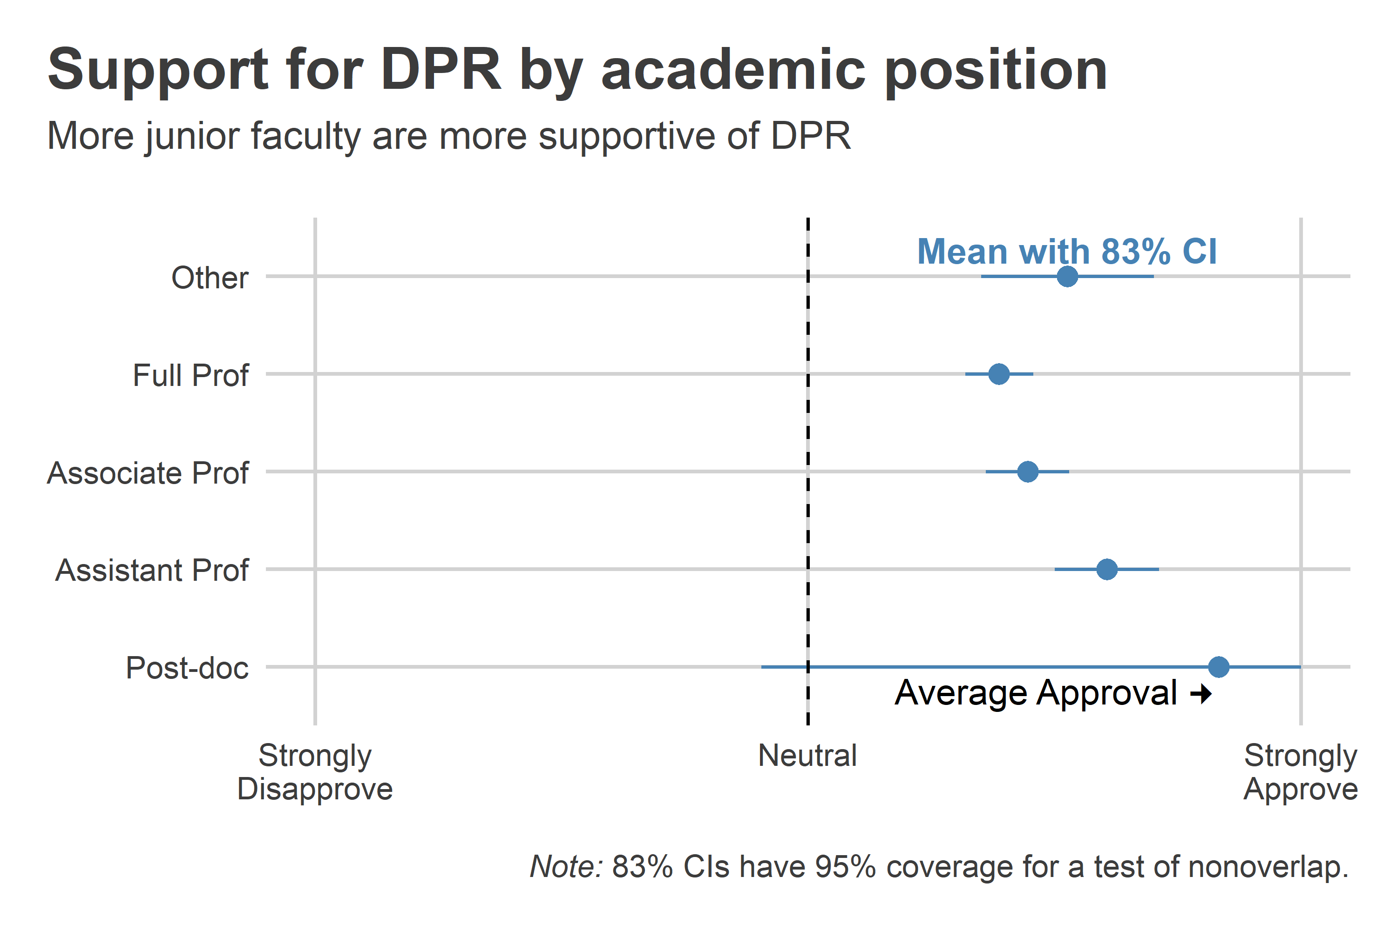

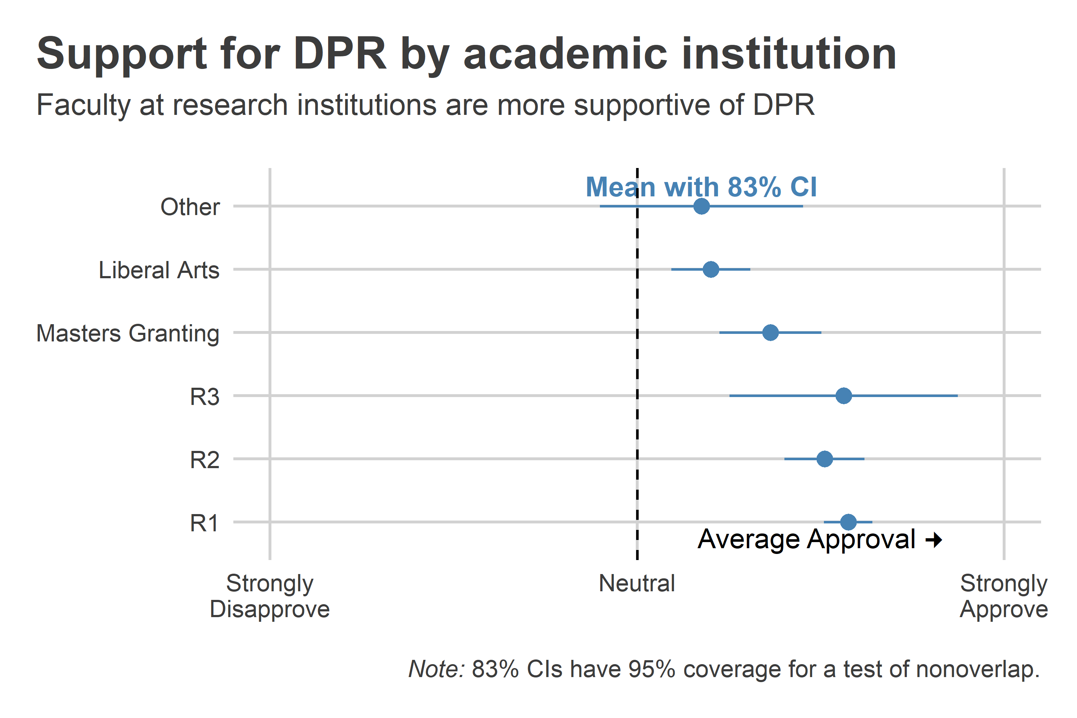

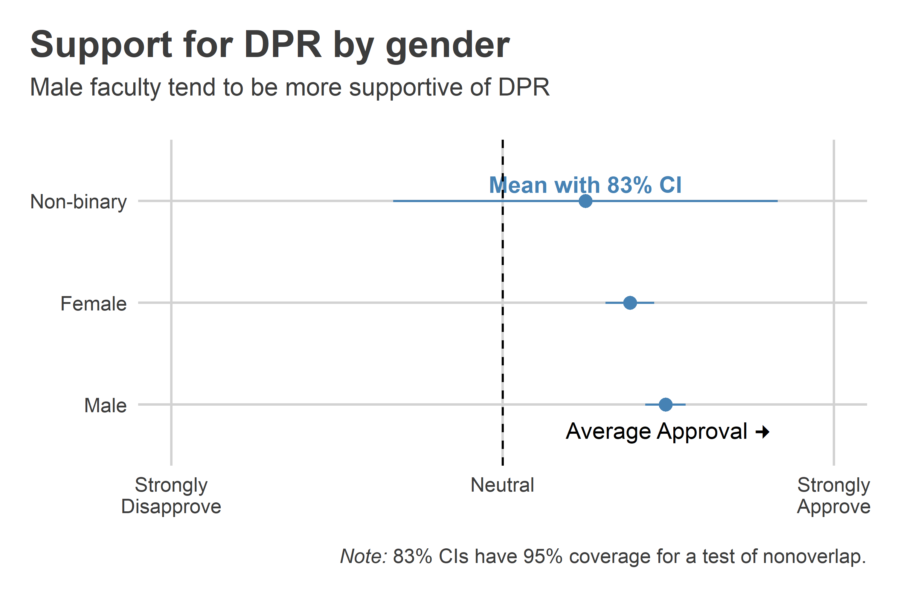

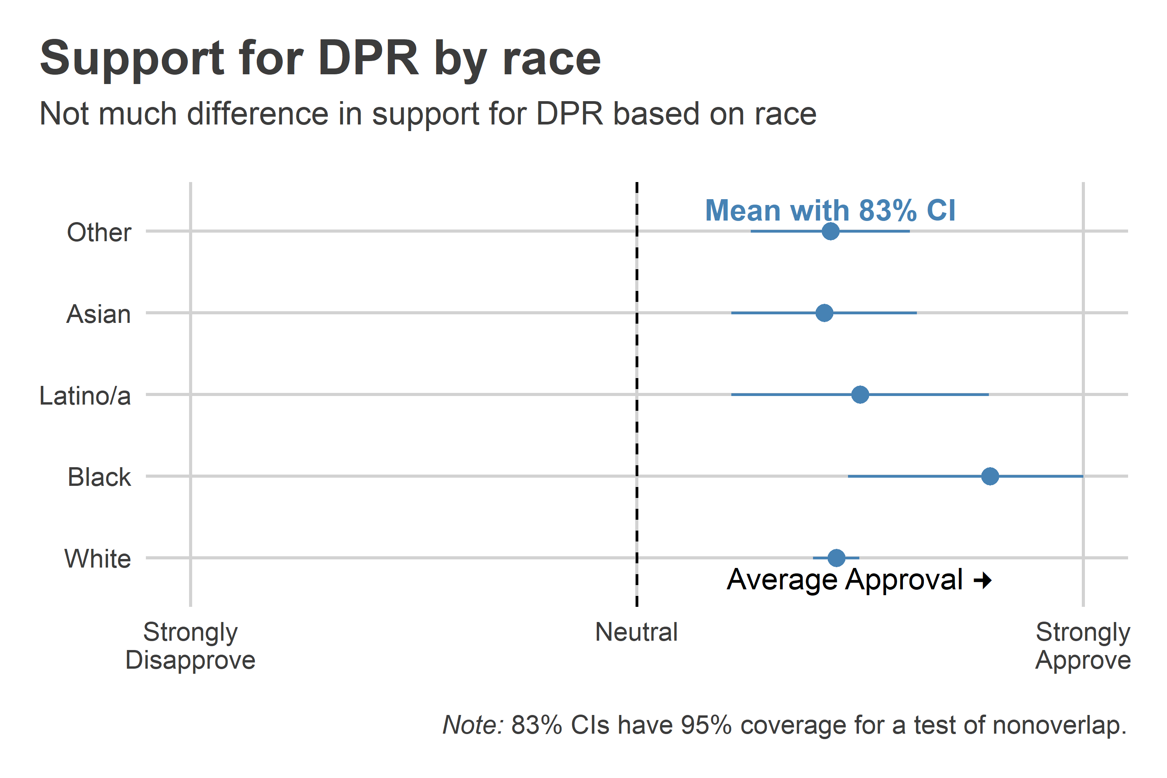

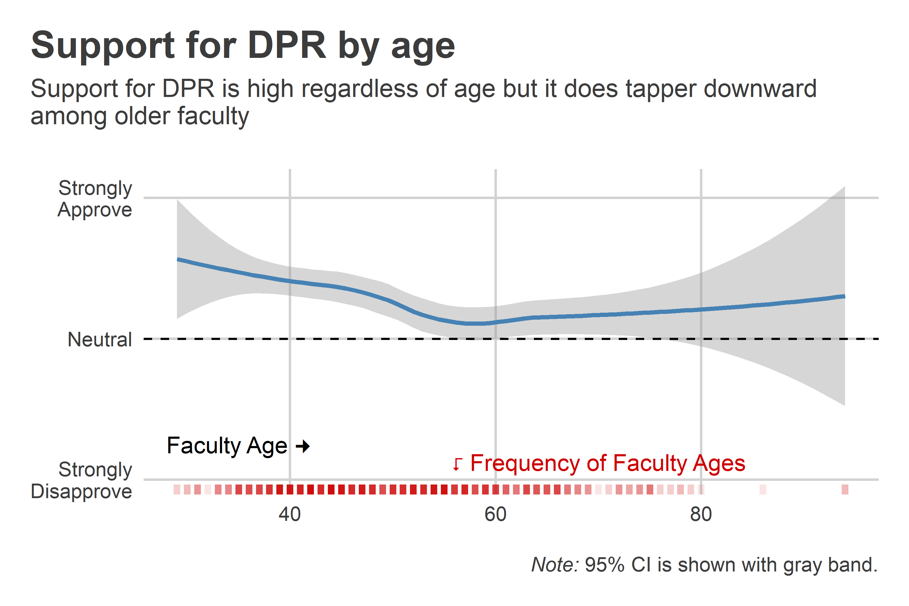

## 2 The Code

## Setup ----  
library(tidyverse)  
library(socsci)  
library(ggtext)  
library(coolorrr)  
set_theme()  
set_palette(  
 binary = c("steelblue", "gray")  
)  
library(googlesheets4)  
gs4_deauth()  
  
## Read in data ----  
ps <- range_speedread("https://docs.google.com/spreadsheets/d/1MPEl2xX5194wsIH744Q6tvI0GhM_FSpyj4wc-wWeiQc/edit?usp=sharing")  
  
ps <- ps %>% rename_all(tolower)  
  
ps <- ps %>% filter(finished==1)  
  
## Recodes ----  
val7 <- c("Strongly\nDisapprove", "Disapprove",   
 "Somewhat\nDisapprove", "Neither",  
 "Somewhat\nApprove", "Approve",  
 "Strongly\nApprove")  
val5 <- c("Strongly\nDisagree", "Disagree",  
 "Neither", "Agree", "Strongly\nDisagree")  
qnam <- c("...be good for\nstudent jobs",  
 "...drive students\naway",  
 "...fix STEM's leaky\npipeline",  
 "...be better as a\nminor than major",  
 "...be good for\ncritical thinking",  
 "...idealy be tought\ninhouse")  
ps |>  
 transmute(  
 ## support for DPR (-3 lowest and +3 highest)  
 pro_dpr = 4 - q26,  
   
 ## followups (-2 lowest and +2 highest)  
 good_jobs = 3 - q27_1,  
 drive_away = 3 - q27_2,  
 fix_leaky_pipe = 3 - q27_3,  
 better_minor = 3 - q27_5,  
 critical_thinking = 3 - q27_4,  
 inhouse = 3 - q27_6,  
   
 ## academic position:  
 position = frcode(  
 q28 == 1 ~ "Grad Student",  
 q28 == 2 ~ "Post-doc",  
 q28 == 3 ~ "Assistant Prof",  
 q28 == 4 ~ "Associate Prof",  
 q28 == 5 ~ "Full Prof",  
 TRUE ~ "Other"  
 ),  
 public = (q29 == 1) + 0,  
 institution = frcode(  
 q30 == 1 ~ "R1",  
 q30 == 2 ~ "R2",  
 q30 == 3 ~ "R3",  
 q30 == 4 ~ "Masters Granting",  
 q30 == 5 ~ "Liberal Arts",  
 q30 == 6 ~ "Community College",  
 TRUE ~ "Other"  
 ),  
 retired = (q31 == 1) + 0,  
 gender = frcode(  
 q37 == 1 ~ "Male",  
 q37 == 2 ~ "Female",  
 q37 == 3 ~ "Non-binary"  
 ),  
 race = frcode(  
 q38 == 1 ~ "White",  
 q38 == 2 ~ "Black",  
 q38 == 3 ~ "Latino/a",  
 q38 == 4 ~ "Asian",  
 q38 == 5 ~ "Other"  
 ),  
 age = 2024 - q39_4  
 ) -> newps  
## Data viz ----   
  
### Figure 1 ----  
  
## Show how support for DPR predicts other  
## attitudes about the benefits of DPR for  
## students  
  
newps |>  
 pivot_longer(  
 good_jobs:inhouse  
 ) |>  
 mutate(  
 name = rep(  
 qnam, len = n()  
 )  
 ) |>  
 ggplot() +  
 aes(  
 x = pro_dpr,  
 y = value  
 ) +  
 geom_smooth(  
 method = "lm",  
 formula = y ~ poly(x, 2),  
 color = "steelblue"  
 ) +  
 facet_wrap(~ name) +  
 geom_text(  
 data = . %>%   
 filter(name == "...drive students\naway"),  
 aes(  
 x = 0.25,   
 y = -1.2,   
 label = sprintf("Approval of DPR \U1F846")  
 )  
 ) +  
 geom_text(  
 data = . %>%   
 filter(name == "...drive students\naway"),  
 aes(  
 x = -2.5,   
 y = 0,   
 label = sprintf("Agree \U1F846")  
 ),  
 angle = 90  
 ) +  
 labs(  
 title = paste0(  
 "Attitudes toward DPR predict agreement\n",  
 "about the value of DPR for students\n",  
 "along several dimensions"  
 ),  
 subtitle = paste0(  
 "Respondent agreement with the idea that DPR would...\n"  
 ),  
 x = NULL,  
 y = NULL  
 ) +  
 theme(  
 axis.text.y = element_text(  
 angle = 0  
 )  
 )  
  
### Figure 2 ----  
  
# Show mean support for DPR by position:  
  
newps |>  
 group_by(position) |>  
 mean_ci(pro_dpr, ci = .83) |>  
 mutate(  
 upper = ifelse(  
 upper > 2, 2, upper  
 )  
 ) |>  
 ggplot() +  
 aes(  
 x = mean,  
 xmin = lower,  
 xmax = upper,  
 y = position  
 ) +  
 geom_pointrange(  
 color = "steelblue"  
 ) +  
 geom_text(  
 data = . %>% filter(position == "Other"),  
 aes(label = "Mean with 83% CI"),  
 vjust = -.5,  
 color = "steelblue",  
 fontface = "bold"  
 ) +  
 geom_vline(  
 xintercept = 0,  
 lty = 2  
 ) +  
 scale_x_continuous(  
 breaks = c(-2, 0, 2),  
 labels =   
 c("Strongly\nDisapprove", "Neutral", "Strongly\nApprove"),  
 limits = c(-2, 2)  
 ) +  
 annotate(  
 "text",  
 x = 1,  
 y = .75,  
 label = sprintf("Average Approval \U1F80A")  
 ) +  
 labs(  
 title = paste0(  
 "Support for DPR by academic position"  
 ),  
 subtitle = paste0(  
 "More junior faculty are more supportive of DPR\n"  
 ),  
 x = NULL,  
 y = NULL,  
 caption = paste0(  
 "<p> </p>",  
 "<p><i>Note:</i> 83% CIs have 95% coverage for a test of nonoverlap.</p>"  
 )  
 ) +  
 theme(  
 plot.caption = element_markdown()  
 )  
  
### Figure 3 ----   
  
# Show support for DPR by institution:  
  
newps |>  
 group_by(institution) |>  
 mean_ci(pro_dpr, ci = .83) |>  
 ggplot() +  
 aes(  
 x = mean,  
 xmin = lower,  
 xmax = upper,  
 y = institution  
 ) +  
 geom_pointrange(  
 color = "steelblue"  
 ) +  
 geom_text(  
 data = . %>% filter(institution == "Other"),  
 aes(label = "Mean with 83% CI"),  
 vjust = -.5,  
 color = "steelblue",  
 fontface = "bold"  
 ) +  
 geom_vline(  
 xintercept = 0,  
 lty = 2  
 ) +  
 scale_x_continuous(  
 breaks = c(-2, 0, 2),  
 labels =   
 c("Strongly\nDisapprove", "Neutral", "Strongly\nApprove"),  
 limits = c(-2, 2)  
 ) +  
 annotate(  
 "text",  
 x = 1,  
 y = .75,  
 label = sprintf("Average Approval \U1F80A")  
 ) +  
 labs(  
 title = paste0(  
 "Support for DPR by academic institution"  
 ),  
 subtitle = paste0(  
 "Faculty at research institutions are more supportive of DPR\n"  
 ),  
 x = NULL,  
 y = NULL,  
 caption = paste0(  
 "<p> </p>",  
 "<p><i>Note:</i> 83% CIs have 95% coverage for a test of nonoverlap.</p>"  
 )  
 ) +  
 theme(  
 plot.caption = element_markdown()  
 )  
  
### Figure 4 ----  
  
# Show support for DPR by gender:  
  
newps |>  
 group_by(gender) |>  
 mean_ci(pro_dpr, ci = .83) |>  
 drop_na() |>  
 ggplot() +  
 aes(  
 x = mean,  
 xmin = lower,  
 xmax = upper,  
 y = gender  
 ) +  
 geom_pointrange(  
 color = "steelblue"  
 ) +  
 geom_text(  
 data = . %>% filter(gender == "Non-binary"),  
 aes(label = "Mean with 83% CI"),  
 vjust = -.5,  
 color = "steelblue",  
 fontface = "bold"  
 ) +  
 geom_vline(  
 xintercept = 0,  
 lty = 2  
 ) +  
 scale_x_continuous(  
 breaks = c(-2, 0, 2),  
 labels =   
 c("Strongly\nDisapprove", "Neutral", "Strongly\nApprove"),  
 limits = c(-2, 2)  
 ) +  
 annotate(  
 "text",  
 x = 1,  
 y = .75,  
 label = sprintf("Average Approval \U1F80A")  
 ) +  
 labs(  
 title = paste0(  
 "Support for DPR by gender"  
 ),  
 subtitle = paste0(  
 "Male faculty tend to be more supportive of DPR\n"  
 ),  
 x = NULL,  
 y = NULL,  
 caption = paste0(  
 "<p> </p>",  
 "<p><i>Note:</i> 83% CIs have 95% coverage for a test of nonoverlap.</p>"  
 )  
 ) +  
 theme(  
 plot.caption = element_markdown()  
 )  
  
### Figure 5 ----  
  
# Show support for DPR by race:  
  
newps |>  
 group_by(race) |>  
 mean_ci(pro_dpr, ci = .83) |>  
 mutate(  
 upper = ifelse(  
 upper > 2, 2, upper  
 )  
 ) |>  
 drop_na() |>  
 ggplot() +  
 aes(  
 x = mean,  
 xmin = lower,  
 xmax = upper,  
 y = race  
 ) +  
 geom_pointrange(  
 color = "steelblue"  
 ) +  
 geom_text(  
 data = . %>% filter(race == "Other"),  
 aes(label = "Mean with 83% CI"),  
 vjust = -.5,  
 color = "steelblue",  
 fontface = "bold"  
 ) +  
 geom_vline(  
 xintercept = 0,  
 lty = 2  
 ) +  
 scale_x_continuous(  
 breaks = c(-2, 0, 2),  
 labels =   
 c("Strongly\nDisapprove", "Neutral", "Strongly\nApprove"),  
 limits = c(-2, 2)  
 ) +  
 annotate(  
 "text",  
 x = 1,  
 y = .75,  
 label = sprintf("Average Approval \U1F80A")  
 ) +  
 labs(  
 title = paste0(  
 "Support for DPR by race"  
 ),  
 subtitle = paste0(  
 "Not much difference in support for DPR based on race\n"  
 ),  
 x = NULL,  
 y = NULL,  
 caption = paste0(  
 "<p> </p>",  
 "<p><i>Note:</i> 83% CIs have 95% coverage for a test of nonoverlap.</p>"  
 )  
 ) +  
 theme(  
 plot.caption = element_markdown()  
 )  
  
### Figure 6 ----  
  
# Show support for DPR by age:  
  
newps |>  
 ggplot() +  
 aes(  
 x = age,  
 y = pro_dpr  
 ) +  
 geom_smooth(  
 color = "steelblue"  
 ) +  
 geom_rug(  
 color = "red3",  
 sides = "b",  
 alpha = .1,  
 size = 1.5  
 ) +  
 geom_hline(  
 yintercept = 0,  
 lty = 2  
 ) +  
 scale_y_continuous(  
 breaks = c(-2, 0, 2),  
 labels = c("Strongly\nDisapprove", "Neutral", "Strongly\nApprove"),  
 limits = c(-2, 2.2)  
 ) +  
 annotate(  
 "text",  
 x = 35,  
 y = -1.5,  
 label = sprintf("Faculty Age \U1F80A")  
 ) +  
 annotate(  
 "text",  
 x = 70,  
 y = -1.75,  
 label = sprintf("\U2BA6 Frequency of Faculty Ages"),  
 color = "red3"  
 ) +  
 labs(  
 title = paste0(  
 "Support for DPR by age"  
 ),  
 subtitle = paste0(  
 "Support for DPR is high regardless of age but it does tapper downward\n",  
 "among older faculty\n"  
 ),  
 x = NULL,  
 y = NULL,  
 caption = paste0(  
 "<p> </p>",  
 "<p><i>Note:</i> 95% CI is shown with gray band.</p>"  
 )  
 ) +  
 theme(  
 plot.caption = element_markdown()  
 )  
  
## END OF CODE