Miles Ring

CSCI 3830

10/29/2017

1. Drop the .war file in the tomcat webapp server  
   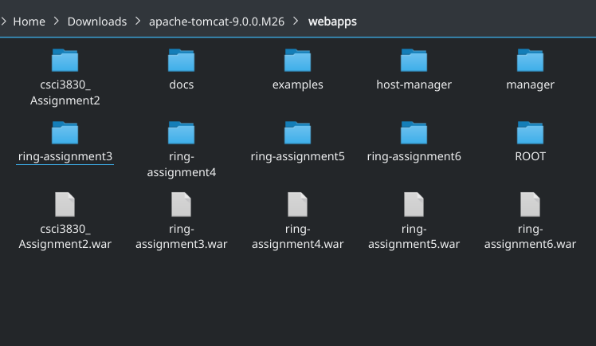
2. I chose to rewrite DataSourceExample.jsp and StatementExample.jsp. They are located at DataSourceExampleWTags.jsp and StatementExampleWTags.jsp  
   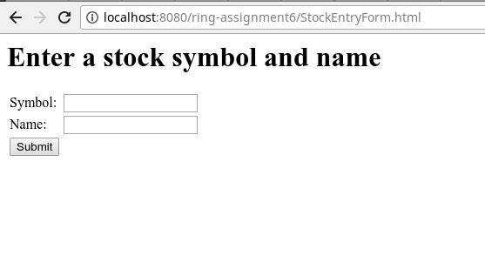  
   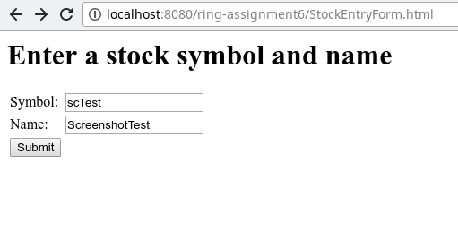  
   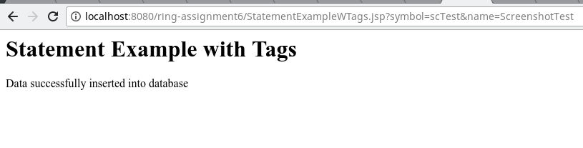  
   Updated table  
   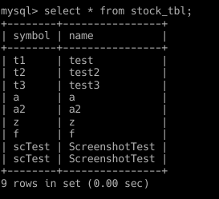  
     
   DataSourceExampleWTags.jsp  
   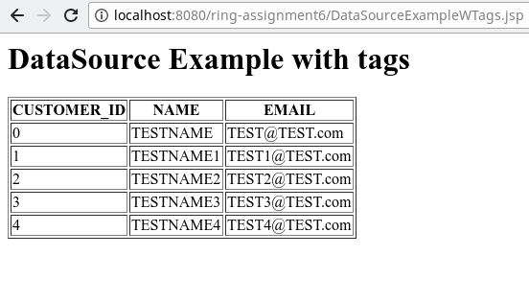  
   Customer table  
   