Miles Ring

CSCI3830 Final Project

12/12/2017

* Put .war file in tomcat WEBAPP directory and start server
* navigate to <http://localhost:8080/csci3830_FinalProject/HomePage.html>  
  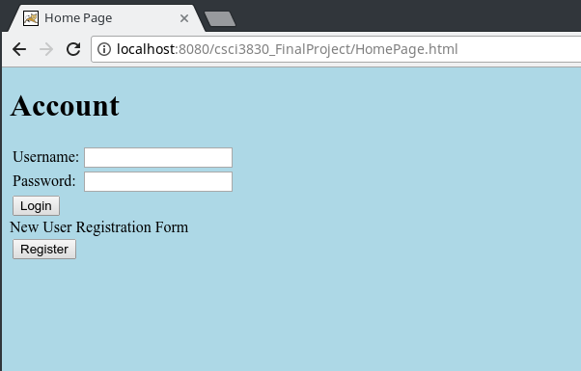
* Login with new account by clicking register  
  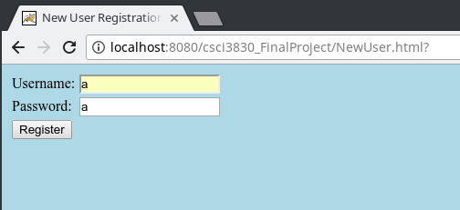
* After registering  
  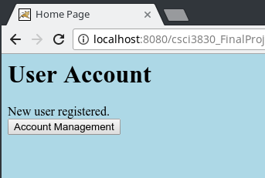
* Change password and username with account management  
  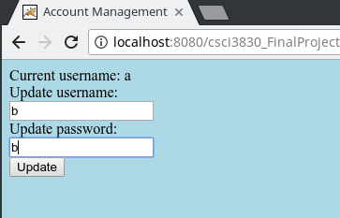
* after changing password and username  
  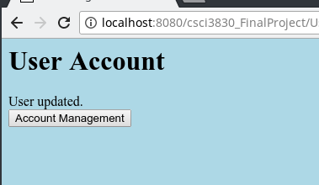
* going back to homepage and attempt to login with old name  
  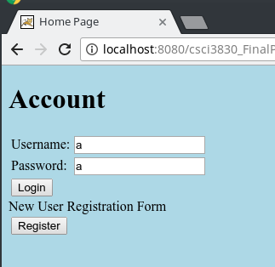
* after login attempt  
  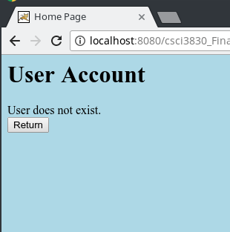
* correct login  
  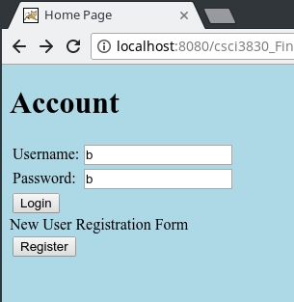  
  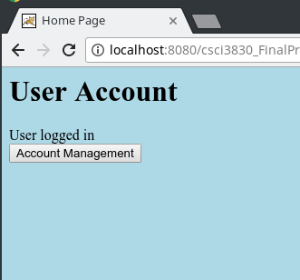
* back to home page, attempt to register account that already exists  
  