CSCI – 2510: Intro to Game Programming
Project 4.1
Points: 150
Due: TBA

Sprites and Animation

Create a small Sprite demo that incorporates input, image rendering, image transformation, and bounding shapes.

How you chose to demo these is up to you, but must meet the following requirements at a minimum:
- Sprites
  - Must have one player controlled Sprite
  - Player must be able to move Sprite in multiple directions
  - Sprite must have at least one additional ability (jump, shoot, etc.) that uses different animation than movement (see Transformation and Animation)
  - Must have at least one non-player controlled Sprite that interacts with the player controlled Sprite in some way (see Bounding Shapes)
- Background
  - Give the controlled Sprite some context of a world it exists in by providing a background
  - The controlled Sprite must interact with this background (that is don’t have it just be an image that the Sprite exists ON, but rather exists IN, see Bounding Shapes)
  - Do not allow the controlled Sprite to leave the background (walk off the screen)
- Bounding Shapes
  - Use Bounding Shapes to define the boundaries of Sprites
  - Design your Sprite class such that it can utilize single outer and multiple inner Bounding Shapes (not necessarily only Bounding Boxes/Circles)
  - Use both Bounding Boxes and Bounding Circles
  - The option to render Bounding Shapes must be present and toggled by hitting the ‘B’ key
- Transformation and Animation
  - The player controlled Sprite must be animated using multiple frames of animation
  - Animation must appear “smooth”
  - All three types of transformations (translation, rotation, and scaling) must be demonstrated

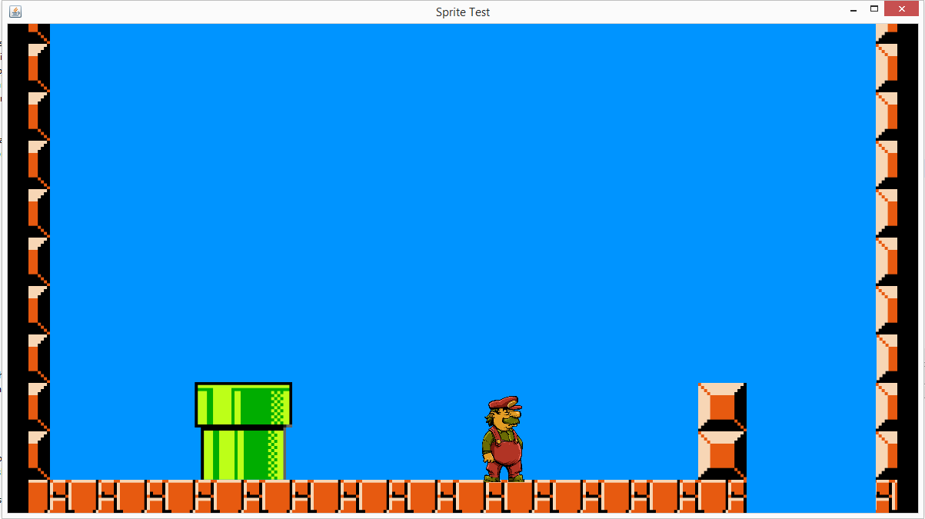
Background with some features

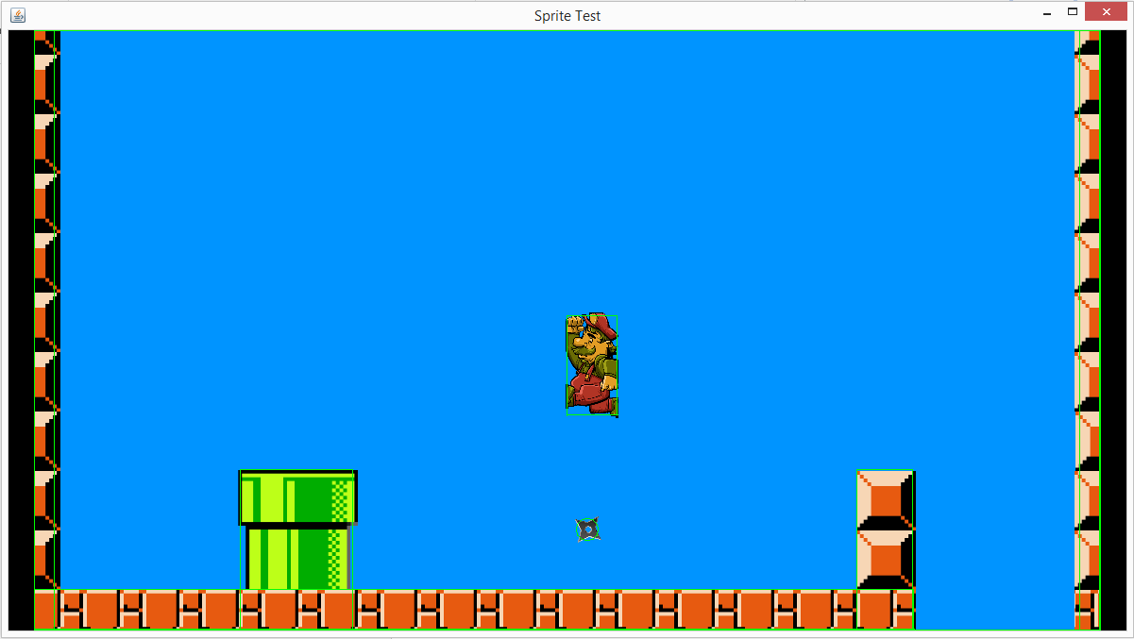
Bounding Shapes rendered

Class Design
You must create a reusable Sprite class that will serve as a super class to your actual sprites. Before starting, think about what is common to all Sprites in terms of data members and actions. Make your Sprite class flexible enough to be used for all types of Sprites.
Some things to think about regarding your Sprite class:
- Can this be used for Sprites that utilize different forms of Bounding Shapes?
- Can this be used for both animated and non-animated Sprites?
- How would it handle creating multiple Sprites that have the same frames of animation?
- Can this be used for creating a Background?

The Bounding Shapes is another place where good class design will be helpful. What do the two different Bounding Shapes have in common? What can be defined within a shared super class?

Take the design of these classes seriously, and put thought into them. You will most likely use them again later. Don’t simply write them to solve the immediate problem, assume you will need them to solve other problems and make them flexible enough to reflect that.

Design Document
Describe in detail your class hierarchies and why you designed them the way you did. Answer the above questions. What options did you put into your design that you may not necessarily be using for this assignment but could be of use in some other project?

Grading Rubric
The requirements listed above are a minimum to receive a passing grade, not necessarily an ‘A’. There are plenty of ways to add flavor to this. For example, if your character jumps, is the jump height static or is it dependent on how long the player holds the button. Does the jump or other action look natural? Try to make it interesting and clear that work above the minimum was put into it.

Your submission will be graded on the following points for the given values:

Class Design Document – 15 points
Class Design – 25 points
Player Controlled Sprite – 30 points
Control
Movement
Action
Background – 15 points
Aesthetics
Interaction
Bounding Shapes – 25 points
Collision Detection
Use of Bounding Box
Use of Bounding Circle
Bounding Shapes Rendered
Transformation and Animation – 25 points
Translation, Rotation, and Scaling
Animation
Other Requirements – 15 points

This assignment will be used for Assignment 4.2. Both will be submitted as a single project.

