COMP329 Group Log

Group 6

Members: Geri Georgieva, Yuan Gao, Amelia Blow

**Date: Friday 24th November**

Members Present: Geri, Yuan, Amelia

* First team meeting
* Read over the assignment
* Came up with some initial ideas:
  + Could use A* search to find the patients
  + Investigate some methods to sort out localisation at the beginning to find out where the scout agent is placed in relation to the grid that the doctor has
  + Need to practise using Jason – not fully confident with implementing actions, beliefs etc.
* Discussed which code we could use from first assignment
  + Odometry code to fix alignment issues when the robot moves around the arena
  + Scanning behaviour to help with localisation at the start and scanning the colour of the robot’s current position square to check whether it has found a patient or not
  + A* code to help the scout find a potential patient

**Date: Monday 27th November**

Members Present: Geri, Yuan, Amelia

* Yuan presented some code that he had written to create the 6x6 grid for the doctor, including coloured squares to represent potential patients
* Discussed some ideas to help with localisation - could have the robot scan left, right and in front of itself, then move forward and repeat as necessary until the scans of the scout match with a position on the grid that the doctor has.
* Decided to split the assignment into 3 main parts to work on in turn:
  1. Create the grid, the beliefs of each agent, locations of patients, communication between agents
  2. Odometry, localisation and scanning behaviour
  3. Link the agents to the robot that will move around the arena

**Date: Tuesday 5th December**

Members Present: Geri, Yuan, Amelia

* This meeting focussed on ideas for the communication between the pc and robot
* Could use sockets or java remote method invocation (RMI)
* Decided to use sockets as we all had some experience with using sockets in past year’s assignments
* Client/server setup, where the pc acts as the client and the robot as the server
* Client and server pass messages to each other as strings
* E.g. During localisation, the robot would scan around and pass the string “1,2,4” to indicate that there is 1 square to the left before an obstacle is reached, 2 squares ahead and 4 squares to the right, which the pc will receive and compare to the initial grid to try and locate the robot
* Communication will be done over Wi-Fi

**Date: Monday 11th December**

Members Present: Geri, Yuan, Amelia

* Refined the localisation algorithm so that the robot only needs to scan the adjacent squares, so e.g. would pass the string “true,false,false,false” to indicate that the squares to the right, left and back are empty, but there is an obstacle in the square to the front.
* Started working with the robot to test the odometry and localisation methods
* Algorithm planning:

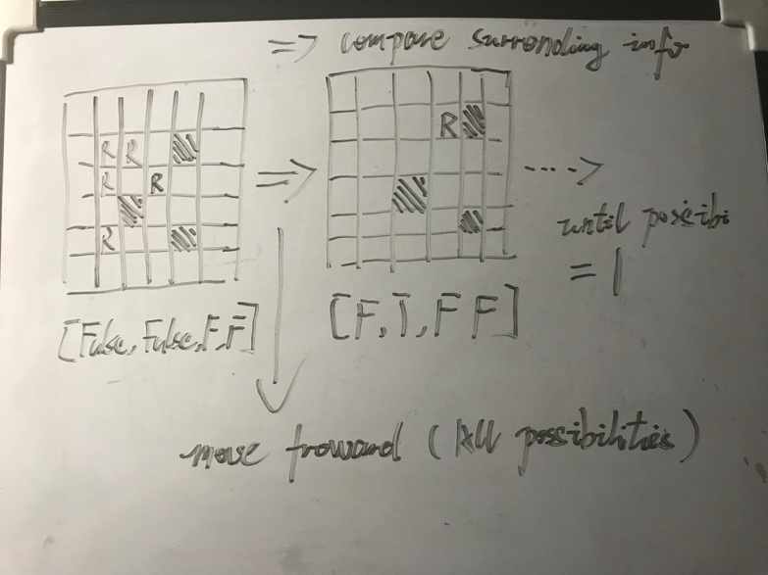

Figure 1. Localization algorithm planning

**Date: Wednesday 13th December**

Members Present: Geri, Yuan, Amelia

* Put all code together and tested solution in labs
* Had some initial issues
  + Needed to adjust wheel parameters to help with the odometry – sometimes the robot would turn too far and would then move diagonally across squares in the arena
  + For the client/server communication, some messages needed to be changed to pass an array instead of a string

**Date: Friday 16th December**

Members Present: Geri, Yuan, Amelia

* Had final meeting to discuss submission
* All code is now complete, just need to finish group/individual longs
* Decided to complete those over Christmas and submit beginning of January