In amphibians (n=18), adult body mass was not significantly associated with maximum longevity (Figure 1). The OLS model estimated a small positive slope (β=0.036, SE = 0.093, t=0.39, P=0.704). After accounting for phylogenetic non-independence using PGLS, the estimated relationship remained positive but non-significant (β=0.076, SE = 0.089, t=0.86, P=0.404). Thus, the available amphibian data do not provide evidence that larger-bodied species have greater maximum longevity. The PGLS model estimated moderate phylogenetic signal in the residual structure (λ_{ML}=0.474). Although the PGLS fit had a lower AIC than the OLS model (5.89 versus 10.69), accounting for phylogeny did not alter the substantive conclusion that the body-mass effect was not significant.
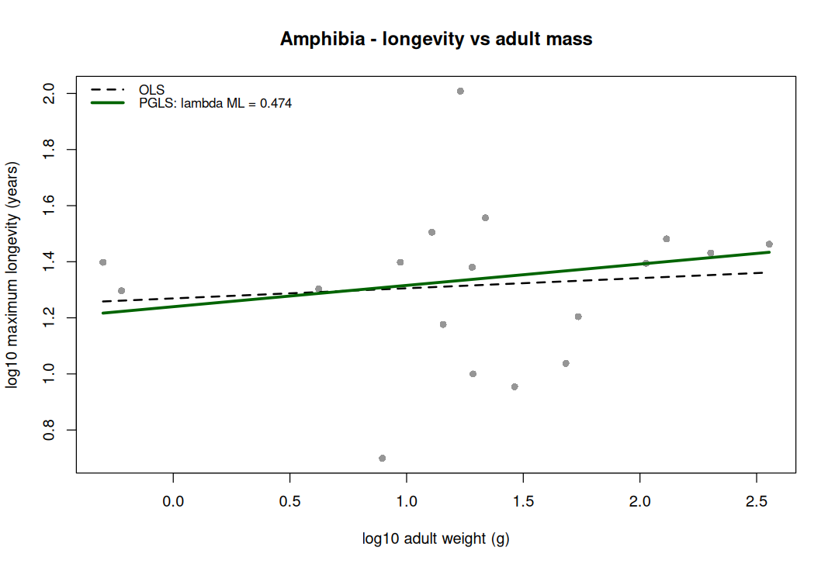
Figure 1. Relationship between adult body mass and maximum longevity among amphibian species (n=18). Points represent species-level observations of log10​-transformed adult weight (g) and log10​-transformed maximum longevity (years). The dashed black line shows the ordinary least-squares (OLS) regression, and the solid green line shows the phylogenetic generalized least-squares (PGLS) regression with maximum-likelihood-estimated phylogenetic signal (λ=0.474). Although both fitted slopes were positive, adult body mass was not significantly associated with longevity in the PGLS model (β=0.076, SE = 0.089, t=0.857, P=0.404).

Among birds (n=1,099), maximum longevity was positively associated with adult body mass (Figure 2). The OLS model showed a strong positive relationship between log10​-transformed adult weight and log10​-transformed maximum longevity (β=0.211, SE = 0.0072, t=29.30, P=6.89×10−140). This relationship remained strongly significant after accounting for phylogenetic non-independence using PGLS (β=0.225, SE = 0.0126, t=17.89, P<0.001). The PGLS analysis estimated moderate phylogenetic signal (λ_{ML}​=0.594), indicating that related bird species exhibited partially correlated longevity patterns. The PGLS model also had substantially stronger support than the OLS model based on AIC (−668.95 versus −470.39). Overall, these results indicate that larger-bodied bird species tend to have greater maximum longevity, and this association persists after accounting for shared evolutionary history.
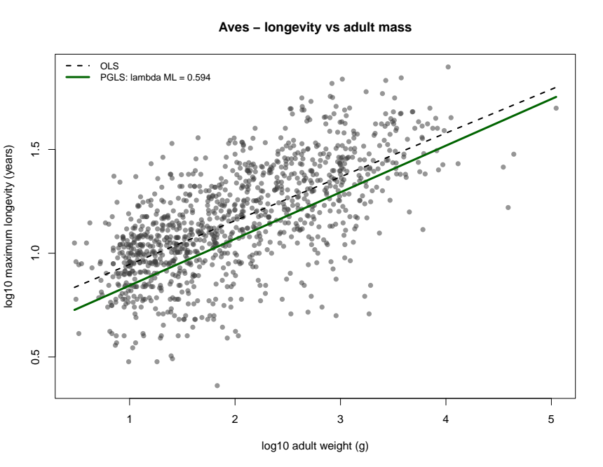
Figure 2. Relationship between adult body mass and maximum longevity among bird species (n=1,099). Points represent species-level observations of log10​-transformed adult weight (g) and log10​-transformed maximum longevity (years). The dashed black line shows the ordinary least-squares (OLS) regression, whereas the solid green line shows the phylogenetic generalized least-squares (PGLS) regression using a Grafen topology-derived phylogeny. Maximum longevity increased significantly with adult body mass after phylogenetic correction (β=0.225, SE = 0.013, t=17.89, P<0.001); the estimated phylogenetic signal was moderate (λML​=0.594).

Among reptiles (n=341), maximum longevity was positively associated with adult body mass (Figure 3). The OLS regression detected a significant positive relationship between log10​-transformed adult weight and log10​-transformed maximum longevity (β=0.139, SE = 0.012, t=11.99, P=7.44×10−28). After accounting for phylogenetic non-independence using PGLS, the relationship remained positive and highly significant, although the estimated slope was lower (β=0.092, SE = 0.016, t=5.71, P=2.45×10−8). The PGLS analysis estimated substantial phylogenetic signal (λ_{ML}​=0.788), consistent with strong covariance in longevity among closely related reptile species. The phylogenetically informed model was better supported than the OLS model based on AIC (−142.61 versus −12.15). Overall, larger-bodied reptile species tended to have greater maximum longevity, and this association remained robust after controlling for shared evolutionary history.
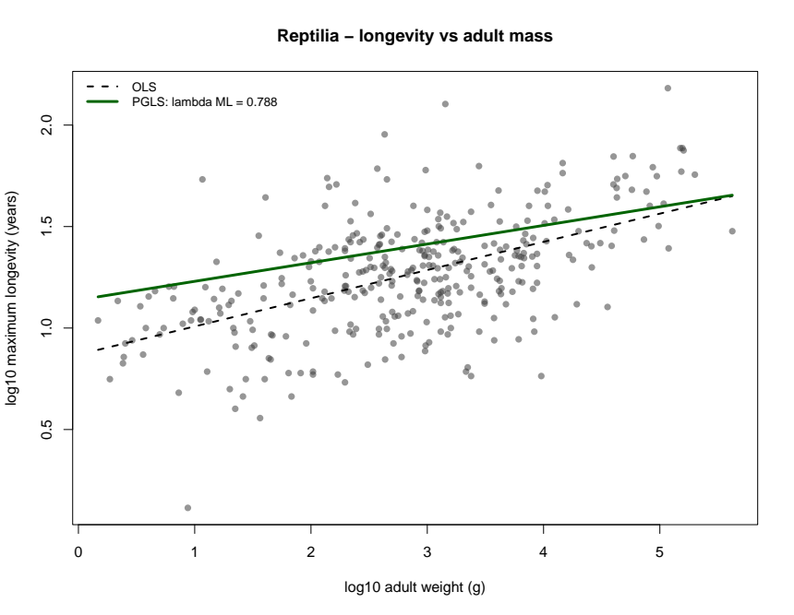
Figure 3. Relationship between adult body mass and maximum longevity among reptile species (n=341). Points represent species-level observations of log10​-transformed adult weight (g) and log10​-transformed maximum longevity (years). The dashed black line shows the ordinary least-squares (OLS) regression, whereas the solid green line shows the phylogenetic generalized least-squares (PGLS) regression. Maximum longevity increased significantly with adult body mass after accounting for phylogenetic non-independence (β=0.092, SE = 0.016, t=5.71, P=2.45×10−8). The estimated phylogenetic signal was substantial (λML​=0.788).

Among mammals (n=936), maximum longevity was strongly and positively associated with adult body mass (Figure 4). The OLS regression identified a significant positive relationship between log10-transformed adult weight and log10-transformed maximum longevity (β=0.161, SE = 0.005, t=30.74, P=6.17×10−144). After accounting for phylogenetic non-independence using PGLS, adult mass remained a strong positive predictor of maximum longevity (β=0.126, SE = 0.009, t=13.82, P<0.001). The PGLS model estimated very high phylogenetic signal (λ_{ML}​=0.974), indicating that closely related mammalian species had strongly correlated longevity patterns. Despite a reduction in the estimated slope after phylogenetic correction, the relationship between body mass and longevity remained highly significant. The PGLS model was substantially better supported than the OLS model based on AIC (−1226.46 versus −82.57). Overall, larger-bodied mammalian species tended to have greater maximum longevity, even after accounting for shared evolutionary history.
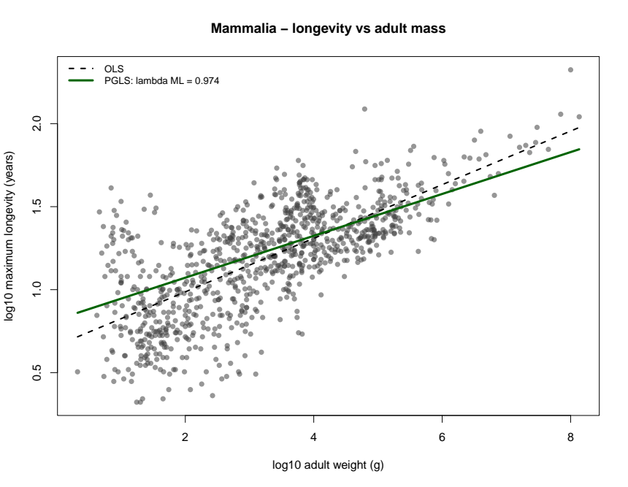
Figure 4. Relationship between adult body mass and maximum longevity among mammalian species (n=936). Points represent species-level observations of log10-transformed adult weight (g) and log10-transformed maximum longevity (years). The dashed black line shows the ordinary least-squares (OLS) regression, whereas the solid green line shows the phylogenetic generalized least-squares (PGLS) regression. Maximum longevity increased significantly with adult body mass after accounting for phylogenetic non-independence (β=0.126, SE = 0.009, t=13.82, P<0.001). The estimated phylogenetic signal was very high (λ_{ML}​=0.974).

Chromatin-module score results
A predefined 16-gene chromatin-maintenance module was scored from liver RNA-seq data across 24 mammalian species in GSE190756. For each gene, log2​-transformed expression was averaged across liver replicates within species, standardized across species as a gene-wise z-score, and then averaged across module genes. Thus, positive values indicate relatively higher module expression and negative values indicate relatively lower module expression relative to the 24-species liver panel.
The phylogenetically matched analysis included 19 mammal species. All retained taxa had adequate module representation, with 14–16 of 16 module genes available per species. The chromatin-module score ranged from −2.75 in Sciurus carolinensis to 0.615 in Blarina brevicauda. Sciurus carolinensis had an unusually low score, but this reflected a coherent pattern across the full module: all 16 genes had negative cross-species z-scores, including strong reductions for Trim28 (z=−3.75), Ehmt (z=−3.56), Cbx3 (z=−3.46), Atrx (z=−3.44), and Dnmt3a (z=−3.35). This species was represented by five liver samples and all 16 module genes, indicating that the score was not driven by missing genes or a single sample.
Genome-wide expression QC did not support a simple global expression-scale explanation for the low Sciurus module score. The species’ median genome-wide log2​ expression was 6.12, corresponding to a standardized genome-wide median of z = 0.356 across the 24-species panel. Therefore, Sciurus had slightly above-average overall median expression despite markedly reduced relative expression of the chromatin module. However, Sciurus had fewer detected genes on average (8,324) than many other species, so species-specific annotation and quantification differences remain a limitation of this cross-species expression comparison.

PGLS association with longevity
I tested whether the liver chromatin-module score was associated with maximum longevity after accounting for adult body mass and shared evolutionary history. The primary PGLS model was:
longevity, years mass, g scorelog10​(maximum longevity, years)=β0​+β1​log10​(adult mass, g)+β2​(chromatin-module score).
The fitted model included all 19 species, with no tree tips or observations dropped during phylogenetic matching. The chromatin-module score showed a negative mass-adjusted association with maximum longevity:
βmodule​=−0.137,SE=0.069,t=−1.97,p=0.067.
Thus, species with lower relative liver expression of the chromatin module tended to have longer maximum longevity after adjustment for adult mass and phylogenetic covariance. On the original longevity scale, the estimated effect corresponds to a factor of:
10−0.137≈0.73
per one-unit increase in module score. Equivalently, a one-unit lower score was associated with approximately 1.37-fold, or 37%, greater predicted maximum longevity, conditional on body mass and phylogeny. This is an association and should not be interpreted as evidence that lower chromatin-module RNA expression causes increased lifespan.
Adult mass was not independently associated with longevity in the full two-predictor PGLS:
βmass​=0.060,SE=0.052,t=1.15,p=0.268.
The full model explained 25.9% of the model-scale variance in log10​ longevity (R²=0.259; adjusted R²=0.166) and had a residual standard error of 0.0337 log10​-years. The overall model was not conventionally significant:
F_{2,16}​ = 2.79, p=0.091.
The phylogenetic covariance parameter was estimated at the upper boundary:
λ_{ML} ​= 1.00,
with a 95% profile-likelihood interval of 0.339 to 1.00, with the upper confidence limit reaching the permitted boundary. The likelihood test rejected λ=0 (p=0.019), indicating substantial residual phylogenetic structure and supporting the use of PGLS rather than an independence-based regression. In PGLS, λ describes phylogenetic signal in the model residuals, conditional on included predictors, rather than the phylogenetic signal of longevity or module score alone.

Model comparison
Adding the chromatin-module score modestly improved model fit relative to the adult-mass-only model:
Model | Parameters | AIC
PGLS: log10​(longevity) ∼ log10​(adult mass) | 2 | 3.712
PGLS: log10​(longevity) ∼ log10​(adult mass) + chromatin module | 3 | 1.905
The full model had a lower AIC by: ΔAIC=1.81.
This gives modest support for including the chromatin-module score, but the difference is below the common 2-AIC-unit threshold for a clearly preferred model. Therefore, the mass-only and mass-plus-module models should be regarded as similarly plausible rather than as decisively different. AIC ranks candidate models by balancing goodness of fit against model complexity; lower values are preferred, but small differences provide limited discrimination.

Sensitivity and leverage
Leave-one-species-out analyses showed that the negative coefficient direction was retained in all 19 refits, with slopes ranging from −0.150 to −0.0096. The result was robust to excluding Condylura cristata, the one tree-matched species with a single liver RNA-seq replicate:
βmodule​=−0.147,SE=0.066,p=0.041.
However, the result was strongly influenced by Sciurus carolinensis. Excluding this species reduced the module coefficient to near zero:
βmodule​=−0.0096,SE=0.158,p=0.953.
Accordingly, the primary association should be interpreted as a hypothesis-generating, leverage-sensitive pattern, not as robust evidence of a general mammalian relationship. The influential status of Sciurus appears to reflect a real feature of the input data—an extreme but coherent low-expression module signature across five liver samples and 16 genes—rather than an obvious one-gene, missingness, tissue-label, or global-expression-scale artifact. Nonetheless, because the cross-species dataset contains only 19 phylogenetically matched species and species-specific quantification platforms may introduce systematic differences, replication in an independent cross-mammal liver expression dataset and direct chromatin-state measurements would be needed before making a mechanistic claim.
