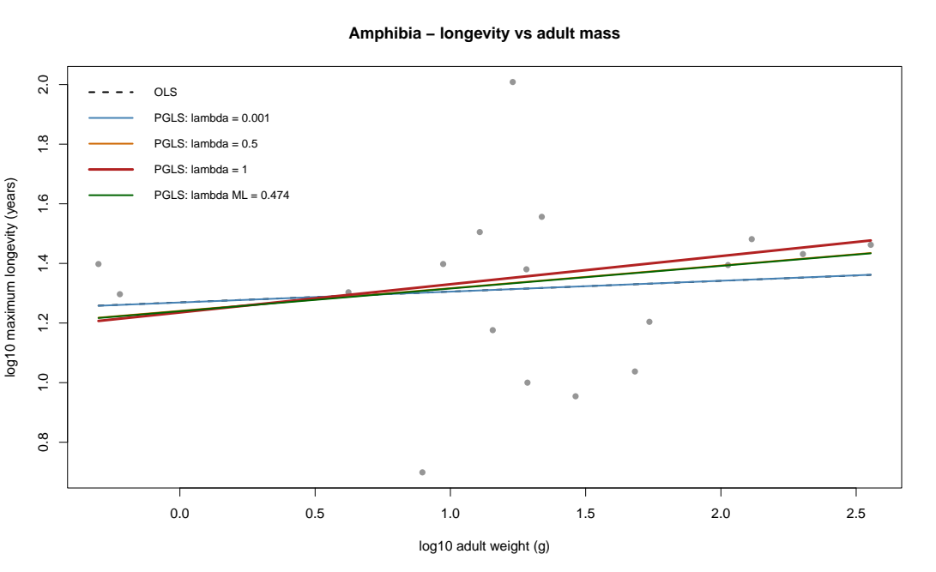
.
Figure S1. Phylogenetic-signal sensitivity analysis for amphibian longevity. Maximum-likelihood phylogenetic generalized least-squares (PGLS) analysis of 18 amphibian species estimated Pagel’s λ at 0.474, indicating moderate phylogenetic dependence in the residual covariance structure. After accounting for this dependence, adult body mass was not significantly associated with longevity (β=0.076±0.089 SE, t=0.857, P=0.404). The PGLS model provided a better fit than the nonphylogenetic OLS model (AIC = 5.89 vs. 10.69), although the inferred body-mass effect remained weak and nonsignificant under both approaches.

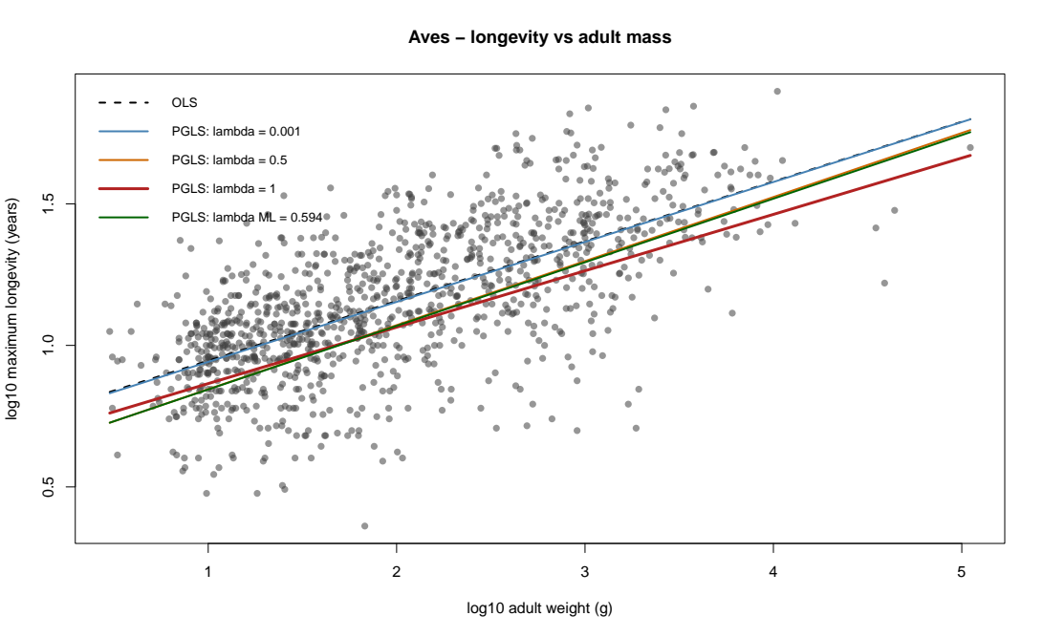
Figure S2. Phylogenetic-signal sensitivity analysis for avian longevity. Maximum-likelihood phylogenetic generalized least-squares (PGLS) analysis of 1,099 bird species estimated Pagel’s λ at 0.594, indicating moderate phylogenetic dependence in residual variation in longevity after accounting for adult body mass. Adult body mass was positively associated with longevity in the PGLS model (β=0.225±0.013 SE, t=17.89, P<0.001). Although the positive association was also recovered by ordinary least squares (β=0.211±0.007 SE, t=29.30, P=6.89×10−140), the phylogenetically informed model showed substantially better fit (AIC = −668.95) than OLS (AIC = −470.39), supporting the importance of accounting for shared evolutionary history.

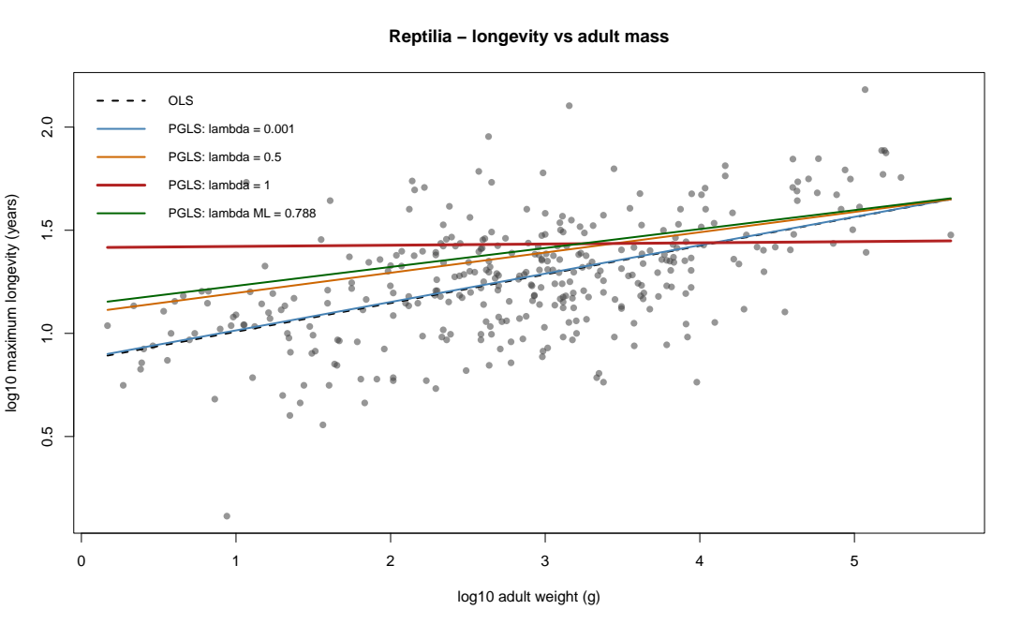
Figure S3. Phylogenetic-signal sensitivity analysis for reptilian longevity. Maximum-likelihood phylogenetic generalized least-squares (PGLS) analysis of 341 reptile species estimated Pagel’s λ at 0.788, indicating substantial phylogenetic dependence in residual longevity after accounting for adult body mass. Adult body mass remained positively associated with longevity in the PGLS model (β=0.092±0.016 SE, t=5.71, P=2.45×10−8). The relationship was likewise positive under ordinary least squares (β=0.139±0.012 SE, t=11.99, P=7.44×10−28); however, the PGLS model provided a markedly better fit (AIC = −142.61) than OLS (AIC = −12.15), indicating that accounting for shared evolutionary history materially improved model performance.

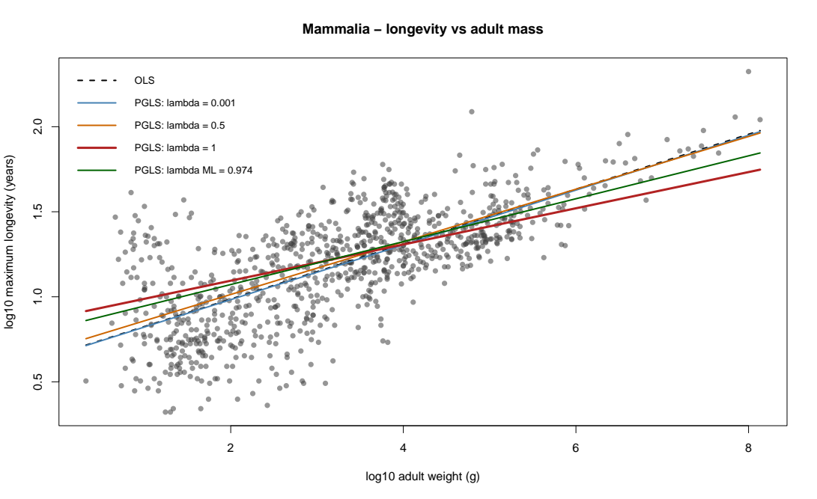
Figure S4. Phylogenetic-signal sensitivity analysis for mammalian longevity. Maximum-likelihood phylogenetic generalized least-squares (PGLS) analysis of 936 mammal species estimated Pagel’s λ at 0.974, indicating that residual variation in longevity after accounting for adult body mass closely followed the expected phylogenetic covariance structure. Adult body mass was positively associated with longevity in the PGLS model (β=0.126±0.009 SE, t=13.82, P<0.001). The association was also strongly positive in the ordinary least-squares model (β=0.161±0.005 SE, t=30.74, P=6.17×10−144); however, the PGLS model had a substantially lower AIC (−1226.46) than OLS (−82.57), supporting the need to account for strong phylogenetic non-independence among mammalian species.

