|  |  |  |  |  |  |  |
| --- | --- | --- | --- | --- | --- | --- |
| **Test Case ID** | **Description** | **Input** | **Expected Result** | **Actual Result** | **Pass/Fail** | **Remarks** |
| 1 | Pressing Enter starts the game | Enter key | Game starts | Game starts | Pass | NIL |
| 2 | Player is able to move left and right only | AD/Left and Right arrow keys | Player is able to only move left and right | Player is able to only move left and right | Pass | NIL |
| 3 | Objects randomly spawn in different positions | Random.range() | Objects randomly spawn | Objects randomly spawn | Pass | NIL |
| 4 | When player collides with objects, explosion spawns | Instantiate | Explosion plays when player collide with object | Explosion  plays when player collides with object | Pass | NIL |
| 5 | When player goes pass objects, score +1 | Score += 1 | Player goes pass object, score +1 | Player goes pass object, score doesn’t add | Pass | NIL |
| 6 | When player collides with objects, health -1 | Health -= 1 | Player collides with object, health -= 1 | Health doesn’t -1 when collide | Pass | NIL |
| 7 | When health = 0, goes to end scene | Health = 0 | When heath = 0, goes end scene | Health = 0, doesn’t go to end scene | Pass | NIL |
| 8 | Random objects instantiate | Random.range(0,5) | When game starts, objects instantiate randomly | When game starts, objects instantiate randomly | Pass | NIL |
| 9 | When game over scene, press enter and restarts game | Enter button | SceneLoad when enter is pressed | Scene does load when enter is pressed | Pass | NIL |
| 10 | Background moves | Transform.position | Background moves when game starts | Background moves when game starts | Pass | NIL |

<https://github.com/mileyzero/GIT_PA02>

How to play

A/D or Left/Right arrow keys to move left and right

Avoid objects and earn as many points as possible

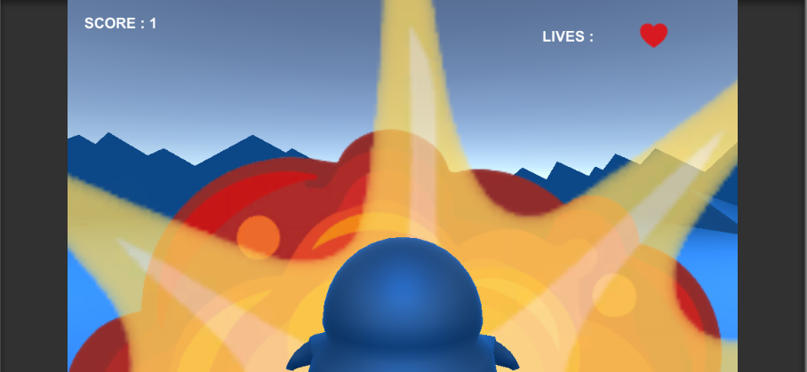When collide with object, you lose lives

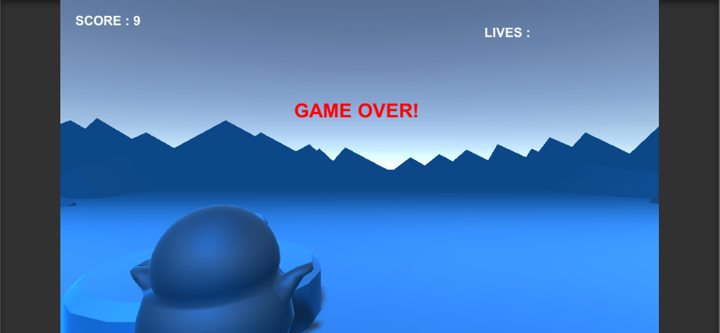

When player’s life is 0, shows game over

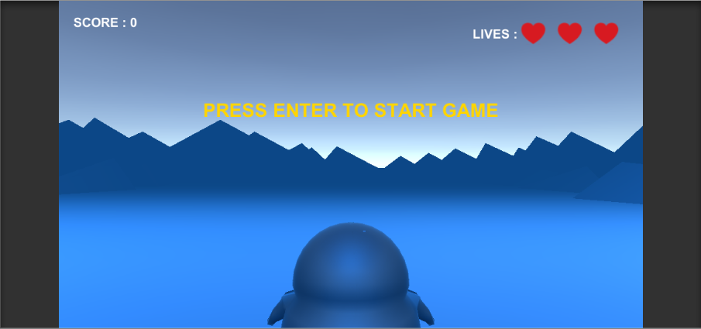

Press enter to start game, A and D to move left and right

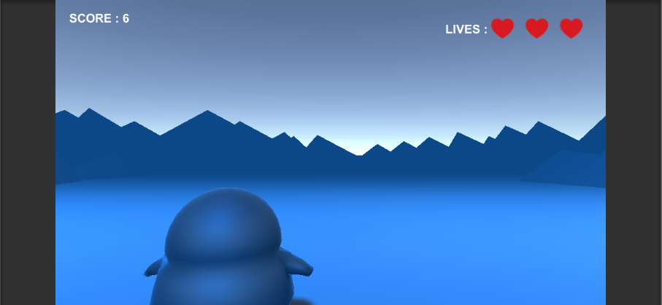

Going pass objects will grant you points

