Check this out!

<https://pdbj.org/emnavi/quick.php?id=3x1e&img_mode=y>

If you scroll down to **Components** you can see *Sites* in the protein/peptide.

I don’t know if these are the active sites but they could help us get the right amino acids to check.

TO949- ideas

* <https://onlinelibrary.wiley.com/doi/pdf/10.1002/ejic.200600087> - Copper-containing Nitrile Reductase for T0949
* Look at the distances between the glutamate amino acids (G) in pymol
* Use 4HPO, 3X1E, 1SQB
* Criteria for choosing the pdb proteins: the length of the query sequence used (Query cover) and the % alignment

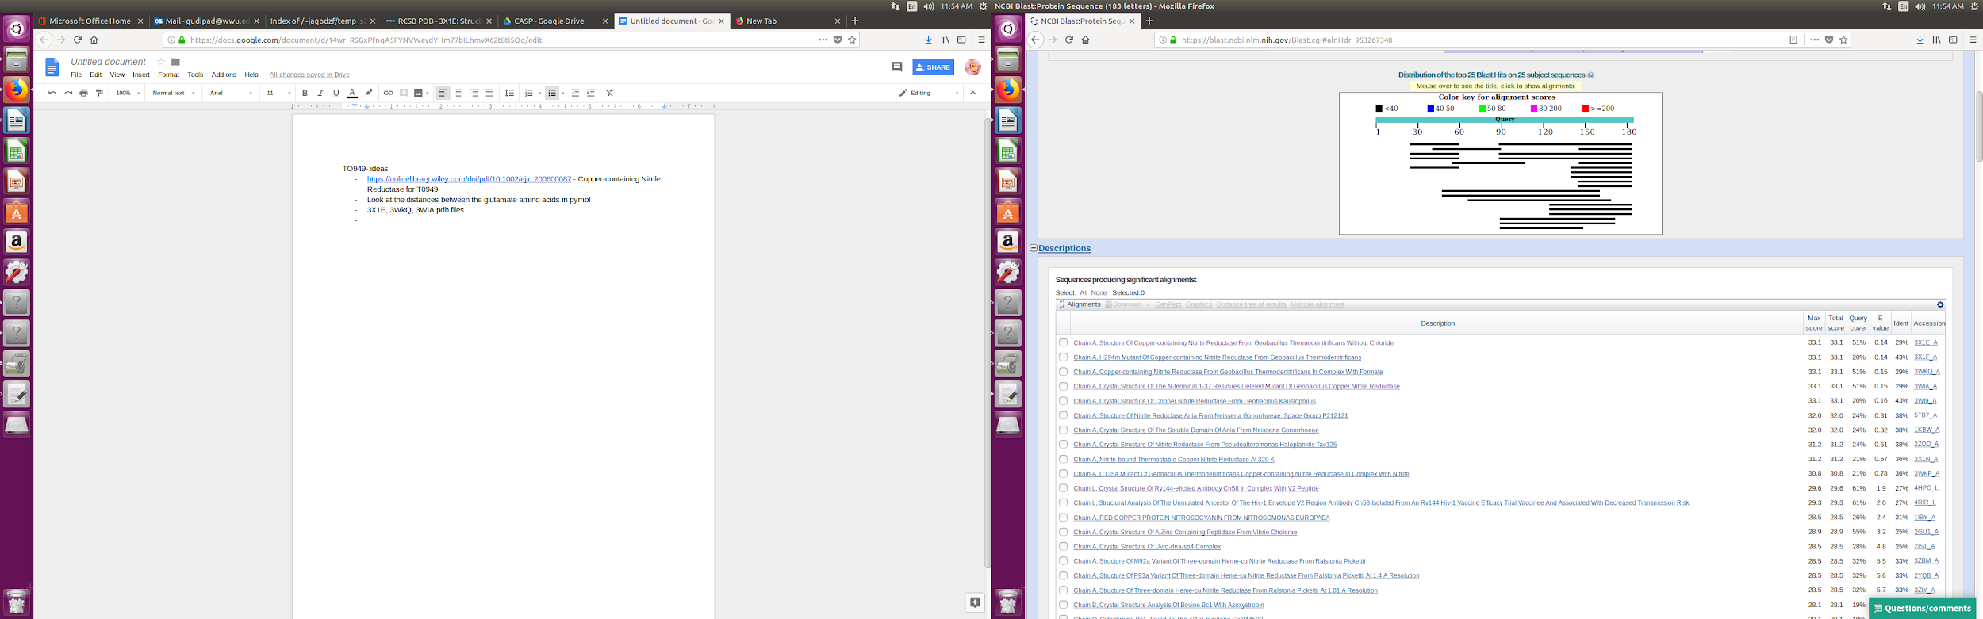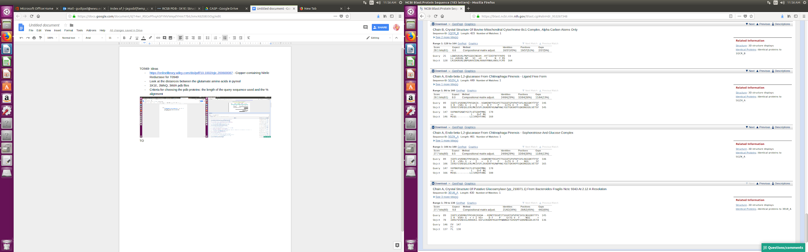

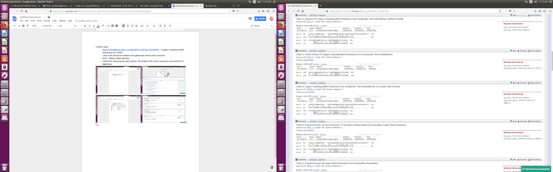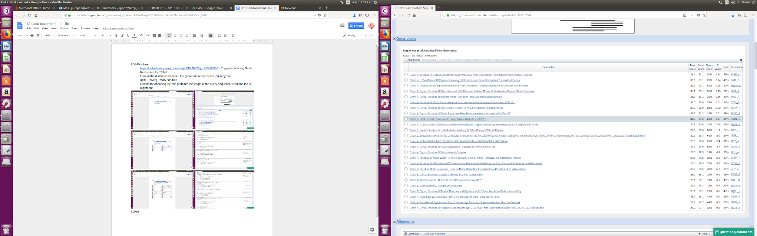

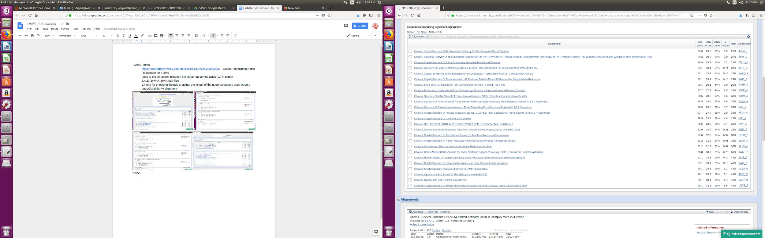

T0950

* Honestly we can choosing any amino acid we want for this sequence. And run it.
* Also can use this as a control.
* Since 6EK4 is the protein itself, we can omit this pdb file and use the next best data.
* Aspartic acid(D)
* Use 6EK8, 3O53,

T0951

* Use 3W06, 5CBK, 5DNU
* https://www.ncbi.nlm.nih.gov/pmc/articles/PMC5684176/
* Use lysine (K)
* 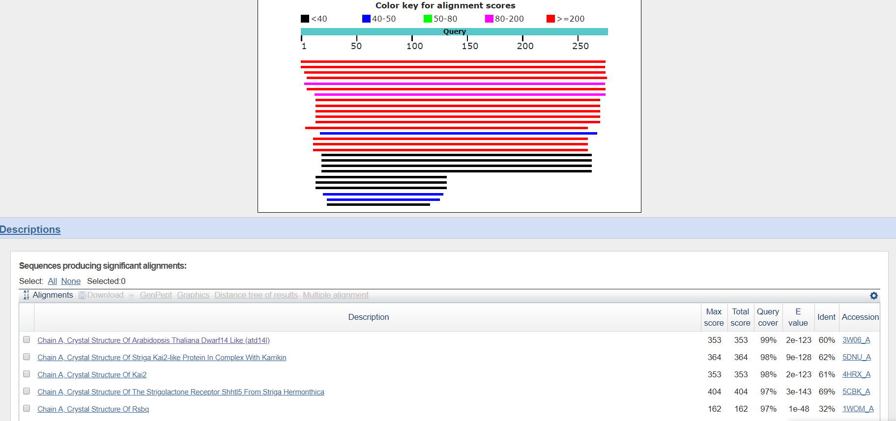

T0953s1

* Use 2GMQ, 4EBB, 2VCY
* Use Glycine (GLY, G)
* https://www.ncbi.nlm.nih.gov/pmc/articles/PMC4872383/

T0953s2

* Use 6CN1, 3EEH, 3JSA
* Use Glycine (G, Gly)
* https://www.ncbi.nlm.nih.gov/pmc/articles/PMC2847664/
* 