**Project title: Fruit Ninja**

**Prepared by**

Mursheda Tasnim (1605095)

Mobashwira Urmi (1605116)

**Prepared for**

# Level 1 – Term 2 term project

**Project supervisor**

# Md. Iftekharul Islam Sakib

***Description***:

This game is mainly based on Java GUI applicatons,Java Networking and multi Threading.

***Features:***

At first a welcome screen comes.

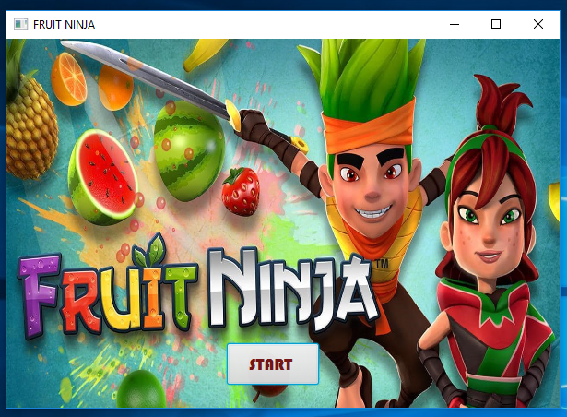

Fig: welcome window

If you click the ‘start’ button the next screen will come which is a log in window.You have to input a valid user name and a valid password for this user name.there are two valid user name ‘tasnim’ for which password is ‘123’ and another is ‘urmi’ for which password is ‘234’.If you enter one of this pair,the log in will be successful.Otherwise the log in will be failed and an alert message will be shown.

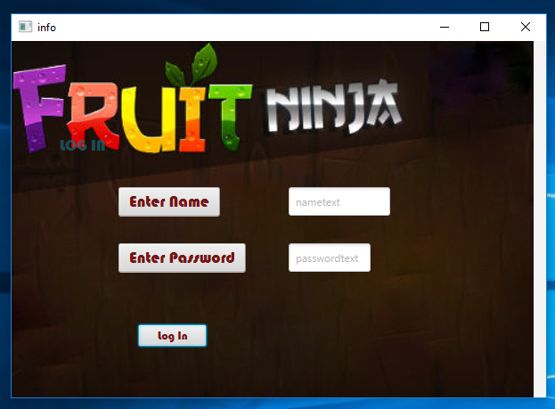

Fig : Log in window

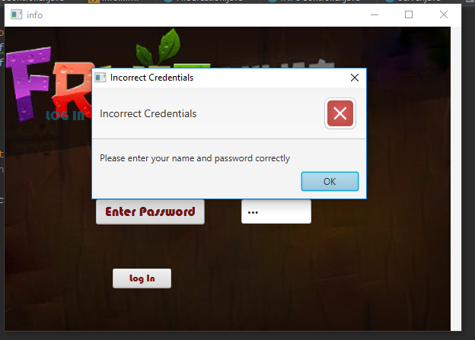

Fig : Incorrect log in alert

If the log in is successful there will come another window that contains three buttons : ‘Play’ , ‘Help’ and ‘Back’ . If the ‘Back’ button is clicked the log in window will come again. If the ‘Help’ button is clicked there will come a window containing two instruction regarding how to play this game.

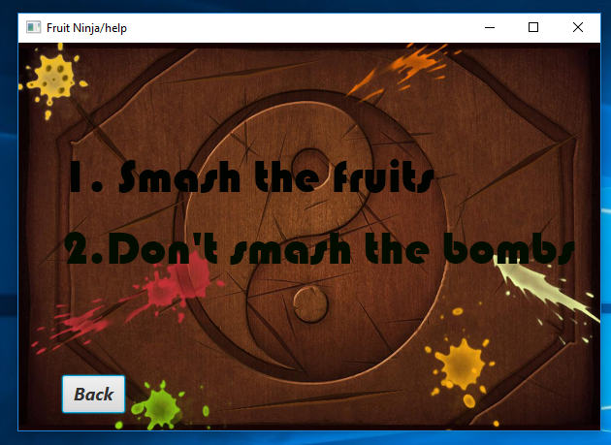

Fig : Help window

The previous window can be reached by clicking the back button.Clicking the ‘Play’ button of the previous screen,the game can be played.

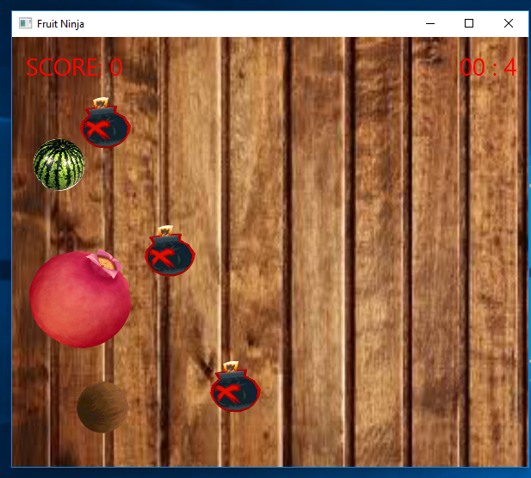 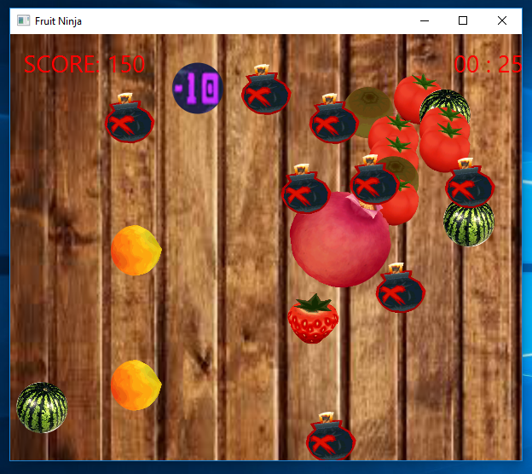

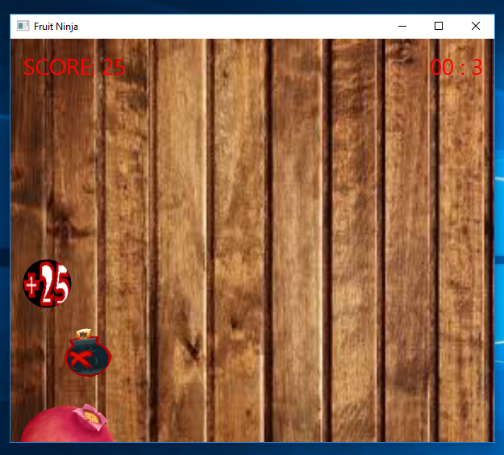 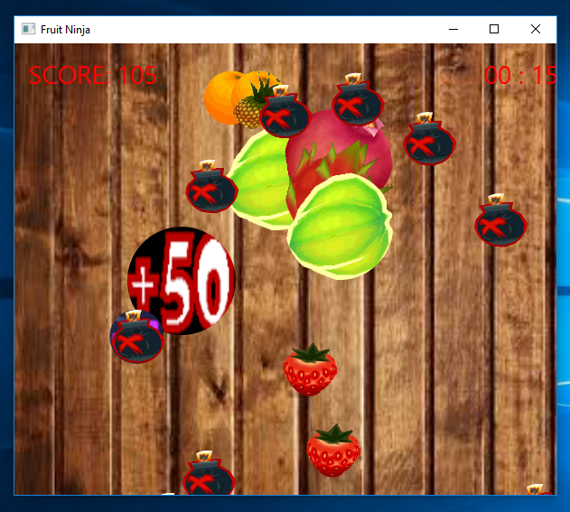

Fig : Game screen shots

There are three types of elements in the game : small fruits,big fruits and bomb.If a small fruit is being touched ,25 points will be added.If a big fruit is being touched 50 points will be added.On the other hand touching the bomb will cut 10 points for each.The game continues for 30 seconds.If the the is up,the game will over.Then the next window will come.

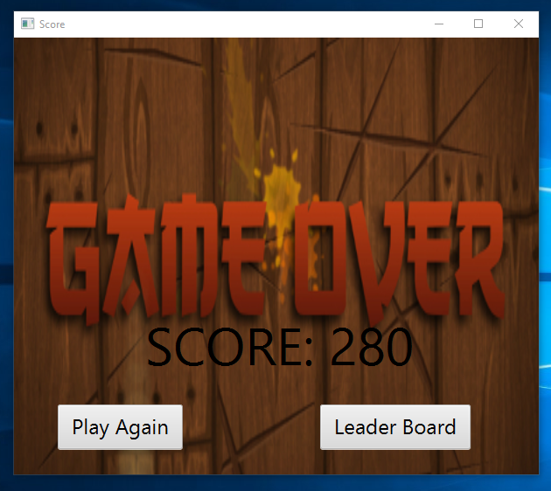

Fig : Game over window

This window will show tha score .There is a button for playing the game again and another button for seeing the leader board like this:

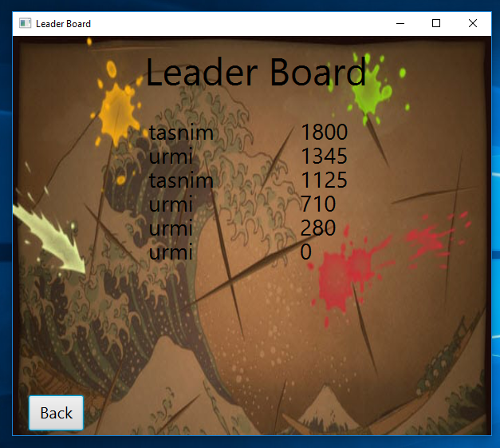

Fig : Leader board

Thus the game works. We hope that everybody will enjoy this game very much.