AI-Assisted Cybersecurity Threat Detection and Risk Prioritization Framework for Small and Medium-Sized Organizations
A Capstone Project Report of MSIT 5910
Submitted by
Milhan Ahmed Mustafa | Student ID S381642
For the partial fulfilment of the requirements for the degree of
Master of Science in Information Technology
Supervised by
Dr. Sirisha Pavuluri
Department of CS & MSIT
University of the People, Pasadena, CA 91101, United States
Term 1, October 2026

ABSTRACT
This capstone develops and evaluates an AI-assisted cybersecurity threat detection and risk prioritization prototype for small and medium-sized organizations. A modular implementation combines event validation, logistic-regression classification, explicit weighted scoring, SQLite persistence, and an analyst dashboard. Following instructor feedback, the final local revision adds domain constraints, configured analyst authentication, safer dashboard rendering, and regression tests. All thirty-three final tests pass. Five invalid-input regressions now return HTTP 422, and anonymous event-history access returns HTTP 401. One hundred authenticated sequential requests succeed and persist, with mean local TestClient latency of 1.277 milliseconds. Actual browser captures demonstrate successful analysis, blank-input handling, and literal markup display. Independent evaluation uses the legacy NSL-KDD benchmark with explicit feature-mapping limitations. The frozen event model misses almost all projected attacks. A separate offline native-feature candidate achieves 75.56 percent accuracy and 62.57 percent recall after training-overlap exclusion, but is not integrated into the API. These findings invalidate generalization from the earlier six-case synthetic success rate. The contribution is a reproducible integration and assurance record, including corrections and measured limitations. Contemporary representative telemetry, managed identity, protected deployment, analyst usability assessment, and operational recovery testing remain necessary before real-data adoption.

ACKNOWLEDGEMENT
I thank Dr. Sirisha Pavuluri, the Department Chair, and the University of the People for the academic guidance and learning environment supporting this capstone. I also acknowledge the authors and maintainers of the research, public guidance, and open-source tools cited in this report. Their work provided the foundation for evaluating the prototype and documenting its limitations.

LIST OF TABLES
Table 3.1 Implemented components and remaining requirements 21
Table 3.2 Requirements and Week 7 evidence 27
Table 4.1 Fresh Week 7 results 43
Table 4.2 Six-case classification confusion matrix 44
Table 4.3 External benchmark results and interpretation 53
Table 5.1 Proposed maintenance schedule 60
Table A1 Expanded Week 7 expected and observed outcomes 72
Table D1 Confirmed gaps and proposed closure 76

LIST OF FIGURES
Figure 3.1 Implemented system architecture. 21
Figure 3.2 Final local architecture and access boundary. 30
Figure 4.1 Implemented risk scoring code. 34
Figure 4.2 Integrated API orchestration code. 35
Figure 4.3 Parameterized database insertion code. 36
Figure 4.4 Fresh integrated request and response. 37
Figure 4.5 Actual Week 7 browser submission and history. 38
Figure 4.6 Actual pytest result for the original suite. 42
Figure 4.7 Actual failed Week 7 acceptance checks. 42
Figure 4.8 Actual 100-request latency trace. 44
Figure 4.9 Actual authentication dependency. 46
Figure 4.10 Actual request domain constraints. 46
Figure 4.11 Actual closure responses and valid output. 47
Figure 4.12 Final regression test output. 48
Figure 4.13 Actual authenticated browser analysis and history. 49
Figure 4.14 Actual blank-input message. 50
Figure 4.15 Actual literal markup display in event history. 51
Figure 5.1 Week 7 Docker Compose configuration. 61
Figure 5.2 External benchmark accuracy recall and F1. 63
Figure B1 Recorded Week 7 execution environment. 75

SYMBOLS AND ABBREVIATIONS
AI Artificial intelligence
API Application programming interface
CI/CD Continuous integration and continuous delivery
CSF Cybersecurity Framework
F1 Harmonic mean of precision and recall
FR and NFR Functional and non-functional requirement
HTTP Hypertext Transfer Protocol
JSON JavaScript Object Notation
ML Machine learning
NIST National Institute of Standards and Technology
P95 Ninety-fifth percentile
RBAC Role-based access control
RPO and RTO Recovery point and recovery time objective
SIEM Security information and event management
SME Small and medium-sized organization
SQL Structured Query Language
TLS Transport Layer Security

CONTENTS
ABSTRACT 2
ACKNOWLEDGEMENT 3
LIST OF TABLES 4
LIST OF FIGURES 5
SYMBOLS AND ABBREVIATIONS 6
INTRODUCTION 11
1.1 Background of the Study 11
1.2 Problem Statement 12
1.3 Objectives of the Study 12
1.4 Scope and Limitations 13
1.5 Report Organization 14
1.6 Final Milestone and Evidence Boundaries 14
LITERATURE REVIEW 16
2.1 Overview of Related Work 16
Machine Learning for Intrusion Detection 16
Cybersecurity Risk Management 17
Responsible and Trustworthy AI 17
Application Security 18

CONTENTS CONTINUED
2.2 Comparative Analysis of Existing Systems 19
2.3 Research Gap Identification 20
SYSTEM DESIGN AND METHODOLOGY 21
3.1 System Architecture 21
3.2 Methodologies and Tools Used 22
3.3 Data Flow and System Components 23
Preprocessing Module Design Target 24
AI Classification Module Design Target 24
Risk-Prioritization Module Design Target 25
Database and API Design Target 25
Analyst Dashboard Design Target 25
Governance and Security Controls Design Target 26
3.4 Design Diagrams and Data Model 26
3.5 Requirements and Verification Traceability 27
3.6 Final Revision Methodology and Security Controls 28
RESULTS AND EVALUATION 31
4.1 Implementation Overview 31
4.2 Output and Screenshots 34

CONTENTS CONTINUED
4.3 Evaluation Metrics 37
4.4 Week 7 Comprehensive System Testing 40
4.5 Week 7 Performance Stability and Recovery 42
4.6 Final Regression and Browser Results 44
4.7 Independent Benchmark Protocol and Findings 51
DISCUSSION 54
5.1 Interpretation of Results 54
5.2 Comparison with Literature Findings 55
5.3 Implications and Limitations 56
5.4 Future Work 58
5.5 Maintenance and Release Readiness 59
5.6 Interpretation of Final Corrections and External Validity 61
CONCLUSION AND FUTURE WORK 64
6.1 Summary of Main Findings 64
6.2 Contributions and Implications 64
6.3 Lessons Learned and Challenges 65
6.4 Deployment Recommendation 66
6.5 Next Improvements 66

CONTENTS CONTINUED
6.6 Final Conclusion 67
6.7 Research Questions and Next Release 67
6.8 Final Contributions and Prioritized Future Work 68
REFERENCES 70
APPENDICES 72
Appendix A Week 7 Test Record 72
Appendix B Evidence Logs and Environment 75
Appendix C Baseline Configuration and Reproduction 75
Appendix D Defect Register and Closure Criteria 76
Appendix E Source and Measurement Provenance 77
Appendix F Final Source and Evidence Manifest 78

INTRODUCTION

1.1 Background of the Study
Cybersecurity monitoring produces a large amount of information. Logs, authentication events, endpoint activity, network traffic, vulnerability information, and application events can all contribute to the detection of suspicious behavior. For a large security operations center, these inputs can be supported by dedicated analysts, SIEM platforms, threat-intelligence services, automation, and specialized detection engineering. Small and medium-sized organizations often have fewer people and less infrastructure available for the same type of monitoring. The practical problem is therefore not simply whether an organization can collect security events; it is whether available personnel can consistently identify which events deserve attention first.
This capstone addresses that problem through an AI-assisted threat detection and risk prioritization framework. The system is intended to receive structured security events, prepare them for analysis, classify potentially suspicious events, assign a risk priority, and present the results to an authorized analyst. The architecture deliberately treats AI as decision support rather than as an autonomous response mechanism. A high-risk result should trigger investigation, not an irreversible action such as automatically disabling an account or blocking a network segment.
The project is grounded in established cybersecurity and AI risk-management guidance. NIST Cybersecurity Framework 2.0 is designed to help organizations of different sizes and sectors understand, assess, prioritize, and communicate cybersecurity risk (Pascoe et al., 2024). NIST AI RMF 1.0 provides a complementary perspective by encouraging organizations to consider validity, reliability, security, resilience, transparency, explainability, privacy, and fairness when designing and evaluating AI systems (Tabassi, 2023). OWASP Top 10:2025 is also relevant because the proposed dashboard and API introduce ordinary web-application risks such as broken access control, security misconfiguration, authentication failures, data-integrity failures, and logging weaknesses (OWASP Foundation, 2025).
The remainder of this report reviews relevant literature and industry guidance, defines the problem and project objectives, describes the architecture and modules, specifies functional and non-functional requirements, and documents progress and challenges.

1.2 Problem Statement
The engineering problem is to transform a structured security event into a traceable recommendation that a person can investigate. A useful result must connect its identifier, source, event category, predicted label, confidence, business context, and priority. If any link is missing, the analyst cannot reliably connect a recommendation to the original observation. The prototype therefore treats persistence and retrieval as essential parts of the workflow rather than optional additions to a classifier demonstration.
The resource constraint is a project motivation, not a measured outcome. No participating organization supplied staffing figures or real alert volumes, and the project did not run a field study of analyst productivity. It would therefore be inappropriate to claim that this implementation reduced incident-response time or staffing costs. The demonstrated contribution is a working integration pattern that could support a later operational study. Its usefulness must eventually be assessed against a specific organization's workflows, investigation capacity, telemetry, and tolerance for missed threats and unnecessary escalation.

1.3 Objectives of the Study
The first objective is functional integration: accept a supported event, transform its fields, invoke a trained baseline model, calculate a priority, persist the result, and expose it to an analyst. The second objective is explainable prioritization: keep the risk formula separate from the classifier and identify how severity, model confidence, and business impact contribute. The third objective is verifiability: create repeatable tests with explicit expectations and preserve the outcomes, including failures. The fourth objective is maintainability: define a controlled process for defects, updates, configuration changes, backups, and model reassessment.
These objectives translate the original research questions into observable work. RQ1 asks how AI can assist event classification and prioritization; the integrated endpoint and example output address that feasibility question. RQ2 asks how architecture and scoring combine prediction with context while preserving oversight; the module interfaces, formula, and human-facing dashboard address it. RQ3 asks how security, privacy, and responsible-AI requirements enter design and evaluation; the synthetic-data boundary, acceptance checks, limitations register, and maintenance plan provide partial answers. Unit 8 closes the specified failures; broader operational assurance remains incomplete.
Success is defined at two levels. Demonstration success requires a functioning supported pathway, reproducible software evidence, and honest interpretation of metrics. Operational readiness would additionally require secure access, robust semantic validation, realistic independent evaluation, tested recovery, and stakeholder acceptance. This distinction avoids changing the project's definition of success simply because a test reveals a problem. A failure becomes a documented requirement gap with a future acceptance criterion, rather than being removed from the results.

1.4 Scope and Limitations
The project focuses on a bounded prototype for structured cybersecurity-event ingestion, preprocessing, AI-assisted classification, risk prioritization, service/API access, analyst visualization, auditability, and evaluation. It does not attempt to build a complete SIEM, a full security-orchestration platform, autonomous incident response, automatic blocking of users or network traffic, or integration with every commercial SIEM or EDR product.
At the Week 7 milestone, the prototype uses synthetic events and has not been deployed with live SME telemetry. Its current baseline includes classification, scoring, API access, storage, and a single-page dashboard. Authentication, RBAC, complete auditability, drift monitoring, analyst feedback, and independent usability acceptance remain target capabilities. The report evaluates the implemented subset and records the gaps instead of describing all design requirements as delivered functions.

1.5 Report Organization
Chapter 1 defines the motivation, objectives, research questions, scope, and limitations. Chapter 2 evaluates relevant intrusion-detection research and the risk-management and application-security guidance that informs design choices. Chapter 3 explains the implemented architecture, algorithms, data flow, interfaces, and testing methodology. Chapter 4 consolidates the Week 6 implementation and adds the Week 7 outcomes. Chapter 5 interprets those outcomes, identifies limitations, and links them to maintenance and future work. Chapter 6 answers the research questions and summarizes the contribution and next steps. References support external claims, while the appendices preserve test records, configuration, and evidence provenance.

1.6 Final Milestone and Evidence Boundaries
This final report evaluates an implemented academic prototype and the corrections made after the Week 7 review. The historical milestone is repository commit 9d4cf2722093ab657e681976314e073647cc5b56. The Unit 8 revision is a separately delivered local source snapshot derived from that baseline. It adds domain validation, authenticated access, safer dashboard handling, and regression evidence. The source archive identifies its files through a SHA-256 manifest. The public repository remains the baseline unless those local changes are subsequently reviewed and published; this report does not imply that a remote merge or deployment occurred.
The instructor identified six unresolved validation and access-control checks and requested authentication, improved dashboard input handling, and independent representative classifier evaluation. The first three work items are addressed through implemented controls and observed regressions. The evaluation request is addressed through an external benchmark experiment and an explicit assessment of representativeness. Independent data reveals substantial limitations rather than confirming the earlier synthetic accuracy result. A contemporary organizational evaluation remains necessary before operational adoption.
The report preserves Week 6 and Week 7 measurements as historical evidence and adds the final revision in Sections 3.6, 4.6, 4.7, 5.6, and 6.8. Where historical sections describe missing authentication or unresolved defects, those statements apply to the earlier milestone. The current implementation status is defined by the final revision and its associated tests. Neither the earlier baseline nor the revised prototype is certified as a production security service. The measurable final objective is a reproducible, protected demonstration with transparent performance boundaries.

LITERATURE REVIEW

2.1 Overview of Related Work
The literature review focuses on four related areas: machine-learning-based intrusion detection, cybersecurity risk management, responsible AI, and application security. Together, these areas establish why the proposed system needs both an analytical component and a security-conscious software architecture.

Machine Learning for Intrusion Detection
Machine-learning intrusion detection treats observed event characteristics as information from which a model can learn. Buczak and Guven (2016) survey machine-learning and data-mining methods, datasets, algorithm complexity, and challenges in cybersecurity intrusion detection. Their comparison supports examining the relationship between the selected method, data, and problem rather than assuming one universally best algorithm. Sommer and Paxson (2010) examine the distance between anomaly-detection research and operational deployment. These sources inform the capstone's emphasis on realistic evaluation and cautious interpretation of controlled experiments.
However, the existence of a machine-learning model does not automatically produce a useful cybersecurity system. Detection data can be imbalanced, noisy, incomplete, or representative of only one environment. A model can therefore demonstrate strong performance on a test dataset while behaving differently when deployed against another organization's traffic or event patterns. This is one reason the proposed project includes dataset inspection, preprocessing, train/test separation, multiple evaluation metrics, and explicit documentation of the dataset's limitations.
The capstone also separates classification from risk prioritization. Classification answers a question such as “what type of event does this record resemble?” Risk prioritization answers a different operational question: “which event should the analyst investigate first?” The second question may depend on severity, asset importance, confidence, and business context. Combining these concepts in a single opaque model could make the result difficult to interpret. The proposed design instead uses a model for classification and a transparent risk-scoring layer for prioritization.

Cybersecurity Risk Management
NIST CSF 2.0 provides a broad risk-management structure that is applicable across organizations regardless of size, sector, or maturity. It is not a prescriptive implementation manual; rather, it provides outcomes and links to practices that organizations can use to manage cybersecurity risk (Pascoe et al., 2024). This distinction is important for the capstone. The proposed system does not claim to implement an entire cybersecurity program. Instead, it addresses a narrower operational problem within cybersecurity risk management: organizing security-event information so that limited personnel can focus attention on higher-priority events.
The framework's emphasis on prioritization supports the project's central design decision. A list of alerts without prioritization still leaves analysts with a workload-management problem. The proposed risk-prioritization module attempts to provide a structured indication of urgency. Because NIST CSF 2.0 can be used by organizations of different sizes, it also provides an appropriate conceptual reference for an SME-oriented project.
Risk prioritization also requires caution. A risk score should not be interpreted as an objective measurement of absolute danger. It is a decision-support value produced from selected inputs and assumptions. The project therefore documents the factors used to calculate the score and keeps human review in the workflow.

Responsible and Trustworthy AI
NIST AI RMF 1.0 describes trustworthy AI in terms that include validity and reliability, safety, security and resilience, accountability and transparency, explainability and interpretability, privacy enhancement, and fairness with harmful bias managed (Tabassi, 2023). These characteristics are directly relevant to an AI-assisted security system.
Validity and reliability are addressed through model evaluation. Future external evaluation will use measures such as precision, recall, F1-score, and confusion matrices to identify different types of classification errors. Security and resilience are target requirements for protected execution, controlled ingestion, access control, logging, and testing; only a subset is implemented. Transparency and explainability are addressed by displaying the main classification result and relevant event indicators to the analyst instead of exposing only a final risk label. Privacy is addressed through use of public or synthetic datasets for the prototype and through data minimization. Fairness assessment remains future work requiring representative categories and sufficient labeled examples.
The AI RMF is especially useful because it encourages consideration of AI risks during pre-design, design, development, deployment, use, and evaluation rather than treating responsible AI as a final compliance check. NIST's AI RMF resources describe these trustworthiness characteristics as socio-technical considerations, meaning that technical performance alone does not determine whether an AI system is trustworthy (Tabassi, 2023).

Application Security
At the Week 7 milestone, the proposed system also creates an ordinary application-security boundary. The target architecture includes an API, database, authentication mechanism, and browser-based dashboard; authentication remains unimplemented in the current prototype. OWASP Top 10:2025 identifies Broken Access Control, Security Misconfiguration, Software Supply Chain Failures, Cryptographic Failures, Injection, Insecure Design, Authentication Failures, Software or Data Integrity Failures, Security Logging and Alerting Failures, and Mishandling of Exceptional Conditions as major web-application risks (OWASP Foundation, 2025).
Several of these categories directly influence the architecture. Server-side authorization is required to prevent users from bypassing role restrictions through modified requests. Secure transport and protected secrets address cryptographic risks. Dependency management and a controlled requirements file address supply-chain concerns. Input validation reduces injection exposure. Centralized logging supports detection and investigation of security events. These controls demonstrate that an AI application still needs conventional secure software engineering.
Overall, the literature and guidance suggest that an effective cybersecurity AI prototype needs more than a high-performing classifier. It requires a defined operational problem, suitable data, measurable evaluation, secure application architecture, transparent risk logic, and human oversight. These findings directly inform the proposed design.

2.2 Comparative Analysis of Existing Systems
The comparison is between approaches, rather than a product procurement exercise. A rule-based detector applies explicit conditions chosen by a human. For the capstone's login examples, a rule could flag repeated failures with a known bad source. Such a rule is easy to inspect and can operate without training labels, but its coverage depends on the conditions maintained by the developer. The current logistic-regression baseline instead learns coefficients from labeled feature dictionaries. It is useful for demonstrating training, encoding, prediction, and probability output, but the six-example training set cannot establish an advantage over a simple rule.
A classifier-only prototype can report suspiciousness yet leave the analyst without an operational ordering. A separate policy layer adds severity and business impact, which are not model features in the current API. The comparison therefore concerns software responsibilities: prediction characterizes the event; prioritization translates selected information into an investigation recommendation. Neither output is an estimate of financial loss. The project would need organizational evidence and a validated risk model before making that stronger interpretation.
Sommer and Paxson (2010) analyze obstacles between machine-learning intrusion-detection experiments and operational deployment, including evaluation and the meaning of anomalies. Buczak and Guven (2016) survey machine-learning and data-mining methods and emphasize the relevance of datasets, algorithm characteristics, and deployment challenges. These studies justify caution about selecting a method solely because it performs well on a controlled sample. For this project, the practical implication is to evaluate a rule baseline and alternative classifiers on the same independently defined data before deciding whether additional model complexity helps.

2.3 Research Gap Identification
The gap addressed here is a local integration and assurance gap: the student project needed one evidence chain connecting event input, prediction, policy scoring, persisted history, analyst presentation, and maintenance. The capstone does not claim to discover a previously unknown gap in the entire intrusion-detection literature. Its contribution lies in making those responsibilities explicit and testable within a modest prototype.
The Week 7 findings sharpen that gap. Positive examples demonstrated the intended pathway, while semantic validation and access-control checks exposed requirements that remained in design documents rather than code. This supports an assurance approach in which implementation claims must be checked against observable behavior. Future research should investigate whether better validation, threat-specific probabilities, and richer explanations improve actual analyst decisions. Those questions require independent participants and representative events; they cannot be answered by a developer score or six synthetic labels.

SYSTEM DESIGN AND METHODOLOGY

3.1 System Architecture
The Week 7 implemented architecture is a modular synchronous application. FastAPI orchestrates the ingestion check, normalization, four-feature classifier, score calculation, database write, and response. Figure 3.1 depicts the implementation, while the earlier requirements describe a broader target including access control, feedback, and audit logging. The source revision and requirement records are available in the project repository (Mustafa, 2026).
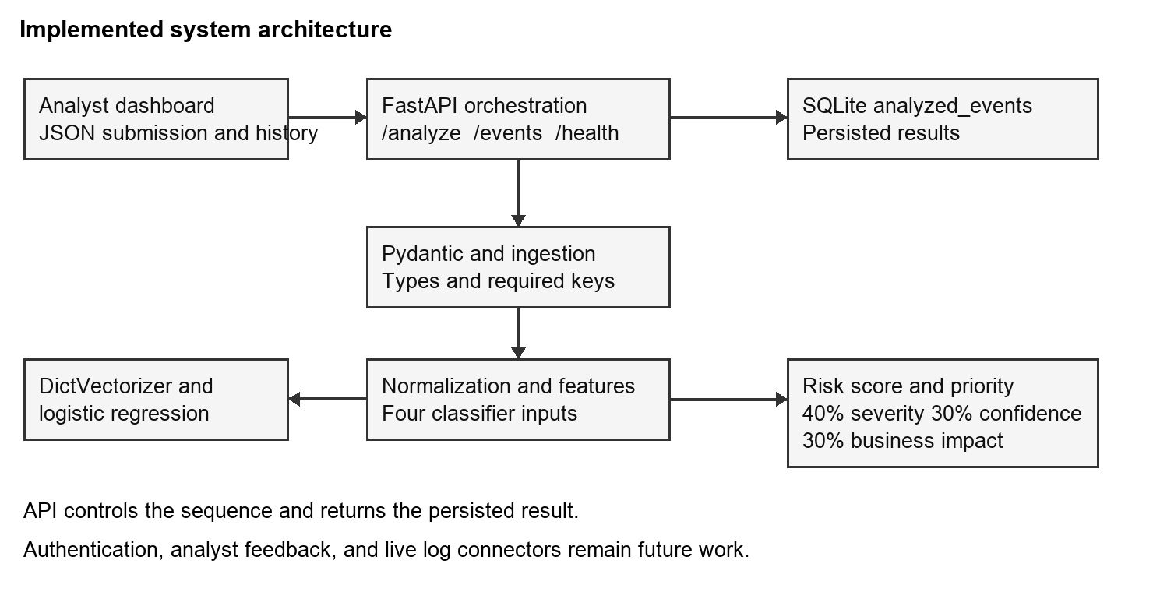
Figure 3.1 Implemented system architecture. Source: diagram derived from milestone source code.
Table 3.1 Implemented components and remaining requirements
Component | Verified implementation | Remaining requirement
Input boundary | Typed Pydantic request; required keys | Semantic validation and category policy
Classifier | Six-row logistic-regression baseline | Independent data and calibrated probability
Risk policy | 40/30/30 weighted score | Threat probability and validated weights
Storage | SQLite result history | Complete input and model provenance
Dashboard | Form, output, recent history | Safe text rendering; analyst feedback
Access control | No authentication at milestone | Authenticated role-aware endpoints

3.2 Methodologies and Tools Used
The development method is iterative implementation with evidence-based verification. Requirements were recorded before integration; small modules were implemented and connected through the API; the integrated behavior was then tested against supported scenarios and deliberate invalid inputs. Week 7 preserved the milestone source and added a separate verification harness. This allows the results to be associated with a stable source revision rather than a changing application. Each downloaded source blob was checked against its Git object identifier, confirming that the tested source matched the repository snapshot.
The expanded harness records a test identifier, level, objective, expected outcome, observed outcome, and pass or fail status. A negative test passes when an invalid input is rejected as expected. A requirement check fails when the prototype accepts input that the chosen requirement says should be rejected. These distinctions prevent a successful HTTP request from being mistaken for successful validation. The original pytest suite and the expanded harness are reported separately because they have different scope and counting rules.
The execution environment used the bundled Python 3.12 interpreter on macOS with a workspace-local dependency installation. Versions were recorded for pytest, FastAPI, Pydantic, HTTPX, NumPy, and scikit-learn. The repository specifies package names without version pins, so this environment differs from the Dockerfile's Python 3.11 baseline. The results support the recorded local environment. They do not prove that an unbuilt container will behave identically, nor that every future dependency release will remain compatible.
The classifier uses a scikit-learn Pipeline containing DictVectorizer and LogisticRegression, with max_iter set to 500 and random_state to 42. Categorical event types and numeric indicators are converted into a feature representation. Training occurs at application import from the six baseline examples in app.py. Prediction selects the largest class probability and rounds it to four decimal places. The implementation is a small supervised baseline, consistent with the documented classifier interface (scikit-learn developers, n.d.), and contains no online retraining or external threat-intelligence lookup.
The risk algorithm clamps severity, confidence, and business impact to the range zero to one, calculates 100 times the sum of 0.40 times severity, 0.30 times confidence, and 0.30 times business impact, and rounds to two decimal places. Scores below 50 map to Low, scores from 50 to below 75 map to Medium, and scores at least 75 map to High. These are prototype policy choices. The formula uses confidence in the selected label, which is not necessarily suspicious-class probability. This distinction is examined in the Week 7 discussion.
The original tests are ordinary pytest functions; the expanded harness makes explicit expected-versus-observed checks against the unchanged application. Future regression work should use isolated fixtures and temporary database paths so one test cannot satisfy another through old rows. pytest documents reusable setup through fixtures (pytest developers, n.d.). Isolation is especially relevant because the existing integration suite assigns a fixed database filename and verifies event presence rather than comparing an isolated insertion count.

3.3 Data Flow and System Components
The following specifications retain the intent of the earlier design while distinguishing target controls from the current milestone. The implemented status is summarized in Table 3.1. In particular, the proposed protected API, role-aware dashboard, feedback records, and audit controls are not yet implemented; no diagram should be read as evidence that these controls are present.
The ingestion module is the entry point for security events. Its input may be a CSV/JSON security-event record or a controlled event feed. The target module should validate required fields, data types, timestamp formats, and allowed values. Invalid records are rejected or flagged for review rather than silently entering the analytical pipeline.
The module should also enforce basic size and format limits. This is both a reliability and security measure because unexpected input should not cause application failures. The ingestion boundary should not accept arbitrary executable content or unvalidated parameters.

Preprocessing Module Design Target
The preprocessing module converts validated records into a consistent representation for the model. Tasks may include missing-value treatment, categorical encoding, numerical transformation, feature selection, and removal or masking of unnecessary identifying information. The preprocessing pipeline must be reproducible so that training and inference apply the same transformations.
The project should avoid data leakage between training and evaluation sets. Features that would only be known after an incident outcome should not be used to train a model intended to operate before that outcome is known. Documentation of preprocessing decisions is therefore part of the technical design.

AI Classification Module Design Target
The AI classification module receives feature vectors and returns a predicted event category and confidence-related information. A baseline supervised model will be selected based on dataset characteristics and interpretability. Candidate models can include logistic regression, decision trees, random forests, or another suitable classifier.
The project does not assume that a complex deep-learning model is automatically superior. A model that is easier to evaluate and explain may be more appropriate for a capstone decision-support prototype. Performance will be assessed using precision, recall, F1-score, and a confusion matrix. Where class imbalance exists, per-class performance will be examined rather than relying only on aggregate accuracy.

Risk-Prioritization Module Design Target
The risk-prioritization module converts analytical output into an operational priority. A conceptual score can be based on threat classification, predicted confidence, event severity, affected-asset importance, and other documented factors. The result can be mapped to Low, Medium, High, or Critical.
The important design decision is that the risk score should be explainable. The dashboard should show enough information for an analyst to understand the factors contributing to the priority. The score should not be treated as an autonomous security decision. Human review remains mandatory before consequential action.

Database and API Design Target
The target database should store event records, model outputs, risk scores, user information required for authorization, and audit information. Access should be restricted to the application service account and authorized administrative functions. Sensitive information should be protected at rest, and communication between components should use secure transport.
The target API should act as the controlled interface between the dashboard and backend. Authentication should occur before protected resources are returned. Authorization should be enforced on every protected endpoint. This directly addresses OWASP's Broken Access Control and Authentication Failures categories (OWASP Foundation, 2025). Input validation, controlled error responses, rate limits where appropriate, and logging should also be considered.

Analyst Dashboard Design Target
The target dashboard should provide a human-facing view of prioritized events. Core functions include event listing, filtering, sorting, risk-level visualization, event details, and review status. The interface should avoid presenting the model as infallible. Labels such as “AI classification” and “risk priority” make the distinction between analytical output and human judgment clearer.
Role-aware views should prevent unauthorized users from seeing sensitive information or performing administrative actions. Audit logging should capture significant actions such as authentication events, administrative changes, and analyst review actions.

Governance and Security Controls Design Target
Security controls should be applied throughout the architecture rather than being isolated in one module. Authentication and RBAC should protect application access. Encryption should protect data in transit and, where appropriate, at rest. Audit logs should support accountability. Dependency management should reduce supply-chain exposure. Model evaluation supports reliability and fairness. Data minimization reduces privacy exposure.
NIST CSF 2.0 provides the overall cybersecurity-risk-management context, while NIST AI RMF supports the AI-specific trustworthiness requirements. OWASP Top 10:2025 provides application-security considerations for the web/API layer. Together, these references help translate broad security principles into architectural decisions.

3.4 Design Diagrams and Data Model
The processing sequence follows the synchronous implemented path. The analyst submits JSON; FastAPI parses it through AnalyzeRequest; the endpoint builds the event dictionary; normalization trims strings; feature construction supplies four classifier inputs; prediction returns the chosen label and confidence; the scoring module returns a number and priority; SQLite stores the analysis; and the response returns to the caller. A later history request retrieves records ordered by descending database identifier. This is the Week 7 sequence; Section 3.6 adds authentication, while analyst feedback remains proposed.
The storage model contains one analyzed_events table. Its integer primary key identifies each insertion. Event ID, timestamp, source, event type, predicted label, confidence, risk score, and priority are persisted. Event ID is not a unique database key, so repeated submissions can create repeated records. Original failed-attempt counts, bad-IP and privileged-account indicators, severity, business impact, model version, and policy version are absent from the stored row. Consequently, the current history can display a result but cannot reconstruct every input that produced it. Adding those fields would improve forensic reproducibility and should be treated as a schema migration.
The module diagram distinguishes the API's control flow from the analytical data flow. Source architecture documentation depicts a conceptual linear flow in which the API follows scoring. In actual code, the API orchestrates validation, model inference, scoring, and persistence. The revised implementation diagram reflects that distinction. No message queue, background worker, feedback service, or role-aware user table exists at the tested milestone. These elements remain proposals, not components hidden behind the diagram.

3.5 Requirements and Verification Traceability
The source requirements distinguish event acceptance, type checking, feature construction, classification, contextual scoring, explanation, persistence, analyst feedback, evaluation, and malformed-input handling. The implemented workflow satisfies portions of these requirements, but passing one integration case does not close them all. Week 7 maps each verified behavior to specific checks and documents partial fulfillment. In particular, the acceptance minimum for a displayed prioritized event is demonstrated, while the secure-access and semantic-validation requirements remain open.
Table 3.2 Requirements and Week 7 evidence
Requirement | Evidence | Status
FR-01–03 structured input and features | W7-01–09; W7-19–23 | Partial; semantic gaps
FR-04–05 label confidence and score | W7-01; W7-04; W7-10–14 | Demonstrated synthetic pathway
FR-07 persistence | W7-02; W7-26–27 | Result storage verified
FR-08 analyst review and feedback | W7-18 and browser capture | Display only; feedback absent
FR-09 evaluation metrics | Six-case confusion matrix | Consistency only; overlap
FR-10 malformed input handling | W7-05–09 and W7-19–23 | Partial
NFR-05 secure access | W7-24 | Failed; control absent

3.6 Final Revision Methodology and Security Controls
The final revision treats input validation as an application boundary rather than relying on the dashboard to produce well-formed requests. The request model trims strings, rejects blank identifiers and sources, limits their length, parses timestamps as datetimes, and restricts event categories to the five supported values. Failed-attempt counts must be strict integers between zero and one million. Binary indicators accept zero or one, and severity and business impact must fall between zero and one. Nonfinite numerical values and unexpected properties are rejected. These decisions connect domain requirements to explicit field constraints, consistent with Pydantic's documented validation mechanisms (Pydantic, n.d.).
The timestamp change also requires a serialization decision. The endpoint serializes its validated model in JSON mode before normalization and storage, so parsed date values remain suitable for the existing string-based SQLite record. Parsing demonstrates that a value is a valid datetime; it does not establish that an event occurred at that time or enforce a timezone policy. A future ingestion connector should require timezone-aware timestamps and preserve source-clock information. The present contract therefore improves validity without claiming full event provenance.
Authentication uses an HTTP Basic dependency on the dashboard, analysis, and history endpoints. Expected credentials come from CYBER_USERNAME and CYBER_PASSWORD. There are no functioning default credentials. Missing configuration or a password shorter than sixteen characters produces HTTP 503; absent or incorrect credentials produce HTTP 401 and an authentication challenge. Username and password comparisons use secrets.compare_digest, following the comparison pattern in FastAPI's official example (FastAPI, n.d.-b). The health endpoint remains public and returns only availability status. Authentication is enforced for both reading records and creating new analysis records.
This implementation is a single-analyst demonstration control. It does not implement separate user accounts, password hashing at rest, role-based authorization, session revocation, multifactor authentication, or rate limiting. Basic authentication requires protected transport outside a loopback demonstration. The delivered Compose configuration binds the published port to localhost and requires credentials from the environment, but no successful container execution is claimed. Any hosted deployment would need HTTPS, managed identity, controlled secret storage, and operational review. Requiring credentials improves the demonstrated access boundary without making those additional controls redundant.
Dashboard changes support the server contract through trimmed text values, explicit control lookup, numeric conversion, accessible control names, and a status region. The submit button is disabled while a request is active and re-enabled through a finally block. Non-success responses are converted into visible errors rather than being displayed as if analysis succeeded. History rows are built using DOM elements and textContent, so event identifiers are displayed as text. MDN distinguishes textContent from HTML parsing and describes its use for assigning textual content (MDN contributors, n.d.). This change addresses the previously identified source-level HTML interpolation concern.
Verification combines endpoint regression tests and a real browser walkthrough. Temporary database paths isolate negative tests, allowing the test to confirm that a rejected request does not add a record. The first combined run exposed an isolation error in the test fixture because the database module reads its path at import time. The fixture was corrected to patch the module's path explicitly. This was a test-environment correction, not evidence that the application accepted invalid input. The final recorded run verifies the corrected fixture and the implemented application together.
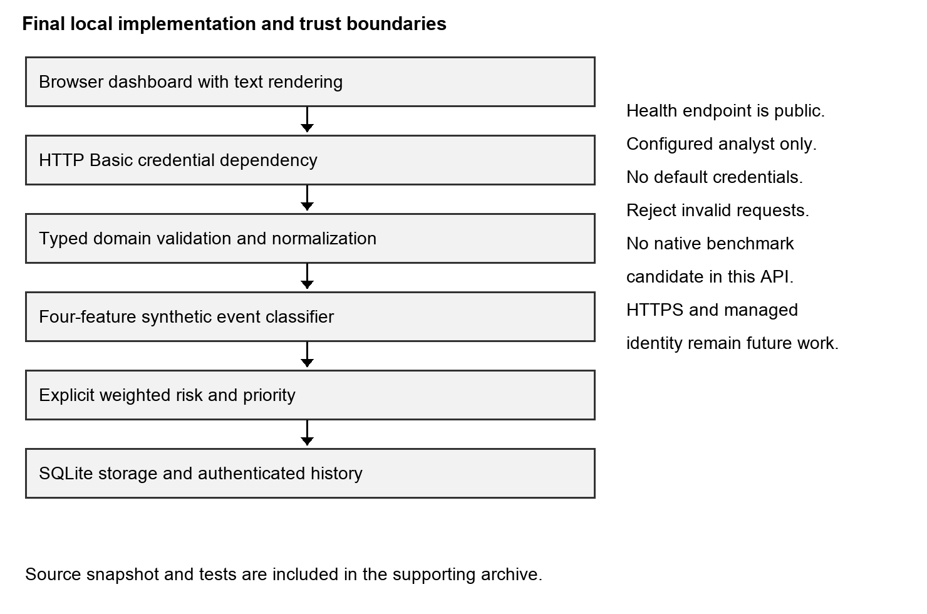
Figure 3.2 Final local architecture and access boundary. Source: delivered Unit 8 implementation.

RESULTS AND EVALUATION
This chapter retains the Week 6 integration findings as historical observations and adds the fresh Week 7 verification in Sections 4.4 and 4.5. Historical benchmarks are labeled and are not substituted for the current 100-request run. The Week 7 results correct the training-overlap claim and distinguish supported demonstrations from failed acceptance requirements.

4.1 Implementation Overview
This chapter presents the implementation and integration results of the AI-Assisted Cybersecurity Threat Detection and Risk Prioritization Framework for Small and Medium-Sized Organizations. Earlier capstone units established the problem statement, architecture, requirements, ethical considerations, and initial modular implementation. The current development stage converted those separate components into a cohesive prototype that accepts cybersecurity events, validates and normalizes them, performs machine-learning classification, calculates an explainable risk score, stores the result, and presents recent analyses through a browser-based dashboard.
The purpose of the project is not to build a fully autonomous incident-response platform. Instead, it demonstrates a decision-support workflow for organizations that may have limited cybersecurity personnel. NIST Cybersecurity Framework 2.0 emphasizes understanding, assessing, prioritizing, and communicating cybersecurity risk, and it is designed to be adaptable across organizations of different sizes and maturity levels (Pascoe et al., 2024). The implemented prototype addresses a narrow portion of that goal by translating event characteristics into a classification, model confidence value, risk score, and priority category that can guide human investigation.
The analytical core uses two distinct stages: machine-learning classification and risk prioritization. The classifier uses scikit-learn's LogisticRegression in a pipeline with DictVectorizer. Dictionary features allow the application to pass categorical and numerical values without requiring the API layer to manipulate model matrices directly. The classifier receives information such as event type, failed-attempt count, whether the source is a known bad IP, and whether a privileged account is involved. It returns the highest-probability label and its confidence score.
The baseline classifier is intentionally small. Its role is to demonstrate a functioning AI component inside a complete software architecture, not to claim state-of-the-art intrusion detection. Training examples are synthetic and contain benign and suspicious patterns suitable for testing the software pathway. This approach makes the project reproducible while keeping the limitations transparent.
Risk prioritization is kept outside the classifier. The scoring module combines normalized severity, model confidence, and business impact. Severity contributes 40 percent, while confidence and business impact contribute 30 percent each. The weighted score is multiplied by 100 and mapped to Low, Medium, or High priority. Values are clamped to the interval between zero and one so malformed numerical inputs cannot create scores outside the intended range.
This separation is important because model probability is not the same as business risk. A technically suspicious event affecting a low-value system may not deserve the same response as a similar event affecting a privileged account or critical asset. By separating model output from policy-based prioritization, the system supports explainability and organizational customization. NIST AI RMF emphasizes trustworthy AI characteristics including validity, reliability, transparency, explainability, privacy, security, and fairness (Tabassi, 2023). An explicit scoring layer supports transparency more directly than hiding operational prioritization inside an opaque model.
FastAPI provides the service boundary. The /analyze endpoint accepts event identifiers, security features, severity, and business impact. The endpoint extracts required event fields and passes them through validation. String values are normalized before model features are built. The classifier predicts a label and confidence, the risk module calculates the priority score, and the final record is persisted to SQLite. The endpoint then returns a structured JSON response.
The implementation therefore uses the API primarily as an orchestration layer rather than embedding every responsibility in one function. Validation remains in the ingestion module, preprocessing remains in the preprocessing module, classification remains in the model module, scoring remains in the risk module, and persistence remains in the database module. This separation improves maintainability and testability because individual modules can be changed without redesigning the full application.
SQLite was selected as the persistence layer because it provides real database behavior while remaining appropriate for a student prototype. The database records event ID, timestamp, source, event type, predicted label, confidence, risk score, and priority. The /events endpoint returns recent records so the dashboard can display analysis history. This design demonstrates actual persistence rather than keeping results only in memory.
The browser dashboard completes the UI-backend connection. The page includes a structured form for submitting security-event characteristics. JavaScript serializes form values to JSON and sends them to /analyze. When the response arrives, the page displays the classification and risk result, then requests /events to refresh the recent-event table. This establishes communication across user interface, API, validation, preprocessing, machine learning, scoring, and database layers.

4.2 Output and Screenshots
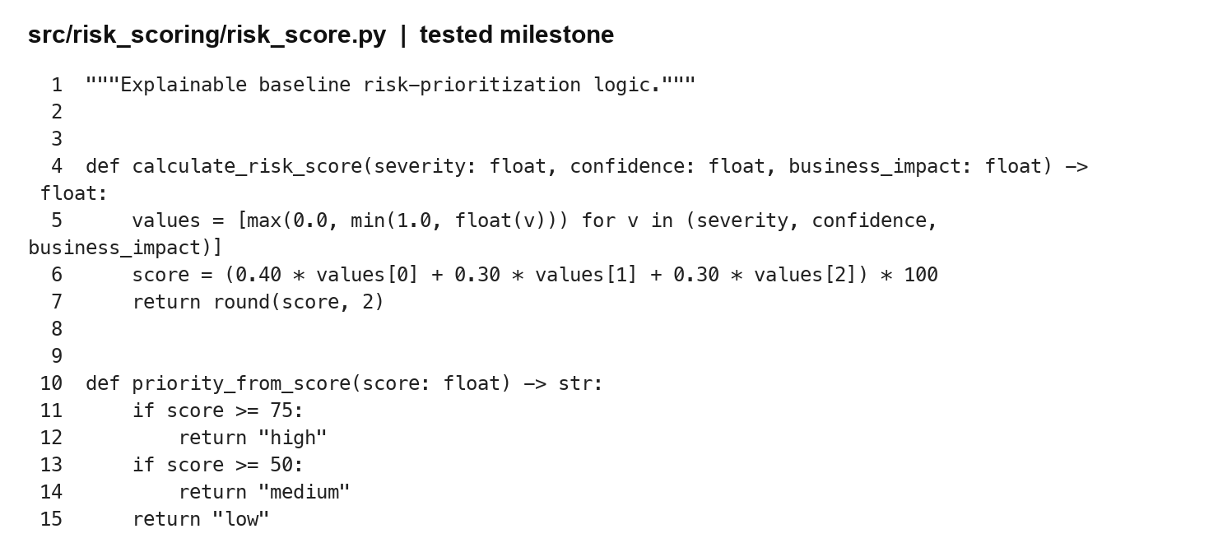
Figure 4.1 Implemented risk scoring code. Source: src/risk_scoring/risk_score.py at the tested commit.
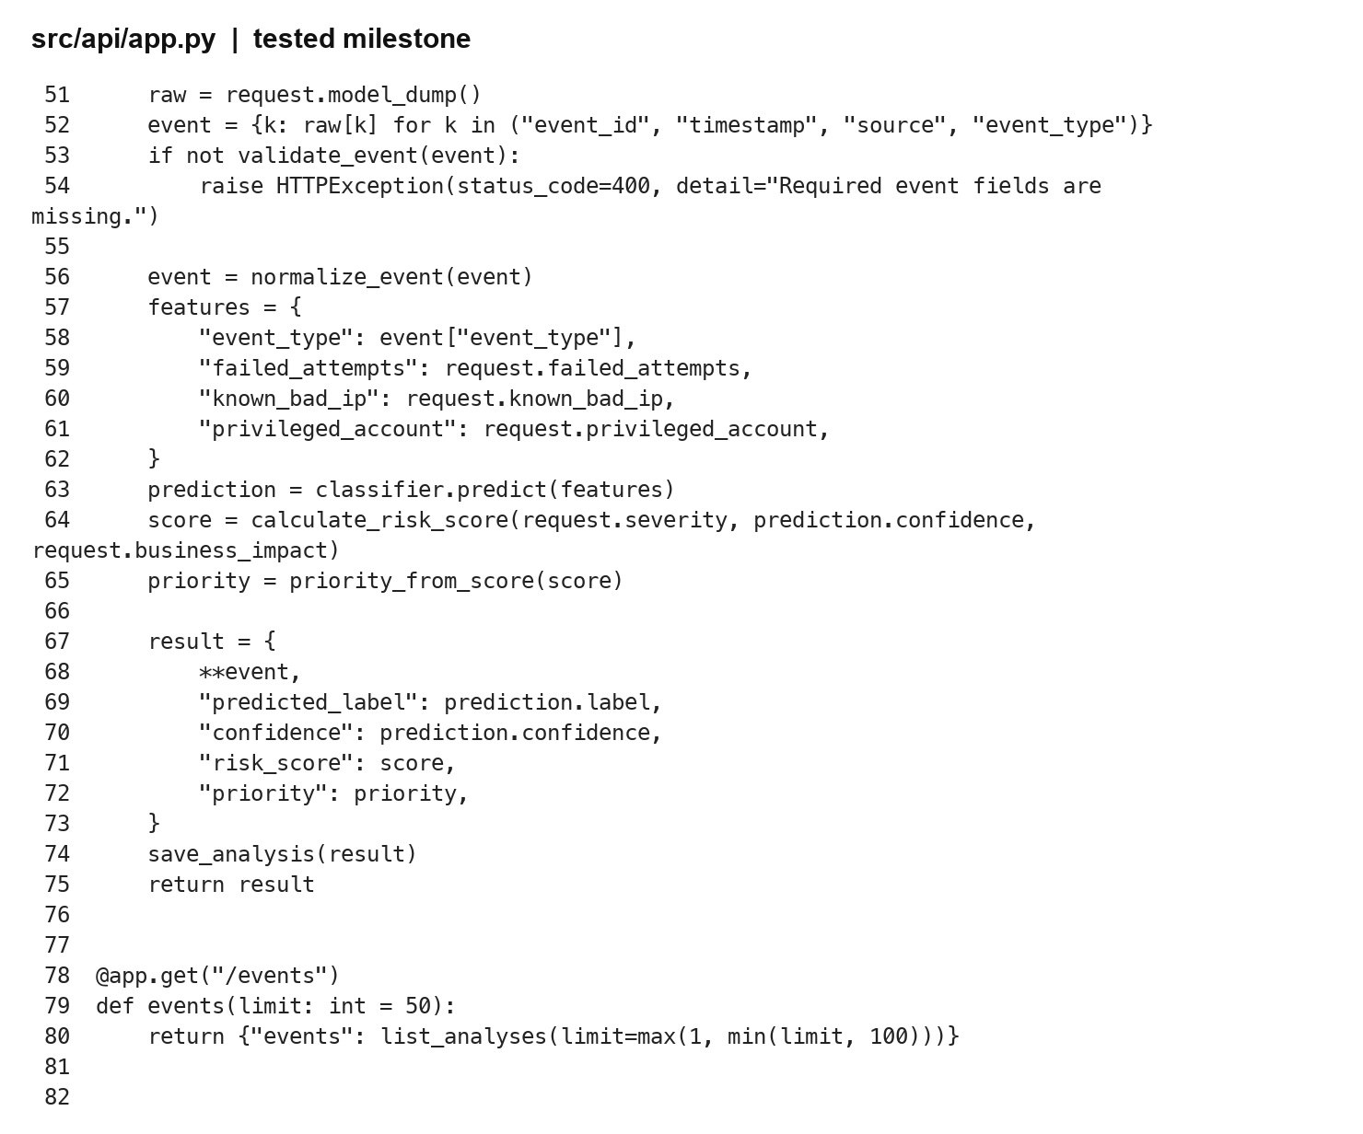
Figure 4.2 Integrated API orchestration code. Source: src/api/app.py at the tested commit.
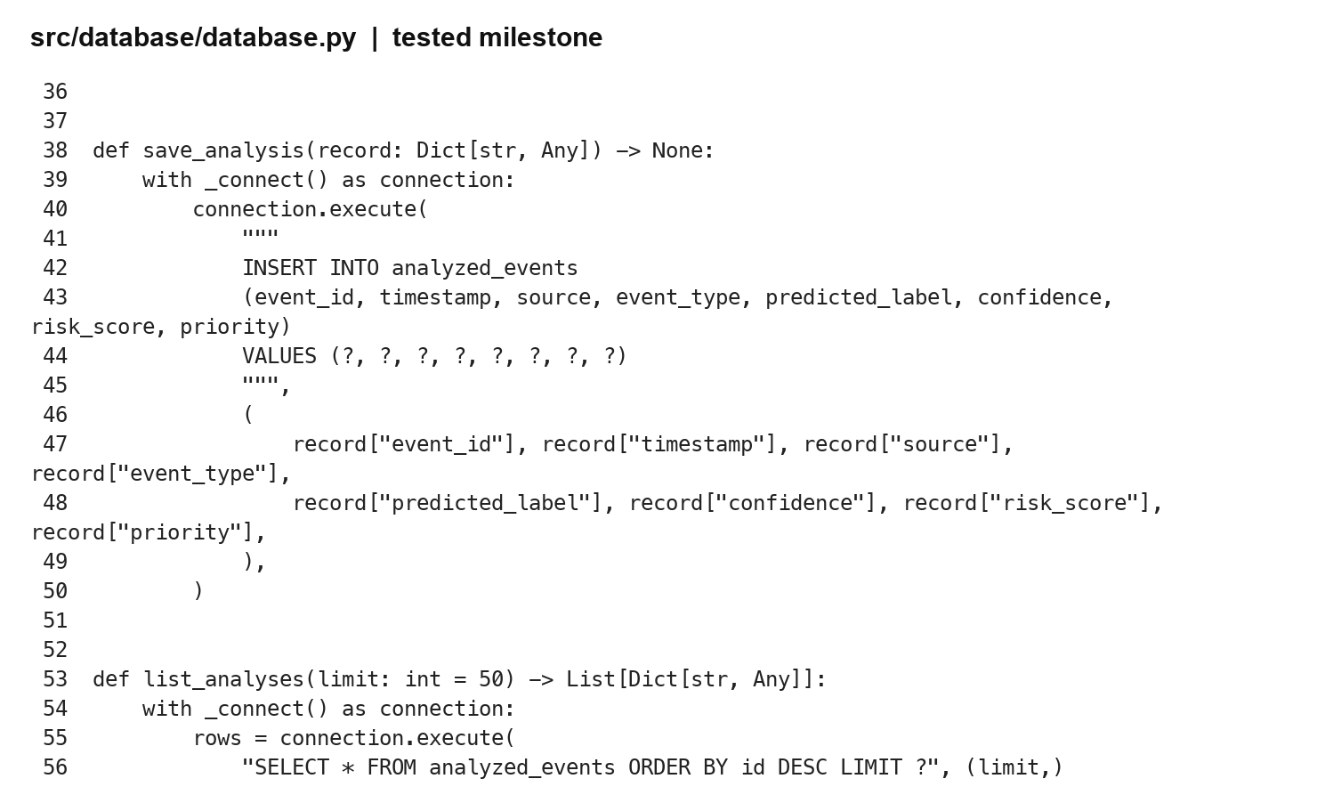
Figure 4.3 Parameterized database insertion code. Source: src/database/database.py at the tested commit.
A representative input used event ID E-DEMO-1, source vpn-gateway, event type login_failure, eight failed attempts, a known-bad-IP indicator of one, a privileged-account indicator of one, severity 0.9, and business impact 0.8. The system classified the event as suspicious with 0.9141 confidence. The risk module calculated an 87.42 score and assigned High priority.
The example illustrates why the integrated design is valuable. The event must pass validation before analysis. Preprocessing creates consistent input. The classifier evaluates suspiciousness, while the risk module also considers severity and business context. Persistence allows the result to be retrieved after the API response. The dashboard gives the analyst one place to submit an event and review current and previous outcomes.
The project uses PyTest for automated verification. Ten tests passed in the evaluation environment. Core tests cover required-field validation, invalid-event rejection, string normalization, risk-score calculation, score clamping, classifier preconditions, and fitted-model prediction. Integration tests cover the health endpoint, end-to-end event analysis and persistence, and dashboard availability.
FastAPI documents TestClient as an HTTPX-based mechanism that integrates directly with PyTest for endpoint testing (FastAPI, n.d.-c). This approach allows the project to validate request parsing, Pydantic models, endpoint orchestration, database writes, and response formatting without starting an external server. The persistence integration test is especially important because it verifies that an analyzed event can later be retrieved through /events.

4.3 Evaluation Metrics
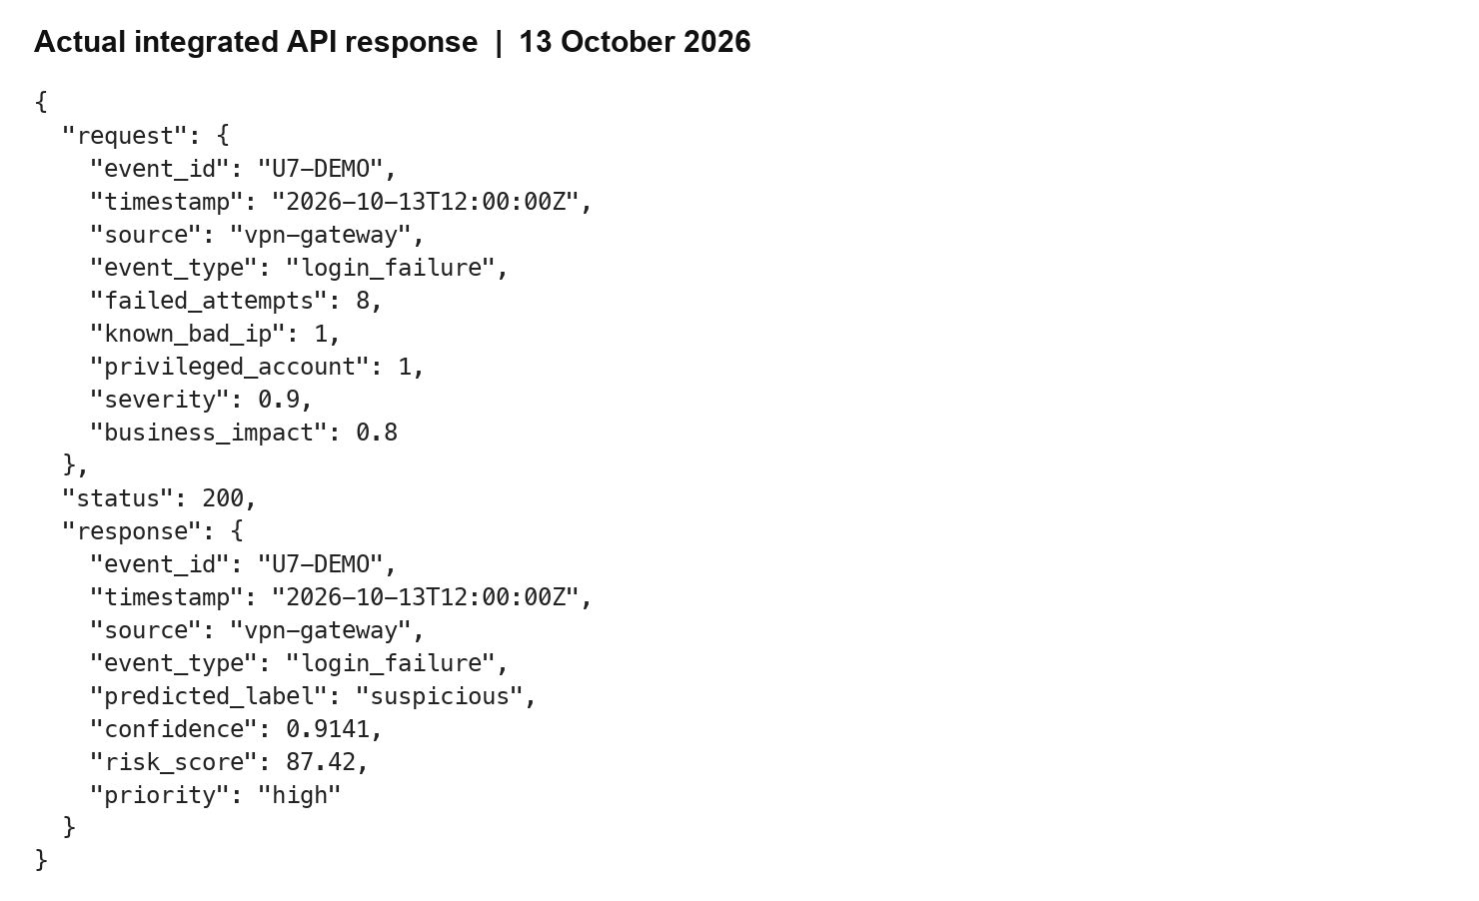
Figure 4.4 Fresh integrated request and response. Source: rendered demo.json, 13 October 2026.
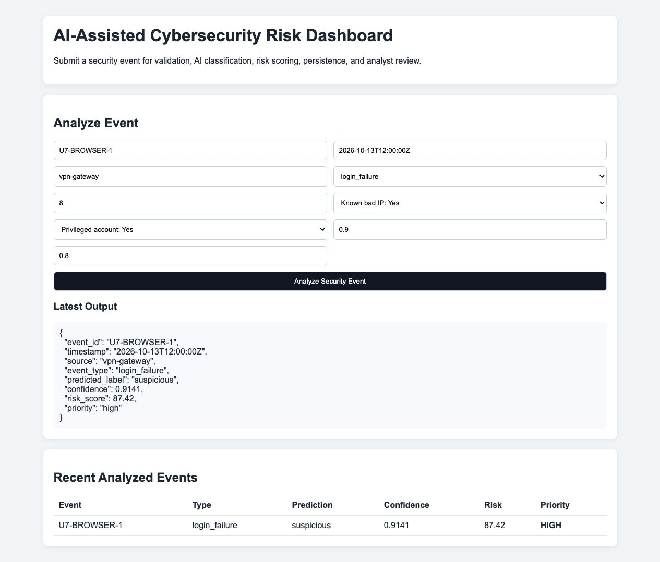
Figure 4.5 Actual Week 7 browser submission and history. Source: local browser capture, 13 October 2026.
The Week 6 evaluation was designed to address three practical questions. First, does the classifier behave consistently on controlled examples similar to the training patterns; Week 7 confirms three exact training duplicates? Second, can the integrated API process events with low overhead in the local prototype environment? Third, is the dashboard sufficiently clear to demonstrate the intended analyst workflow? Quantitative measures were used for model behavior and latency, while a formative qualitative review was used for usability.
This mixed approach is appropriate because production readiness cannot be established through one number. NIST AI RMF treats AI risk management as a socio-technical activity in which model behavior, human interaction, security, transparency, and operational context all matter (Tabassi, 2023). Likewise, NIST CSF 2.0 is outcome-oriented rather than prescribing one implementation. The project therefore evaluates software behavior, performance, and interface clarity together.
The baseline model was tested against six synthetic cases containing benign and suspicious examples. Cases included login success, file access, low-intensity failed login, repeated failed login from a known bad IP, malware alert behavior, and privileged-account change behavior. All six expected labels were predicted correctly, resulting in 100 percent accuracy on the small evaluation set.
This result should be interpreted carefully. It demonstrates internal consistency of the feature pipeline, model training, probability prediction, and label mapping. It does not demonstrate 100 percent real-world detection accuracy. The evaluation set is small, synthetic, and structurally similar to the training data. Real security events contain class imbalance, missing fields, noisy telemetry, evolving attack techniques, legitimate behavior that resembles malicious behavior, and differences among organizations.
Future evaluation should therefore use larger public or appropriately authorized datasets, stratified train-test procedures, precision, recall, F1-score, ROC-AUC where suitable, probability calibration, and detailed error analysis. False negatives may cause important threats to be missed, while false positives can overwhelm analysts. Accuracy alone is not sufficient for operational cybersecurity evaluation.
The Week 6 report recorded the following historical measurements. End-to-end latency was measured across 50 sequential /analyze requests using FastAPI TestClient. Each request exercised parsing, validation, preprocessing, model inference, risk scoring, SQLite insertion, and response serialization. Mean latency was 2.972 milliseconds, median latency was 2.135 milliseconds, and 95th-percentile latency was 6.683 milliseconds. Approximate sequential throughput derived from mean latency was 336.47 requests per second.
These measurements indicate that the local prototype adds little computational overhead. Logistic regression is lightweight for the small feature representation, and SQLite writes are inexpensive at this scale. Most measured requests completed within a narrow low-millisecond range.
However, TestClient does not reproduce network latency, TLS termination, container scheduling, multiple concurrent users, authentication checks, cloud database latency, or production observability. The throughput value is therefore a development baseline rather than a service-capacity guarantee. Future work should use an external load-testing tool against an actually deployed server and record CPU, memory, concurrency, and database contention.
The main result is that the capstone moved from a modular design to a functioning integrated prototype. The system now provides a complete path from analyst input to persisted prioritized output. The machine-learning component produces a probability-based confidence value, the risk logic remains transparent, and automated tests provide repeatable evidence that the core functions work together. These implementation results form the basis for the evaluation and deployment discussion in Chapter 5.

4.4 Week 7 Comprehensive System Testing
Week 7 testing took place on 13 October 2026 against commit 9d4cf2722093ab657e681976314e073647cc5b56. All 37 retrieved source blobs matched the Git identifiers in the repository tree. The original ten pytest tests passed, with one framework deprecation warning. The expanded harness added 27 documented checks: 21 passed and six failed. Counts are presented by suite; the combined 37-check record contains 31 passes and six failures, but it should not be mistaken for one homogeneous test suite or a statistical reliability estimate.
Integration checks demonstrated suspicious-event analysis and retrieval from actual SQLite storage. System checks verified trimming, benign classification, missing-field rejection, nonnumeric-count rejection, history-limit clamping, and dashboard serving. Boundary checks confirmed Low below 50, Medium from 50 to below 75, and High from 75. The risk function's out-of-range test returned 55.0. These checks add coverage around transitions and invalid inputs that is absent from a single happy-path demonstration.
The semantic rejection checks failed for whitespace-only event ID, a non-date timestamp, a negative failed-attempt count, a flag value of two, and an unsupported event category. Each received HTTP 200. The request model provides types and required fields but does not enforce these domain constraints. The ingestion function only checks key presence. Since Pydantic already creates the required keys for accepted requests, the endpoint's later missing-key check adds little protection against semantic errors. A proposed correction should use parsed datetimes, nonblank constrained strings, nonnegative integers, binary flags, and a documented category policy.
At the Week 7 milestone, the security acceptance check also failed: unauthenticated GET /events returned HTTP 200. This confirms that the design requirement for protected history is unimplemented at this milestone. It does not indicate that authentication was bypassed; there is no authentication mechanism to bypass. The immediate containment is a restricted synthetic-data demonstration. The corrective acceptance criterion is that unauthorized requests are denied and authorized roles see only permitted data. Analysis submission requires the same review because arbitrary callers can currently add records.
A narrow SQL test submitted an identifier containing SQL metacharacters. The endpoint accepted it as literal data, and the analyzed_events table remained readable. This is consistent with the database module's bound parameters, but one string cannot establish resistance to every injection technique. The dashboard also uses innerHTML to build history rows. This creates a source-level HTML injection concern for stored event text. No exploit was executed during the reported run. The appropriate fix is safe text rendering, followed by a controlled browser regression test that verifies markup is displayed as text.
The acceptance scenarios were executed by the project verification process. They establish behavior against requirements, not formal user acceptance. An independent analyst has not signed off on tasks, explanations, accessibility, or workload impact. The browser demonstration and developer usability review are therefore supporting evidence with explicit limits. Stakeholder acceptance remains a separate activity requiring agreed tasks and criteria.
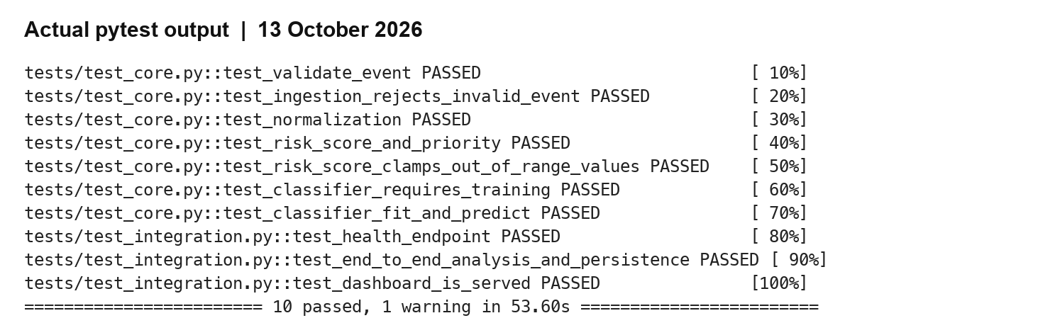
Figure 4.6 Actual pytest result for the original suite. Source: rendered baseline.log excerpt, 13 October 2026.
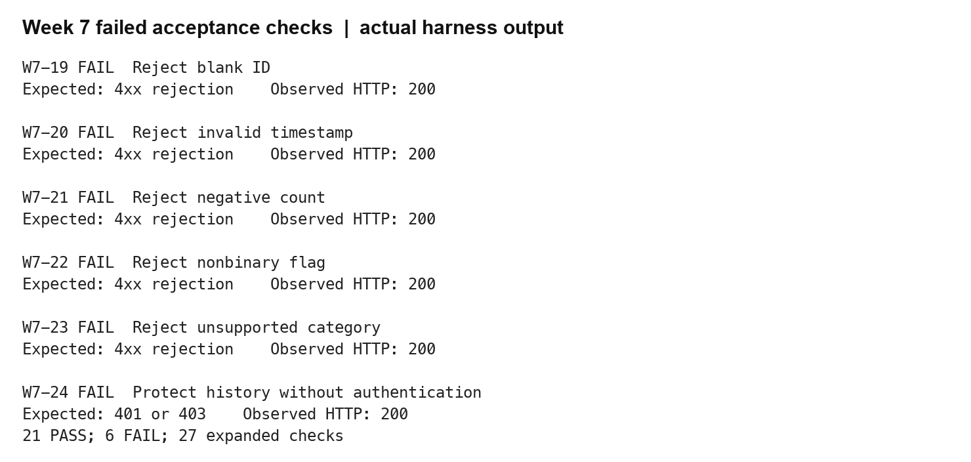
Figure 4.7 Actual failed Week 7 acceptance checks. Source: rendered week7_results.json excerpt, 13 October 2026.

4.5 Week 7 Performance Stability and Recovery
The stability experiment issued 100 sequential POST /analyze requests with distinct synthetic identifiers. All returned success, and the SQLite row count increased by exactly 100. Mean latency was 1.022 milliseconds, median 1.012 milliseconds, nearest-rank P95 1.144 milliseconds, and maximum 1.213 milliseconds. The reciprocal mean was 978.43 requests per second. This last number is arithmetic over sequential local measurements and is not a demonstrated sustainable arrival rate. No concurrent clients, network transport, TLS, reverse proxy, or container resource limits were included.
The repository's unchanged evaluate_system.py produced a separate 30-request observation with 1.260 ms mean and 1.037 ms median latency. The earlier Week 6 report recorded a different 50-request benchmark. Keeping these measurements separate is necessary because sample size, runtime, warm-up, storage state, and machine conditions can affect timings. The available evidence does not support attributing the lower Week 7 times to a code optimization: the source revision was unchanged. They instead provide a baseline for repeating the same protocol in a controlled future environment.
Recovery verification launched a fresh process against the same isolated database and retrieved U7-STABILITY-99. This demonstrates that persisted records survive the original process boundary. It is not a crash-recovery, backup-restore, power-loss, or disaster-recovery test. Those experiments require controlled failure conditions and a verified backup copy. The distinction matters because ordinary persistence is a prerequisite for recovery, but it cannot establish a recovery-time objective by itself.
The six-case classifier evaluation returned a confusion matrix with three correct benign and three correct suspicious predictions. Accuracy, suspicious-class precision, recall, and F1 were each 1.00. Direct comparison of feature dictionaries found three exact training duplicates. The other cases are near variations of the training patterns. These metrics therefore describe a controlled consistency check, not a held-out estimate. The Week 6 statement that the examples were not direct training inputs is corrected here. A stronger study must select independent labeled records before model selection and keep them separate from tuning and threshold design.
Table 4.1 Fresh Week 7 results
Measure | Observed result | Limit
Existing automated suite | 10 passed; one warning | Narrow original coverage
Expanded checks | 21 passed; 6 failed | Requirement scenarios
Stability | 100/100 successes; 100 rows | Sequential in-process
Mean median P95 latency | 1.022 / 1.012 / 1.144 ms | P95 nearest rank
Classifier accuracy precision recall F1 | 1.00 for each metric | 6 synthetic cases; 3 duplicates
Fresh-process retrieval | Final record retrieved | Not backup restoration
Table 4.2 Six-case classification confusion matrix
Actual class | Predicted benign | Predicted suspicious
Benign | 3 | 0
Suspicious | 0 | 3
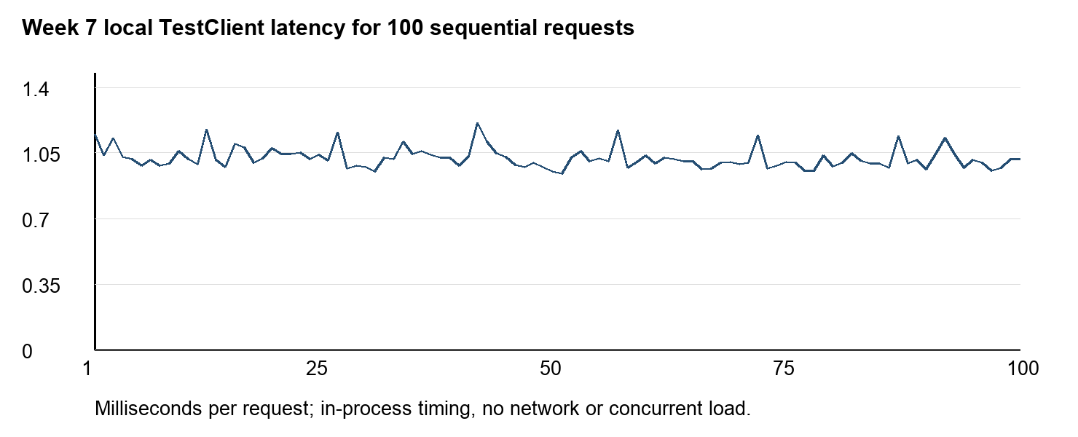
Figure 4.8 Actual 100-request latency trace. Source: measured latencies in week7_results.json.

4.6 Final Regression and Browser Results
The final local suite contains thirty-three passing tests and one framework deprecation warning. It includes the original ten tests, with authenticated integration requests adapted to the new interface, and twenty-three additional regression checks. The five previously accepted invalid values now return HTTP 422: a whitespace-only identifier, an invalid timestamp, a negative count, a nonbinary reputation flag, and an unsupported event category. Anonymous history access now returns HTTP 401. These six responses satisfy the earlier negative acceptance requirements under configured credentials.
Additional checks reject a nonbinary privilege indicator, an empty source, out-of-range severity and impact, fractional counts, and oversized identifiers. Tests verify incorrect credentials, missing configuration, short-password configuration, unauthorized analysis, and unauthorized dashboard access. A valid authenticated request still returns suspicious classification, confidence 0.9141, risk score 87.42, and High priority, followed by retrieval from SQLite history. Successful closure is therefore based on negative cases and preserved positive behavior. The final test count is not directly comparable to the twenty-seven-check Week 7 harness because the suites contain different cases and aggregation rules.
The browser walkthrough provides separate evidence for user-facing behavior. An authenticated visit submitted U8-BROWSER-1 and displayed the returned analysis and stored history. A whitespace-only identifier produced a clear message requiring non-space characters and retained the previous history. A harmless identifier containing literal bold tags appeared with the tags visible in history. This confirms the observed display behavior for that marker. It is not a comprehensive cross-site scripting assessment or an accessibility certification. The screenshot captions identify these as actual local browser captures rather than reconstructed interface images.
The final stability experiment repeated one hundred authenticated requests through TestClient, with one hundred successes and exactly one hundred additional database rows. A fresh process retrieved U8-STABILITY-99 from the same database. Mean latency was 1.277 milliseconds, median latency 1.205 milliseconds, nearest-rank P95 1.645 milliseconds, and maximum latency 2.835 milliseconds. These are local in-process measurements. They do not include network transport, TLS, concurrent clients, external identity services, container scheduling, or production data volume. The earlier Week 7 run used the unauthenticated baseline and should not be treated as a controlled before-and-after optimization experiment.
The evidence supports closure of the specified input and access regressions in the delivered local revision. It does not establish deployment readiness with real security records. Authentication is still limited to a configured analyst account, the training set remains synthetic, and resilience checks demonstrate persistence across ordinary process boundaries rather than recovery after corruption or power loss. The distinction is material because a functioning demonstration can still be unsuitable for consequential operational decisions.
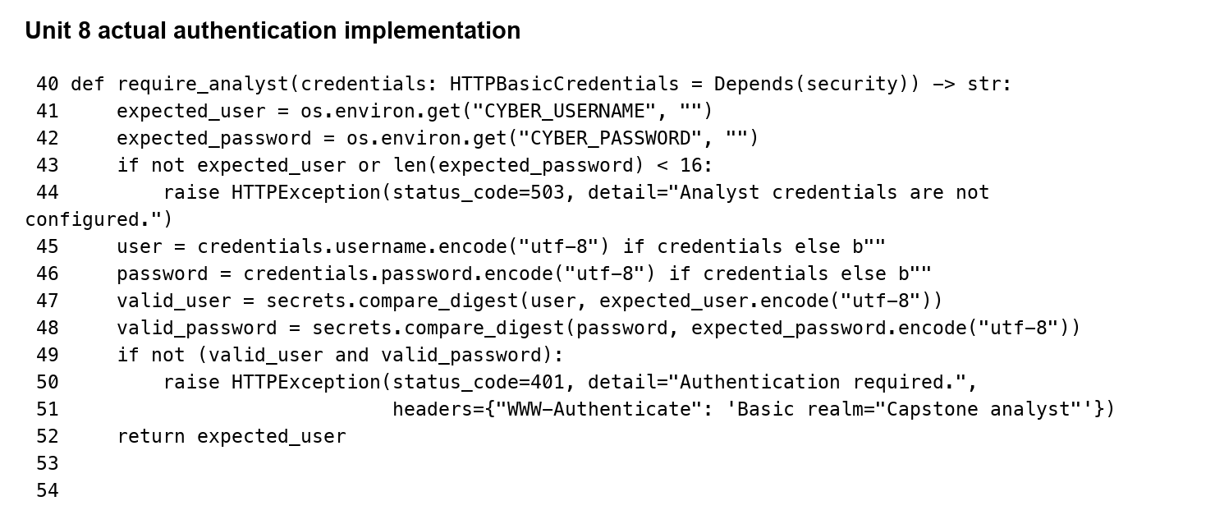
Figure 4.9 Actual authentication dependency. Source: Unit 8 source or recorded local execution on 26 October 2026.
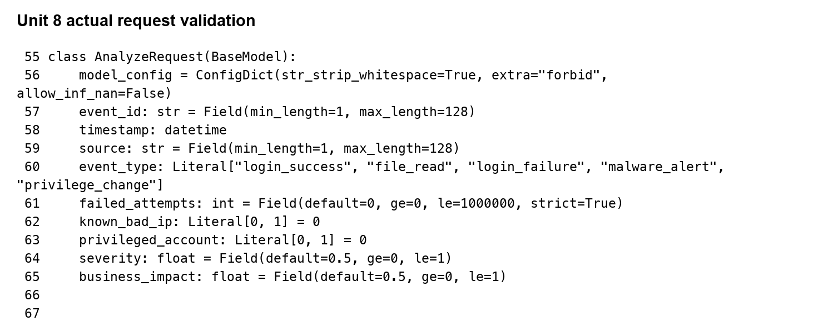
Figure 4.10 Actual request domain constraints. Source: Unit 8 source or recorded local execution on 26 October 2026.
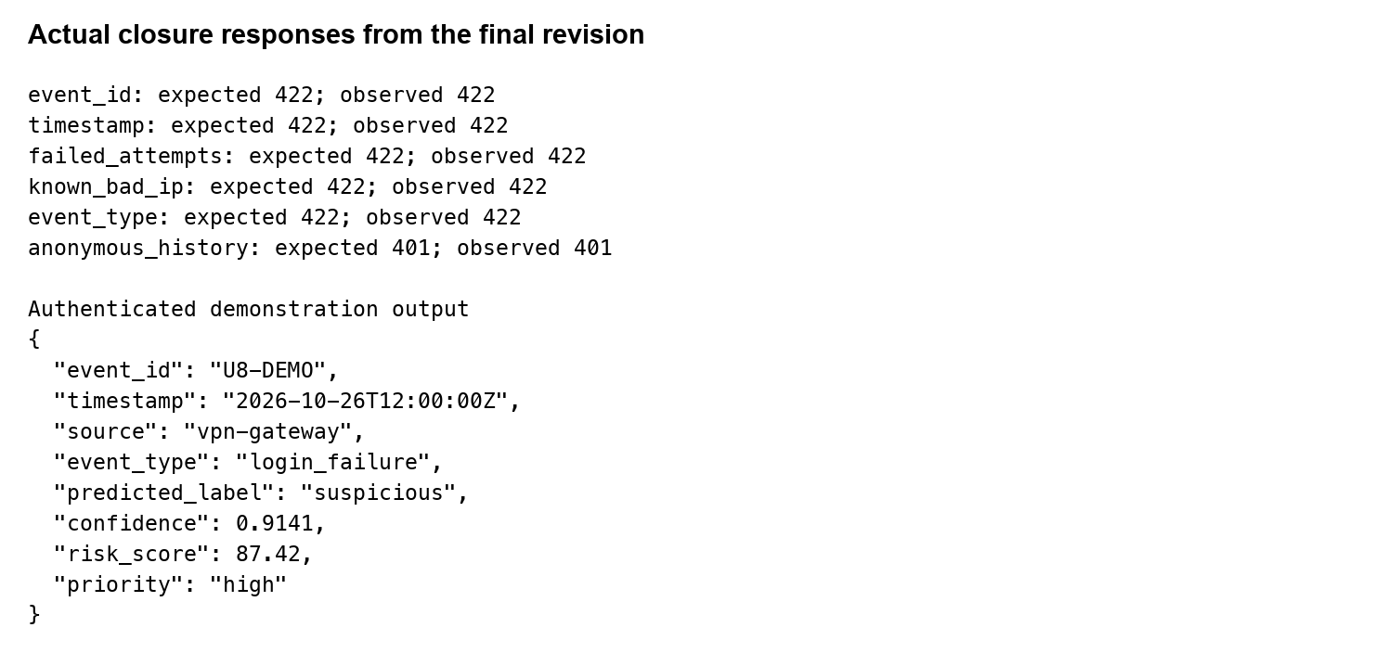
Figure 4.11 Actual closure responses and valid output. Source: Unit 8 source or recorded local execution on 26 October 2026.
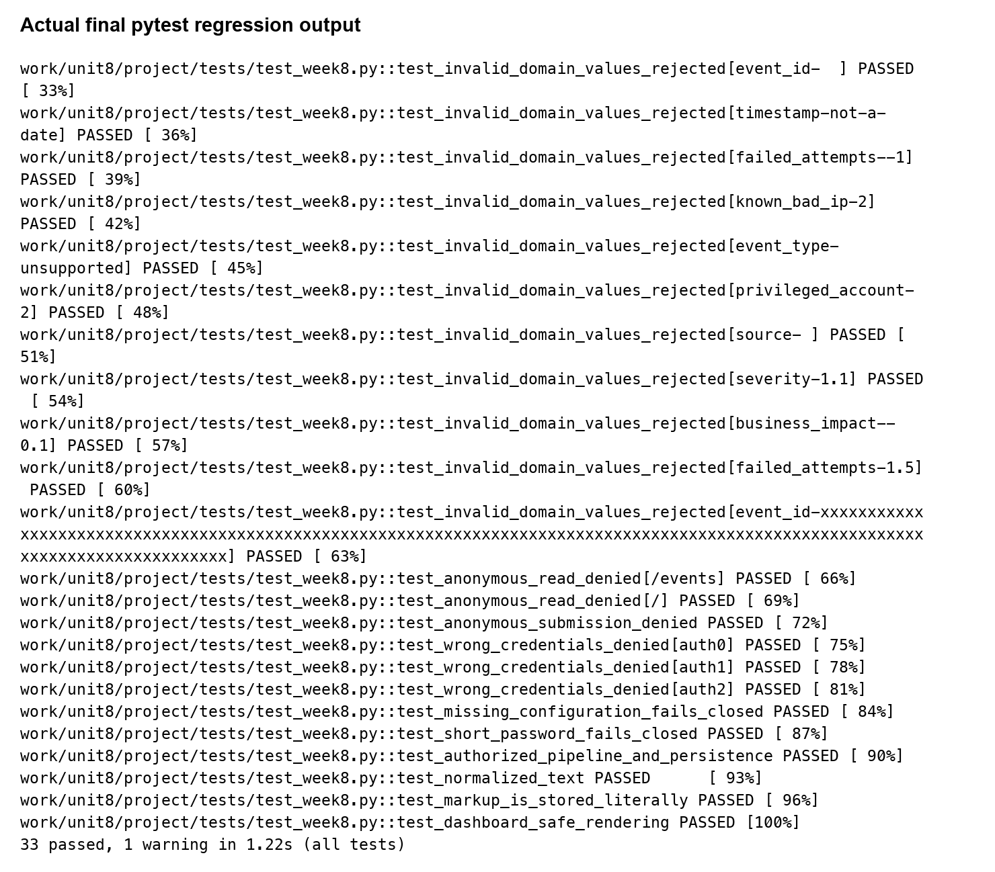
Figure 4.12 Final regression test output. Source: Unit 8 source or recorded local execution on 26 October 2026.
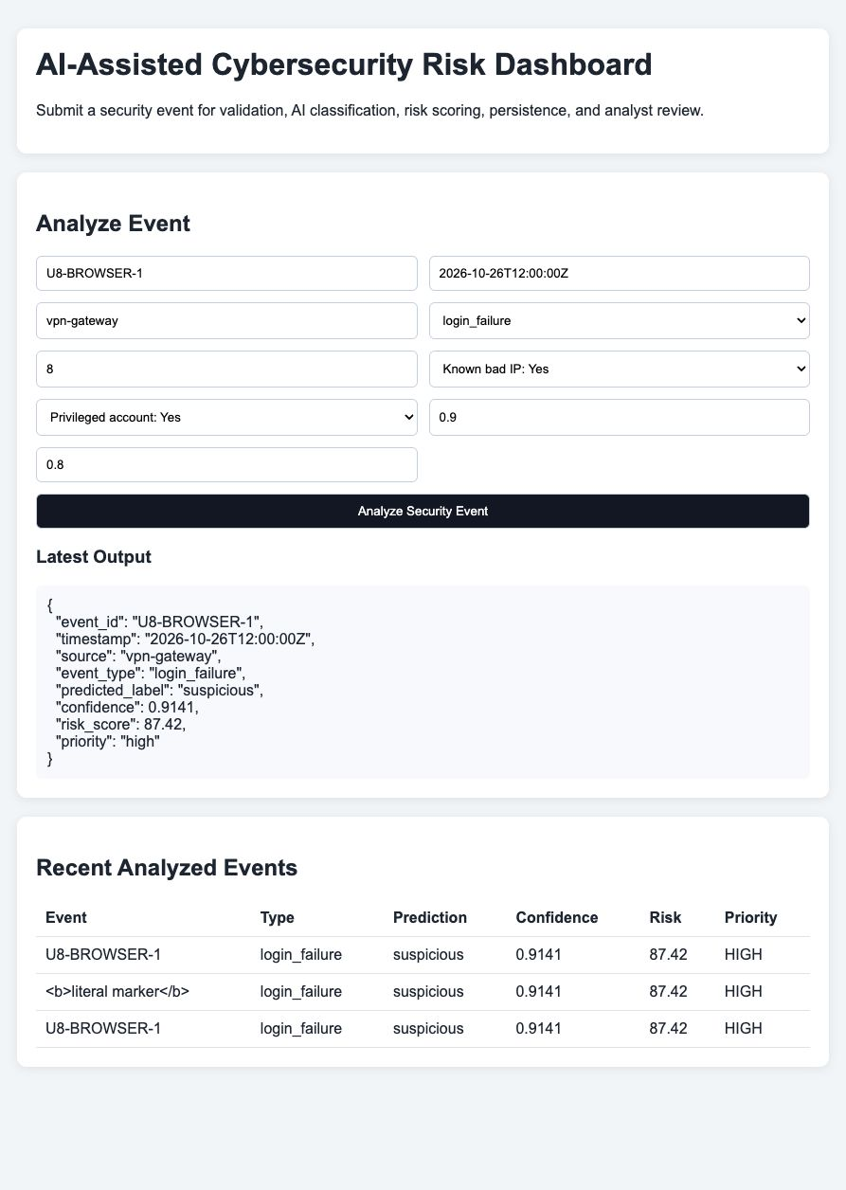
Figure 4.13 Actual authenticated browser analysis and history. Source: Unit 8 source or recorded local execution on 26 October 2026.
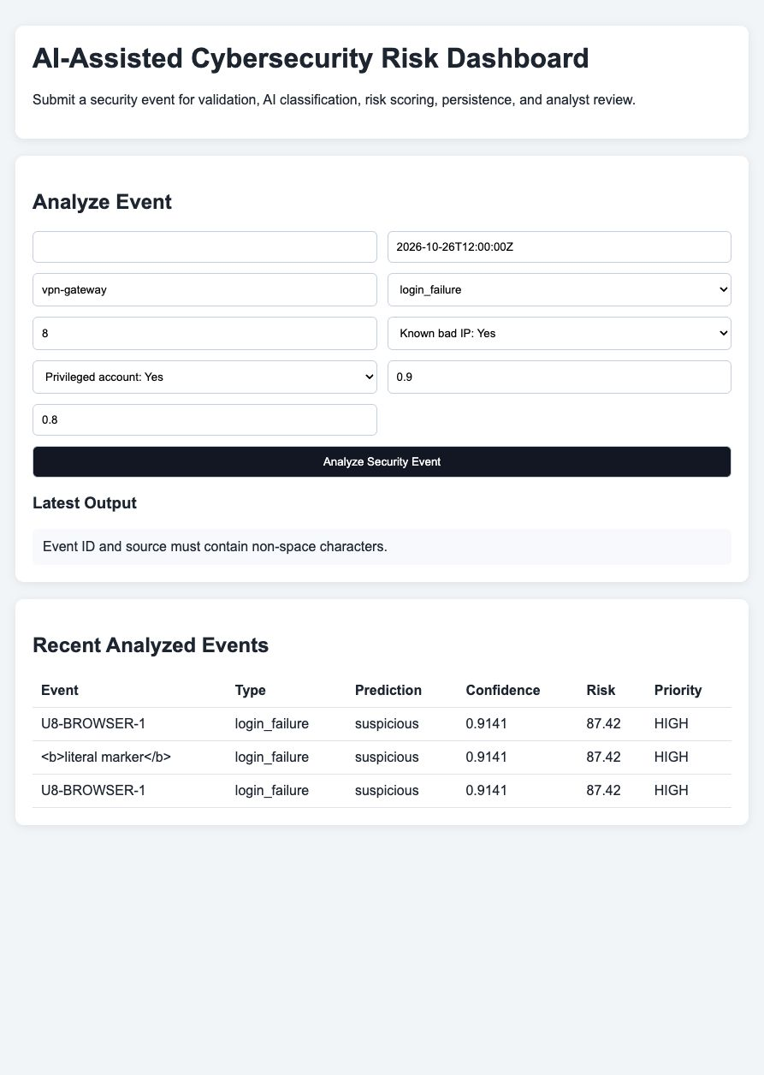
Figure 4.14 Actual blank-input message. Source: Unit 8 source or recorded local execution on 26 October 2026.
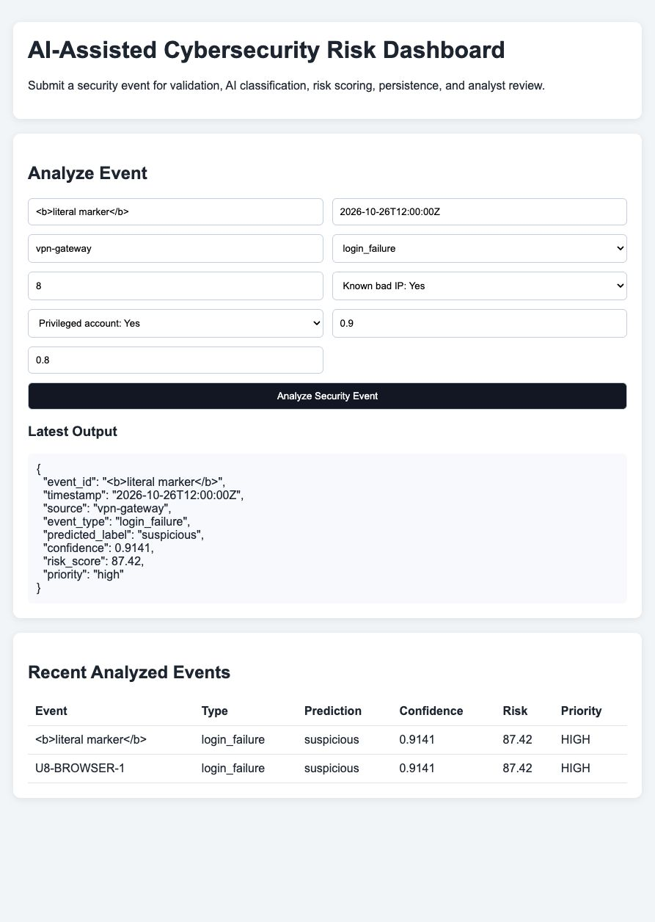
Figure 4.15 Actual literal markup display in event history. Source: Unit 8 source or recorded local execution on 26 October 2026.

4.7 Independent Benchmark Protocol and Findings
Independent evaluation used the publicly mirrored NSL-KDD training subset and test partition (Jehuty4949, n.d.). The University of New Brunswick describes NSL-KDD as a benchmark designed to reduce weaknesses in KDD'99 while acknowledging that it may not represent existing real networks (Canadian Institute for Cybersecurity, n.d.; Tavallaee et al., 2009). The originating distribution is no longer hosted on that page, so the artifact records the public mirror, file sizes, and SHA-256 hashes. The experiment used 25,192 training records from the twenty-percent training subset and 22,544 test records. Labels and difficulty metadata were excluded from predictive features.
The existing event classifier cannot directly consume forty-one network-connection features. A frozen adapter therefore mapped failed-login count directly, root-shell presence to a privilege proxy, and missing reputation to zero. It assigned login_failure when failed logins were positive, login_success when logged_in was positive, and file_read otherwise. This mapping uses observed fields, never the attack label, but it is deliberately documented as a lossy stress test. Root-shell presence is not identical to account privilege, and unknown reputation is not evidence of a benign address. Consequently, the resulting numbers measure adapter-plus-model behavior rather than native detector accuracy.
On all 22,544 test records, that frozen projection produced 9,711 true negatives, zero false positives, 12,832 false negatives, and one true positive. Accuracy was 43.0802 percent, recall 0.0078 percent, precision 100 percent, and F1 approximately 0.0156 percent. The apparently perfect precision is based on a single positive prediction and is not evidence of useful detection. Most attack records were missed. The result contradicts any attempt to generalize the six-case synthetic success rate to independent network traffic and shows that the current features and training examples are insufficient for this benchmark domain.
A separate offline candidate tested whether preserving native features offers a more credible research direction. It used DictVectorizer, MaxAbsScaler, and logistic regression with the liblinear solver, fixed random state forty-two, and a maximum of one thousand iterations. Training used only the twenty-percent training partition. The label and difficulty fields were excluded. Before scoring, 118 test records whose complete forty-one-feature vectors also appeared in training were removed. No model or threshold selection was performed using the remaining test labels. The candidate is an experimental artifact and is not substituted into the event API.
The remaining 22,426 test records contained 9,690 normal connections and 12,736 attacks. The candidate produced 8,977 true negatives, 713 false positives, 4,767 false negatives, and 7,969 true positives. Accuracy was 75.5641 percent, precision 91.7876 percent, recall 62.5707 percent, F1 74.4140 percent, and ROC-AUC 0.8569. These values establish a measured legacy-benchmark result for the offline candidate. They do not establish current SME detection performance, and the candidate and frozen projection use different effective test populations after overlap removal. The comparison is exploratory rather than a controlled claim of improvement in the deployed application.
Table 4.3 External benchmark results and interpretation
Experiment | Accuracy and recall | Interpretation
Frozen event projection | 43.08% / 0.0078% | Lossy adapter stress test; n 22544
Offline native candidate | 75.56% / 62.57% | Separate model; n 22426; legacy data

DISCUSSION

5.1 Interpretation of Results
All ten baseline automated tests passed; the final suite has thirty-three passes. Unit tests improve modular reliability by checking narrow behaviors. The ingestion test verifies incomplete records are rejected. The preprocessing test checks normalization. Classifier tests verify that prediction requires a fitted model and that training produces valid output. Risk tests verify the maximum score and clamping; Week 7 adds explicit threshold checks. Integration tests then check behavior across module boundaries.
The combination of unit and integration testing is important. A module may work alone while failing when another module sends the wrong field or data type. Integration tests expose these interface problems. For example, the end-to-end API test submits an event, receives an analysis, then calls /events to verify persistence. This tests more than one function and provides stronger evidence that the application operates as a system.
A formative usability review scored five dashboard characteristics on a five-point scale. Clarity of purpose received 5/5 because the page title and introductory text identify the system's function. Input simplicity received 4/5 because the important demonstration fields are contained in one form, though further help text could support novice users. Output clarity received 4/5 because prediction, confidence, score, and priority are visible. Navigation efficiency received 5/5 because the workflow is contained on one page. Error prevention received 4/5 because constrained controls reduce entry errors and backend validation remains authoritative.
The average score was 4.4/5. This is useful as a development review but not as independent usability evidence. The assessment was developer-led and does not measure real analyst satisfaction, accessibility, task completion time, or cognitive load. Future work should recruit representative users and apply task-based evaluation and a standardized usability instrument such as the System Usability Scale.

5.2 Comparison with Literature Findings
The implemented design aligns with several themes in NIST guidance. NIST CSF 2.0 emphasizes prioritization and communication of cybersecurity risk rather than treating security as only a detection problem (Pascoe et al., 2024). The project follows this principle by separating threat classification from operational risk prioritization. Model confidence alone does not determine the final priority; severity and business impact are also included.
NIST AI RMF encourages validity, reliability, transparency, explainability, privacy, security, and fairness across the AI lifecycle (Tabassi, 2023). The capstone supports transparency through an explicit scoring formula, reliability through automated tests, and human oversight because the system recommends a priority rather than automatically blocking a user or device. The implementation is not yet mature enough for comprehensive responsible-AI claims because it lacks large-scale fairness analysis, monitoring, and real-world validation.
At the Week 7 milestone, OWASP Top 10:2025 also remains relevant to the web application. Categories include broken access control, security misconfiguration, software supply-chain failures, cryptographic failures, injection, insecure design, authentication failures, integrity failures, and logging weaknesses (OWASP Foundation, 2025). The prototype includes schema validation and controlled processing, but authentication and authorization are not yet implemented in the demonstration. This is an acknowledged limitation and an important production requirement.
Three deployment approaches were considered. Direct Python execution on an on-premise server is simple but can lead to environment drift if operating-system packages and Python dependencies differ among machines. A cloud platform can provide scalability and managed services but introduces provider-specific configuration that is not central to the academic objective. Docker provides a useful middle path by packaging the runtime and application into a repeatable container image.
Docker was selected as the recommended prototype deployment method. FastAPI's official guidance identifies Linux container images as a common deployment approach and notes benefits including replicability and isolation (FastAPI, n.d.-a). The repository includes a Dockerfile based on Python 3.11 slim, installs requirements, copies the application, sets the database path, exposes port 8000, and starts Uvicorn.
Docker Compose adds a named volume for database persistence and maps port 8000 to the host. The CYBER_DB_PATH setting is supplied through environment configuration. Docker documentation supports environment variables for configuration while warning that passwords and other secrets should use secrets-management mechanisms rather than ordinary environment variables (Docker, n.d.). The current database path is not secret, but future credentials must be handled differently.
Configuration management separates environment-specific values from application logic. The prototype reads the database location from CYBER_DB_PATH with a development default. The .env.example file documents expected settings without storing credentials. Docker and Compose define build instructions, runtime port, data persistence, and startup commands.
This improves reproducibility because developers and operators do not need to remember hidden machine-specific steps. Final local setup uses the delivered archive, a virtual environment, requirements-tested.txt, configured credentials, pytest, and Uvicorn; the public repository remains the baseline. The container workflow builds an image and starts the service, or uses docker compose up --build -d. These instructions are version controlled and can be reviewed along with source code.

5.3 Implications and Limitations
The largest limitation is data realism. Baseline training and evaluation examples were synthetic and small. They do not represent the scale, noise, diversity, and adversarial evolution of operational event streams. The 100 percent accuracy result must therefore be restricted to the designed evaluation cases.
The risk formula is another limitation. Fixed weights for severity, confidence, and business impact are appropriate for demonstrating logic but would require calibration in a real organization. Operational risk might also include asset criticality, exploitability, vulnerability exposure, user role, data sensitivity, threat intelligence, and existing controls.
At the Week 7 milestone, security hardening is incomplete. The prototype does not yet include authentication, fine-grained RBAC, HTTPS termination, rate limits, centralized security logging, secret rotation, or automated backup. These controls would be mandatory before Internet-facing production deployment.
SQLite is suitable for the academic prototype but not ideal for high write concurrency, multi-instance scaling, or advanced availability requirements. A production evolution should use a managed relational database such as PostgreSQL. Finally, latency was measured in-process rather than over a deployed network, and the usability score was developer-generated rather than collected from independent participants.
The project repository stores source code, tests, deployment configuration, documentation, and evaluation scripts. This supports reproducibility because the benchmark logic can be rerun after future code changes. Git history also provides traceability from implementation changes to pull requests and integration milestones.
The Unit 6 integration milestone was developed on the development branch and merged into main through Pull Request #3. That pull request grouped the API, dashboard, persistence, evaluation, testing, and deployment changes into one visible integration event. In a larger team, branch protection and peer approval should be added, but the current workflow demonstrates controlled progression from development work to the stable branch.
Reproducibility does not replace external validity. Another developer may be able to reproduce the same synthetic result, but that does not make the synthetic dataset representative of real threats. Reproducibility ensures current claims can be checked, while external validation determines how far those claims can be generalized.
Project monitoring also benefited from version control and milestone-based integration. Each significant change was recorded through meaningful commits and then reviewed through pull requests before reaching the stable branch. This created a documented relationship between requirements, implementation, testing, and deployment. It also reduced the risk that experimental changes would be mixed directly into the stable codebase. For future professional use, the same workflow could be strengthened with automated CI checks, required reviews, signed releases, and deployment approvals. These controls would support both engineering quality and governance by making it easier to identify when a change was introduced, who approved it, and which automated checks were completed before release.
The evaluation scripts also create a simple mechanism for regression monitoring. After future changes to the model, database, or API, the same metrics can be rerun and compared with the current baseline. A latency increase, test failure, or change in classification behavior would then be visible rather than discovered informally. This is particularly valuable in cybersecurity systems, where changes in detection logic can alter analyst workload and incident prioritization. Maintaining benchmark scripts alongside the code therefore supports technical accountability and continuous improvement.

5.4 Future Work
The next implementation stage should use a larger security dataset and evaluate multiple models, including logistic regression, random forest, and gradient boosting. Precision, recall, F1-score, class-specific error analysis, and calibration should be emphasized. Thresholds should reflect the different costs of false positives and false negatives.
Risk prioritization should incorporate asset criticality and organizational policy. Explainability can be improved by showing which features influenced the classifier and which factors contributed to the final score. Model versioning, drift monitoring, and periodic re-evaluation should be added for long-lived deployments.
Beyond the implemented analyst authentication, the application needs RBAC, HTTPS, secure headers, dependency scanning, secret management, audit logs, and monitoring. The database should move to a managed platform if multi-user concurrency grows. CI/CD should enforce tests and security checks before deployment.
Usability evaluation should involve real or representative security analysts. Participants should complete tasks such as identifying the highest-priority event, understanding why it was prioritized, correcting a misleading result, and reviewing event history. Task completion time, error rate, standardized questionnaire scores, and interviews would provide stronger evidence than developer review alone.
The evaluation indicates that the prototype demonstrates the supported academic workflow. Modules operate together, tests pass, the classifier and risk engine produce coherent output, the API has low local processing overhead, and the dashboard provides a clear workflow. At the same time, the results demonstrate the difference between a successful prototype and a production cybersecurity product. Realistic data, independent usability evaluation, stronger security controls, external performance testing, and production-grade persistence remain necessary. Unit 8 closes those failures; model validity still prevents operational readiness.

5.5 Maintenance and Release Readiness
The Week 7 failures changed the release decision. The prototype is suitable for a bounded academic demonstration with synthetic events; it is not ready to process real organizational security records through an exposed service. The six failed checks are now corrected and verified; operational security and representative model evaluation remain release prerequisites. The maintainer should record each issue with its test identifier, input, observed response, desired response, affected version, owner, severity, and closure evidence. An issue should remain open until a rerun demonstrates the correction.
Maintenance combines corrective, adaptive, perfective, and preventive work. Corrective work addresses validation and access failures. Adaptive work keeps event schemas and runtime dependencies compatible. Perfective work improves filtering, explanations, investigation state, and analyst feedback. Preventive work stabilizes dependency versions, rehearses restoration, reviews capacity, and checks model and policy behavior. The proposed daily, weekly, monthly, and quarterly schedule in Table 5.1 connects these categories to concrete records and owners rather than relying on an unspecified promise to maintain the application.
Release control should preserve main as the reviewed stable baseline while isolating changes in a development or review branch. Every release should identify source, tested runtime, model, score policy, schema, and configuration. A successful application rollback does not automatically undo a database migration; forward-compatible changes or a rehearsed restore procedure are needed. The proposed 24-hour recovery point and four-hour recovery time must be approved by an operational owner and verified experimentally before being reported as achieved targets.
Model maintenance must be coupled to scoring maintenance. The current score uses confidence in whichever class wins, so certainty that an event is benign still increases the confidence term. W7-21 illustrates a benign prediction with High priority after a negative count is accepted. Rejecting negative counts fixes the malformed input, but it does not resolve the underlying policy question. A future policy could use suspicious-class probability or separate classification confidence from threat likelihood. That change requires labeled validation and analyst review rather than silently changing a formula that downstream users may interpret differently.
Table 5.1 Proposed maintenance schedule
Interval | Action | Owner and record
Daily | Availability errors database size backup completion | Operator; monitoring record
Weekly | Triage validation anomalies count reconciliation | Maintainer; issue log
Monthly | Dependency review staging regression benchmark | Maintainer; release evidence
Quarterly | Restore drill access review model policy review | Owner and analyst; review record
Urgent | Contain security defect test patch and regression | Maintainer and owner; incident record
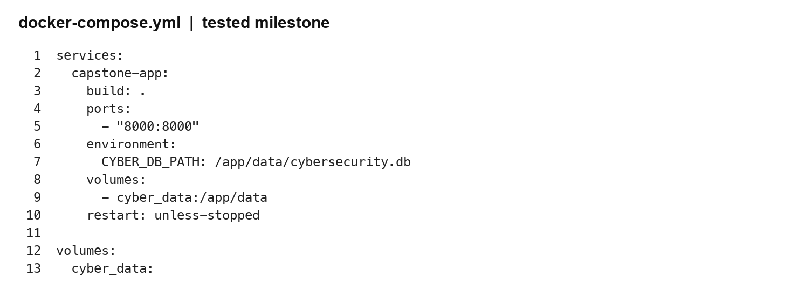
Figure 5.1 Week 7 Docker Compose configuration. Source: repository docker-compose.yml; container execution not tested in Week 7.

5.6 Interpretation of Final Corrections and External Validity
The final revision changes the assurance conclusion in a specific way. Input-domain enforcement and authenticated access are now demonstrated in the local artifact, so the six Week 7 failures need not remain open as identical implementation defects. The model-validity concern remains open. Independent evaluation gives the report stronger evidence by revealing a weakness that synthetic cases concealed. This is consistent with the broader methodological distinction between evaluating a classifier in a controlled setting and demonstrating useful intrusion detection in an operational environment (Sommer & Paxson, 2010).
The benchmark charts separate implementation closure from predictive utility. A passing rejection test means that one malformed request was rejected under the tested configuration. High attack recall would mean that labeled attacks were identified within a defined evaluation population. These are different properties and cannot be combined into a single readiness score. Thirty-three passing software tests do not compensate for the frozen model missing nearly every projected benchmark attack. Likewise, the offline candidate's higher recall does not prove that authentication or data storage is reliable. Each claim requires its own evidence and acceptance criterion.
False negatives are particularly consequential in the external results. The frozen projection produces few positive predictions because it lacks the network context needed to distinguish many attack types. The native candidate detects more attacks but still misses 4,767 of them. Its 713 false positives would also require analyst review in the benchmark population. The organization would need to consider investigation capacity, event prevalence, and the cost of missed attacks before choosing a threshold. Since the benchmark is not sampled from a current SME environment, its positive predictive value should not be projected directly into operational workload estimates.
The present scoring formula also remains a policy assumption. It uses confidence in the winning class, so high confidence that an event is benign can still contribute positively to the risk score. Fixing malformed counts does not remove that conceptual issue. Future work should compare suspicious-class probability with alternative prioritization formulas and test the policy using independently labeled events and analyst judgments. The coefficients should be approved for an intended decision context rather than selected because one demonstration produces a plausible number. The current final revision leaves the scoring formula unchanged so its corrective effects can be traced without silently changing classification policy.
Data representativeness is only partially addressed by the new experiment. NSL-KDD is independent of the six handwritten training records and provides a published evaluation population, but it is a legacy network benchmark. It lacks the precise event categories and business-impact context used by the dashboard. The report therefore distinguishes independence from representativeness. Establishing actual detection performance would require authorized contemporary telemetry, a defensible labeling process, temporal separation between training and evaluation, and an explicit mapping from source records to features. That work is not completed by downloading a public benchmark.
Operationally, the revised application remains suitable for a controlled synthetic-data demonstration. Before real-data deployment, the owner should implement managed accounts, HTTPS, role separation, rate limits, audit records, retention rules, backup restoration checks, and a verified model-evaluation process. Regression tests should run after changes to validation, authentication, scoring, or storage. Benchmark results should be retained with the source manifest and dataset hashes so later improvements are compared under a documented protocol. These recommendations extend the maintenance plan while preserving the difference between implemented controls and proposed operational safeguards.
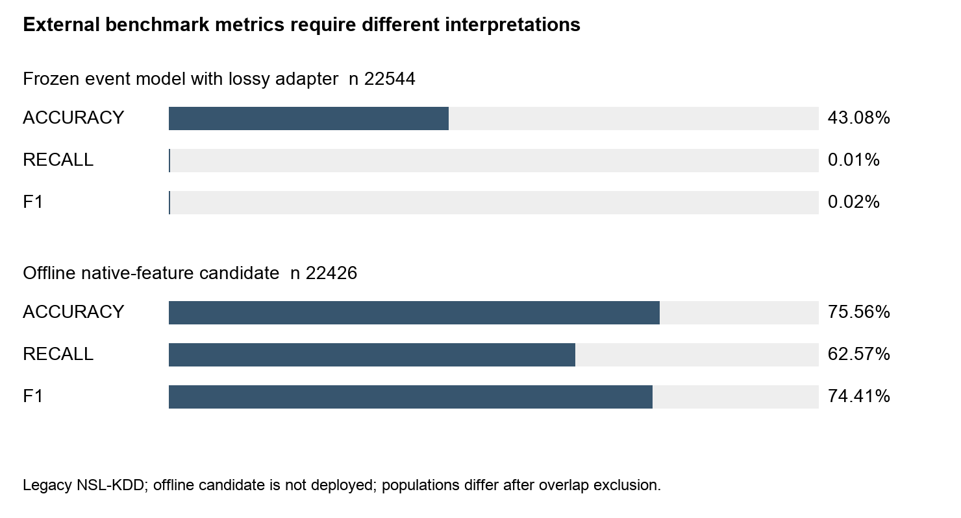
Figure 5.2 External benchmark accuracy recall and F1. Source: external_results.json; different test populations after overlap exclusion.

CONCLUSION AND FUTURE WORK

6.1 Summary of Main Findings
This capstone developed an AI-assisted cybersecurity threat detection and risk prioritization framework intended for small and medium-sized organizations. The motivating problem was that smaller organizations may receive more security events than limited staff can investigate with equal attention. The project therefore focused on both classification and prioritization so that analysts can direct attention toward potentially higher-impact events.
The completed prototype integrates ingestion, validation, preprocessing, logistic-regression classification, explainable risk scoring, SQLite persistence, FastAPI services, and an analyst dashboard. A representative suspicious login event was processed end to end and produced a suspicious prediction with 0.9141 confidence, an 87.42 risk score, and High priority. The result was stored and made available through the recent-events workflow.
Baseline automated testing produced ten successful tests covering core and integration behavior. A small synthetic evaluation set produced 100 percent classification accuracy. Fifty local integrated requests produced 2.972 ms mean latency, 2.135 ms median latency, and 6.683 ms 95th-percentile latency. A formative usability review produced an average score of 4.4/5. These findings demonstrate that the prototype is cohesive, testable, and responsive within the controlled development environment. Week 7 added 21 passing and six failing checks. Unit 8 closes the failures with 33 passing tests and independent evaluation in Sections 4.6–4.7.

6.2 Contributions and Implications
The project's principal contribution is a practical integration pattern rather than a novel machine-learning algorithm. Model confidence is not treated as equal to organizational risk. Classification output is combined with severity and business impact in a separate visible prioritization layer. This design supports explanation and customization because risk weights can be changed without retraining the classifier.
Modularity is another contribution. The classifier can be replaced without changing the database or dashboard contract as long as it continues to return a label and confidence. The persistence layer can also be upgraded without rewriting the analytical modules. This separation reduces coupling and creates a clearer path for future development.
The project also demonstrates the importance of integrating responsible-AI and cybersecurity principles during implementation. Human review remains part of the workflow, the risk formula is explicit, data validation occurs at the application boundary, and the limits of synthetic data are documented. These choices reflect the risk-management orientation of NIST CSF 2.0 and NIST AI RMF.

6.3 Lessons Learned and Challenges
One important lesson is that integration reveals failures that isolated module testing cannot expose. A model may work correctly while an API sends the wrong feature names. A scoring function may be mathematically correct while the UI passes text instead of numbers. A database may store data while the dashboard fails to refresh it. End-to-end testing is therefore necessary in addition to unit-level testing.
A second lesson is that performance numbers require context. Low latency measured through TestClient is useful as a reproducible baseline but not as a production service-level guarantee. Likewise, 100 percent accuracy on six synthetic cases confirms implementation coherence but not real-world detection quality.
A third lesson is that deployment planning improves software design. Building a Docker image requires explicit dependencies, ports, database paths, persistent storage, and startup commands. Hidden assumptions become visible configuration. This makes the system easier to reproduce and maintain.
A fourth lesson is that model output should not automatically become operational action. Security decisions can affect access, incident escalation, and business continuity. The prototype therefore maintains human oversight and uses AI as decision support rather than an autonomous authority.
The first challenge was creating a functional machine-learning demonstration without overstating synthetic data. This was resolved by describing the classifier as a baseline and limiting claims to the controlled evaluation environment. The second challenge was adding persistence without unnecessary infrastructure. SQLite provided real database behavior while keeping setup manageable. The third challenge was maintaining modularity during integration. The API was kept as an orchestration layer rather than becoming a monolithic function.
Deployment also created a balance between convenience and security. Docker improves repeatability but does not automatically secure an application. The deployment plan therefore distinguishes current prototype capabilities from production requirements such as HTTPS, managed identity, secret management, backups, monitoring, and stronger authorization.

6.4 Deployment Recommendation
Docker is the recommended packaging approach for the current system. It supports a repeatable runtime and can be used locally, on-premise, or on a cloud container service. For classroom demonstration, Docker Compose with a persistent data volume is sufficient. For production-oriented use, the container should be deployed behind HTTPS, connected to a managed identity service, use centralized logs, and use an external managed database.
Configuration should remain externalized. Non-sensitive values such as paths and ports can use environment variables, while secrets should use a secret manager. Images should be built from reviewed code, dependencies should be pinned and scanned, and CI/CD should require successful tests before image publication.

6.5 Next Improvements
Future work should begin with stronger data and model evaluation. A larger dataset should be selected, preprocessing should be aligned to that dataset, and multiple algorithms should be compared. Performance should be measured using precision, recall, F1-score, confusion matrices, probability calibration, and error analysis. Drift monitoring should be considered if the model becomes long-lived.
The analyst experience should be expanded with event search, filtering, investigation status, analyst notes, richer explanations, and export capabilities. Managed accounts and role-based permissions should replace the single analyst credential before multi-user deployment. Audit logs should record who reviewed or changed an event.
The database should move to PostgreSQL or another managed relational platform for multi-instance deployment. Background processing and a message queue may become appropriate for higher-volume ingestion. Observability should include metrics, structured logs, tracing, and alerting.
Security hardening should explicitly address relevant OWASP Top 10 categories, including access control, authentication, dependency integrity, cryptography, secure design, and logging. Threat modeling and penetration testing should be added before Internet-facing use.

6.6 Final Conclusion
The project achieved its immediate objective of developing and integrating an AI-assisted cybersecurity risk-prioritization prototype. It demonstrates a complete workflow from security-event input to classification, risk scoring, persistence, and analyst display. Automated testing and measured local performance provide evidence that the implementation operates coherently.
The project also reinforces that successful AI-assisted cybersecurity depends on more than model accuracy. Operational usefulness requires reliable integration, interpretable risk logic, secure deployment, configuration discipline, human oversight, and honest reporting of limitations. The Week 7 system provides a foundation on which those capabilities can be expanded.
For small and medium-sized organizations, the concept is valuable because it focuses on prioritization rather than simply generating more alerts. With larger and more realistic data, stronger security controls, independent usability evaluation, and production-grade infrastructure, the framework could evolve into a more credible security-operations decision-support tool.

6.7 Research Questions and Next Release
The evidence answers RQ1 at the level of technical feasibility: the prototype can classify supported synthetic events and attach a persisted priority. It answers RQ2 through a modular API, a distinct scoring policy, and an analyst-facing result. RQ3 is partially answered through synthetic-data handling, transparent reporting, final authentication, and domain constraints. Broader identity governance, operational safeguards, and representative model validation remain incomplete despite closure of the six Week 7 checks.
The next release should extend the final corrections and independent legacy experiment. A contemporary independently labeled evaluation dataset, calibrated threat probability, complete input provenance, and task-based analyst evaluation should determine whether the integration actually supports better prioritization. The contribution remains a reproducible prototype and an honest assurance record. Demonstrated functionality, known failures, historical metrics, fresh measurements, and proposed maintenance actions are kept distinct so later reviewers can judge progress without treating plans as completed controls.

6.8 Final Contributions and Prioritized Future Work
The final capstone contribution is an integrated cybersecurity decision-support prototype supported by traceable implementation, test evidence, and candid evaluation. The application accepts structured events, validates their domain values, requires configured analyst authentication, classifies accepted inputs, calculates an explicit priority, persists the result, and displays history through safer text rendering. Thirty-three tests pass in the delivered local revision. Browser captures demonstrate a successful analysis, rejection of blank input, and literal display of stored markup. One hundred authenticated sequential requests persist successfully, and a separate process retrieves the final record.
The instructor's validation, authentication, and dashboard feedback is addressed through code changes and regression evidence rather than explanatory edits alone. The classifier feedback produces a qualified outcome: an independent benchmark experiment was completed, but actual contemporary SME detection performance remains unestablished. The frozen model's poor projected recall and the offline candidate's remaining errors provide a practical reason to prioritize data and feature engineering before claiming deployment readiness. The initial synthetic result is retained only as a consistency check.
The next development stage should first define a realistic data contract and obtain authorized representative records. Training, threshold selection, and final evaluation should use separated populations, with labels and provenance preserved. A native model candidate should be integrated only after its feature requirements, calibration, and failure modes are reviewed. The interface should then be assessed by intended analysts through task-based usability testing. Access control should move from one configured account to managed identities with auditable permissions. Backup restoration and external load tests should complete the operational evidence.
The project demonstrates applied learning through problem analysis, modular implementation, rigorous testing, ethical boundaries, and professional communication. Its professional value lies in the ability to show both functioning behavior and the conditions under which claims fail. The delivered report, source snapshot, evidence logs, benchmark protocol, and presentation script allow a reviewer to examine those conclusions. They support an academically complete capstone while making clear that production adoption requires further evidence and governance.

REFERENCES
Buczak, A. L., & Guven, E. (2016). A survey of data mining and machine learning methods for cyber security intrusion detection. IEEE Communications Surveys & Tutorials, 18(2), 1153–1176. https://doi.org/10.1109/COMST.2015.2494502
Canadian Institute for Cybersecurity. (n.d.). ISCX NSL-KDD dataset 2009. https://www.unb.ca/cic/datasets/nsl.html
Docker. (n.d.). Set environment variables within your container environment. https://docs.docker.com/compose/how-tos/environment-variables/set-environment-variables/
FastAPI. (n.d.-a). FastAPI in containers — Docker. https://fastapi.tiangolo.com/deployment/docker/
FastAPI. (n.d.-b). HTTP Basic Auth. https://fastapi.tiangolo.com/advanced/security/http-basic-auth/
FastAPI. (n.d.-c). Testing. https://fastapi.tiangolo.com/tutorial/testing/
Jehuty4949. (n.d.). NSL-KDD dataset mirror [Data set]. https://github.com/Jehuty4949/NSL_KDD
MDN contributors. (n.d.). Node textContent property. https://developer.mozilla.org/en-US/docs/Web/API/Node/textContent
Mustafa, M. A. (2026). AI-assisted cybersecurity threat detection and risk prioritization [Computer software; commit 9d4cf2722093ab657e681976314e073647cc5b56]. GitHub. https://github.com/milhanahmed/ai-cybersecurity-threat-detection-risk-prioritization/tree/9d4cf2722093ab657e681976314e073647cc5b56
OWASP Foundation. (2025). OWASP Top 10 2025. https://top10.owasp.org/2025/
Pascoe, C., Quinn, S., & Scarfone, K. (2024). The NIST cybersecurity framework (CSF) 2.0 (NIST CSWP 29). National Institute of Standards and Technology. https://doi.org/10.6028/NIST.CSWP.29
Pydantic. (n.d.). Fields. https://docs.pydantic.dev/latest/concepts/fields/
pytest developers. (n.d.). How to use fixtures. https://docs.pytest.org/en/stable/how-to/fixtures.html
scikit-learn developers. (n.d.). LogisticRegression. https://scikit-learn.org/stable/modules/generated/sklearn.linear_model.LogisticRegression.html
Sommer, R., & Paxson, V. (2010). Outside the closed world: On using machine learning for network intrusion detection. In 2010 IEEE Symposium on Security and Privacy (pp. 305–316). IEEE. https://doi.org/10.1109/SP.2010.25
Tabassi, E. (2023). Artificial intelligence risk management framework (AI RMF 1.0) (NIST AI 100-1). National Institute of Standards and Technology. https://doi.org/10.6028/NIST.AI.100-1
Tavallaee, M., Bagheri, E., Lu, W., & Ghorbani, A. A. (2009). A detailed analysis of the KDD CUP 99 data set. In 2009 IEEE Symposium on Computational Intelligence for Security and Defense Applications (pp. 1–6). IEEE. https://doi.org/10.1109/CISDA.2009.5356528

APPENDICES

Appendix A Week 7 Test Record
Source: expanded harness records for the unchanged milestone, executed on 13 October 2026. PASS means the stated expectation was met; FAIL means an unmet requirement was observed. These are developer-executed checks, not independent stakeholder acceptance.
Table A1 Expanded Week 7 expected and observed outcomes
ID and result | Objective | Expected | Observed
W7-01 PASS | Analyze known suspicious event | 200 and suspicious high | suspicious high 87.42
W7-02 PASS | Retrieve persisted event | U7-DEMO present | True
W7-03 PASS | Normalization | TRIM | TRIM
W7-04 PASS | Benign scenario | benign | benign
W7-05 PASS | Missing event_id | 422 | 422
W7-06 PASS | Missing timestamp | 422 | 422
W7-07 PASS | Missing source | 422 | 422
W7-08 PASS | Missing event_type | 422 | 422
W7-09 PASS | Nonnumeric count | 422 | 422
W7-10 PASS | Threshold 49.99 | low | low
W7-11 PASS | Threshold 50 | medium | medium
W7-12 PASS | Threshold 74.99 | medium | medium
W7-13 PASS | Threshold 75 | high | high
W7-14 PASS | Clamp score inputs | 55.0 | 55.0
W7-15 PASS | History limit -1 | 200 and at most 1 | HTTP 200
W7-16 PASS | History limit 1 | 200 and at most 1 | HTTP 200
W7-17 PASS | History limit 1000 | 200 and at most 100 | HTTP 200
W7-18 PASS | Dashboard served with analyst form | 200 and event form | HTTP 200
W7-19 FAIL | Reject blank ID | 4xx rejection | HTTP 200
W7-20 FAIL | Reject invalid timestamp | 4xx rejection | HTTP 200
W7-21 FAIL | Reject negative count | 4xx rejection | HTTP 200
W7-22 FAIL | Reject nonbinary flag | 4xx rejection | HTTP 200
W7-23 FAIL | Reject unsupported category | 4xx rejection | HTTP 200
W7-24 FAIL | Protect history without authentication | 401 or 403 | 200
W7-25 PASS | SQL metacharacters retained as data | 200 with table intact | 200
W7-26 PASS | 100 sequential requests persisted | 100 successes and 100 new rows | 100 successes; 100 rows
W7-27 PASS | Read database in fresh process | U7-STABILITY-99 | U7-STABILITY-99

Appendix B Evidence Logs and Environment
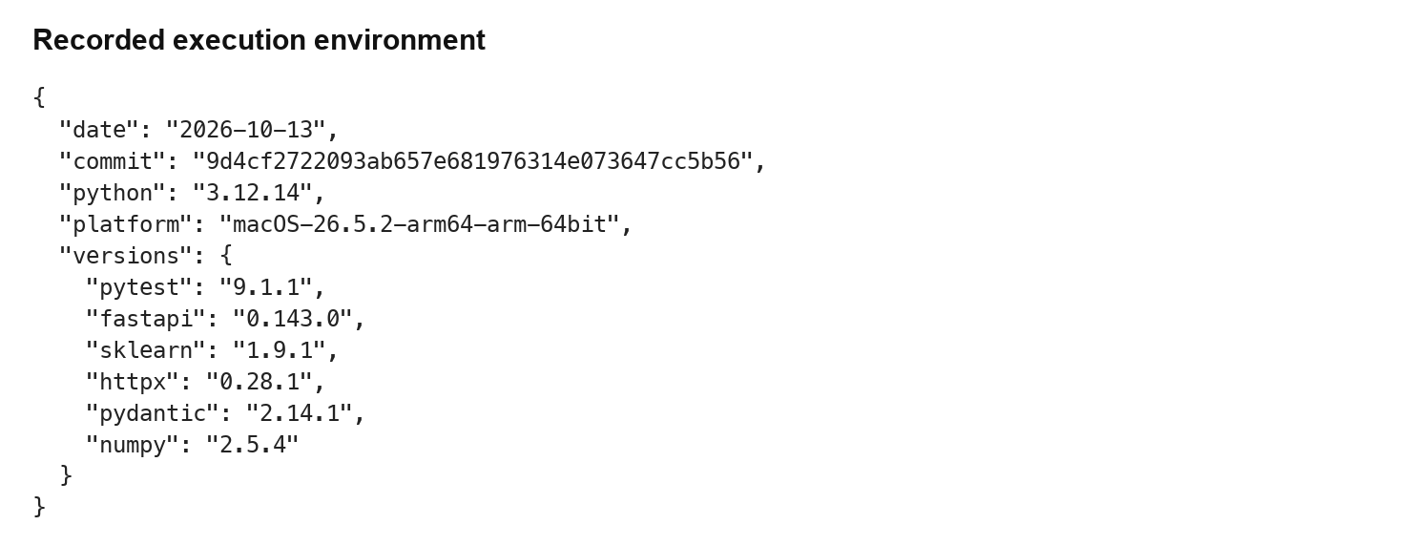
Figure B1 Recorded Week 7 execution environment. Source: week7_results.json.
Original pytest log: 10 passed, 1 warning in 53.60 seconds. The warning concerns deprecated use of HTTPX with the installed Starlette TestClient; the run still exited successfully. The cold-start test duration is not an API latency measurement. Full expected and observed results are preserved in Table A1.
Repository evaluation script output: classification_accuracy 1.0; requests_measured 30; mean_latency_ms 1.260; median_latency_ms 1.037; approximate reciprocal rate 793.37 requests per second. This is a separate run from the expanded 100-request stability experiment.
Fresh-process log: event_id U7-STABILITY-99; predicted_label suspicious; confidence 0.9141; risk_score 87.42; priority high. The database stored 100 additional rows during the sequential experiment. Database history limits display at most 100 records, so insertion count was independently checked through SQLite counts.

Appendix C Baseline Configuration and Reproduction
Retrieve the repository at the stated commit, create an isolated Python environment, install the repository requirements, record resolved versions, and run python -m pytest -v. Set CYBER_DB_PATH before importing the application. The original integration tests set their own test path; keep their database separate from deployment data. Run python scripts/evaluate_system.py for the repository 30-request benchmark. Week 7 additional checks use the same application with a separate database and expected-versus-observed harness.
For the documented container route, Dockerfile uses python:3.11-slim and starts Uvicorn on port 8000. Docker Compose supplies CYBER_DB_PATH and a named cyber_data volume. Build and startup are proposed reproduction steps; no successful container build or deployment is claimed by this Week 7 verification. APP_HOST and APP_PORT appear in .env.example, but the current startup command hardcodes host and port. A .env file is not automatically read by the application.
Proposed command sequence: git checkout 9d4cf2722093ab657e681976314e073647cc5b56; python -m pip install -r requirements.txt; python -m pytest -v; python scripts/evaluate_system.py; uvicorn src.api.app:app --host 127.0.0.1 --port 8000. For containers, use docker compose up --build -d after reviewing network exposure and persistence. Use synthetic data until access and validation controls are implemented.

Appendix D Defect Register and Closure Criteria
Table D1 Confirmed gaps and proposed closure
Issue | Priority | Closure evidence
W7-19 blank ID | High data quality | Trim then reject blank; 4xx regression
W7-20 invalid timestamp | High data quality | Parse valid format; reject invalid date
W7-21 negative count | High data quality | Nonnegative domain constraint; regression
W7-22 nonbinary indicator | High data quality | Restrict to zero or one; regression
W7-23 unsupported category | Medium data quality | Document vocabulary or explicit unknown policy
W7-24 unprotected history | High security | Deny anonymous request; test authorized roles
HTML interpolation in history | High source-level concern | Use safe text; controlled browser regression
Training overlap | High evaluation limitation | Independent labeled evaluation set
The following confirmed acceptance gaps were unresolved at Week 7 delivery; Unit 8 closure evidence appears in Section 4.6. Source review concerns are distinguished from executed failures. These entries describe baseline failures; final closure tests and fixes are included in the Unit 8 snapshot. Priorities are project triage judgments that should be reviewed with the future operational owner.

Appendix E Source and Measurement Provenance
Source revision: 9d4cf2722093ab657e681976314e073647cc5b56. All 37 source blobs retrieved through the GitHub connector matched the Git blob hashes in the repository tree. The verification harness and evidence files are task-local additions; the repository milestone remains unchanged. Repository integration history includes Pull Request 3, Integrate full system evaluation and Docker deployment.
The retained official template is the uploaded Capstone Project Report Template in legacy Word format, converted with the bundled renderer for editing. The cover uses the student identification and supervisor recorded in the submitted Week 6 report. Week 3 Chapters 1–3 and Week 6 Chapters 4–6 are integrated and updated to reflect current implementation and evidence.
Latency protocol: 100 sequential successful analysis requests; elapsed time measured with perf_counter around each TestClient call; median is the sample median; P95 is the 95th value after sorting 100 observations. Precision, recall, and F1 use suspicious as the positive class. Confusion-matrix order is benign then suspicious. Exactly three feature dictionaries match the six training dictionaries. These definitions allow a future reviewer to reproduce the calculations without interpreting charts as independent experiments.

Appendix F Final Source and Evidence Manifest
The supporting archive contains the final local source snapshot, regression tests, browser captures, machine-readable test outcomes, external evaluation script, dataset provenance, and file hashes. The snapshot derives from the cited public baseline; it is not a published remote revision. The source manifest records the final delivered files so reviewers can distinguish the baseline from local corrections.
Final run record: 33 passed and one deprecation warning; 100 authenticated requests and 100 new rows; fresh-process retrieval of U8-STABILITY-99. Local mean 1.277 ms, median 1.205 ms, nearest-rank P95 1.645 ms, maximum 2.835 ms. The warning concerns the existing HTTPX and Starlette TestClient combination. Container deployment and production recovery were not verified.
External data KDDTrain20.txt: 3822033 bytes; SHA-256 7ea86479faab5ca2190b7f18b4982fb058ce5bf2b46e0e1017d0d9ef90f9c16e. Source: public NSL-KDD mirror; labels and difficulty excluded from native predictor features.
External data KDDTest.txt: 3441513 bytes; SHA-256 fa46b0935342616aa83b7c2578db355b6a7aaabbc492248172c7a1e8b7ab8f84. Source: public NSL-KDD mirror; labels and difficulty excluded from native predictor features.
The final browser demonstration used configured temporary local credentials. Credentials are not part of report screenshots or the deliverable configuration. Configure CYBER_USERNAME and a CYBER_PASSWORD of at least sixteen characters in the execution environment before starting the service; the application does not load .env automatically. Use the supplied setup instructions and a fresh synthetic-data database for the demonstration.

