Artificial Intelligence for HVAC Fault Detection and Diagnosis
Industry Research Project Report
Smart Facilities SA
Group C262F-B106-D01
27 October 2026
Draft for final team verification

Contents
Executive Summary
1. Project Background and Opportunity
1.1 Organisational Context and Problem
1.2 Project Aim
1.3 Scope and Deliverables
1.4 Expected Organisational Benefits
2. Project Delivery and Management
2.1 Original Plan and Schedule
2.2 Roles and Responsibilities
2.3 Budget and Resource Allocation
2.4 Risks and Mitigation
2.5 Scope Changes and Actual Progress
3. Methods and Implementation
3.1 Dataset and Data Audit
3.2 Feature Engineering
3.3 Normal Pattern Discovery
3.4 Detection and Diagnosis Methods and Justification
4. Evaluation and Results
4.1 Evaluation Design and Metrics
4.2 Normal Operating Patterns
4.3 Anomaly Detection Results
4.4 Fault Diagnosis Results
5. Deliverables and Operational Considerations
5.1 Delivered System and Reproducibility
5.2 Operational Outputs and Staff Use
5.3 Ethical, Legal, Cultural, and Accessibility Considerations
6. Discussion, Reflection, and Recommendations
6.1 Interpretation, Utility, and Limitations
6.2 Reflection on Decisions and the Original Proposal
6.3 Lessons Learned and Future Development
6.4 Recommendations for Smart Facilities SA
References
Submission Verification Checklist

Executive Summary
Smart Facilities SA manages building systems that generate large volumes of operational data. Manual review and fixed alarms can identify known limit violations, but they are less effective when a fault appears through a combination of temperature, airflow, pressure, and control signals. This project investigated whether statistical and machine-learning methods could identify normal AHU operation, detect abnormal behaviour, classify likely faults, and present the results in a form that supports facilities staff.
The project used the real component of the RBC-ASHRAE1312 dataset, containing 49 controlled fault sessions and 49 paired normal sessions recorded at one-minute intervals. A reproducible Python pipeline was developed for data auditing, cleaning, feature engineering, normal-pattern analysis, model training, evaluation, event grouping, diagnosis reporting, and priority scoring. Complete scenarios, dates, and seasons were held out during testing so that closely related observations from the same experimental session did not appear in both training and test data.
XGBoost produced the strongest binary fault-detection result. Across 41 leave-one-scenario-out folds, it achieved mean precision of 0.999966, recall of 1.000000, F1 of 0.999983, and a false-positive rate of 0.0000339. It also achieved mean F1 of 0.99998 across three leave-one-season-out folds. The statistical baseline remained an important comparison, achieving F1 of 0.9765, while Isolation Forest achieved 0.3832. These results show that the controlled fault sessions were highly distinguishable from their paired normal sessions and that the supervised model reduced false alarms substantially. The result applies to this dataset and facility; testing on continuous data from another building is still required before production use.
Fault diagnosis was more difficult. The strongest hierarchical experiment used physics-informed features and achieved overall accuracy of 0.7206, broad-group accuracy of 0.7818, and exact fault-type accuracy of 0.4413. The lower macro F1 of 0.3303 showed that performance varied considerably across fault classes. Several faults had only a small number of independent sessions, and related faults often produced similar physical responses.
The final reporting layer handled this uncertainty by displaying a fault group or type only when the corresponding diagnosis met a documented reliability rule. Of 40 held-out fault reports, 17 displayed a fault group and 10 displayed an exact type. Fourteen displayed groups and eight displayed types were correct; the remaining reports were marked Uncertain. A configurable priority layer combined fault severity, observed duration, and equipment criticality. It demonstrated the complete reporting process, although its practical ranking could not be validated because the dataset labels each fault session for a full day and does not include a client asset-criticality register.
The final deliverable is a reproducible offline analysis pipeline supported by configuration files, tests, notebooks, saved evidence, and staff-oriented example outputs. A live dashboard and production BMS integration were excluded after project review because no live data source was available. The recommended next step is a shadow-mode pilot on one target AHU using continuous building data, verified fault onset times, maintenance records, and client-approved severity and criticality values.

1. Project Background and Opportunity

1.1 Organisational Context and Problem
Smart Facilities SA manages buildings that may include access-control systems, heating and cooling equipment, environmental sensors, lifts, electrical systems, and building-management servers. These systems produce large volumes of time-stamped operational records. The records contain valuable information about equipment condition and building operation, but their volume makes continuous manual review impractical. Facilities staff therefore rely on alarms, fixed thresholds, trend inspection, and their own knowledge of plant behaviour.
Fixed thresholds remain necessary for known safety and operating limits, but they are less suited to multivariate deviations. For example, a supply-air temperature may be acceptable under one load and control state but abnormal under another. A cooling-coil problem may be evident only through the combined behaviour of valve position, water temperature, airflow, and supply-air response. Machine-learning methods can model these relationships and identify observations that differ from previously observed operation. However, anomaly detection alone does not establish the cause, severity, or operational importance of a deviation. Building staff must be able to inspect the supporting measurements and understand the uncertainty associated with any diagnostic label.
The project addressed two related opportunities. The technical opportunity was to determine whether the available AHU data could support accurate fault detection and useful classification of fault groups and types. The operational opportunity was to convert model outputs into event-level information that could guide investigation while keeping the final maintenance decision with facilities staff.
The host organisation did not provide live BMS records, alarm histories, or work orders. The project therefore focused on technical feasibility rather than claiming measured reductions in breakdowns, energy use, or staff time. A later operational trial would be required to measure these benefits. This approach is consistent with anomaly-detection research, which emphasises that a statistical deviation must be interpreted within its operational context (Chandola, Banerjee and Kumar, 2009).

1.2 Project Aim
The project aimed to develop and evaluate a reproducible Python workflow for AHU log analysis. The workflow was required to cover data preparation, feature engineering, normal-pattern discovery, anomaly detection, fault diagnosis, visualisation, evaluation, and operational interpretation.
Four research questions guided the implementation:
- What recurring patterns can be identified in normal AHU operation?
- How accurately can statistical, unsupervised, and supervised methods distinguish labelled fault sessions from paired normal sessions?
- When an anomaly is detected, how accurately can the system identify the affected fault group and exact fault type?
- How can uncertain model outputs be reported and prioritised in a form suitable for facilities staff?
The project was designed as a decision-support study rather than an autonomous maintenance system. Its contribution is a transparent comparison of methods supported by saved configurations, data splits, features, predictions, and metrics. All planned comparisons were retained, including results where a machine-learning method did not outperform the statistical baseline.

1.3 Scope and Deliverables
The final technical scope focused on the real RBC-ASHRAE1312 AHU dataset. The source contains deliberately faulted sessions and corresponding normal baseline sessions recorded at one-minute intervals. The implemented workflow includes:
- source-file auditing and manifest generation;
- data cleaning, timestamp reconstruction, and label parsing;
- symptom, control, weather, temporal, physics-informed, and instrumented-BMS feature policies;
- normal operating-mode analysis and principal-component visualisation;
- statistical, one-class, histogram-gradient-boosting, and XGBoost detection experiments;
- flat and hierarchical fault-diagnosis experiments;
- scenario, date, fault-family, and season holdout designs;
- reliability-gated fault-group and fault-type reporting;
- event grouping and configurable priority scoring;
- command-line interfaces, configuration files, tests, saved run artefacts, and four explanatory notebooks.
The original proposal covered two HVAC categories, including chiller plants, and proposed statistical methods, Isolation Forest, XGBoost, an LSTM autoencoder, and a Streamlit dashboard. The implemented project narrowed the empirical analysis to one coherent AHU dataset. It retained the statistical, unsupervised, and supervised comparisons, but did not implement the LSTM autoencoder or the chiller-plant study. It expanded the diagnosis component through hierarchical classification, physical relationship features, instrumented-BMS features, and uncertainty-aware reporting.
The dashboard was removed following feedback that a simulated live interface would not provide meaningful evidence in the absence of a live data source. Static figures, notebooks, run artefacts, and example operational reports were retained as more appropriate research deliverables. This change reduced breadth but enabled a more detailed evaluation of data leakage, seasonal generalisation, class imbalance, diagnostic uncertainty, and operational interpretation.
The repository contains the implementation, configurations, documentation, notebooks, and a compact evidence package. The raw dataset and complete model-run directories are excluded because of size and licensing considerations. A user can reproduce the project by obtaining the public source data separately and placing it in the directory documented in the repository.

1.4 Expected Organisational Benefits
The project provides Smart Facilities SA with a structured method for investigating abnormal AHU operation. Normal-pattern analysis describes recurring operating states and time-of-day behaviour. Detection models identify observations that differ from learned operation. Diagnosis models suggest a subsystem or fault type when the available evidence is sufficiently reliable. Event grouping and priority scoring then convert minute-level predictions into a smaller number of records for staff review.
The pipeline also improves traceability. Each experiment records its configuration, input features, data splits, selected threshold, predictions, and metrics. A reviewer can therefore determine which data was held out, which features were available to the model, and how the reported result was calculated. This is important because a high aggregate score has limited value if it cannot be linked to a reproducible evaluation design.
The expected benefits include earlier fault investigation, reduced manual review, more consistent prioritisation, and improved traceability of model decisions. These benefits have not yet been measured in operation. A target-building trial would need to record verified incidents, normal operating periods, investigation effort, maintenance outcomes, and false alarms. The present project provides the technical foundation for that trial.

2. Project Delivery and Management

2.1 Original Plan and Schedule
The proposal, dated 28 August 2026, described a ten-week implementation divided into six overlapping stages: data preparation, feature extraction, pattern discovery, model development, interpretation and prioritisation, and visualisation and reporting. The sequence was methodologically appropriate because later modelling results were expected to reveal additional data-quality and feature requirements. It also broadly reflected the iterative relationship among data understanding, preparation, modelling, and evaluation described by CRISP-DM (Chapman et al., 2000).
The initial schedule combined two technically different HVAC datasets, four model families, a dashboard, operational scoring, evaluation, and documentation. This created a broad ten-week programme. Each dataset required separate interpretation of its sensors, labels, experimental design, and fault mechanisms, together with its own preparation and evaluation process.
During implementation, the work retained the original progression but allocated more effort to methodological controls. Dataset auditing and paired-session validation preceded modelling. Normal-operation profiles were generated before anomaly detection. Detection and diagnosis were separated into distinct tasks, and complete experimental units were held out to reduce leakage. Operational reporting was implemented only after the model results had been saved and assessed.
The final repository demonstrates completion of the technical stages. The original ten-week programme remains the planning baseline because actual milestone dates and individual effort were not available when this report was prepared. These details must be confirmed from team records before submission.

2.2 Roles and Responsibilities
The proposal assigned primary responsibility for each project stage while expecting all members to contribute to testing, review, and documentation. Shweta Bhattacharjee Porna was assigned data preparation and cleaning; Harshal Lad was assigned feature extraction and pattern discovery; Jaineel Patel was assigned modelling and evaluation; Rifat Ahmed was assigned interpretation, priority scoring, and the proposed dashboard; and Mehak Batra was assigned coordination, documentation, evaluation, and liaison. Corbin Chen served as project mentor, and David Menzies represented the client organisation.
The technical implementation was subsequently completed mainly by one team member. This provided consistency across the data pipeline, experiment configuration, and reporting logic, but it also concentrated technical knowledge and delivery responsibility. Modular code, configuration-driven experiments, automated tests, saved results, and reproducibility documentation were used to reduce this risk and support handover to the rest of the team.
The table in the proposal records the planned allocation rather than the final contribution of each member. Before submission, the team must add a confirmed contribution statement covering implementation, review, experiment execution, report preparation, presentation development, and stakeholder communication. The planned weekly communication schedule should also be compared with the available meeting records.

2.3 Budget and Resource Allocation
The proposal estimated 750 hours of labour, based on five students contributing 15 hours per week for ten weeks. At the notional consulting rate of AUD $60 per hour, the planned labour value was AUD $45,000. This figure was used for project planning and represents estimated labour value rather than an amount paid to the project team.
The software stack consisted primarily of open-source Python packages, including pandas, scikit-learn, XGBoost, matplotlib, and supporting libraries. The proposal assumed the use of existing computers and free tiers for version control, cloud notebooks, file sharing, and communication. No direct software-licence cost was budgeted.
Resource | Planned basis | Position at completion
Labour | 750 hours valued at AUD $45,000 | Actual hours by person and activity have not been verified.
Computing | Existing hardware and free services; paid compute only if necessary | Full-fold experiments were completed locally; any direct computing expenditure requires confirmation.
Software | Open-source Python environment | No licence fee was identified; licence notices and redistribution requirements remain applicable.
Data | Public research dataset | Dataset access and attribution are documented; raw files are not included in the repository.
Dashboard | Streamlit development within planned labour | Removed from final scope following stakeholder feedback.

The removal of the dashboard reduced one area of planned work, while diagnosis, generalisation testing, operational reporting, and reproducibility required additional effort. Actual hours and direct expenses were not available when this report was prepared. The original AUD $45,000 estimate is therefore retained as the approved planning baseline. Actual effort should only be added after it has been confirmed from team records.

2.4 Risks and Mitigation
The original risk register identified data quality, limited fault coverage, leakage, detection error, computing constraints, dashboard integration, priority-score interpretation, schedule overrun, team availability, delayed feedback, and demonstration failure. Several of these risks affected the final design.
Data leakage presented the most significant methodological risk. The source consists of highly correlated minute-level observations from repeated day-long experiments. A random row split would place neighbouring observations from the same session in both training and test data and could substantially overstate generalisation. The implemented evaluation therefore held out complete scenarios, dates, fault families, or seasons. Preprocessing parameters and imputation values were fitted on training data only, while validation data was used for threshold or parameter selection.
Limited fault coverage affected diagnosis. Some fault types were represented by only a small number of independent sessions, even though each session contained 1,440 rows. Session balancing and macro-averaged metrics reduced the influence of dominant classes, but they could not create independent experimental evidence. The limitation was addressed through hierarchical grouping, per-class outputs, unsupported-class handling, and an Uncertain reporting state.
Risk | Evidence observed during the project | Mitigation and residual exposure
Data quality and schema variation | Timestamp interpretation and four missing cells required explicit handling. | File manifest, schema checks, paired-session validation, and training-only imputation.
Data leakage | Adjacent rows and paired dates could produce optimistic scores. | Complete-unit holdouts, validation-only model selection, and saved split membership.
Limited fault coverage | Several diagnostic classes contained few independent sessions. | Hierarchical diagnosis, macro metrics, session weighting, and uncertainty reporting; additional data remains necessary.
Detection error | Isolation Forest performed poorly, and classical seasonal models produced many false positives. | Multiple baselines, fold-level reporting, and false-alarm metrics alongside F1.
Priority misinterpretation | Fault sessions were labelled for whole days; asset criticality was unavailable. | Configurable policy, explicit assumptions, and no claim of validated work-order priority.
Schedule and personnel concentration | The original scope exceeded the practical capacity of one main implementer. | Scope reduction, modular implementation, reproducibility artefacts, and removal of the dashboard.

The technical evidence confirms that several major risks occurred and were addressed, particularly leakage, limited fault coverage, detection error, priority-score interpretation, and scope pressure. The team should complete the final risk review by checking meeting notes for delayed feedback, compute expenditure, and demonstration issues, then compare the original ratings with the remaining risk at project completion.

2.5 Scope Changes and Actual Progress
The most significant scope change was the decision to evaluate one real AHU dataset rather than two HVAC categories. The proposed AHU/RTU and chiller-plant datasets used different schemas, equipment configurations, and fault-generation processes. Concentrating on RBC-ASHRAE1312 created a consistent experimental basis and allowed the project to examine holdout design, feature policies, diagnosis, and uncertainty in greater depth. The chiller-plant component of the original proposal was not completed.
The model scope changed in parallel. Statistical and unsupervised models were retained as comparators, and XGBoost became the primary supervised detector. Histogram gradient boosting was included as a closely related benchmark. The proposed LSTM autoencoder was not implemented. Temporal behaviour was examined through engineered rolling and lag features, but this should not be described as an LSTM experiment.
The project added several elements that were not prominent in the proposal: hierarchical fault diagnosis, physics-informed relationships, session-balanced training, instrumented-BMS features, a reliability gate for diagnosis, and an auditable priority policy. These additions increased analytical depth, particularly in the distinction between detecting an anomaly and identifying its cause.
The planned dashboard was removed after the client representative advised that a live-style interface was not required without a live data source. The final visual and operational deliverables therefore consist of generated figures, research notebooks, saved results, reliability-gated diagnosis reports, and priority cards. This was a deliberate scope decision and is recorded as a change from the original proposal.

3. Methods and Implementation

3.1 Dataset and Data Audit
The project used the real-data branch of the RBC-ASHRAE1312 AHU dataset. The associated publication describes labelled AHU operation under faulted and fault-free conditions across summer, winter, and spring (Ghalamsiah et al., 2026). The local dataset contained 49 fault files and 49 paired baseline files. Each file contained 1,440 one-minute observations, giving 70,560 fault observations and 70,560 corresponding normal observations.
Each minute formed one model observation, but the 1,440 rows in a day were not treated as 1,440 independent experiments. Rows from the same day shared environmental conditions, control settings, and temporal behaviour. For this reason, the evaluation held out complete scenarios, dates, fault families, and seasons rather than randomly splitting individual rows.
The audit procedure enumerated the source files, calculated checksums, verified the expected normal-fault pairing, compared schemas, reconstructed timestamps, and checked alignment between each fault session and its baseline. The final manifest identified one schema variant, no missing baseline pair, no timestamp-quality failure, and no unaligned pair. Four missing values were found across two files. These values were imputed using statistics fitted exclusively to the training partition within each fold.
Timestamp reconstruction required specific treatment because the source TIME field is encoded as HHMM rather than as elapsed minutes. The audit converted this field into minute-level timestamps and checked continuity. Correct interpretation was necessary for hourly profiles, temporal features, event grouping, and any discussion of detection delay.
Fault types and intensities were parsed from filenames and mapped to a documented taxonomy. Normal baseline rows were labelled normal, while fault-file rows inherited the label associated with the experimental session. The labels therefore describe the complete session. They do not identify an independently measured physical fault-onset time. A reported delay of zero minutes means that the first row labelled as faulty was detected; it does not confirm that the model detected a newly imposed fault instantaneously.
The simulated branch and the separate Nesbitt building were excluded from the main analysis because their features, equipment, and fault protocols differ from the selected real dataset. Combining these sources would require an explicit sensor mapping, common fault definitions, and a separate transfer-evaluation design. The Nesbitt dataset remains a useful option for future work because its timed injections could support a stronger evaluation of detection delay.

3.2 Feature Engineering
Feature selection was controlled through named policies so that each experiment could be linked to a specific information set. The symptom-only policy used measured temperatures, pressures, airflows, water flows, and related sensor responses. It excluded direct actuator positions and several control variables. This policy was used for the principal detection comparison because it tested whether faults could be recognised from their observed effects.
The control-inclusive policy added selected damper, valve, fan, and control signals. A further variant added weather variables. These experiments assessed whether additional operational context improved anomaly detection. The safe-context diagnosis policy included variables that describe intended operation, including system-control state and relevant setpoints, while avoiding direct fault settings where possible.
Physics-informed features represented relationships among measurements. Examples included supply-air temperature relative to setpoint, differences among outdoor, return, mixed, and supply-air temperatures, coil-side temperature changes, airflow balance, and residuals between expected and observed response. These variables were intended to represent physical behaviour more directly than isolated measurements. For example, a low supply-air temperature is not necessarily abnormal during cooling; its relationship to the cooling demand, setpoint, and coil response provides more diagnostic information.
The instrumented-BMS policy used the broader set of available AHU and zone variables, including actuator and control telemetry. These inputs are appropriate when the same signals would be available from an operational BMS at prediction time. However, an actuator position in a controlled experiment may also reflect part of the imposed fault setting. The instrumented result was therefore reported separately from symptom-only detection.
Temporal features were constructed within session boundaries. Rolling statistics and changes were reset at each date and scenario so that values from a fault session could not enter its paired normal session. Preprocessing was fitted on the training fold and then applied to validation and test data. Each run stored the selected feature list, which allowed later results to be interpreted according to the information actually available to the model.
Experiments D04a and D04b tested controls and weather, D05 tested temporal features, G02b tested physics-informed relationships, G02c added safe operating context, G02d added session-level balancing, and G03a tested XGBoost with instrumented-BMS inputs. This staged design isolated the effect of each feature policy rather than combining all available fields into one unexamined model.

3.3 Normal Pattern Discovery
Normal-operation analysis was conducted before fault modelling. Experiment P01 used the paired normal sessions to generate hourly profiles, identify four recurring operating modes, and create a two-dimensional principal-component projection of the selected 70-feature representation.
The first principal component explained 37.19% of the variance and the second explained 18.74%, giving a combined value of 55.93%. The projection therefore represented more than half of the variation in two dimensions, while the models continued to use the full selected feature space. The sampled silhouette coefficient was 0.355, indicating moderate separation among the four clusters. A two-repeat stability analysis produced a mean adjusted Rand index of 0.791, showing that the broad cluster structure was reasonably stable even though some observations remained close to cluster boundaries.
The four modes represented 44.7%, 22.1%, 12.1%, and 21.1% of normal observations. Their hourly distribution was not uniform. The largest mode dominated the early overnight period, while other modes became more prevalent during occupied hours. This pattern is consistent with changes in AHU schedule, load, and control state. The clusters were not assigned fixed engineering labels because no independent operating-state annotation was available.
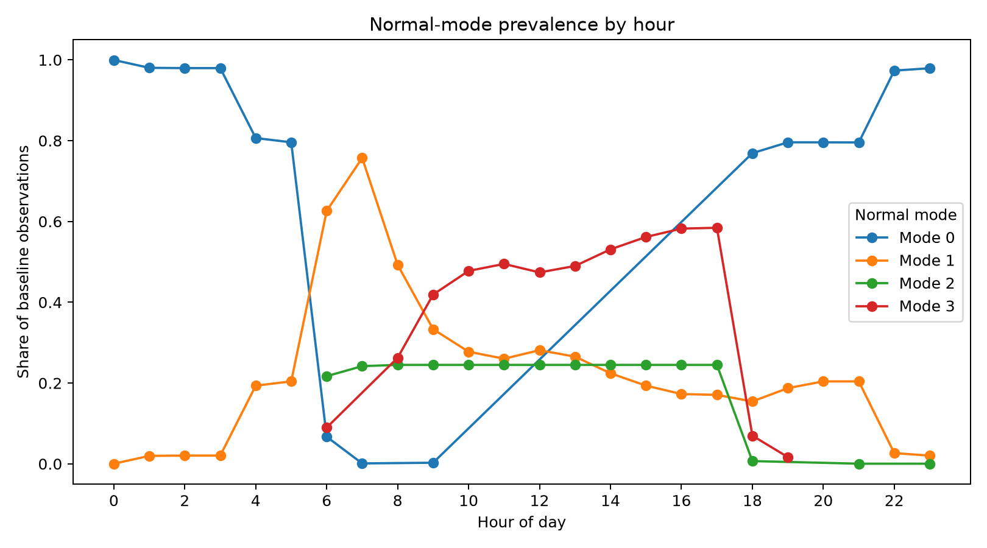
Figure 1. Hourly prevalence of the four normal-operation modes. Source: P01 normal_mode_by_hour.csv.
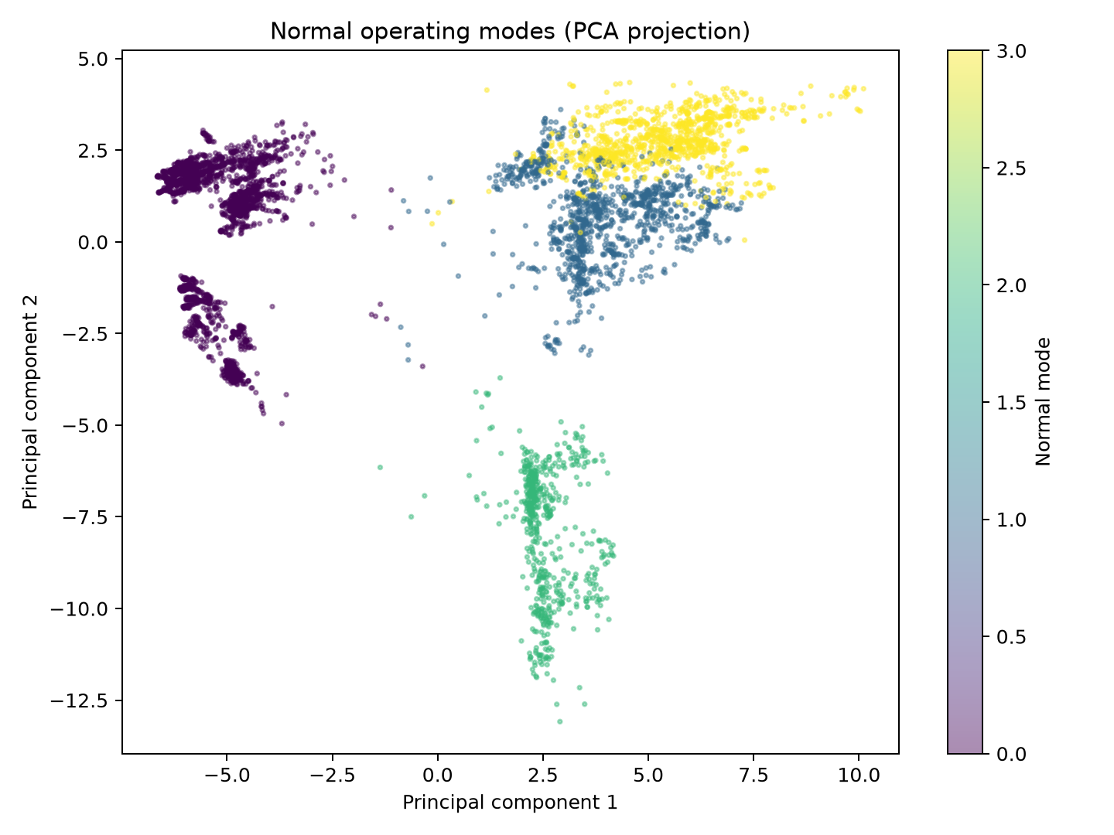
Figure 2. Principal-component projection of normal AHU observations. The first two components explain 55.93% of feature variance. Source: P01 saved outputs.
The analysis shows that normal operation changes with time and operating condition. A single global reference would ignore this variation and could classify legitimate changes in schedule or load as anomalies. The identified modes provide a useful reference for comparing an alert with similar normal operation. Engineering schedules and control records would be required before assigning fixed physical names to the clusters.

3.4 Detection and Diagnosis Methods and Justification
The detection experiments addressed a binary classification problem: normal operation versus a labelled fault session. D01 compared a multivariate statistical deviation baseline with Isolation Forest. The statistical method established whether simple deviations from training-normal behaviour were sufficient. Isolation Forest represented an unsupervised machine-learning approach that could be trained without fault examples.
D02 evaluated classical one-class methods under fault-family holdout. This design asked whether models trained without a particular fault family could identify it as abnormal. D03 used histogram gradient boosting as a supervised comparator. D07 used XGBoost with the symptom-only feature policy. XGBoost was selected because boosted decision trees can model nonlinear interactions in tabular data and because the method was specified in the project proposal (Chen and Guestrin, 2016). Its retention as the primary detector was based on the final comparison with D03 and the statistical baseline.
D06 and D08 evaluated seasonal generalisation. D06 applied the statistical and unsupervised methods, while D08 applied XGBoost. In each case, one season was held out for testing. This design examined whether models trained on the other two seasons could operate under different weather and loading conditions within the same facility.
Fault diagnosis was treated as a separate classification task. G01 used a flat classifier that predicted normal operation or one of the fine-grained fault types. G02 used a hierarchical design. Its first stage predicted normal operation or a broad subsystem group; its second stage predicted a specific fault type within the selected group. The G02 variants assessed baseline symptoms, physical relationships, safe context, and session balancing. G03a replaced the histogram classifier with XGBoost and used the instrumented-BMS feature policy.
Session balancing assigned training weights so that fault groups and sessions with many repeated minute rows did not dominate solely because they were more common. This intervention addressed representation during model fitting, although it could not compensate for the absence of independent fault sessions.
The O01 reliability policy was applied after diagnosis. It converted held-out minute-level predictions into one report for each fault session. A predicted group or type was displayed only when the corresponding label had at least five reports and at least 70% observed correctness in the held-out report set. Predictions that did not satisfy these requirements were reported as Uncertain. This was a practical reporting rule based on the available evidence, not a calibrated probability for future buildings.
O02 also operated after modelling. It grouped consecutive anomalous rows into events, attached an O01 diagnosis where available, and calculated a priority score from severity, duration, and equipment criticality. The mappings and weights were stored in configuration files so that their assumptions could be reviewed and modified without retraining a model.

4. Evaluation and Results

4.1 Evaluation Design and Metrics
The main detection evaluation used leave-one-scenario-out cross-validation. Each test fold contained the fault session for one scenario and its paired normal baseline. Training and validation observations were drawn from other complete scenarios. This produced 41 usable test folds for the principal detection comparisons. D02 used fault-family holdout, while D06 and D08 used three leave-one-season-out folds.
Diagnosis used complete-date holdout. This prevented observations recorded under the same date and environmental conditions from appearing in both training and test data. It also produced one independent session-level report for each held-out fault day when O01 was applied.
Model and threshold selection were confined to training and validation data. Test labels were used only for final evaluation. The saved run directories contain fold membership, validation selections, thresholds, predictions, and fold-level metrics. This structure supports reproducibility and reduces the risk of selecting a favourable result after inspecting the test fold.
All accepted experiments were completed without a smoke-test fold limit. The scenario-holdout detection studies contain 41 folds, the fault-family study contains 20 folds, the seasonal studies contain three folds, and each diagnosis study contains 40 complete date-holdout folds. The results in this section were taken from these completed runs and copied into the final evidence package.
Precision measured the proportion of flagged observations that were labelled faulty. Recall measured the proportion of labelled fault observations detected. F1 provided the harmonic mean of precision and recall. False-positive rate measured the proportion of normal observations incorrectly flagged. The reported false alarms per day are normal minute rows flagged per observed normal day; they are not equivalent to distinct staff notifications. Consecutive rows were grouped into events only in O02.
ROC-AUC and PR-AUC assessed ranking across thresholds where both classes were present. Event recall measured whether a labelled fault session contained at least one detected observation. Detection delay was calculated from the first labelled observation, not from an independently verified physical onset.
Diagnosis was evaluated using overall accuracy, macro F1, broad-group accuracy, broad-group macro F1, and fault-type accuracy. Macro F1 assigned equal importance to each evaluated class and was therefore essential in the presence of class imbalance. Overall accuracy was retained because it describes the proportion of correct row-level decisions, but it was not used alone to assess diagnostic reliability.
Means and medians were calculated across folds. Bootstrap intervals described variation among folds in this dataset. They did not represent uncertainty across a wider population of buildings; D08, for example, contained only three season folds from the same facility.

4.2 Normal Operating Patterns
P01 identified four recurring modes within the normal sessions. Their distribution varied systematically by hour, with the largest mode concentrated overnight and a broader mixture during occupied periods. The result supports the inclusion of operating context in exploratory analysis and demonstrates that normal operation cannot be represented adequately by a single constant state.
The moderate silhouette coefficient indicates that the clusters overlap. This is plausible for HVAC data because plant operation changes continuously with load, weather, and control action. The cluster assignments were therefore used as descriptive profiles rather than as fault labels or definitive control modes. The PCA figures also show that two components capture only part of the variation. The pattern results are useful for visual comparison and hypothesis generation, but anomaly detection was evaluated in the full selected feature space.

4.3 Anomaly Detection Results
Study and evaluation | Feature policy | Method | Folds | Mean F1 | Mean FPR | Flagged normal minutes per day
D01, scenario holdout | Symptoms | Statistical baseline | 41 | 0.9765 | 0.05049 | 72.71
D01, scenario holdout | Symptoms | Isolation Forest | 41 | 0.3832 | 0.08804 | 126.78
D02, fault-family holdout | Symptoms | Isolation Forest | 20 | 0.3434 | 0.10008 | 144.12
D02, fault-family holdout | Symptoms | One-class SVM | 20 | 0.9567 | 0.09183 | 132.23
D03, scenario holdout | Symptoms | Histogram gradient boosting | 41 | 0.9940 | 0.01237 | 17.82
D04a, scenario holdout | Controls, no weather | Statistical baseline | 41 | 0.9735 | 0.05673 | 81.69
D04a, scenario holdout | Controls, no weather | Isolation Forest | 41 | 0.5040 | 0.08295 | 119.45
D04b, scenario holdout | Controls and weather | Statistical baseline | 41 | 0.9734 | 0.05682 | 81.83
D04b, scenario holdout | Controls and weather | Isolation Forest | 41 | 0.4024 | 0.07563 | 108.90
D05, scenario holdout | Temporal features | Statistical baseline | 41 | 0.9677 | 0.06791 | 97.78
D05, scenario holdout | Temporal features | Isolation Forest | 41 | 0.4455 | 0.11630 | 167.48
D06, season holdout | Symptoms | Statistical baseline | 3 | 0.7993 | 0.54250 | 781.20
D06, season holdout | Symptoms | Isolation Forest | 3 | 0.4061 | 0.34082 | 490.78
D07, scenario holdout | Symptoms | XGBoost | 41 | 0.99998 | 0.0000339 | 0.049
D08, season holdout | Symptoms | XGBoost | 3 | 0.99998 | 0.0000386 | 0.056

Table 1. Complete mean fold-level detection results from the accepted final runs. False alarms are flagged normal minute rows rather than grouped incidents. D02 and the season-holdout studies use different test designs and should not be compared directly with the scenario-holdout results.
The statistical baseline performed strongly under scenario holdout. It achieved mean F1 of 0.9765 and detected the labelled fault observations, although it also flagged approximately 5.0% of normal observations. This shows that many controlled faults produced clear departures from their paired normal sessions and established a demanding benchmark for the machine-learning models.
Isolation Forest performed poorly in the same comparison. Its mean F1 was 0.3832, and it produced more flagged normal minutes per day than the statistical baseline. For this dataset and feature policy, its unsupervised outlier assumptions were less effective than the direct statistical comparison. The result also shows why a machine-learning method must be compared with a simple baseline rather than assumed to be better.
Histogram gradient boosting substantially reduced the false-positive burden while preserving high recall. D03 achieved mean F1 of 0.9940 and averaged 17.82 flagged normal minutes per test day. XGBoost improved this result further. D07 achieved mean precision of 0.999966, recall of 1.000000, and F1 of 0.999983. Its mean false-positive rate was 0.0000339, equivalent to approximately 0.049 flagged normal minutes per test day.
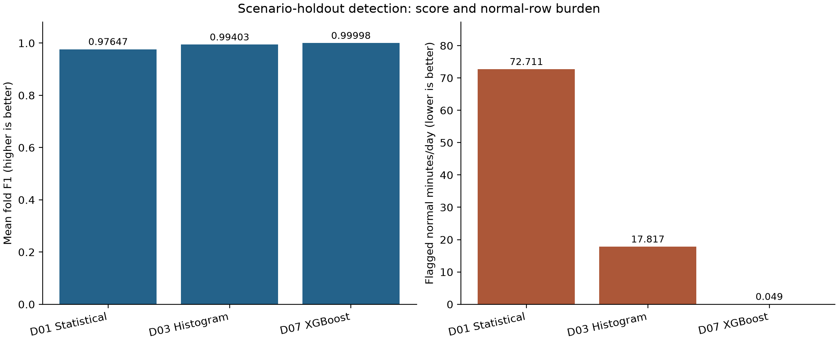
Figure 3. Scenario-holdout comparison of the statistical baseline, histogram gradient boosting, and XGBoost. The panels use separate units. Source: final D01, D03, and D07 summaries.
The completed feature-sensitivity runs did not show a consistent benefit from adding inputs to the classical detectors. Control features in D04a increased Isolation Forest F1 from 0.3832 to 0.5040 and reduced its flagged normal minutes from 126.78 to 119.45 per day. Adding weather in D04b reduced Isolation Forest F1 to 0.4024, although the false-positive burden fell to 108.90 minutes per day. Temporal features in D05 produced Isolation Forest F1 of 0.4455 and the highest scenario-holdout false-positive burden in the comparison, at 167.48 flagged normal minutes per day. The statistical baseline remained strong but declined from F1 of 0.9765 in D01 to 0.9735 in D04a, 0.9734 in D04b, and 0.9677 in D05. These results show that additional controls, weather, and rolling features changed model behaviour but did not improve the statistical baseline or produce a competitive unsupervised detector.
The seasonal results differed by method. In D06, the statistical baseline fell to mean F1 of 0.7993 and flagged 54.25% of normal observations. Isolation Forest remained weak. These results indicate substantial seasonal change in the distributions used by the classical detectors. D08 retained near-perfect XGBoost performance when one season was held out. This provides evidence of cross-season transfer within the same facility and fault protocol.
D08 confirms that XGBoost transferred across the three seasons represented in this facility. It is not yet an external-building test because the folds used the same installation, sensor system, and controlled experimental process. A production assessment must still include a different building, continuous normal operation, gradual degradation, maintenance interventions, novel faults, and sensor changes.
Event recall of 1.0 means that every labelled fault session contained a detection. The reported zero-minute delay means that the first labelled row was detected. Because the dataset does not record the verified physical onset time for each real session, this measure is reported as labelled-session delay rather than as proof of instantaneous real-world detection.

4.4 Fault Diagnosis Results
Study | Main change | Overall accuracy | Macro F1 | Broad-group accuracy | Broad-group macro F1 | Fault-type accuracy
G01 flat | Symptom features | 0.7180 | 0.2983 | — | — | —
G02a hierarchical | Symptom features | 0.7134 | 0.3184 | 0.7713 | 0.4268 | 0.4268
G02b hierarchical | Physical relationships | 0.7206 | 0.3303 | 0.7818 | 0.4433 | 0.4413
G02c hierarchical | Safe operating context | 0.6861 | 0.2965 | 0.7626 | 0.4254 | 0.3723
G02d hierarchical | Session-balanced training | 0.7008 | 0.3054 | 0.7793 | 0.4480 | 0.4017
G03a hierarchical XGBoost | Instrumented-BMS inputs | 0.7163 | 0.3087 | 0.7761 | 0.4426 | 0.4326

Table 2. Mean results over 40 complete date-holdout folds. G01 uses a flat label structure, whereas G02 and G03a report hierarchical group and type metrics.
Diagnosis performance was substantially lower than binary detection performance. G01 reached overall accuracy of 0.7180, but its macro F1 was 0.2983. The difference shows that correct predictions were concentrated in the better-represented or easier classes and that the flat classifier did not perform consistently across all fault types.
The hierarchical design improved interpretability by separating subsystem identification from exact fault classification. G02b produced the strongest overall set of metrics, including broad-group accuracy of 0.7818 and fault-type accuracy of 0.4413. Its macro F1 of 0.3303 remained low. Physical relationships provided a modest improvement over the symptom-only hierarchical baseline, but they did not resolve ambiguity among related faults.
Safe operating context in G02c reduced most headline metrics. Session balancing in G02d increased broad-group macro F1 to 0.4480, the highest value in the hierarchical comparison, but reduced overall and fault-type accuracy relative to G02b. This represents the expected trade-off between performance on dominant classes and more equal treatment of the available groups.
G03a tested whether XGBoost and the full instrumented-BMS feature set would improve diagnosis. Its overall accuracy of 0.7163 and fault-type accuracy of 0.4326 were comparable with the histogram-based hierarchical models. The additional BMS variables did not overcome the limited number of independent sessions or the similar physical responses produced by several faults. G02b therefore remained the strongest overall diagnostic experiment.
The O01 reporting policy reduced the number of precise diagnoses shown to staff. Among 40 fault-session reports, a fault group was shown in 17 cases and an exact type in 10 cases. The group was reported as Uncertain in 23 cases, and the type was Uncertain in 30 cases. Fourteen displayed groups were correct, giving 82.4% observed correctness among displayed groups. Eight displayed types were correct, giving 80.0% observed correctness among displayed types.
Both incorrect displayed types were predicted as cooling-coil-valve faults: one was a heating-coil-valve-leak session and the other was an outdoor-air-damper-stuck session. The example shows that a label can meet the 70% historical rule and still be wrong for an individual event. The reliability gate reduces unsupported detail, but it does not replace engineering review.

5. Deliverables and Operational Considerations

5.1 Delivered System and Reproducibility
The primary technical deliverable is a Python package with a command-line interface. Building definitions and experiment settings are stored in YAML files. Separate commands audit the source data, generate normal-pattern artefacts, train detection and diagnosis models, group events, apply reliability rules, and calculate priority scores.
Each completed model run preserves the resolved configuration, dataset manifest, selected feature list, software environment, fold membership, validation selection, thresholds, predictions, and metrics. This record permits a reviewer to reproduce the result and to examine the relationship between the data split, feature policy, and reported score. The implementation also includes automated tests for key preparation, modelling, and reporting behaviour.
Four notebooks organise the research outputs into normal-pattern analysis, detection experiments, diagnosis experiments, and operational outputs. They use the package and saved artefacts rather than maintaining independent modelling code. This arrangement reduces the risk that notebook results diverge from the tested implementation.
The repository does not include the raw dataset or every large model artefact. A new user must obtain the public data and place it in the documented directory. The final evidence package was generated from the accepted P01, D01–D08, G01–G03a, O01, and O02 outputs. It contains the resolved configurations, manifests, metrics, diagnosis evidence, operational policies, and report figures required to review the findings without adding every run directory to version control. Before submission, the team must still test installation, data placement, and notebook execution from a clean clone.
The final deliverable is a reproducible offline analysis and reporting system. It provides a complete research workflow but does not claim to be a deployed monitoring service or production maintenance application.

5.2 Operational Outputs and Staff Use
The operational reporting design distinguishes three questions: whether an anomaly was detected, whether its fault group can be identified, and whether an exact fault type can be stated. A report can therefore contain the following fields:
- Status: Normal or Anomaly detected;
- Fault group: a named subsystem or Uncertain;
- Fault type: a named type or Uncertain;
- observed event start, end, and alert duration;
- relevant supporting signals;
- priority score, band, and recommended response.
This structure keeps fault detection and fault diagnosis separate. Normal means that the detector did not issue an alert under the selected threshold. Anomaly detected indicates abnormal behaviour, while Uncertain allows the system to withhold a fault group or type that is not sufficiently supported.
O02 grouped the D07 predictions into 49 fault events. The priority score was calculated as:
100 × [0.50 × (severity − 1)/4 + 0.30 × (duration − 1)/4 + 0.20 × (criticality − 1)/4].
Scores below 40 were classified as Low, scores from 40 to 59.9 as Medium, scores from 60 to 79.9 as High, and scores of at least 80 as Critical. The policy assigned 50% of the weight to severity, 30% to duration, and 20% to equipment criticality. Severity mappings were defined by fault group and type. The example AHU criticality was set to 3 out of 5 as a project assumption because no client asset register was available.
All 49 detected events were assigned to the High band. Each event spanned the complete 1,440-minute labelled fault session, giving it the maximum duration level. Seventeen events also had a displayed diagnosis from O01. This confirms that detection, diagnosis, event grouping, and priority calculation operate together. However, the result cannot test whether the policy would rank live faults correctly because the dataset represents every fault session as a full day.
The priority layer is best presented through audited example cards and a clear explanation of the calculation. Operational validation will require client-approved severity definitions, an asset criticality register, independently timed incidents, and comparison with actual work-order priorities and outcomes.

5.3 Ethical, Legal, Cultural, and Accessibility Considerations
The research dataset contains equipment telemetry rather than employee identifiers or access-control records, so privacy exposure is limited in the present study. A live deployment would require additional controls because occupancy schedules, zone-level behaviour, location-linked records, or combined access logs may allow inferences about individuals. Smart Facilities SA should define the purpose of collection, limit access and retention, provide appropriate notice, and review the Australian Privacy Principles and relevant workplace arrangements (OAIC, Australian Privacy Principles; OAIC, personal information guidance; Fair Work Ombudsman, workplace privacy).
Detection and diagnosis errors can affect staff and building occupants. False positives may create unnecessary inspections and alarm fatigue, while false negatives can delay maintenance. An incorrect fault label may also direct staff to the wrong component. The reporting design addresses these risks by keeping a human reviewer in the process, separating detection from diagnosis, and displaying uncertainty. A production system should record overrides, investigation outcomes, and maintenance actions so that performance can be monitored after deployment. The NIST AI Risk Management Framework provides a useful structure for this governance process (NIST, 2023).
Accessibility is necessary for safe operational communication. Status must not be communicated through colour alone. Figures and alerts require text labels, units, sufficient contrast, and a logical reading order. The proposed output uses explicit Normal, Anomaly detected, and Uncertain values. Figures in the report include alternative text and explanatory captions. Any future interface should be evaluated for keyboard access, screen-reader compatibility, contrast, scalable text, and comprehension in accordance with WCAG 2.2 (W3C, WCAG 2.2).
Cultural considerations affect how operational priorities are defined and how alerts influence staff and occupants. A severity policy designed without the technicians who respond to alarms may not reflect local working practices or occupant needs. Consultation should therefore include facilities staff, shift teams, and affected building users. Model outputs should not be repurposed as hidden measures of employee performance. Where facilities serve Aboriginal and Torres Strait Islander communities or manage data that affects those communities, the organisation should establish appropriate consultation and data-governance arrangements.
Licensing also affects the handover. The dataset record specifies a CC BY 4.0 licence, which requires attribution. Software dependencies have separate terms; XGBoost is distributed under Apache 2.0 and scikit-learn under BSD-3-Clause. The repository should retain attribution, dependency information, and applicable licence notices. Commercial hosting or integration may introduce additional contractual and licensing obligations.

6. Discussion, Reflection, and Recommendations

6.1 Interpretation, Utility, and Limitations
The main result is that symptom-only XGBoost distinguished the controlled fault sessions from their paired normal sessions with extremely high accuracy. It also retained this performance when each season was held out within the same facility. Compared with the statistical baseline, its clearest improvement was the reduction in flagged normal minutes.
The result must be interpreted within the dataset design. The faults were deliberately imposed, all sessions came from one facility, and complete days were labelled as faulted or normal. The evaluation shows strong scenario and seasonal generalisation within this source. It does not yet show how the model will perform in a different building or in a continuous stream containing gradual degradation, maintenance interventions, unseen faults, and sensor changes.
Isolation Forest produced an important negative result. It was less effective than both the supervised models and the statistical baseline, confirming the value of simple comparators and the advantage of using fault labels when reliable labels are available.
Diagnosis remained the main technical limitation. Broad subsystem classification was more successful than exact fault classification, but macro F1 remained below 0.45. Neither additional context, session balancing, nor the full instrumented-BMS feature set produced a decisive improvement. The likely constraints are limited independent sessions, class imbalance, overlapping physical effects, and the absence of stronger command-versus-feedback relationships for some actuators.
The reliability gate provided a practical response to this limitation. It withheld the fault group or type when the available results did not support a reliable label, and the diagnoses that remained visible were correct in approximately 80% of held-out reports. The rule should be recalibrated on independent building data before operational use.
The priority layer demonstrates how severity, duration, and equipment criticality can be combined through a transparent and configurable policy. Its ranking was not validated because every labelled fault lasted a full session and the client did not provide an asset-criticality register. These inputs must be confirmed before the score is used to prioritise real work orders.

6.2 Reflection on Decisions and the Original Proposal
The original proposal emphasised breadth through two HVAC categories, four model families, and a dashboard. During implementation, the project shifted towards a deeper study of one real AHU dataset. This improved the comparability of experiments and allowed more detailed work on leakage, seasonality, feature provenance, diagnosis, and uncertainty. The trade-off was that the chiller-plant analysis and LSTM autoencoder were not delivered.
Retaining the statistical baseline strengthened the project because it showed that the controlled task was already suitable for relatively simple detection. The supervised models were therefore required to demonstrate a clear improvement rather than receiving credit for complexity alone. XGBoost was selected as the main detector because it produced the strongest result and reduced false positives under the same scenario-holdout design.
Separating diagnosis from detection was another important decision. The near-perfect anomaly detector could identify abnormal operation, but it could not identify every fault type reliably. The hierarchical experiments measured this difference, while O01 converted it into a clear reporting policy. This produced a more honest and useful staff output than forcing an exact diagnosis for every alert.
The dashboard was removed because no live data source was available and the client representative did not require a historical replay. The four notebooks, saved artefacts, generated figures, and sample reports provide a clearer representation of the completed research and can be reviewed without suggesting that the system has already been deployed.
The concentration of implementation in one person improved technical consistency but also created a knowledge and continuity risk. Future projects should begin with a smaller set of evaluation questions, maintain dated decision and effort records, and assign active review responsibilities throughout the implementation period.

6.3 Lessons Learned and Future Development
The first methodological lesson was the importance of the evaluation unit. Randomly splitting minute rows would have produced an optimistic result because neighbouring observations from the same session are highly related. Holding out complete dates, scenarios, fault families, and seasons produced a more credible test. The next improvement should be an external-building evaluation rather than another random split of the same dataset.
The second lesson concerned feature provenance. A measured actuator position may be a legitimate operational input and may improve diagnosis. In a controlled experiment, the same variable may also reflect part of the imposed condition. Every feature must therefore be justified according to how it would be produced and obtained at prediction time.
The third lesson concerned uncertainty. Requiring an exact fault label for every anomaly creates unjustified precision. A report that states Anomaly detected and records the diagnosis as Uncertain can still guide investigation. A fault group or type should only be displayed when independent evidence shows that the label is sufficiently reliable.
Future development should begin with continuous data from a target building linked to maintenance records. Fault onset should be recorded independently of the model, and the sensor map should document units, sampling rates, commands, feedback signals, replacements, and missing periods. The existing D07 model and threshold should be fixed before external testing so that the result represents a genuine test rather than further model development.
The external study should report alert events during normal operation, verified fault recall, delay from confirmed onset, investigations per week, and staff assessment of usefulness. The statistical baseline should remain in the comparison. Diagnosis should be recalibrated using independent events, with separate evidence for broad groups and exact types.
Additional model development may be justified after the external dataset is available. A temporal model such as an LSTM autoencoder could be compared under the same fixed holdout protocol if sequence length and computing requirements are appropriate. Its inclusion should be driven by a temporal research question and measured improvement, rather than by the presence of the method in the original proposal.

6.4 Recommendations for Smart Facilities SA
Smart Facilities SA should treat the completed package as an offline feasibility study and reproducible research handover. Production integration should not proceed directly from the controlled-dataset results.
The next stage should be a shadow-mode pilot on one mapped AHU. The model should process live or newly collected data without generating automatic work orders. Facilities staff should review alerts alongside plant trends, known operating schedules, and maintenance observations. Pilot acceptance criteria should be established before results are examined and should include maximum investigation burden, minimum recall for verified important faults, and acceptable delay from confirmed onset.
The pilot should retain both XGBoost and the statistical baseline. Performance should be monitored across seasons, maintenance changes, occupancy regimes, and sensor interruptions. Any retraining or threshold change should be versioned and evaluated on data that was not used to make the change.
Diagnostic outputs should continue to distinguish the anomaly status, fault group, and fault type. A category should be displayed only after independent calibration supports the required reliability. Uncertain should remain an acceptable operational outcome. Engineers should review incorrect diagnoses to determine whether the cause is insufficient data, missing BMS signals, ambiguous fault behaviour, or unsuitable taxonomy.
The priority policy should be revised with facilities personnel before it influences work orders. Smart Facilities SA should provide an asset register, equipment criticality ratings, existing response categories, and examples of completed work orders. Severity and duration weights should then be tested against actual operational decisions. Privacy, accessibility, staff consultation, licensing, cybersecurity, retention, and accountability requirements should be included in the pilot plan.

References
- Chandola, V., Banerjee, A. and Kumar, V. (2009). ‘Anomaly detection: A survey’. ACM Computing Surveys, 41(3), Article 15. DOI.
- Chapman, P. et al. (2000). CRISP-DM 1.0: Step-by-step data mining guide. Primary guide.
- Chen, T. and Guestrin, C. (2016). ‘XGBoost: A scalable tree boosting system’. Proceedings of KDD 2016. DOI.
- Ghalamsiah, M. et al. (2026). ‘Labeled datasets for air handling units operating in faulted and fault-free states’. Scientific Data. DOI; dataset and licence.
- National Institute of Standards and Technology (2023). Artificial Intelligence Risk Management Framework AI RMF 1.0. Official publication.
- Office of the Australian Information Commissioner (n.d.). Australian Privacy Principles; What is personal information?.
- Fair Work Ombudsman (n.d.). Workplace privacy best practice guide.
- World Wide Web Consortium (2024). Web Content Accessibility Guidelines WCAG 2.2.
- Group C262F-B106-D01 (2026). Artificial Intelligence for Smart-Building Log Analysis. Project proposal dated 28 August 2026.
- Project evidence: final P01, D01–D08, G01–G03a, O01, and O02 run artefacts; results/manifests/rbc_real_manifest_final.json; configs/operational_policies; and docs/evaluation_protocol.md.

Submission Verification Checklist
- Confirm actual contributions, hours, direct expenditure, milestone dates, meetings, and scope decisions with all team members.
- Inspect the generated results/final_evidence package and include it in the repository submission.
- Execute the installation instructions and all four notebooks from a clean clone.
- Replace local run references with stable repository links where required by the submission format.
- Verify every reported number and figure against the final evidence package, confirm the final word count, and remove this checklist before submission.

