**CHAPTER 1**

**INTRODUCTION**

The rapid evolution of the digital era has transformed the way individuals connect and share information. Traditional social media platforms, while ubiquitous, often grapple with challenges related to centralized control, data privacy, and content censorship. In response to these concerns, the "Decentralized Social Media Web Application" emerges as a groundbreaking project poised to redefine the social networking paradigm. By integrating innovative technologies such as Next.js, Solidity, MongoDB, and IPFS, this platform seeks to establish a secure, transparent, and user-centric alternative to conventional social media platforms. At its core, the project embraces decentralization as a fundamental principle, leveraging the Ethereum blockchain for smart contract execution. The use of Solidity, a robust and secure programming language, empowers the platform to execute critical functions like user authentication and secure post interactions in a trustless and transparent manner. Complementing this, Next.js, a versatile React framework, facilitates the development of a dynamic and intuitive frontend, ensuring a seamless user experience.

In addition to its blockchain foundation, the project adopts IPFS (InterPlanetary File System) for decentralized storage, addressing concerns related to content censorship and data ownership. Users can securely store and share multimedia content, fostering a resilient and tamper-resistant environment. The Decentralized Social Media Web Application, therefore, stands as a testament to the potential of decentralized technologies in reshaping the digital landscape, promising a future where users have greater control over their data and interactions in the online social sphere.

**1.1 MOTIVATION**

The motivation behind the "Decentralized Social Media Web Application" project stems from a profound commitment to addressing the inherent shortcomings of centralized social media platforms. Traditional platforms often raise concerns related to data privacy, censorship, and the concentration of control in the hands of a few entities. As digital connectivity becomes an integral part of our daily lives, it is imperative to foster an environment where users have greater autonomy and ownership over their data. This project seeks to empower users with a decentralized alternative, leveraging blockchain technology to ensure transparent and secure interactions while mitigating the risks associated with centralized control. Furthermore, the project is driven by a vision to create a more resilient and censorship-resistant social networking experience. By embracing technologies like Solidity for Ethereum smart contracts and IPFS for decentralized storage, the platform aims to establish a new standard for user-centric social media. This motivation is rooted in the belief that decentralized technologies can not only provide enhanced security but also redefine the dynamics of online communication, fostering a community where users are in control of their digital identities and content dissemination.

**1.2 PROBLEM STATEMENT**

In the current landscape of social media, centralized platforms have given rise to significant concerns regarding user data privacy, content censorship, and the concentration of control in the hands of a select few. The constant threat of data breaches, the risk of arbitrary content removal, and the lack of user control over personal information have eroded trust in these platforms. The "Decentralized Social Media Web Application" project addresses these issues by recognizing the pressing need for a more secure, transparent, and user-centric social media experience. The project seeks to mitigate the vulnerabilities associated with centralized architectures, offering a decentralized alternative that empowers users with greater control over their data and interactions.

**1.3 OBJECTIVE**

The primary objective of the project is to design and implement a decentralized social media web application that leverages cutting-edge technologies to enhance user privacy, eliminate single points of failure, and create a censorship-resistant environment. Through the integration of Next.js for the frontend, Solidity for Ethereum smart contracts, MongoDB for user data storage, and IPFS for decentralized file storage, the project aims to provide users with a seamless and secure platform for social interactions. Key objectives include the implementation of secure user authentication, robust profile management, and the utilization of smart contracts for trust less interactions. By achieving these objectives, the project aspires to set a new standard for decentralized social media, fostering a community where users have the utmost control over their digital identities and content.

**1.4 SUMMARY**

The "Decentralized Social Media Web Application" project aims to revolutionize the social media landscape by addressing the shortcomings of centralized platforms. Through a decentralized architecture built on Next.js, Solidity, MongoDB, and IPFS, the project endeavours to provide users with enhanced privacy, data ownership, and content distribution capabilities. The objectives include the development of a secure and intuitive frontend, the integration of Ethereum smart contracts for trustless interactions, and the use of IPFS for decentralized storage. The ultimate goal is to create a resilient and censorship-resistant social media platform, reshaping the way users engage and share in the digital sphere.

**CHAPTER 2**

**PROBLEM FORMULATION AND PROPOSED WORK**

In addressing the challenges prevalent in traditional Web2 social media platforms, our decentralized social media web application aims to tackle key issues related to user privacy, content moderation, and centralized control. The following sections articulate the problem formulation and present our proposed work to revolutionize the social media landscape**.**

**2.1 PROBLEM DEFINITION**

In the contemporary digital landscape, the pervasive use of centralized social media platforms has given rise to a myriad of challenges that impede user trust, autonomy, and privacy. The overarching problem lies in the concentration of control within these platforms, leading to concerns related to data privacy risks, arbitrary content censorship, and the lack of user control over personal information. As users increasingly seek a more secure, transparent, and decentralized alternative to traditional social media, the "Decentralized Social Media Web Application" project emerges as a response to these critical issues, aiming to redefine the norms of social networking by leveraging innovative technologies and mitigating the inherent shortcomings of centralized architectures.

**2.1.1 Centralized Control**

Traditional social media platforms are characterized by centralized control, leading to concerns over user data ownership, privacy, and potential misuse of power by platform administrators.

**2.1.2 Data Privacy Risks**

Users face constant threats to their data privacy, with centralized platforms being susceptible to data breaches and unauthorized access, raising serious concerns about the security of personal information.

**2.1.3 Content Censorship**

Centralized platforms often exercise arbitrary control over content, resulting in censorship, removal of posts, and limitations on free expression. This diminishes user autonomy and fosters an environment of restricted communication.

**2.1.4** **Single Points of Failure**

Centralized architectures create single points of failure, making platforms vulnerable to hacking, service outages, and other technical issues that can disrupt user experiences and compromise the integrity of the platform.

**2.1.5 Lack of User Control**

Users typically have limited control over their digital identities, and the data they generate within centralized social media ecosystems. This lack of control can erode trust and hinder the user's ability to manage their online presence.

**2.1.6 Security Concerns**

Traditional platforms often rely on conventional security measures that may not be robust enough to withstand evolving cybersecurity threats, exposing users to potential risks such as account hijacking and unauthorized access.

**2.1.7 Need for Resilience**

With increasing instances of data breaches and content manipulation, there is a growing need for a more resilient social media infrastructure that ensures secure and transparent interactions among users.

**2.1.8 Privacy Invasion**

Users often experience privacy invasion through data tracking, targeted advertisements, and the sale of personal information to third parties, contributing to a growing discontent with centralized social media platforms.

**2.1.9 Monopolization of User Data**

Centralized platforms tend to monopolize user data for commercial purposes, limiting user control over how their data is used and potentially exploiting it for financial gain without adequate user consent.

**2.1.10 Lack of Transparency**

The lack of transparency in the algorithms and decision-making processes of centralized platforms contributes to a sense of distrust among users, who often feel uninformed about how their data is managed and how content moderation decisions are made.

**2.2 PROPOSED WORK**

The "Decentralized Social Media Web Application" project envisions a comprehensive solution to the challenges posed by traditional centralized social media platforms. The proposed work encompasses the design and development of a decentralized ecosystem, utilizing a robust technology stack to enhance user privacy, data ownership, and overall security. The key components of the proposed work include:

**2.2.1 Decentralized Architecture**

Establishing a decentralized architecture leveraging Next.js for the frontend, Solidity for Ethereum smart contracts, MongoDB for user data storage, and IPFS for decentralized file storage. This architecture aims to distribute control, eliminating single points of failure and enhancing the platform's resilience.

**2.2.2 User-Centric Features**

Implementing user-centric features such as secure user authentication, profile management, and the creation and editing of posts. These features prioritize user control over their digital identities, fostering a sense of ownership and autonomy within the decentralized social media experience.

**2.2.3 Blockchain Integration**

Integrating Ethereum smart contracts coded in Solidity to facilitate trustless interactions among users. This includes functionalities such as secure user authentication, post management, and other critical aspects governed by transparent and immutable smart contract executions.

**2.2.4 IPFS for Decentralized Storage**

Leveraging IPFS for decentralized storage of multimedia content, ensuring tamper-resistant and censorship-resistant file storage. This integration enhances the platform's capacity to securely store and share content while mitigating the risks associated with centralized control over data distribution.

**2.2.5 User-Friendly Frontend**

Developing an intuitive frontend using Next.js to provide users with a seamless and engaging experience. The frontend will enable users to perform standard social media activities, including liking, sharing, and commenting on posts, fostering a familiar and user-friendly environment.

**2.2.6 Security Measures**

Implementing robust security measures to safeguard user data and interactions. This includes encryption protocols, secure authentication methods, and measures to protect against potential cyber threats, ensuring the highest standards of security for users of the decentralized social media platform.

**2.2.7 Testing and Optimization**

Conducting thorough testing throughout the development process to identify and address potential vulnerabilities or performance issues. Optimization efforts will focus on ensuring the platform's efficiency, responsiveness, and overall user satisfaction.

Through these proposed initiatives, the project seeks to not only address the existing problems associated with centralized social media but also contribute to the broader conversation surrounding decentralized technologies and user-centric digital experiences.

**CHAPTER 3**

**LITERATURE SURVEY**

The literature survey for the "Decentralized Social Media Web Application" project delves into existing research and developments related to decentralized social networking, blockchain technology, and decentralized storage systems. Researchers have extensively explored the potential of blockchain in addressing issues of trust, security, and transparency in various applications, including social media. Studies highlight the advantages of utilizing smart contracts to enable secure and verifiable interactions among users, thereby reducing the reliance on centralized authorities. Moreover, the literature emphasizes the role of decentralized storage solutions, such as IPFS, in mitigating the challenges associated with content censorship and data ownership. Research in this domain emphasizes the importance of tamper-resistant, distributed file storage systems for fostering a more resilient and censorship-resistant infrastructure. Several studies have investigated the practical implementation and performance of IPFS in different scenarios, offering insights into its strengths and potential challenges.

Additionally, a significant portion of the literature survey focuses on frameworks for developing decentralized applications (DApps), with Next.js emerging as a popular choice for building user-friendly and dynamic frontends. Comparative analyses of various frontend technologies shed light on the advantages and limitations of Next.js in the context of decentralized social media applications. This literature survey serves as a foundation for the design and implementation decisions in the project, drawing on existing knowledge to inform the development of a robust and innovative decentralized social media platform.

**3.1 METHODOLOGIES**

**3.1.1 Requirements Analysis**

Conducting a thorough requirements analysis to identify the functional and non-functional aspects of the decentralized social media platform. This involves understanding user needs, system capabilities, and potential challenges, laying the groundwork for a comprehensive project plan.

**3.1.2 Literature Review**

Engaging in an extensive literature review to explore existing research and developments related to decentralized social media, blockchain technology, and decentralized storage solutions. This step informs the project with insights, best practices, and potential challenges faced by similar endeavours.

**3.1.3 Technology Selection**

Carefully selecting the technology stack based on the project requirements and literature review findings. This involves choosing Next.js for the frontend, Solidity for Ethereum smart contracts, MongoDB for user data storage, and IPFS for decentralized file storage, ensuring a cohesive and effective combination of tools.

**3.1.4 Architecture Design**

Developing a detailed architectural design for the decentralized social media platform, outlining the interactions between different components. This involves creating system diagrams, flowcharts, and other visual representations to ensure a clear understanding of the platform's structure and functionality.

**3.1.5 Prototyping**

Creating prototypes to visualize and validate key features of the platform. Prototyping allows for early feedback and iterative development, ensuring that user interfaces and interactions align with the project's goals and user expectations.

**3.1.6 Agile Development**

Adopting an Agile development methodology to facilitate incremental and iterative development. This involves breaking down the project into smaller, manageable tasks or sprints, allowing for continuous improvement and adaptation to evolving requirements.

**3.1.7 Smart Contract Development**

Implementing Ethereum smart contracts using Solidity to govern critical functionalities such as user authentication, post management, and interactions. This involves coding secure and efficient smart contracts, conducting thorough testing, and ensuring adherence to best practices in blockchain development.

**3.1.8 Frontend Development**

Utilizing Next.js to develop an intuitive and user-friendly frontend. This involves implementing features like secure user authentication, profile management, and interactive post functionalities. Continuous testing and feedback collection during this phase contribute to a responsive and engaging user interface.

**3.1.9 Integration Testing**

Performing integration testing to ensure seamless interactions between different components of the platform. This involves testing the interoperability of the frontend, smart contracts, and backend functionalities to identify and resolve any integration issues.

**3.1.10 Security Measures Implementation**

Incorporating robust security measures throughout the development process, including encryption, secure authentication, and protection against common cybersecurity threats. This ensures the confidentiality and integrity of user data and interactions.

**3.1.11 User Testing**

Conducting user testing to gather feedback on the platform's usability and overall user experience. This iterative process involves refining features based on user input, ensuring the final product aligns with user expectations and preferences.

**3.1.12 Optimization**

Optimizing the platform for performance, scalability, and efficiency. This involves addressing bottlenecks, improving response times, and enhancing overall system reliability to deliver a seamless user experience.

**3.1.13 Continuous Improvement**

Embracing a philosophy of continuous improvement throughout the project's lifecycle. This involves incorporating feedback, addressing issues, and adapting to emerging technologies or user needs to ensure the platform remains innovative and effective.

**CHAPTER 4**

**DATA MODELING**

**Entity-Relationship**

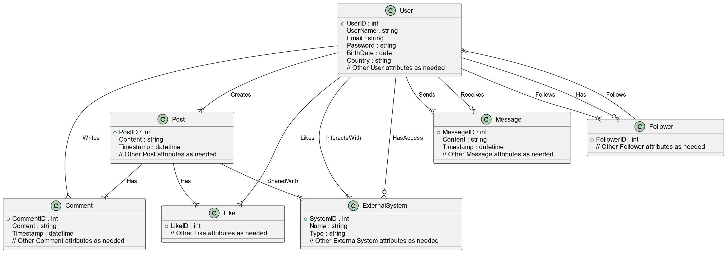

**Fig. 4.1 ER Diagram**

**Data Flow within the web application**

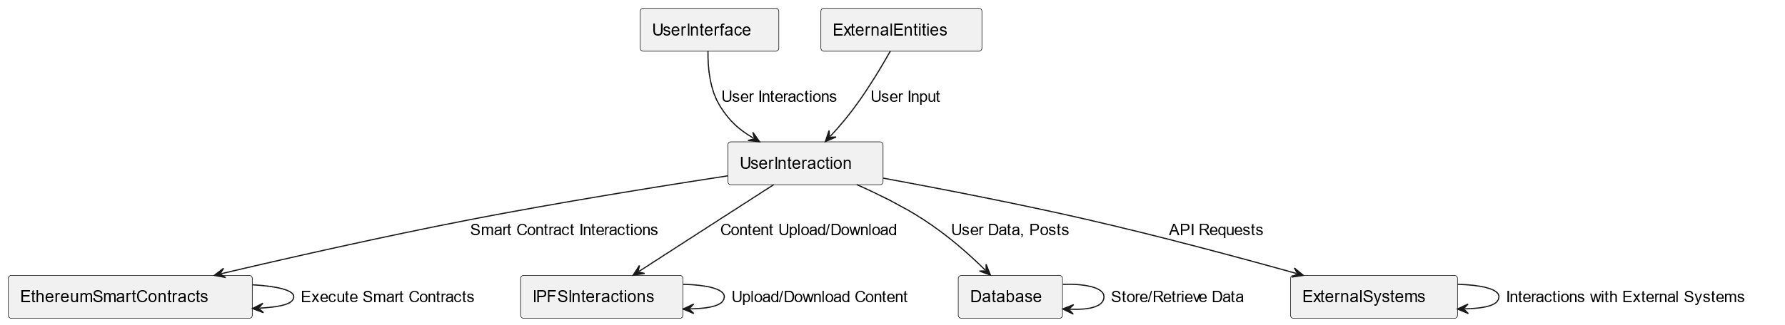

**Fig. 4.2 DFD Level 0**

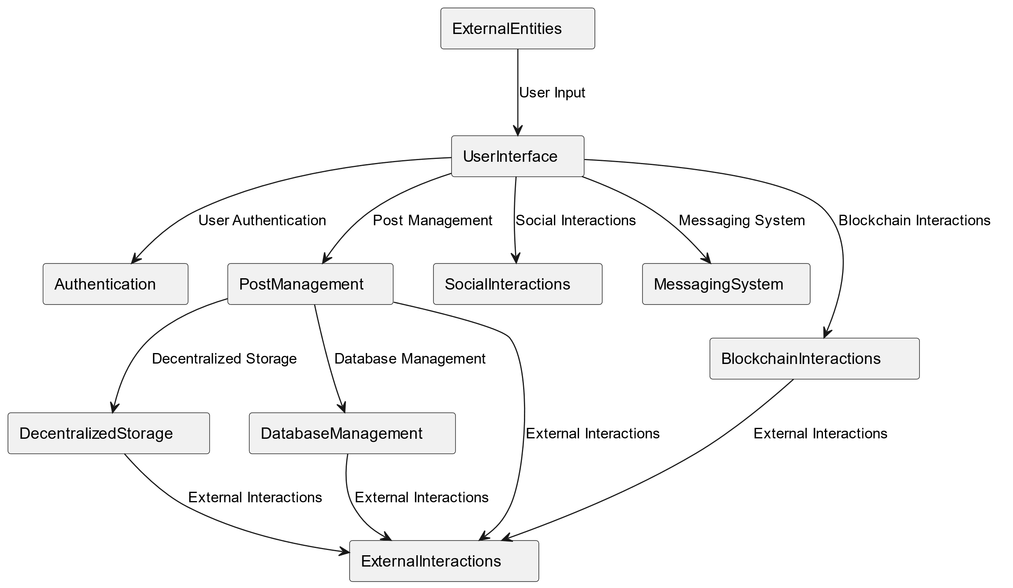

**Fig. 4.3 DFD level 1**

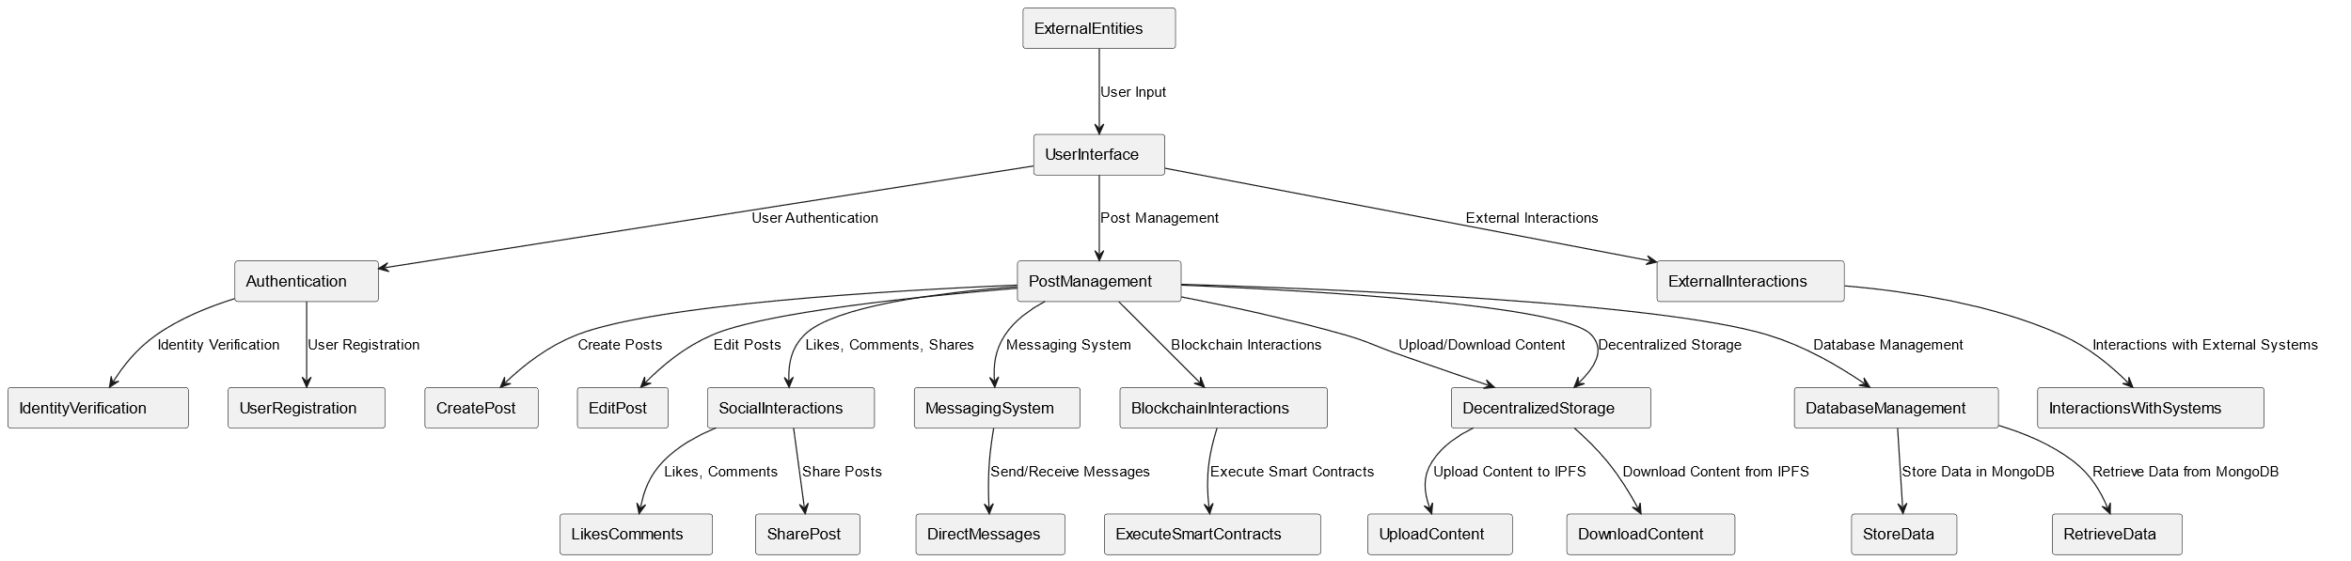

**Fig. 4.4 DFD level 2**

**CHAPTER 4**

**SYSTEM REQUIREMENTS**

The success of the "Decentralized Social Media Web Application" hinges on a comprehensive understanding and specification of the system requirements that will govern its development. System requirements serve as the blueprint for the entire project, delineating the functionalities, performance expectations, and constraints that will shape the decentralized social media platform. This section elucidates the pivotal role that these requirements play in guiding the development process, ensuring the alignment of the final product with user needs, technical specifications, and the overarching goals of establishing a resilient and user-centric decentralized social networking experience. The subsequent discussion will delve into the specific categories of system requirements, encompassing functional, non-functional, and technical considerations that collectively define the blueprint for the project's successful realization.

**4.1 HARDWARE REQUIREMENTS**

The efficient functioning of the "Decentralized Social Media Web Application" necessitates a robust hardware infrastructure that supports the various components of the system. The hardware requirements outlined below ensure optimal performance, scalability, and responsiveness, enabling users to engage seamlessly with the decentralized social media platform:

**4.1.1 Server Infrastructure**

* **Processor**- Multi-core processors (e.g., Intel Core i5 or AMD Ryzen) to handle concurrent user requests efficiently.
* **RAM**- A minimum of 8 GB RAM to support concurrent user sessions and provide smooth operation.
* **Storage**- SSD storage for faster data retrieval and improved overall system responsiveness.

**4.1.2 Blockchain Node**

* **Processor**- A capable processor (e.g., Intel Core i7 or equivalent) to handle Ethereum blockchain node operations.
* **RAM**- At least 16 GB RAM to ensure optimal performance during smart contract interactions and Ethereum network synchronization.
* **Storage**- SSD storage with sufficient capacity to store the Ethereum blockchain data.

**4.1.3 Database Server**

* **Processor**- Multi-core processor for efficient database operations.
* **RAM**- Adequate RAM (8 GB or more) to support database queries and data retrieval.
* **Storage**- Depending on the scale of the application, use SSD storage for faster database read and write operations.

**4.1.4 IPFS Node**

* **Processor**- A mid-range processor to handle IPFS node operations.
* **RAM**- Sufficient RAM (8 GB or more) to support the IPFS network interactions and decentralized storage operations.
* **Storage**- SSD storage with ample capacity for storing and retrieving decentralized file storage on IPFS.

**4.1.5 Networking**

* **Network Bandwidth**- High-speed internet connection to ensure low latency and quick data transfer between components.

**4.2 SOFTWARE REQUIREMENTS**

The "Decentralized Social Media Web Application" relies on a carefully selected set of software components to ensure seamless integration, security, and efficient operation. These software requirements encompass a range of technologies that collectively contribute to the development, deployment, and maintenance of the decentralized social media platform:

**4.2.1 Operating System:**

* **Server Side-** Linux-based operating systems such as Ubuntu Server or CentOS are preferred for their stability, security features, and compatibility with the chosen technology stack.
* **Client Side-** Platform-agnostic, supporting major web browsers including Google Chrome, Mozilla Firefox, Safari, and Microsoft Edge.

**4.2.2 Web Server**

* **Node.js**- Required for running the Next.js server on the backend, facilitating server-side rendering and providing a foundation for scalable and performant web applications.
* **Nginx or Apache-** Used as a reverse proxy to efficiently handle incoming HTTP requests and distribute them to the appropriate backend services.

**4.2.3 Database Management System**

* **MongoDB-** A NoSQL database chosen for its flexibility, scalability, and ability to store user data in JSON-like BSON documents.

**4.2.4 Blockchain Node**

* **Ethereum Client-** Necessary for interacting with the Ethereum blockchain, executing smart contracts, and ensuring the platform's decentralized identity and security features.

**4.2.5 Smart Contract Development**

* **Solidity Compiler-** Required for compiling Solidity smart contracts into bytecode that can be deployed on the Ethereum blockchain.
* **Hardhat-** Development frameworks facilitating the testing, compilation, and deployment of smart contracts.

**4.2.6 Frontend Framework**

* **Next.js-** A React framework used for building the frontend of the decentralized social media platform. Next.js provides server-side rendering, facilitating a dynamic and interactive user experience.

**4.2.7 IPFS Integration**

* **IPFS Node Software-** Software components like the IPFS daemon are necessary for integrating decentralized file storage capabilities into the platform.

**4.2.8 Version Control**

* **Git-** Utilized for version control, enabling collaborative development, code tracking, and management of the project's source code.

**4.2.9 Package Managers**

* **NPM (Node Package Manager)-** Used to manage and install Node.js packages for the backend.

**4.2.10 Development Environment**

* **Code Editor-** Visual Studio Code for development tasks.
* **Thunder client-** Useful for API testing during development and integration phases.

**4.3 FUNCTIONAL REQUIREMENTS**

Functional requirements outline the specific features and capabilities that the "Decentralized Social Media Web Application" must exhibit to meet user expectations and achieve its intended goals. These requirements encompass a range of functionalities, ensuring the platform provides a comprehensive and user-friendly experience:

**4.3.1 User Authentication**

* **Registration and Login**- Users should be able to register for an account and log in securely, with password encryption and secure authentication mechanisms.
* **Account Recovery-** A secure mechanism for users to recover their accounts in case of forgotten passwords or compromised access.

**4.3.2 Profile Management**

* **Profile Creation and Editing-** Users can create and customize their profiles, including uploading profile pictures and updating personal information.
* **Privacy Settings-** Configurable privacy settings allow users to control the visibility of their profiles and content.

**4.3.3 Post Management**

* **Create and Edit Posts-** Users can create new posts, edit existing ones, and attach multimedia content. Posts should support text, images, and other media types.
* **Post Deletion-** Users can delete their posts, ensuring control over their content.

**4.3.4 Social Interactions**

* **Like, Share**- Users can engage with posts by liking, sharing, and saving them for future reference.
* **Comments**- Support for commenting on posts, fostering interactive conversations among users.

**4.3.5 User Relationships**

* **Follow/Unfollow-** Users can follow and unfollow other users, controlling their network and customizing their feeds.
* Friend Requests- A mechanism for users to send and accept friend requests, enhancing social connectivity.

**4.3.6 Search and Discovery**

* **User** **Search**- A search functionality to find and connect with other users based on usernames or other criteria.
* **Content** **Discovery**- Explore and discover posts from users not in the immediate network, promoting content diversity.

**4.3.7 Decentralized Storage Integration**

* **IPFS** **Integration**- Integration with IPFS for decentralized storage of multimedia content, ensuring content resilience and censorship resistance.

**4.3.8 Security Measures**

* **Secure** **Data** **Transmission**- Implementation of secure communication protocols (HTTPS) to safeguard data during transmission.
* **Blockchain**-**Based** **Identity** **Verification**- Leveraging Ethereum smart contracts for secure user identity verification.

**4.4 NON-FUNCTIONAL REQUIREMENTS**

Non-functional requirements are essential aspects that characterize the performance, reliability, and usability of the "Decentralized Social Media Web Application" beyond its core functionalities. These requirements address qualities such as performance, security, and user experience, ensuring a well-rounded and robust system.

**4.4.1 Performance**

* **Response Time-** The platform should exhibit low latency, with response times for common actions (e.g., loading a feed or posting content) kept within acceptable limits.
* **Scalability-** The system should scale seamlessly to accommodate an increasing number of users and posts without compromising performance.

**4.4.2 Security**

* **Data Encryption-** All sensitive data, including user credentials and private messages, should be encrypted using secure protocols to protect against unauthorized access.
* **Smart Contract Security**- Smart contracts must adhere to best practices for security, and thorough testing should be conducted to identify and address potential vulnerabilities.

**4.4.3 Reliability**

* **System Uptime-** The platform should maintain high availability, minimizing downtime for regular maintenance and updates.
* **Fault Tolerance-** The system should be resilient to failures, with mechanisms in place to handle and recover from unexpected errors.

**4.4.4 Scalability**

* **Horizontal Scalability-** The architecture should support horizontal scalability, enabling the addition of resources to handle increased user loads.
* **Database Scalability-** The database should scale efficiently to manage a growing volume of user data.

**4.4.5 Usability**

* **Intuitive User Interface-** The user interface should be intuitive, with clear navigation and user-friendly design to enhance the overall user experience.
* **Accessibility-** The platform should adhere to accessibility standards, ensuring inclusivity for users with diverse needs.
  + 1. **Compatibility**
* **Cross-Browser Compatibility**- The platform should function consistently across major web browsers to accommodate a wide range of users.
* **Device Compatibility**- The application should be responsive and compatible with various devices, including desktops, tablets, and mobile phones.

**4.4.7 Interoperability**

* **Integration with Blockchain-** Seamless integration with the Ethereum blockchain for secure and transparent smart contract interactions.
* **API Support-** Provide well-documented APIs to enable third-party integrations and foster an ecosystem of complementary applications.

**4.4.8 Maintainability**

* **Code Modularity-** The codebase should be modular, facilitating ease of maintenance and updates.

**4.4.9 Privacy**

* **User Data Privacy-** Strict adherence to privacy regulations and policies, ensuring the protection of user data and compliance with applicable laws.
* **Content Privacy**- Users should have control over the visibility and accessibility of their posted content.

**4.4.10 Regulatory Compliance**

* **Compliance with Data Protection Laws-** The platform must comply with data protection regulations, such as GDPR, to safeguard user rights and privacy.

**4.4.11 Auditability**

* **Logging and Auditing-** Implementation of robust logging mechanisms to capture system activities for auditing purposes, aiding in issue resolution and security analysis.

**4.4.12 Cost Efficiency**

* **Resource Optimization-** Efficient utilization of resources to minimize operational costs, including server expenses and data storage**.**