Template version: 1.0

[[doc-title]]
[[doc-subtitle]]

[[doc-type]]

[[doc-company]]
[[doc-company-url]]

Document Number: [[doc-id]]
Version: [[doc-version]]
Release Date: [[release-date]]

Document History

Author Name: [[doc-author]]
Author Contact: [[doc-author-email]]

Document Revision
Version Number | Release Date | Status | Change Description | Author
[[doc-version]] | [[doc-release-date]] | Draft | [[change-description]] | [[doc-author-name]]

Intellectual Property Rights

This document is exclusive property of [[doc-company]] and all rights are reserved.

Table of Contents
Introduction 1
References 1
Test Title 1
markdownCodedUML.md 1
This is md file with coded UML diagram 1
title: UC3 Work in our App and Publish Docs in GIT weight: 3 layout: docs 1
This is first uml 1
This is second UML diagram 1
markdown2.md 1
Formatted Text Examples 1
Font buttons: 1
Text Format: 1
Text Justification: 1
Useful markdown links: 1
I just have to store some code here, if you don't mind 1
I'll put it here 1
And also here 1
You know the process... 1
markdown1.md 1
PUZZLES CLOUD MARKDOWN FILE HEADING 1 1
Welcome to the puzzles cloud md file HEADING 2 1
Let's start with stupid jokes HEADING 3 1
Let me tell you stupid joke on German: HEADING4 1
Let's switch to the Czech language HEADING 4 1
Real Czech language HEADING 5 1
Longest Serbian word he he HEADING 1 1
Serbian literature HEADING 2 1
It's enough, lets start with some smart things HEADING 1 1
markdown4.md 1
From today's featured article 1
Did you know ... 1
In the news 1
On this day 1
March 2 1
Today's featured picture 1
Armed conflicts and attacks 1
Health and environment 1

Table of Tables
Table 1: Document references 1

Table of Figures

Introduction

References
Referenced documents in creation of this document are listed in the Table 1.
Document Reference | Document Title | Version | Filename
[1] | [[ reference-doc-title ]] |  | [[ reference-doc-filename ]]
[2]
[3]
[4]
[5]
[6]
[7]
[8]
Table 1: Document references

Test Title

markdownCodedUML.md

This is md file with coded UML diagram

title: UC3 Work in our App and Publish Docs in GIT weight: 3 layout: docs

This is first uml
In this section we will explain the workflow on how you can work in our Webapp and publish docs in Git. The workflow is outlined in the following UML diagram:
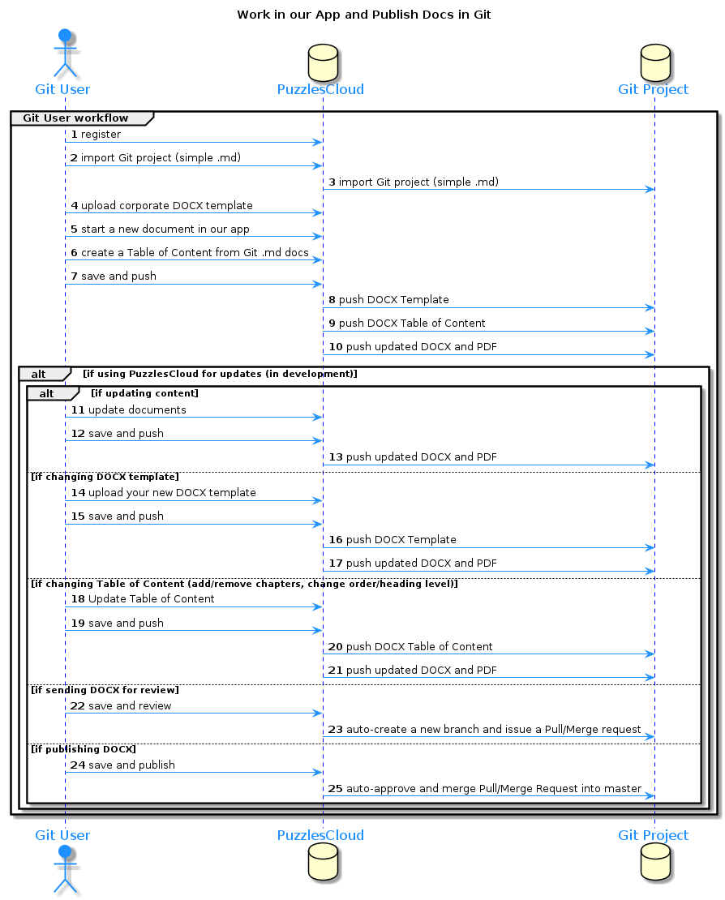

preview: https://www.planttext.com/ -->

This is second UML diagram
YOU CAN CHECK IT BELLOW
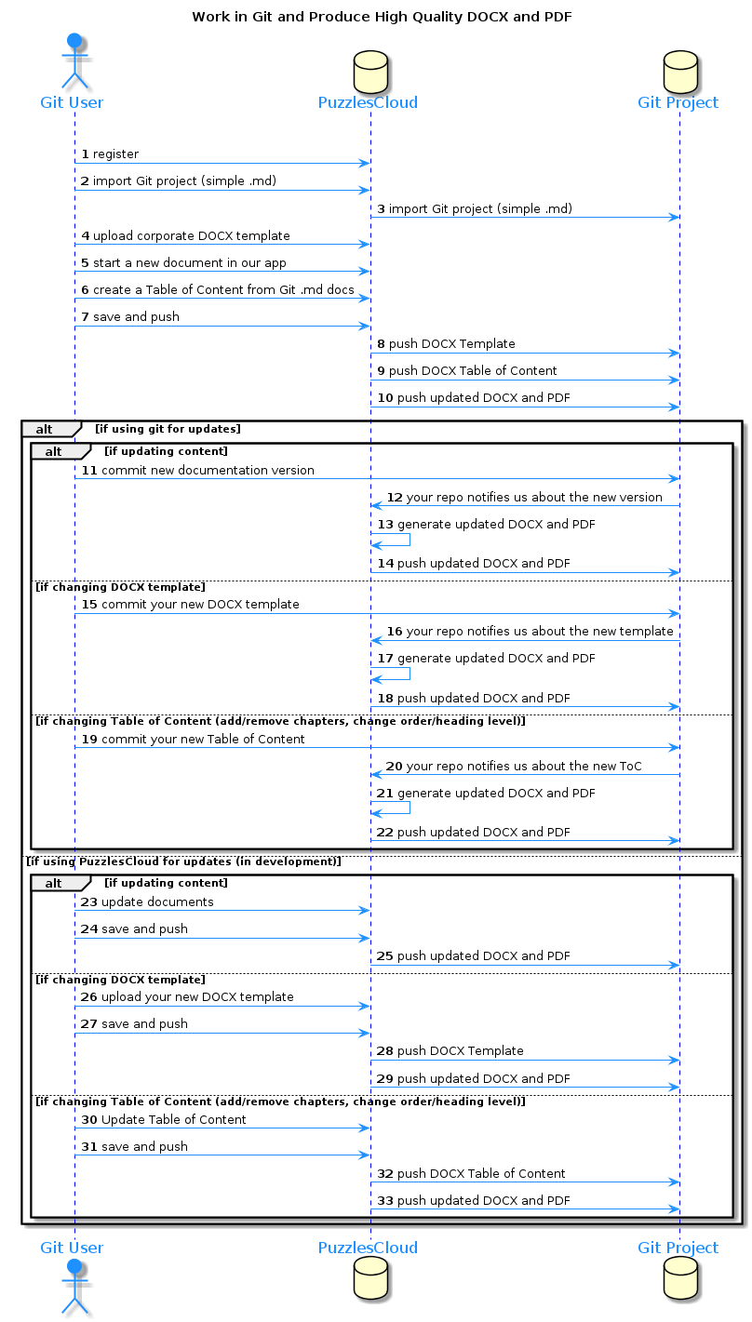

markdown2.md

Formatted Text Examples
Below is an illustration of the Format toolbar used to format text:

Here are some examples of the effects different options have on text:

Font buttons:
As well as the standard Font drop down box showing a list of all the fonts on your system and the Point size box that allows you to set the font size,
two shortcut buttons have been added that allow you to increase the selected text or group of text objects at the press of a button:
Will increase the font size by 2 points every time you press the button.
Will decrease the font size by 2 points every time you press the button.

Text Format:
The standard text format options are also available for text i.e. bold, italic, underline and outline:

Note:
You can combine any of these formats together, as in the last example above which is a combination of the bold, underline and outline formats.

Text Justification:
- Text can be aligned to the
  - left,
  - right,
  - centre
- or one of the three full justifications: Full Justification, Density Justification and Aspect Justification.
Note:
The Full justification spreads the words across the page but does not change the size of them. The Density Justification also spreads the words and does not change their size but puts spaces between the characters in a word. The Aspect Justification spreads the words but stretches the words to fill the space as well.
The Density and Aspect methods can provide some visually interesting effects.

Go back to the top

Useful markdown links:
- Link 1
  - This is link 1
- Link 2
  - This is link 2
- Link 3
  - This is link 3
    - Link 4
      - This is link 4 ordered under link 3

I just have to store some code here, if you don't mind

I'll put it here
LoGiC iS rEaL !!!
if(a == 0){
a = 0;
}

And also here
It's getting better
if (false == true) {
// log some message
}

You know the process...

I'll just assert and finish this...
public void justAssert(){
boolean checkTrue = true;
Assert.assertTrue(checkTrue);
}
//let me return true he he
public boolean trueStatement(){
return true;
}

markdown1.md

PUZZLES CLOUD MARKDOWN FILE HEADING 1

Welcome to the puzzles cloud md file HEADING 2

Let's start with stupid jokes HEADING 3

Let me tell you stupid joke on German: HEADING4
- "Hey Philipp, wie war denn der Urlaub?"
- "Gräßlich! Im Hotel hatte ich Zimmernummer hundert. Und vom Türschild ist die Eins abgefallen!"

ÜÜÜÜÜÜ- that was stupid

Let's switch to the Czech language HEADING 4
- "Co rłńóobi trakłńótośźr u fśźryśźżzjera?"
- Warćękocze.
ąćęłńóśźż!!!!
Just kidding, that was Poland language u fool, let's switch to the Czech for real

Real Czech language HEADING 5
ýžáčďéěíňóřšťúů
- Jak říkáte albínskému muži z Prahy?
- Prázdný Čech.

Longest Serbian word he he HEADING 1
Here you go: АБВГДЂЕЖЗИЈКЛЉМНЊОПРСТУФХЦЧЏШ

Serbian literature HEADING 2
Весела песма
Из школе се враћа Стева
сав весео путем пева.
Уз пут среће бака Јелу:
„Ћирилицу знадем целу!"
Кући дође, па са врата:
„Ћирилицу знадем, тата!"
„Све сад, мајко, читам сам,
јер од данас и „ш" знам!"
Оком тражи и сестрицу:
„Сејо, знадем ћирилицу!"
Потом оде до икона,
па начини три поклона.
Хоће Стева да се јави
и захвали Светом Сави.
Свети Сава Стеву чује,
па се скупа с њим радује:
„Српство ми је од сад јаче
за још једно вредно ђаче!"

It's enough, lets start with some smart things HEADING 1

1.
PLAY THIS VIDEO AND THANKS ME LATER!

HIT THAT PLAY BUTTON 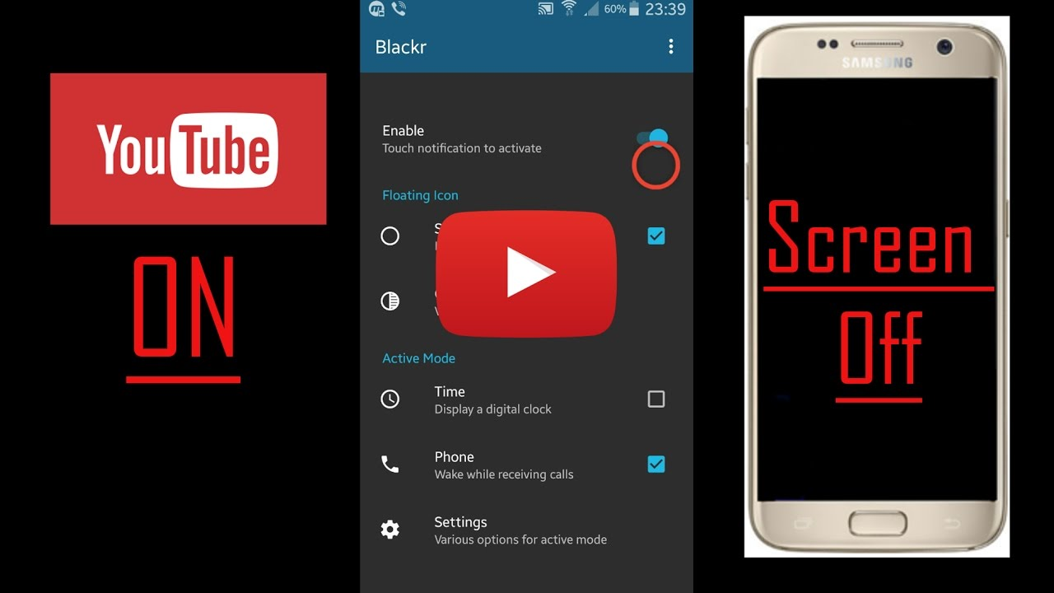
Yep, it's a picture, fool... lol
Here you go, CLICK IT:

markdown4.md

From today's featured article
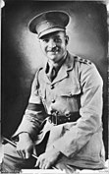
Lionel Matthews (15 August 1912 -- 2 March 1944) was an Australian Army officer during World War II who was posthumously awarded the George Cross, the highest non-combat award for heroism for members of the Australian armed forces at the time. Matthews served in the 27th Brigade during the Malayan campaign, and at the surrender of Singapore in 1942 became a prisoner of war (POW). He was awarded the Military Cross for courage, energy and ability under fire during this fighting.

Did you know ...
- that in 2017 you could finally have breakfast at Tiffany's (pictured)?
- that the British mycologist Denis Garrett, "one of the last 'string and sealing wax' scientists", once bought plastic lavatory cisterns for his laboratory to use in experiments?
- that sand in the stomach of the ocean surgeon helps to grind up its food?

In the news
- More than 300 girls are kidnapped from a secondary school by armed bandits in Zamfara, Nigeria.
- In tennis, Naomi Osaka wins the women's singles and Novak Djokovic wins the men's singles at the Australian Open (both winners pictured).

On this day

March 2
1444 -- The League of Lezhë, an alliance of regional chieftains, was established in Venetian Albania with Skanderbeg as its commander.
1865 -- New Zealand Wars: Carl Sylvius Völkner (pictured), a Protestant missionary, was killed by Hauhau militants in Ōpōtiki for working as an agent for George Grey, Governor-General of New Zealand.
1937 -- The Steel Workers Organizing Committee, precursor to the United Steel Workers of America, had a major success when it signed a collective-bargaining agreement with U.S. Steel.
1962 -- Led by General Ne Win, the Burmese military seized power in a coup d'état.
aaaaaaaaaaaaaaaaaa

Today's featured picture
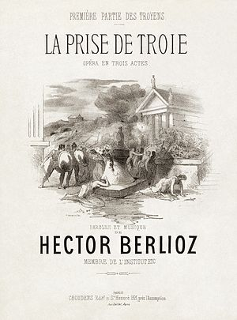

Armed conflicts and attacks
- Zamfara kidnapping
  - All 279 abducted schoolgirls from a boarding school in Zamfara State, Nigeria, are released by their armed kidnappers. (Reuters)

Health and environment
- COVID-19 pandemic
  - COVID-19 pandemic in Asia
    - COVID-19 pandemic in Indonesia
      - Indonesia reports their first two cases of Lineage B.1.1.7 variant first detected in the United Kingdom. (Liputan6.com)
    - COVID-19 pandemic in Iraq
      - Iraq receives 50,000 doses of Sinopharm vaccines as the country officially begins its vaccination campaign. (Asharq Al-Awsat)
    - COVID-19 pandemic in Mongolia
      - Mongolia surpasses 3,000 cases of COVID-19. (Montsame)
    - COVID-19 pandemic in the Philippines
      - The Philippines reports their first six cases of 501.V2 variant first detected in South Africa. (GMA News)


Figure 1: Last Page

