Homework 4: Trigonometric Ratios and Inverse Trigonometric Relations
10 points

Complete your homework and submit it to your instructor.
- An airplane is 3800 feet above the ground. The angle of depression between the airplane and the airport is 8.5°. How far does the plane have to fly in order to land?
Sin 8.5 = 3800/x
X sin 8.5 = 3800
X = 3800/sin 8.5
X = 25,708.78 ft
X = 25,709 ft rounded to the ones place
- An airplane is 3800 feet above the ground. The angle of depression between the airplane and the airport is 8.5°. What is the plane's ground distance to the airport?
Tan 8.5 = 3800/x
X Tan 8.5 = 3800
X = 3800 / Tan 8.5
X = 25,426.39
X = 25,426 ft rounded to the ones place

- A ladder is leaning against a wall. It is 5 ½ feet from the wall and has an angle of elevation 55°. How long is the ladder?
Cos 55 = 5.5/x
X cos 55 = 5.5
X = 5.5/cos 55
X = 9.6 ft rounded to the tenths place

Use the following triangle for problems 4 and 5.
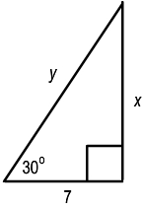
- Find the value of x.
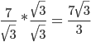
- Find the value of y.
