a) Borough 1

Multiple Regression Model:

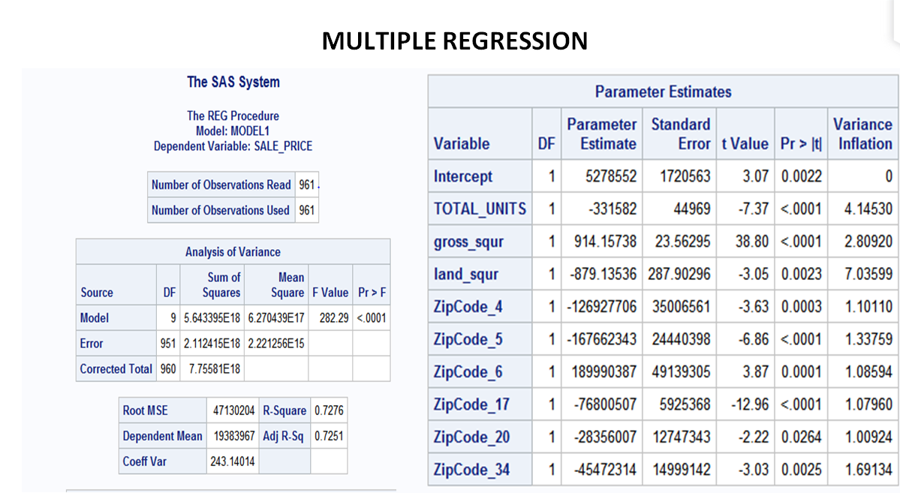

Since the R-Square of the model is around 72.76%, this is considered as a significant model.

Below are the significant variables which provides significant impact on sale price:

* Total_Units
* Gross_Square_Feet
* Land_Square_Feet
* Zipcode_4 - **10004**
* ZipCode_5 - **10005**
* ZipCode_6 - **10006**
* ZipCode_17 - **10019**
* ZipCode_20 - **10023**
* ZipCode_34 - **10037**