**Adv. Java Lab Assignment**

**JDBC 20 Programs**

**Name:-Root Bajaj**

**M.Tech(5th Sem)**

**Rollno.:-IT-2k17-35**

**1.Program for mysql connection with JDBC.**

**Solution:-**

import java.sql.Connection;

import java.sql.DriverManager;

import java.sql.SQLException;

import java.sql.Statement;

public class JdbcConnection {

public static void main(String a[]){

try {

Class.forName("com.mysql.jdbc.Driver");

Connection con = DriverManager.

getConnection("jdbc:mysql://localhost:3306/firstdb","root","root");

Statement stmt = con.createStatement();

System.out.println("Created DB Connection....");

} catch (ClassNotFoundException e) {

e.printStackTrace();

} catch (SQLException e) {

e.printStackTrace();

}

}

}

**Output 1:-**

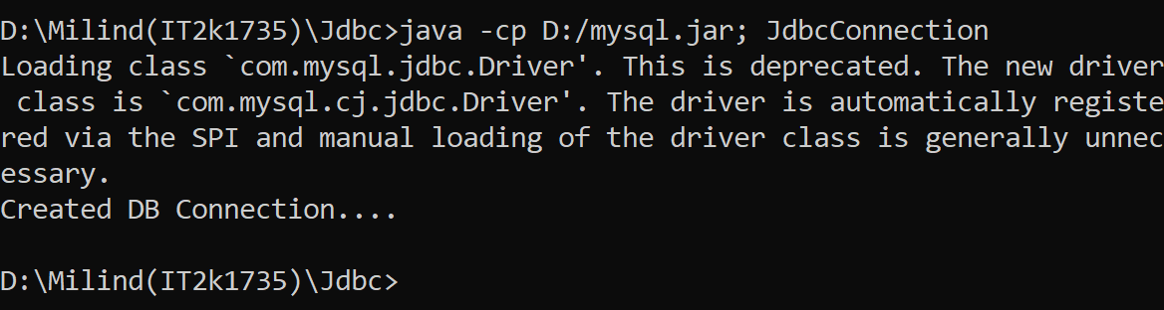

**2.Program of CREATE table in jdbc.**

**Solution:-**

import java.sql.*;

public class CreateTable{

Connection con;

CreateTable()

{

try

{

Class.forName("com.mysql.jdbc.Driver");

con=DriverManager.getConnection("jdbc:mysql://localhost:3306/firstdb","root","root");

PreparedStatement ps=con.prepareStatement("create table Student(sId int primary key,sName VARCHAR(30) not null )");

int count=ps.executeUpdate();

System.out.println(count);

System.out.println("Table created successfully!!");

}

catch (Exception e)

{

e.printStackTrace();

}

}

public static void main(String s[])

{

new CreateTable();

}

}

**Output 2:-**

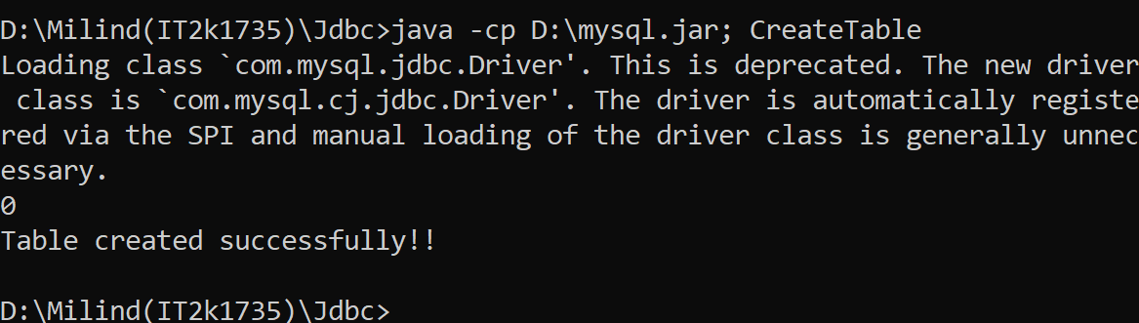

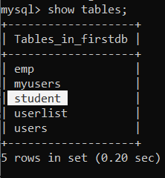

**3.Program of INSERT query in jdbc.**

**Solution:-**

import java.sql.*;

class Sinsert

{

public static final String DBURL = "jdbc:mysql://localhost:3306/firstdb";

public static final String DBUSER = "root";

public static final String DBPASS = "root";

public static void main(String args[])

{

try

{

Class.forName("com.mysql.jdbc.Driver");

Connection con = DriverManager.getConnection(DBURL, DBUSER, DBPASS);

String sql = "INSERT INTO Student(sId,sName) VALUES (?, ?)";

PreparedStatement statement = con.prepareStatement(sql);

statement.setInt(1, 3);

statement.setString(2, "mahesh");

int rowsInserted = statement.executeUpdate();

if (rowsInserted > 0)

{

System.out.println("A new employee was inserted successfully!\n");

}

}

catch(Exception e)

{

System.out.println(e);

}

}

}

**Output 3:-**

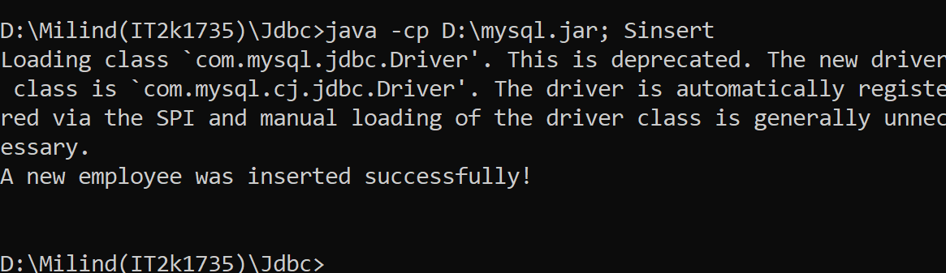

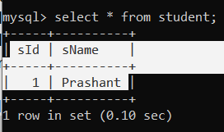

**4.Program of SELECT query.**

**Solution:-**

import java.sql.*;

class Sselect

{

public static final String DBURL = "jdbc:mysql://localhost:3306/firstdb";

public static final String DBUSER = "root";

public static final String DBPASS = "root";

public static void main(String args[])

{

try

{

Class.forName("com.mysql.jdbc.Driver");

Connection con = DriverManager.getConnection(DBURL, DBUSER, DBPASS);

String sql1 = "SELECT * FROM Student";

Statement stmt = con.createStatement();

ResultSet result = stmt.executeQuery(sql1);

while (result.next())

{

System.out.println (result.getInt(1)+" "+

result.getString(2));

}

}

catch(Exception e)

{

System.out.println(e);

}

}

}

**Output 4:-**

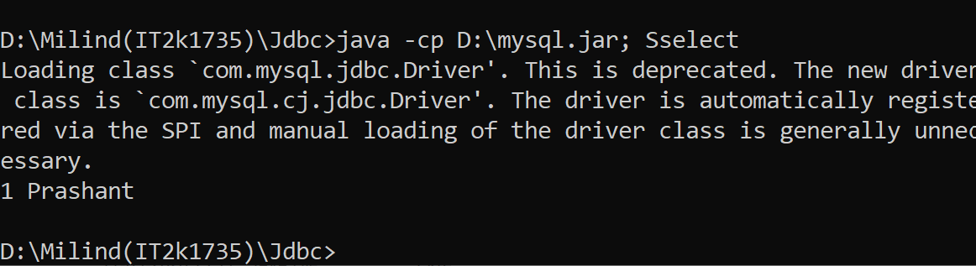

**5.Program of Update Query in jdbc.**

**Solution:-**

import java.sql.*;

class Supdate

{

public static final String DBURL = "jdbc:mysql://localhost:3306/firstdb";

public static final String DBUSER = "root";

public static final String DBPASS = "root";

public static void main(String args[])

{

try

{

Class.forName("com.mysql.jdbc.Driver");

Connection con = DriverManager.getConnection(DBURL, DBUSER, DBPASS);

String sql2 = "Update Student set sName = ? where sId = ?";

PreparedStatement pstmt = con.prepareStatement(sql2);

pstmt.setString(1, "Ramesh");

pstmt.setInt(2,1);

int rowUpdate = pstmt.executeUpdate();

if (rowUpdate > 0)

{

System.out.println("\nRecord updated successfully!!\n");

}

}

catch(Exception e)

{

System.out.println(e);

}

}

}

**Output 5:-**

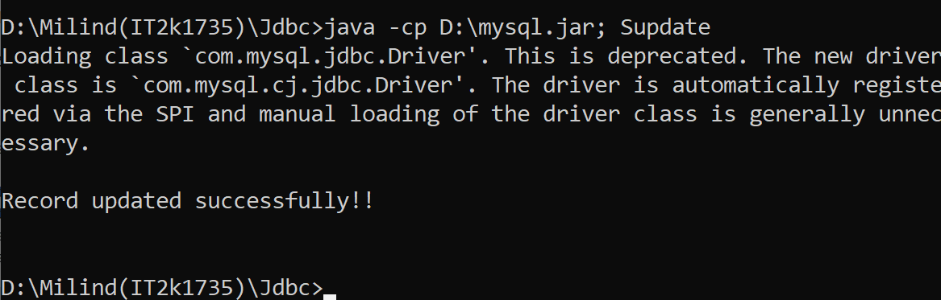

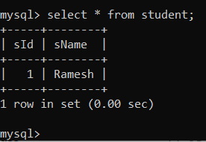

**6.Program of DELETE query in jdbc.**

**Solution:-**

import java.sql.*;

class Sdelete

{

public static final String DBURL = "jdbc:mysql://localhost:3306/firstdb";

public static final String DBUSER = "root";

public static final String DBPASS = "root";

public static void main(String args[])

{

try

{

Class.forName("com.mysql.jdbc.Driver");

Connection con = DriverManager.getConnection(DBURL, DBUSER, DBPASS);

String sql3 = "DELETE FROM Student WHERE sName=?";

PreparedStatement statement1 = con.prepareStatement(sql3);

statement1.setString(1, "Suresh");

int rowsDeleted = statement1.executeUpdate();

if (rowsDeleted > 0)

{

System.out.println("A Employee was deleted successfully!\n");

}

}

catch(Exception e)

{

System.out.println(e);

}}}

**Output 6:-**

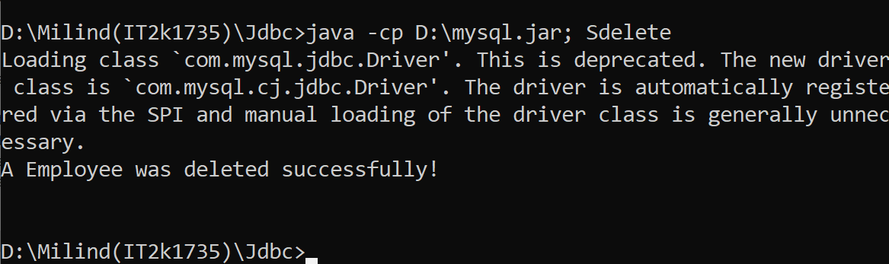

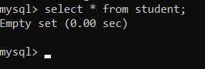

**7.Program of deleting more than one record at a time.**

**Solution:-**

import java.sql.*;

import java.util.Scanner;

class DeleteTest

{

public static final String DBURL = "jdbc:mysql://localhost:3306/firstdb";

public static final String DBUSER = "root";

public static final String DBPASS = "root";

public static void main(String[] args) throws Exception

{

Scanner sc = new Scanner(System.in);

System.out.print("Enter record number which you want to delete: ");

int stno = sc.nextInt();

Class.forName("com.mysql.jdbc.Driver");

Connection con = DriverManager.getConnection(DBURL, DBUSER, DBPASS);

String qry = "delete from Student where sId=(select max(sId) from Student where sName<=?)

PreparedStatement pst=con.prepareStatement(qry);

pst.setInt(1,stno);

int count = pst.executeUpdate();

if(count != 0)

System.out.println(count+" Record deleted successfully\n");

else

System.out.println("Record deletion failed\n");

pst.close();

con.close();

}

}

**Output 7:-**

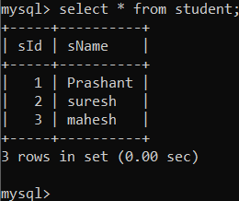

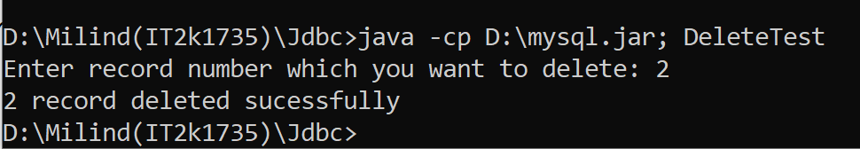



**8.Program of Auto Generated Keys.**

**Solution:-**

import java.sql.Connection;

import java.sql.DriverManager;

import java.sql.PreparedStatement;

import java.sql.ResultSet;

import java.sql.SQLException;

import java.sql.Statement;

import java.util.logging.Level;

import java.util.logging.Logger;

public class AutoGenKey {

public static void main(String[] args) {

String url = "jdbc:mysql://localhost:3306/firstdb?useSSL=false";

String user = "root";

String password = "root";

String sName = "lakhan";

int rn=19;

String sql = "INSERT INTO users(name,rollno) VALUES(?,?)";

try (Connection con = DriverManager.getConnection(url, user, password);

PreparedStatement preparedStatement = con.prepareStatement(sql,Statement.RETURN_GENERATED_KEYS))

{

preparedStatement.setString(1, sName);

preparedStatement.setInt(2,rn);

preparedStatement.executeUpdate();

try (ResultSet resultSet = preparedStatement.getGeneratedKeys()) {

if (resultSet.first()) {

System.out.printf("The ID of new student : %d", resultSet.getLong(1));

}

}

System.out.println("record inserted");

System.out.println("The ID of new student:");

} catch (SQLException ex) {

Logger lgr = Logger.getLogger(AutoGenKey.class.getName());

lgr.log(Level.SEVERE, ex.getMessage(), ex);

}

}

}

**Output 8:-**

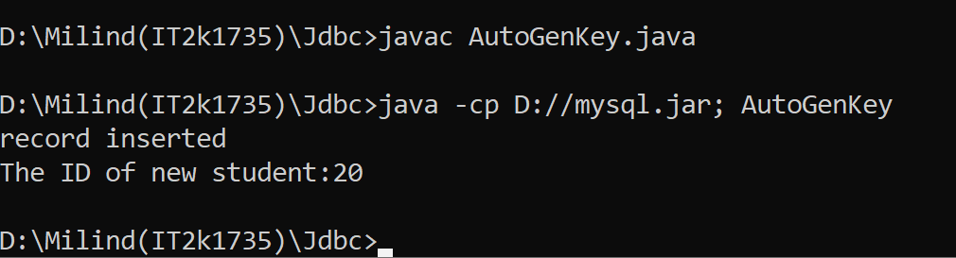

**9.Program of joining two tables in jdbc.**

**Solution:-**

import java.sql.*;

class JoinExample

{

public static final String DBURL = "jdbc:mysql://localhost:3306/firstdb";

public static final String DBUSER = "root";

public static final String DBPASS = "root";

public static void main(String args[])

{

try

{

Class.forName("com.mysql.jdbc.Driver");

Connection con = DriverManager.getConnection(DBURL, DBUSER, DBPASS);

String sql = "select rollno,id from emp inner join users ON users.name = emp.name";

Statement stmt = con.createStatement();

ResultSet result = stmt.executeQuery(sql);

System.out.println("Two table join successfully");

System.out.println("Id Rollno ");

System.out.println("**===========**==========**");

while (result.next())

{

System.out.println (

result.getInt(1)+" "+

result.getInt(2));

}

System.out.println("**===========**==========**\n");

}

catch(Exception ex)

{

ex.printStackTrace();

}}}

**Output 9:-**

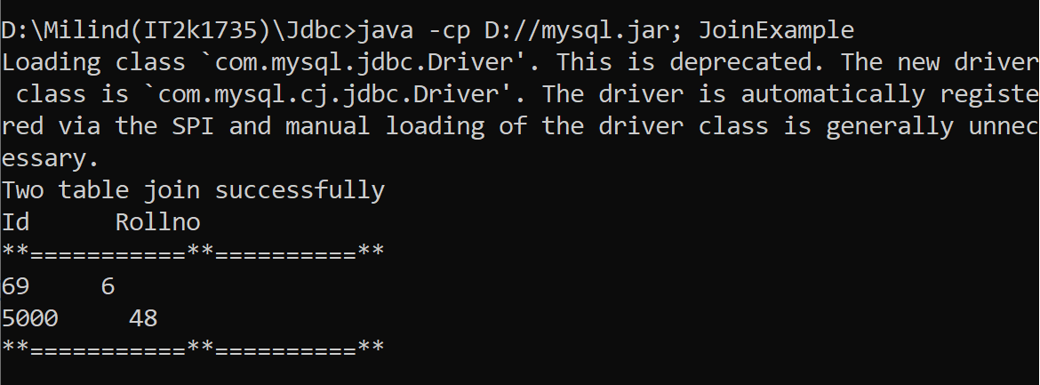

**10.Program of Query update in jdbc.**

**Solution:-**

import java.sql.Connection;

import java.sql.DriverManager;

import java.sql.SQLException;

import java.sql.Statement;

public class MyQueryUpdate {

public static void main(String[] args) {

Connection con = null;

Statement stmt = null;

try {

Class.forName("com.mysql.jdbc.Driver");

con = DriverManager.

getConnection("jdbc:mysql://localhost:3306/firstdb","root","root");

stmt = con.createStatement();

String query = "UPDATE users SET name=name WHERE rollno=1";

int count = stmt.executeUpdate(query);

System.out.println("Updated queries: count");

} catch (ClassNotFoundException e) {

e.printStackTrace();

} catch (SQLException e) {

e.printStackTrace();

} finally{

try{

if(stmt != null) stmt.close();

if(con != null) con.close();

} catch(Exception ex){}

}

}

}

**Output 10:-**

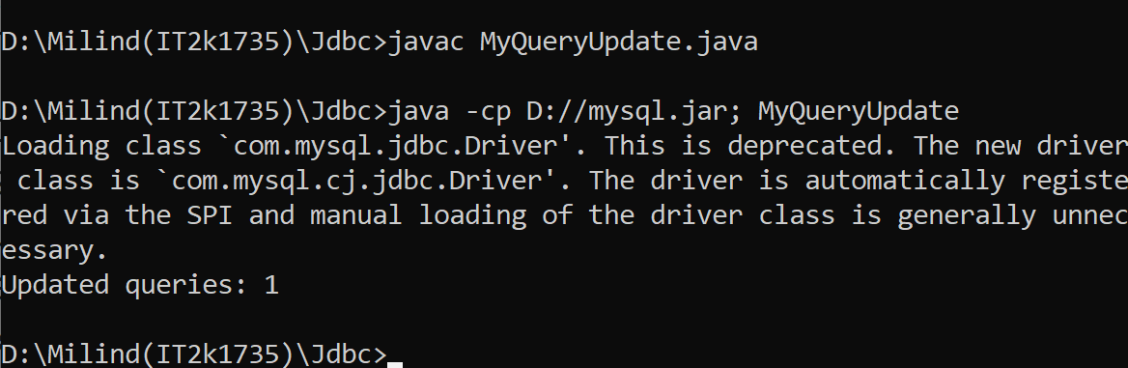

**11.Program of sinple callable Statement with stored procedue.**

**Solution:-**

import java.sql.CallableStatement;

import java.sql.Connection;

import java.sql.DriverManager;

import java.sql.SQLException;

public class MySimpleCallableStatement {

public static void main(String a[]){

Connection con = null;

CallableStatement callSt = null;

try {

Class.forName("com.mysql.jdbc.Driver");

con = DriverManager.

getConnection("jdbc:mysql://localhost:3306/firstdb","root","root");

callSt = con.prepareCall("{call hello(?,?)}");

callSt.setString(1,"drak");

callSt.setInt(2,10);

callSt.execute();

System.out.println("Executed stored procedure!!!");

} catch (ClassNotFoundException e) {

e.printStackTrace();

} catch (SQLException {

e.printStackTrace();

} finally{

try{

if(callSt != null) callSt.close();

if(con != null) con.close();

} catch(Exception ex){}

}

}

}

**Output 11:-**

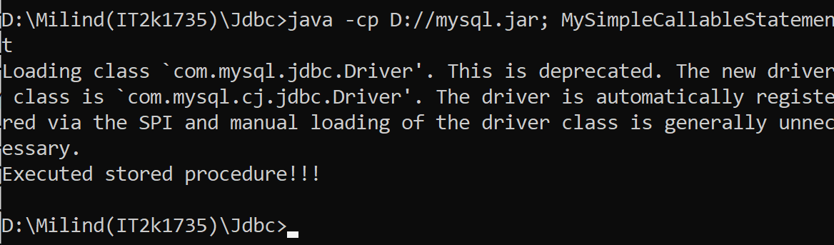

**12. Program of Simple Prepared Statement.**

**Solution:-**

import java.sql.Connection;

import java.sql.DriverManager;

import java.sql.PreparedStatement;

import java.sql.SQLException;

public class MyPreparedStatement {

public static void main(String a[]){

Connection con = null;

PreparedStatement prSt = null;

try {

Class.forName("com.mysql.jdbc.Driver");

con = DriverManager.

getConnection("jdbc:mysql://localhost:3306/firstdb","root","root");

String query = "insert into users(name,rollno) values(?,?)";

prSt = con.prepareStatement(query);

prSt.setString(1, "ebun");

prSt.setInt(2, 13);

int count = prSt.executeUpdate();

prSt.setString(1, "fagun");

prSt.setInt(2, 14);

count = prSt.executeUpdate();

System.out.println("records Successfully inserted");

} catch (ClassNotFoundException e) {

e.printStackTrace();

} catch (SQLException e) {

e.printStackTrace();

} finally{

try{

if(prSt != null) prSt.close();

if(con != null) con.close();

} catch(Exception ex){}

}

}}

**Output 12:-**

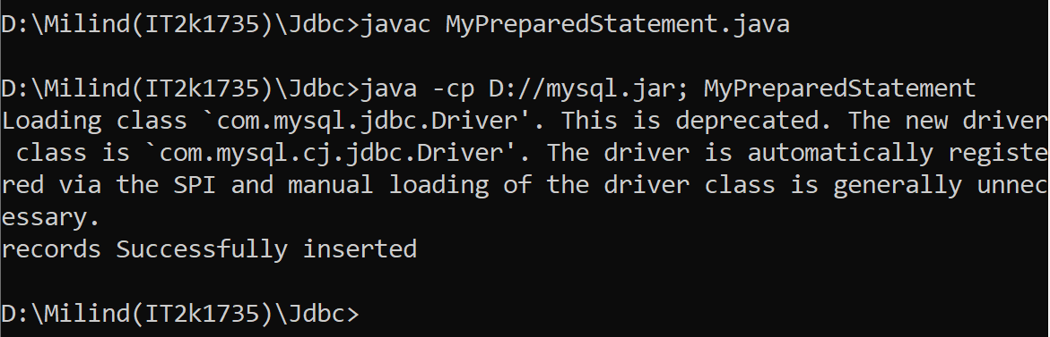

**13.Program of Batch Callable Statement with Stored Procedure.**

**Solution:-**

import java.sql.CallableStatement;

import java.sql.Connection;

import java.sql.DriverManager;

import java.sql.SQLException;

public class MyBatchCallableStatement {

public static void main(String a[]){

Connection con = null;

CallableStatement callSt = null;

try {

Class.forName("com.mysql.jdbc.Driver");

con = DriverManager.

getConnection("jdbc:mysql://localhost:3306/firstdb","root","root");

callSt = con.prepareCall("{call hello(?,?)}");

callSt.setString(1,"bajaj");

callSt.setInt(2,9);

callSt.addBatch();

callSt.setString(1,"bmw");

callSt.setInt(2,15);

callSt.addBatch();

int[] updateCounts = callSt.executeBatch();

System.out.println("all batch added!!!");

} catch (ClassNotFoundException e) {

e.printStackTrace();

} catch (SQLException e) {

e.printStackTrace();

} finally{

try{

if(callSt != null) callSt.close();

if(con != null) con.close();

} catch(Exception ex){}

}

}}

**Output 13:-**

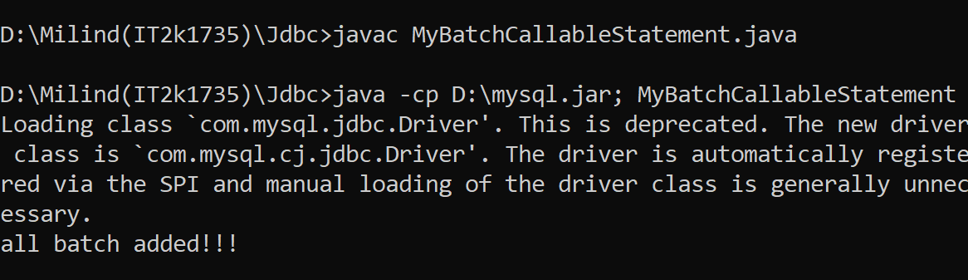

**14.Program of Batch Prepared Statement with Stored Procedure.**

**Solution:-**

import java.sql.Connection;

import java.sql.DriverManager;

import java.sql.PreparedStatement;

import java.sql.SQLException;

public class MyBatchPreparedStmt {

public static void main(String a[]){

Connection con = null;

PreparedStatement pst = null;

try {

Class.forName("com.mysql.jdbc.Driver");

con = DriverManager.

getConnection("jdbc:mysql://localhost:3306/firstdb","root","root");

con.setAutoCommit(false);

pst = con.prepareStatement("update users set rollno=? where name=?");

pst.setInt(1,68);

pst.setString(2,"mohan");

pst.addBatch();

pst.setInt(1, 100);

pst.setString(2,"police");

pst.addBatch();

int count[] = pst.executeBatch();

for(int i=1;i<=count.length;i++){

System.out.println("Query "+i+" has effected "+count[i]+" times");

}

con.commit();

} catch (ClassNotFoundException e) {

try {

con.rollback();

} catch (SQLException e1) {

e1.printStackTrace();

}

e.printStackTrace();

} catch (SQLException e) {

try {

con.rollback();

} catch (SQLException e1) {

e1.printStackTrace();

}

e.printStackTrace();

} finally{

try{

if(pst != null) pst.close();

if(con != null) con.close();

} catch(Exception ex){}

}}}

**Output 15:-**

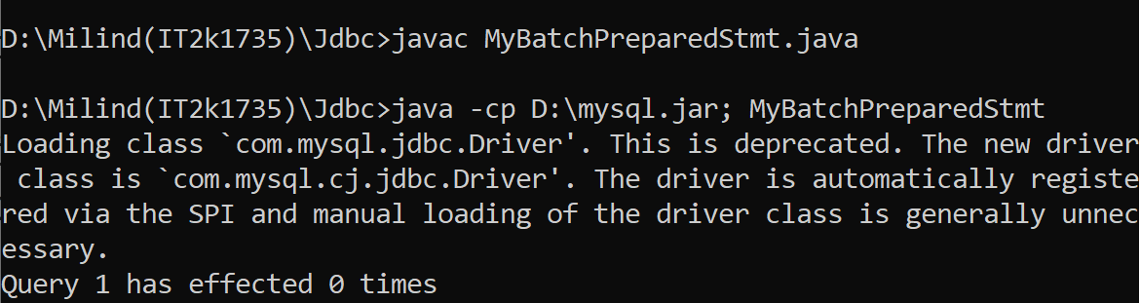

**16.Program of Statement Batch Update.**

**Solution:-**

import java.sql.Connection;

import java.sql.DriverManager;

import java.sql.SQLException;

import java.sql.Statement;

public class MyStatementBatchUpdate {

public static void main(String a[]){

Connection con = null;

Statement st = null;

try {

Class.forName("com.mysql.jdbc.Driver");

con = DriverManager.

getConnection("jdbc:mysql://localhost:3306/firstdb","root","root");

con.setAutoCommit(false);

st = con.createStatement();

st.addBatch("update users set rollno=5 where name='kalu'");

st.addBatch("insert into users values ('thor',12)");

st.addBatch("update users set name='Ram' where rollno=5");

int count[] = st.executeBatch();

for(int i=1;i<=count.length;i++){

System.out.println("Query "+i+" has effected "+count[i]+" times");}

con.commit();

} catch (ClassNotFoundException e) {

try {

con.rollback();

} catch (SQLException e1) {

e1.printStackTrace();

}

e.printStackTrace();

} catch (SQLException e) {

try {

con.rollback();

} catch (SQLException e1) {

e1.printStackTrace();

}

e.printStackTrace();

} finally{

try{

if(st != null) st.close();

if(con != null) con.close();

} catch(Exception ex){}

}}}

**Output 16:-**

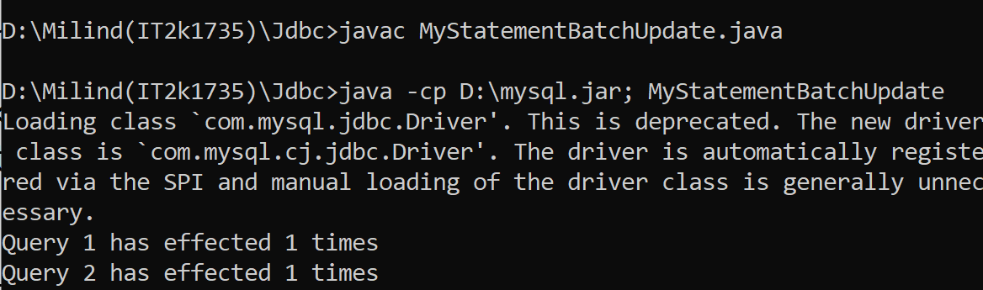

**17.Program of Prepared Statement Result Set.**

**Solution:-**

import java.sql.Connection;

import java.sql.DriverManager;

import java.sql.PreparedStatement;

import java.sql.ResultSet;

import java.sql.SQLException;

public class MyPrepStmtResltSet {

public static void main(String a[]){

Connection con = null;

PreparedStatement prSt = null;

ResultSet rs = null;

try {

Class.forName("com.mysql.jdbc.Driver");

con = DriverManager.

getConnection("jdbc:mysql://localhost:3306/firstdb","root","root");

String query = "select * from users where rollno=?";

prSt = con.prepareStatement(query);

prSt.setInt(1,69);

rs = prSt.executeQuery();

while(rs.next()){

System.out.println(rs.getString("name")+" -- "+rs.getInt("rollno"));

}

rs.close();

prSt.setInt(1,5000);

rs = prSt.executeQuery();

while(rs.next()){

System.out.println(rs.getString("name")+" -- "+rs.getInt("rollno"));

}

} catch (ClassNotFoundException e) {

e.printStackTrace();

} catch (SQLException e) {

e.printStackTrace();

} finally{

try{

if(rs != null) rs.close();

if(prSt != null) prSt.close();

if(con != null) con.close();

} catch(Exception ex){}

}

}

}

**Output 17:-**

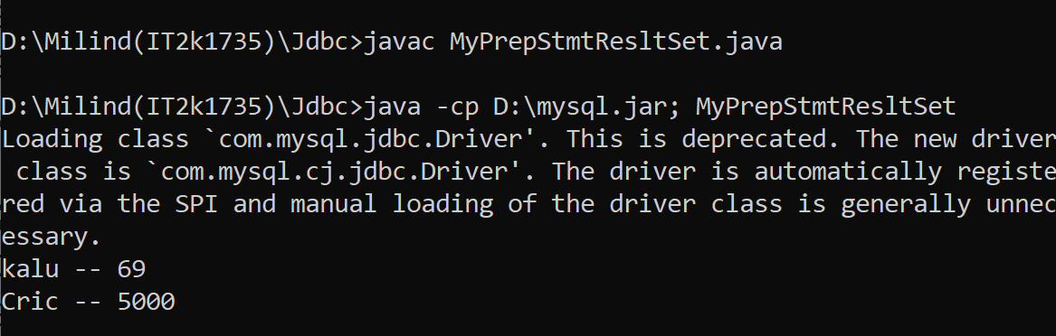

**18.Program of Read Database Structure in jdbc.**

**Solution:-**

import java.sql.*;

public class ReadDatabaseStructureExample {

public static void main(String[] args) {

String url = "jdbc:mysql://localhost:3306/firstdb";

String username = "root";

String password = "root";

try (Connection conn = DriverManager.getConnection(url, username, password)) {

DatabaseMetaData meta = conn.getMetaData();

String catalog = null, schemaPattern = null, tableNamePattern = null;

String[] types = {"TABLE"};

ResultSet rsTables = meta.getTables(catalog, schemaPattern, tableNamePattern, types);

while (rsTables.next()) {

String tableName = rsTables.getString(3);

System.out.println("\n=== TABLE: " + tableName);

String columnNamePattern = null;

ResultSet rsColumns = meta.getColumns(catalog, schemaPattern, tableName, columnNamePattern);

ResultSet rsPK = meta.getPrimaryKeys(catalog, schemaPattern, tableName);

while (rsColumns.next()) {

String columnName = rsColumns.getString("COLUMN_NAME");

String columnType = rsColumns.getString("TYPE_NAME");

int columnSize = rsColumns.getInt("COLUMN_SIZE");

System.out.println("\t" + columnName + " - " + columnType + "(" + columnSize + ")"); }

while (rsPK.next()) {

String primaryKeyColumn = rsPK.getString("COLUMN_NAME");

System.out.println("\tPrimary Key Column: " + primaryKeyColumn);

}

}

} catch (SQLException ex) {

System.out.println(ex.getMessage());

ex.printStackTrace();

}}}

**Output 18:-**

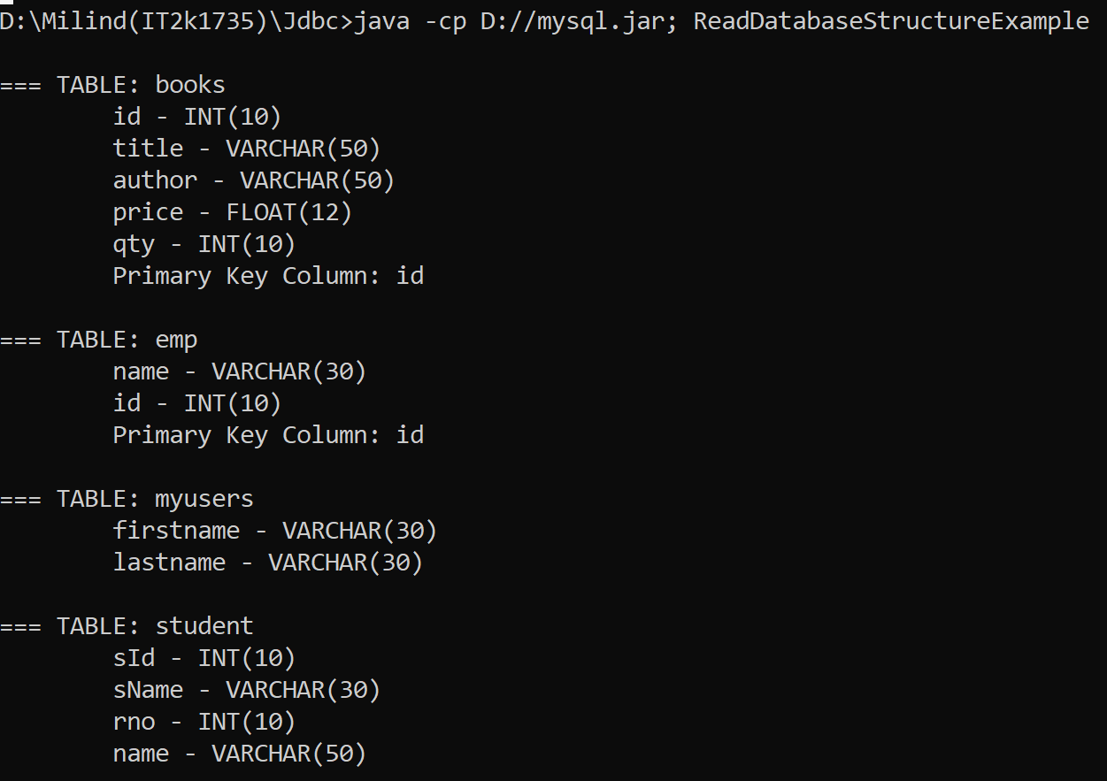

**19.Program of Simple Transction Management in jdbc.**

**Solution:-**

import java.sql.*;

class Mytranction{

public static void main(String args[])throws Exception{

Class.forName("com.mysql.jdbc.Driver");

Connection con=DriverManager.getConnection("jdbc:mysql://localhost:3306/firstdb","root","root");

con.setAutoCommit(false);

Statement stmt=con.createStatement();

stmt.executeUpdate("insert into users values('hari',16)");

stmt.executeUpdate("insert into users values('irish',17)");

con.commit();

System.out.print("record sucessfully inserted");

con.close();

}

}

**Output 19:-**

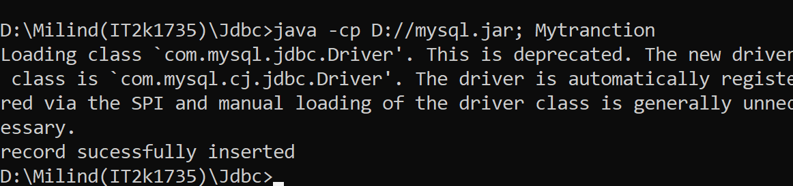

**20.Program of Transction Management.**

**Solution:-**

import java.sql.*;

import java.io.*;

class TM{

public static void main(String args[]){

try{

Class.forName("com.mysql.jdbc.Driver");

Connection con=DriverManager.getConnection("jdbc:mysql://localhost:3306/firstdb","root","root");

con.setAutoCommit(false);

PreparedStatement ps=con.prepareStatement("insert into users values(?,?)");

BufferedReader br=new BufferedReader(new InputStreamReader(System.in));

while(true){

System.out.println("enter name");

String name=br.readLine();

System.out.println("enter rollno");

String s1=br.readLine();

int rollno=Integer.parseInt(s1);

ps.setString(1,name);

ps.setInt(2,rollno);

ps.executeUpdate();

System.out.println("commit/rollback");

String answer=br.readLine();

if(answer.equals("commit")){

con.commit();

}

if(answer.equals("rollback")){

con.rollback();

}

System.out.println("Want to add more records y/n");

String ans=br.readLine();

if(ans.equals("n")){

break;

}

}

con.commit();

System.out.println("record successfully saved");

con.close();

}catch(Exception e){System.out.println(e);}

}}

**Output 20:-**

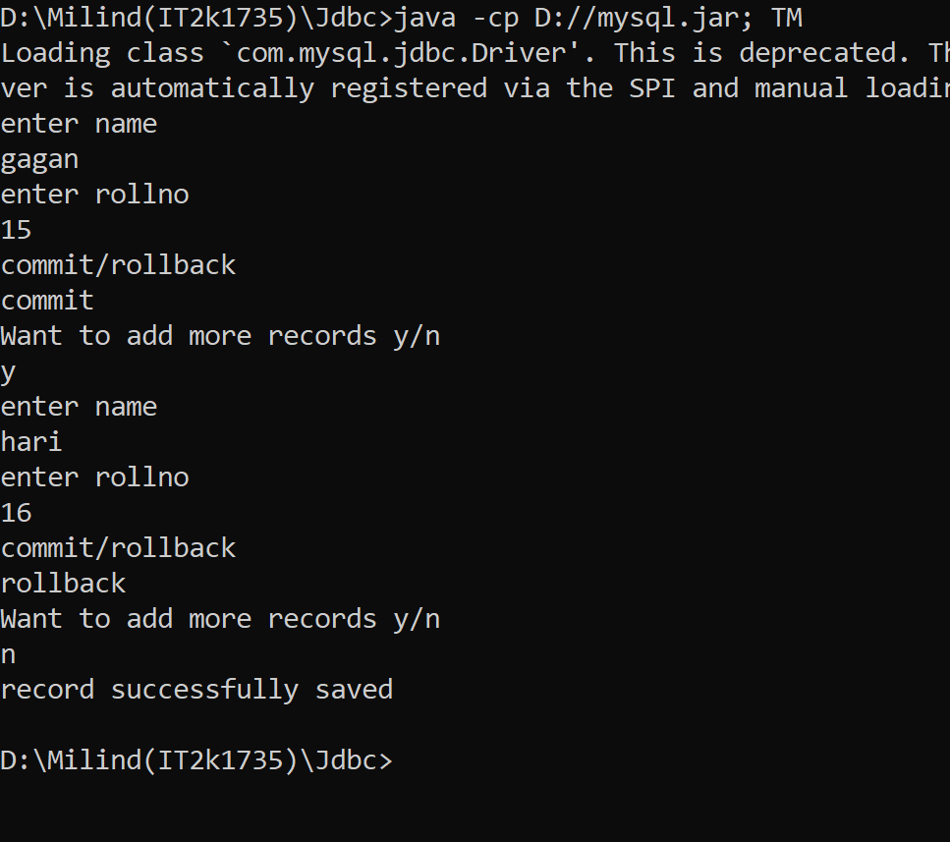

**END**