**Adv. Java Lab Assignment**

**Servlet 20 Programs**

**Name:-Milind Bajaj**

**M.Tech(5th Sem)**

**Rollno.:-IT-2k17-35**

**1.Simple Program of the doGet() runs once per HTTP GET request to servlet and showing details like URL,Path:-**

**Solution:-**

**HelloServlet.html:-**

import java.io.*;

import javax.servlet.*;

import javax.servlet.http.*;

import javax.servlet.annotation.*;

@WebServlet("/sayhello")

public class HelloServlet extends HttpServlet

@Override

public void doGet(HttpServletRequest request, HttpServletResponse response)

throws IOException, ServletException {

response.setContentType("text/html");

PrintWriter out = response.getWriter();

out.println("<!DOCTYPE html>");

out.println("<html>");

out.println("<head><title>Hello, World</title></head>");

out.println("<body>");

out.println("<h1>Hello, world!</h1>");

out.println("<p>Request URI: " + request.getRequestURI() + "</p>");

out.println("<p>Protocol: " + request.getProtocol() + "</p>");

out.println("<p>PathInfo: " + request.getPathInfo() + "</p>");

out.println("<p>Remote Address: " + request.getRemoteAddr() + "</p>");

out.println("<p>A Random Number: <strong>" + Math.random() + "</strong></p>");

out.println("</body></html>");

out.close(); }}

**Output 1:-**

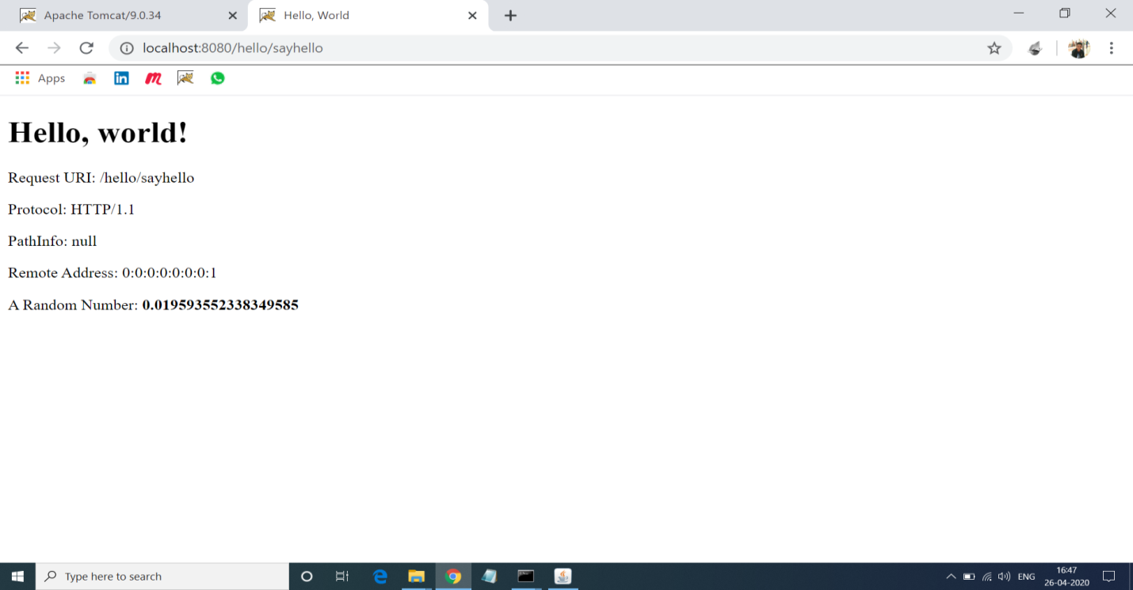

**2. Program for Adding Two Numbers With the Servlets:**

**Solution:-**

**Addnum.html:-**

<!DOCTYPE html>

<html>

<head>

<meta charset="UTF-8">

<title>Add Numbers</title>

</head>

<body>

<center>

<h1>Enters the Number For Adding:</h1>

<form action="add" method="post">

Enter 1st Number:<input type="text" name="num1"><br>

Enter 2nd Number:<input type="text" name="num2"><br>

<input type="submit">

</form>

</center>

</body>

</html>

**Addnum.java:-**

import java.io.IOException;

import java.io.PrintWriter;

import javax.servlet.annotation.WebServlet;

import javax.servlet.http.HttpServlet;

import javax.servlet.http.HttpServletRequest;

import javax.servlet.http.HttpServletResponse;

@WebServlet("/add")

public class AddNum extends HttpServlet

private static final long serialVersionUID = 1L;

public void doGet(HttpServletRequest req, HttpServletResponse res) throws IOException

{

int i = Integer.parseInt(req.getParameter("num1"));

int j = Integer.parseInt(req.getParameter("num2"));

int k= i+j;

PrintWriter out = res.getWriter();

out.println(k);

}

public void doPost(HttpServletRequest req, HttpServletResponse res) throws IOException

{

int i = Integer.parseInt(req.getParameter("num1"));

int j = Integer.parseInt(req.getParameter("num2"));

int k= i+j;

PrintWriter out = res.getWriter();

out.println(k);

}

}

**Output 2:-**

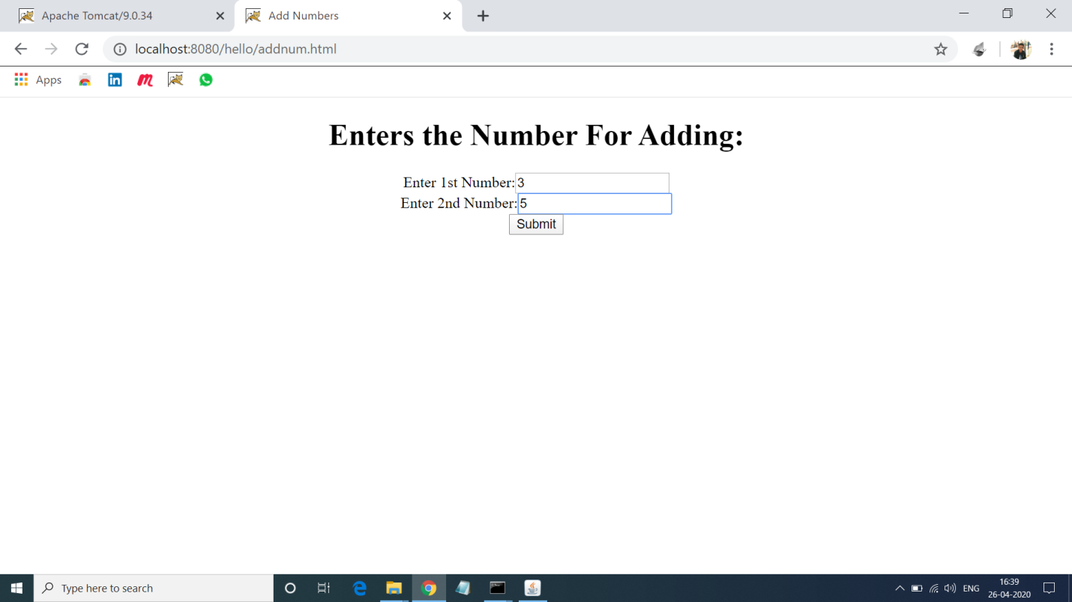

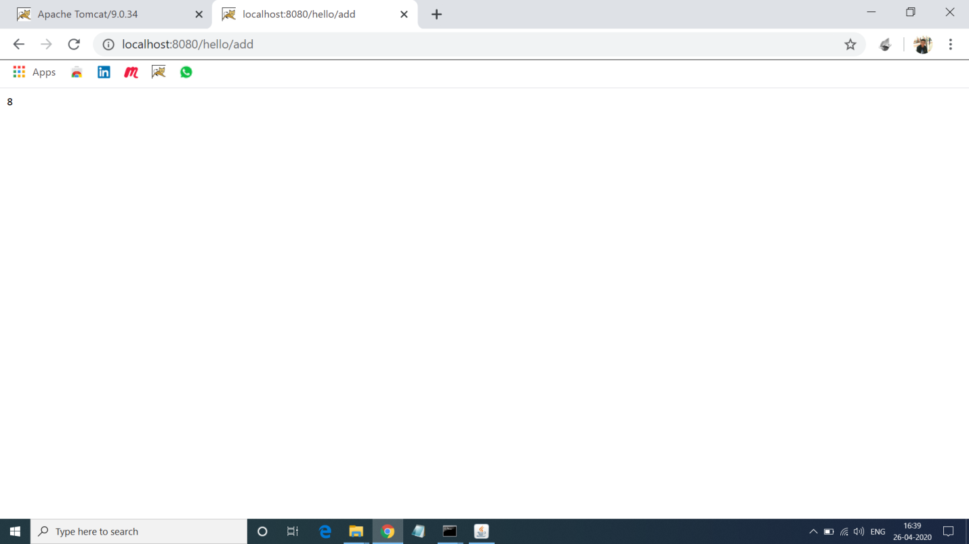

**3. Program of Displaying Entered details using Java Servlet:**

**Solution:-**

**Detail.html:-**

<html>

<head>

<title>Form</title>

<meta charset="UTF-8">

<meta name="viewport" content="width=device-width, initial-scale=1.0">

</head>

<body>

<h1>Enter Details </h1>

<form name="Form1" method="post" action="detail" bgcolor="blue">

<center>

<label>Name:</label>

<input type="text" name="name" ><br><br>

<label>Phone No.:</label>

<input type="text" name="phone" ><br>

<input type="submit" value="submit details">

</center>

</form>

</body>

</html>

**Detail.java:-**

import java.io.IOException;

import java.io.PrintWriter;

import java.util.Enumeration;

import javax.servlet.ServletException;

import javax.servlet.annotation.WebServlet;

import javax.servlet.http.HttpServlet;

import javax.servlet.http.HttpServletRequest;

import javax.servlet.http.HttpServletResponse;

@WebServlet("/detail")

public class Detail extends HttpServlet {

private static final long serialVersionUID = 1L;

protected void doPost(HttpServletRequest request, HttpServletResponse response) throws ServletException, IOException {

response.setContentType("text/html");

PrintWriter pw = response.getWriter();

Enumeration e = request.getParameterNames();

while(e.hasMoreElements())

{

String pname = (String)e.nextElement();

pw.println(pname + " = ");

String pvalue = request.getParameter(pname);

pw.println(pvalue);

}

pw.close();

}

}

**Output 3:-**

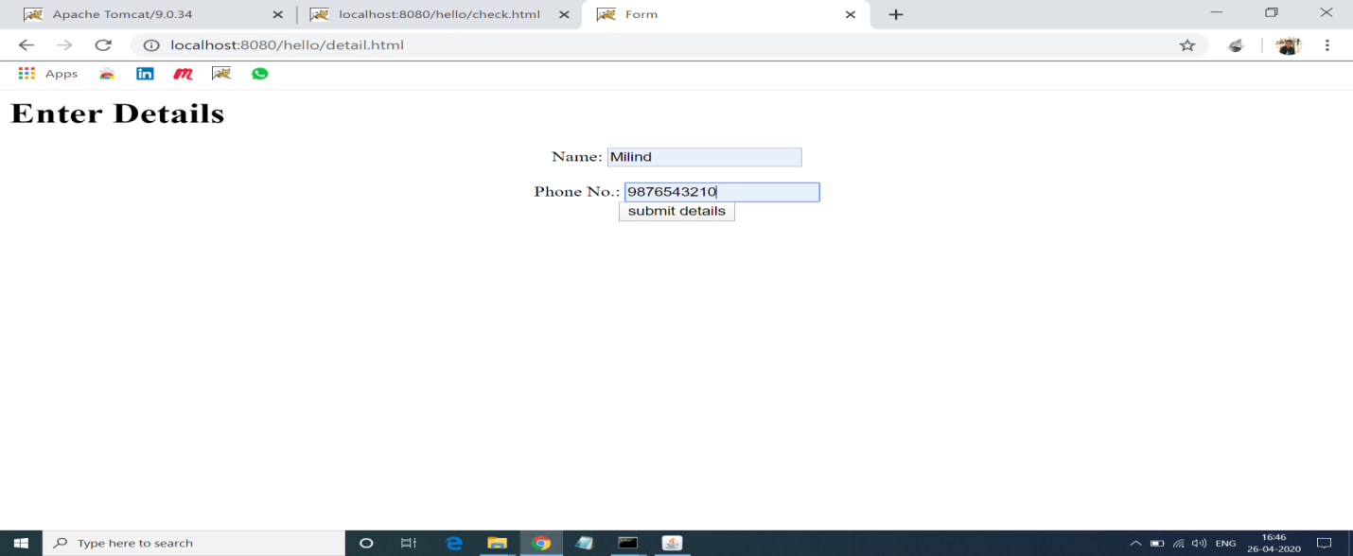

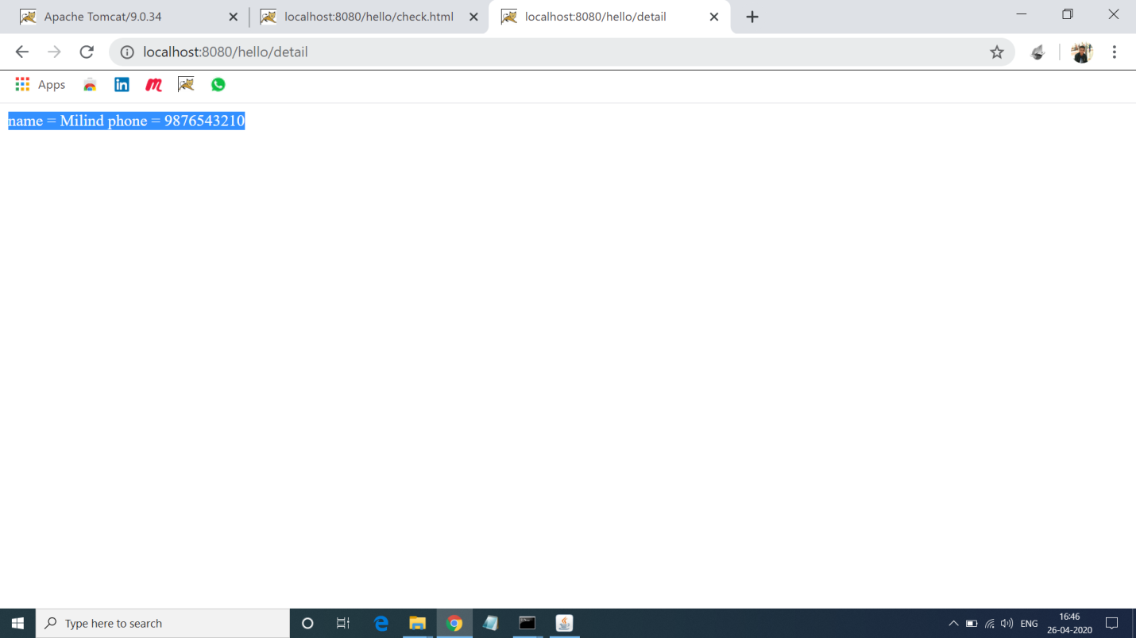

**4. Program of Reading Checkbox In Servlet:**

**Solution:-**

**Check.html:-**

<html>

<body>

<center>

<h1>See Which checkbox is checked</h1>

<form action = "Servlet" method = "POST" target = "_blank">

<input type = "checkbox" name = "Mtech" checked = "checked" /> Mtech<br>

<input type = "checkbox" name = "MCA" /> MCA<br>

<input type = "checkbox" name = "MBA" checked = "checked" />

MBA<br>

<input type = "submit" value = "Select Course" /><br>

</form>

</center>

</body>

</html>

**Check.java:-**

import java.io.IOException;

import java.io.PrintWriter;

import javax.servlet.ServletException;

import javax.servlet.annotation.WebServlet;

import javax.servlet.http.HttpServlet;

import javax.servlet.http.HttpServletRequest;

import javax.servlet.http.HttpServletResponse;

@WebServlet("/Servlet")

public class Check extends HttpServlet {

private static final long serialVersionUID = 1L;

protected void doGet(HttpServletRequest request, HttpServletResponse response) throws ServletException, IOException {

response.setContentType("text/html");

PrintWriter out = response.getWriter();

String title = "Reading Checkbox Data";

String docType =

"<!doctype html public \"-//w3c//dtd html 4.0 " + "transitional//en\">\n";

out.println(docType +

"<html>\n" +

"<head><title>" + title + "</title></head>\n" +

"<body bgcolor = \"#f0f0f0\">\n" +

"<h1 align = \"center\">" + title + "</h1>\n" +

"<ul>\n" +

" <li><b>Mtech Flag : </b>: "

+ request.getParameter("Mtech") + "\n" +

" <li><b>MCA Flag: </b>: "

+ request.getParameter("MCA") + "\n" +

" <li><b>MBA Flag: </b>: "

+ request.getParameter("MBA") + "\n" +

"</ul>\n");

out.println( "</body>");

out.println("</html>");

}

protected void doPost(HttpServletRequest request, HttpServletResponse response) throws ServletException, IOException {

doGet(request, response);

}

}

**Output 4:-**

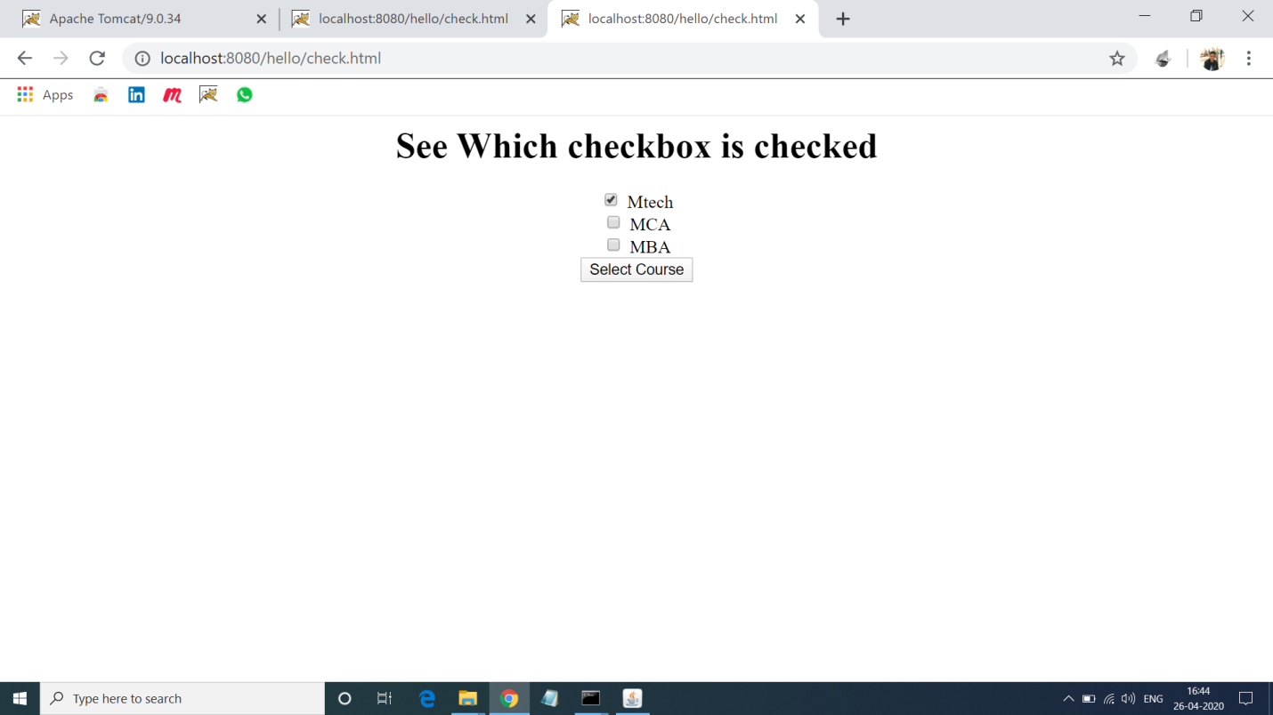

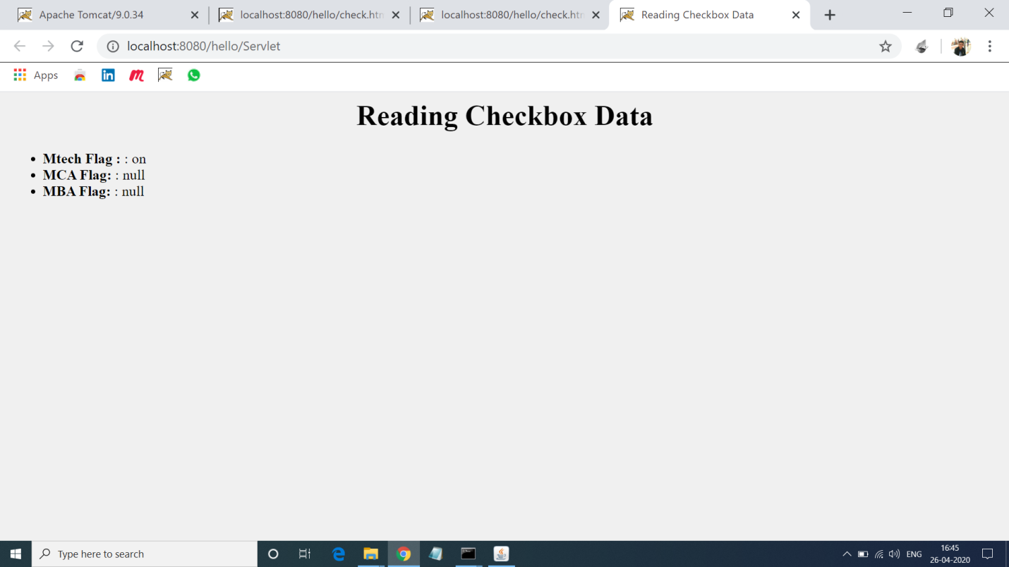

**5.Program of Adding and Getting Cookies in Java Servlets:-Solution:-**

**addCokkie.html:-**

<!DOCTYPE html>

<html>

<head>

<meta charset="ISO-8859-1">

<title>Username</title>

</head>

<body>

<cenetr>

<form action="AddCookie" method="post">

<label>Enter Username: </label><br>

<input name="unm" type="text"><br>

<input type="submit" value="Enter"><br>

</form>

</center>

</body>

</html>

**addCookie.java:-**

import java.io.IOException;

import java.io.PrintWriter;

import javax.servlet.ServletException;

import javax.servlet.annotation.WebServlet;

import javax.servlet.http.Cookie;

import javax.servlet.http.HttpServlet;

import javax.servlet.http.HttpServletRequest;

import javax.servlet.http.HttpServletResponse;

@WebServlet("/AddCookie")

public class AddCookie extends HttpServlet {

private static final long serialVersionUID = 1L;

protected void doPost(HttpServletRequest request, HttpServletResponse response) throws ServletException, IOException {

response.setContentType("text/html");

PrintWriter out=response.getWriter();

String unm=request.getParameter("unm");

out.println("<h3>Welcome</h3>"+unm);

try {

Cookie c=new Cookie("unm",unm);

response.addCookie(c);

out.println("<form action='GetCookie' method='get'>");

out.println("<input type=submit value=go>");

out.println("</form>");

}

catch(Exception e) {

}

}

}

**getCookie.java:-**

import java.io.IOException;

import java.io.PrintWriter;

import javax.servlet.ServletException;

import javax.servlet.annotation.WebServlet;

import javax.servlet.http.Cookie;

import javax.servlet.http.HttpServlet;

import javax.servlet.http.HttpServletRequest;

import javax.servlet.http.HttpServletResponse;

@WebServlet("/GetCookie")

public class GetCookie extends HttpServlet {

private static final long serialVersionUID = 1L;

protected void doGet(HttpServletRequest request, HttpServletResponse response) throws ServletException, IOException {

response.setContentType("text/html");

PrintWriter out=response.getWriter();

try {

Cookie c2[]=request.getCookies();

out.println("<h3>Hello</h3>"+c2[0].getValue());

}

catch(Exception e) {

out.println(e); }}}

**Output 5:-**

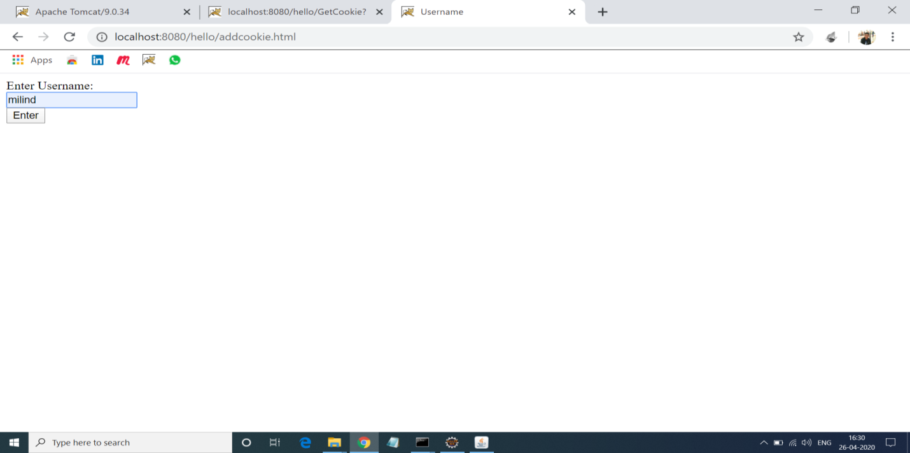

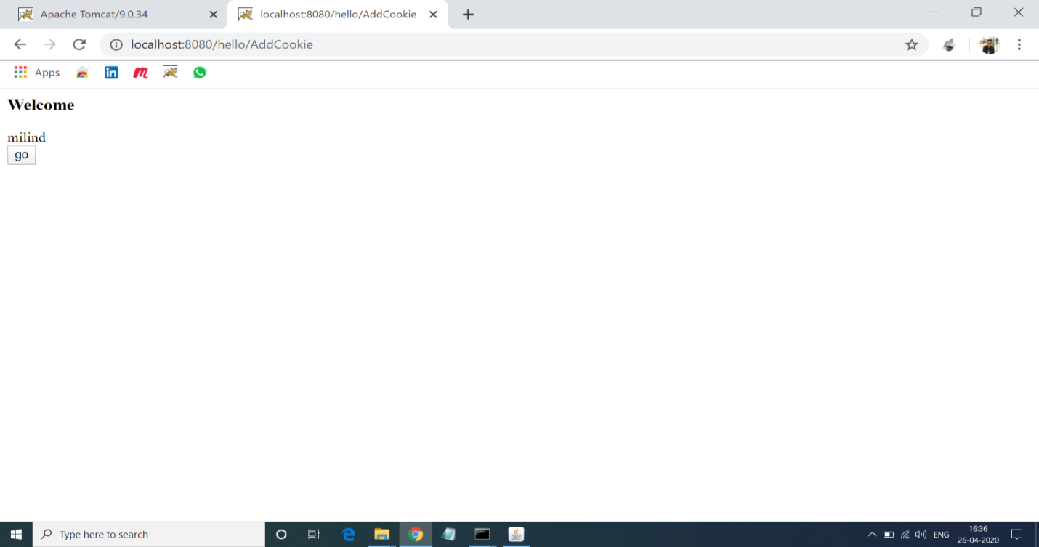

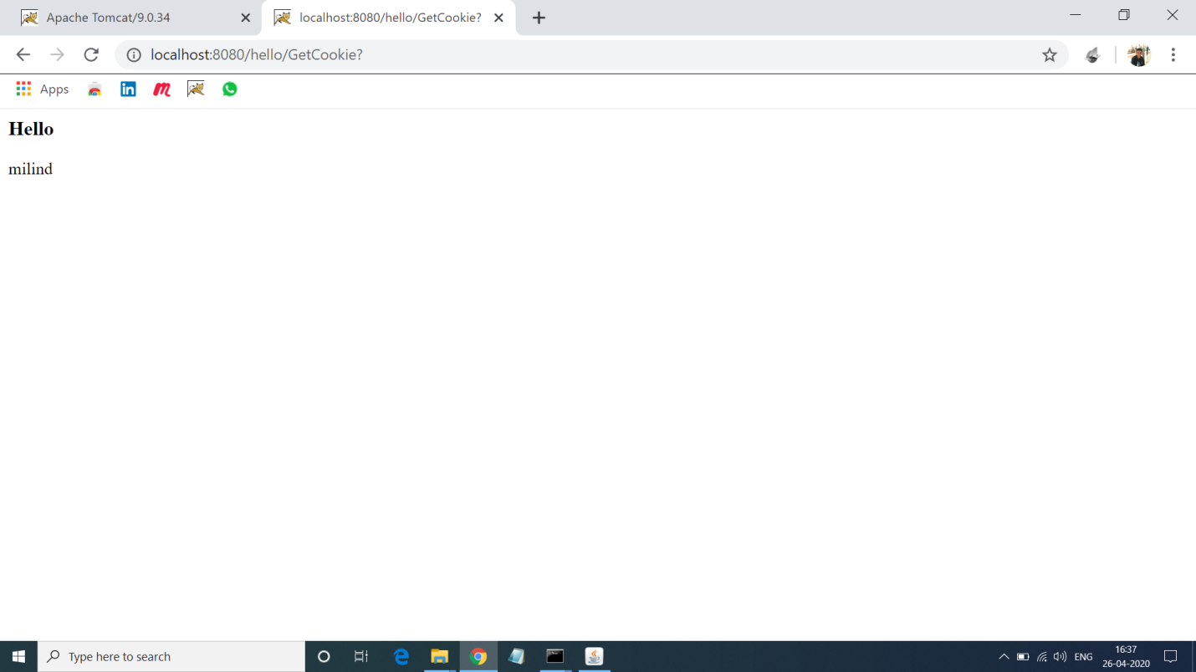

**6. Program of Retriving Data from database using Mysql and Servlet.**

**Solution:-**

**Querybook.html:-**

<!DOCTYPE html>

<html>

<head>

<title>Yet Another Bookshop</title>

</head>

<body>

<h2>Yet Another Bookshop</h2>

<form method="get" action="http://localhost:8080/hello/query">

<b>Choose an author:</b>

<input type="checkbox" name="author" value="Tan Ah Teck">Ah Teck

<input type="checkbox" name="author" value="Mohammad Ali">Ali

<input type="checkbox" name="author" value="Kumar">Kumar

<input type="submit" value="Search">

</form>

</body>

</html>

**queryServlet.java:-**

import java.io.*;

import java.sql.*;

import javax.servlet.*;

import javax.servlet.http.*;

import javax.servlet.annotation.*;

@WebServlet("/query")

public class QueryServlet extends HttpServlet {

@Override

public void doGet(HttpServletRequest request, HttpServletResponse response)

throws ServletException, IOException {

response.setContentType("text/html");

PrintWriter out = response.getWriter();

out.println("<!DOCTYPE html>");

out.println("<html>");

out.println("<head><title>Query Response</title></head>");

out.println("<body>");

try (

Connection conn = DriverManager.getConnection(

"jdbc:mysql://localhost:3306/ebookshop?allowPublicKeyRetrieval=true&useSSL=false&serverTimezone=UTC",

"milind", "vasu19@@"); // For MySQL

Statement stmt = conn.createStatement();

) {

String sqlStr = "select * from books where author = "

+ "'" + request.getParameter("author") + "'" // Single-quote SQL string

+ " and qty > 0 order by price desc";

out.println("<h3>Thank you for your query.</h3>");

out.println("<p>Your SQL statement is: " + sqlStr + "</p>");

ResultSet rset = stmt.executeQuery(sqlStr); // Send the query to the server

int count = 0;

while(rset.next()) {

out.println("<p>" + rset.getString("author")

+ ", " + rset.getString("title")

+ ", $" + rset.getDouble("price") + "</p>");

count++;

}

out.println("<p>==== " + count + " records found =====</p>");

} catch(Exception ex) {

out.println("<p>Error: " + ex.getMessage() + "</p>");

out.println("<p>Check Tomcat console for details.</p>");

ex.printStackTrace();

}

out.println("</body></html>");

out.close();

}}

**Output 6:-**

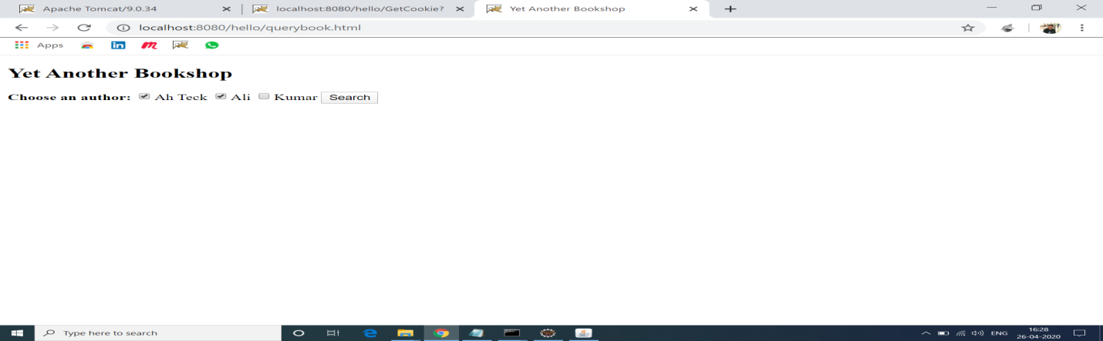

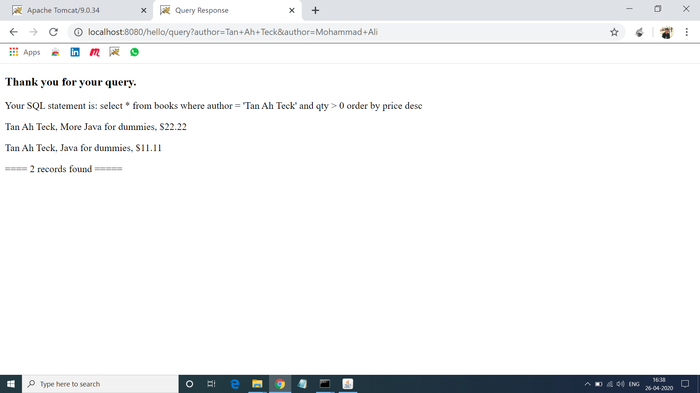

**7. Program of Storing Data in Database:**

**Solution:-**

**Addstudent.html:-**

<html>

<head>

<title>Add Student</title>

<meta charset="UTF-8">

<meta name="viewport" content="width=device-width, initial-scale=1.0">

</head>

<body>

<h1>Enter Details of Add student:</h1>

<form method="post" action="addstudent">

<label>Roll no.:</label><br>

<input type="number" name="rno" ><br>

<label>Name:</label><br>

<input type="text" name="name" ><br>

<label>Class:</label><br>

<input type="text" name="class" ><br>

<input type="submit" value="submit">

</form>

</body>

</html>

**AddStudent.java:-**

import java.io.IOException;

import java.io.PrintWriter;

import java.sql.Connection;

import java.sql.DriverManager;

import java.sql.PreparedStatement;

import javax.servlet.ServletException;

import javax.servlet.annotation.WebServlet;

import javax.servlet.http.HttpServlet;

import javax.servlet.http.HttpServletRequest;

import javax.servlet.http.HttpServletResponse;

@WebServlet("/addstudent")

public class AddStudent extends HttpServlet {

private static final long serialVersionUID = 1L;

protected void doPost(HttpServletRequest request, HttpServletResponse response) throws ServletException, IOException {

response.setContentType("text/html");

PrintWriter out=response.getWriter();

try{

Class.forName("com.mysql.jdbc.Driver");

Connection con=DriverManager.getConnection("jdbc:mysql://localhost:3306/mydb","milind","vasu19@@");

int rno=Integer.parseInt(request.getParameter("rno"));

String name=request.getParameter("name");

int cls=Integer.parseInt(request.getParameter("class"));

String section=request.getParameter("section");

String sql="INSERT INTO student(`rno`, `name`, `class`, `section`) VALUES (?,?,?,?)";

PreparedStatement stmt=con.prepareStatement(sql);

stmt.setInt(1, rno);

stmt.setString(2,name);

stmt.setInt(3, cls);

stmt.setString(4, section);

int x=stmt.executeUpdate();

if(x==1){

System.out.println("Row inserted!");

out.println("Row inserted successfully");

}

else{

System.out.println("Row could not be inserted!");

}

out.close();

}

catch(Exception ex){

System.out.println(ex);

out.println(ex);

}

}

}

**Output 7:-**

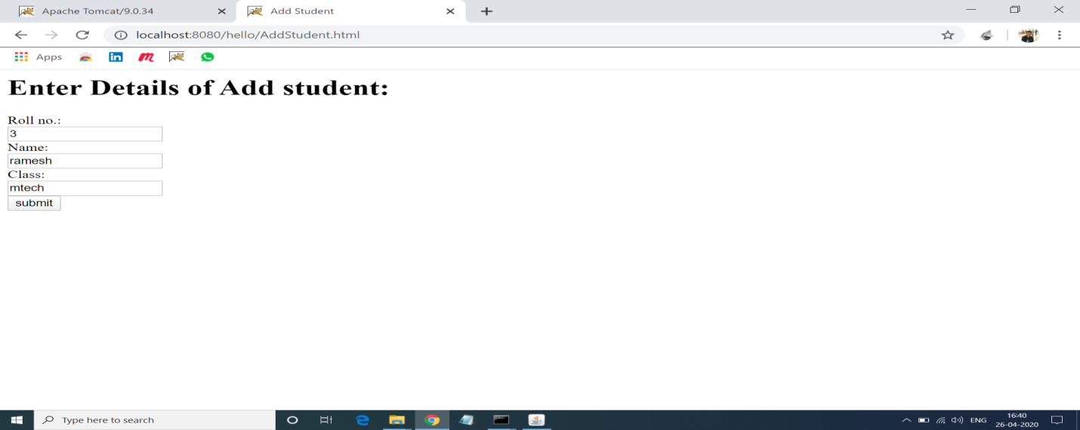

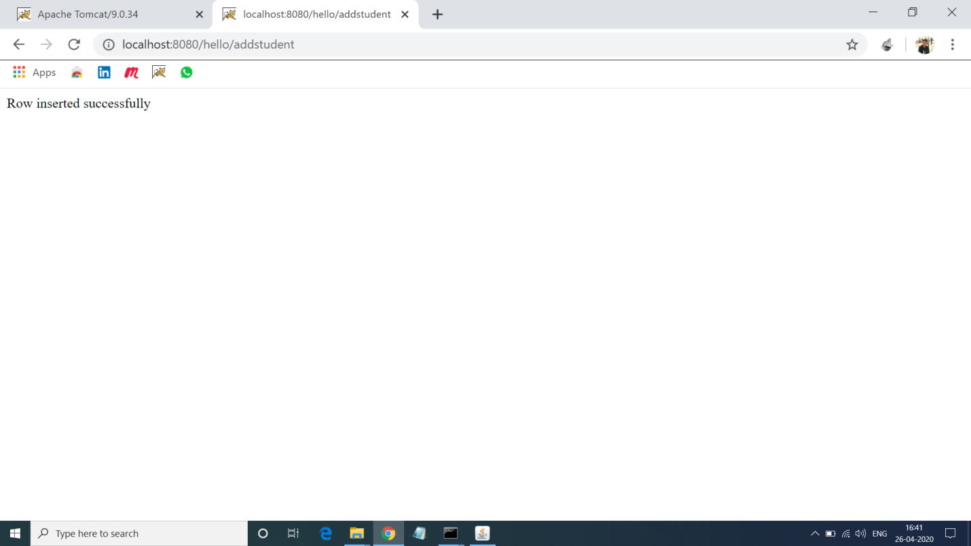

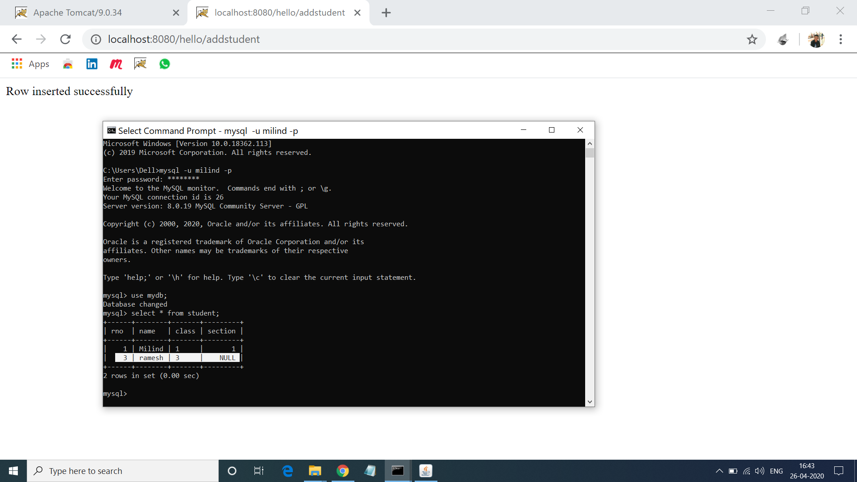

**8. Program of Simple Login and Logut Form using Cookies.**

**Solution:-**

**Login.html:-**

<!DOCTYPE html>

<html>

<head>

<meta charset="ISO-8859-1">

<title>Login using cookies</title>

</head>

<body>

<center>

<h3>Login using cookies!</h3>

<form action="Servlet1" method="post">

<input name=unm type=text placeholder= EnterUsername><br><br>

<input name=upass type=password placeholder=EnterPassword><br>

<button type=submit>Submit</button>

</form>

</center>

</body>

</html>

**Login.java:-**

import java.io.IOException;

import java.io.PrintWriter;

import javax.servlet.ServletException;

import javax.servlet.annotation.WebServlet;

import javax.servlet.http.Cookie;

import javax.servlet.http.HttpServlet;

import javax.servlet.http.HttpServletRequest;

import javax.servlet.http.HttpServletResponse;

@WebServlet("/Servlet1")

public class Login extends HttpServlet {

private static final long serialVersionUID = 1L;

protected void doPost(HttpServletRequest request, HttpServletResponse response) throws ServletException, IOException {

response.setContentType("text/html");

PrintWriter out=response.getWriter();

String unm=request.getParameter("unm");

String upass=request.getParameter("upass");

if(upass.equals("123")) {

out.println("<form action=http://localhost:8080/hello/LogoutServlet method=post>");

out.println("<button type=submit>Logout</button>");

out.println("</form>");

out.println("<center>");

out.println("<h3>Welcome "+unm+"</h3>");

out.println("<form action=http://localhost:8080/hello/ProfileServlet method=post>");

out.println("<button type=submit>View your profile</button>");

out.println("</form>");

out.println("</center>");

Cookie ck=new Cookie("unm",unm);

response.addCookie(ck);

}

else {

request.getRequestDispatcher("login.html").include(request, response);

out.println("<h3>Incorrect username or password! </h3>");

} }}

**LogoutServlet.java:-**

import java.io.IOException;

import java.io.PrintWriter;

import javax.servlet.ServletException;

import javax.servlet.annotation.WebServlet;

import javax.servlet.http.Cookie;

import javax.servlet.http.HttpServlet;

import javax.servlet.http.HttpServletRequest;

import javax.servlet.http.HttpServletResponse;

@WebServlet("/LogoutServlet")

public class LogoutServlet extends HttpServlet {

private static final long serialVersionUID = 1L;

protected void doPost(HttpServletRequest request, HttpServletResponse response) throws ServletException, IOException {

response.setContentType("text/html");

PrintWriter out=response.getWriter();

request.getRequestDispatcher("login.html").include(request, response);

Cookie ck=new Cookie("unm","");

ck.setMaxAge(0);

response.addCookie(ck);

out.print("you are successfully logged out!");

}}

**Output 8:-**

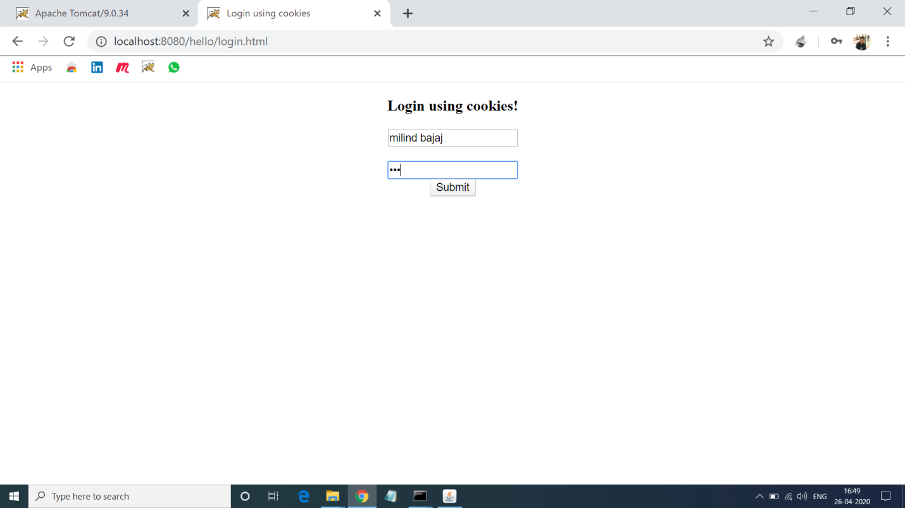

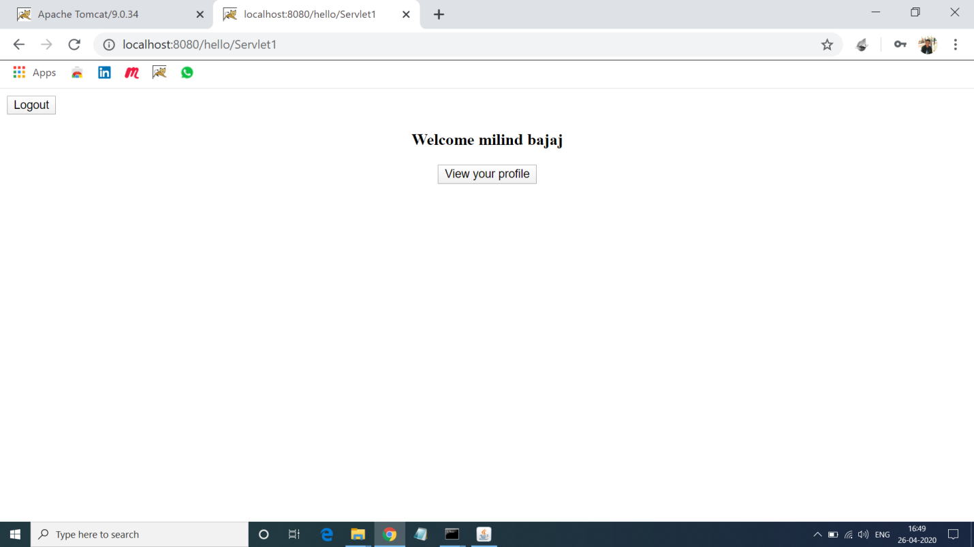

**Logout:-**

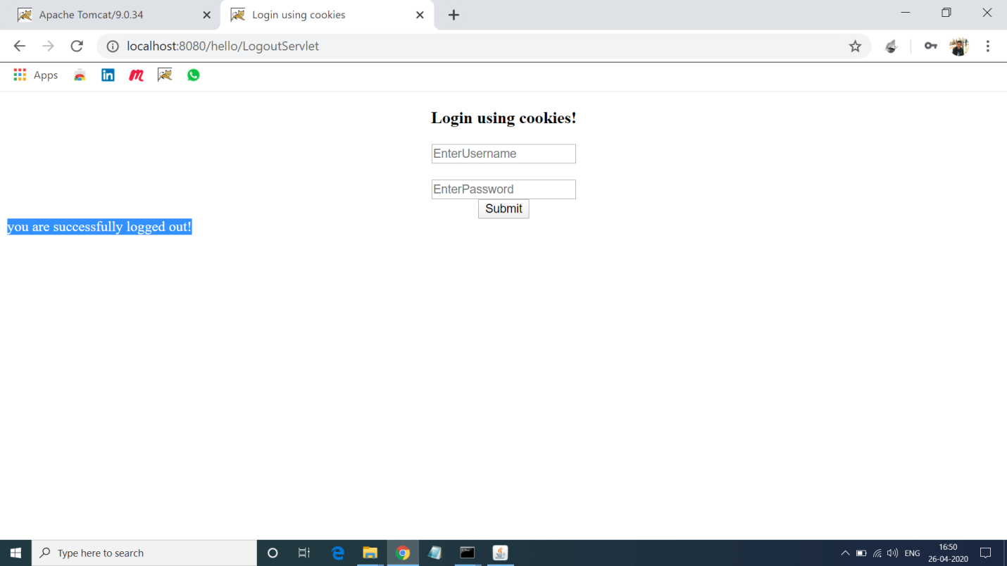

**9.Program of Auto Refeshing a Page in Servelt.**

**Solution:-**

**Auto.java:-**

import java.io.*;

import javax.servlet.*;

import javax.servlet.http.*;

import java.util.*;

import javax.servlet.annotation.*;

@WebServlet("/refresh")

public class Refresh extends HttpServlet

{

public void doGet(HttpServletRequest request, HttpServletResponse response) throws ServletException, IOException

{

response.setIntHeader("Refresh", 1);

response.setContentType("text/html");

Calendar calendar = new GregorianCalendar();

String am_pm;

int hour = calendar.get(Calendar.HOUR);

int minute = calendar.get(Calendar.MINUTE);

int second = calendar.get(Calendar.SECOND);

if(calendar.get(Calendar.AM_PM) == 0)

am_pm = "AM";

else

am_pm = "PM";

String CT = hour+":"+ minute +":"+ second +" "+ am_pm;

PrintWriter out = response.getWriter();

out.println("<h1 align='center'>Auto Refresh Page</h1><hr>");

out.println("<h3 align='center'>Current time: "+CT+"</h3>");

}

public void doPost(HttpServletRequest request, HttpServletResponse response) throws ServletException, IOException

{

doGet(request, response); }}

**Output 9:-**

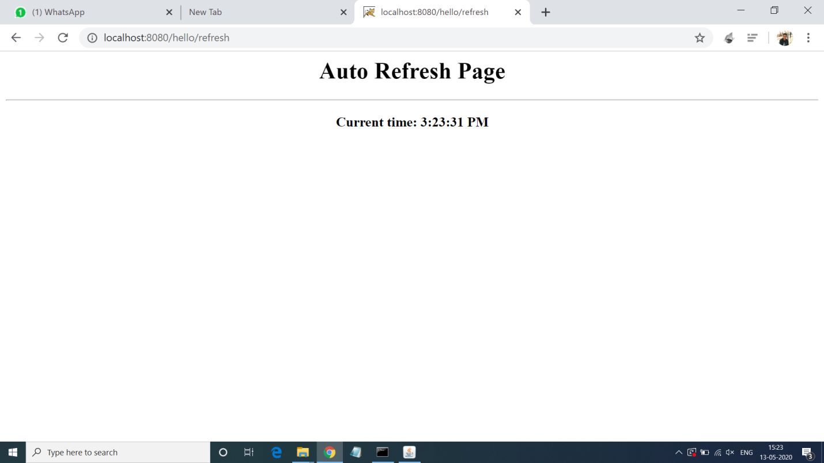

**10.Program for Checking Voting Egibilitiy using Servlet.**

**Solution:-**

**Index.html:-**

<!doctype html>

<html lang="en">

<head>

<meta charset="UTF-8">

<title>VoterApp</title>

</head>

<body>

<form action= "Voter" method="get">

<fieldset style="width:20%; background-color:#80ffcc">

<table>

<tr><td>Name</td><td><input type="text" name="name"></td></tr>

<tr><td>Age</td><td><input type="text" name="age"></td></tr>

<tr><td></td><td><input type = "submit" value="check voting eligibility"></td></tr>

</table>

</fieldset>

</form>

</body>

</html>

**Voter.java:-**

import java.io.*;

import java.util.*;

import javax.servlet.*;

import javax.servlet.http.*;

import javax.servlet.annotation.*;

@WebServlet("/Voter")

public class Voter extends HttpServlet

{

public void service(HttpServletRequest req, HttpServletResponse res) throws IOException,ServletException

{

res.setContentType("text/html");

PrintWriter pw = res.getWriter();

String name = req.getParameter("name");

int age = Integer.parseInt(req.getParameter("age"));

if (age>=18)

{

pw.println("<font color='green' size='4'>"+name+" you are eligible to vote</font>");

}

else

pw.println("<font color='red' size='4'>"+name+" you are not eligible to vote</font>");

pw.println("<br><br><a href= 'Voter.html'>Home</a>");

pw.close();

}

}

**Output 10:-**

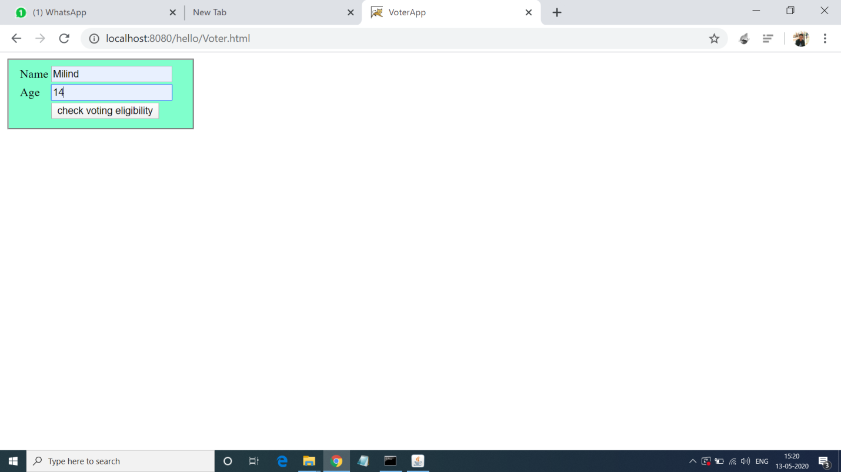

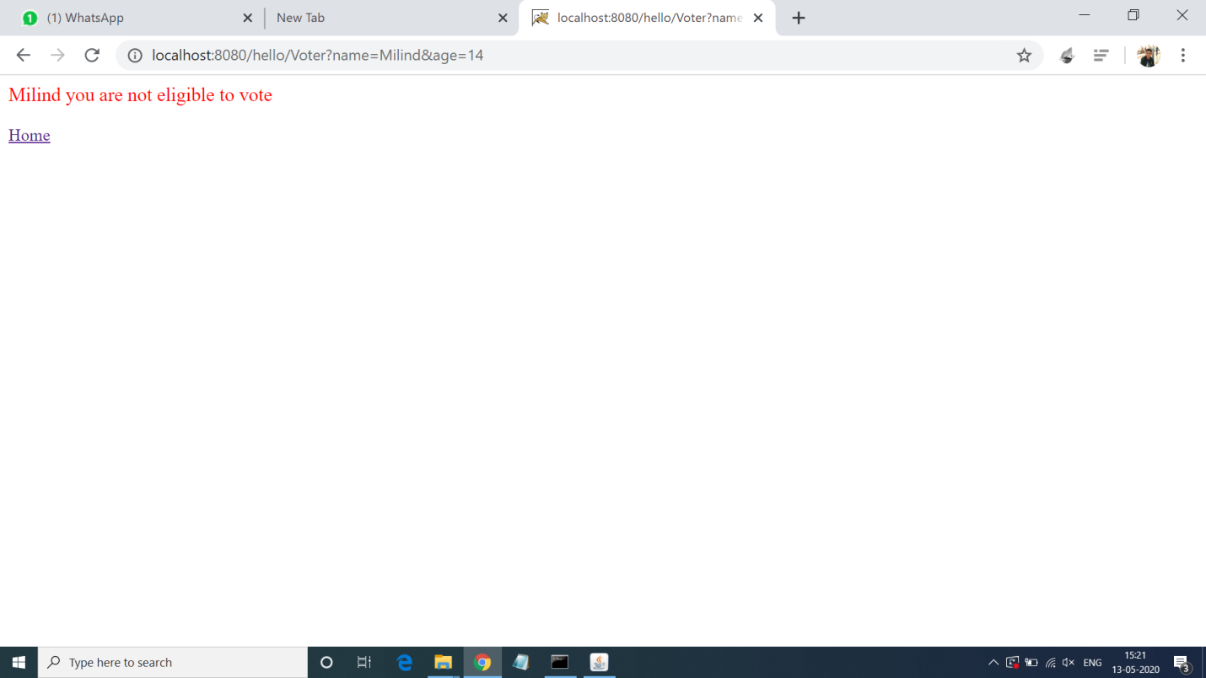

**11.Program of Session Tracking using Sevlet.**

**Solution:-**

**Session.java:-**

import java.io.*;

import javax.servlet.*;

import javax.servlet.http.*;

import java.util.*;

import java.util.Date;

import javax.servlet.annotation.*;

@WebServlet("/session")

public class SessionDemo extends HttpServlet

{

public void doGet(HttpServletRequest request, HttpServletResponse response) throws ServletException, IOException

{

HttpSession session = request.getSession(true);

Date createTime = new Date(session.getCreationTime());

Date lastAccessTime = new Date(session.getLastAccessedTime());

String title = "Welcome Back to my website";

Integer visitCount = new Integer(0);

String visitCountKey = new String("visitCount");

String userIDKey = new String("userID");

String userID = new String("Surendra");

if (session.isNew())

{

title = "Welcome to my website";

session.setAttribute(userIDKey, userID);

}

else

{

visitCount = (Integer)session.getAttribute(visitCountKey);

visitCount = visitCount + 1;

userID = (String)session.getAttribute(userIDKey);

}

session.setAttribute(visitCountKey, visitCount);

response.setContentType("text/html");

PrintWriter out = response.getWriter();

String docType =

"<!doctype html public \"-//w3c//dtd html 4.0 " +

"transitional//en\">\n";

out.println(docType +

"<html>\n" +

"<head><title>" + title + "</title></head>\n" +

"<body bgcolor=\"#e5f7c0\">\n" +

"<h1 align=\"center\">" + title + "</h1>\n" +

"<h2 align=\"center\">Session Infomation</h2>\n" +

"<table border=\"1\" align=\"center\">\n" +

"<tr bgcolor=\"#eadf8c\">\n" +

"<th>Session info</th><th>value</th></tr>\n" +

"<tr>\n" +

" <td>id</td>\n" +

" <td>" + session.getId() + "</td></tr>\n" +

"<tr>\n" +

" <td>Creation Time</td>\n" +

" <td>" + createTime +

" </td></tr>\n" +

"<tr>\n" +

" <td>Time of Last Access</td>\n" +

" <td>" + lastAccessTime +

" </td></tr>\n" +

"<tr>\n" +

" <td>User ID</td>\n" +

" <td>" + userID +

" </td></tr>\n" +

"<tr>\n" +

" <td>Number of visits</td>\n" +

" <td>" + visitCount + "</td></tr>\n" +

"</table>\n" +

"</body></html>") }}

**Output 11:-**

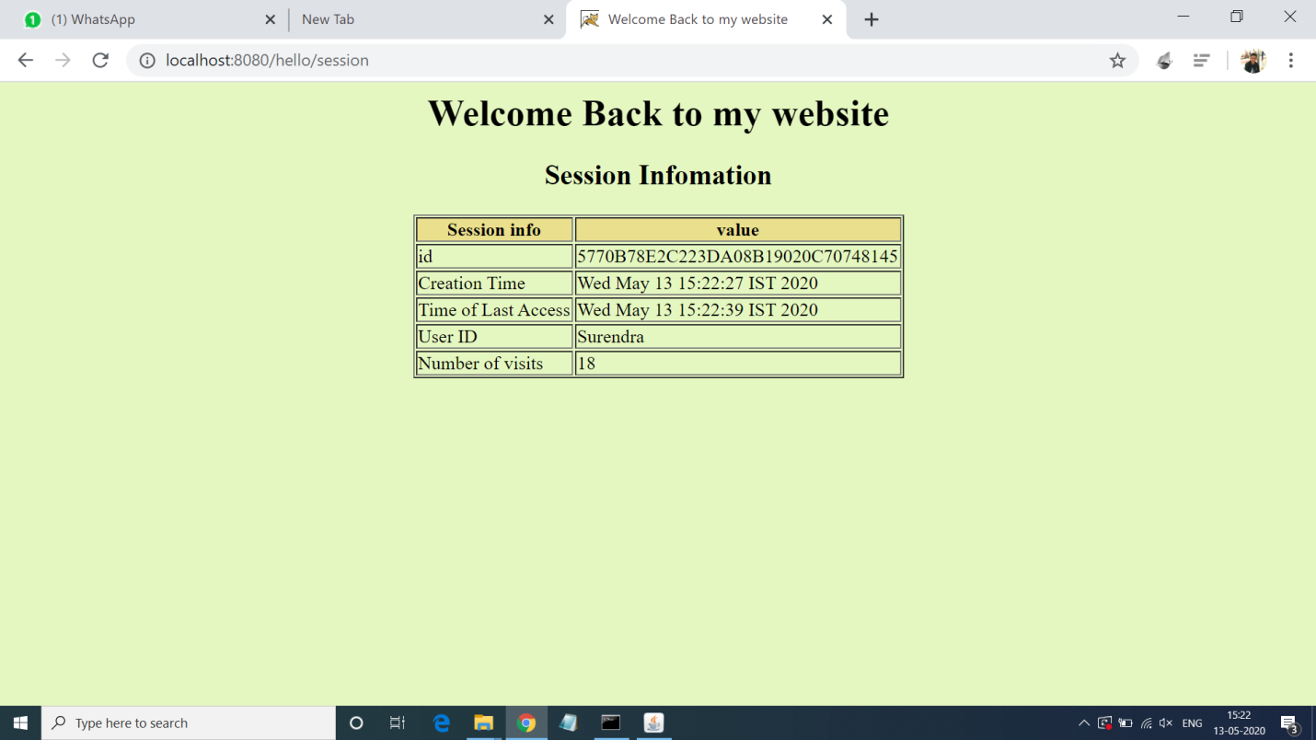

**12.Program to count number of visitor in website.**

**Solution:-**

**Counter.java:-**

import java.io.IOException;

import java.io.PrintWriter;

import javax.servlet.ServletException;

import javax.servlet.http.HttpServlet;

import javax.servlet.http.HttpServletRequest;

import javax.servlet.http.HttpServletResponse;

import javax.servlet.annotation.*;

@WebServlet("/counter")

public class CounterServlet extends HttpServlet

{

private int iHitCounter;

public void init() throws ServletException

{

iHitCounter = 0;

}

public void doGet(HttpServletRequest request, HttpServletResponse response) throws ServletException, IOException

{

PrintWriter out = response.getWriter();

Out.println("Welcome to my website !");

out.println("You are visitor number: "+ (++iHitCounter));

}

public void doPost(HttpServletRequest request, HttpServletResponse response) throws ServletException, IOException

{

doGet(request, response); }}

**Output 12:-**

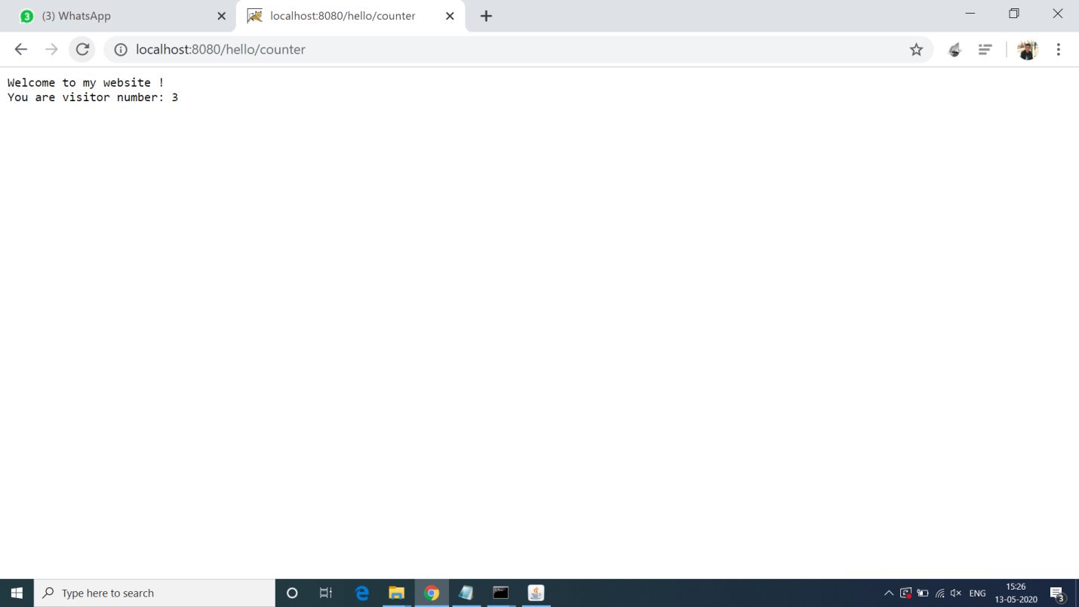

**13.Program to get current time and date using Servlet.**

**Solution:-**

**Date.java:-**

import javax.servlet.*;

import javax.servlet.annotation.*;

import java.io.*;

import javax.servlet.*;

import javax.servlet.http.*;

import java.util.*;

@WebServlet("/date")

public class Date extends GenericServlet

{

public void service(ServletRequest req, ServletResponse res) throws IOException, ServletException

{

res.setContentType("text/html");

PrintWriter pw = res.getWriter();

java.util.Date date = new java.util.Date();

pw.println("<h2>"+"Current Date & Time: " +date.toString()+"</h2>");

pw.close(); }}

**Output 13:-**

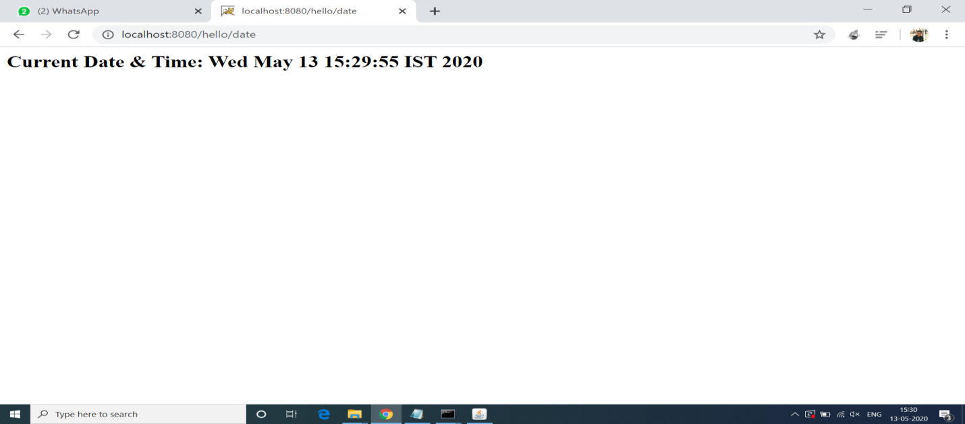

**14.Program for Adding Cookie at selected Value.**

**Solution:-**

**Index.html:-**

<!doctype html>

<head>

<title>CookiesExample</title>

</head>

<body>

<form method='post' action='ACookie'>

<fieldset style="width:14%; background-color:#ccffcc">

<h2>Select Course</h2> <hr>

<input type='radio' name='course' value='Java'>Java<br>

<input type='radio' name='course' value='UNIX'>UNIX<br>

<input type='radio' name='course' value='MCA'>DBMS<br>

<input type='radio' name='course' value='OOSE '>OOSE<br><br>

<input type='submit'> <input type='reset'><br>

</fieldset>

</form>

</body>

</html>

**Cookie.java:-**

import java.io.*;

import javax.servlet.*;

import javax.servlet.http.*;

import javax.servlet.annotation.*;

import javax.servlet.http.Cookie;

@WebServlet("/ACookie")

public class ACookie extends HttpServlet

{

public void doPost(HttpServletRequest req, HttpServletResponse res) throws ServletException,IOException

{

res.setContentType("text/html");

PrintWriter pw = res.getWriter();

Cookie []c = req.getCookies();

int id=1;

if(c!=null) id = c.length+1;

String value = req.getParameter("course");

Cookie newCookie = new Cookie("course:"+id,value);

res.addCookie(newCookie);

pw.println("<h4>Cookie added with value "+value+"</h4>");

}

}

**Output 14:-**

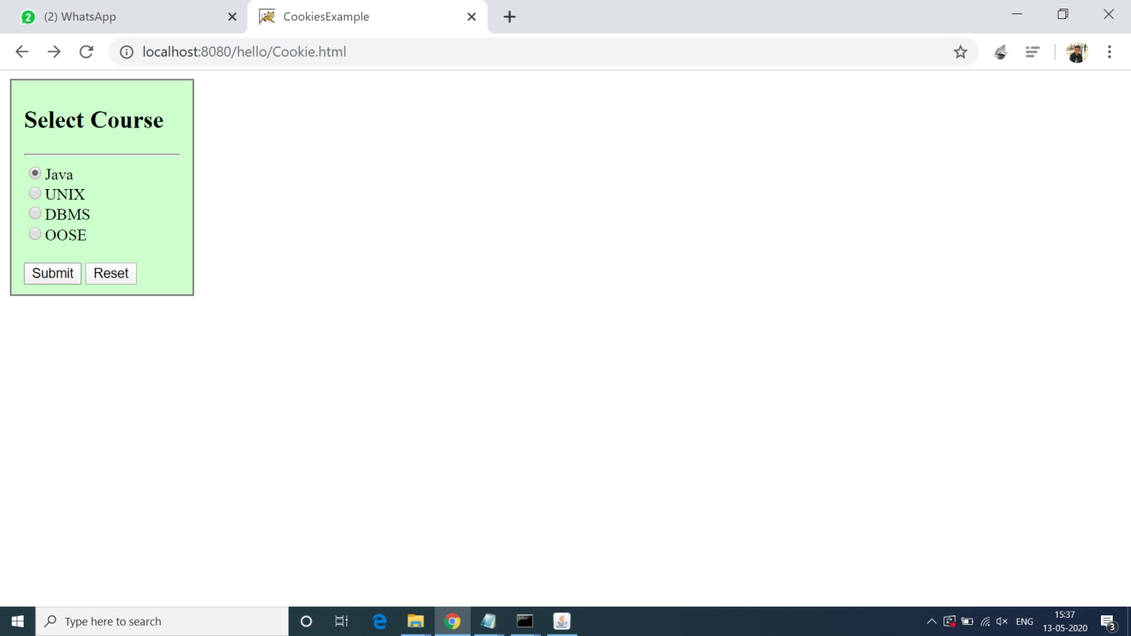

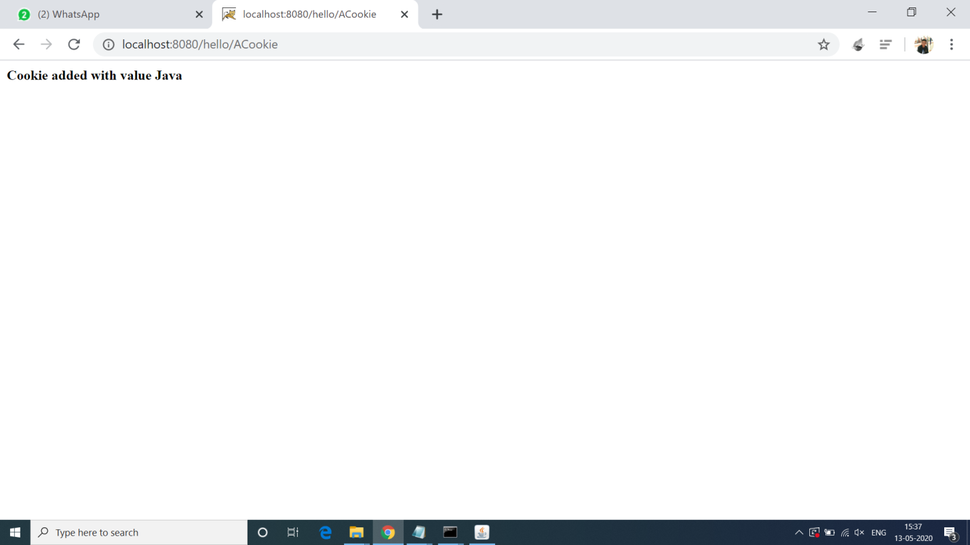

**15.Program of inserting Image in page using Servlet.**

**Solution:-**

**Image.java:-**

import java.io.*;

import javax.servlet.*;

import javax.servlet.http.*;

import javax.servlet.annotation.*;

@WebServlet("/image")

public class DisplayImage extends HttpServlet {

public void doGet(HttpServletRequest request,HttpServletResponse response)

throws IOException

{

response.setContentType("image/jpeg");

ServletOutputStream out;

out = response.getOutputStream();

FileInputStream fin = new FileInputStream("c:\\java.jpg");

BufferedInputStream bin = new BufferedInputStream(fin);

BufferedOutputStream bout = new BufferedOutputStream(out);

int ch =0; ;

while((ch=bin.read())!=-1)

{

bout.write(ch);

}

bin.close();

fin.close();

bout.close();

out.close(); } }

**Output 15:-**

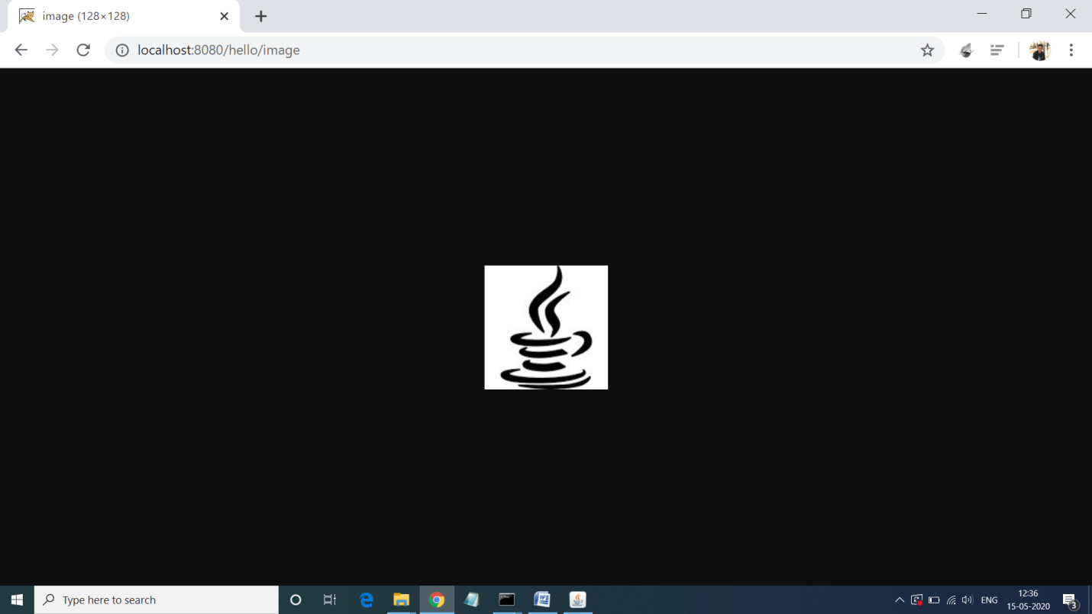

**16.Program of Downloading File using Servlet.**

**Solution:-**

**index.html:-**

<a href="Download">download the html file</a>

**Download.java:-**

import java.io.*;

import javax.servlet.ServletException;

import javax.servlet.http.*;

import javax.servlet.annotation.*;

@WebServlet("/Download")

public class DownloadServlet extends HttpServlet {

public void doGet(HttpServletRequest request, HttpServletResponse response)

throws ServletException, IOException {

response.setContentType("text/html");

PrintWriter out = response.getWriter();

String filename = "home.html";

String filepath = "e:\\";

response.setContentType("APPLICATION/OCTET-STREAM");

response.setHeader("Content-Disposition","attachment; filename=\"" + filename + "\"");

FileInputStream fileInputStream = new FileInputStream(filepath + filename);

int i;

while ((i=fileInputStream.read()) != -1) {

out.write(i);

}

fileInputStream.close();

out.close(); }}

**Output 16:-**

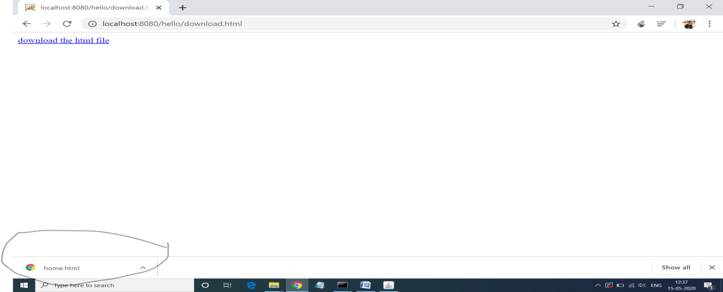

**17.Program of Uploading File using Servlet.**

**Solution:-**

**Index.html:-**

<html>

<body>

<form action="upload" method="post" enctype="multipart/form-data">

Select File:<input type="file" name="fname"/><br/>

<input type="submit" value="upload"/>

</form>

</body>

</html>

**Upload.java:-**

import java.io.*;

import javax.servlet.ServletException;

import javax.servlet.http.*;

import com.oreilly.servlet.MultipartRequest;

import javax.servlet.annotation.*;

@WebServlet("/upload")

public class UploadServlet extends HttpServlet {

public void doPost(HttpServletRequest request, HttpServletResponse response)

throws ServletException, IOException {

response.setContentType("text/html");

PrintWriter out = response.getWriter();

MultipartRequest m=new MultipartRequest(request,"d://");

out.print("successfully uploaded");

}

}

**Output 17:-**

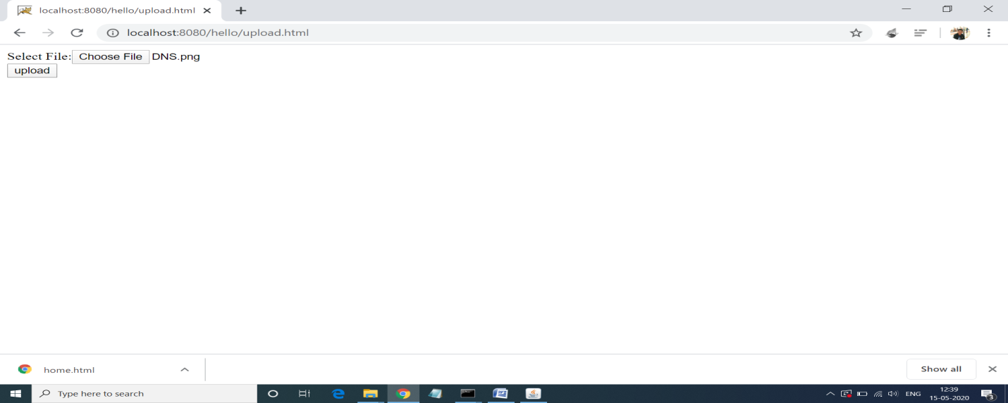

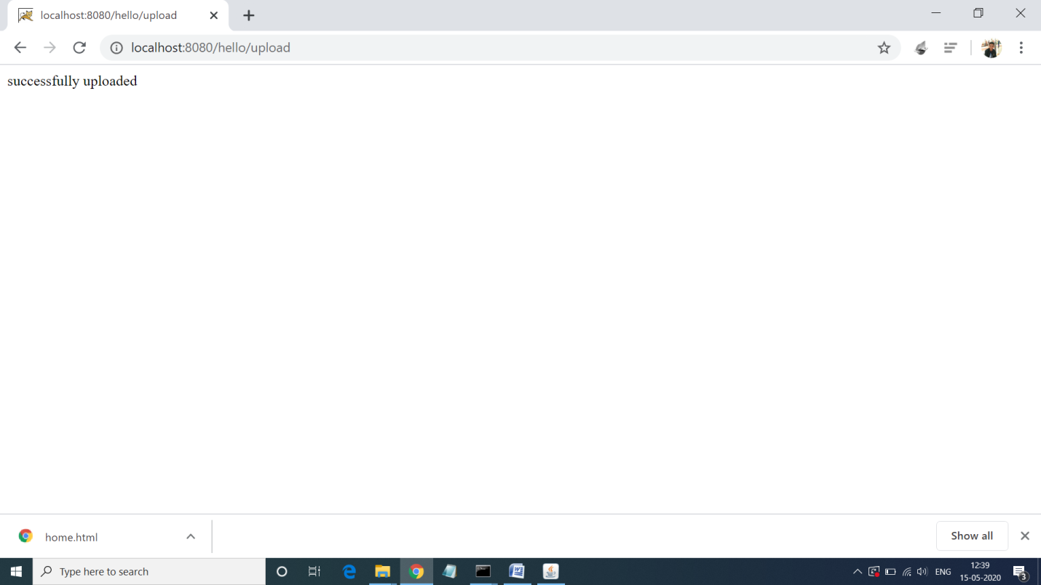

**18.**