CIFAR-10 Representation Learning Benchmark
By group 2

Objective:
To compare and evaluate the quality of learned representations across I-JEPA, MAE and CNN-based methods. Two evaluation processes- Linear Probe and LoRA / QLoRA Fine-tune were used.

2.MAE
Used Meta’s pretrained Masked Autoencoder (MAE) encoder

Training loss:
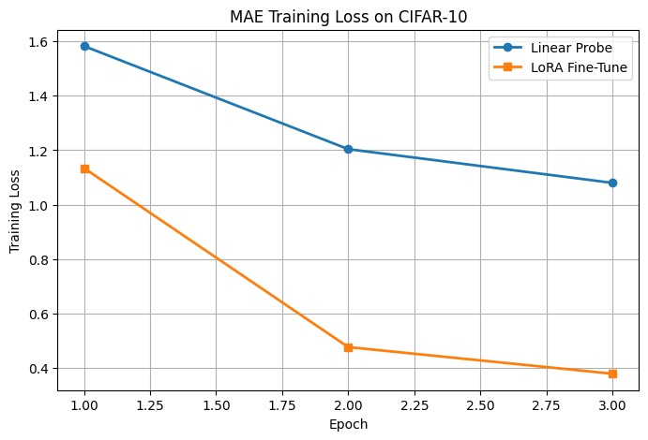

Evaluation Accuracy:

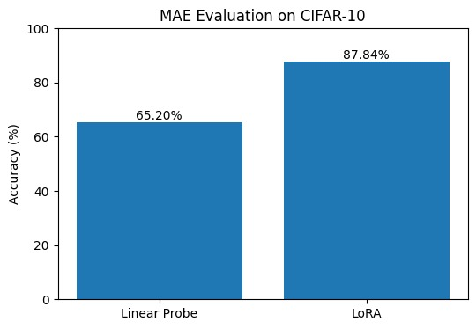

3. CNN-based model: ResNet50

Training loss:

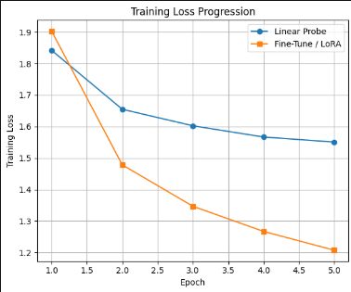

Testing Accuracy:

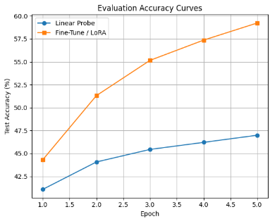

Results Table:
Final Accuracy of each model:

Model | Linear Probe Accuracy | LoRA / QLoRA Fine-tune
I-JEPA
MAE | 65.20% | 87.84%
ResNet50 | 45.44% | 55.16%

