SIEWGRAM

**A Mini Project Report**

**Submitted in Partial fulfillment for the award of Bachelor of Technology in CSE**

Submitted to

**RAJIV GANDHI PROUDYOGIKI VISHWAVIDYALAYA BHOPAL (M.P)**



**MINI PROJECT REPORT**

Submitted by

Milind Gajbhiye [0103CS221232] Manjas Dahate [0103CS221224] M a y a n k S e w a t k a r [0103CS221229]

Under the supervision of Prof. Vivek Kumar Sharma

[Assistant professor(LNCT,Bhopal)]

**Department of CSE**

**Lakshmi Narain College of Technology, Bhopal (M.P.)**

**Session 2023-24**

# LAKSHMI NARAIN COLLEGE OF TECHNOLOGY, BHOPAL

**DEPARTMENT OF CSE**



**CERTIFICATE**

This is to certify that the work embodied in this project work entitled **”Siewgram”** has been satisfactorily completed by the **Milind Gajbhiye [0103CS221232]**  **,**

**Manjas Dahate [0103CS221224]** **, M a y a n k S e w a t k a r [0103CS221229]**

**.** It is a bonafide piece of work, carried out under the guidance in **Department of CSE**, **Lakshmi Narain College of Technology, Bhopal** for the partial fulfillment of the **Bachelor of Technology** during the academic year 2023-2024.

Prof. Vivek Kumar Sharma [Assistant professor(LNCT,Bhopal)]

**(GUIDE)**

Approved By

**Professor & Head**

**Department of Computer Science & Engineering**

# LAKSHMI NARAIN COLLEGE OF TECHNOLOGY, BHOPAL

**DEPARTMENT OF CSE ACKNOWLEDGEMENT**

We express our deep sense of gratitude to Prof. Vivek Kumar Sharma(Guide) department of CSE L.N.C.T., Bhopal. Whose kindness valuable guidance and timely help encouraged me to complete this project.

A special thank goes to Dr. Sadhna Mishra (HOD) who helped me in completing this project work. She exchanged his interesting ideas & thoughts which made this project work successful.

We would also thank our institution and all the faculty members without whom this project work would have been a distant reality.

**Signature**

Milind Gajbhiye [0103CS221232] …………………….

Manjas Dahate [0103CS221224] ……………………..

M a y a n k S e w a t k a r [0103CS221229] ………………………….

**INDEX**

|  |  |  |
| --- | --- | --- |
| **S.NO.** | **TOPICS** | **PAGE**  **No.** |
| **1.** | Problem Domain Description | 5-6 |
| **2.** | Literature Survey | 7-11 |
| **3.** | Mini objective & scope of project | 12-13 |
| **4.** | Problem Analysis and requirement specification | 14-18 |
| **5.** | Detailed Design(Modeling and ERD/DFD) | 19-25 |
| **6.** | Hardware/Software platform environment | 26-28 |
| **7.** | Snapshots of Input & Output | 29-30 |
| **8.** | Coding | 31-35 |
| **9.** | Project limitation and Future scope | 36-38 |
| **10.** | References | 39 |

**CHAPTER-01**

**Problem domain description**

### 1.1 INTRODUCTION

Instagram has become an integral part of our daily lives, transforming the way we connect, share, and experience the world through a visually rich and interactive platform. Firstly, Instagram serves as a virtual social space where individuals, irrespective of geographical boundaries, can establish and maintain connections. In this digital realm, users curate their lives through a collection of images and videos, offering a glimpse into their daily activities, milestones, and personal interests. The app facilitates real-time communication, enabling users to comment, like, and share these moments, fostering a sense of community and interconnectedness.

Instagram has redefined self-expression and creativity by providing a platform for users to showcase their talents, hobbies, and artistic endeavors. Through visually captivating posts, individuals can build personal brands, share their passion projects, and engage with a diverse audience. The app's various features, such as Stories, IGTV, and Reels, empower users to experiment with different forms of content creation, contributing to a dynamic and ever-evolving digital landscape.

### 1.2 Rationale

* Instagram plays a pivotal role in shaping cultural trends and influencing public discourse. As a hub for content discovery, users can explore a wide array of topics, from fashion and travel to social justice issues. Influencers and brands leverage the platform to reach and impact audiences on a global scale, making Instagram a powerful tool for disseminating information, promoting awareness, and shaping societal narratives. The app's algorithm-driven content delivery ensures that users are exposed to a diverse range of perspectives, fostering a more interconnected and informed society.
* In essence, Instagram transcends its role as a mere social networking app; it has become a multifaceted digital ecosystem that mirrors, influences, and enriches our daily lives in profound way

### 1.3 PROBLEM STATEMENT

The Instagram app, despite its widespread popularity and positive impact on social connectivity and creative expression, faces several challenges that necessitate attention and strategic intervention. One prominent issue is the growing concern around user well-being and mental health, particularly linked to the platform's emphasis on curated and often idealized representations of life. The continuous exposure to polished images and lifestyles can contribute to feelings of inadequacy, fostering a culture of comparison and negatively impacting users' self-esteem.

### 1.4 Objectives

Instagram's objectives revolve around fostering a vibrant and engaged user community, aiming to attract and retain a growing user base while enhancing the quality and diversity of content. The platform seeks to encourage users to express themselves creatively through features like Stories, IGTV, and Reels, ensuring a positive and fulfilling user experience. Additionally, Instagram aims to strike a balance between personalized content delivery and addressing challenges related to mental health impacts, misinformation, and data security to maintain a trustworthy digital environment.

**CHAPTER-02**

**Literature Survey**

### Background of the Studies

* The study of Instagram's front-end development using HTML, CSS, and JavaScript represents a crucial exploration into the web technologies that underpin the user interface of this popular social media platform. In the realm of front-end development, HTML serves as the structural backbone, defining the content and layout of web pages. CSS complements this by providing styling and presentation, ensuring a visually appealing and cohesive design. JavaScript, as a dynamic scripting language, adds interactivity to the front end, enabling features such as real-time updates, dynamic content loading, and responsive user interfaces.
* Numerous studies and tutorials have delved into the intricacies of Instagram's front-end, offering insights into the specific HTML elements, CSS styles, and JavaScript functionalities employed to create its visually engaging and user-friendly interface. Researchers and developers often explore best practices and innovative techniques used in Instagram's front-end development to draw inspiration for creating responsive and visually compelling web applications.
* The literature survey in this area typically involves an analysis of Instagram's front-end architecture, the implementation of responsive design principles, the utilization of CSS frameworks for styling consistency, and the role of JavaScript in enhancing user interactions. Additionally, researchers may explore how Instagram adapts its front-end to accommodate various devices and screen sizes, providing a seamless user experience across platforms.
* Understanding the background of studies on Instagram's front-end using HTML, CSS, and JavaScript is fundamental for developers and researchers looking to gain insights into modern web development practices, user interface design, and the integration of interactive features in social media platforms. It provides a valuable foundation for those seeking to optimize their own web applications for usability, aesthetics, and overall user satisfaction.

### Functionalities

* Photo and Video Sharing:
* Users can upload and share photos and videos.
* Apply filters and editing tools for customization.
* Stories:
* Share ephemeral content that disappears after 24 hours.
* Add stickers, text, and interactive elements.
* IGTV (Instagram TV):
* Share long-form vertical videos.
* Platform for content creators and influencers.
* Explore:
* Discover new accounts and trending content.
* Content suggestions based on user interests.
* Direct Messaging:
* Send private messages, photos, and videos.
* Group messaging functionality.
* Likes and Comments:
* Express appreciation for posts with likes.
* Comment on posts to interact with others.
* These functionalities collectively contribute to Instagram's diverse and engaging user experience.
  1. OVERVIEW

Instagram has solidified its place as an indispensable component of our daily lives, standing out among various social media applications through its unique blend of visual storytelling, cultural influence, and economic opportunities. In comparison with other apps, Instagram's meteoric rise is underscored by compelling data that highlights its distinct features and the profound impact it has on user engagement and connectivity.

Firstly, Instagram's emphasis on visual content sets it apart from other platforms. With over 1 billion monthly active users globally, it has become the go-to space for sharing moments, experiences, and creative expressions through images and videos. This visual-centric approach differentiates Instagram from text-heavy platforms, creating a dynamic and immersive environment that resonates with a diverse user base.

The platform's success is also evident in its engagement metrics. Instagram boasts an average engagement rate per post of around 1.22%, which is significantly higher than other platforms like Facebook and Twitter. This higher engagement rate can be attributed to the platform's user-friendly interface, visually appealing content, and innovative features such as Stories and Reels.

From an economic perspective, Instagram's impact is profound, not only for individual content creators but also for businesses. Over 200 million users visit at least one business profile daily, and more than 130 million users tap on shopping posts each month. This showcases Instagram's evolution into a powerful e-commerce and advertising platform, providing businesses with unprecedented access to potential customers.

Comparatively, while other platforms may excel in specific aspects, such as Twitter's real-time information dissemination or LinkedIn's professional networking focus, Instagram has carved a niche as the premier visual storytelling platform. The platform's success is not solely tied to its parent company, Facebook; instead, it has developed its identity and user community, attracting a younger demographic that values creativity, self-expression, and visual communication.

Moreover, Instagram's features, such as IGTV and Explore, contribute to its uniqueness, providing a diverse range of content consumption options. The platform's algorithm, leveraging extensive user data, ensures that content is tailored to individual preferences, enhancing the overall user experience and encouraging prolonged engagement.

In conclusion, Instagram's indispensability in our lives is a result of its distinctive visual appeal, high engagement rates, and its evolution into a multifaceted platform that transcends traditional social media boundaries. The data-driven comparison with other apps underscores Instagram's unique position, showcasing its capacity to fulfill a myriad of needs, from personal expression to economic opportunities, making it an integral part of the digital landscape.

**CHAPTER -03**

**Mini Objectives**

* Responsive Design:

Ensure that the user interface is responsive, adapting seamlessly to various screen sizes and devices. This involves implementing a mobile-first approach to provide a consistent user experience.

* User Authentication:

Implement a user authentication system to allow users to sign up, log in, and manage their profiles. This includes features like password recovery and profile picture uploads.

* Photo and Video Upload:

Create functionality for users to upload photos and videos. Include options for users to add captions, apply filters, and edit their media before posting.

* Interactive Feed:

Develop a dynamic and interactive feed that displays user posts. Include features like likes, comments, and the ability to click on a post to view more details.

* Stories and Highlights:

Integrate a Stories feature that allows users to post temporary content, and Highlights that enable users to curate and showcase their best Stories on their profiles.

* Explore Page:

Design an Explore page that suggests content to users based on their interests, interactions, and trending topics. Implement smooth transitions and an engaging user interface.

* Direct Messaging:

Incorporate a direct messaging system, enabling users to send private messages, photos, and videos to each other. Include notifications for new messages.

* User Profile:

Develop user profile pages where individuals can view and edit their profiles, including details such as bio, profile picture, and a grid of their posts.

* Notifications:

Implement a notification system to alert users about likes, comments, new followers, and other relevant activities. Ensure that notifications are real-time and visually appealing.

**Scope of the Project**

User Authentication and Profile Management.

Implement secure user authentication with features for account creation, login, and password recovery.

Enable users to create and customize profiles with profile pictures, bios, and privacy settings.

Content Sharing and Feed.

Allow users to upload, share, and interact with photos and videos.

Create a dynamic feed that displays posts from followed users in real-time.

Engagement Features.

Include essential engagement features like likes, comments, and direct messaging.

Implement a notification system to alert users about interactions on their content.

Stories and Highlights.

Enable users to share temporary Stories and save highlights on their profiles.

Implement features for viewing and interacting with Stories in a user's network.

Explore and Search Functionality.

Develop an Explore page suggesting content based on user interests and popular trends.

Implement a robust search functionality for finding users, hashtags, and locations.

**CHAPTER-04**

|  |  |  |  |  |
| --- | --- | --- | --- | --- |
|  | | | | |
| **Problem Analysis** | | | |  |
|  | | | | |
| **A. Introduction** | |  | | |
|  | | | | |
|  |  | | | |
| The development of an Instagram clone app involves a comprehensive problem analysis to identify the challenges, requirements, and objectives that will shape the project. The purpose of this analysis is to gain a deep understanding of the key issues and opportunities associated with replicating the functionalities of the Instagram platform | | | | |
|  | | |  | |

**Requirement Specification:**

Functional Requirements for Instagram Clone App :

* User Authentication and Registration:

Requirement: Users should be able to create accounts and log in securely.

Users must provide a unique username, email, and password during registration.

The system should store passwords securely using industry-standard encryption.

Email verification is required for account activation.

User accounts must be accessible only through secure login credentials.

* Profile Management:

Requirement: Users should have the ability to customize and manage their profiles.

Users can upload, change, or remove their profile pictures.

A bio section allows users to provide personal information.

Privacy settings must include options for public, private, or customized visibility.

Content Sharing:

Requirement: Users should be able to share photos and videos.

The system should support the upload of images and videos from users' devices.

Users can add captions and apply basic editing features to their posts.

Integration with the device's camera for real-time photo capture is necessary.

* Feed and Timeline:

Requirement: Users should have a dynamic feed displaying posts from followed accounts.

The feed should update in real-time to display new posts from followed accounts.

Users can like and comment on posts directly from the feed.

Infinite scrolling functionality for a seamless content browsing experience.

Engagement Features:

Requirement: Users should be able to interact with content.

Users can like and unlike posts.

The system must support commenting on posts.

Users can share posts with other users through direct sharing functionality.

|  |  |
| --- | --- |
| Non-functional Requirements: |  |
|  | |

* Performance:

Requirement: The application must have low-latency response times.

Response time for critical user actions (e.g., liking, posting) should be under 1 second.

The system should handle a minimum of 1000 concurrent users without significant degradation in performance.

Scalability:

Requirement: The system should be scalable to accommodate a growing user base.

The architecture must support horizontal scalability for increased user load.

The system should handle a 20% growth in user base within a six-month period.

Reliability:

Requirement: The application should be highly reliable with minimal downtime.

Aim for a system uptime of 99.9%.

Implement failover mechanisms to ensure service continuity in case of server failures.

Security:

Requirement: The application must adhere to high-security standards to protect user data.

Use encryption for data transmission and storage.

Implement secure authentication practices to prevent unauthorized access.

Regular security audits and vulnerability assessments should be conducted.

* Usability:

Requirement: The user interface should be intuitive and user-friendly.

The application should adhere to industry-standard design principles.

Provide clear and concise instructions for using various features.

Compatibility:

Requirement: The application should be compatible with a range of devices and browsers.

Support the latest versions of popular browsers (Chrome, Firefox, Safari).

Ensure a consistent user experience across devices, including smartphones, tablets, and desktops.

Maintainability:

Requirement: The application should be easy to maintain and update.

Implement modular coding practices for ease of code maintenance.

Provide comprehensive documentation for developers and administrators.

Data Backup and Recovery:

Requirement: Implement robust data backup and recovery mechanisms.

Regularly backup user data to prevent data loss.

Develop and test a data recovery plan to restore the system in case of failures.

Technical Requirements:

* Programming Languages and Frameworks:

Requirement: Utilize modern and widely adopted programming languages and frameworks.

Backend: Use languages like Python, Node.js, or Java.

Frontend: Utilize HTML5, CSS3, and a frontend framework like React or Vue.js.

Frameworks for backend development, such as Django, Express, or Spring.

Database Management:

Requirement: Employ a robust database management system for efficient data storage.

Use a relational database like PostgreSQL or MySQL for structured data.

Implement caching mechanisms for improved performance.

Cloud Services:

Requirement: Leverage cloud services for scalability and reliability.

Utilize cloud platforms like AWS, Azure, or Google Cloud.

Employ services like Amazon S3 for media storage**.**

**CHAPTER -5**

**Detailed Design for a Instagram Clone Website**

**Entity-Relationship Diagram (ERD):**

An ERD visually represents the data structure and relationships within the social media system.

**Entities:**

* User:

Attributes: UserID (PK), Username, Email, Password, ProfilePicture, Bio, RegistrationDate

* Post:

Attributes: PostID (PK), UserID (FK), Caption, ImageURL, VideoURL, PostDate

* Comment:

Attributes: CommentID (PK), PostID (FK), UserID (FK), Text, CommentDate

* Like:

Attributes: LikeID (PK), PostID (FK), UserID (FK), LikeDate

* Follow:

Attributes: FollowerID (PK), FollowingID (FK), FollowDate

* Story:

Attributes: StoryID (PK), UserID (FK), ImageURL, VideoURL, ExpiryDate

* Highlight:

Attributes: HighlightID (PK), UserID (FK), Title, CoverImageURL

* Message:

Attributes: MessageID (PK), SenderID (FK), ReceiverID (FK), Text, ImageURL, VideoURL, Timestamp

**Relationships:**

* User-Post (One-to-Many):

Each user can have multiple posts, but each post is associated with one user.

* User-Comment (One-to-Many):

Each user can make multiple comments, but each comment is associated with one user.

* User-Like (One-to-Many):

Each user can give multiple likes, but each like is associated with one user.

* User-Follow (Many-to-Many):

Users can follow multiple users, and each user can be followed by multiple users.

* User-Message (One-to-Many):

Each user can send and receive multiple messages, but each message has one sender and one receiver.

* User-Story (One-to-Many):

Each user can have multiple stories, but each story is associated with one user.

* User-Highlight (One-to-Many):

Each user can have multiple highlights, but each highlight is associated with one user.

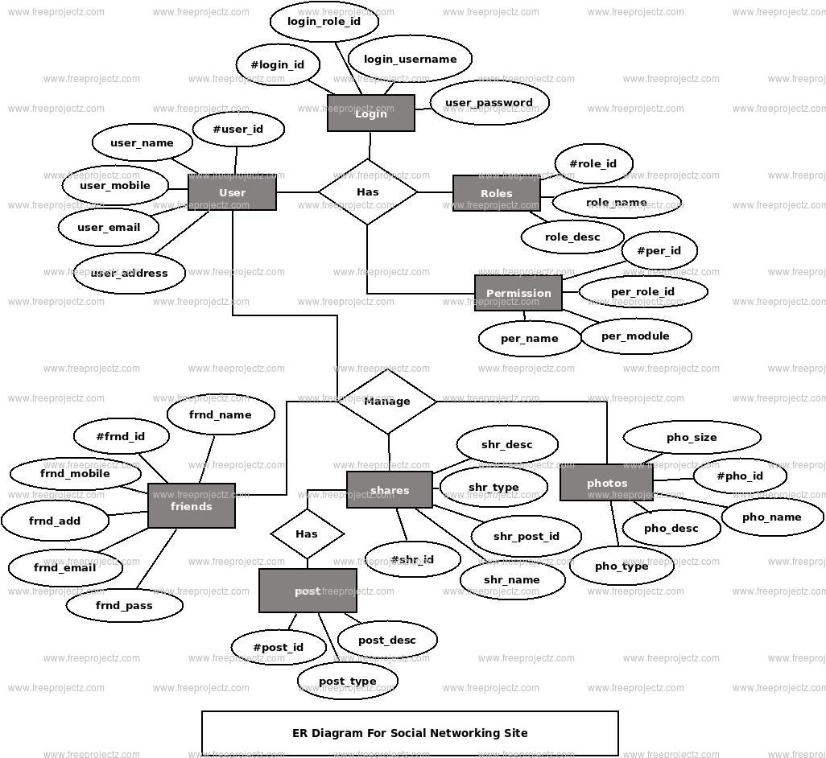

**Data Flow Diagram (DFD):**

A DFD illustrates the flow of data and processes within theysocial networking system.

**External Entities:**

- User

- Admin

**Processes:**

1. User Registration and Login

2. Create and Share Post

3. Interact with Post (Like, Comment)

4. Follow/Unfollow User

5. Send and Receive Messages

6. View Feed and Explore Content

7. Admin Moderation

**Data Stores:**

- User Data (Database)

- Post Data (Database)

- Comment Data (Database)

- Like Data (Database)

- Follow Data (Database)

- Message Data (Database)

**Data Flows:**

- User Registration and Login:

- User -> (Registration) -> User Data (Database)

- User -> (Login) -> User Data (Database)

- Create and Share Post:

- User -> (Create Post) -> Post Data (Database)

- Interact with Post:

- User -> (Like, Comment) -> Like/Comment Data (Database)

- Follow/Unfollow User:

- User -> (Follow/Unfollow) -> Follow Data (Database)

- Send and Receive Messages:

- User -> (Send Message) -> Message Data (Database)

- User <- (Receive Message) <- Message Data (Database)

- View Feed and Explore Content:

- User -> (View Feed) <- Post Data (Database)

- User -> (Explore) <- Post Data (Database)

- Admin Moderation:

- Admin -> (Moderate Content) <- Post/Comment/Like Data (Database)

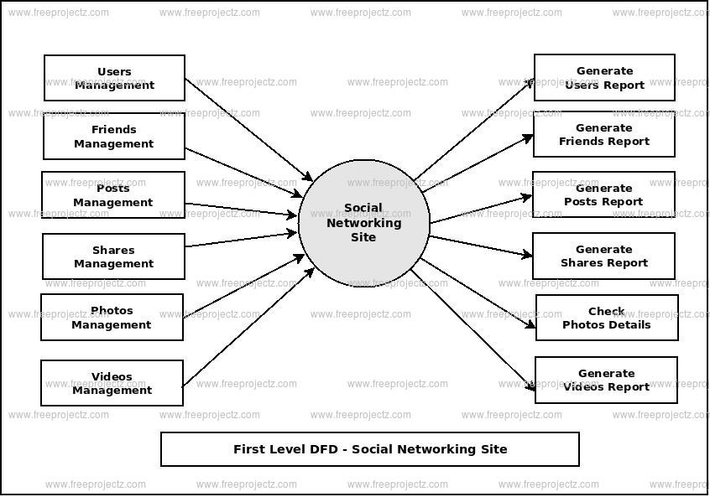

This ERD and DFD provide a high-level overview of the data structure, relationships, and flow of information within the social networking system. These models serve as a foundation for system development, helping developers and stakeholders understand and communicate the system's architecture

and functionality**.**

**CHAPTER-06**

**HARDWARE/SOFTWARE PLATFORM ENVIROMENT**

**Hardware Requirement:**

1. **Servers:**

* Use dedicated or cloud servers to host your website and database.
* Consider load balancing to distribute traffic and ensure high availability.

## Database Servers:

* Employ a reliable database server to store and manage data.
* Choose a database system suitable for your needs, such as MySQL.

## Content Delivery Network (CDN):

* Utilize a CDN to cache and deliver static content (images, CSS, JS) to users.

## Firewalls and Security Appliances:

* Implement firewalls and security appliances to protect against cyber threats.

## Payment Gateways:

* Integrate secure payment gateways for online transactions.
* Ensure compliance with PCI DSS standards for handling payment data securely.

## SSL Certificates:

* Secure the communication between the user's browser and your server with SSL certificates.

## Monitoring Tools:

* Use monitoring tools to keep an eye on server performance, uptime, and user experience.

|  |  |  |
| --- | --- | --- |
| Hardware | -- | Pentium Speed |
| Speed | -- | 1.1 GHz |
| RAM | -- | 1GB |
| Hard Disk | -- | 20 GB |
| Mouse | -- | Two or Three Button Mouse |
| Monitor | -- | SVGA |

**Software Platform Environment:**

* 1. **Operating System:**
  + Choose a robust and secure operating system, such as Linux (e.g., Ubuntu, CentOS).

## Web Server:

* + Use a web server like Apache or Nginx to handle HTTP requests.

## Programming Languages:

* + Employ languages suitable for web development, such as HTML, CSS, JavaScript on the client side, and server-side languages like Python, Ruby, Node.js, or PHP

## Framework:

* + Use a web framework to streamline development (e.g., Django, Ruby on Rails, Laravel).

## Database Management System (DBMS):

* + Select a database management system for storing and retrieving data efficiently.
  1. **Backend Development:**
  + Develop backend logic to handle order processing, user authentication, and business logic.

## Frontend Development:

* + Design an intuitive and responsive user interface for customers, restaurants, and delivery personnel.

## APIs:

* + Create APIs for communication between the frontend and backend, as well as integration with external services (e.g., maps, payment gateways).

## Mobile Application (Optional):

* + Develop mobile apps for iOS and Android platforms if you plan to provide a mobile experience.

Operating System -- Windows/Linux / Mac Technology -- PHP

Web Technologies -- Html, JavaScript, CSS

IDE -- Notepad++, Visual studio code

Database -- MySQL

**CHAPTER-07**

**SNAPSHOT OF INPUT AND OUTPUT**

**So this is how our website looks :**

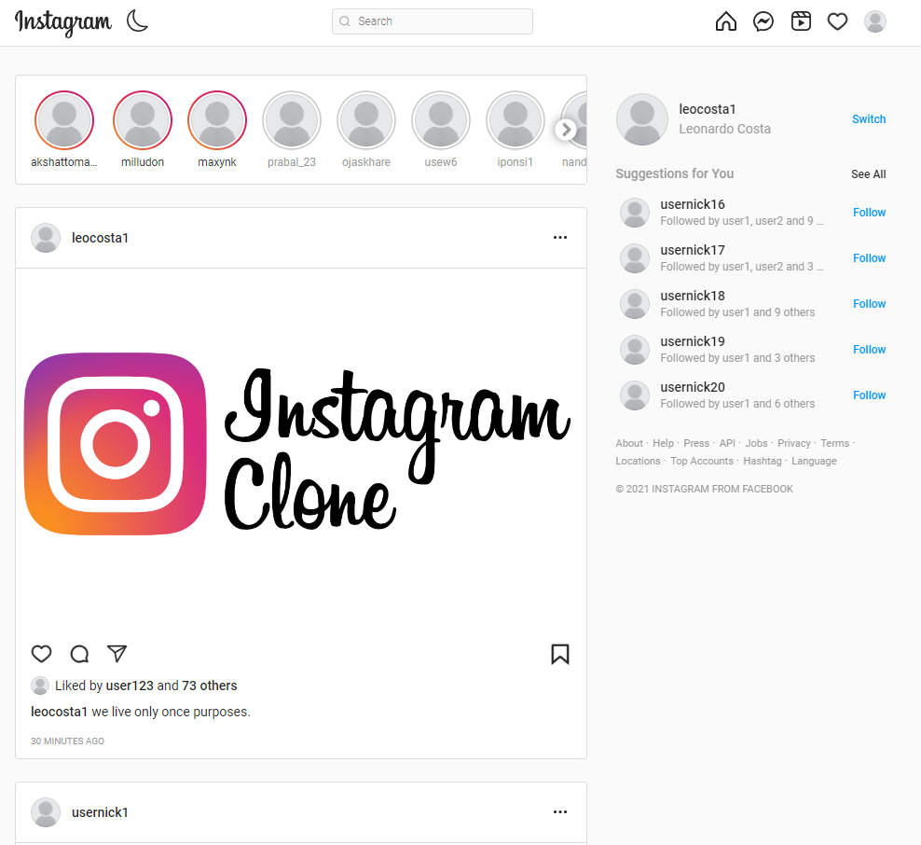

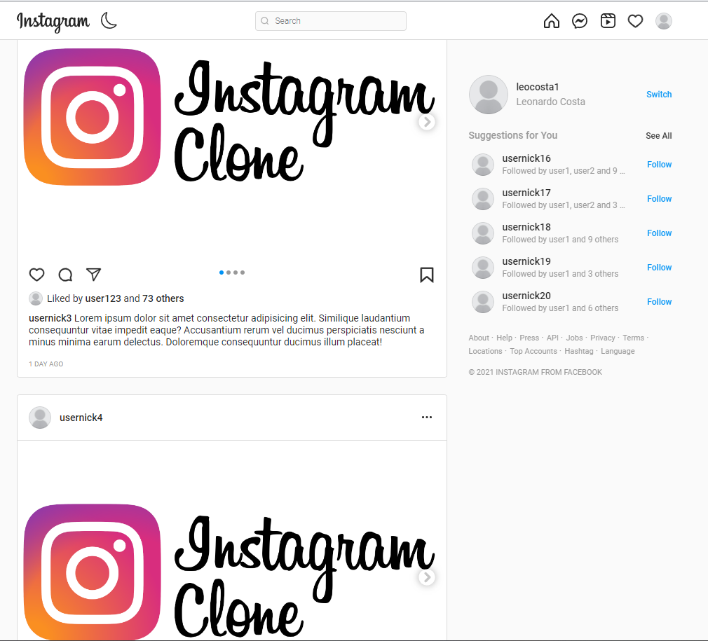

**CHAPTER-08**

**CODING**

### Technologies used in the development of website is as follows:

* JAVASCRIPT

### CSS

* + HTML

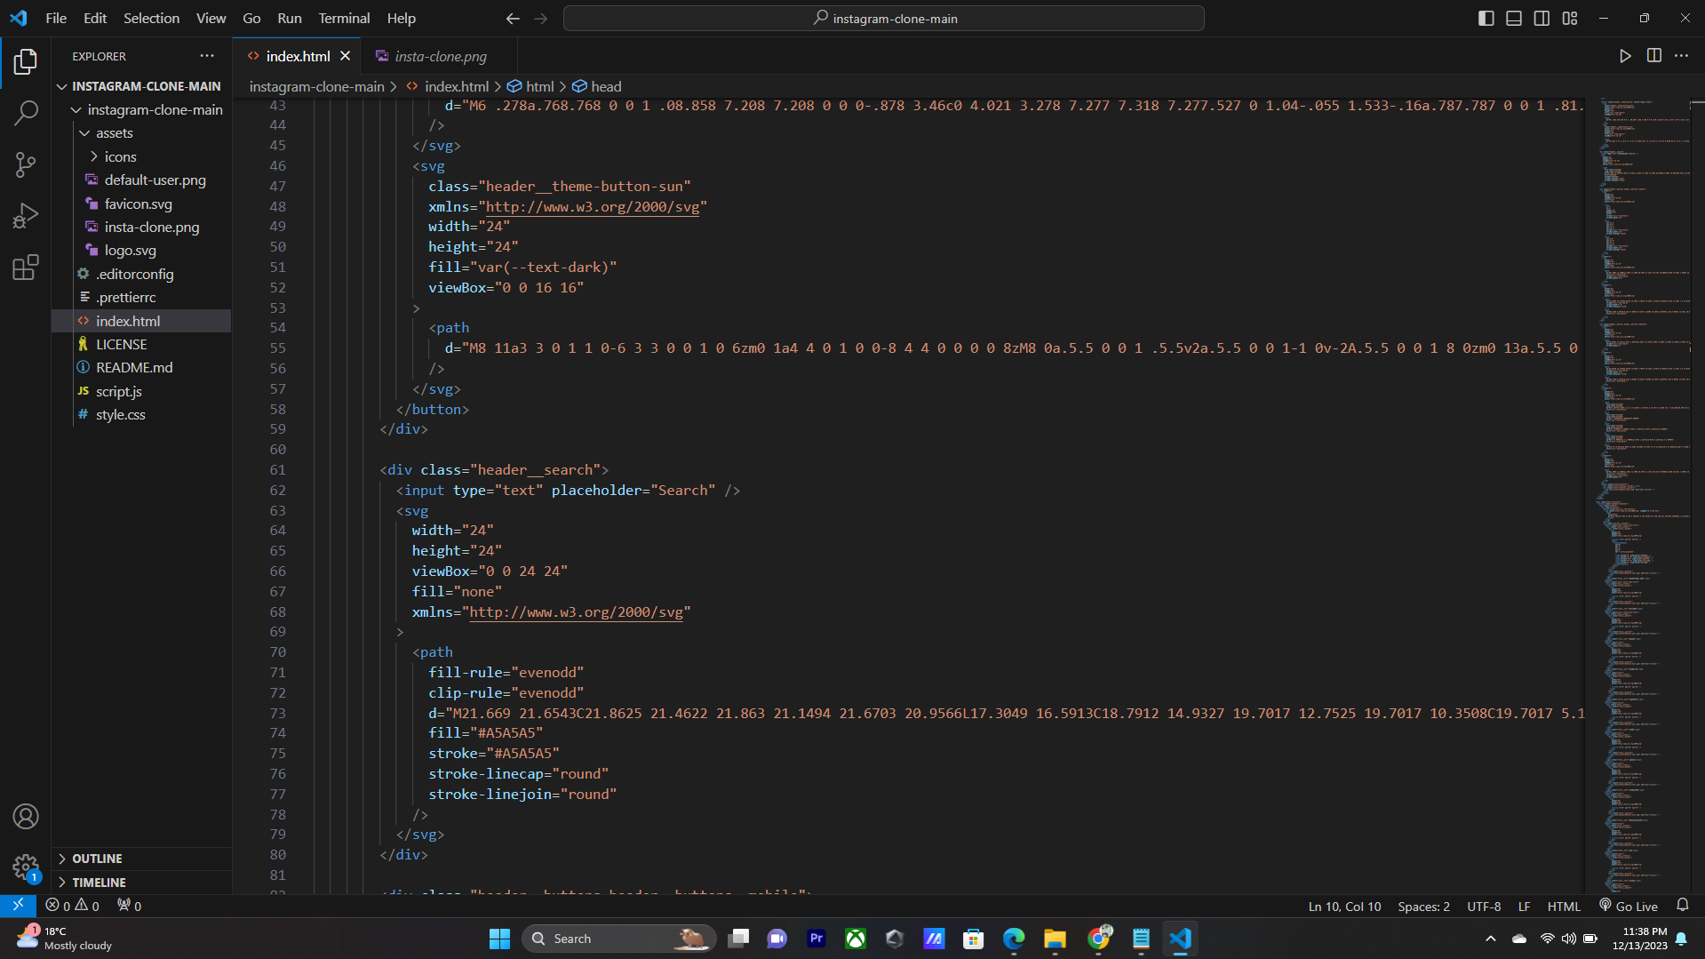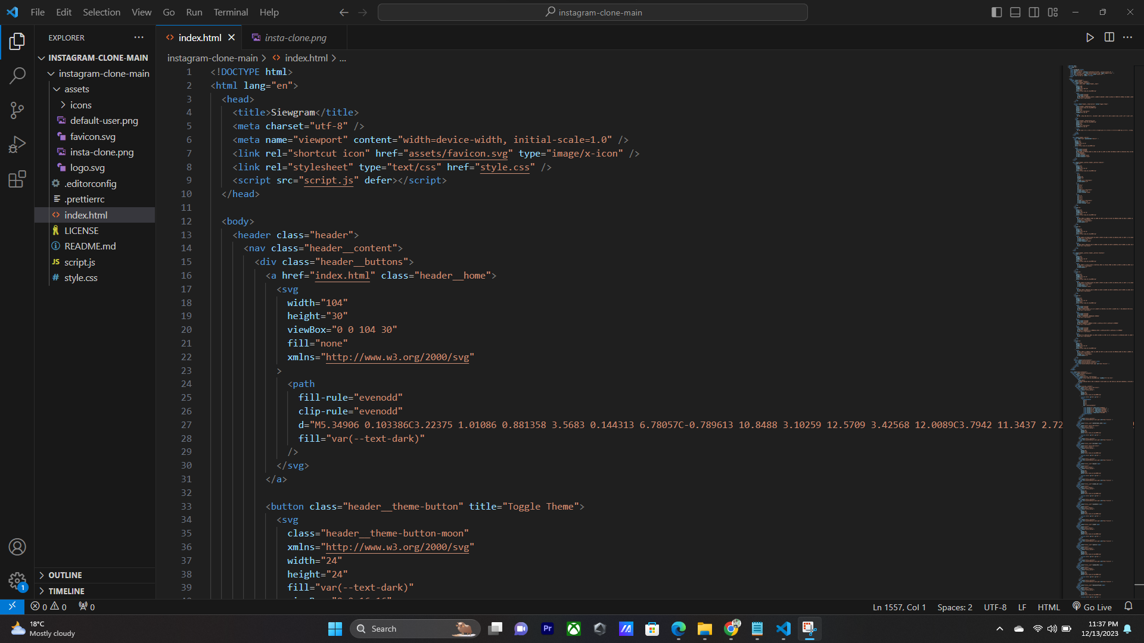

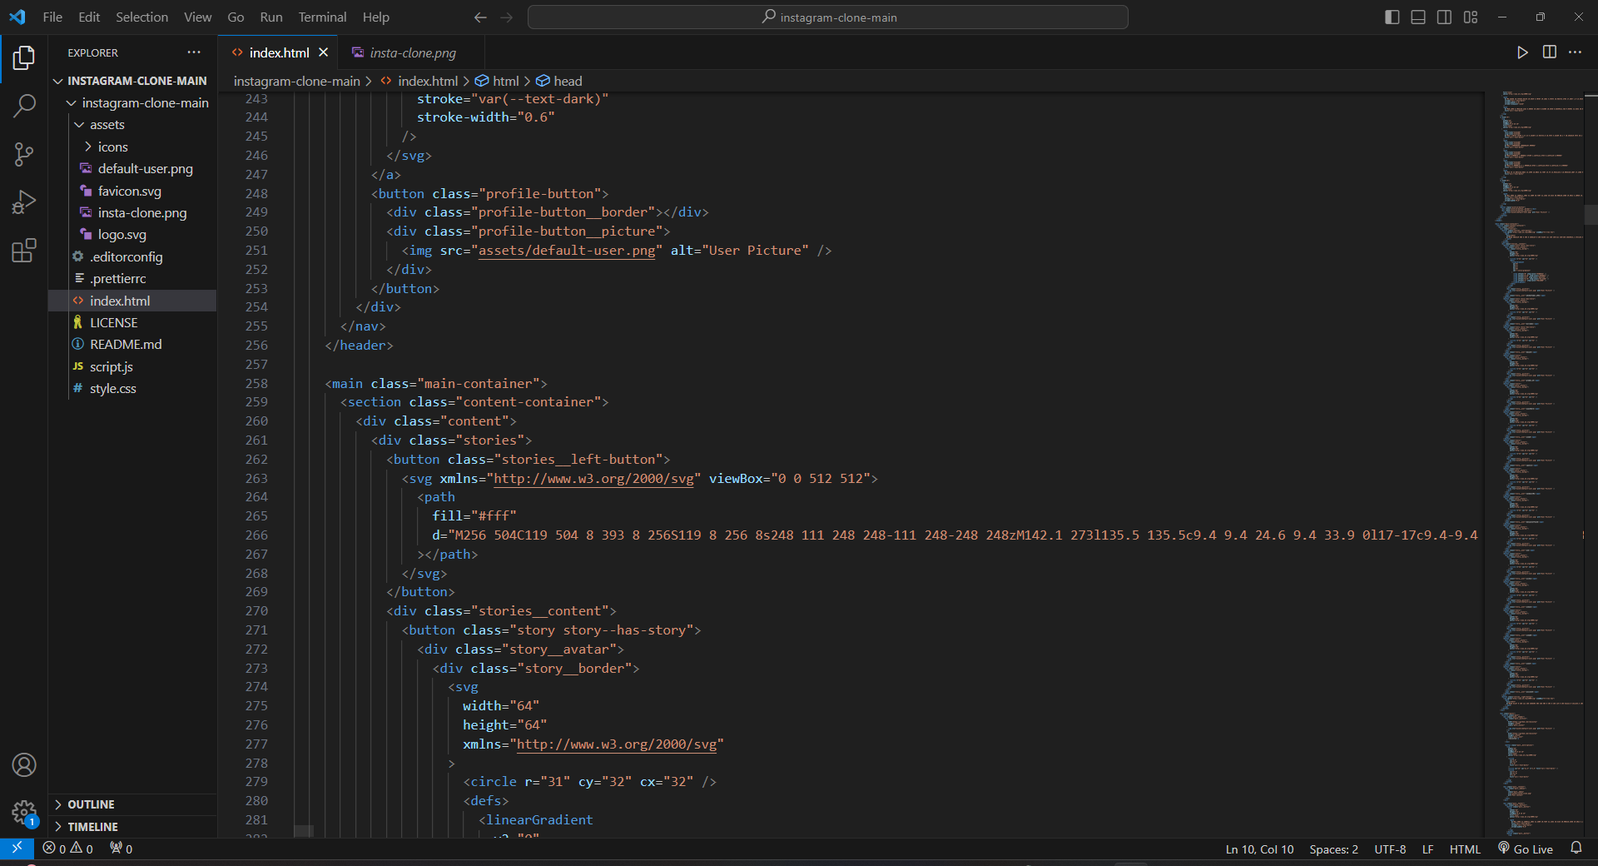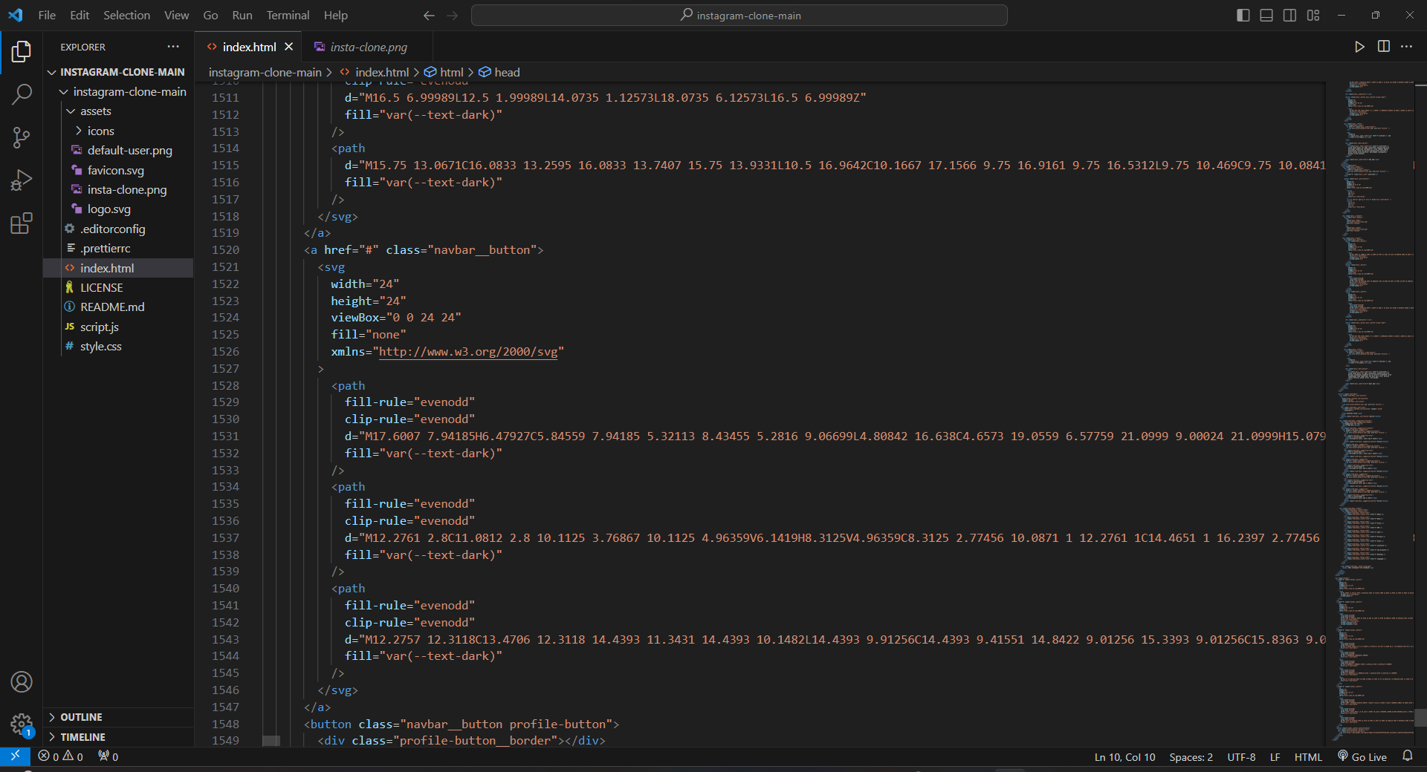

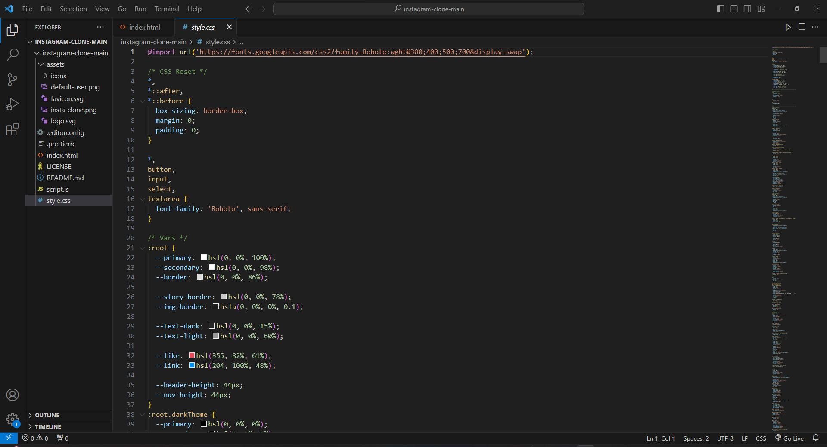

**CHAPTER -9**

**PROJECT LIMITATION AND FUTURE SCOPE**

**Project Limitations:**

* **Feature Set: Due to the scope of a clone project, certain advanced features of the original Instagram app might be excluded or simplified to meet development constraints and resources.**
* **Scalability: The clone might not handle the same scale as the original Instagram platform, limiting the number of users and data it can effectively manage.**
* **Third-Party Integrations: Integration with external services or APIs used by Instagram may not be fully replicated due to access restrictions or licensing issues.**
* **Security: While security measures will be implemented, achieving the same level of security as a mature platform may be challenging, especially considering the resources and time constraints of a clone project.**
* **User Engagement: The app's ability to engage users might not match that of Instagram, as user behavior and preferences are unique to each platform.**

## Future Scope:

**Enhanced Features: As resources become available, additional features beyond the basic Instagram functionality can be developed and integrated.**

**Advanced Security Measures: Continuous improvement of security protocols to match industry standards and address emerging threats.**

**Scalability Improvements: Optimize the application for scalability to handle a larger user base and increased data load.**

**Integration with Emerging Technologies: Explore integrations with emerging technologies like augmented reality (AR) or virtual reality (VR) to enhance the user experience.**

**Mobile App Development: Extend the project to include mobile app development for iOS and Android platforms, allowing users to access the platform on their smartphones.**

**Geographic Expansion: Consider expanding the app's availability to different regions and languages to increase its global appeal.**

**Monetization Strategies: Implement various monetization strategies, such as advertisements, premium features, or partnerships, to generate revenue.**

**Community Building: Develop community-building features to encourage user interaction, such as forums, events, or interest groups.**

**Machine Learning Integration: Implement machine learning algorithms to enhance content recommendations, user engagement predictions, and content moderation.**

**Accessibility Improvements: Focus on making the platform more accessible to users with disabilities by incorporating accessibility features.**

**CHAPTER-10**

**REFERENCES**

### We took the reference of an application called as ‘Siewgram’. It is a type of website that is used to order online food.

For writing codes,we took help of different books such as :

**For Javascript**

* Clean Code in Javascript(by James Padolsey)

**For HTML and CSS**

### Start programming using HTML,CSS and Javascript(by Iztok Fajfar)

* The Coding Workbook(by Sam Taylor)

We also took reference and help of certain onlines websites such as:

https://geeksforgeeks.org https://javapoint.com https://cssdeck.com https://developer.mozilla.org https://codepen.io

# The compiler that we used for writing and compiling the source codes for our website Anian is Visual Studio.