**BT – 307**

Assignment – 5

1) Name - Milind Lakhwani

2) Roll No. – 200106046

3)

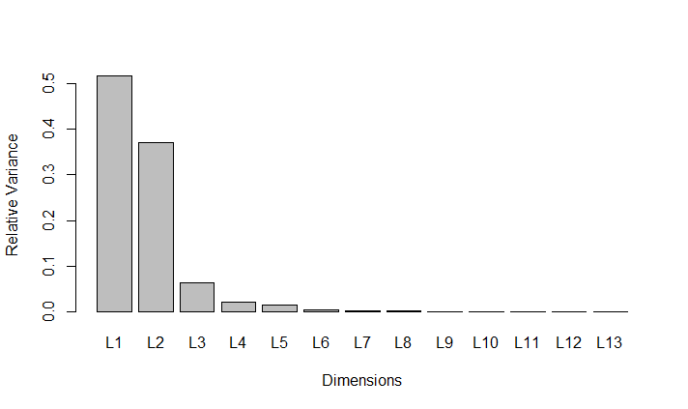

4) PC1 and PC2

5)

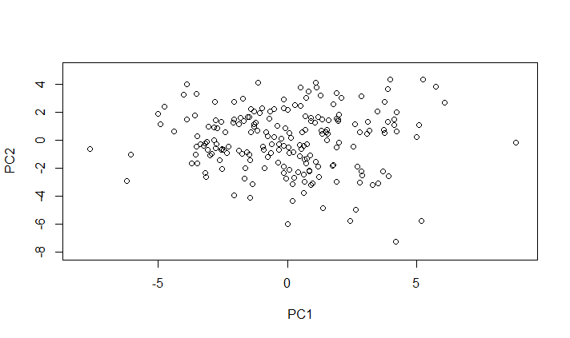

6) Original features with the maximum positive contributions for these two selected principal components are ->

PC1 – AreaShape_Area

PC2 - AreaShape_FormFactor