**Airbnb – Zillow Data Challenge Recommendation**

1. Below graph shows the median prices for each of zipcodes. As per the observation, below five zipcodes have the highest prices.

10011, 10036, 10022, 10013 and 10014

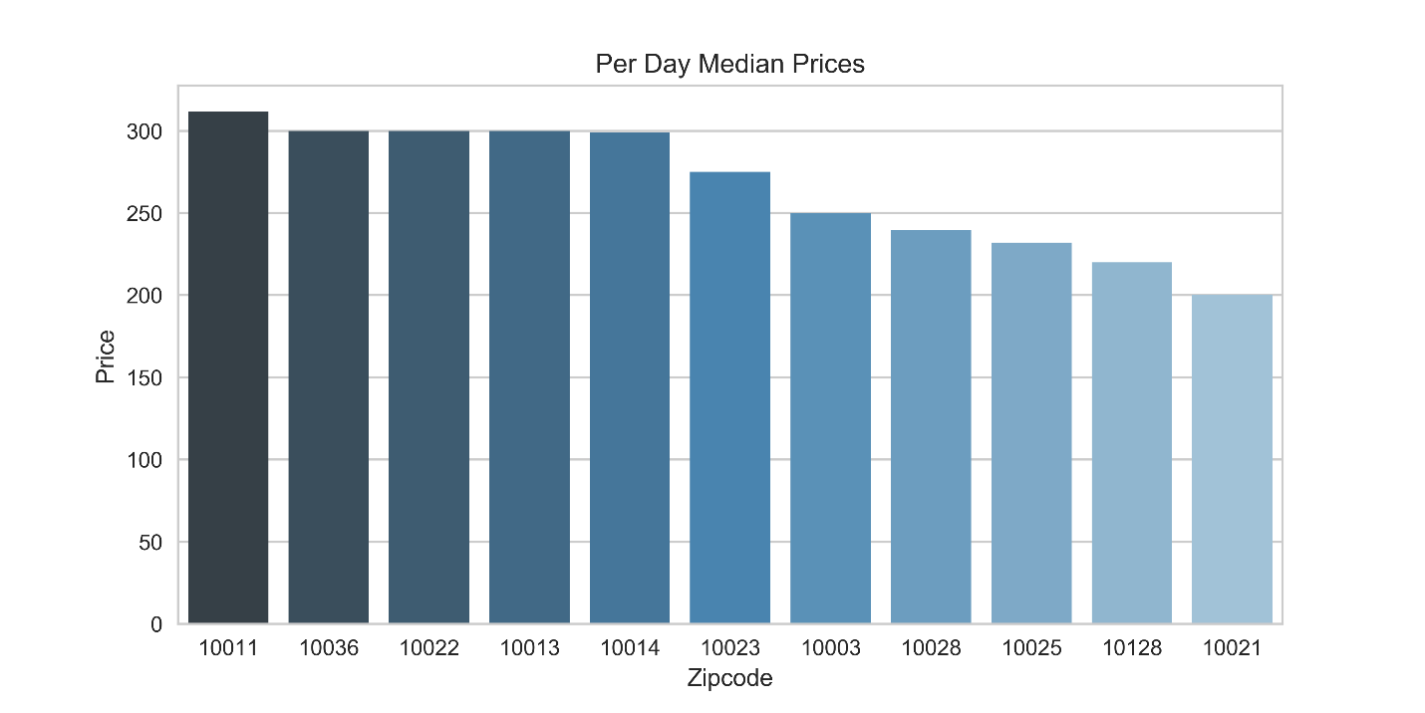

2. Below graph shows the price variation in each of zipcodes. As per the observation, price variations are not significant except 10011, 10013 and 10003.

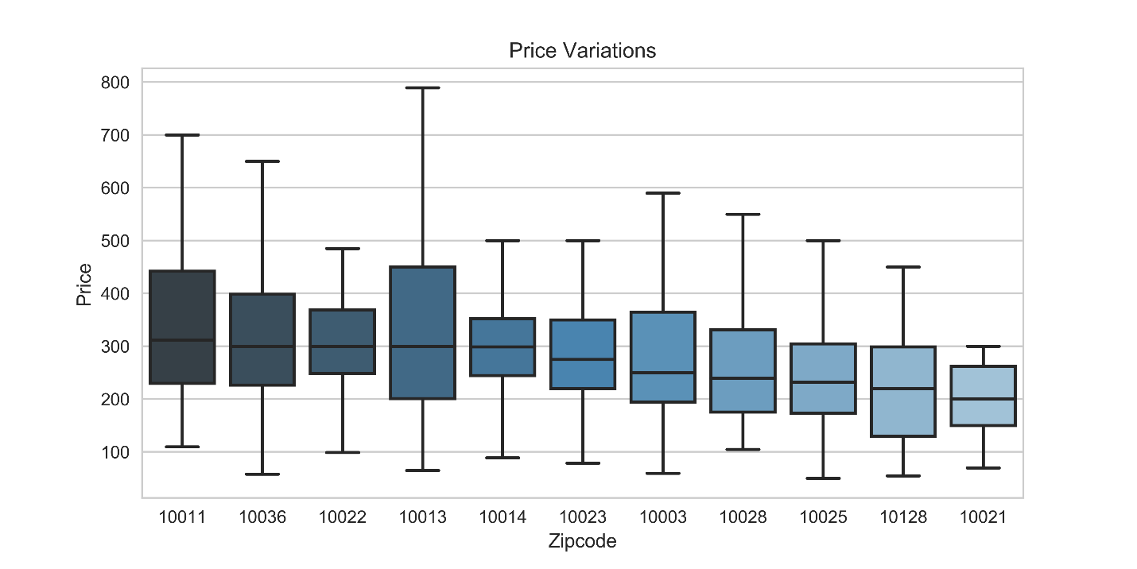

3. Below graph shows the trend in the cost of houses. For most of the zipcodes, the cost is increasing except for 10036 and costs of houses in this region are on the lower side compared to most other regions. Few other other zipcodes like 10028, 10128,10025 and 10023 also have costs on the lower side.

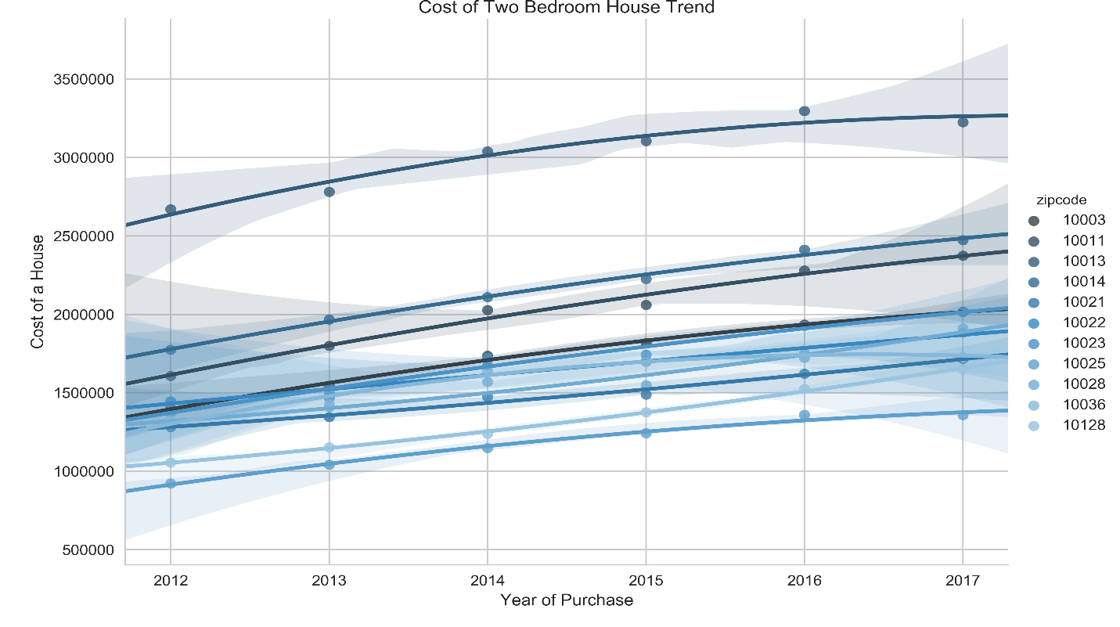

4. Below graph shows the trend in return on investment on a year-year basis. ROI is increasing in recent years for 10036 regions only.

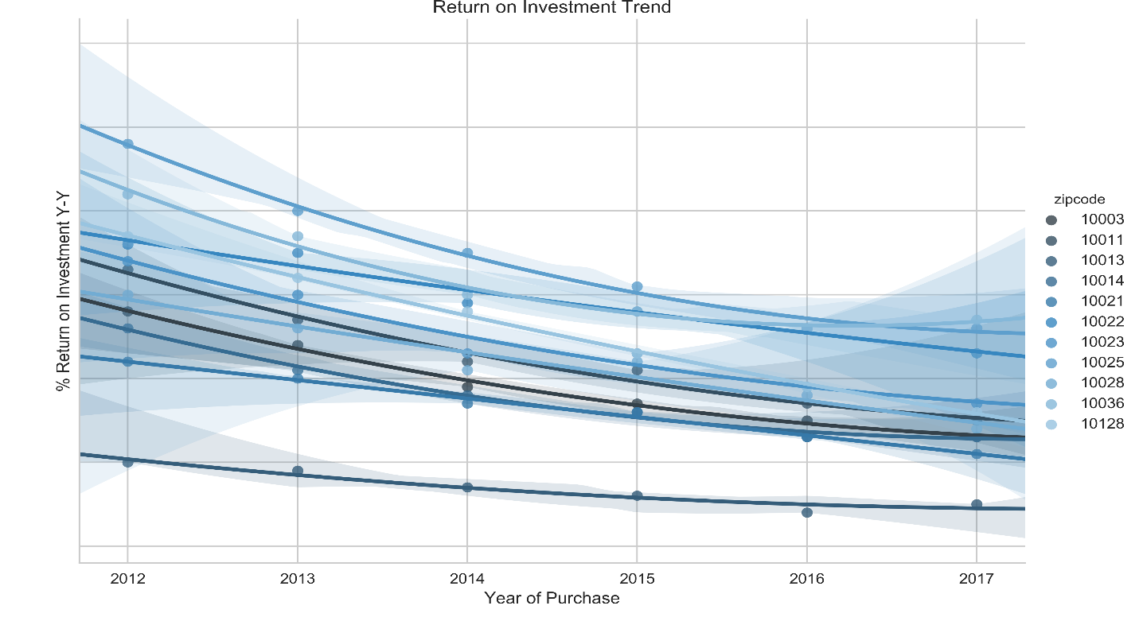

5. Below graph shows year on year ROI if houses are bought in current year i.e. 2018. Region 10036 will provide highest ROI which will be around 5% followed by 10025.

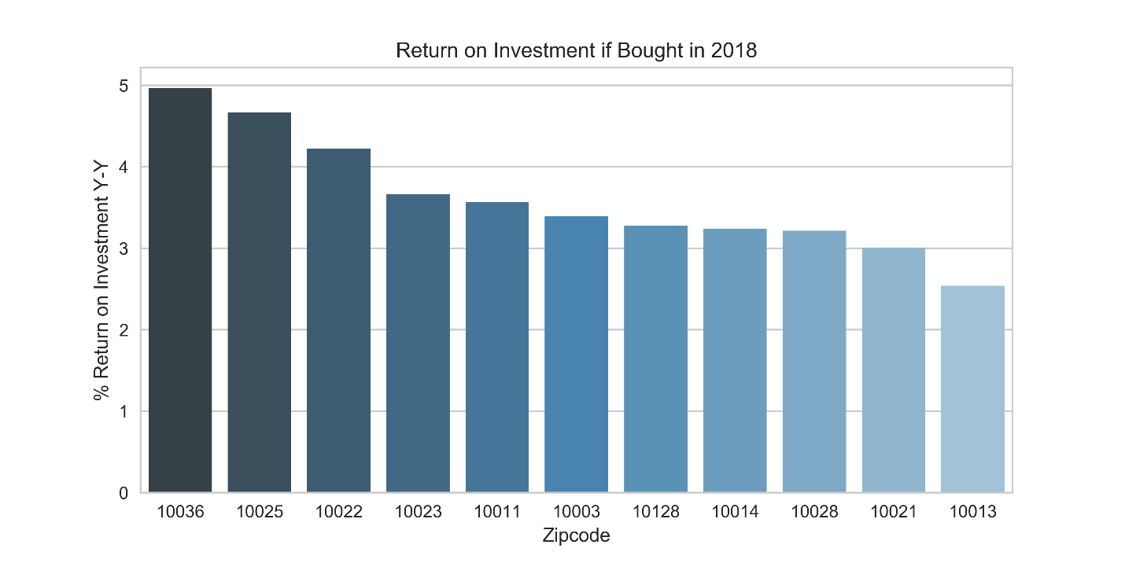

**Recommendation:** After all observation, I recommend to buy houses in region 10036, which would give the highest ROI.