This document is for project setup. Instructions are given below with screen prints:

Step1: check out project from git - <https://github.com/milindparlawar123/recruiting-exercises.git>

Import demo project from [inventory-allocator](https://github.com/milindparlawar123/recruiting-exercises/tree/master/inventory-allocator) folder.

Provide java jdk path till bin :

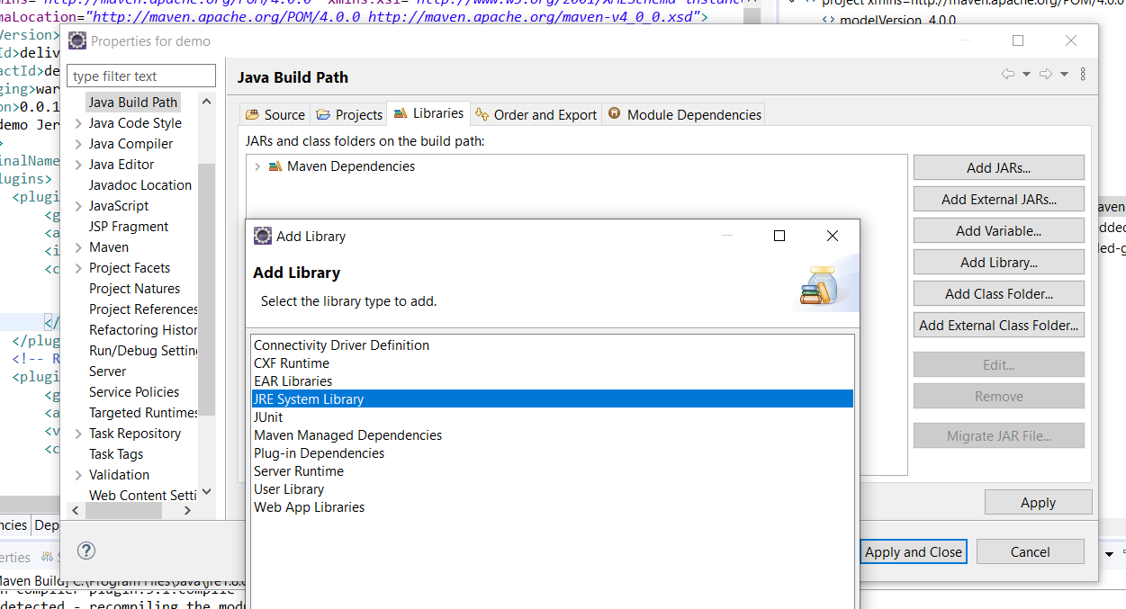

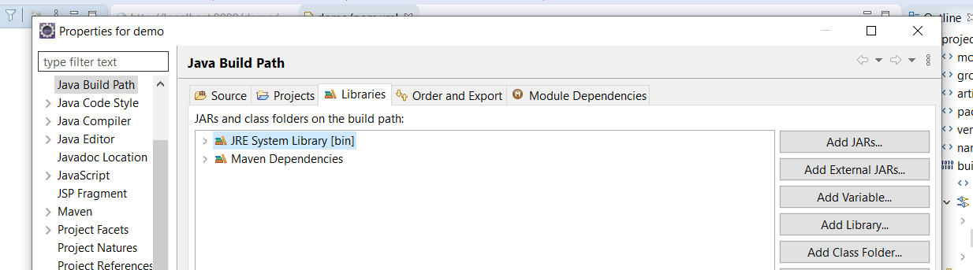

Step 2: do maven clean, install : 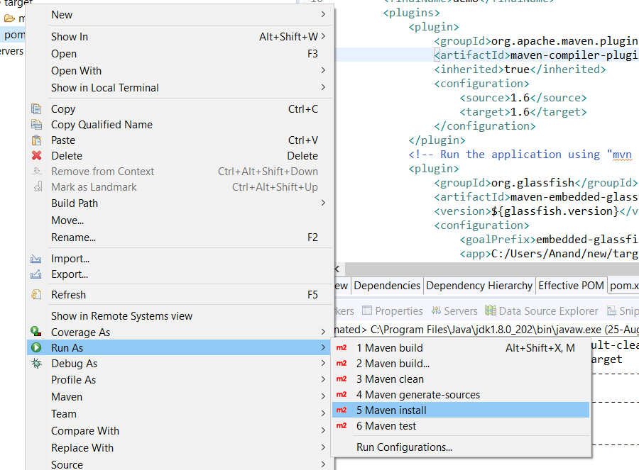

Step 3: build project:

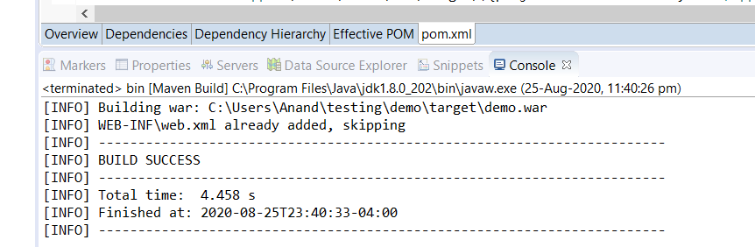

Step 4: run on server, I run application on tomcat server.

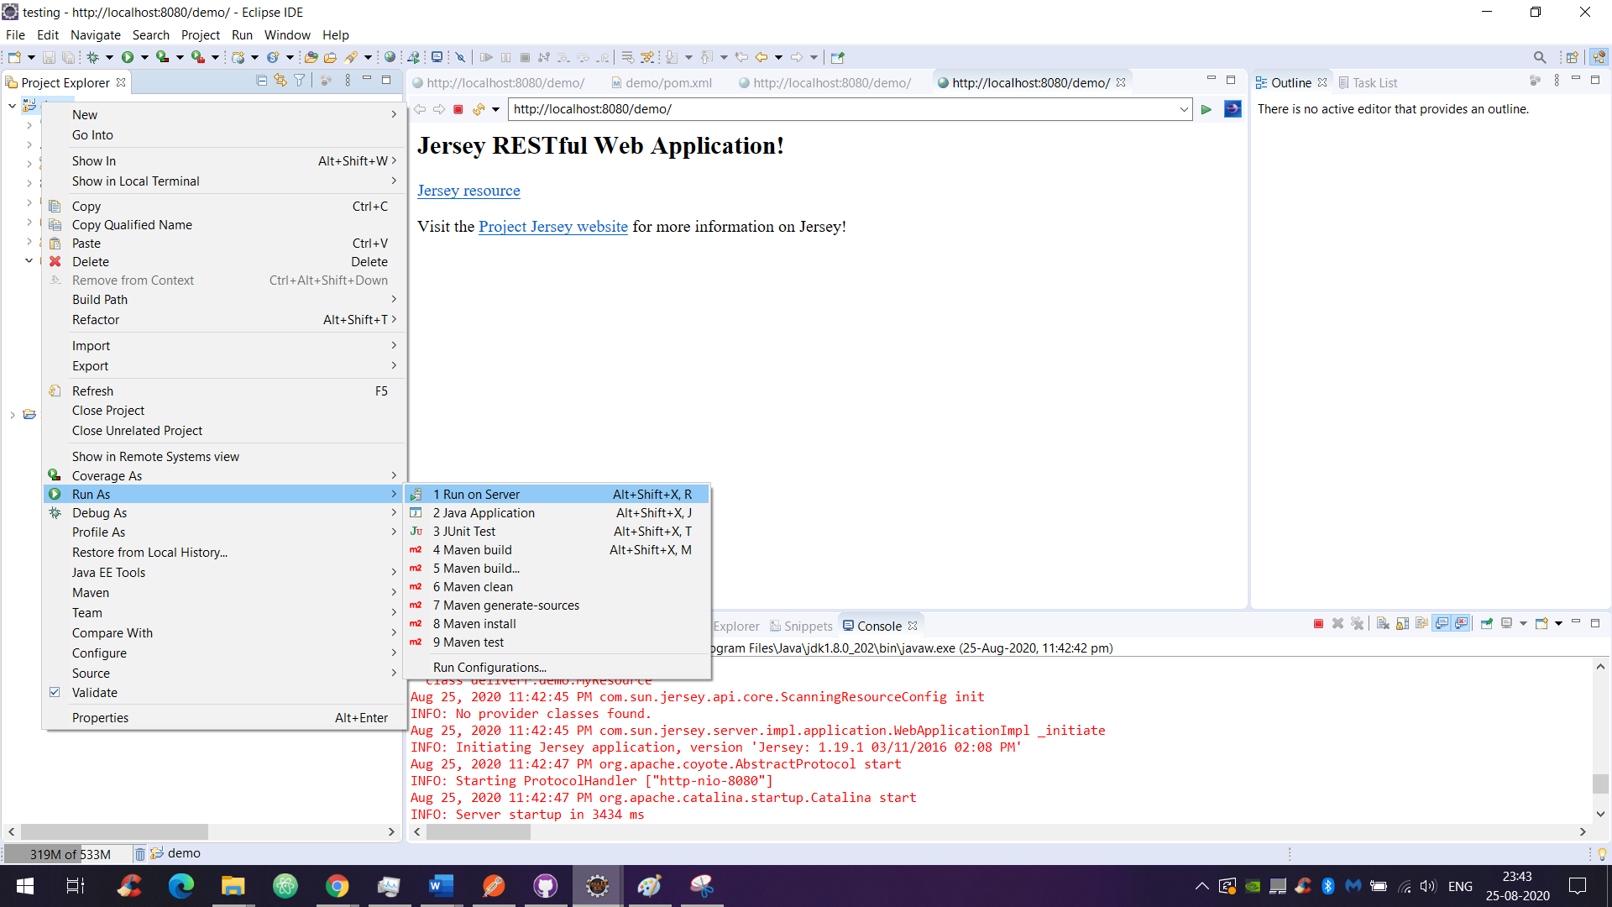

Step 6: for testing, we can any tool, web client to test. I used postman.

End point URL: http://localhost:8080/demo/webresources/inventoryallocater/

Please provide your server name and port number in above url

first input: { apple: 5, banana: 5, orange: 5 }

second input [ { name: owd, inventory: { apple: 5, orange: 10 } }, { name: dm:, inventory: { banana: 5, orange: 10 } } ]

**Provide input in body as:**

Input format: **first input** – **second input**

For example:

{ apple: 5, banana: 5, orange: 5 } - input [ { name: owd, inventory: { apple: 5, orange: 10 } }, { name: dm:, inventory: { banana: 5, orange: 10 } } ]

Output:

I am showing output format as:

Input <first input>

Output <whatever output>

…………………………………………………..

Status of warehouse < status of warehouse stock, post input item taken out from warehouses >

