Tech stack used: Java, Maven, and web service.

I have created below end point:

<http://localhost:8080/demo/webresources/inventoryallocater/>

**Provide input in body as:**

Input format: **first input** – **second input**

For example:

{ apple: 5, banana: 5, orange: 5 } - input [ { name: owd, inventory: { apple: 5, orange: 10 } }, { name: dm:, inventory: { banana: 5, orange: 10 } } ]

Output:

I am showing output format as:

Input <first input>

Output <whatever output>

…………………………………………………..

Status of warehouse < status of warehouse stock, post input item taken out from warehouses >

I have used postman as client:

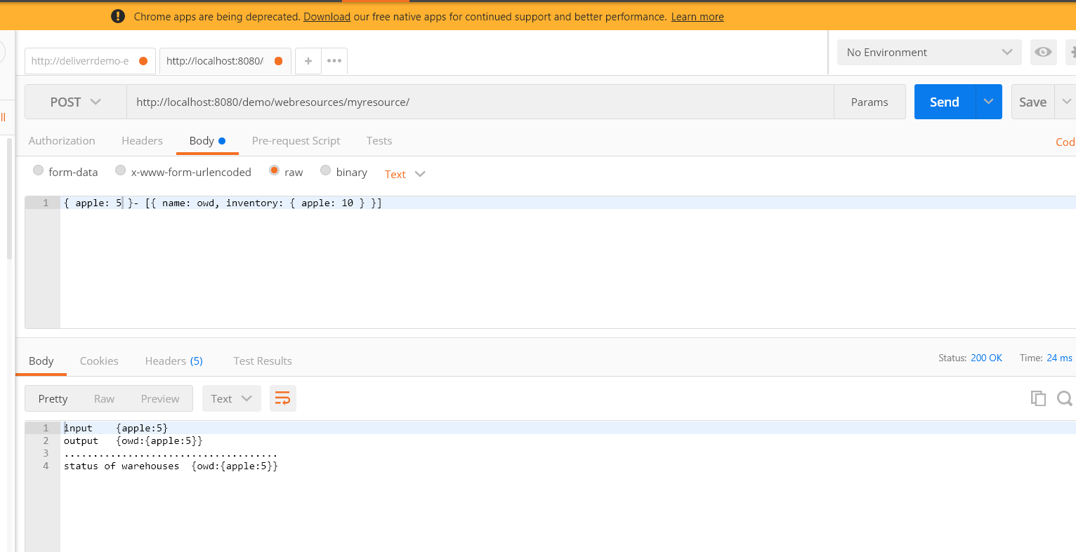

Class name and endpoint API name code:

