MATH1318 Time-Series Analysis Assignment 1

### Milind Shaileshkumar Parvatia

### s3806853

# Time Series Analysis of thickness of Ozone

rm(list = ls())  
library(readr)  
library(xts)

## Loading required package: zoo

##   
## Attaching package: 'zoo'

## The following objects are masked from 'package:base':  
##   
## as.Date, as.Date.numeric

library(TSA)

##   
## Attaching package: 'TSA'

## The following object is masked from 'package:readr':  
##   
## spec

## The following objects are masked from 'package:stats':  
##   
## acf, arima

## The following object is masked from 'package:utils':  
##   
## tar

ds <- read.csv("data1.csv", header = FALSE)  
  
timeseries <- ts(ds, start = 1927, end = 2016)  
  
plot(timeseries,ylab='Dobson units',xlab='Years',type='o', main = "thickness of Ozone layer 1927 to 2016")

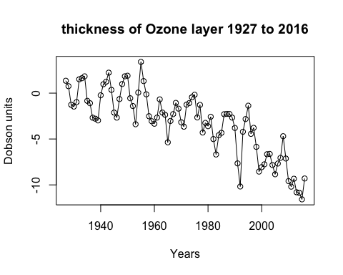

plot(y=timeseries, x=zlag(timeseries), ylab='Dobson units', xlab='Years', main = "thickness of Ozone layer 1927 to 2016")

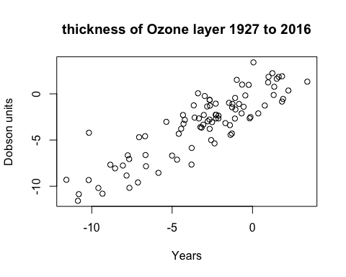

y = timeseries # Read the color data into y  
x = zlag(timeseries) # Generate first lag of the color series  
index = 2:length(x) # Create an index to get rid of the first NA value in x  
cor(y[index],x[index]) # Calculate correlation between numerical values in x and y```

## [1] 0.8700381

model1 = lm(timeseries~time(timeseries)) # label the model as model1  
summary(model1)

##   
## Call:  
## lm(formula = timeseries ~ time(timeseries))  
##   
## Residuals:  
## Min 1Q Median 3Q Max   
## -4.7165 -1.6687 0.0275 1.4726 4.7940   
##   
## Coefficients:  
## Estimate Std. Error t value Pr(>|t|)   
## (Intercept) 213.720155 16.257158 13.15 <2e-16 ***  
## time(timeseries) -0.110029 0.008245 -13.34 <2e-16 ***  
## ---  
## Signif. codes: 0 '***' 0.001 '**' 0.01 '*' 0.05 '.' 0.1 ' ' 1  
##   
## Residual standard error: 2.032 on 88 degrees of freedom  
## Multiple R-squared: 0.6693, Adjusted R-squared: 0.6655   
## F-statistic: 178.1 on 1 and 88 DF, p-value: < 2.2e-16

plot(timeseries,ylab='Dobson units',xlab='Years',type='o', main = "thickness of Ozone layer 1927 to 2016")  
abline(model1) # add the fitted least squares line from model1

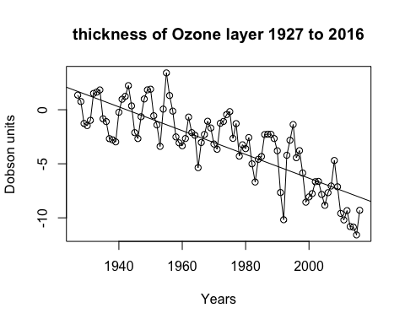

hist(rstudent(model1),xlab='Standardized Residuals', main = "Figure 10. Histogram of the standardized residuals from the seasonal means model.")

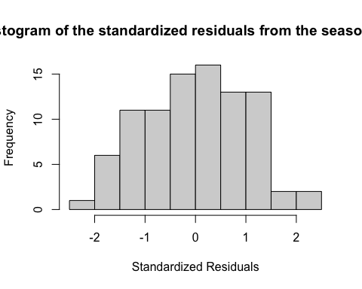

plot(y=rstudent(model1),x=as.vector(time(timeseries)),xlab='Time', ylab='Standardized Residuals',type='l', main = "Figure 8. Time series plot of residuals with labels.")

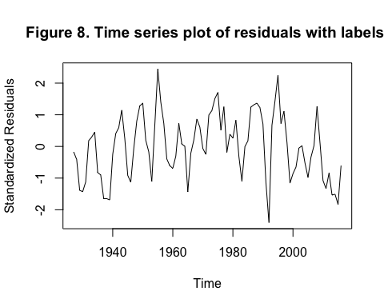

y = rstudent(model1)  
qqnorm(y, main = "Figure 11. Normal Q-Q plot of the standardized residuals from the seasonal means model.")  
qqline(y, col = 2, lwd = 1, lty = 2)

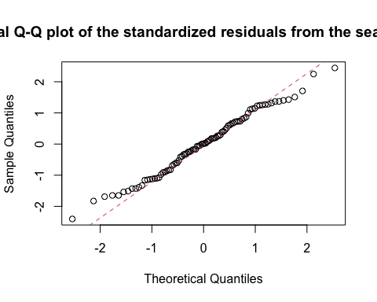

y = rstudent(model1)  
shapiro.test(y)

##   
## Shapiro-Wilk normality test  
##   
## data: y  
## W = 0.98733, p-value = 0.5372

t = time(timeseries)  
t2 = t^2  
model1.1 = lm(timeseries~t+t2) # label the model as model1  
summary(model1.1)

##   
## Call:  
## lm(formula = timeseries ~ t + t2)  
##   
## Residuals:  
## Min 1Q Median 3Q Max   
## -5.1062 -1.2846 -0.0055 1.3379 4.2325   
##   
## Coefficients:  
## Estimate Std. Error t value Pr(>|t|)   
## (Intercept) -5.733e+03 1.232e+03 -4.654 1.16e-05 ***  
## t 5.924e+00 1.250e+00 4.739 8.30e-06 ***  
## t2 -1.530e-03 3.170e-04 -4.827 5.87e-06 ***  
## ---  
## Signif. codes: 0 '***' 0.001 '**' 0.01 '*' 0.05 '.' 0.1 ' ' 1  
##   
## Residual standard error: 1.815 on 87 degrees of freedom  
## Multiple R-squared: 0.7391, Adjusted R-squared: 0.7331   
## F-statistic: 123.3 on 2 and 87 DF, p-value: < 2.2e-16

plot(ts(fitted(model1.1)), ylim = c(min(c(fitted(model1.1),  
 as.vector(timeseries))),   
 max(c(fitted(model1.1),as.vector(timeseries)))), ylab='Dobson units',  
 xlab='Years', main = "thickness of Ozone layer 1927 to 2016")  
lines(as.vector(timeseries),type="o")

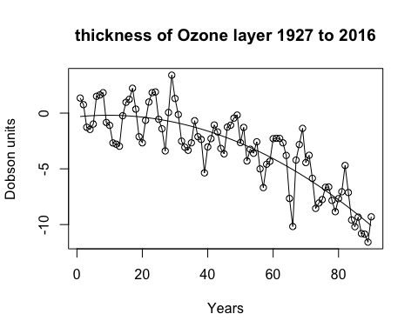

hist(rstudent(model1.1),xlab='Standardized Residuals', main = "Figure 10. Histogram of the standardized residuals from the seasonal means model.")

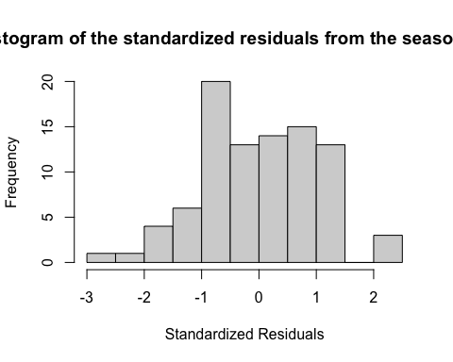

plot(y=rstudent(model1.1),x=as.vector(time(timeseries)),xlab='Time', ylab='Standardized Residuals',type='l', main = "Figure 8. Time series plot of residuals with labels.")

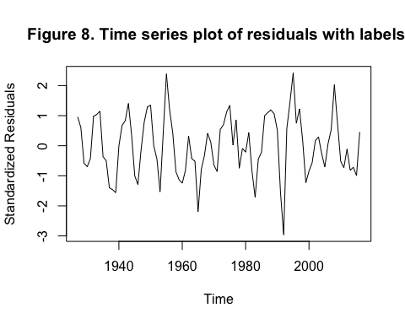

y = rstudent(model1.1)  
qqnorm(y, main = "Figure 11. Normal Q-Q plot of the standardized residuals from the seasonal means model.")  
qqline(y, col = 2, lwd = 1, lty = 2)

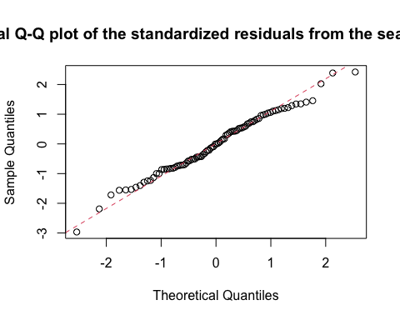

y = rstudent(model1.1)  
shapiro.test(y)

##   
## Shapiro-Wilk normality test  
##   
## data: y  
## W = 0.98889, p-value = 0.6493

timeseries1 <- ts(ds$X1, start = 1927, end=2016, frequency = 2) plot(timeseries1,ylab=‘Dobson units’, type= ‘o’, xlab=‘Years’, main = “thickness of Ozone layer 1927 to 2016”)

abline(model2)

month.=season(timeseries1) # period added to improve table display and this line sets up indicators model2=lm(timeseries1~month. -1) # -1 removes the intercept term summary(model2)

hist(rstudent(model2),xlab=‘Standardized Residuals’, main = “Figure 10. Histogram of the standardized residuals from the seasonal means model.”)

plot(y=rstudent(model2), x=as.vector(time(timeseries1)),xlab=‘Time’, ylab=‘Standardized Residuals’,type=‘l’, main = “Figure 8. Time series plot of residuals with labels.”)

y = rstudent(model2) qqnorm(y, main = “Figure 11. Normal Q-Q plot of the standardized residuals from the seasonal means model.”) qqline(y, col = 2, lwd = 1, lty = 2)

y = rstudent(model2) shapiro.test(y)