# Google Page Rank Summary:

We, Humans thrive to achieve advancement in life, so does we have to guide ourselves by being in competition with technology. One of the most profound invention in nature of mathematics, as well as in computing technology is, which gave our lives an uplift, is Google. Decades has been passed when research on google page rank has been published and Thousand of researchers are still interested in working and improvement in pagerank algorithm, which has been done over a period. One such moment we try to summaries here, by conducting and developing experiment on GOOGLE PR Algorithm.  
 **In Part 1**, of the project, we developed a comprehensive pagerank algorithm in C++, ran certain individual instances. This provided an Insight on how the pagerank works, and how to improve it? In part-1, as methodology, we describe all the parameters. Based on the parameters, PR decides to proceed or to not to proceed.

In Below Given Figure, It is shown that upon providing parameters, how the pagerank are shown.Upon wrong information fed, It will give Error as show above in figure.

Figure : Error Detected

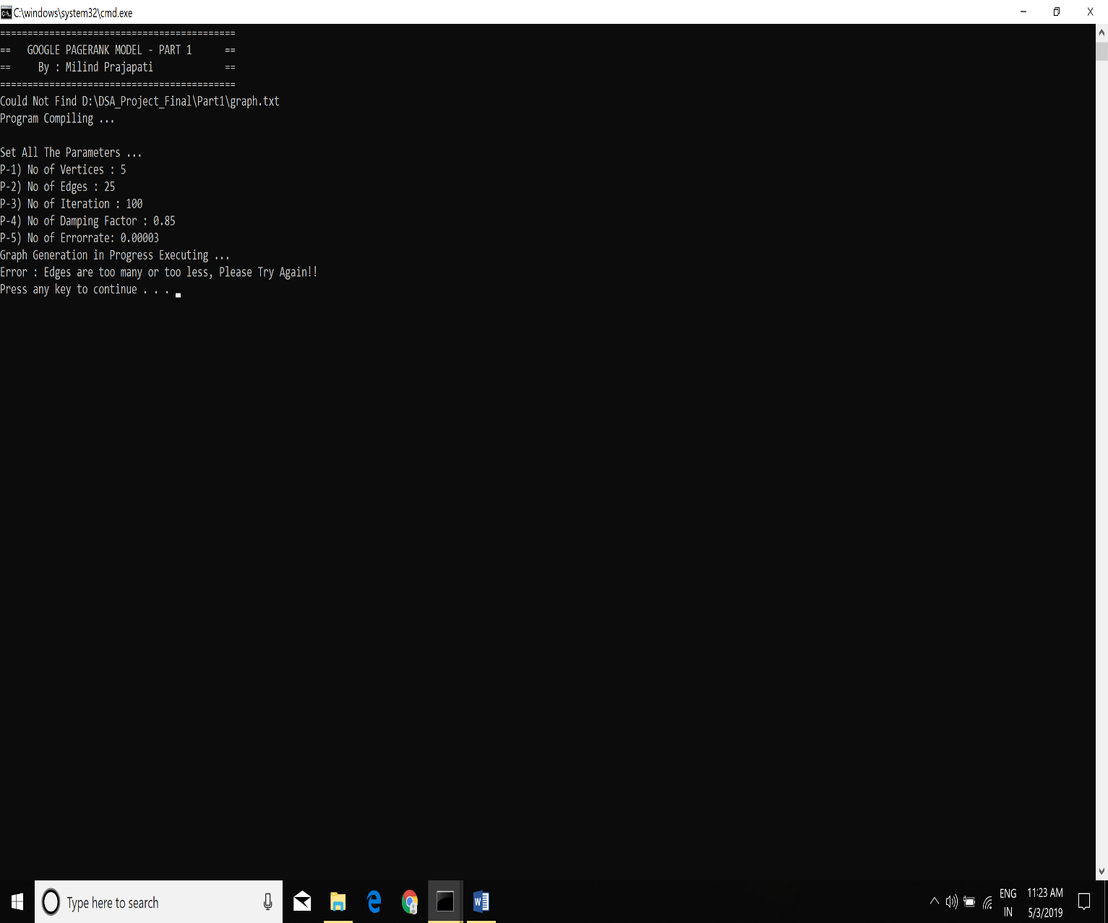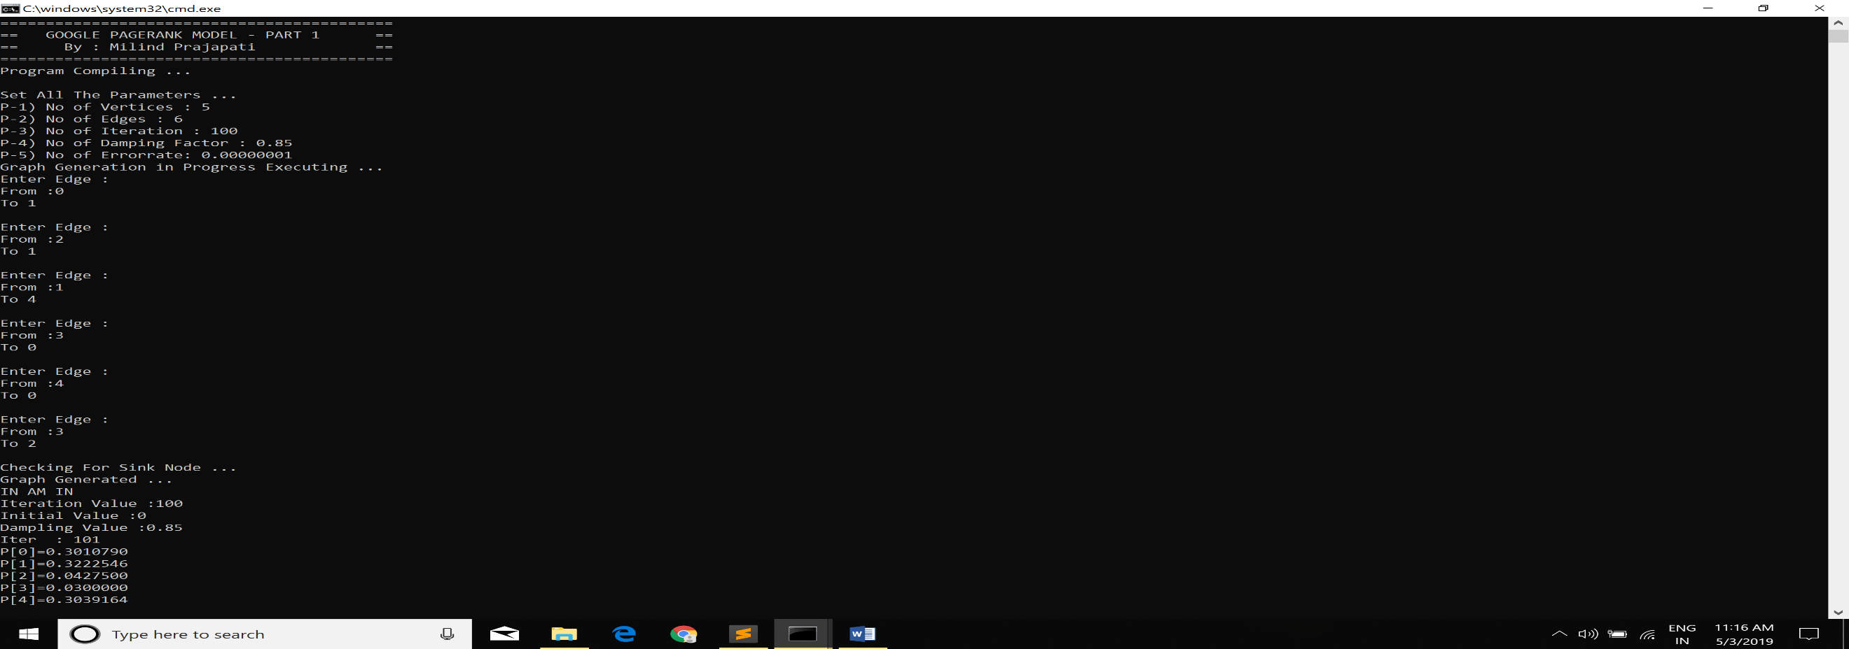

Figure : Setting Parameters

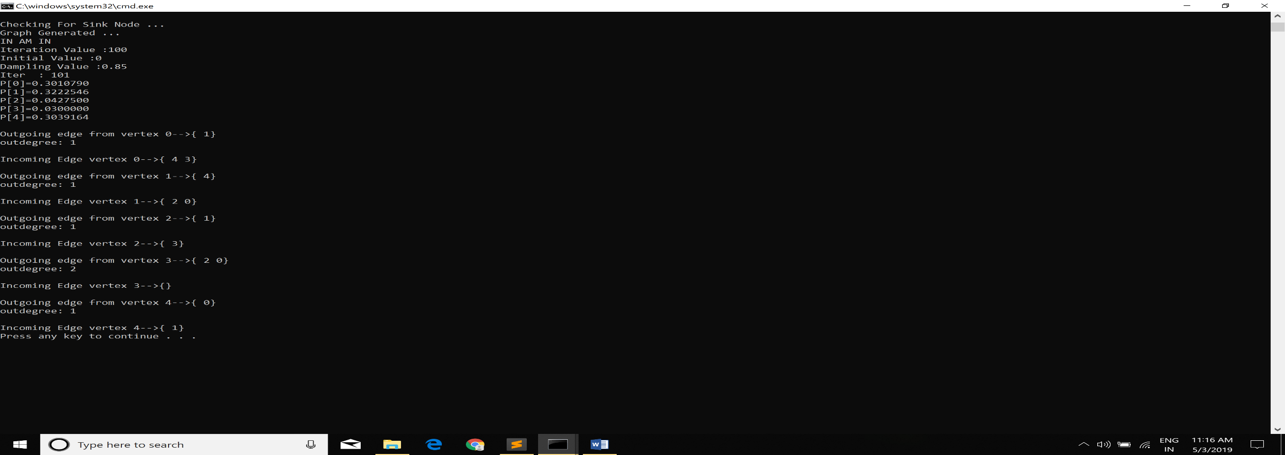

Figure : Provides PageRank and Graph

A screen shot of a computer

Description generated with very high confidence

**In Part 2**, We will dynamically generate graph as an input for each instance, and each RUN contains 50 different instances. Further, increment in nodes above 800 and Out Degree Between 20-90, Average time taken by each instance is around 6 secs – 1800 secs. Also, Graph of outdegree to nodes for RUNTIME is given. Note here the runtime is average of 50 RUN.

TIME COMPLEXITY : O(n3)

Explanation for Adjacency list it is **O(n+m)**, while for Accessing Pagerank matrix **O(n2),**  Therefore total Time Complexity is expected to be O((n+m)*(n2)) which is nearly equal to **O(n3).**

Figure : Average Runtime

A close up of a map

Description generated with high confidence

Figure : Performance Graph