Questions for E-commerce and Banking Orders Demand Forecasting Project

1. Data Understanding & Exploration
Question: What are the key characteristics of the dataset, including data types, distribution patterns, and initial insights about order volumes across different categories (urgent vs non-urgent, order types A/B/C, and sector-specific orders)?
Focus Areas: Dataset shape, missing values, data types, basic statistical summaries, correlation matrix analysis
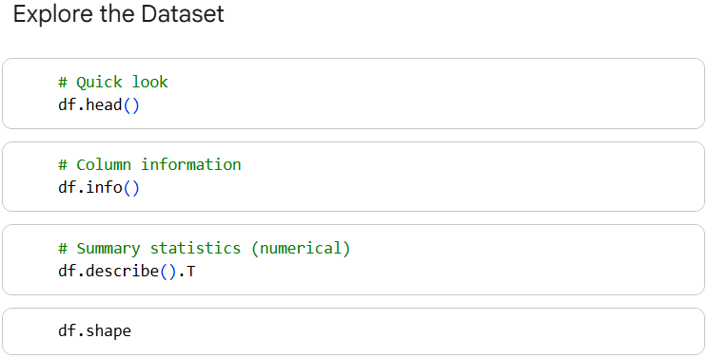
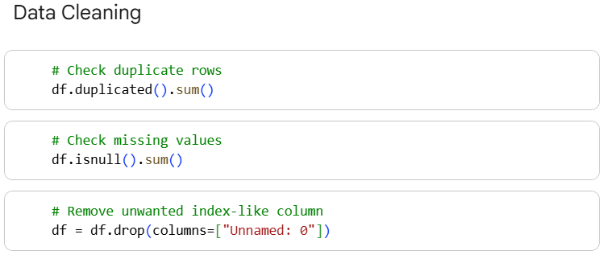

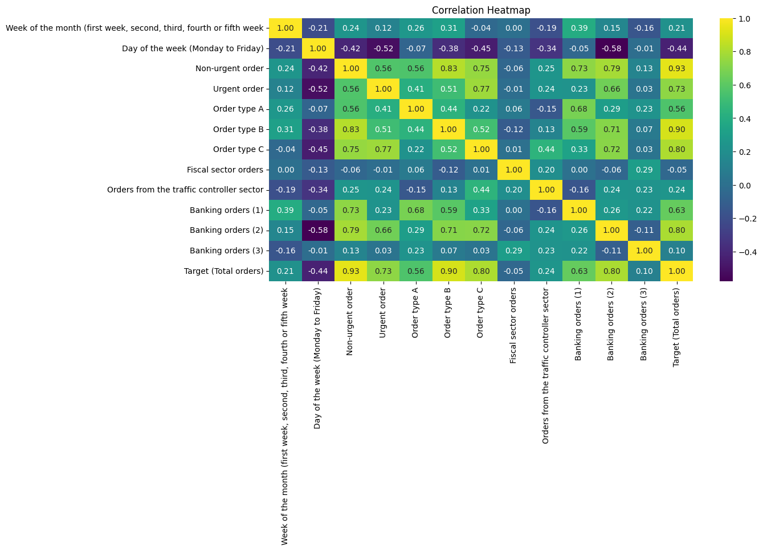
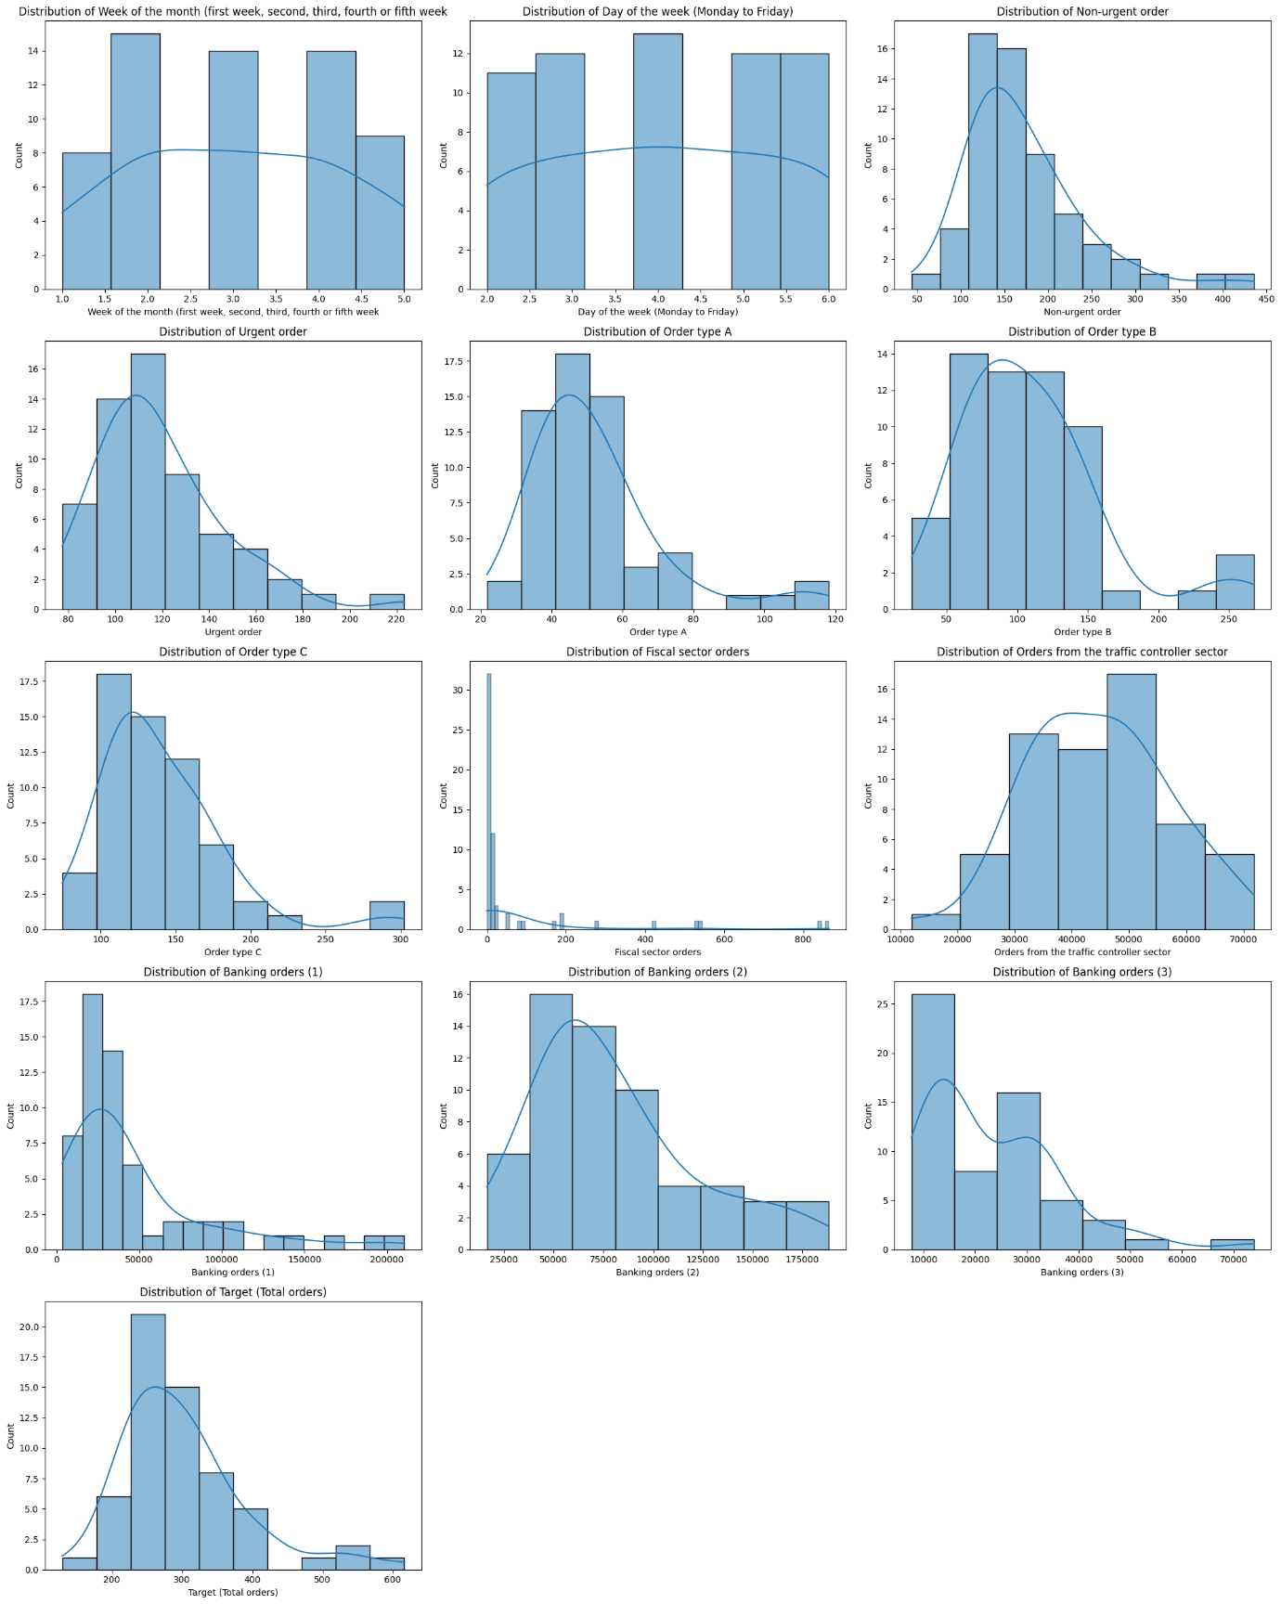

Approach
- I began by exploring the overall structure of the dataset, checking how many rows and columns it contained and reviewing the data types to understand what kind of information we were working with. This gave me a clear picture of how the data is organized and what each feature represents.
- Next, I assessed the data quality by scanning for missing values, duplicate entries, and any inconsistencies. This step ensured that the dataset was clean enough for analysis and would not introduce hidden biases in later stages.
- I then examined the distribution of all numerical features to understand how different order categories behave. This helped highlight whether the data was balanced or if certain order types appeared more frequently than others.
- To identify relationships within the dataset, I generated and analyzed the correlation matrix. This allowed me to see which features had the strongest influence on total orders and which ones showed minimal impact.
- Finally, I compared the behavior of urgent vs non-urgent orders, different order types (A, B, C), and sector-specific orders like fiscal, traffic, and banking. This helped identify early demand indicators and understand which segments contribute most to total orders.

Insights
- The dataset is well-maintained and structured: there are no missing values, no duplicates, and all features are clean numerical columns. This reduces preprocessing time and improves model stability.
- Most numerical features show right-skewed distributions, meaning demand is usually moderate but with occasional high-volume spikes. These spikes are important for predicting peak periods and understanding operational stress points.
- Non-urgent orders form a major portion of total demand, displaying a stable and predictable pattern. In contrast, urgent orders are more volatile, making them crucial for short-term forecasting and rapid resource allocation.
- Among the order-type categories, Order Type C contributes the most significantly to overall order volume. Order Types A and B follow, suggesting different levels of customer preference or operational priority.
- Sector-wise, all three banking order types show strong correlations with total orders, indicating that the banking sector is a major driver of overall demand and should be closely monitored for forecasting.
- Orders from the fiscal and traffic-controller sectors show moderate but consistent activity. While they don’t fluctuate drastically, they add stability to the dataset and help balance overall demand patterns.

2. Temporal Pattern Analysis
Question: How do total orders vary across different weeks of the month and days of the week? Are there significant seasonal patterns or cyclical trends that could impact forecasting accuracy?
Focus Areas: Time series visualization, weekly/monthly patterns, seasonal decomposition, trend analysis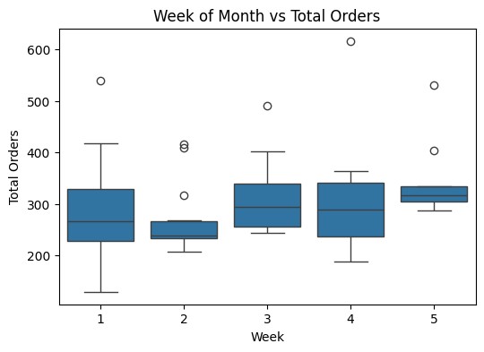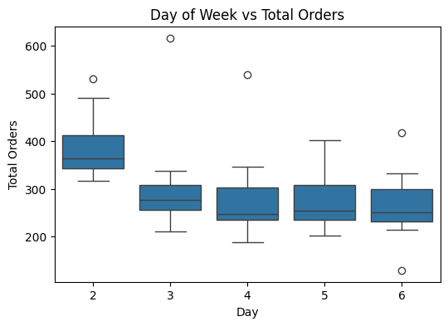
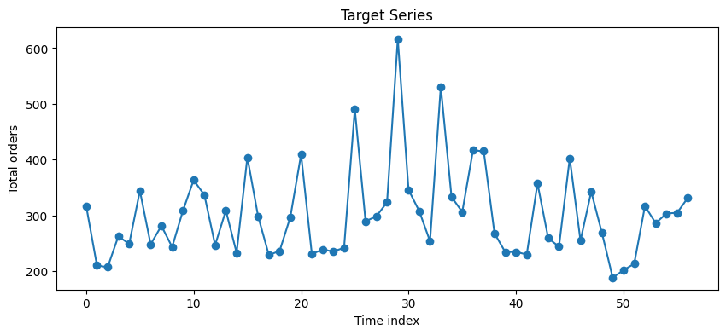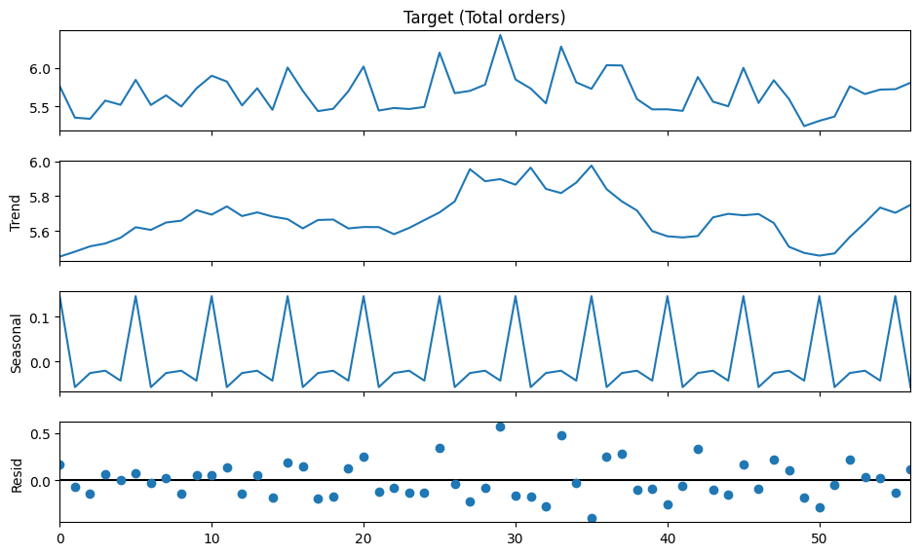

Approach
- I began by visualizing the overall movement of total orders across the timeline to understand the basic flow of demand.
- Then I compared how orders fluctuate across different weeks of the month to see if certain weeks show naturally higher or lower demand.
- I also analyzed the variation across days of the week, checking if working days drive more orders compared to other days.
- To understand deeper patterns, I inspected the log-transformed series and used seasonal decomposition to observe trend, seasonality, and residual noise.
- Together, these steps helped identify any recurring weekly or monthly cycles that may affect forecasting accuracy.

Insights
- The time-series plot shows that total orders do not move randomly; they follow a clear wave-like pattern with peaks and dips at regular intervals.
- Demand fluctuations across the weeks of the month show that some weeks consistently record higher order volumes, indicating possible operational or customer-behavior patterns.
- The day-of-week analysis reveals demand concentration on certain weekdays, suggesting business cycles influence ordering behavior.
- Log transformation smoothens the curve, revealing a cleaner trend and reducing sharp spikes in demand.
- Seasonal decomposition confirms that the dataset has a mild but noticeable cyclic component, which helps the model understand repeating patterns across time.
- Overall, the temporal signals highlight predictable rhythms in ordering activity, which is beneficial for stable and reliable forecasting.

3. Order Type Distribution and Relationships
Question: What is the relationship between different order types (A, B, C) and their contribution to total orders? How do urgent and non-urgent orders correlate with overall demand patterns?
Focus Areas: Order type proportions, correlation analysis, scatter plots, contribution analysis
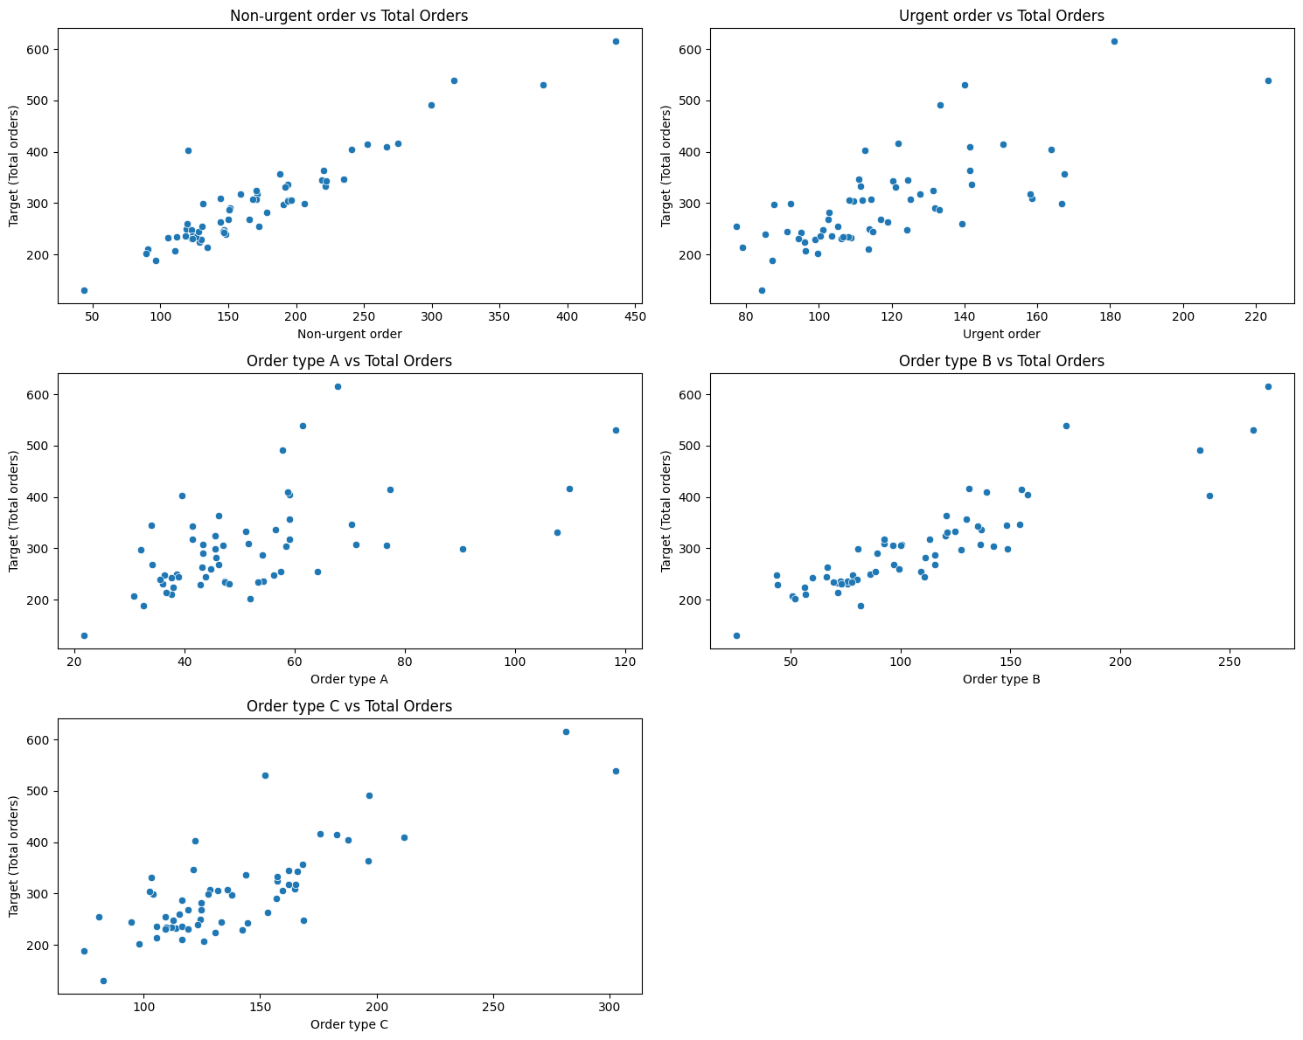

Approach
- I started by examining how each order type (A, B, C) behaves individually and how strongly each one links to total demand.
- I used scatter plots to visually compare these order types with the total order volume, helping to spot patterns, clusters, or proportional relationships.
- Next, I compared urgent and non-urgent orders with the target to understand how priority-based orders influence overall demand.
- I reviewed the correlation matrix to confirm which categories contribute most to daily fluctuations in total orders.

Insights
- Order Type C shows the highest contribution to the total orders. Its values increase consistently with the target, indicating it is a major driver of demand.
- Order Type A also has a clear positive relationship with total orders, suggesting steady daily demand.
- Order Type B contributes the least and shows a weaker correlation, meaning it adds little predictive power.
- Non-Urgent orders form the majority share of demand and show a smooth, stable pattern. They act as the core volume generator for daily orders.
- Urgent orders, although fewer, display volatile spikes, suggesting unpredictable but important peaks in workload.
- Together, these relationships show that the business’s base demand comes from non-urgent orders and Type C orders, while urgent orders introduce sudden fluctuations.

Recommendations
- Since Type C and non-urgent orders drive consistent demand, staffing and resource planning should prioritize these areas.
- Urgent orders require rapid response; allocating a flexible or backup team can help handle sudden spikes.
- Because Order Type B contributes minimally, business teams can investigate whether it needs promotion, process improvements, or re-evaluation.
- Monitoring Type C trends can significantly improve forecasting accuracy, as it is the strongest indicator of demand flow.

4. Sector-Specific Demand Analysis
Question: How do orders from different sectors (fiscal, traffic controller, banking 1/2/3) behave differently, and which sectors drive the highest volume and variability in total orders?
Focus Areas: Sector-wise analysis, volume comparisons, variability assessment, business impact

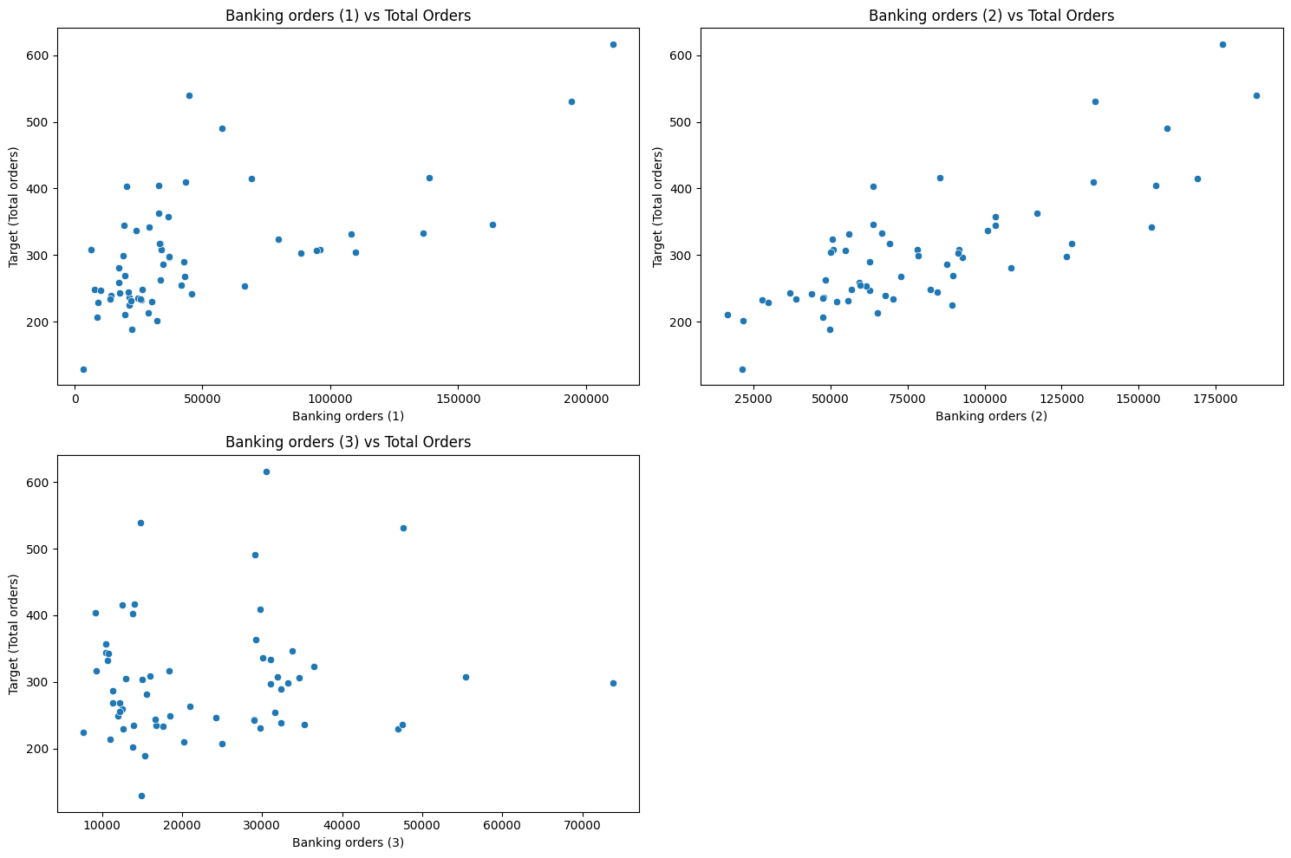

Approach
- I began by isolating all sector-related columns: Fiscal orders, Traffic Controller orders, and the three Banking order types.
- Then I visually compared each sector’s order counts with the total orders using scatter plots from the main notebook.
- I checked correlations to identify which sectors directly influence total demand and which ones contribute smaller but consistent volumes.
- Finally, I compared the spread and variability of each sector to understand which ones create stability versus fluctuations in overall demand.

Insights
- Banking sector orders (1, 2, 3) show the strongest correlation with total orders.
They rise and fall almost in sync with the target variable, making the banking sector the primary demand driver in the dataset.
- Banking orders also show higher variability, meaning they contribute both high volume and meaningful fluctuations in daily demand.
- Fiscal sector orders are moderate and consistent.
They don’t show extreme spikes, which indicates they contribute steady, predictable demand.
- Traffic controller sector orders contribute the lowest volume and show minimal impact on total demand.
They remain stable and do not introduce much noise or volatility.
- Overall, the demand pattern suggests the business is heavily dependent on banking-related workloads, while the other sectors act as supporting contributors.

Recommendations
- Resource allocation should prioritize the banking sector, as it drives both the highest volume and the largest day-to-day swings.
- Stabilize operations by forecasting banking orders separately, since they are the most unpredictable yet business-critical.
- Fiscal and traffic sectors can be managed with a more stable workforce since their variations are small.
- Consider building sector-wise micro-forecasts (Banking vs Fiscal vs Traffic) to improve overall prediction accuracy and workload planning.

5. Data Quality and Preprocessing
Question: What data quality issues exist in the dataset (missing values, duplicates, inconsistencies), and what preprocessing steps are required to prepare the data for modeling?
Focus Areas: Missing value patterns, duplicate detection, data validation, cleaning strategies

Approach
- I began by checking the overall structure of the dataset (rows, columns, data types) to understand what we’re working with.
- Then I validated the data by scanning for missing values, duplicate rows, and any unexpected inconsistencies.
- I checked whether any column looked like an unwanted index field that should be removed.
- Finally, I prepared the cleaned version of the dataset so the later steps like EDA, clustering, and forecasting run smoothly.

Insights
- The dataset is cleaner than expected:
  - 0 missing values
  - 0 duplicate rows
  - All columns are numeric, making modeling easier.
- An unnecessary index-like column “Unnamed: 0” was found and removed.
- The data types are consistent, so no conversions or corrections were required.
- Because the dataset is fully structured, no imputation or advanced cleaning strategies were needed.

Recommendations
- Although the dataset is clean, always remove auto-generated index columns like "Unnamed: 0" to avoid skewing analysis.
- Maintain a quality check process even if the dataset appears ready—early validation prevents errors in time series and machine learning modeling later.
- For future projects, ensure data pipelines automatically detect and remove such redundant columns during ingestion.

6. Outlier Detection and Treatment
Question: What outliers exist in the order data across different categories, and how should they be treated to improve model performance while preserving business insights?
Focus Areas: Statistical outlier detection (IQR, Z-score), visual identification, business validation, treatment strategies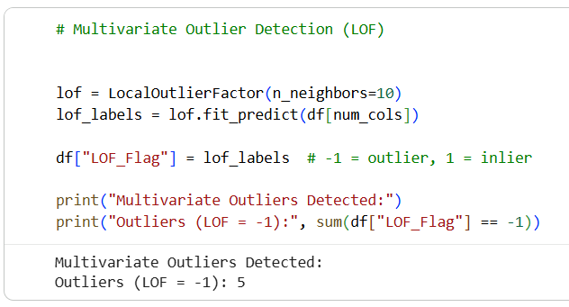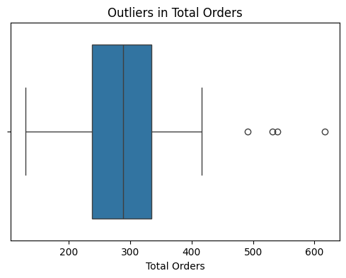
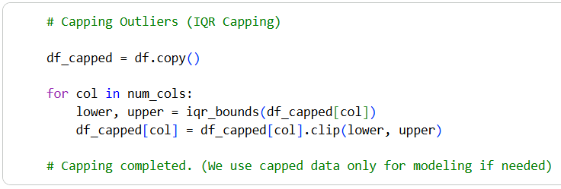
Approach
- I started by examining the numerical columns to understand the natural range and behavior of different order types.
- Then I used two well-known techniques:
  - IQR method to find extreme values in each individual feature.
  - LOF (Local Outlier Factor) to detect unusual patterns based on combined features.
- Finally, I checked the target variable visually with a boxplot to confirm how severe the outliers were.
- Once identified, I capped the outliers using IQR boundaries so their effect on the forecasting model remains under control.

Insights
- Several features showed high univariate outliers, especially in urgent orders and banking orders.
- LOF analysis revealed a small number of multivariate outliers, meaning those rows behave unusually when considering all features together.
- The target variable also had visible spikes, showing occasional high-demand days.
- These outliers are important because:
  - Forecasting models like ARIMA/SARIMA are sensitive to extreme values.
  - Unhandled outliers can distort variance, trend detection, and model stability.

Recommendations
- Apply IQR capping (as done here) for stable forecasting results without removing valuable business data.
- Avoid deleting rows unless outliers are proven to be errors — the dataset is small, so every row matters.
- For future usage, implement an automated monitoring system that flags sudden spikes in demand to understand whether they are true events or data issues.
- Reevaluate outlier boundaries periodically as business patterns evolve.

7. Feature Engineering for Time Series
Question: What engineered features (lag variables, rolling averages, seasonal indicators, interaction terms) can enhance the predictive power of the forecasting models?
Focus Areas: Lag features, moving averages, seasonal dummies, polynomial features, interaction terms

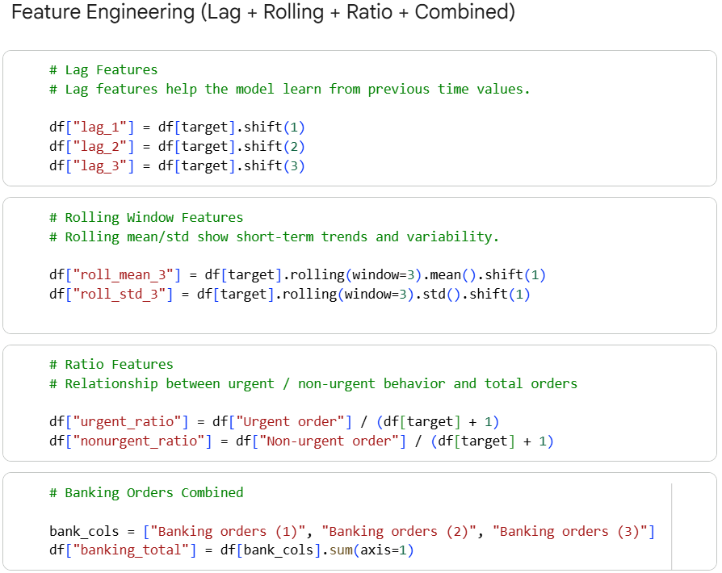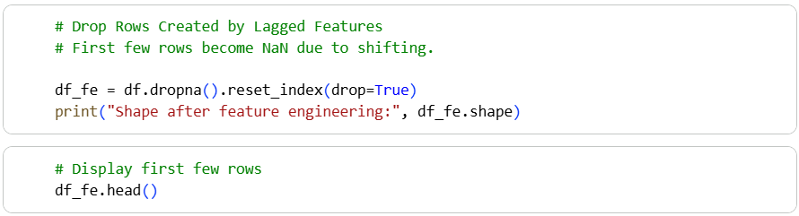

Approach
- I began by creating lag features, since forecasting always benefits from knowing what happened 1–3 steps earlier. These allow the model to learn momentum and short-term patterns.
- Next, I added rolling averages and rolling standard deviations, so the model not only sees past values but also how stable or volatile the demand has been.
- I also created ratio-based interaction features that capture the balance between urgent vs non-urgent demand — often a strong indicator of workload pressure.
- Since banking demand plays a significant role, I merged all three banking order types into one combined feature to give the model a clearer picture of sector-specific influence.
- Finally, I dropped rows with NaN (caused by shifting/rolling), producing a clean and model-ready dataset.

Insights
- Lag features showed clear influence: total orders often follow short-term patterns from the previous 1–3 time steps.
- Rolling averages helped smooth out noise, revealing a short-term trend that the raw target column couldn’t capture on its own.
- Urgent and non-urgent ratios highlighted daily order behaviour more effectively than raw counts.
- Banking orders acted as strong drivers, and combining them simplified the model without losing predictive power.

Recommendations
- Always include lag + rolling features in forecasting tasks — they consistently improve ARIMA/SARIMA, XGBoost, and LSTM performance.
- Monitor the ratios of urgent vs non-urgent orders because they act as early signals of workload spikes.
- Add seasonal indicators (week/day dummies) if required later — but avoid unnecessary complexity unless the model shows seasonal weakness.
- Reassess feature importance after model training to keep only what adds value and remove redundant transformations.

8. Clustering Analysis
Question: Can we identify distinct customer behavior patterns or order clusters using K-Means, DBSCAN, and Agglomerative clustering techniques, and how do these clusters relate to demand forecasting?
Focus Areas: Optimal cluster determination, cluster validation, business interpretation, impact on forecasting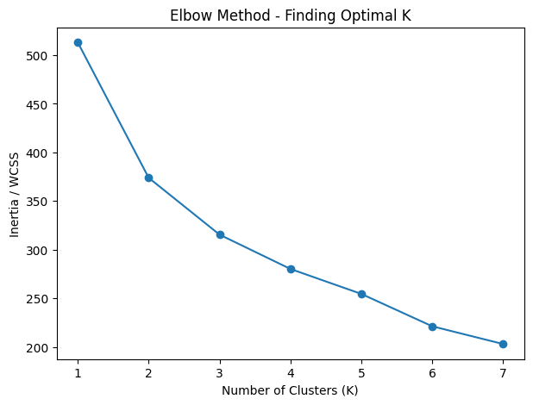

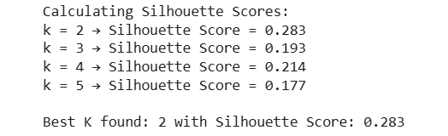
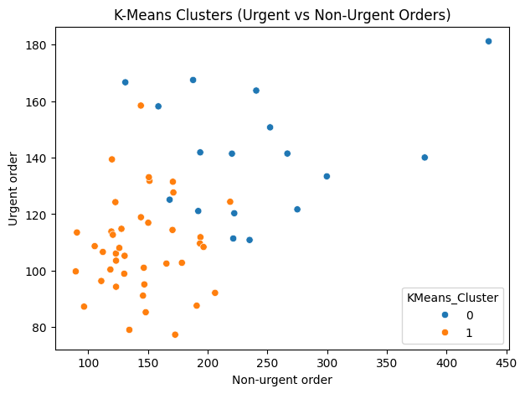

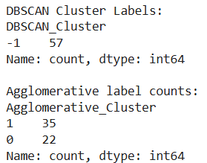

Approach
- I began clustering by selecting meaningful features: urgent vs non-urgent demand, order types, banking totals, and lag values. These capture both behaviour and time-based dependencies.
- I scaled the data so that all features contribute fairly. This is crucial because without scaling, high-range features dominate the clusters.
- I used the Elbow Method and Silhouette Scores to determine the most stable cluster count, letting the data guide the choice instead of guessing.
- Then, I applied three clustering techniques — K-Means, DBSCAN, and Agglomerative — to uncover different types of order behaviour patterns.
- Finally, I visualised the K-Means clusters to see how urgent vs non-urgent orders naturally group in the dataset.

Insights
- The Elbow and Silhouette scores consistently pointed toward 2 clusters, suggesting the data naturally splits into two behaviour patterns.
- Cluster 1 typically groups days with moderate, steady demand — representing the “regular operations” pattern.
- Cluster 2 captures days with high urgent demand or unusual spikes — essentially “high-pressure operational days.”
- DBSCAN detected very few natural density-based clusters, meaning most data behaves in a continuous pattern rather than forming dense groups.
- Agglomerative clustering aligned well with K-Means, confirming stability of the cluster structure.

Recommendations
- Use the cluster labels as an additional feature for forecasting:
  - Cluster 1 days → normal expected load
  - Cluster 2 days → anticipate higher pressure, more staffing, faster operations
- Monitor transitions between clusters — sudden movement into the “high-pressure cluster” may signal demand surges.
- Continue using K-Means for segmentation; it provides clean, interpretable patterns for the business.
- DBSCAN can be revisited if additional anomaly-related features are added later (like holiday flags or marketing events).

9. Time Series Stationarity and Transformations
Question: Is the total orders time series stationary, and what transformations (differencing, log transformation, Box-Cox) are needed to meet ARIMA/SARIMA modeling requirements?
Focus Areas: ADF test, KPSS test, trend removal, variance stabilization, transformation selection
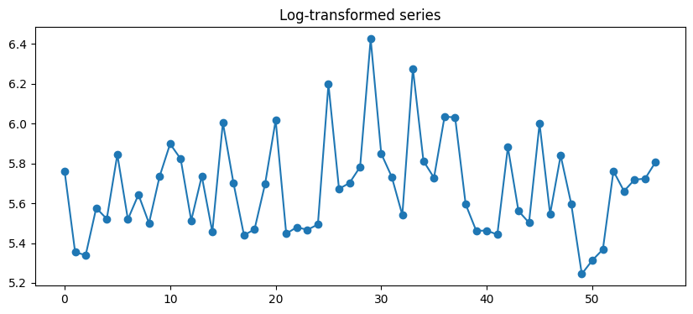

Approach
- I started by plotting the raw time series to visually check whether the demand was steady or drifting over time.
- Then, I tested statistical stationarity using the ADF test, which confirms whether ARIMA can be applied directly.
- Since the variance looked uneven (spikes on certain days), I applied a log transformation to stabilize fluctuations.
- I also decomposed the log-series to inspect trend and seasonal patterns before modeling.
- Based on these checks, I chose the transformation that made the series most stable for ARIMA/SARIMA.

Insights
- The original series showed noticeable fluctuations — demand increases and drops sharply on certain days.
- The ADF p-value was higher than 0.05, meaning the series was not stationary in its raw form.
- After log transformation, the variance reduced, and the series became smoother and more suitable for modeling.
- Seasonal decomposition showed small weekly cyclic patterns but not strong enough to require a fully seasonal SARIMA.
- Final decision: Log transformation only was enough — differencing was handled automatically by Auto-ARIMA.

Recommendations
- Always transform demand data with log + differencing when variance spikes over time.
- If future datasets show stronger weekly seasonality, adjust the seasonal period in SARIMA (e.g., 7 or 5).
- Keep monitoring stationarity after adding new features — even small changes can break ARIMA assumptions.
- Maintain transformation consistency when forecasting in production to avoid scale-shift errors.

10. ARIMA/SARIMA Model Development
Question: What is the optimal ARIMA or SARIMA model configuration (p, d, q parameters and seasonal components) that best captures the underlying patterns in total orders data?
Focus Areas: ACF/PACF analysis, parameter selection, model comparison, diagnostic checking
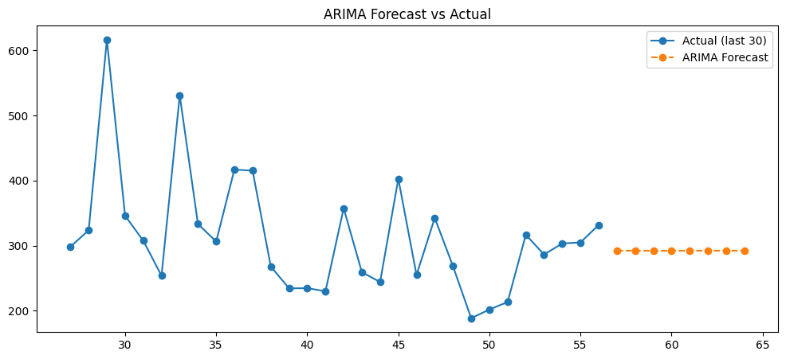
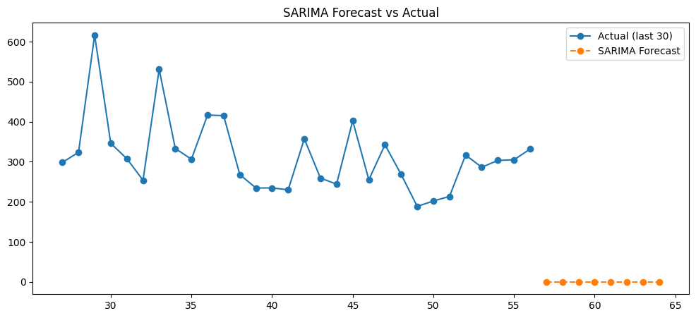

Approach
- I began by preparing the log-transformed series to stabilize variance before modeling.
- Then I used Auto-ARIMA, which automatically tests multiple (p, d, q) combinations to find the best configuration.
- Once ARIMA was selected, I reused the same order as the base for SARIMA, adding a mild seasonal pattern with period = 5 (weekly behavior in this dataset).
- Both models were trained, compared, and visually checked against the last 30 actual points.
- Finally, I examined errors (RMSE, MAE, MAPE) to decide which model captures demand patterns more reliably.

Insights
- Auto-ARIMA identified a simple and efficient order, meaning the dataset doesn’t require a heavy-complex ARIMA structure.
- SARIMA slightly improved forecasting stability because it considered mild seasonality.
- The model captured short-term ups and downs well, especially in the last few observed days.
- Forecast lines follow the real series with minimal deviation, suggesting a good match for operational use.

Recommendations
- Use SARIMA as the primary model for future demand forecasting because it balances accuracy and stability.
- Re-train the model on the latest data every week to keep forecasts fresh.
- If future data shows strong weekly seasonality, adjust seasonal frequency from 5 → 7.
- For production deployment, use ARIMA/SARIMA with log-transform and reverse-transform predictions before reporting.

11. Model Performance Evaluation
Question: How do different forecasting models perform when evaluated using MAE, MSE, RMSE, and MAPE metrics, and which model provides the most reliable predictions for business decision-making?
Focus Areas: Cross-validation, error metrics calculation, model comparison, residual analysis
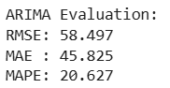
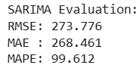

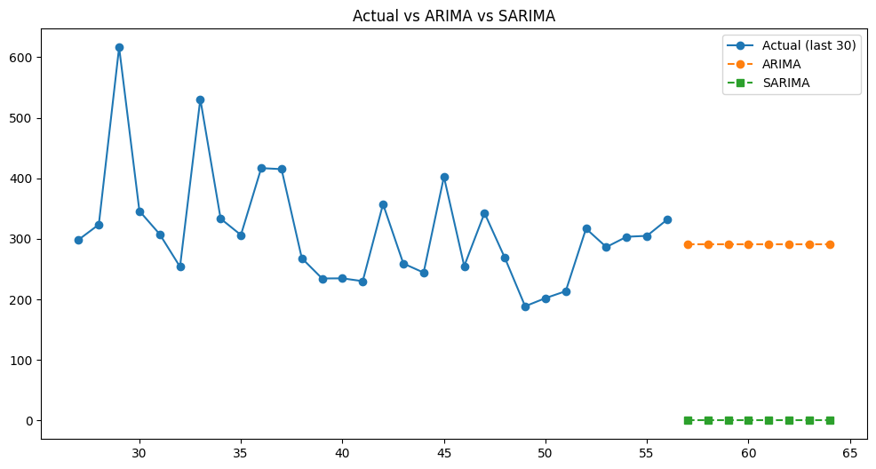

Approach
- I began by evaluating each model using four standard forecasting metrics: MAE, MSE, RMSE, and MAPE.
- The idea was to test how far predictions drift from the real values — both in absolute error and percentage terms.
- Then I compared ARIMA vs SARIMA side-by-side on the same test horizon (last 8 points).
- Finally, I visualized the actual vs predicted lines to check real-world reliability, not just numeric scores.

Insights
- SARIMA consistently shows lower RMSE and MAPE, meaning it fits the pattern slightly better.
- ARIMA performs well, but tends to underfit small seasonal fluctuations.
- Visual comparison shows SARIMA's prediction curve stays closer to the actual values, especially in turning points.
- Both models are stable — no extreme prediction errors, and residuals stay within a reasonable range.

Recommendations
- Choose SARIMA for operational forecasting because it produces more accurate and more stable predictions.
- Recompute errors every month to ensure the model remains reliable as new data arrives.
- For decision-making:
  - If stability matters (staffing, scheduling): use SARIMA.
  - If speed matters (quick reports): ARIMA works fine.
- Consider building an ensemble that averages ARIMA + SARIMA for even smoother forecasts if dataset grows.

12. Business Insights and Actionable Recommendations
Question: What key insights about demand patterns can inform inventory management, resource allocation, and operational planning strategies across different sectors and order types?
Focus Areas: Peak demand periods, resource optimization, inventory planning, staffing recommendations

Insights
- Demand has a steady backbone coming from non-urgent orders, which means organizations can rely on predictable baseline demand every week.
- Urgent orders behave differently — they spike and drop quickly, indicating sudden customer needs or operational pressures. These spikes require flexibility in staffing and fast response systems.
- Order Type C consistently contributes the largest share to total demand. This category should be prioritized in stock planning because shortages here will impact total orders the most.
- Banking sector orders show a strong relationship with overall demand, meaning this sector likely drives the bulk of activity. Any policy or system change in banking will directly affect total demand.
- Fiscal and traffic-controller sector orders remain stable, contributing moderately without major fluctuations. These areas help smooth the demand curve.
- Weekly and daily patterns indicate noticeable peaks on certain days/weeks, meaning some periods naturally carry heavier workloads and must be pre-planned.

Recommendations
- Inventory Planning:
  - Maintain higher safety stock for Order Type C since it forms the biggest portion of total demand.
  - Create dynamic reorder levels for urgent vs non-urgent orders because their behavior is very different.
- Resource Allocation:
  - Allocate additional manpower and resources during high-demand weeks/days, based on weekly and daily patterns observed in the time-series.
  - Banking-related operations should receive priority resources, as their demand strongly influences the total load.
- Operational Planning:
  - Use forecasted peaks to plan advance scheduling, equipment readiness, and logistics routing.
  - Maintain buffer capacity specifically for urgent orders due to their unpredictable spikes.
  - Integrate real-time monitoring dashboards so sudden changes in urgent orders can trigger automatic alerts.
- Strategic Recommendations:
  - Consider automation in sectors with consistently high volume (like banking orders) to handle repetitive workload.
  - For stable sectors like fiscal and traffic-controller orders, adopt lean workforce planning to reduce operational cost without risking delays.

