Hotel Booking Application Analysis

Initial Tasks:

- Data Cleaning: Handling missing values, correcting data types, and removing duplicates.

Approach:- Data cleaning and pre-processing –
To check null values in our dataframe
df.isnull().sum().sort_values(ascending=False)

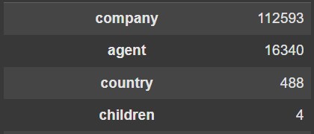

      - Handling Missing Values :-

- children (4 missing) :- Filled with 0, assuming those bookings had no children.
df['children'].fillna(0, inplace=True)

- country (488 missing) :- Replaced missing entries with 'Unknown' so we can keep the records without losing any data.
df['country'].fillna('Unknown', inplace=True)

- agent (16,340 missing) :- Filled with 0 to mark bookings without a known agent, then converted to integer for consistency.
df['agent'].fillna(0, inplace = True)
df['agent'] = df['agent'].astype(int)

- company (112,593 missing) :- Filled with 0, assuming most of these bookings were made directly without a company, then converted to an integer.
df['company'].fillna(0, inplace = True)
df['company'] = df['company'].astype(int)

      - Correcting data types:- Converted this column to datetime format so that we can easily analyze booking trends over time (like monthly, yearly, or weekday patterns).
df['reservatiton_status_date'] = pd.to_datetime(df['reservation_status_date'])

      - removing duplicates :- Removed duplicate rows from the dataset to make sure each booking is counted only once. This helps maintain the accuracy and reliability of our analysis.
df.drop_duplicates(inplace=True)

- Descriptive Statistics: Generating summary statistics for numerical and categorical variables.
Approach:- 1. Numerical Data Summary - This command helped me explore columns with numbers like lead_time, adr, stays_in_week_nights, etc.
df.describe()

2. Categorical Data Summary - This command gave me details about columns with text values like hotel, meal, customer_type, etc.
df.describe(include='object')

- Data Visualization: Creating visualizations to understand the distribution of variables and relationships between them.
Approach:- 3.1 :- Booking Cancellation Distribution :-
This chart shows how many bookings were canceled versus not canceled. It helps us quickly understand the overall cancellation trend and the scale of canceled bookings compared to completed ones.

ax = sns.countplot(data=df, x='is_canceled')
plt.title('Booking Cancellation Distribution')
plt.xlabel('Is Canceled (0 = No, 1 = Yes)')
plt.ylabel('Number of Bookings')

for i in ax.containers:
plt.bar_label(i)

plt.show()

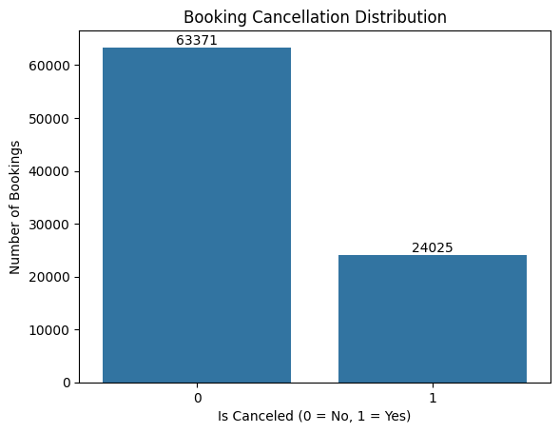

3.2 Bookings Per Hotel Type :-
This bar plot compares the number of bookings between city hotels and resort hotels. It helps us identify which hotel type is more preferred by guests overall.

ax = sns.countplot(data=df, x='hotel')
plt.title('Number of Bookings by Hotel Type')
plt.xlabel('Hotel Type')
plt.ylabel('Number of Bookings')

for i in ax.containers:
plt.bar_label(i)

plt.show()

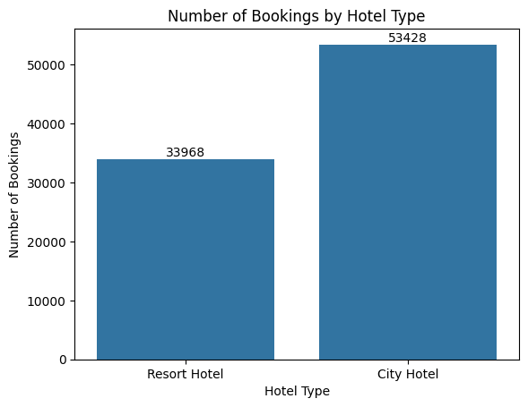

3.3 Distribution of Average Daily Rate (ADR):-
This histogram shows how room prices (ADR) are distributed. It helps us identify common pricing ranges and spot any extreme high or low rates.

sns.histplot(data=df, x='adr', bins=50, kde=True, color='skyblue')

plt.title('Distribution of Average Daily Rate (ADR)')

plt.xlabel('Average Daily Rate')

plt.ylabel('Frequency')

plt.show()

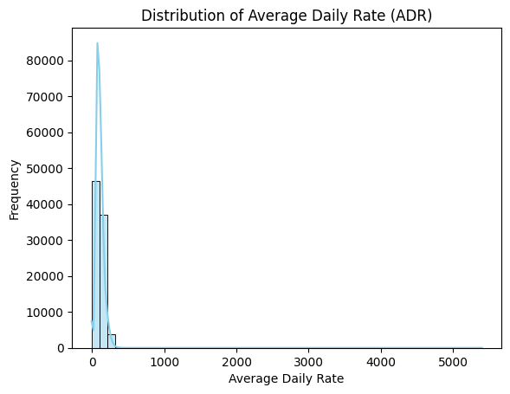

3.4 Booking Trends Over Time:-
This line plot shows how booking volumes changed month by month. It helps in spotting peak and low seasons, supporting better planning and forecasting.

monthly_bookings = df['reservation_status_date'].dt.to_period('M').value_counts().sort_index()
monthly_bookings.plot(kind='line', figsize=(12,6), marker='o')
plt.title('Monthly Booking Trends')
plt.xlabel('Month')
plt.ylabel('Number of Bookings')
plt.xticks(rotation=45)
plt.show()

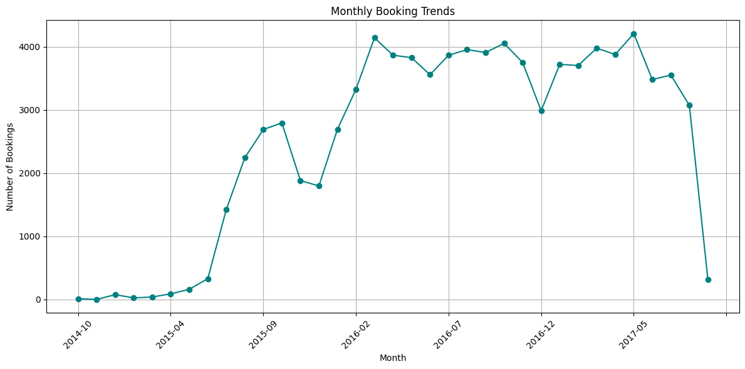

3.5 Lead Time vs. Booking Cancellation:-
This box plot compares the number of days booked in advance (lead time) between canceled and non-canceled bookings. It shows whether early bookings are more likely to be canceled.

plt.figure(figsize=(10,6))
sns.boxplot(data=df, x='is_canceled', y='lead_time')
plt.title('Lead Time vs Booking Cancellation')
plt.xlabel('Is Canceled (0 = No, 1 = Yes)')
plt.ylabel('Lead Time (days)')
plt.show()

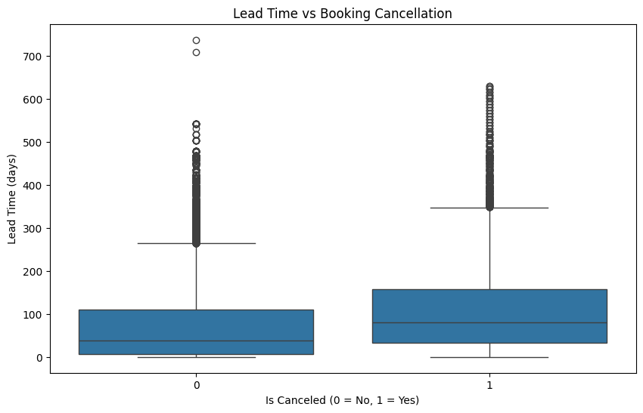

3.6 Correlation Heatmap:-
This heatmap shows how numerical variables relate to each other. It helps identify strong positive or negative relationships, which is useful for feature selection and deeper analysis.

plt.figure(figsize=(12,8))
sns.heatmap(df.corr(numeric_only=True), annot=True, cmap='coolwarm', fmt=".2f")
plt.title("Correlation Heatmap")
plt.show()

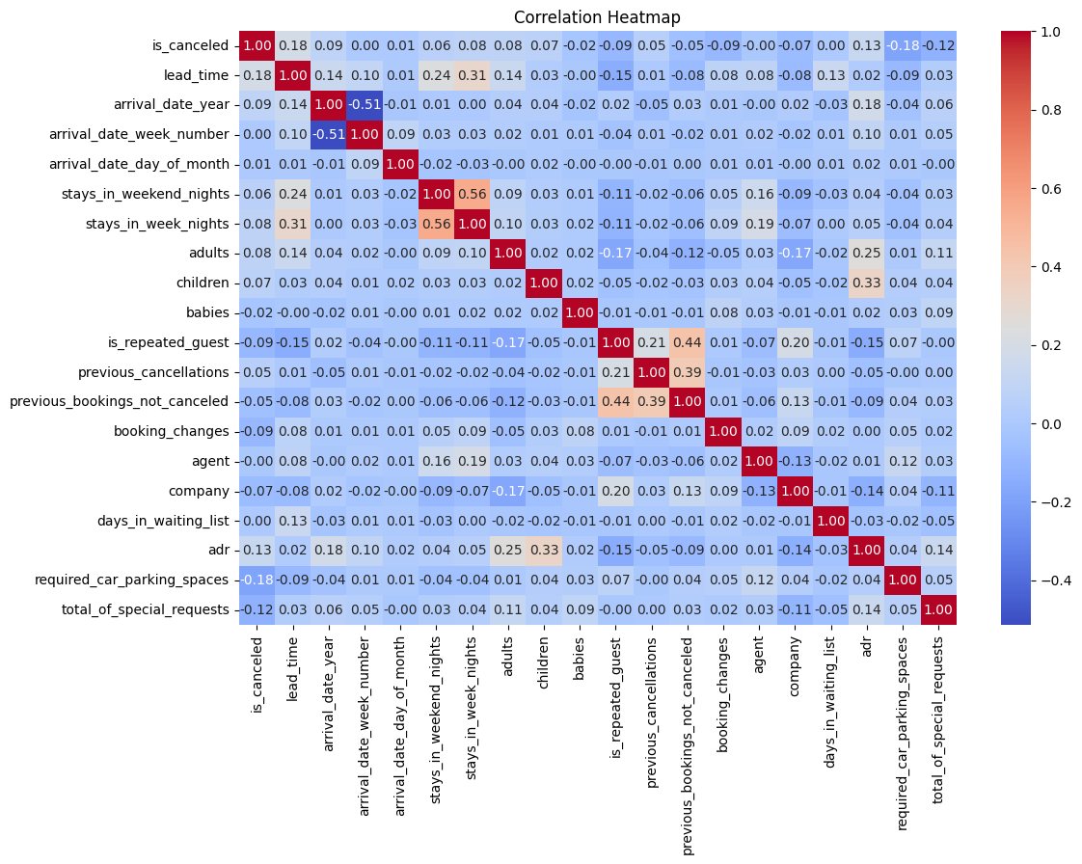

- Time Series Analysis: Analyzing trends and patterns over time.
Approach:- # Combine year and month for timeline
df['year_month'] = pd.to_datetime(df['arrival_date_year'].astype(str) + '-' + df['arrival_date_month'] + '-01')

# Monthly bookings
monthly_bookings = df.groupby('year_month').size()
monthly_bookings.plot(figsize=(12,5), title="Monthly Bookings Over Time")
plt.ylabel("Number of Bookings")
plt.show()
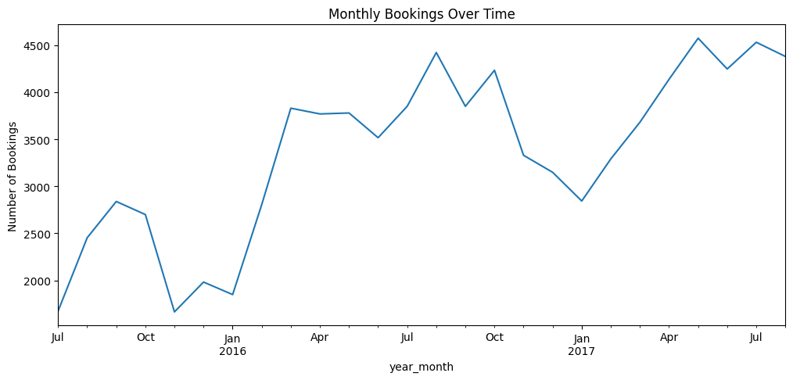
# Monthly cancellations
df[df['is_canceled'] == 1].groupby('year_month').size().plot(figsize=(12,5), title="Monthly Cancellations Over Time", color='red')
plt.ylabel("Cancellations")
plt.show()
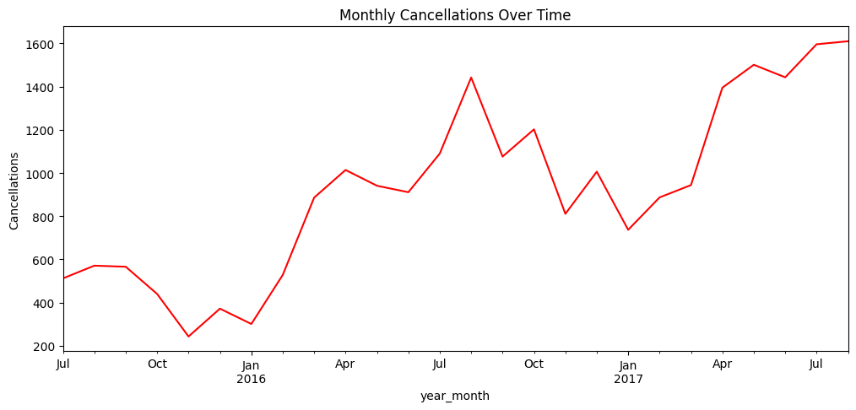

- Segmentation Analysis: Identifying and analyzing different customer segments.
Approach:- Cancellation by customer type:
ax = sns.countplot(data=df, x='customer_type', hue = 'is_canceled')
plt.title("Cancellations by Customer Type")
for i in ax.containers:
plt.bar_label(i)
plt.show()
# Get counts of each combination of customer_type and is_canceled
df.groupby('customer_type')['is_canceled'].mean()
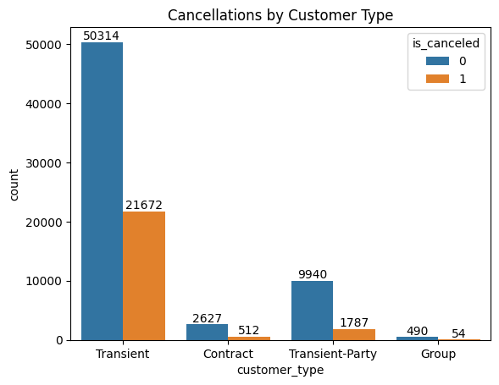

 | is_canceled
customer_type
Contract | 0.163109
Group | 0.099265
Transient | 0.301059
Transient-Party | 0.152383

Cancellations by repeated guests :-

sns.countplot(data=df, x='is_repeated_guest', hue = 'is_canceled')
plt.title("Cancellations by Repeated Guests")
plt.show()

df.groupby('is_repeated_guest')['is_canceled'].mean()

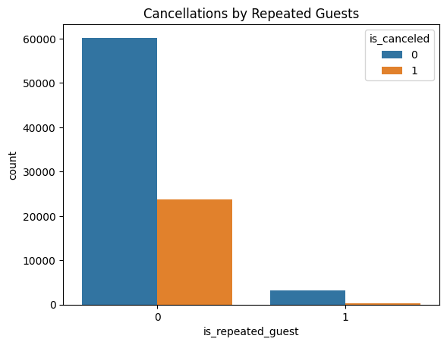

is_repeated_guest | is_canceled
0 | 0.282969
1 | 0.076428

- Booking and Cancellation Analysis: Examining booking attributes and their impact on cancellations and ADR.
Approach:- Cancellation by Hotel
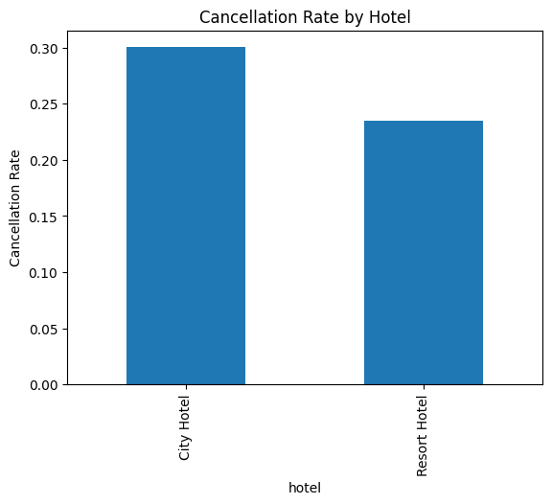

hotel | is_canceled
City Hotel | 0.300386
Resort Hotel | 0.234809

Lead time Impact :-

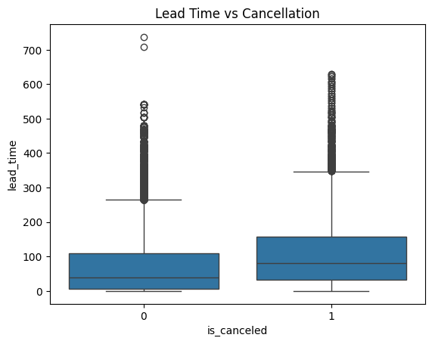
ead time Impact :-

count | mean | std | min | 25% | 50% | 75% | max
is_canceled
0 | 63371.0 | 70.099588 | 81.629723 | 0.0 | 7.0 | 38.0 | 110.0 | 737.0
1 | 24025.0 | 105.719251 | 91.877339 | 0.0 | 32.0 | 80.0 | 158.0 | 629.0
ADR vs Cancellations :-
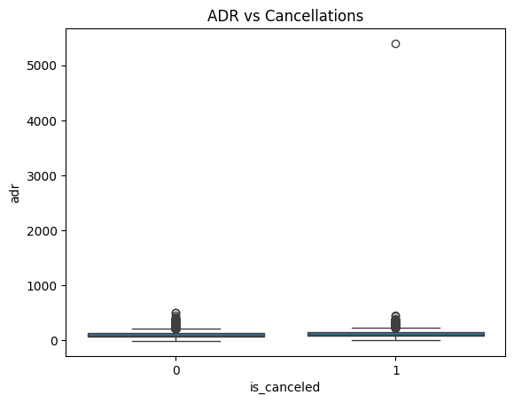

is_canceled | count | mean | std | min | 25% | 50% | 75% | max
0 | 63371.0 | 102.001961 | 51.393422 | -6.38 | 67.99 | 94.5 | 129.2 | 510.0
1 | 24025.0 | 117.772476 | 62.149188 | 0.00 | 81.00 | 109.8 | 144.0 | 5400.0

Deposit Type Impact :-
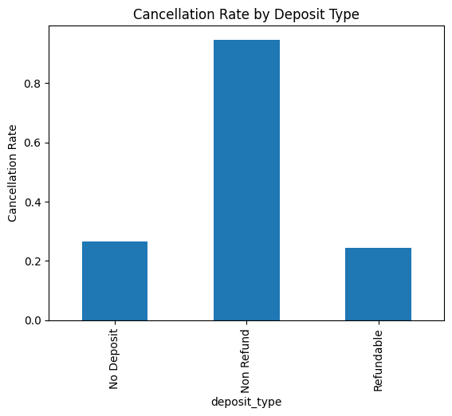

deposit_type | is_canceled
No Deposit | 0.266849
Non Refund | 0.947013
Refundable | 0.242991

- asdasnas

- Actionable Insights: Providing recommendations based on the analysis to improve hotel operations and customer satisfaction.

Key Insights:

- City Hotel Faces More Cancellations:
City Hotels have a noticeably higher number of booking cancellations (around 30%) compared to Resort Hotels (around 23%). Although more guests book City Hotels, the cancellations are also higher in both number and percentage.

- Non-Refund Bookings Are Being Canceled a Lot:
Surprisingly, bookings marked as Non-Refund are being canceled over 94% of the time. This is unusual, since people generally avoid canceling non-refundable reservations. This could either be due to errors in data or system misuse, and needs further checking.

- Transient Customers Cancel More Often:
One-time or short-stay customers (called Transient customers) cancel about 30% of their bookings. On the other hand, Contract customers (who are usually tied to companies) have a much lower cancellation rate of about 16%. Group bookings are even more reliable, with only 10% cancellations.

- Loyal Guests Rarely Cancel:
Repeat guests cancel much less (only about 7.6%) compared to new or one-time guests (around 28%). This clearly shows that loyal customers are more trustworthy.

- Special Requests Are Made by Certain Guests:
Transient and Contract guests tend to make more special requests per booking, which means the hotel staff should be prepared to serve these types of guests with more attention.

- City Hotels Charge More:
City Hotels have a higher Average Daily Rate (ADR), around 111, compared to 99 at Resort Hotels. This could mean they are targeting business travelers or offering premium services.

Recommendations:

- Reduce Cancellations:
  - City Hotels should review their booking policies, pricing models, and communication methods to understand why guests are canceling more.
  - Transient guests could be offered benefits if they choose non-cancellation options, such as discounts or extra services.
  - The very high cancellation rate in Non-Refund bookings should be looked into carefully. It may be a sign of system loopholes or incorrect data.

- Reward Loyal Guests:
  - Encourage one-time guests to return by giving them loyalty points, special offers, or faster booking experiences.
  - Give repeat guests extra benefits like free upgrades or exclusive deals to maintain their trust.

- Focus on Reliable Customers:
  - Promote contract and group bookings, as they are more reliable and bring in stable revenue.
  - Consider offering special packages for businesses or large groups.

- Improve Staff Readiness:
  - Since some customer types make more special requests, the front desk and housekeeping teams should be trained to handle these requests efficiently.
  - This improves the guest experience and leads to better reviews.

- Smart Marketing and Pricing:
  - For City Hotels, try offering early booking discounts or cancellation protection to reduce risk.
  - Use the higher rates of City Hotels to offer added value, like flexible cancellations or loyalty perks, which can increase retention and reduce cancellations.

---------- Objective Questions----------

- What is the average lead time for bookings that are cancelled versus those that are not cancelled?
Approach:- df.groupby('is_canceled')['lead_time'].mean()
is_canceled | lead_time
0 | 70.099588
1 | 105.719251

- Which month has the highest number of bookings?
Approach :- df['arrival_date_month'].value_counts().idxmax()
Output:- `August`

- What is the distribution of ADR (Average Daily Rate) across different customer types?

Approach :-
sns.boxplot(data=df, x='customer_type', y='adr')
plt.title("Distribution of ADR by Customer Type")
plt.show()
df.groupby('customer_type')['adr'].describe()

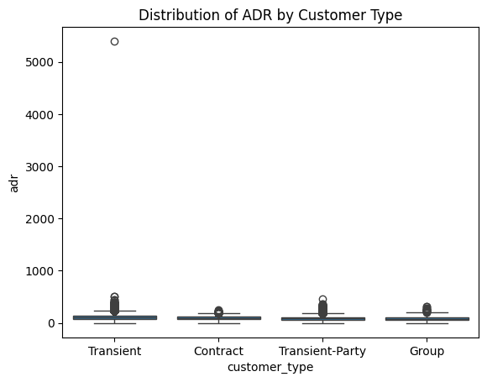

customer_type | count | mean | std |  | min | 25% | 50% |  | 75% | max
Contract | 3139.0 | 92.753036 |  | 35.095893 | 0.00 | 68.0 | 90.90 | 113.6700 |  | 250.0
Group | 544.0 | 84.361949 |  | 51.449532 | 0.00 | 50.0 | 75.00 | 110.4675 |  | 318.0
Transient | 71986.0 | 110.135859 |  | 56.613558 | 0.00 | 75.0 | 102.00 | 139.2800 |  | 5400.0
Transient-Party | 11727.0 | 87.675056 |  | 43.821641 | -6.38 | 62.0 | 81.28 | 109.0000 |  | 451.5

- How many bookings had special requests, and what is the average number of special requests per booking?
Approach :-
# Count of bookings with any special request
(df['total_of_special_requests'] > 0).sum()
# Average number of special requests per booking
df['total_of_special_requests'].mean()

Output :- np.float64(0.6985674401574443)

- What is the cancellation rate for each market segment?
Approach :-
# Cancellation rate for each market segment
df.groupby('market_segment')['is_canceled'].mean()

market_segment | is_canceled
Aviation | 0.198238
Complementary | 0.125356
Corporate | 0.121083
Direct | 0.147154
Groups | 0.270134
Offline TA/TO | 0.148535
Online TA | 0.353462
Undefined | 1.000000
Output:-

- Which distribution channel has the highest average ADR?
Approach :- df.groupby('distribution_channel')['adr'].mean().idxmax()
Output :- `GDS`

- What is the correlation between lead time and the length of stay?
Approach :-
df['length_of_stay'] = df['stays_in_week_nights'] + df['stays_in_weekend_nights']
df['lead_time'].corr(df['length_of_stay'])
Output :- `np.float64(0.31827157953643465)`

- How many bookings include children and/or babies?
Approach :- int(((df['children'] > 0) | (df['babies'] > 0)).sum())
Output :- `9103`

- What is the average lead time for repeated guests compared to new guests?
Approach :- df.groupby('is_repeated_guest')['lead_time'].mean()
Output :-
is_repeated_guest | lead_time
0 | 82.442255
1 | 17.160469

- What is the most common combination of reserved room type and assigned room type?
Approach :-
df.groupby(['reserved_room_type', 'assigned_room_type']).size().idxmax()
Output :- ('A', 'A')

---------- Subjective Questions ----------

- How does the lead time affect the likelihood of booking cancellations?

Approach :- We calculated the average lead time (the number of days between the booking date and the arrival date) for both cancelled and non-cancelled bookings.

#Calculate Average Lead Time by Cancellation Status

lead_time_by_cancellation = df.groupby('is_canceled')['lead_time'].mean()
print("Average Lead Time:\n", lead_time_by_cancellation)

plt.figure(figsize=(6, 5))
lead_time_by_cancellation.plot(kind='bar', color=['green', 'red'], edgecolor='black')
plt.title('Average Lead Time by Cancellation Status')
plt.xlabel('Cancellation Status (0 = Not Canceled, 1 = Canceled)')
plt.ylabel('Average Lead Time (days)')
plt.xticks([0, 1], ['Not Canceled', 'Canceled'], rotation=0)
plt.grid(axis='y', linestyle='--', alpha=0.7)
plt.tight_layout()
plt.show()

df.groupby('is_canceled')['lead_time'].mean()

is_canceled | lead_time
0 | 70.099588
1 | 105.719251

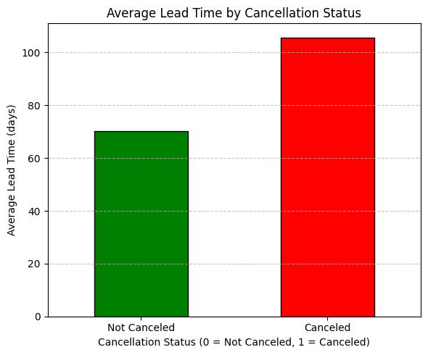

Insights :-
- Guests who book early (around 106 days before) are more likely to cancel.
- Guests who book closer to their stay (around 70 days before) usually do not cancel.
- So, longer lead time = higher chance of cancellation.
Recommendations :-
- Ask for a small deposit from guests who book very early (to reduce cancellations).
- Offer better deals to guests who book closer to the stay date, as they’re more likely to show up.
- Send reminders or offers to early bookers to keep them interested and reduce the chance of cancellation.
- Overbook slightly during busy times, knowing that early bookings may cancel.
- Use lead time to predict cancellations and manage bookings smartly.

- What impact do special requests have on booking cancellations?
Approach :- we examined how the number of special requests relates to booking cancellations.
# Group by number of special requests and calculate cancellation rate
cancellation_by_requests = df.groupby('total_of_special_requests') ['is_canceled'].mean()
cancellation_by_requests

# Plot the result
plt.figure(figsize=(10, 5))
cancellation_by_requests.plot(kind='bar', color='skyblue', edgecolor='black')
plt.title('Cancellation Rate by Number of Special Requests')
plt.xlabel('Number of Special Requests')
plt.ylabel('Cancellation Rate')
plt.xticks(rotation=0)
plt.tight_layout()
plt.show()

# Group by number of special requests and calculate cancellation rate
df.groupby('total_of_special_requests')['is_canceled'].mean()

total_of_special_requests | is_canceled
0 | 0.332027
1 | 0.224110
2 | 0.212919
3 | 0.171342
4 | 0.106250
5 | 0.055556

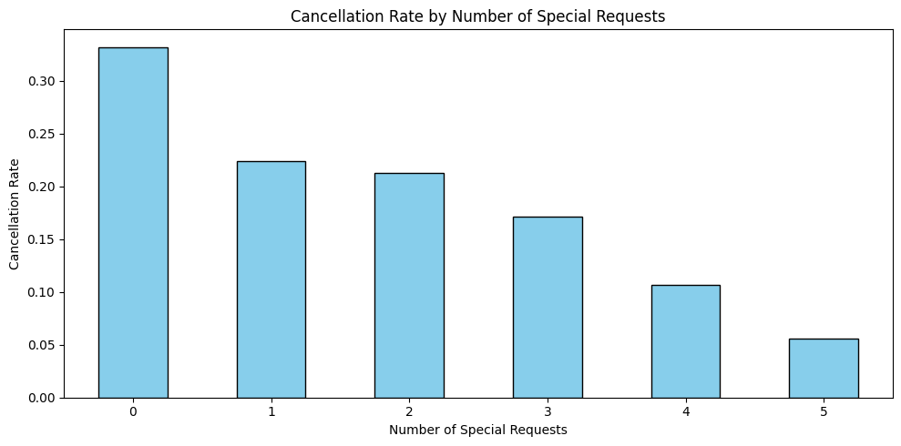

Insights :-
- Guests with zero special requests cancel their bookings most often.
- Guests with more special requests are less likely to cancel.
- When a guest makes 3 or more requests, the chances of cancellation drop a lot.
- This shows that guests who make special requests are usually more serious about their stay.
- Special requests show a guest’s interest or personal planning, which makes them more committed.

Recommendations :-
- Use the number of special requests as a way to predict cancellations in the future.
- During booking, ask guests if they have any preferences or special needs to increase commitment.
- Offer small rewards like upgrades or gifts to guests who make 3 or more requests, as they are more likely to show up.
- Keep a record of past guest preferences to personalize future bookings and increase loyalty.
- Since these bookings are reliable, hotel staff can prioritize preparation for rooms with special requests.

- What trends can be observed in the booking behaviour of international guests compared to domestic guests?
Approach :- We created a new column guest_origin to classify each booking as Domestic or International, based on the guest's country code. If the country was PRT (Portugal), it was labeled as Domestic, otherwise International.
We then grouped the data by guest origin and calculated:
- Average cancellation rate
- Average lead time
- Average daily rate (ADR)
- Average weekday and weekend stay durations
- Average number of special requests
- Total stay duration (weekday + weekend combined)

df['guest_origin'] = df['country'].apply(lambda x: 'Domestic' if x == 'PRT' else 'International')
# Group by guest origin and calculate key statistics
guest_comparison = df.groupby('guest_origin').agg({
'is_canceled': 'mean', 'lead_time': 'mean', 'adr': 'mean',
'stays_in_week_nights': 'mean','stays_in_weekend_nights': 'mean',
'total_of_special_requests': 'mean'
})
# Calculate total stay duration
guest_comparison['avg_total_stay'] = guest_comparison['stays_in_week_nights'] + guest_comparison['stays_in_weekend_nights']
# Display DataFrame (no print)
guest_comparison

guest_origin | is_canceled | lead_time | adr | stays_in_week_nights | stays_in_weekend_nights | total_of_special_requests | avg_total_stay
Domestic | 0.356646 | 65.101228 | 95.839512 | 2.272575 | 0.815794 | 0.594252 | 3.088369
International | 0.237459 | 86.665032 | 111.145052 | 2.786981 | 1.092037 | 0.746342 | 3.879018

Insights :-
  - Domestic guests cancel more often (35.66%) than international guests (23.75%).
  - International guests book earlier (avg. lead time: 87 days) than domestic ones (65 days).
  - ADR is higher for international guests (€111.15) compared to domestic (€95.84).
  - International guests stay longer (3.88 nights total vs 3.09 for domestic).
  - Special request frequency is higher among international guests (0.75 vs 0.59), suggesting more personalized needs.

Recommendations :-
  - Reduce Domestic Guest Cancellations
  - Provide flexible rescheduling or loyalty discounts.
  - Send reminder emails or texts closer to check-in.
  - Leverage International Guests’ Value
  - Offer long-stay or premium packages with international-friendly features.
  - Add multilingual support, welcome guides, and region-specific amenities.
  - Prepare for High-Request Guests
  - Track and pre-stock common amenities for guests with prior requests.
  - Implement a system to save guest preferences for future stays.
  - Segmented Marketing Strategy
  - Launch early-bird offers to attract international guests.
  - Use last-minute discounts to appeal to domestic travelers.
  - Weekend Boosting for International Guests
  - Introduce weekend experiences, upgrades, or bundled deals to extend stays.

- What is the impact of the day of the week on booking cancellations?
Approach :- To evaluate the effect of arrival day on cancellations, we:
- Created a new datetime column using year, month, and day.
- Extracted the day name (e.g., Monday, Tuesday) from the arrival date.
- Grouped the data by arrival day of week and calculated the average cancellation rate.
- Visualized the trend using a bar plot for better interpretation.

# Create a datetime column if not already present
df['arrival_date'] = pd.to_datetime(df['arrival_date_year'].astype(str) + '-' +
df['arrival_date_month'] + '-' +
df['arrival_date_day_of_month'].astype(str))
# Extract day of the week (Monday=0, Sunday=6)
df['arrival_day_of_week'] = df['arrival_date'].dt.day_name()
# Calculate cancellation rate by day of the week
cancellation_by_day = df.groupby('arrival_day_of_week')['is_canceled'].mean().reindex([
'Monday', 'Tuesday', 'Wednesday', 'Thursday', 'Friday', 'Saturday', 'Sunday'
])
# Display cancellation rates
cancellation_by_day
arrival_day_of_week | is_canceled
Monday | 0.267509
Tuesday | 0.243209
Wednesday | 0.255138
Thursday | 0.277401
Friday | 0.305381
Saturday | 0.300953
Sunday | 0.265802

cancellation_by_day.plot(kind='bar', figsize=(8,5), color='coral', title='Cancellation Rate by Arrival Day of Week')
plt.ylabel('Cancellation Rate')
plt.xlabel('Day of Week')
plt.xticks(rotation=45)
plt.show()

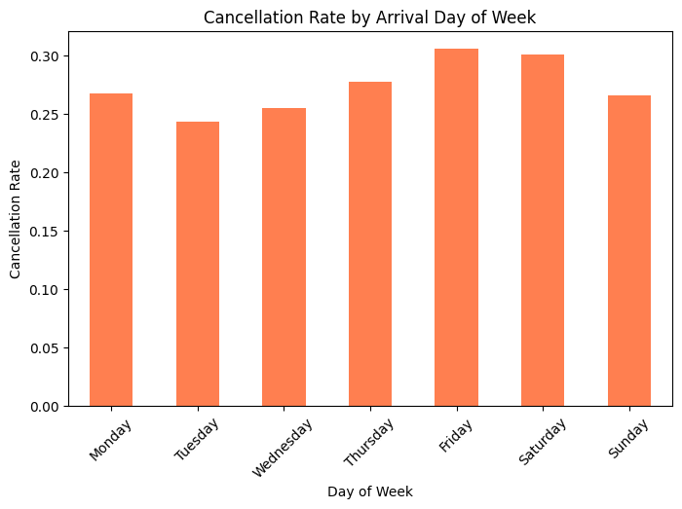
Insights :-
• Friday and Saturday show the highest cancellation rates (~30.5% and ~30.1%), suggesting weekend bookings are more prone to be canceled.
• Thursday also has a relatively high cancellation rate (~27.7%).
• Tuesday has the lowest cancellation rate (~24.3%), implying more stable mid-week bookings.
• Monday, Wednesday, and Sunday fall in the middle, ranging from ~25.5% to ~26.8%.

Recommendations :-
• Reduce Weekend Cancellations (Friday & Saturday):
- Use non-refundable pricing or stricter cancellation windows.
- Offer advance booking discounts to lock in guests earlier.
- Send reminders or personalised confirmations a few days before check-in.
• Leverage Mid-Week Stability (Tuesday):
- Maintain flexible policies to drive bookings for low-risk days.
- Introduce mid-week stay promotions or business travel bundles.
• Watch Thursday Trends:
- Target Thursday guests with custom offers or reassurance messaging to reduce dropouts.
• Segment Analysis:
- Cross-reference day-of-week cancellations with market segment or guest type.
- Apply targeted strategies based on who cancels more often on specific days.

- What are the most common countries for international guests, and how do their booking patterns compare to domestic guests?
Approach :-
- Created a new column called guest_origin to classify guests as Domestic (Portugal - PRT) or International.
- Identified the Top 10 countries with the highest number of international bookings.
- Compared booking behavior between domestic and international guests using key metrics:
  - Cancellation rate
  - Lead time
  - ADR (Average Daily Rate)
  - Length of stay
  - Number of special requests
- Visualized the top international sources using a bar plot.

# Create guest_origin column if not present
df['guest_origin'] = df['country'].apply(lambda x: 'Domestic' if x == 'PRT' else 'International')

# Filter international guests
international_guests = df[df['guest_origin'] == 'International']

# Count bookings by country and get top 10
top_countries = international_guests['country'].value_counts().head(10)
top_countries

country | count
GBR | 10433
FRA | 8837
ESP | 7252
DEU | 5387
ITA | 3066
IRL | 3016
BEL | 2081
BRA | 1995
NLD | 1911
USA | 1875

booking_patterns = df.groupby('guest_origin').agg({
'is_canceled': 'mean', # Cancellation rate
'lead_time': 'mean', # Average lead time
'adr': 'mean', # Average daily rate
'length_of_stay': 'mean', # Average length of stay
'total_of_special_requests': 'mean' # Average special requests
}).reset_index()

booking_patterns

 | guest_origin | is_canceled | lead_time | adr | length_of_stay | total_of_special_requests
0 | Domestic | 0.356646 | 65.101228 | 95.839512 | 3.088369 | 0.594252
1 | International | 0.237459 | 86.665032 | 111.145052 | 3.879018 | 0.746342

#plot
top_countries.plot(kind='bar', figsize=(10,5), color='teal', title='Top 10 Countries of International Guests')
plt.ylabel('Number of Bookings')
plt.xlabel('Country')
plt.xticks(rotation=45)
plt.show()
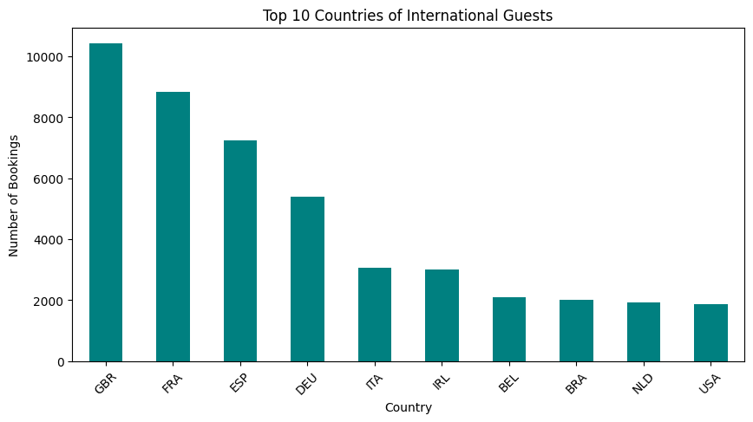

Insights :-
• Top International Guest Origins:
Most international guests come from European countries: UK (GBR), France (FRA), Spain (ESP), Germany (DEU), Italy (ITA), and others. Brazil and the USA are also among the top 10.
• Lower Cancellation Rate:
International guests cancel less (23.7%) compared to domestic guests (35.7%).
• Longer Lead Time:
International bookings are made earlier (avg. 86.7 days vs. 65.1 days for domestic).
• Higher ADR (Average Daily Rate):
International guests pay more per night (~111.1) than domestic guests (~95.8).
• Longer Stays & More Requests:
International travelers stay longer (3.88 nights) and make more special requests (0.75), possibly indicating higher expectations.

Recommendations :-
• Focus on High-Value International Markets:
- Run targeted campaigns in countries like UK, France, Spain, and Germany.
- Prioritize excellent customer service and multilingual support for these regions.
• Encourage Early Bookings:
- Provide early-bird offers or flexible but advance-booking promotions for international guests.
• Enhance Services:
- Prepare for higher service expectations by offering custom amenities or upsells tailored for international guests.
- Provide travel guidance, airport transfers, and language support to improve experience.
• Domestic Guest Retention:
- Use flexible pricing or refund policies to reduce cancellations.
- Promote short stay packages, weekend deals, and loyalty perks for local guests.
• Revenue Optimization:
- Take advantage of higher ADR from international guests during tourist seasons using dynamic pricing models.

