# **Tasks**

**Learners have to develop a dashboard to support the answers to the following questions and suggestions for places for newer restaurants.**

**Objective Questions**:

1. What is the total no. of tables present in the data?

**Answer=2**

There are 2 tables are available in the given sheet Row data & Country description.

1. What is the total no. of attributes present in the data?

**Answer=21**

There are total 21 attributes are there, Basically 20 columns in row data and one Unique column in Country description

1. How many categorical columns are there in the data? [Search about categorical and continuous data, and try to answer this question]

**Answer=14**

The columns contain discrete values or labels Those we can consider categorical columns and the columns that contain numerical value with range are considered as continuous columns So according to that, I had Extracted the category column as follows-

1 CountryCode, 2 RestaurantName, 3 City, 4 Address, 5 Locality,  
6 LocalityVerbose, 7 Cuisines, 8 Currency, 9 Has_Table_booking,   
10 Has_Online_delivery, 11 Is_delivering_now, 12 Switch_to_order_menu,  
13 Price_range, 14 Country Name

1. The data consists of some inconsistent and missing values so ensure that the data used for further analysis is cleaned.

**Answer**= Cuisines were missing in the Row data. but most common thing was that they all has country (US). so the most comman cuisine in US were maxican as per the row data so missing values were replaced it by **maxican**. You can check the approach in sheet name “Q4 MISSING DATA”.

**Approach is available in sheet “obj.Q4”**

1. Using the LookUp functions, fill up the countries in the original data using the country code.

**Answer**=done in the sheet “Raw Data”, column D with the formula **=VLOOKUP(C2,'country description'!$A$2:$B$16,2,0) and then dragged it down.**

1. Create a table to represent the number of restaurants opened in each country.

**Answer**=done in the sheet country description.

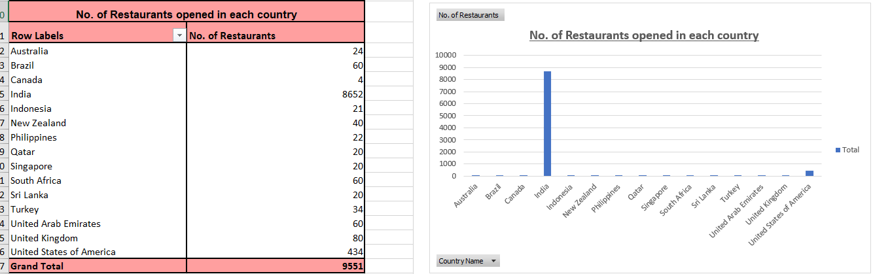



1. Also, the management wants to look at the number of restaurants opened each year, so provide them with something here.

**Answer=**done in the sheet country description.

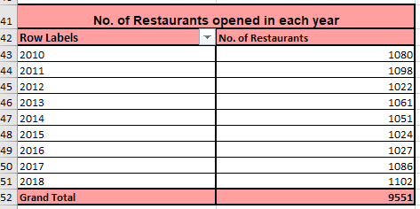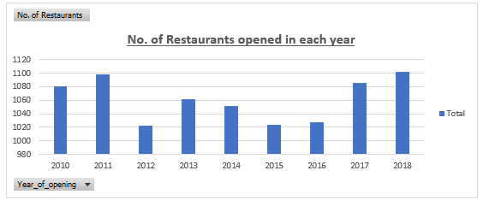

1. What is the total number of restaurants in India in the price range of 4?

**Answer=388** also done in the sheet country description.

**Formula = COUNTIFS('Raw Data'!$C:$C, "1", 'Raw Data'!$Q:$Q, "4")**

1. What is the average number of voters for the restaurants in each country according to the data?

**Answer=**done in the sheet country description.

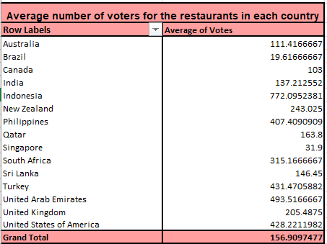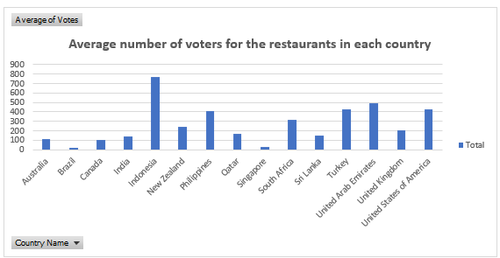

1. Calculate the average rating for all the restaurants that have price_range < 4 and provide online delivery. Use only the “IF” function, Logical Operators, and Aggregation functions to solve this problem. **[Note: Don’t use Conditional aggregation in this question.]**

**Answer=** **3.27381150959133** also done in the sheet country description.

**Formula = =AVERAGEIFS('Raw Data'!$T:$T,'Raw Data'!Q:Q,"<4",'Raw Data'!$N:$N,"yes")**

1. Using Conditional formatting highlight the rows of restaurants that are located in the countries or cities that you’ve suggested to the management for opening new restaurants.

**Answer=** First, we have to decide which countries we can expand our restaurants business, on the basic on the following database.

**Strategy : -** On the basis of data provided, the higher **rating** shows the customer satisfaction & less restaurant count shows more opportunity for expansion.

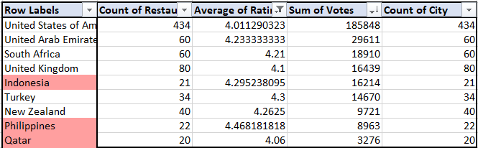

These following countries are having high potential for business expansion On the basis of data we have analysed.

1. Philippines (4.47 rating, 22 restaurants, 8,963 votes): **Highest customer satisfaction** & moderate demand.
2. Indonesia (4.29 rating, 21 restaurants, 16,214 votes): **High demand** & high rating.
3. Qatar (4.06 rating, 20 restaurants, 3276 votes): **Higher customer** satisfaction and moderate demand.
4. Create a new customized price column that consists of the abbreviation/symbol of the currency along with the Average_cost_for_two value. [Use string operations to do this task]

**Answer=** done in the sheet Row data.

**Formula = S2 & " " & MID(L2, FIND("(", L2) + 1, FIND(")", L2) - FIND("(", L2) - 1)**

1. How can you create an array formula in Excel or Google Sheets to count the number of restaurants listed that do not offer online delivery, are in the lowest price range, and have an average cost for two people less than or equal to 250 Indian Rupees?



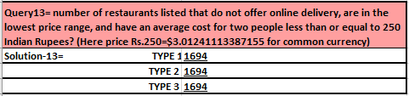

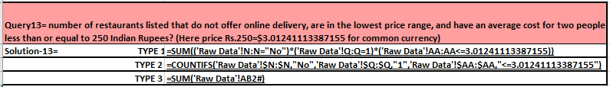

**Answer=** done in the sheet Row data and country description.

As we can see in picture one I had applied array formula in one cell And due to that the values are showing in whole column In the form of 0 and 1 which means true and false.

And if we want the total count as per the given condition. we have these three formulas, which gives same values as picture no. two and three We are the first formula shows the array condition And second formula is as per the concept of countifs function And the third formula is normal sum formula.

**Subjective Question:**

1. Suggest a few countries where the team can open newer restaurants with lesser competition. Which visualization/technique will you use here to justify the suggestions?

**Answer=** * Strategy: -

1. A lower restaurant count shows higher opportunity and less competition.
2. Then sorting the data by rating from higher to lower will gone reflect customer satisfaction, which will helping to prioritize markets with the most positive feedback about us.

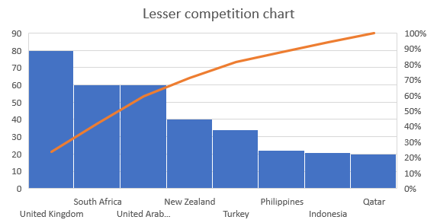

* Decision :-

Here we can clearly see that Philippines, Indonesia and Qatar is the country having least restaurants which shows least competition and also, the rating line shows the customer are satisfied in that country with the restaurants That means there are higher probability for profitable restaurant opening in least competition.

Note- approach is visible in the sheet “< comp. anl. SQ-1”.

1. Come up with the names of States and cities in the suggested countries suitable for opening restaurants.

**Answer**= **Approach**: I analysed restaurant ratings and competition levels in the Philippines, Indonesia, and Qatar to identify the cities with the highest customer satisfaction. The goal was to find the most suitable cities for new restaurant openings based on ratings.

**Insights**: In the Philippines, Quezon City has the highest rating of 4.8, indicating strong customer satisfaction. Jakarta in Indonesia has a solid rating of 4.36, while Doha in Qatar holds a respectable 4.06 rating, making these cities prime locations for expansion.

**Recommendation**: Focus on opening new restaurants in Quezon City, Jakarta, and Doha. These cities show high customer satisfaction and provide opportunities for growth with less competition, enhancing the potential for successful restaurant ventures.

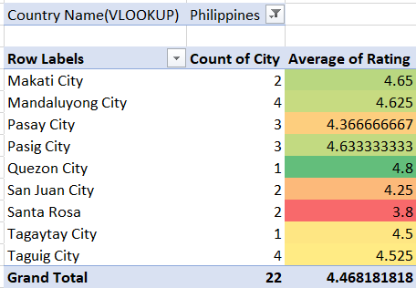

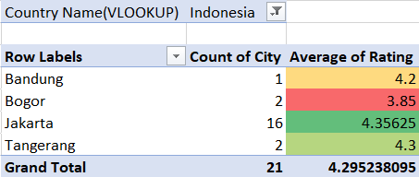

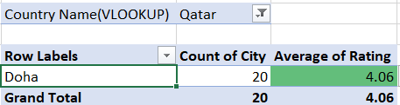

1. According to the countries you suggested, what is the current quality regarding ratings for restaurants that are open there?

**Answer**= **Approach**: I checked the average ratings of existing restaurants in the Philippines, Indonesia, and Qatar to understand their quality. This helps to evaluate customer satisfaction in these regions.

### **Insights**: The Philippines has the highest rating of 4.47, showing excellent satisfaction. Indonesia's 4.29 is also impressive, and Qatar's 4.06 reflects a positive reception, although slightly lower.

### **Recommendation**: Given high customer satisfaction, the Philippines, Indonesia, and Qatar are promising for new restaurants. The Philippines leads in potential, followed closely by Indonesia, while Qatar offers solid opportunities.

|  |  |  |
| --- | --- | --- |
| **Row Labels** | **Count of RestaurantID** | **Average of Rating** |
| Australia | 24 | 3.658333333 |
| Brazil | 60 | 3.846666667 |
| Canada | 4 | 3.575 |
| India | 8652 | 2.770550162 |
| Indonesia | 21 | 4.295238095 |
| New Zealand | 40 | 4.2625 |
| Philippines | 22 | 4.468181818 |
| Qatar | 20 | 4.06 |
| Singapore | 20 | 3.575 |
| South Africa | 60 | 4.21 |
| Sri Lanka | 20 | 3.87 |
| Turkey | 34 | 4.3 |
| United Arab Emirates | 60 | 4.233333333 |
| United Kingdom | 80 | 4.1 |
| United States of America | 434 | 4.011290323 |
| **Grand Total** | **9551** | **2.89126793** |

|  |  |  |
| --- | --- | --- |
| **Row Labels** | **Count of RestaurantID** | **Average of Rating** |
| Indonesia | 21 | 4.295238095 |
| Philippines | 22 | 4.468181818 |
| Qatar | 20 | 4.06 |

Quality of restaurants in suggested countries:-

1. Also, what is the current expenditure on food in the suggested countries, so we can keep our financial expenditure in control?

**Answer**= **Approach**: I reviewed the average cost for two in Indonesia, the Philippines, and Qatar to assess food expenditure. This helps guide financial planning and control initial investments in these countries.

**Insights**: Indonesia has the lowest average cost for two at $18, followed by Qatar at $61. The Philippines has the highest cost, with an average of $117 for two, indicating higher expenses.

**Recommendation**: To minimize initial investment, it’s advisable to prioritize opening in Indonesia and Qatar, where costs are lower. The Philippines may be considered later due to its higher expenses.

|  |  |
| --- | --- |
| **Row Labels** | **Average cost for two IN USD ($)** |
| Indonesia | 18 |
| Philippines | 117 |
| Qatar | 61 |
| **Total expenditure** | **196** |

1. Come up with the names of restaurants from the recommended states that are our biggest competitors and also those that are rated in the lower brackets, i.e. 1-2 or 2-3.

**Answer= Approach**: I analysed the average ratings of low-performing restaurants in the recommended countries (Qatar, Philippines, and Indonesia). This helps identify potential competitors with lower customer satisfaction in these regions.

**Insights**: Qatar has two restaurants with ratings of 3.4, and another at 3.6. The Philippines has Cafe Arabelle with a 3.6 rating, while Indonesia’s Onokabe has a rating of 3.7, indicating low satisfaction.

**Recommendation**: These restaurants, with their lower ratings, represent opportunities to outperform competitors by offering better service and quality. Focus on improving customer satisfaction to gain an edge in these markets.

|  |  |  |
| --- | --- | --- |
| **`** | **Average of Rating** | **Country** |
| Indian Coffee House | 3.4 | Qatar |
| 7st by Mumbai Spices | 3.4 | Qatar |
| Ponderosa | 3.6 | Qatar |
| Cafe Arabelle | 3.6 | Philippines |
| Onokabe | 3.7 | Indonesia |

1. Which cuisines should we focus on in the newer restaurants to get better feedback? Does the choice of cuisines affect the restaurant ratings?

**Answer**= **Approach**: I reviewed the top-rated cuisines in the Philippines, Indonesia, and Qatar to understand which cuisines lead to higher customer satisfaction. This analysis will help in choosing the best cuisines for our new restaurants.

**Insights**: The top-rated cuisines in the Philippines include European, Asian, Indian, and Japanese, Sushi, all rated 4.9. In Indonesia and Qatar, Sunda, Indonesian, and Sushi, Japanese also hold a perfect 4.9 rating, reflecting their popularity.

**Recommendation**: Focusing on Sushi, Japanese, and Sunda cuisines in Indonesia and Qatar, along with European, Asian, and Indian in the Philippines, is likely to yield better feedback and customer satisfaction, boosting overall ratings.

|  |  |  |
| --- | --- | --- |
| **Country** | **Cuisine** | **Rating** |
| **Philippines** | European, Asian, Indian | 4.9 |
| **Philippines** | Japanese, Sushi | 4.9 |
| **Indonesia** | Sunda, Indonesian | 4.9 |
| **Indonesia** | Sushi, Japanese | 4.9 |
| **Qatar** | Sunda, Indonesian | 4.9 |
| **Qatar** | Sushi, Japanese | 4.9 |

1. According to our current data, should we go for online delivery and table booking? Does that affect the customer’s ratings?

**Answer= Approach**: I analysed the data comparing restaurants with and without online delivery and table booking services. The goal was to assess the impact of these facilities on restaurant ratings and customer satisfaction across various countries, including India.

**Insights**: Restaurants in India with online delivery and table booking have a higher average rating of 3.4, compared to 2.67 for those without these services. This trend is consistent across other regions, where providing these facilities correlates with better customer ratings.

**Recommendation**: To improve customer satisfaction and ratings, it's crucial to offer online delivery and table booking in our new restaurants. These services enhance the overall experience, leading to higher ratings and competitive advantage.

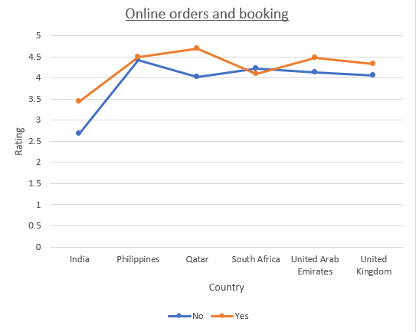

|  |  |  |  |
| --- | --- | --- | --- |
| **Average of Rating** | **Column Labels** |  |  |
|  | **No** | **Yes** | **Grand Total** |
| **Row Labels** |  |  |  |
| Australia | 3.658333333 |  | 3.658333333 |
| Brazil | 3.846666667 |  | 3.846666667 |
| Canada | 3.575 |  | 3.575 |
| **India** | **2.671582018** | **3.44230423** | **2.770550162** |
| Indonesia | 4.295238095 |  | 4.295238095 |
| New Zealand | 4.2625 |  | 4.2625 |
| Philippines | 4.425 | 4.492857143 | 4.468181818 |
| Qatar | 4.026315789 | 4.7 | 4.06 |
| Singapore | 3.575 |  | 3.575 |
| South Africa | 4.213793103 | 4.1 | 4.21 |
| Sri Lanka | 3.87 |  | 3.87 |
| Turkey | 4.3 |  | 4.3 |
| United Arab Emirates | 4.128571429 | 4.477777778 | 4.233333333 |
| United Kingdom | 4.058823529 | 4.333333333 | 4.1 |
| United States of America | 4.011290323 |  | 4.011290323 |
| **Grand Total** | **2.809686644** | **3.482556131** | **2.89126793** |

1. Should the team keep the rate of cuisines higher? Will that affect the feedback? According to our data are the rates of cuisines and ratings, correlated?

**Answer**= **Approach**: I analysed the relationship between restaurant ratings and the cost of meals for two. The data was sorted from higher to lower ratings, examining whether higher-rated restaurants also charge more, and I calculated the correlation between price and rating.

**Insights**: The data shows a moderate correlation (0.793954272620959) between ratings and cost, indicating that restaurants with higher ratings generally charge more. Customers appear satisfied with the quality of the cuisine despite the higher prices, suggesting that price doesn’t negatively impact feedback.

**Recommendation**: Since customers are willing to pay higher prices for better-rated cuisines, it’s reasonable to keep the rates of dishes at a premium. This strategy should not adversely affect customer satisfaction, as long as the quality remains high.

1. What is the distribution of the number of restaurants of different price ranges in all the countries?

**Answer**= **Approach**: I reviewed the distribution of restaurants in different price ranges across various countries. The goal was to understand where most lower-priced restaurants are located and identify opportunities for growth in mid-range markets globally.

**Insights**: India has the largest number of low-priced restaurants, with 4,295 in the lowest price range. The United States also has a strong presence with 136 low-cost options. Meanwhile, countries like Indonesia, Philippines, Qatar, and Canada have more mid-range restaurants, indicating untapped potential in those regions.

**Recommendation**: Focus expansion efforts on India and the USA, where demand is strong but competition is high. To avoid oversaturation, also explore mid-range markets in Indonesia, Philippines, Qatar, and Canada, where there is room for growth and less intense competition.

|  |  |  |  |  |  |
| --- | --- | --- | --- | --- | --- |
| **Count of Country Name(VLOOKUP)** | **Column Labels** |  |  |  |  |
| **Row Labels** | **1** | **2** | **3** | **4** | **Grand Total** |
| Australia | 4 | 14 | 5 | 1 | 24 |
| Brazil | 2 | 7 | 16 | 35 | 60 |
| Canada |  | 3 |  | 1 | 4 |
| India | 4295 | 2858 | 1111 | 388 | 8652 |
| Indonesia |  | 1 | 20 |  | 21 |
| New Zealand | 3 | 4 | 17 | 16 | 40 |
| Philippines |  | 1 | 12 | 9 | 22 |
| Qatar |  | 1 | 5 | 14 | 20 |
| Singapore |  | 1 | 5 | 14 | 20 |
| South Africa |  | 4 | 17 | 39 | 60 |
| Sri Lanka |  | 6 | 11 | 3 | 20 |
| Turkey |  | 11 | 18 | 5 | 34 |
| United Arab Emirates |  | 9 | 29 | 22 | 60 |
| United Kingdom | 4 | 28 | 32 | 16 | 80 |
| United States of America | 136 | 165 | 110 | 23 | 434 |
| **Grand Total** | **4444** | **3113** | **1408** | **586** | **9551** |

1. Explain your approach in brief for suggesting countries/cities in order to open new restaurants, if the objective and subjective questions would have not been given to assist you. **[you have to give bullet pointers in order to answer this question]**

**Answer=** If objective and subjective questions were not provided, my approach to suggesting countries/cities for new restaurant openings could as follow.

1. Data reading, understanding key parameter: - As the data comes for any sort of data analysis. First, we have to read and need to understand what are the key parameters, that are affecting the business. Which is directly reflecting into the given data. It will depend on type of business to business.
2. As in business analyst we know the business works on 3 key parameters. which is product, service and customer satisfaction. So we need to find out which are those parameters.
3. Then we need a strong strategy as per the available data to get Insights. In our Case

Strategy 1:-Higher rating was indicating Those restaurant / city / Country where the customer was satisfied with the product.

Strategy 2:-A lower restaurant count shows higher opportunity and less competition. & Number of votes was also indicating the market demand.

which will helping to prioritize markets with the most positive feedback for opening new restaurants.

1. In the last we have to cheque the cost and expenditure data to ensure the financial feasibility of the new restaurant openings for financial planning.

--------------------------------------------------------------------------------------------------------

**The dashboard must consist of Year-wise and country slicers.**