 Invention Disclosure Format (IDF)-B | Document No.
 | Issue No/Date | 17/09/2026
 | Amd. No/Date

1. Title of the invention
A Self-Adaptive Functional Capability Identity, Drift-Localized Invariant Re-Binding, Causal Transition Verification, and Risk-Gated Navigation System for Dynamic Web Interfaces
Short name: IntentNav-SCFR (also referred to in the earlier disclosure as IntentNav-Capability). The invention is centered on a persistent functional capability identity independent of volatile interface presentation. A browser-resident controller separates capability identity from transient interface state, localizes drift, applies hard functional invariants and contradiction checks, causally verifies transitions, and controls route promotion and execution authorization.

2. Field / Area of invention
The present invention relates to human-computer interaction, web browsers, intelligent software agents, semantic computing, and adaptive user-interface navigation. More particularly, it concerns a browser-side system for discovering functional capabilities that are exposed through dynamic web interfaces and for mapping a user's natural-language objective to a currently valid navigation route.
The invention is intended for websites whose functionality is distributed across menus, dialogs, tabs, settings panels, client-rendered states, and dynamically generated controls. Instead of treating a web page as a fixed collection of DOM selectors, the system represents a function as a capability with semantic, contextual, transition, and risk attributes. This representation can remain useful when labels, DOM identifiers, layout, or navigation hierarchy change.
The technology may be implemented as a browser extension, embedded accessibility/navigation assistant, enterprise browser component, or software library operating alongside a web browser. The principal use cases include locating privacy controls, account settings, security functions, notification controls, data export facilities, and other deeply nested website capabilities.

3. Prior Patents and Publications from literature
A focused patent search was performed around the technical building blocks of the proposed invention: intent-oriented browsing, natural-language web navigation, interactive DOM analysis, semantic UI state/action graphs, change-resilient web interaction, and functionality discovery. The search indicates that the broad problem is already well explored. Accordingly, this disclosure does not rely on the broad statement “intent-based navigation” as the sole novelty; it concentrates on the proposed capability-fingerprint representation and the way it is used together with semantic recovery and risk-gated navigation.

Source / Year | Patent / Publication | What it discloses | Relevance / differentiation
US 2023 / priority 2018 | US 11,625,449 B2 – Intent-oriented internet browsing | Maps user intents to target web pages/hyperlinks across different web architectures. | High overlap with intent-to-target navigation; proposed work instead centers on capability fingerprints and current-interface evidence rather than a known intent-page mapping.
US 2024/2026 family / priority 2018 | US 12,153,642 B2 / US 12,625,918 B2 – Automatic navigation of interactive web documents | Uses natural-language instructions, interactive DOM elements and ML/RL policies to navigate web documents. | Very high overlap with NL-to-web navigation. Proposed distinction is the explicit capability-level fingerprint and risk-gated discovery/rebinding workflow.
US 2024 | US 11,971,936 B2 – Analyzing web pages to facilitate automatic navigation | Abstracts interactive web pages into user states and maintains navigation traces so interaction can survive web-page changes. | High overlap with change-resilient navigation. Proposed work treats a function as a reusable capability fingerprint with semantic invariants and separates discovery from execution.
US 2024 | US 12,147,732 B2 – Analyzing graphical user interfaces to facilitate automatic interaction | Analyzes GUI elements to support automated interaction. | Relevant to UI-element understanding; proposed system focuses on functionality discovery and capability identity rather than generic interaction automation.
US 2023 | US 11,714,843 B2 – Action objects in a semantic graph | Uses semantic-graph data to dynamically identify actions associated with data elements and expose those actions through UI elements. | Relevant to semantic action representation; proposed system applies a capability fingerprint to dynamic website functionality and route recovery.
US 2026 | US 2026/0178830 A1 – Compositionality in web automation via constrained hierarchical planning over a semantic UI state-action space | Represents UI flows as semantic states and actions and plans web automation over the resulting space. | Very close to semantic UI state/action modeling. The proposed work emphasizes capability identity, change detection, semantic re-binding, and a risk gate as a unified discovery architecture.
US 2016 | US 9,274,934 B2 – System and method for creating change-resilient scripts | Creates automation commands that use contextual visual clues instead of brittle UI metadata. | Relevant to change resilience; differs in purpose because the proposed invention discovers a capability from user intent and maintains a capability identity rather than replaying a predefined test script.
US 2021 | US 2022/0070205 A1 – Enhanced crawling of unexposed web applications | Discovers web-application functionality by processing DOM events and framework hooks. | Relevant to functionality discovery; proposed system uses semantic capability construction and intent matching instead of vulnerability-oriented crawling.

Prior-art conclusion
The search shows that individual building blocks are not new in isolation. Natural-language web navigation, DOM-aware automation, semantic state/action modeling, and change-resilient interaction have all been addressed in earlier patent families. The proposed contribution is therefore framed as a specific combination and data representation: a capability fingerprint that identifies the function being offered by a dynamic interface independently of a brittle selector, together with semantic re-binding and a risk gate that keeps capability discovery separate from execution.
This is a patentability-oriented technical positioning, not a legal opinion. A final filing should be subjected to a professional claim chart and a formal novelty/inventive-step search in the jurisdictions in which protection is intended.

4. Summary and background of the invention (Address the gap / Novelty)
Modern websites frequently expose important functions through several layers of navigation. A user may know what they want to accomplish but not know the label chosen by the website, the menu in which the function is located, or the sequence of interface states needed to reach it. The problem becomes harder when a site is rendered dynamically and its DOM structure, element identifiers, labels, or menu hierarchy change between releases.
Conventional browser search treats the problem largely as text retrieval. Selector-based automation treats it as element identification. Intent-oriented browsing treats it as a mapping from an intent to a known target. These approaches can become brittle when the target function remains conceptually unchanged but its presentation moves or its wording changes.
The invention addresses this gap by introducing a semantic capability layer between user intent and the live interface. A capability is a functional unit such as “pause account”, “download personal data”, “change two-factor authentication method”, or “turn off marketing notifications”. Instead of storing only a URL or CSS selector, IntentNav-Capability stores a capability fingerprint containing multiple pieces of evidence about the function and its surrounding interface state.
The capability fingerprint may include semantic labels, accessible names and roles, neighboring text, container relationships, action type, pre-condition state, post-transition state, URL semantics, visual context, and an interaction-risk classification. A capability graph connects these fingerprints to interface states and transitions. When a user expresses an objective, the system matches the intent to candidate capabilities and ranks navigation paths using semantic fit, contextual fit, transition consistency, historical validation, and risk.
If the website changes, the system does not simply fail because an old selector disappeared. It re-observes the current interface, reconstructs candidate fingerprints, and attempts to re-bind the stored capability to a semantically equivalent current capability. The system can then update the stored route while retaining the underlying functional identity.

Proposed novelty focus
- Capability-level representation: the persistent object is a functional capability rather than a page URL or DOM selector.
- Multi-source capability fingerprinting: semantic, accessibility, contextual and transition evidence are combined into a single functional signature.
- Capability-to-state graph separation: capability identity can survive movement between interface states and changes in the presentation layer.
- Semantic re-binding: when a route becomes invalid, the system searches for a current interface representation that satisfies the stored functional invariants.
- Risk-gated execution: discovery and ranking are separated from side-effecting execution; sensitive or destructive capabilities require explicit user confirmation.
- Confidence-aware route selection: candidate paths are scored using independent evidence sources, with low-confidence results presented as suggestions rather than silently executed actions.
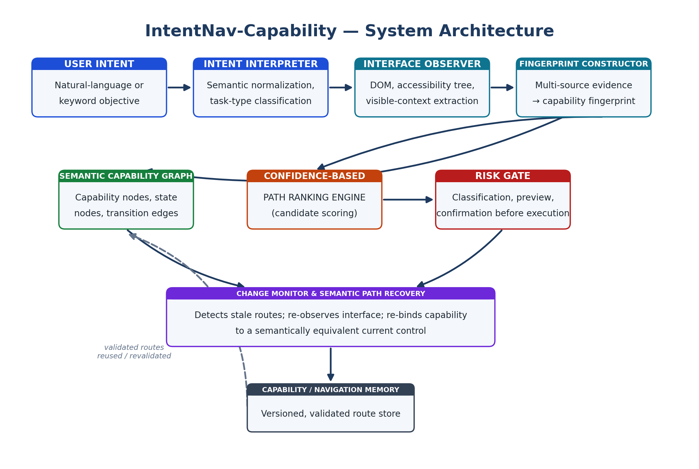
Figure 1 — Original system architecture prepared for this disclosure.

4.1 Technical Problem and Technical Effect
Technical problem. Dynamic web interfaces mutate DOM structure, identifiers, labels, hierarchy, dialogs and client-side state while retaining substantially the same user-facing function. Fixed selectors and page URLs can therefore become stale, while generic semantic similarity can select a nearby but functionally different control. The technical problem addressed is to preserve a reusable executable representation of a function across interface mutation without requiring website modification, while preventing stale or semantically similar controls from being silently executed.
Technical solution and effect. IntentNav-SCFR implements a browser-resident closed-loop controller that separates persistent capability identity from transient interface-state routes; classifies drift by type; uses stable functional invariants and explicit forbidden conditions as hard eligibility gates; uses semantic ranking only after those gates; causally verifies a selected candidate through an ordered, time-bounded transition signature; and promotes a route to executable status only after validation. The intended technical effects are reduced stale-route execution, reduced false re-binding, reduced dependence on volatile DOM identifiers, improved recovery after interface restructuring, and reduced unauthorized side effects. These effects are to be demonstrated by reproducible prototype measurements.
The fingerprint is therefore not merely a stored semantic data structure. It participates in a stateful technical control loop in which observation changes route eligibility, drift classification determines whether replay is inhibited, hard predicates determine candidate admissibility, transition witnesses determine route promotion, and risk policy determines whether a validated capability may be dispatched.

5. Objective(s) of Invention
- To provide a website-independent mechanism for discovering functions expressed through dynamic web interfaces from natural-language user objectives.
- To represent web functionality as semantic capability fingerprints rather than depending primarily on fixed DOM selectors, URLs, or menu positions.
- To combine DOM semantics, accessibility information, visible context, and observed state transitions into a reusable capability representation.
- To construct a semantic capability graph that connects functional capabilities with interface states and navigation transitions.
- To rank candidate routes using semantic relevance, contextual consistency, transition evidence, confidence, and risk.
- To detect when a previously validated route has become stale because of interface changes.
- To recover a route by semantically re-binding the stored capability to a currently available equivalent function.
- To preserve a navigation/capability memory while allowing stale entries to be invalidated and revalidated.
- To prevent unintended side effects by separating functionality discovery from final execution and requiring confirmation for sensitive operations.
- To provide an implementable browser-extension architecture suitable for research prototypes and later integration with enterprise or accessibility tooling.

6. Working principle of the invention (in brief)
The system begins with a user objective such as “I want to stop receiving promotional emails” or “I need to download my personal data.” A semantic intent module converts the expression into a normalized goal representation containing the intended function, possible entities, constraints, and sensitivity hints.
A browser-side observation module then collects non-secret interface evidence from the current website. Depending on browser permissions and implementation, this can include DOM roles and labels, accessibility-tree information, visible text, element types, container relationships, current URL semantics, and the result of permitted navigation observations.
The observation is normalized into capability candidates. Each candidate is assigned a semantic capability fingerprint. The graph engine connects candidate capabilities to the interface states in which they can be reached. A route planner searches the graph and ranks candidate routes. The result is shown to the user as a suggested route or direct navigation action, depending on risk and confidence.
When a stored route is later reused, a validation step compares the stored capability fingerprint with the live interface. If the old selector or route is invalid, the system performs semantic recovery rather than blindly replaying it. A recovered candidate is accepted only when sufficient functional evidence agrees with the stored capability invariants.
The final action is subject to a risk gate. Read-only and low-impact navigation may proceed directly. Sensitive actions, such as changing security controls or initiating account deletion, are presented with a clear preview and require explicit user confirmation.
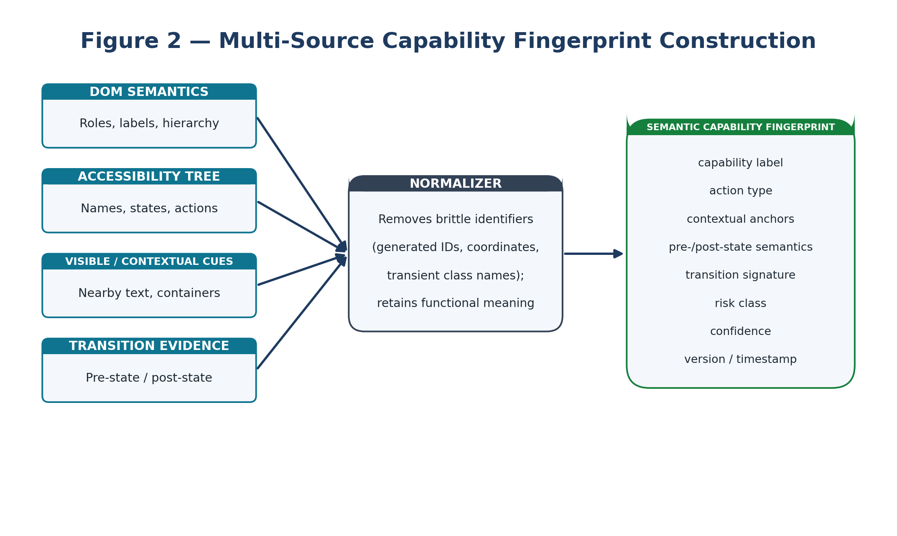
Figure 2 — Original capability-fingerprint construction diagram.
7. Description of the invention in detail
7.1 Intent interpretation module
The intent interpretation module accepts natural-language text or short keyword input. It identifies the likely functional objective and produces a normalized representation. For example, “I want a break from this account” may be interpreted as a temporary account-control capability rather than a literal keyword search for the word “break”. The module may use embeddings, a classifier, a language model, rules, or a hybrid architecture. The output is not treated as a command to execute immediately; it is treated as a query over the capability layer.
7.2 Multi-source interface observation
The browser-side observer collects evidence from the current interface. Example evidence includes accessible name, role, control type, state, visible label, nearby explanatory text, ancestor/container semantics, page title, URL patterns, menu relationships, and observed transitions. Visual embeddings or screenshots may be used when permitted, but visual evidence is supplementary rather than the sole identity of a capability. Brittle identifiers such as generated element IDs, exact screen coordinates, or transient framework-specific class names are treated as low-value evidence.
7.3 Capability fingerprint
A capability fingerprint is a structured representation of a function exposed by a web interface. A representative fingerprint may contain: a canonical capability label; semantic synonyms; action type; UI role; contextual anchors; required pre-state conditions; expected post-state effects; transition evidence; risk category; confidence; source evidence; validation timestamp; and optional historical observations. The fingerprint describes what the interface enables the user to accomplish, so it is intended to remain meaningful when the same capability moves from one menu to another or changes its wording.
7.4 Semantic capability graph
The graph contains interface-state nodes, capability nodes, and transition edges. A state node can represent a page, dialog, panel, tab, modal, or other interaction state. A capability node represents a function that may be available in one or more states. An edge represents a navigation or interaction that can move the user from one state to another or expose a capability.
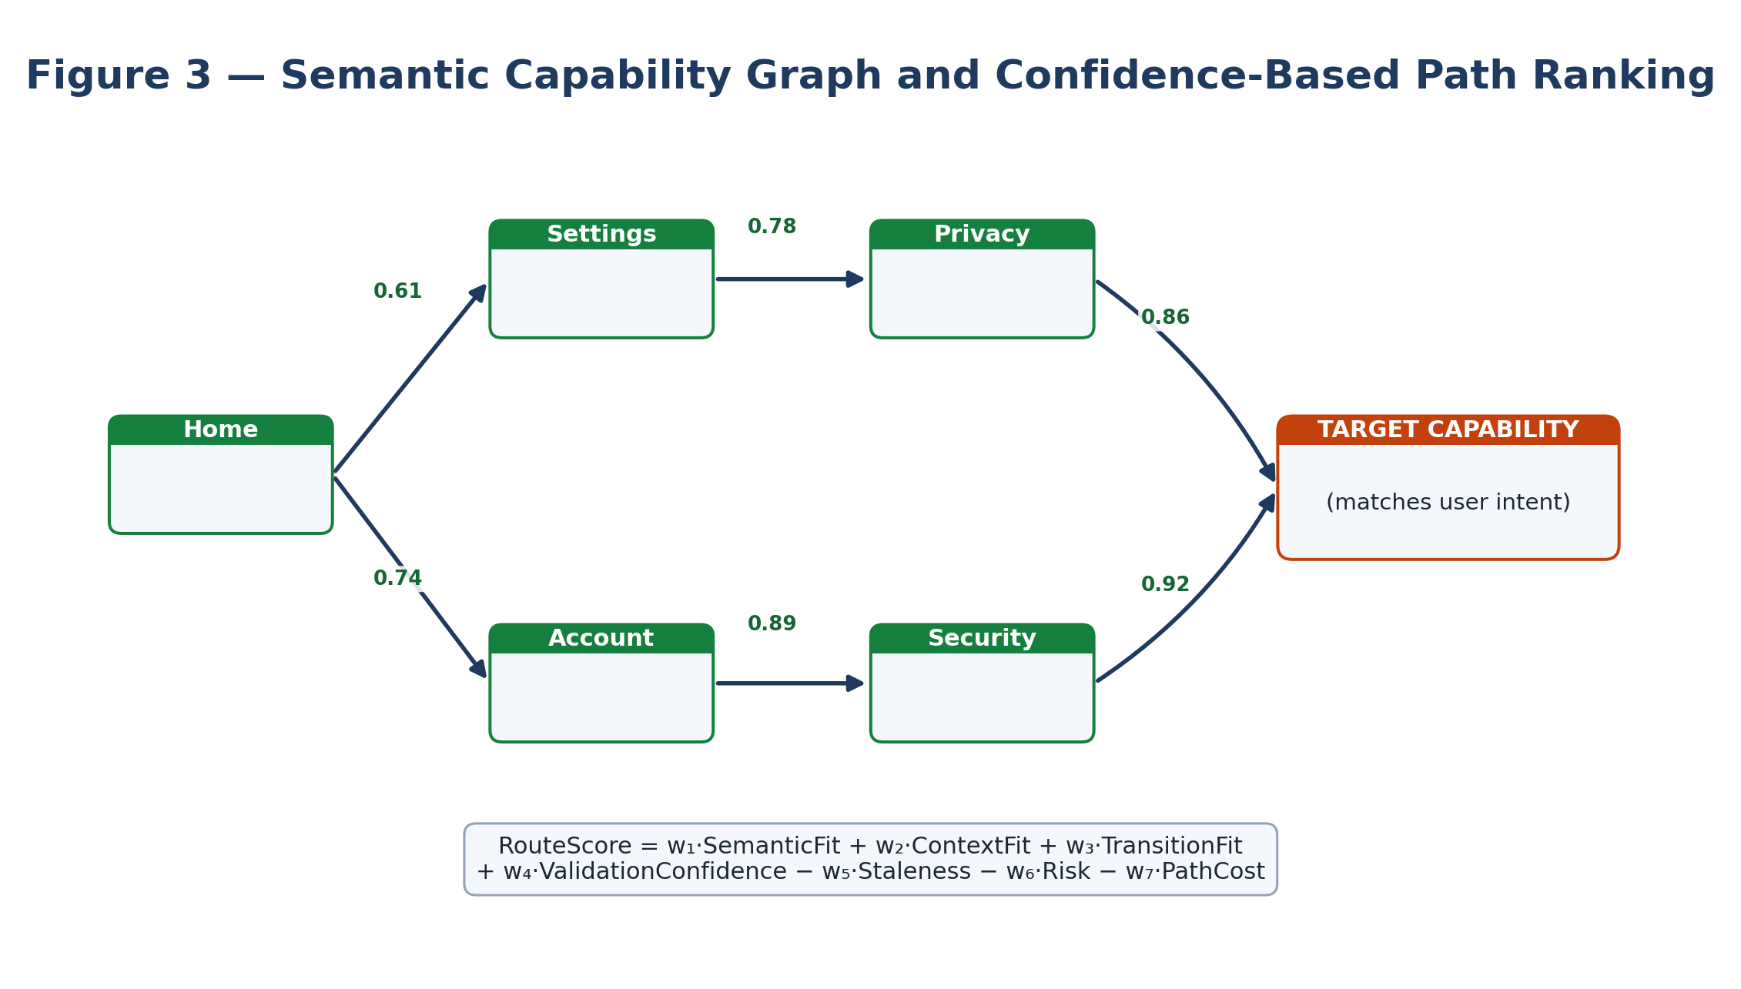
Figure 3 — Original semantic capability graph and route-ranking illustration.
7.5 Candidate path generation and ranking
For a requested intent, the path engine retrieves candidate capability nodes whose fingerprints are semantically compatible with the intent. It then generates one or more routes through the graph. Each route receives a composite confidence score. A representative score may combine semantic similarity, contextual similarity, transition consistency, prior validation success, path length, stale-evidence penalty, and risk penalty. A conceptual score is RouteScore = w1·SemanticFit + w2·ContextFit + w3·TransitionFit + w4·ValidationConfidence − w5·Staleness − w6·Risk − w7·PathCost. The weights may be tuned experimentally.

7.6 Capability validation
Before a stored capability is reused, the system performs validation against the current interface. Validation can compare semantic labels, control role, surrounding context, expected state, and transition behavior. A route is marked stale when the evidence falls below a configurable threshold. Where safe and technically feasible, non-destructive observations or reversible interactions may be used to validate a candidate. Sensitive actions are excluded from automatic probing.

7.7 Semantic path recovery
When a stored route breaks, the recovery engine searches the current interface for candidates satisfying the stored capability invariants. It can use semantic equivalence of labels, role and action type, contextual relationships, expected pre/post states, and transition evidence. A successful recovery creates a new route version while preserving the history of the capability.

For example, a website may move “Deactivate account” from Settings → Account to Account Center → Membership. The old path becomes stale, but the capability fingerprint can still match the new control if its functional and contextual evidence remains consistent.
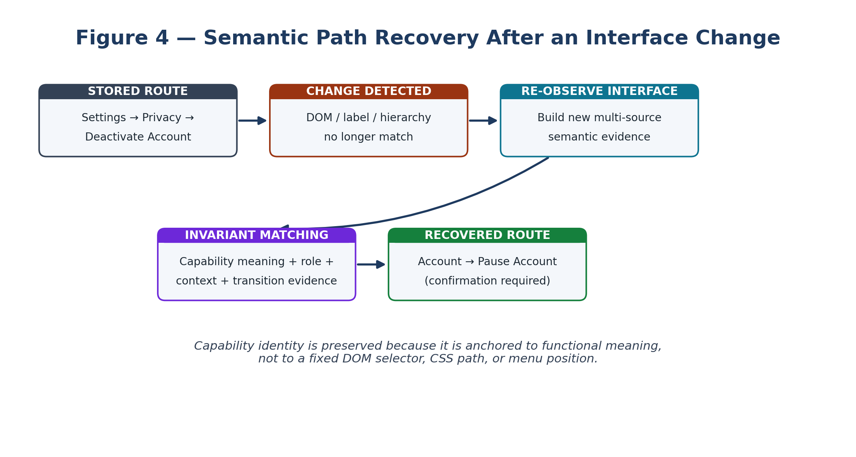
Figure 4 — Original semantic path-recovery flow.
7.8 Risk-gated navigation and execution
The risk gate assigns each candidate capability a risk class. Read-only navigation may be low risk. Actions such as changing preferences may be medium risk. Security changes, account closure, deletion, financial transactions, or irreversible settings may be high risk. For high-risk capabilities, the system provides a human-readable preview describing the function it believes was found and the route that will be used. Execution requires explicit confirmation.

7.9 Capability memory and versioning
The capability store maintains validated capability fingerprints and route versions. Each entry can include evidence timestamps, validation confidence, the interface states in which the capability was observed, and the reason a previous route was invalidated. A capability can therefore have multiple route versions over time, with the most recently validated route preferred when it also satisfies current semantic and risk constraints.
The architecture and workflow illustrations in Figures 1–5 are representative embodiments. They do not limit the invention to a particular browser, graph representation, visual layout, or scoring implementation.

7.10 Browser-extension implementation
A prototype may be implemented using a Chromium-compatible browser extension with a content script, background service worker, local capability store, semantic matching module, and a small user interface. The content script observes the current page and exposes normalized UI evidence. The background layer manages graph search, capability memory, confidence scoring, and the risk gate. A local-first architecture is preferred for privacy; external language-model services may be optional.
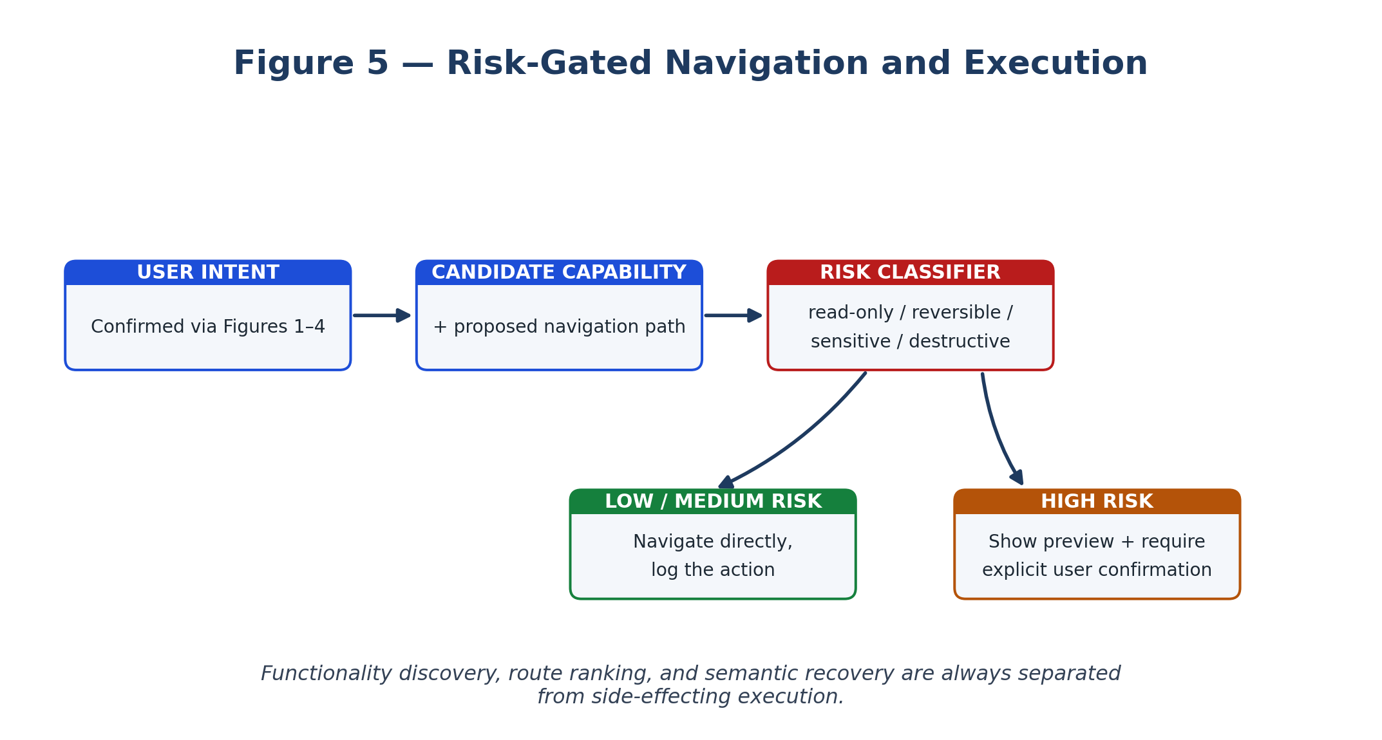
Figure 5 — Original risk-gated navigation flow.
7.11 Capability equivalence certificate and invariant closure
To make functional equivalence objectively testable, the system derives a capability equivalence certificate from a canonical identity tuple: <ActionType, TargetEntity, PreStatePredicates, AllowedStateDelta, ExpectedPostState, RequiredContext, ForbiddenContext, TransitionSignature, RiskClass>. A live candidate is eligible only if mandatory action, target, pre-state, post-state compatibility and required-context predicates are satisfied and no forbidden predicate is triggered. Semantic similarity is evaluated only after this invariant closure. A candidate may therefore have higher language similarity and still be rejected because its target or expected state delta is incompatible.

7.12 Typed drift localization and recovery trigger
The drift engine produces a typed drift vector rather than treating every interface change as a generic page mismatch. Representative components are presentation drift, contextual drift, structural drift, capability drift and transition drift. Presentation-only changes may preserve a validated route; contextual or structural changes can trigger revalidation; capability or transition drift forces re-binding. This prevents unnecessary recovery and prevents a route from being treated as valid merely because the page remains visually or semantically similar.

7.13 Causal transition witness protocol
A transition signature is an ordered relation rather than a single post-action observation. A representative signature is <pre-state, activation-event, expected-delta, witness-window, post-state>. During safe verification, the controller correlates the candidate activation event with two or more independent witness classes when available, such as a DOM/accessibility mutation together with a history/route change or application-state update. Witnesses must occur within a bounded verification interval and satisfy the expected ordering. An unrelated page mutation without the candidate activation event is not sufficient to promote the candidate.

7.14 Provisional route quarantine and promotion
A recovered route is not immediately executable memory. It is first stored as a provisional route version containing the candidate identity, drift vector, invariant results, transition evidence, provenance and acceptance/failure reason. Only after the acceptance condition is met is the route promoted to the active validated set. Failed or contradictory candidates are retained as quarantined negative evidence so the same false re-binding is not repeatedly selected. A later validation failure can demote an active route and restore the most recent validated route or force fresh recovery.

7.15 Safe fallback state machine
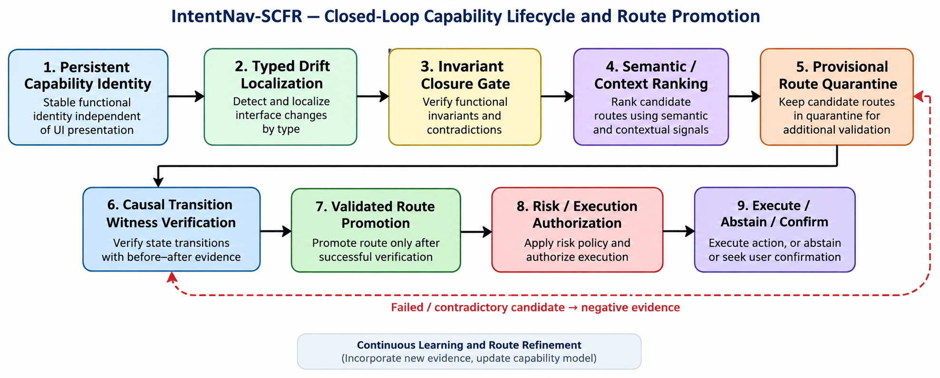
The controller has an explicit abstention state. If hard invariants fail, contradictory evidence is detected, required transition witnesses are unavailable, or evidence channels materially disagree, the controller does not silently execute the candidate. It enters re-observe, ranked-suggestion, or confirmation-required preview according to operation risk. Uncertainty is therefore an executable system state rather than an unreported confidence score.

Figure 6. Closed-loop capability lifecycle showing the strengthened control sequence from persistent capability identity through drift localization, invariant closure, causal transition verification, provisional quarantine, validated promotion, and independent execution authorization.

7.16 Technical advantages
- Reduces dependence on exact wording by matching functional meaning and contextual evidence.
- Reduces dependence on brittle DOM selectors and fixed menu locations.
- Separates capability identity from the presentation state in which the capability currently appears.
- Allows multiple candidate paths to be compared rather than relying on the first keyword match.
- Provides a controlled recovery mechanism when a website changes its interface.
- Allows the same capability to accumulate validated route versions over time.
- Provides an explicit safety boundary between discovery and execution.
- Can operate as a browser-side layer without requiring website owners to modify their sites.

Novelty and inventive-step focus
- A semantic capability fingerprint that persists the functional identity of a web capability using multiple evidence types rather than a URL or selector alone.
- A graph architecture in which functional capability nodes are distinct from interface-state nodes, allowing a capability to be re-bound across changed presentation states.
- A recovery process that compares stored functional invariants with newly observed interface evidence and creates a new route version when an equivalent capability is found.
- A confidence model that combines semantic fit, contextual evidence, transition evidence, validation history, staleness, and risk in route selection.
- A risk-gated workflow in which discovery, recommendation, validation, and final execution are distinct stages.

8. Experimental validation results:
At the present disclosure stage, the invention is a defined technical concept and architecture; a full experimental benchmark has not yet been claimed as completed. The following validation protocol is specified for the prototype rather than presented as fabricated experimental results.
Experiment | Method | Primary metric | Target / interpretation
Intent matching | 50–100 natural-language requests against supported settings functions | Top-1 / Top-3 retrieval | Correct capability should appear among the highest-ranked results.
Deep navigation | Manual clicks vs keyword search vs IntentNav | Clicks / time to target | Lower effort indicates practical benefit.
UI change recovery | Rename labels, move menu items, alter DOM IDs/classes | Recovery rate | Measure capabilities recovered without manual remapping.
False-positive control | Include semantically similar but incorrect controls | False discovery rate | Avoid selecting a nearby but functionally wrong control.
Risk handling | Preference, security and destructive functions | Unauthorized execution count | Target: zero unauthorized high-risk executions.
Overhead | Representative dynamic pages | Latency / CPU / memory | Assess everyday-browser feasibility.

For a college prototype, the strongest demonstration is to create three versions of the same mock website: Version A with the original menu hierarchy, Version B with renamed/reordered controls, and Version C with changed DOM identifiers and an additional intermediate dialog. The same natural-language intents should be issued against all three versions. The key result should be that the capability fingerprint remains stable enough to recover the intended function even when the navigation route changes.
9. What aspect(s) of the invention need(s) protection?
Protection should be directed to the technical control loop and its state-transition behavior, not to the product name or generic AI/semantic navigation. The strongest position is the combination of persistent capability identity, typed drift localization, invariant closure, negative contradiction filtering, causal transition verification, provisional route quarantine, validated route promotion, and independent execution authorization.

9.1 Core inventive concept
• Persistent capability identity is represented independently of URL, selector, DOM identifier, coordinates, or menu position.
• A canonical capability identity tuple contains action, target, pre-state predicates, allowed state delta, expected post-state, required context, forbidden context, transition signature, and risk class.
• Interface drift is localized into typed components; recovery is triggered by functional or transition-relevant drift rather than by every presentation change.
• Candidate re-binding uses mandatory invariant closure and contradiction rejection before any similarity score can make a candidate eligible.
• Causal transition verification correlates an activation event with an ordered set of expected state-change witnesses inside a bounded verification interval.
• Recovered routes are quarantined as provisional until validated; failed routes become negative evidence and are excluded from automatic reuse.
- Capability confidence is maintained separately from execution authorization; high-risk execution requires an independent authorization condition.

9.2 Strengthened Independent Claim 1 — Computer-Implemented Method

- A computer-implemented method for adaptive navigation of an asynchronous web interface, comprising:
(a) receiving, by a browser-resident processing subsystem, a natural-language objective specifying a requested functional operation;
(b) observing a live interface and obtaining multi-source interface evidence comprising document-structure evidence, accessibility evidence, semantic evidence, contextual-neighborhood evidence, and transition-state evidence;
(c) generating or retrieving a persistent Functional Capability Fingerprint for a capability, the fingerprint comprising a canonical capability identity tuple having at least an action type, a target entity, mandatory pre-state predicates, an allowed state delta, an expected post-state, required contextual predicates, forbidden contextual or functional predicates, a transition signature, and a risk class, wherein volatile presentation attributes are excluded from identity-bearing features or assigned a reduced identity weight;
(d) maintaining a capability-state graph in which a persistent capability node is distinct from transient interface-state nodes and is associated with a plurality of route versions;
(e) matching the natural-language objective to the persistent capability node and obtaining a previously validated route version;
(f) generating a typed interface-drift vector by comparing stored and live evidence, the vector distinguishing at least presentation drift from one or more of contextual drift, structural drift, capability drift, and transition drift;
(g) inhibiting replay of the previously validated route when the typed interface-drift vector satisfies a re-binding condition and generating live candidate controls associated with the persistent capability node;
(h) applying an invariant-closure gate to each candidate, the gate requiring satisfaction of mandatory action, target, pre-state, allowed-state-delta, post-state-compatibility, and required-context predicates and rejecting the candidate upon satisfaction of a forbidden predicate;
(i) only after a candidate passes the invariant-closure gate, calculating a re-binding score using semantic fit, contextual fit, transition fit, validation history, contradiction evidence, and route staleness;
(j) creating a provisional route version and a machine-readable validation record for a selected candidate, the validation record storing at least the candidate identity, typed drift vector, invariant results, contradiction results, route version identifier, and transition-verification state;
(k) performing a safe, non-destructive or reversible verification operation when permitted and correlating an activation event produced by the selected candidate with an ordered transition signature comprising an expected state delta and a bounded verification interval containing one or more independent transition witnesses, and accepting the candidate only when the observed witnesses are causally consistent with the expected transition signature;
(l) promoting the provisional route version to an active validated route only when the invariant-closure gate and transition-verification acceptance condition are satisfied, while storing failed or contradictory candidates as quarantined negative evidence associated with the failed predicate or evidence signature;
(m) maintaining capability confidence separately from execution authorization, wherein execution authorization is determined by an operation-risk policy independently of the capability-confidence value; and
(n) dispatching the requested operation only when the execution-authorization condition is satisfied, and otherwise entering an abstention, ranked-suggestion, or confirmation-required state according to the operation-risk policy.

9.3 Dependent Claims 2–17

2. The method of claim 1, wherein volatile presentation attributes comprise generated DOM identifiers, transient framework classes, randomized tokens, exact coordinates, session-specific labels, or equivalent short-lived attributes, and the volatile attributes are prevented from independently establishing capability identity.

3. The method of claim 1, wherein the canonical capability identity tuple is normalized into an invariant closure comprising positive predicates that must hold and negative predicates that must not hold, and a candidate failing any mandatory positive predicate or satisfying any negative predicate is rejected before similarity ranking.

4. The method of claim 1, wherein the typed interface-drift vector comprises separate measurements for presentation, context, structure, capability semantics, and transition behavior, and wherein presentation-only drift does not by itself invalidate an otherwise verified route.

5. The method of claim 1, wherein the re-binding score is evaluated only for candidates that pass the invariant-closure gate, such that semantic similarity cannot compensate for failure of a mandatory functional predicate.

6. The method of claim 1, wherein a contradiction predicate identifies at least one decoy action, target entity, forbidden destination state, incompatible post-state, or incompatible transition, whereby a candidate having a higher semantic similarity than an accepted candidate is nevertheless rejected.

7. The method of claim 1, wherein the transition signature specifies an ordered sequence comprising a pre-state, a candidate activation event, an expected state delta, a verification interval, and a post-state, and wherein at least two independently observable witness classes are correlated within the verification interval before route promotion.

8. The method of claim 1, wherein a transition witness is selected from DOM mutation, accessibility-state mutation, history-state mutation, client-side route-state mutation, application-state mutation, or an asynchronous transaction acknowledgement.

9. The method of claim 1, wherein a selected recovered route is first stored in a provisional quarantine state and is promoted to an active validated route only after the invariant-closure gate and transition acceptance condition are satisfied, and wherein a failed route is retained as negative evidence.

10. The method of claim 1, wherein a subsequent validation failure demotes an active route version and restores a previously validated route version or forces fresh re-binding, while preserving the failed route as historical evidence.

11. The method of claim 1, wherein the browser-resident processing subsystem performs intent normalization, interface observation, drift localization, invariant closure, candidate ranking, transition verification, route promotion, and risk gating locally within the browser runtime without transmitting session credentials or authentication tokens to an external inference service.

12. The method of claim 1, wherein the browser-resident processing subsystem comprises an extension content script, a background service worker, a local capability store, a graph engine, and a verification controller communicating through an extension messaging interface.

13. The method of claim 1, wherein when required transition witnesses are unavailable, contradictory, or causally unrelated to the candidate activation event, the method prevents silent execution and enters the abstention, ranked-suggestion, or confirmation-required state.

14. The method of claim 1, wherein high-risk execution requires an evidence quorum comprising at least semantic evidence, functional invariant evidence, and transition-state evidence, and wherein high capability confidence cannot override failure of the evidence quorum.

9.4 Parallel statutory claim categories

15. The method of claim 1, wherein the machine-readable validation record further stores an activation-event timestamp or sequence identifier and respective timestamps or sequence identifiers of the transition witnesses, and wherein a witness that does not satisfy the configured ordering and verification interval is excluded from the route-promotion condition.

16. The method of claim 1, wherein quarantined negative evidence comprises a normalized evidence signature identifying at least a failed invariant or contradiction predicate, and wherein the signature is used to suppress repeated selection of a materially unchanged rejected candidate until material interface evidence changes.

17. The method of claim 1, wherein route versions are maintained in a state machine comprising at least provisional, validated, demoted, and quarantined states, and wherein a transition between the states is caused by an invariant result or transition-witness result rather than by a confidence score alone.

18. The method of claim 1, wherein, after the invariant-closure gate has accepted a candidate, the route confidence calculation further incorporates semantic fit, contextual fit, transition consistency, prior validation confidence, route staleness, operation risk, and path cost, and wherein the resulting confidence value cannot by itself authorize a high-risk operation.

19. A computing system comprising one or more processors, a browser-resident interface observer, a capability-state graph store, a drift-localization engine, an invariant-closure engine, a transition-verification controller, and an execution-authorization engine, configured to perform the method of claim

20. A non-transitory computer-readable storage medium storing instructions that, when executed by a browser-resident processing device, cause the processing device to perform the method of claim 1.
Visual embodiment support. The architecture, multi-source fingerprint construction, capability-graph ranking, semantic recovery, and risk-gate diagrams are retained as representative implementation figures because they make the claimed control lifecycle concrete without limiting it to one UI layout.

9.5 Prior-art differentiation after the latest search

US 11,971,936 B2 — closest change-resilience boundary: Already covers natural-language intent, interactive elements, contextual/visual universal identifier matrices, mapping from old to updated interface elements, replay of prior actions, and outcome-based validation. IntentNav therefore does not rely on contextual similarity or changed-page recovery alone; its differentiation is the persistent capability identity tuple, typed drift localization, hard invariant closure including negative predicates, causal activation-to-witness correlation, and provisional route quarantine before promotion.

US 12,625,918 B2 — natural-language DOM navigation boundary: Already claims natural-language input, DOM feature vectors, probability distributions/Q-values and automated navigation. IntentNav should not rely on NL-to-element matching or learned ranking as novelty; its center is the post-drift capability lifecycle and mandatory state/transition gates.

US 12,147,732 B2 family — GUI/visual interaction boundary: Already covers GUI visual cues, DOM/screenshot inputs, machine-learning identification of interactive elements and automatic interaction. IntentNav should state that visual/DOM similarity is supporting evidence, while capability identity, invariant closure, typed drift and causal transition promotion determine functional equivalence.

US 9,274,934 B2 — change-resilient anchor boundary: Already uses contextual visual clues/anchors to relocate UI elements across structural changes. IntentNav differentiates by making the persistent object a function-level capability and by requiring functional invariants and verified transition behavior before a recovered route becomes active.

US 11,714,843 B2 — semantic action graph boundary: Already uses action objects and semantic graph relationships to expose executable actions. IntentNav should avoid generic semantic-action-graph language and instead emphasize capability/state separation plus drift-localized invariant and transition verification.

Recent 2026 automation boundary: Recent interface-automation work claims natural-language workflow generation from DOM/screen representations and action blocks, while recent task-mining work claims screen-trace invariants. This reinforces the need to keep the inventive center on the specific capability identity → typed drift → hard invariant closure → causal transition verification → provisional promotion lifecycle.

9.6 Section 3(k) / technical-contribution positioning
For an Indian filing, the disclosure should be presented as a technical solution implemented in a browser runtime, not merely as a computer program for helping a user find settings. The technical contribution is the browser-side state-control mechanism that preserves a capability across interface mutation, localizes drift, rejects functionally incompatible candidates before execution, correlates activation events with observable state-transition witnesses, and controls route promotion and execution through explicit machine states. The current IP India resources list the 2025 CRI Guidelines; counsel should apply the current guidance to the final claims.
The filing should support this position with reproducible measurements of route recovery after controlled UI mutation, false re-binding using semantic decoys, dependence on volatile identifiers, transition-verification precision, route promotion/rollback reliability, unauthorized high-risk execution count, and browser CPU/memory/latency overhead. The present disclosure does not represent these measurements as completed results.

9.6A Validation-record and route-promotion embodiment
In one implementation, each candidate evaluation produces a machine-readable validation record storing the capability identity, typed drift vector, invariant and contradiction results, activation-event timestamp or sequence identifier, transition-witness state, route version identifier, and promotion or rejection state. The route becomes executable only when the required acceptance fields are present.
The drift vector may contain separate components for presentation, context, structure, capability semantics, and transition behavior. Presentation-only drift may trigger revalidation without re-binding, while capability-semantic or transition drift inhibits the old route and re-enters candidate discovery.
The invariant-closure engine may evaluate positive and forbidden predicates deterministically before similarity ranking. A rejected candidate is stored with a normalized evidence signature identifying the failed predicate, allowing repeated materially unchanged false bindings to be suppressed.
For asynchronous interfaces, the verification controller may use monotonic timestamps or sequence identifiers to establish activation-to-witness ordering. A witness outside the verification interval, preceding the activation event, or lacking causal association does not satisfy route promotion.
The route store operates as a state machine with provisional, validated, demoted and quarantined states. Promotion and demotion are driven by invariant and transition evidence rather than confidence alone, allowing multiple route versions while preventing unverified recovery from silently replacing a validated route.
10. Technology Readiness Level (TRL)
TRL | Description | Status | Justification
TRL 1 | Basic principles observed | Achieved | Underlying semantic matching, web UI analysis, graph search and change-resilient interaction are established technologies.
TRL 2 | Technology concept formulated | Achieved | Capability-fingerprint representation, graph architecture, recovery method and risk gate are defined as a coherent invention.
TRL 3 | Experimental proof of concept | Not yet claimed | A browser prototype and controlled mock-web benchmark should be completed before marking this level achieved.
TRL 4 | Technology validated in laboratory | Planned | Requires repeatable experiments across multiple dynamic web-interface versions.
TRL 5–9 | Higher-level validation / operational deployment | Not applicable at present | Requires field validation, production integration and deployment evidence beyond this disclosure.

Appendix A — Suggested prototype workflow
- Create mock Website A with Settings, Privacy, Security, Notifications and Account sections.
- Build a browser extension with an intent input box and a results panel.
- Extract accessible names, roles, labels, button/link types and parent-child context.
- Generate a compact capability fingerprint for each candidate control.
- Store capabilities and state transitions in a local graph representation.
- Implement semantic matching using embeddings or a lightweight local model.
- Rank candidate paths with a transparent weighted score.
- Create Websites B and C with renamed/reordered controls, changed DOM IDs/classes, altered hierarchy, and an intermediate dialog.
- Run the same intents and demonstrate drift-triggered re-binding, invariant rejection of decoys, transition verification, and route version creation.
- Add the risk gate and require confirmation for account/security/destructive actions.
- Measure retrieval accuracy, route recovery rate, clicks saved, latency and false positives.

Appendix B — Example user scenarios
User expression | Expected capability | Expected behavior
“I want a break from this account.” | Temporarily deactivate / pause account | Find the current account-control route and show confirmation before the final sensitive action.
“Stop promotional notifications.” | Marketing/notification preference control | Navigate to the relevant preference without requiring exact website terminology.
“Download everything the site has about me.” | Personal-data export/download | Find the export capability and require confirmation before initiating the export if appropriate.
“Turn off two-factor authentication.” | Security setting | Locate the current control but classify it as high risk and require explicit confirmation.
“Where can I change my privacy settings?” | Privacy settings entry point | Provide the best-ranked route without executing a sensitive change.

Appendix C — Patent-search positioning notes
The current search indicates that the broad IntentNav concept overlaps several active patent families. In particular, Google’s automatic web-navigation patents cover natural-language instructions and interactive DOM analysis, while other families address intent-oriented browsing, web-page state abstraction, semantic UI state/action spaces, and change-resilient scripts. These references should be treated as boundary conditions for claim drafting, not as evidence that the specific proposed combination is already unpatentable.
For the strongest filing strategy, preserve laboratory records showing: (i) the exact capability-fingerprint schema, (ii) the recovery algorithm, (iii) the scoring/ranking formulation, (iv) controlled UI-change experiments, and (v) evidence that the combination provides a measurable technical improvement over selector-based navigation and ordinary intent-to-page mapping.

Appendix D — Claim-Differentiation Matrix
This matrix is a drafting aid rather than a legal opinion. It identifies the limitations that should remain central because the cited prior art already covers broad natural-language navigation, contextual UI matching, DOM/visual interaction, semantic graphs and change-resilient scripts.

IntentNav limitation | US 11,971,936 | US 12,625,918 / GUI art | Drafting position
Persistent function-level capability identity | Partial/indirect | Not central | Keep central
Capability node separated from transient interface state | Not central | Not central | Keep central
Typed drift localization | Not central | Not central | Keep central
Positive + negative invariant closure | Not central | Not central | Keep central
Similarity evaluated only after hard gates | Not central | Ranking is central | Keep central
Activation event + ordered multi-witness transition | Outcome validation present | State validation present | Keep central; define causality
Provisional quarantine before route promotion | Not central | Not central | Keep central
Failed route retained as negative evidence | Not central | Not central | Keep central
Independent confidence vs execution authorization | Not central | Not central | Fallback protection

Appendix E — Suggested invention keywords
- semantic capability fingerprint
- dynamic web interface
- functional capability discovery
- intent-to-capability mapping
- capability-to-state graph
- change-resilient semantic navigation
- semantic route recovery
- risk-gated web navigation
- interface-state re-binding
- browser-side capability memory
- confidence-aware functionality discovery
- causal transition witness verification
- provisional route promotion
- capability invariant closure
- negative evidence quarantine

END OF THE DOCUMENT

