SentinelOps AI
Multi-Agent Platform for Intelligent Cloud Incident Response and Secure Operations
Project Build Guide | Junior FDE Pre-screening Assignment
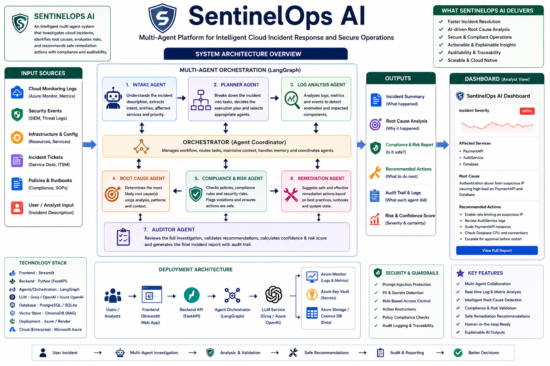
Goal: Build a live Streamlit web app where specialized AI agents investigate a cloud incident, find likely root cause, enforce security/compliance guardrails, recommend safe remediation, and generate an audit-ready incident report.

1. What You Are Actually Building
You are building a deployed interactive web application, not a static website. The user enters a cloud incident description, and the system runs a coordinated multi-agent investigation. The final screen shows each agent output plus a final executive-style incident report.

Final Product
- A public Streamlit web app named SentinelOps AI.
- A GitHub repository with source code, README, data files, architecture diagram, and report.
- A 1-2 page written report summarizing architecture, security, implementation, and LLM collaboration.
- A live demo flow with at least one safe request and one blocked unsafe request.

User Demo Example
User input: "Payment API latency increased and failed logins spiked. Investigate possible root cause and recommend next steps."
Expected final output: severity = high, affected services = PaymentAPI/AuthService/Database, likely cause = suspicious authentication abuse plus backend pressure, safe actions = rate limiting, log review, scaling, approval before restart, audit status = approved with caution.

2. System Architecture
Component | Role in SentinelOps AI
User / Analyst Input | Incident description entered through the Streamlit UI.
Orchestrator | Coordinates all agents, manages workflow state, and passes outputs between agents.
Intake Agent | Classifies the incident, extracts services, severity hints, and intent.
Planner Agent | Breaks the investigation into tasks and decides which agents need to run.
Log Analysis Agent | Reads mock cloud logs/security events and identifies anomalies.
Root Cause Agent | Uses evidence from logs and patterns to infer likely causes.
Compliance & Risk Agent | Checks prompt injection, PII/secrets, blocked actions, and approval-required actions.
Remediation Agent | Recommends safe operational actions based on evidence and policy.
Auditor Agent | Validates the final response, adds risk/confidence scores, and generates audit trail.

Architecture Flow
User -> Streamlit UI -> Orchestrator -> Intake Agent -> Planner Agent -> Log Analysis Agent -> Root Cause Agent -> Compliance & Risk Agent -> Remediation Agent -> Auditor Agent -> Final Report

3. Free / Low-Cost Tools to Use
Layer | Tool | Why Use It | Cost Strategy
App UI | Streamlit | Fastest way to build a live dashboard without frontend complexity. | Streamlit Community Cloud is free for public apps.
Code Hosting | GitHub | Required for public repo submission and Streamlit deployment. | Free.
LLM API | Groq API | Fast hosted Llama models; useful for low-cost demos. | Free tier available, rate-limited.
Backup LLM | OpenAI API or Gemini | Use only if Groq fails or if you already have credits. | Keep usage low; optional.
Cloud Story | Microsoft Azure | Enterprise-ready production architecture for Wipro/client-style explanation. | Use Azure for Students if available; $100 credit for eligible students.
Vector/RAG | ChromaDB | Local vector search for policies/runbooks if you want RAG. | Free/local.
Data Storage | CSV + JSON + SQLite | Simple, reliable, and easy to explain. | Free.
Deployment | Streamlit Community Cloud | Simplest free public link for the live app. | Free.

Official Free Resource Links
- Streamlit Community Cloud: https://streamlit.io/cloud
- Streamlit docs: https://docs.streamlit.io/
- GroqCloud Console: https://console.groq.com/
- Groq rate limits: https://console.groq.com/docs/rate-limits
- Azure for Students: https://azure.microsoft.com/en-us/free/students
- Azure student offer details: https://azure.microsoft.com/en-us/pricing/offers/ms-azr-0170p
- LangGraph docs: https://langchain-ai.github.io/langgraph/
- ChromaDB docs: https://docs.trychroma.com/
- GitHub Docs: https://docs.github.com/

4. Data You Need
Use synthetic/mock enterprise data only. Do not use real customer data, personal data, secrets, or private logs.
File | Purpose | Sample Fields / Content
data/cloud_logs.csv | Simulates Azure Monitor metrics/logs. | timestamp, service, metric, value, status
data/security_events.csv | Simulates SIEM/security alerts. | timestamp, event_type, user, ip, severity
data/config_data.csv | Simulates infrastructure/service configuration. | service, replicas, region, db_connections, owner
data/compliance_rules.json | Defines blocked and approval-required actions. | blocked_actions, requires_approval
data/incident_policy.md | Explains incident handling policy/runbook. | severity definitions, escalation rules, safe actions
data/sample_incidents.csv | Demo incidents for quick testing. | incident_id, title, description, expected_severity

5. Exact Build Steps
Step 1 - Create GitHub repository: Create a public repo named sentinelops-ai. Add README.md, requirements.txt, app.py, agents/, data/, utils/, and docs/ folders.
Step 2 - Create mock data: Add cloud_logs.csv, security_events.csv, compliance_rules.json, and incident_policy.md. Keep all data synthetic.
Step 3 - Build Streamlit UI first: Create app.py with a title, incident text area, Run Investigation button, and output sections for each agent.
Step 4 - Build deterministic guardrails: Create utils/guardrails.py. Block prompt injection phrases, dangerous production actions, secrets/PII exposure, and approval-required actions.
Step 5 - Build simple agents: Create one Python file per agent. Each agent should accept the shared state dictionary and return structured outputs.
Step 6 - Connect the workflow: Start with sequential orchestration in app.py. Later, optionally convert to LangGraph if time allows.
Step 7 - Add LLM summaries: Use Groq for natural-language summaries only. Keep safety checks rule-based, not fully LLM-dependent.
Step 8 - Add audit log: Record each agent name, status, input summary, output summary, and timestamp.
Step 9 - Add demo test cases: Include one safe incident and one unsafe malicious request that gets blocked.
Step 10 - Deploy: Push to GitHub, connect repo to Streamlit Community Cloud, add API key as secret, and deploy app.py.
Step 11 - Prepare deliverables: Add architecture diagram, screenshots, README, 1-2 page report, and optional demo video link.

6. Suggested Repository Structure
sentinelops-ai/
├── app.py
├── requirements.txt
├── README.md
├── agents/
│ ├── intake_agent.py
│ ├── planner_agent.py
│ ├── log_analysis_agent.py
│ ├── root_cause_agent.py
│ ├── compliance_agent.py
│ ├── remediation_agent.py
│ └── auditor_agent.py
├── data/
│ ├── cloud_logs.csv
│ ├── security_events.csv
│ ├── config_data.csv
│ ├── compliance_rules.json
│ └── incident_policy.md
├── utils/
│ ├── guardrails.py
│ └── llm_client.py
└── docs/
├── architecture.png
├── report.md
└── demo_script.md

7. What the App Screens Should Show
- Dashboard header: SentinelOps AI - Multi-Agent Cloud Incident Response.
- Incident input card with sample incident dropdown and text area.
- Agent workflow timeline showing Intake, Planner, Log Analysis, Root Cause, Compliance, Remediation, Auditor.
- Live agent output cards with status: completed, warning, blocked, or needs approval.
- Final incident report with severity, affected services, root cause, safe actions, risk score, confidence score, and audit trail.
- Guardrail panel showing whether any request was blocked or required human approval.

8. Guardrails You Must Explain
- Input validation: reject empty, overly long, or malicious requests.
- Prompt injection protection: block phrases like "ignore previous instructions" or "bypass policy".
- PII/secrets protection: detect SSN/API key/password patterns and mask them.
- Action restrictions: block destructive actions like deleting databases or disabling logging.
- Human approval: production restart, firewall changes, and scaling down databases require approval.
- Audit logging: every agent action is logged for traceability.
- Least privilege: each agent only has access to the tools/data it needs.

9. Implementation Strategy
Recommended MVP approach: build the entire workflow with Python functions first, then optionally add LangGraph if time allows. This keeps the project finishable while still demonstrating multi-agent architecture clearly.
Priority | Feature | Build Decision
Must Have | Working Streamlit app | Required for live demo.
Must Have | 5-7 specialized agents | Shows actual multi-agent collaboration.
Must Have | Guardrails and blocked unsafe request | Directly addresses assignment security requirements.
Must Have | Audit trail | Shows enterprise readiness and explainability.
Should Have | LLM-generated final report | Improves polish and realism.
Optional | LangGraph orchestration | Good if time allows; not required for MVP.
Optional | ChromaDB RAG over policy docs | Useful if you want stronger retrieval story.

10. Realistic Timeline
Day | Goal
Day 1 | Create repo, data files, Streamlit UI, and first three agents.
Day 2 | Add remaining agents, guardrails, audit log, and sample test cases.
Day 3 | Add LLM summaries, improve UI, add screenshots, and deploy.
Day 4 | Write README, report, architecture explanation, and demo script.
Day 5 | Practice presentation, record backup demo video, and submit GitHub link.

11. Final Deliverables Checklist
- Public GitHub repository link.
- Live Streamlit app link.
- 1-2 page written report.
- Architecture diagram with SentinelOps AI name.
- README with setup, deployment, architecture, guardrails, and demo examples.
- At least two demo scenarios: one safe investigation and one blocked unsafe request.
- Optional recorded demo video as backup.

12. Short Presentation Script
Opening: SentinelOps AI is a multi-agent cloud incident response platform that helps enterprise operations teams investigate incidents, identify root causes, enforce compliance guardrails, and recommend safe remediation actions.
Architecture: The system uses an orchestrator that routes the request through specialized agents: Intake, Planner, Log Analysis, Root Cause, Compliance, Remediation, and Auditor. Each agent has a clear responsibility and boundary.
Security: Safety is built into the workflow through deterministic guardrails, prompt-injection checks, PII/secrets detection, blocked actions, approval-required actions, and audit logging.
Implementation: The prototype is built with Python and Streamlit, uses synthetic cloud/security logs, and can optionally use Groq/OpenAI for natural language summaries. The production version would run on Azure with Azure Monitor, Azure Key Vault, Azure OpenAI, Entra ID, and managed storage.

13. Source Notes
The free/low-cost recommendations are based on official platform pages available as of May 18, 2026: Streamlit Community Cloud states apps can be deployed and shared for free; Azure for Students lists $100 credit and no credit card for eligible students; Render lists a free web service tier; Groq describes free-start/API access with rate limits. Always verify account-specific limits before deployment.

