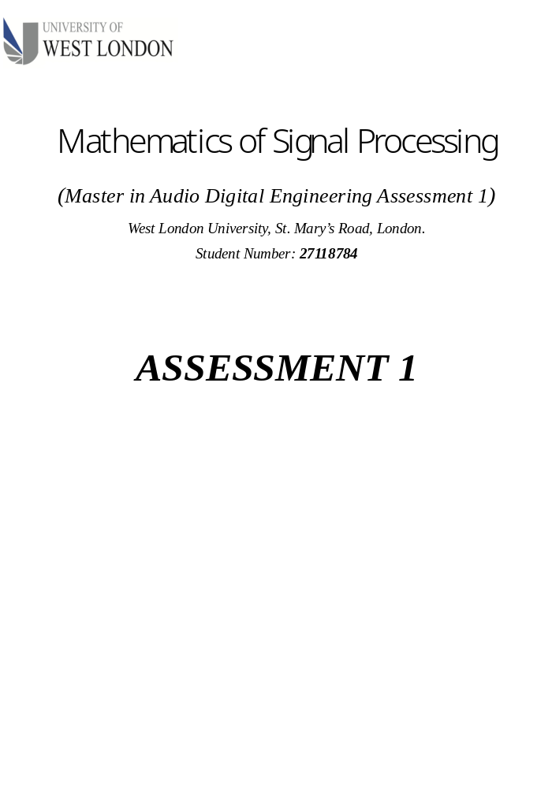
Contents
ABSTRACT 3
OVERVIEW 4
QUESTION 1 4
Introduction 4
Solution 6
1st Harmonic Related Frequency where M= 1 7
2nd Harmonic Related Frequency if M= 2 8
3rd Harmonic Related Frequency if M= 3 8
4th Harmonic Related Frequency if M= 4 9
5th Harmonic Related Frequency if M= 5 9
6th Harmonic Related Frequency if M= 6 10
7th Harmonic Related Frequency if M= 7 10
QUESTION 2 10
Discrete Time Domain Signal Generator Algorithm 11
Graphical Representation of the Harmonic Related Complex Exponential Signal. 11
QUESTION 3 19
Solution 19
QUESTION 4 21
QUESTION 5 23
Zero Crossing Algorithm Pseudocode 23
QUESTION 6 24
Solutions 24
Equation 6.1 Solution 24
Question 6.2 27
Conclusion 29
APPENDIX A 30
Discrete Time Signal Generator 30
Zero Crossing Python Code. 30
Bibliography 31

ABSTRACT

The report is a technical assessment in MSc audio digital signal processing. This report resolved questions on topics like harmonics of related members of complex exponentials signal, unit step functions, zero crossings. It also continues to show how to plot graphs of a member of harmonic related functions, comparison, and discussion of discrete-time signal graph oscillation.

OVERVIEW

This report is the first assessment for the master's degree of mathematics of audio digital signal processing at West London University. The writer assumed that readers whose intention is to understand this report must have some basic knowledge in linear algebra, calculus, and complex analysis. The writer shall discuss topics in complex signal analysis, derivations of members of signal distortions (harmonics) of a basic periodic function. The writer shall, furthermore, discuss topics on zero-crossing and its algorithm. The primary questions from this assessment will serve as a road map for the writer to further explore and discuss some of the basic concepts behind each question and the mathematic descriptions and notations.

According to Albert Einstein, ‘If you can’t explain it simply you don’t understand it well enough’. Therefore, the aim of this report is to show an understanding of the posted questions of this assessment and how to mathematically or algorithmically resolve them.

Each question of the assessment will be treated as individual chapter of discussion for clarity and to aim good presentation format for the report.

QUESTION 1
Determine the members of the family of harmonically related complex exponential signals in discrete time that share a common period of N = 7.

Introduction
The concept behind the family members of harmonic related complex exponential functions; is that, if a signal with a fundamental frequency $ω$ is scaled with a constant value k, the resultant frequency $R_{ω}= ω*k$ $is$an harmonic related member of the fundamental signal. Moreover, if $k=1$ , and if resultant frequency $R_{ω}$ is the same as the fundamental frequency. Therefore, the fundamental basic signal can also be referred to as the 1st harmonic related members. The studies of these members are called “Harmonic Analysis”; a branch of mathematics that is conventionally base on the Fourier transform series, which is a way of expressing a signal as a weight sum of sine and cosine waves. (Folorunso Oladipo, Ojo, & Ajibade, 2013), defined harmonic as “distortion of the electrical signal waveform as a result of non-linear load” which can be mathematically describe as shown below in its complex form.

$∴$ $N$is the number of harmonic related complex exponential signal members whereas, $ω$ is the fundamental frequency of the basic signal. However, this is beyond the scope of this assessment.
A periodic signal has the following mathematical property as expressed in the equation below.

where N is the fundamental period of a discrete time signal, while n is an integer value of the discrete linear time interval of which every sample of the signal is collected.

Mathematically, equation 1.1 can be re-express as $X\left[n+N\right]=X\left[n\right]*X\left[N\right].$if N is the fundamental period, it can be mathematically denoted as shown

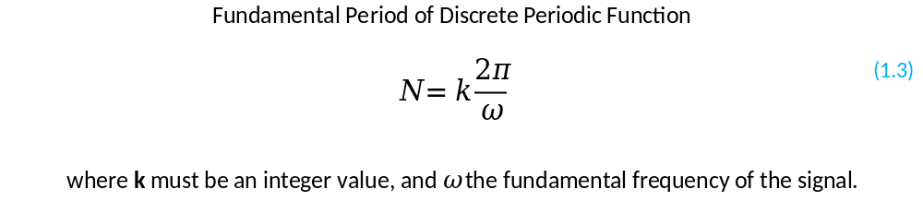
This is primary derived from the period function in equation 1.1. Periodic signal function can further be represented as a complex trigonometric function as shown below using python Pythagoras’s equation of right-angle triangle.

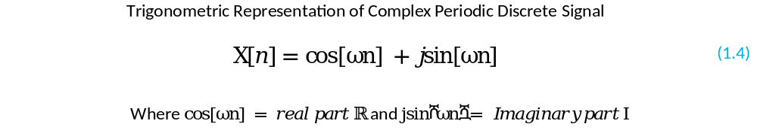
The equation 1.4 can also expressed in Euler formular as shown below. To understand how this equation are derived. The writer will recommend any reader to read about complex analysis and theory.

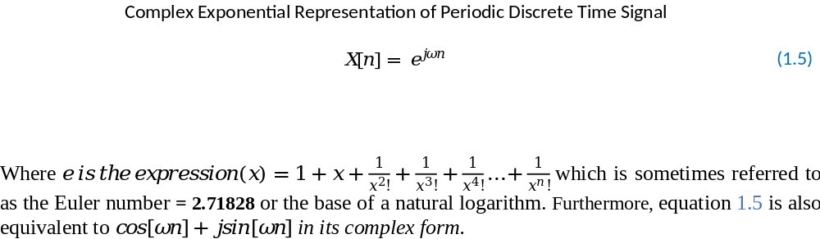

From question 1.3 we can make the $ω$ as the subject formula to find the frequency of the harmonic members. This equation will be heavy use for calculating the harmonic related member of the basic signal.

Hence, to find the harmonic related complex member, we have to introduce the const value M into equation 1.5 as shown below

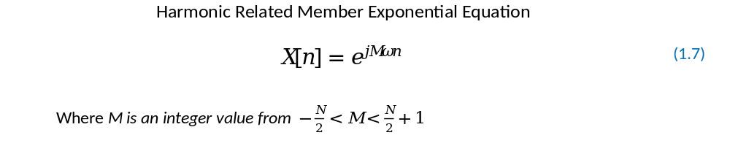
Therefore, if N = 7, and k = 1, substitute N and k into equation 1.6 to represent the fundamental frequency of the basic parent signal for the assessment as shown below


Note: A signal is said to be a fundamental periodic signal if the number of cycle k = 1.

Solution
Therefore, substitute equation 1.8 into equation 1.5 as shown below


1st Harmonic Related Frequency where M= 1

From equation 1.9 substitute M as shown below

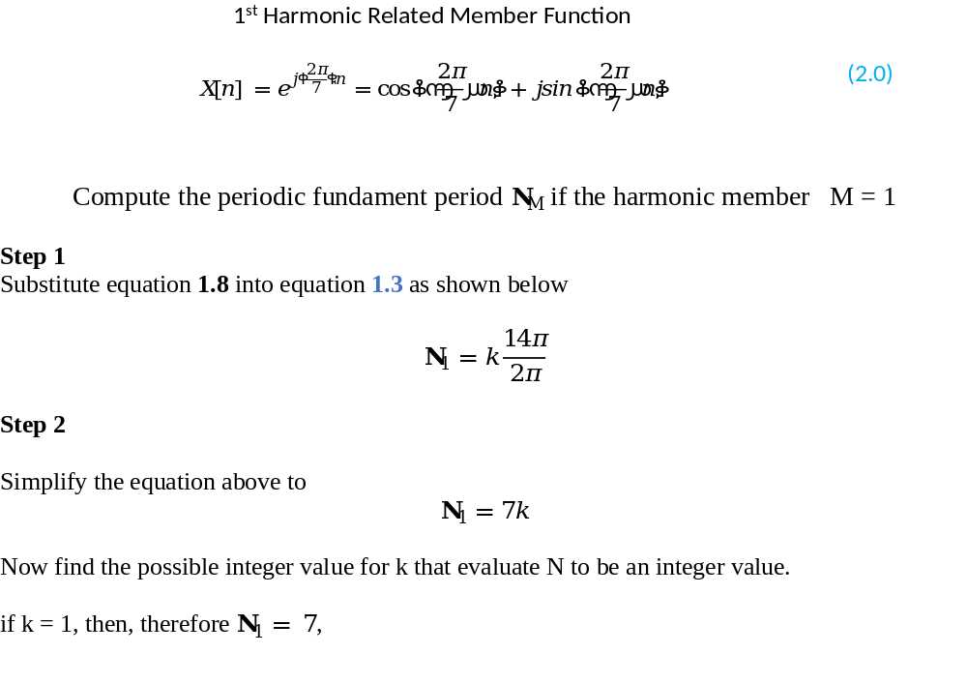

2nd Harmonic Related Frequency if M= 2

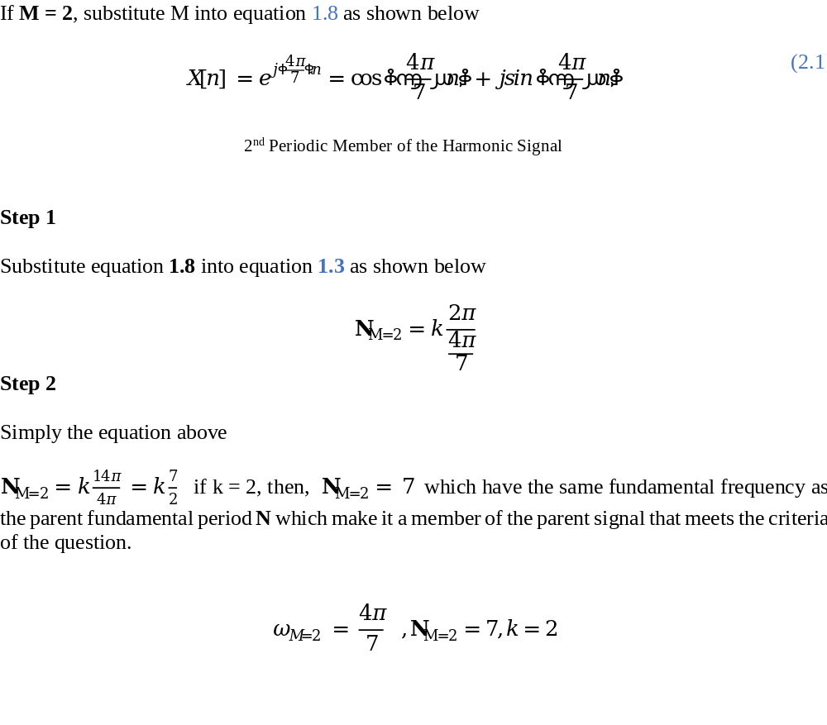

Repeat the same steps for members of 3 to 6 as shown below.

3rd Harmonic Related Frequency if M= 3

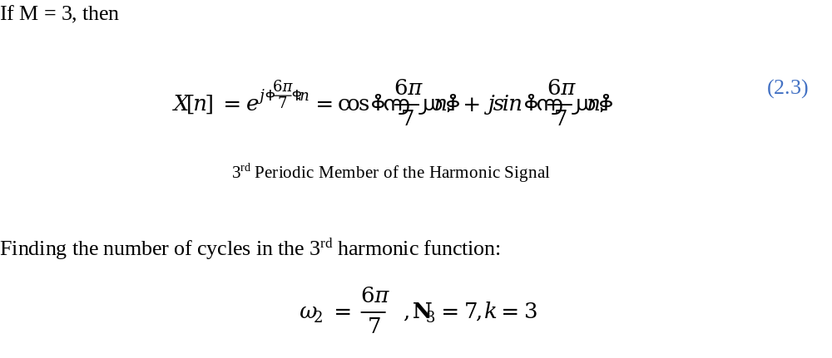

4th Harmonic Related Frequency if M= 4

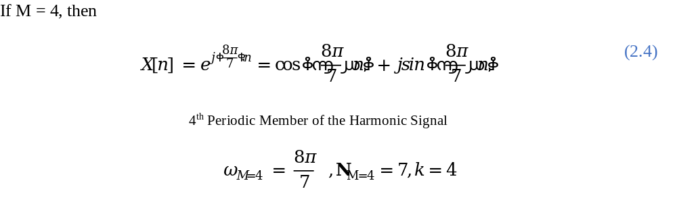

5th Harmonic Related Frequency if M= 5
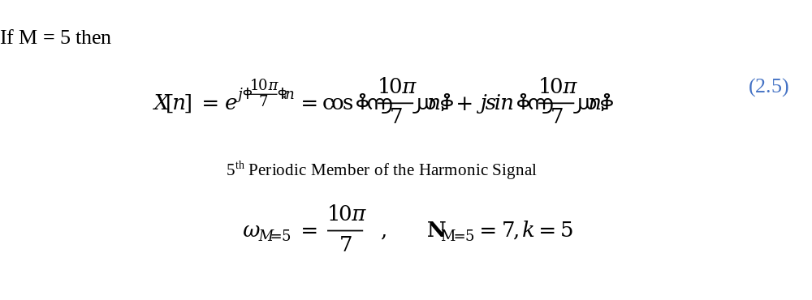

6th Harmonic Related Frequency if M= 6

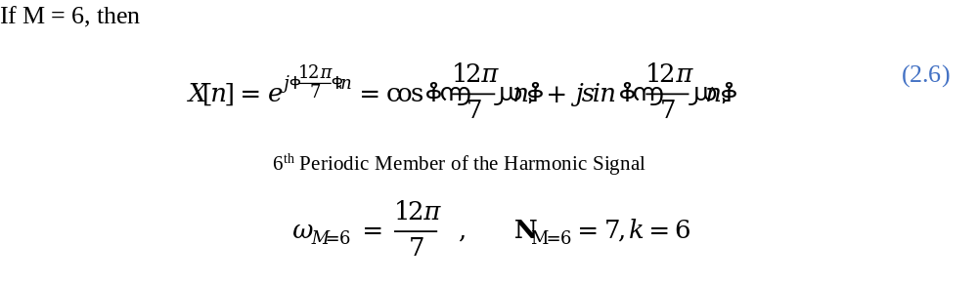

7th Harmonic Related Frequency if M= 7
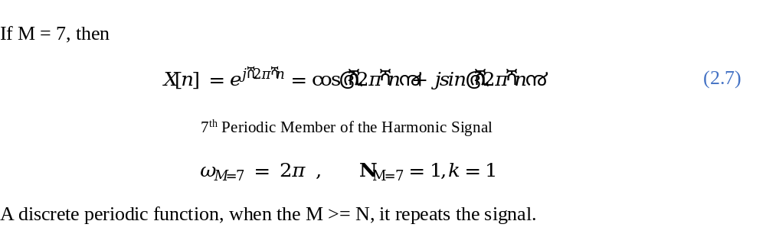

QUESTION 2

Use MATLAB (or similar technical software to plot each member of Question 1.
The writer has decided to use Python 3 and matplotlib.pyplot library to plot the harmonic related member of the fundamental basic signal functions derived in Question.
If N is assumed to be the fundamental sample period per a cycle, then the algorithm to be use to plot and generate the harmonic related members values is listed below

Discrete Time Domain Signal Generator Algorithm

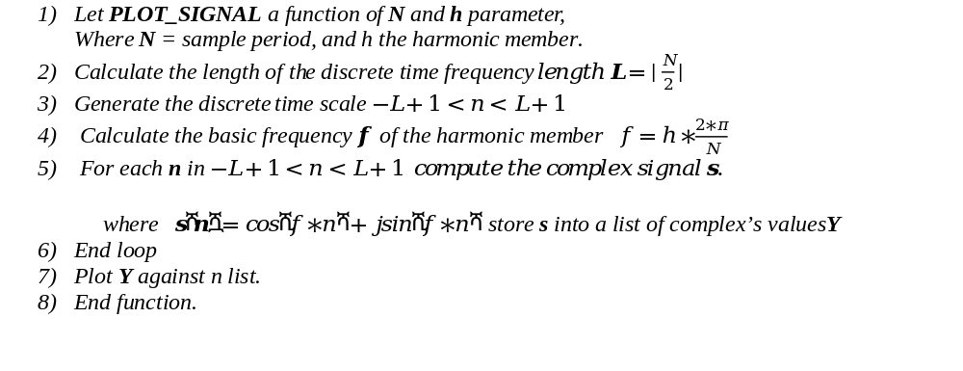

Graphical Representation of the Harmonic Related Complex Exponential Signal.

Calling the python function PLOT_SIGNAL the function graph for each harmonic member related is shown graphically below;

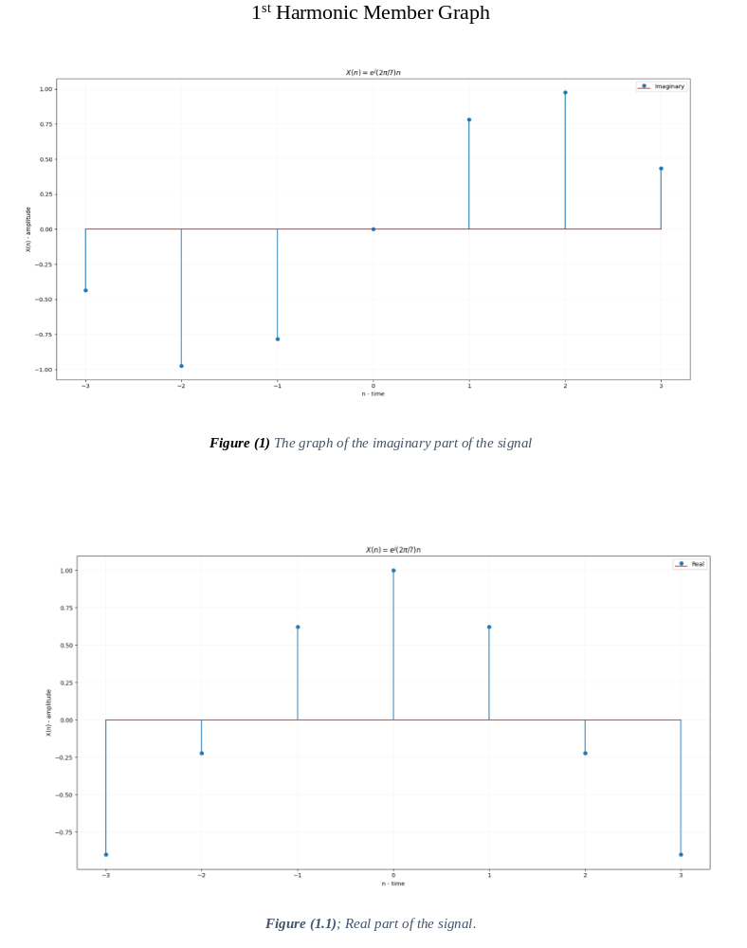
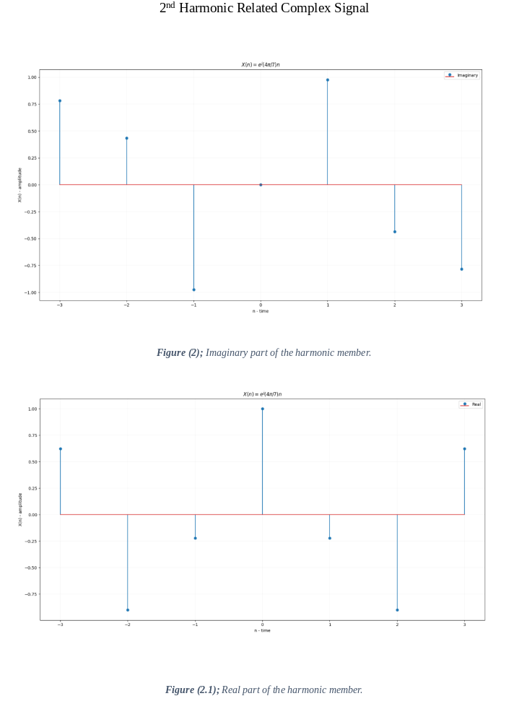
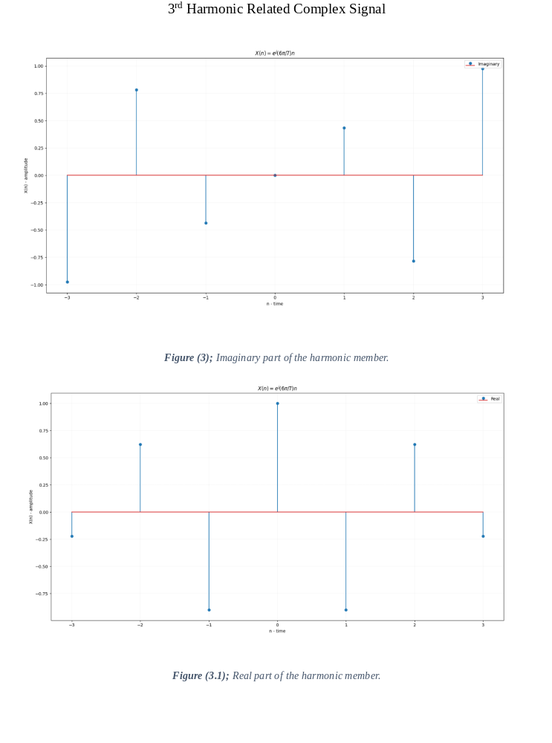
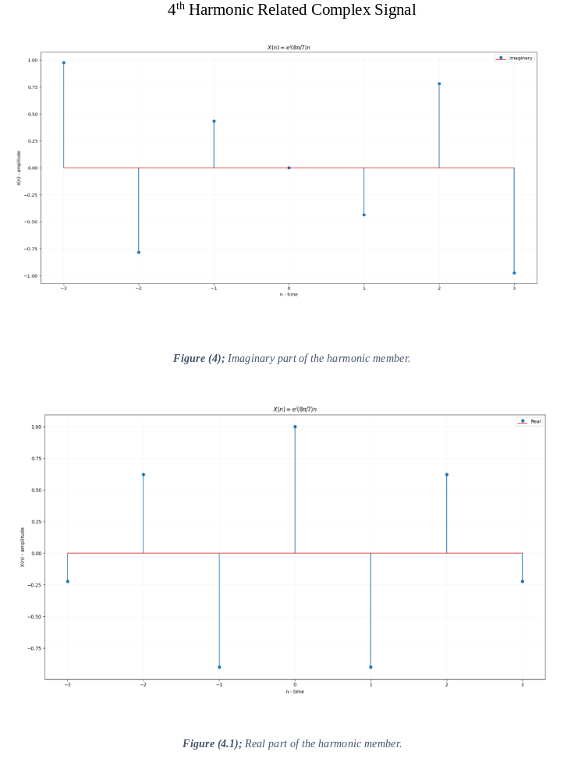
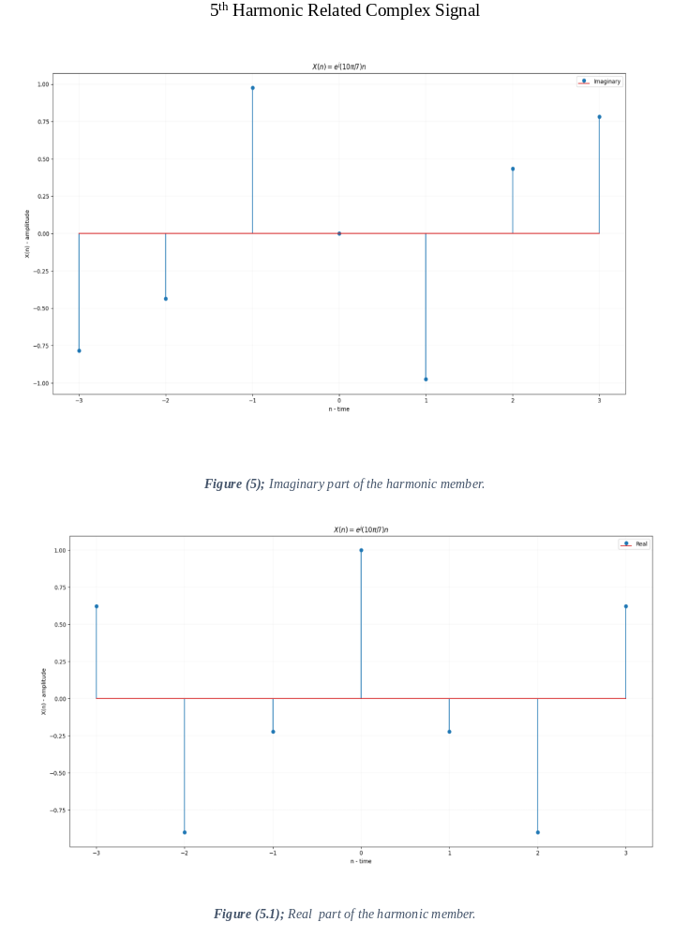
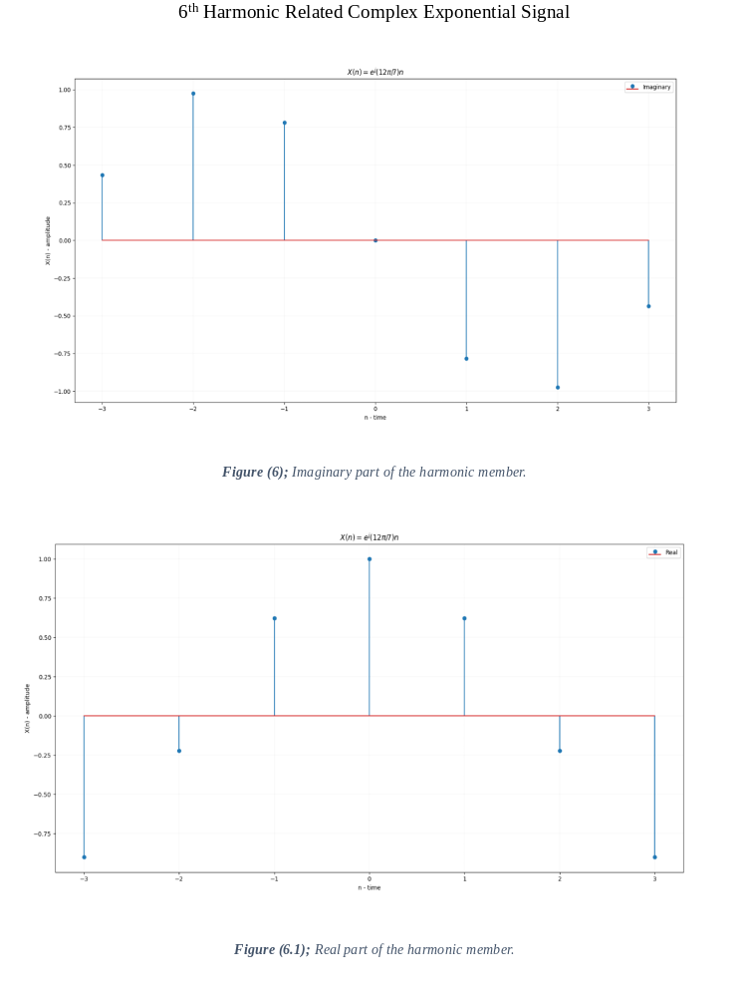
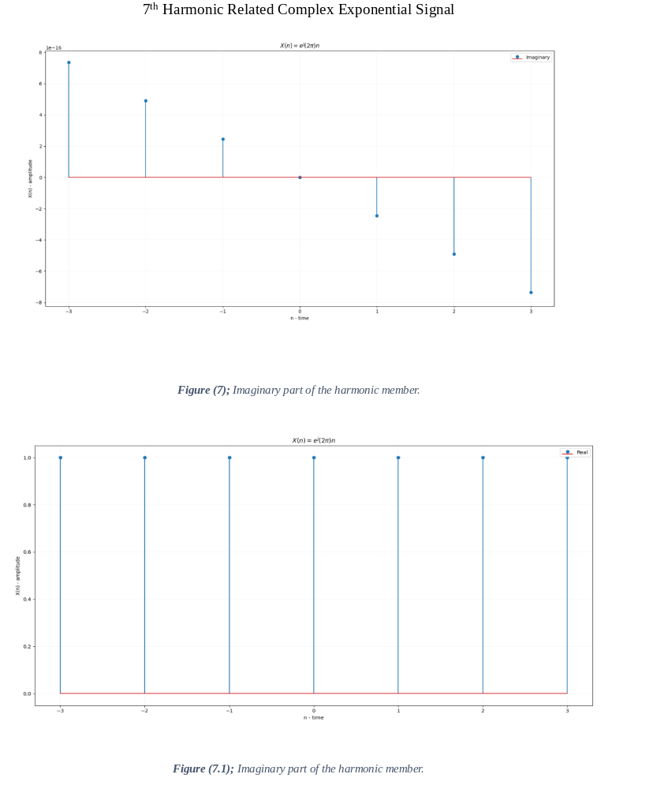

QUESTION 3

Compare the second (m = 2) and fifth (m = 5) members of the family, and judge which one oscillates faster. Justify your answer. Explain how this can be seen from the graphs of the 2 signals.

Solution
One of the obvious comparisons of the signal from the graph fig (2) and fig (5) is that they are conjugate of each other at the imaginary component while their real components are the same. Secondly, from the mathematical point of view in both equation (2.4) and (2.5) representatively. The 5th harmonic related signal has higher frequency and cycles compare to the 2nd harmonic related member per the same fundamental period N.
Furthermore, one can conclude from the mathematical point of view, that the member that oscillate faster is the one that have higher frequency. In this case, it’s the 5th member of the harmonic related signal. This can be calculated using the equation (1.6). Moreover, from the graphical point of view, using fig (2) and fig (5) of the two harmonic member’s signals. It difficult to tell which of the signal is faster in oscillation or have higher cycles per period, but with the help of zero crossing when can deduce a conclusion that both member signal oscillates same. This is because they both have same number of zero crossing. But will that be the actual speed of oscillation of the harmonic member functions?
In that case, the writer will be using the clock analogy to understand discrete time sampling of signal to justify his conclusion. Just imagine a hand of seconds on clock rotating 1 seconds per a cycle. If we are to take a snapshot (sample) of the clock in every 1second of time t per a cycle.

The dotted points will be the samples collected. If 3 samples or snap short is required; as time progressing by a unit. Now let reset the clock again. But this time, increase the speed of rotation of the clock second-hand by 2. This means the second’s hand will complete a cycle twice per second. Take another snap short of the clock at every second per unit again.

The sample results will be the same, but that does not mean the second’s hand oscillate at the same rate. This is the reason why it will be hard to tell which discrete signal graph of harmonic member 2nd and 5th oscillate faster using the graph only; because the information’s needed to make that judgement is lost during the sampling. However, we can actually see the crossing of threshold “Zero” in the graph.
But it will be wrong if the judgement is made base on the zero crossing of the signal while we have information and formula for the origin signal function. Zero crossing is not efficient in terms of detecting the oscillation of signal in discrete time. According to (Junwirth, 2016); a Ph.D. student who discussed how aliasing can make a signal with a faster oscillation behave slower in its discrete form.
Picturised another Clock 3 in your mind, which complete a cycle in $1\frac{1}{2}$ seconds and in every second per cycle take a snap shot compare it with the Clock 2
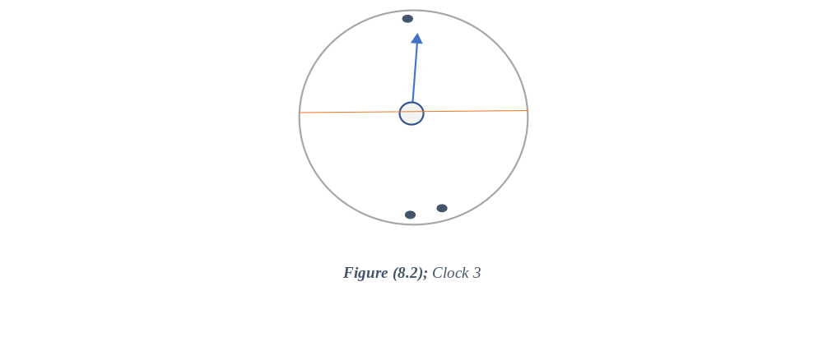

You will find out that Clock 3 have more zero crossing then Clock 2 even though clock two oscillate faster.
This is the reason why, zero crossing in discrete time signal should not be used to judgement how fast an original signal oscillates from the write point of view.
In conclusion, the writer will make his judgement base on the mathematical calculation using Equation (1.6) to find the number of cycles and frequency. In this case, 5th Harmonic Related Signal have 5 cycles and 2nd Harmonic Related Signal have 2 cycles. Therefore, the 5th Harmonic related signal oscillate faster compare to the 2nd harmonic signal even though from the graph’s fig (2) and fig (5) one might think that they oscillate the same. While making judgement base on the member plotted graph, one can also come to conclusion base on the number of zero crossing. if and only if the original signal is unknown and only the graph of the two signals in fig (2) and fig (5) are presented. Then, the writer will make a conclusion base on the number of zero crossing, in this case the two signals oscillate at same rate.

QUESTION 4
Compare the fourth (m = 4) and fifth (m = 5) members of the family, and judge which one oscillates faster. Justify your answer. Explain how this can be seen from the graphs of the 2 signals.
A signal in its natural form is an AC fluctuating, which means quicker the fluctuation of the signal the faster it oscillates. Therefore, from fig 4 and fig 5 of the harmonic members, one can judge that, the 4th member of the harmonic related signal has more zero crossing compare to the 5th member. Per the clock analogy in Question 3. we will discard using zero crossing as a form of judgement, however instead we are going to be looking at the mathematical investigation base on the number of cycles and frequency.
For the purpose of understanding, let take a continuous form of both signals and analysis how the sampling is carried out by our algorithm. The number of samples need is 7 per Question 1 of the assessment per the fundament Period.
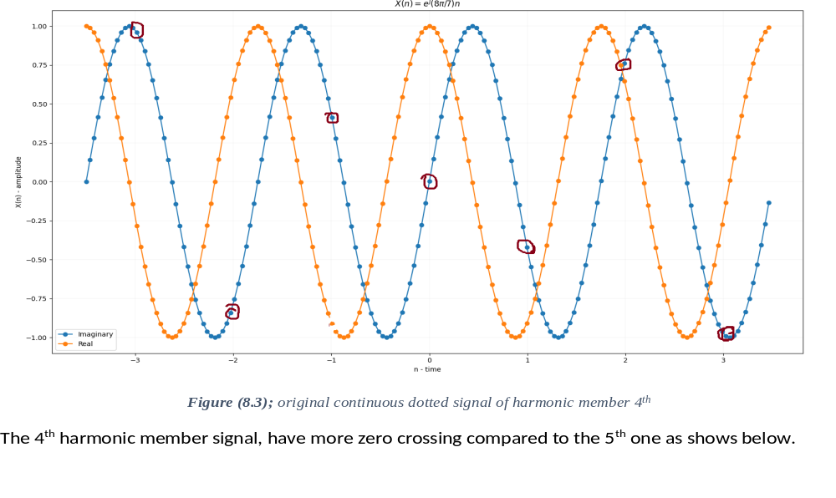
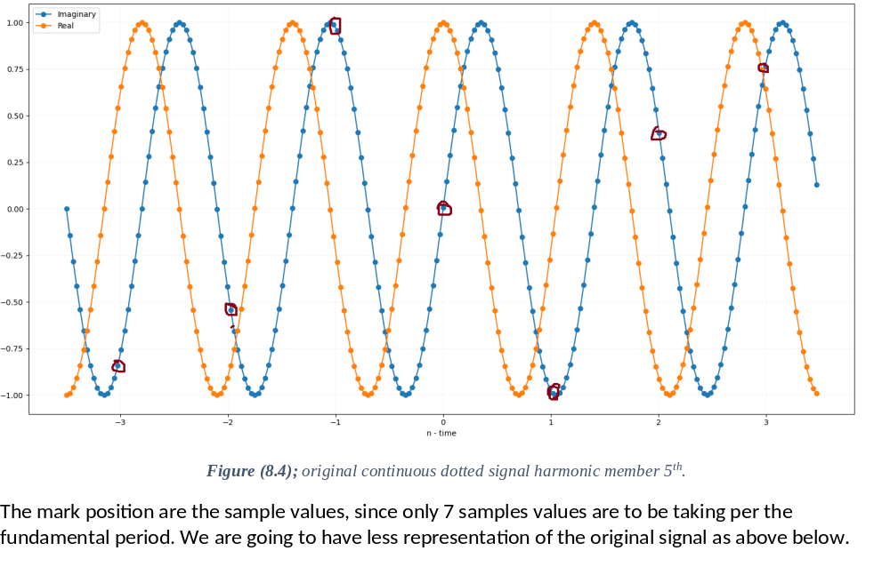
The reason why there are less crossing on Figure 8.4 is because the signal oscillates faster than the sample range.
In conclusion, the writer judgement will be based on the mathematical solution using equation 1.6 to calculate the frequency and the number of cycles. The 5th member has 5 cycles generated per the fundamental period, whereas the 4th member has 4cycles per the fundamental period. Furthermore, the writer will draw a conclusion base on mathematical figures that 5th member of the harmonic signal oscillates faster than the 4th member. Moreover, if the judge was to be base on the graph of the two signals then the writer will have to be force to concluded that 4th harmonic member appears to be faster than the 5th harmonic signal.

QUESTION 5
Use MATLAB (or similar technical software) to write your own function to count the zero crossings of the above discrete-time harmonics. The function should be saved as a separate file (.m file in MATLAB), which you can call in order to compute the zero crossings. Present the results in a Table. Explain how these results agree or not with your conclusions in questions 3 and 4.
Solution
In signal and systems, the term “Zero crossing is used to describe the point at which a function changes sign from positive to negative or negative to positive. (Shayan Motamedi-Fakhr, 2014) state that “Zero-crossings are the points at which the waveform crosses the x-axis” Furthermore, he claimed that higher frequency signal have rapid zero crossing rate and lower frequency have lower frequency rate.

The algorithm to count the zero crossing is listed below.

Zero Crossing Algorithm Pseudocode

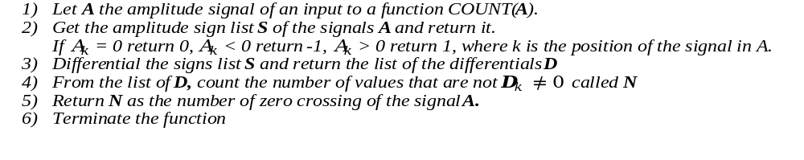
Testing the Zero Crossing Algorithm with the mathematical function in Question 1.

Table (1)

Harmonic Related Members | Number of Zero Crossing
1st Member | 2
2nd Member | 4
3rd Member | 6
4th Member | 6
5th Member | 4
6th Member | 2
7th Member | 2

In Question 3, the zero crossing of 2nd and 5th harmonic are the same. However, my conclusion, in the above two Question 3 and 4, is based on two scenarios. One which the speed is judge base on the zero crossing and the other which the judgement is base on the mathematical calculation of their number of cycles and frequency. If the judgment in Question 3 is based on graphs alone, therefore, the zero crossing support the fact that harmonic related member 2nd and 5th have the same oscillation since their zero crossing are same.

Whereas, in Question 4, if the judgement is base on the graph of the harmonic member 4th and 5th, then, the 4th harmonic related member oscillates faster compare to the 5th harmonic member.

In all things considered, this judgment can only hold if and only if the original information is discarded and we are merely just looking at the discrete time signal without original of the signal.

QUESTION 6
Use MATLAB (or similar technical software) to plot the following two signals
- $X\left(n\right)=u\left[n-4\right]-u[u+5]$
- $Y\left(n\right)=u\left[n\right]* u[-u]$

Solutions
The above equations are linear combination of unit step function $u\left[n\right]$; a function whose amplitude is 1 for all value of $x ≥0$ and 0 for all value of $x<0$ .
This can be mathematical described as shown below.
$u\left(x\right)=\left\{\begin{aligned}1, &x ≥0 \\ 0, &x< 0\end{aligned}\right.$
Therefore, the solution is shown below:

Equation 6.1 Solution

- $X\left(n\right)=u\left[n-4\right]-u[u+5]$
X(n) is a different of two-unit function amplitudes and need to be evaluated them separately, before we can resolve them together.
$u\left[n-4\right]$ is a time shift to the right by 4 units, recall that unit function by default have amp of 1 throughout when n >= 0
Evaluation of signal $u\left[n-4\right]$
If ( $-∞< n<0$) then amplitude u = 0
If ( $0< n<(n-4)$) then amplitude u = 0
If ( $(n-4)< n<∞$) then amplitude u = 1
The graphically representation of the unit signal $u\left[n-4\right] c$an be show below
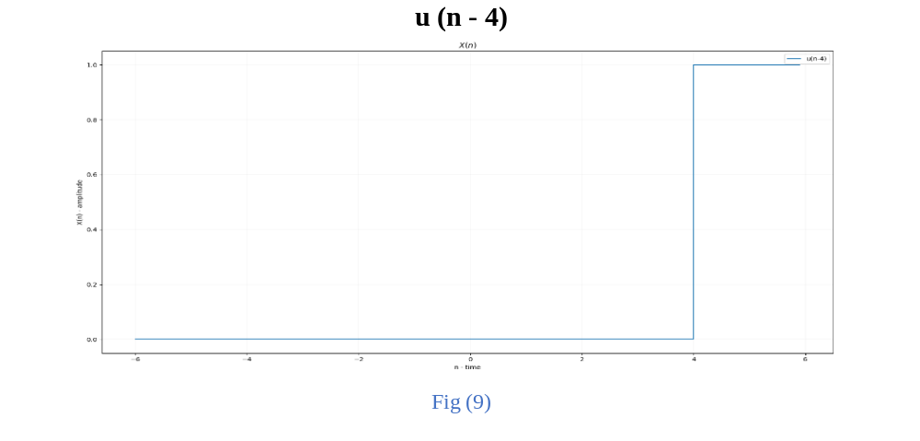
Evaluation of signal $u\left[n+5\right]$, this is a left shifting of the signal $u$ to the left handside by 5 unit from the origin point 0.
If ( $-∞< n<-5$) then amplitude u = 0
If ($-5< n<0)$) then amplitude u = 1
If (0 $< n<∞$) then amplitude u = 1
And can be graphically shown below
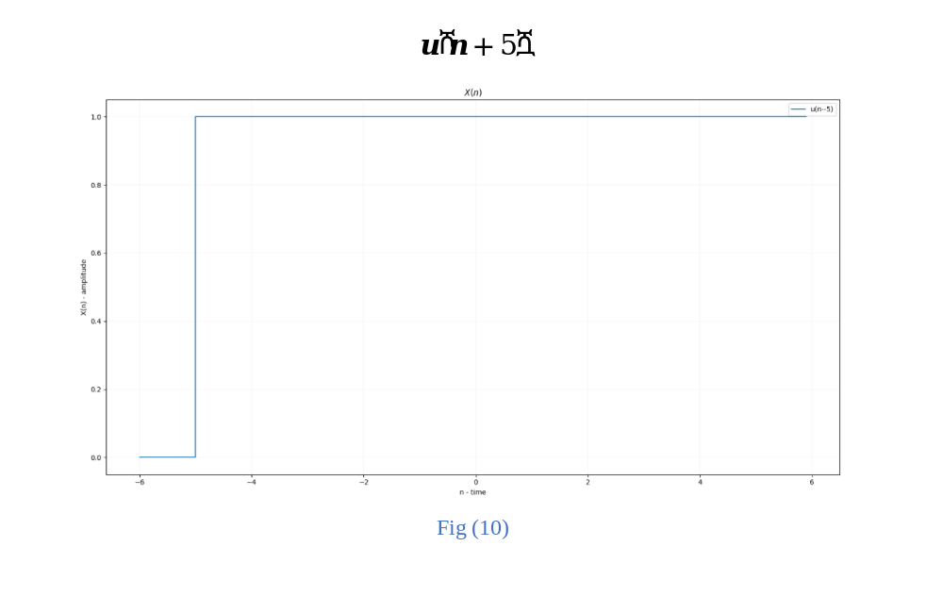

Therefore $X\left(n\right)=u\left[n-4\right]-u[u+5]$ can be resolve as

If ( $-∞< n<-5$) then amplitude $u\left[n-4\right]-u[u+5]$ = 0 + 0 = 0
If ($-5< n<0)$) then amplitude $u\left[n-4\right]-u[u+5]$ = 0 + 1 = 1
If ($0 < n<4)$) then amplitude $u\left[n-4\right]-u[u+5]$ = 0 + 1 = 1
If (4 $< n<∞$) then amplitude $u\left[n-4\right]-u[u+5]$ = 1 + 1 = 2

The signal can be tabularly depicted as show below:

$$X\left(n\right)=u\left[n-4\right]-u[u+5]$$
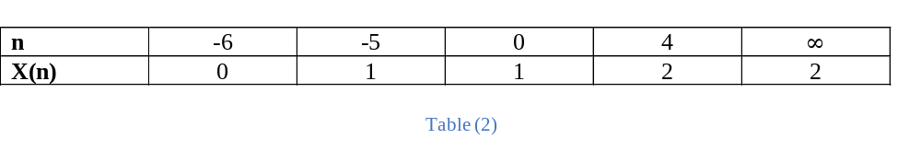
and can be graphically shown as below:
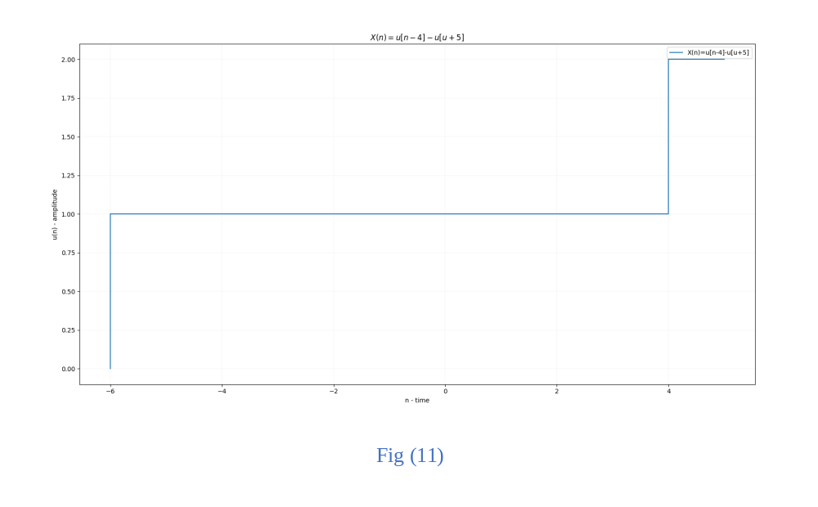

Question 6.2

$Y\left(n\right)=u\left[n\right]* u[-u]$ the Y(n) signal is the linear multiplication of two-unit step function.
$u\left[n\right]$and $u[-u]$. To evaluate these functions, we will look at them individually.

Equation (a) $u\left[n\right]$ as shown
- $u[n]$ ; per the definition of unit step function, we can say that

If ( $-∞< n<0$) then amplitude $u[n]$ = 0
If ($0< n< ∞)$) then amplitude $u\left[n\right]$ = 1
And now, let try to evaluate unit function $u[-u]$ ,you will agree with the writer that this is odd. But if you look at it in a different angle, you will conclude that $-u$ it’s just the amplitude inverse $of u[n]$. Since we already knew the amplitude values of unit $u[n]$ , doing the inverse is a bit simple as show below:
If ( $-∞< n<0$) then amplitude $-u[n]$ = 0
If ($0< n< ∞)$) then amplitude $-u\left[n\right]$ = -1
Recall that, $-u\left[n\right]$ is this $-u$ which is the input value of the function $u[-u]$ therefore we can carry the evaluation of the outermost function $u[-u]$ as shown below.
If ( $-∞< n<0$) then amplitude $-u[n]$ = 0, therefore $u\left[\left(-u\right)=0\right]$= 1
If ($0< n< ∞)$) then amplitude $-u\left[n\right]$ = -1, therefore $u[(-u)=-1]$= 0
Now that the functions are evaluated $u\left[n\right] and u[-u]$ , we can then multiply their amptitude.as shown below:
If ( $-∞< n<0$) , $u\left[n\right]* u[-u]$ = 0 * 1 = 0
If ( $0< n<∞$) , $u\left[n\right]* u[-u]$ = 1 * 0 = 0
The $Y\left(n\right)=u\left[n\right]* u[-u]$ values are all zero from $-∞< n<∞$ and can be depicted into a table as show below
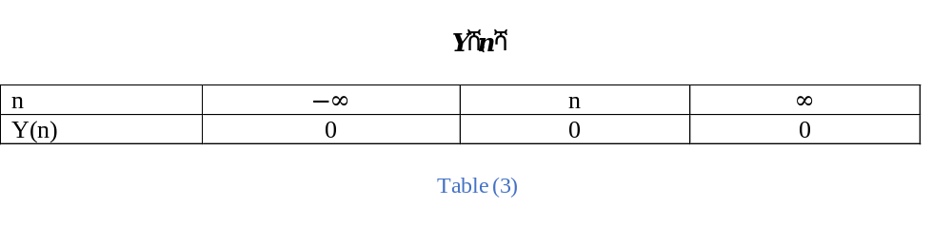

This values in table 3 can be graphical plot using the python function as show below
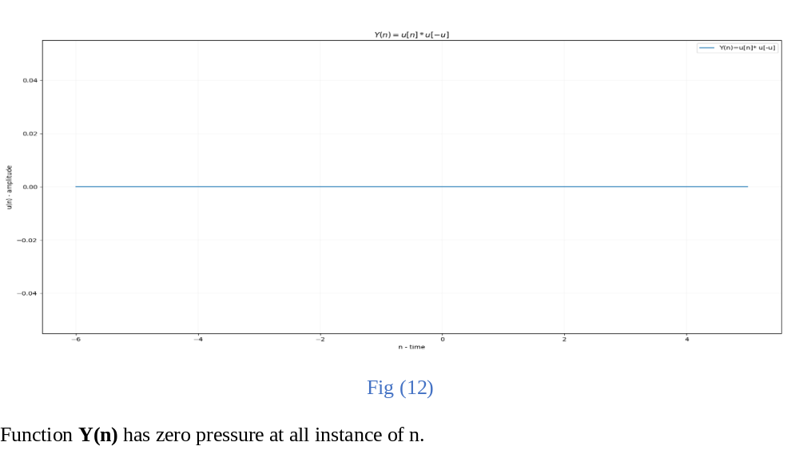

Conclusion

The report has demonstrated the knowledge of the writer in area of harmonic related member function of a fundament basic signal. He has concluded that harmonic related members are simply achieved by just scaling the fundamental frequency $ω$of the basic signal function.
In the discrete time form of signal, if not properly sampled, one can easily judge wrongly how fast a signal oscillated.
Finally, zero crossing are more accurate in continuous time signal compare to discrete time signal.

APPENDIX A

Discrete Time Signal Generator

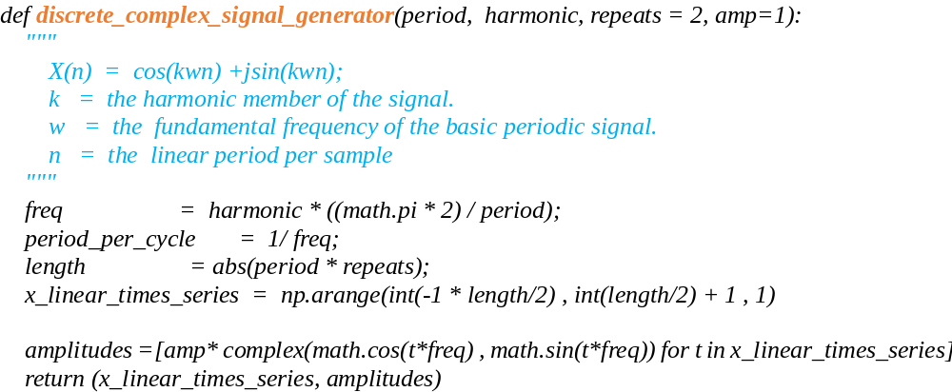

Zero Crossing Python Code.

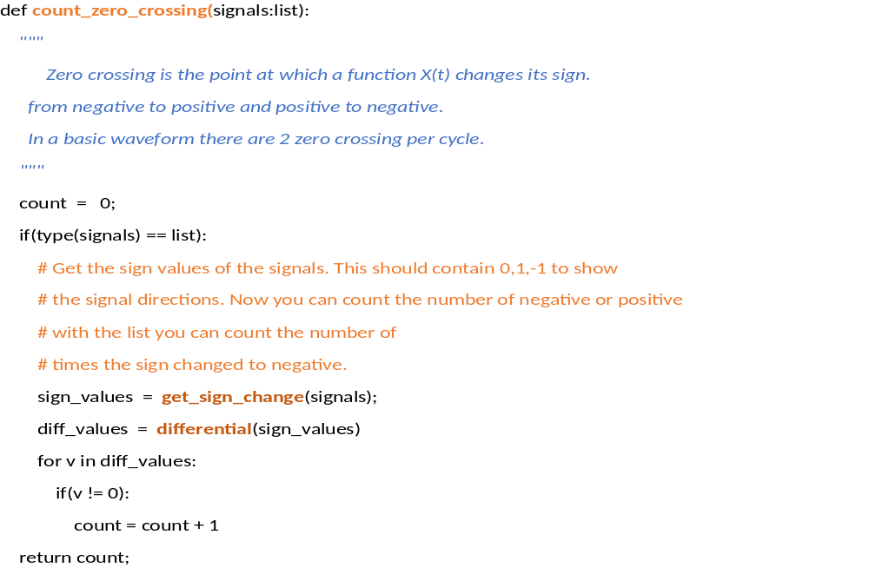

Bibliography
Boulet, B. (2015). Fundamentals of Signals & Systems. 1st ed.
Folorunso Oladipo, Ojo, A. O., & Ajibade, A. (2013). Harmonic Analysis and its Mathematical Philosophy.
Helson, H. (1995). Texts and Readings in Mathematics; Harmonic Analysis. second edition.pp.227 RS.235.
Illing, L. (2008). FOURIER ANALYSIS.
Junwirth, P. (2016). Sampling Theory and Analog to Digital Conversion.
Shayan Motamedi-Fakhr, P. R. (2014). Biomedical Signal Processing and Control.
Susan R. Curtis, A. V. (1985). RECONSTRUCTION OF TWO-DIMENSIONAL SIGNALS FROM THRESHOLD CROSSINGS. Susan R. Curtis, Alan V. Oppenheim (1985).

