# Terms of Reference

# Developing a Sensitivity Atlas Processing Tool using FME

Sensitivity atlases are a way of presenting spatial data on the sensitivity of assets to any given pressure, such as the sensitivity of mangrove forests to oil spills. In Norway this to some extent finds its parallell in the Priority data set currently available at the webpages[1] of The Norwegian Coastal Administration.

A processing tool for creating a sensitivity atlas shall be developed using FME[2]. The tool will have a low entry level and will be used for training as well as for developing country/regional sensitivity atlases.

QGIS project files to facilitate for presenting the resulting data sets are also developed. Documentation is also prepared.

FME procedures and documentation is delivered in english.

### Processing

The tool shall take as input spatially referenced environmental data in predefined formats. The data represents differences of importance/priority. This importance shall be basis for further processing resulting in a gridded presentation of sensitive areas.

### User experience

Using the system will be straightforward for a user inexperienced with using FME.

The preparation of the sensitivity atlas will have four stages:

* Data staging where the input data is read into a database and all layers are written to an excel sheet for further processing.
* The excel sheet serves as a tool for setting priorities and sensitivities to the data sets before processing
* Data processing stage which creates three sensitivity atlas layers based on the input data and the prioritisation stage.
* Visualisation of data

Details on the four steps for users in establishing a sensitivity atlas:

1. Staging
   1. User copies all files to a designated input folder
   2. FME staging routine is initiated.
2. Editing excel template
   1. User opens an excel file. It contains a list of all asset datasets
   2. User edits the excel file and adds asset priority and sensitivity ranking for both local and global. Known update year for the data set is also added in the designated column.
3. Processing
   1. FME processing routine is initiated.
   2. Output data is written to the sensitivity_output.gpkg-file.
4. Visualisation
   1. QGIS template opens database with relevant layers.

### Input data

Required input data for the processing is:

* Grids: A grid dataset which should have some basic attributes like a unique reference, calculated area and centerpoint.
* Assets: A series of datasets describing assets considered of importance

Asset data can be accepted as-is. This means no prior formatting is necessary. Certain attributes will be recognised, if present, and will then be used as part of a structured reference in the resulting dataset. These are:

* asset_type
* asset_name
* asset_referencenumber
* asset_date

The preferred input data format is Geopackage[3], but other data types like shapefiles could be used. If file based asset datasets are used the file names will be used as table names.

### Processing

Asset spatial objects is combined with asset priority and sensitivity ranking from the input table. This The calculation provides a value to the calculated object. The formula is [priority] multiplied by [sensitivity]. The correct term for the product of the mentined factors is vulerability. In the tradition of sensitivity atlases it will be referred to as the sensitivity.

Maximum sensitivity values for each asset relation (priority and sensitivity) grid cell is recorded in the database. Detailed data per grid (flattened dataset) is then calculated. Lastly a dissolved dataset is prepared based on max vulernability value per grid.

The processing should work with any provied grid set. This means the provided grid data set from the user is used in the calculation.

### Output data

The resulting product is a spatial database (geopackage) where the following is contained:

* Input data assets
  + Tables naming convention (tbl_asset_[assetname]
  + Asset datasets
* Input grid dataset
  + Table name: tbl_grid
* Full database
  + Table name: tbl_full
  + For each asset and sensitivity pair the value for one grid cell is calculated. This means each grid id is repeated several times and can not remain the unique identifier.
  + Attributes:
    - Counter calue (Primary key)
    - Grid id
    - Asset priority (1-6)
    - Asset reference (name and dataset)
    - Sensitivity (1-6)
    - Vulnerability (asset priority x sensitivity) -> (1-36)
* Grid database (tbl_grid_overview) with squares indicating relative value
  + Table name: tbl_overview
  + The maximum vulnerability value for each grid cell is calculated. Information about all assets within the grid cell is listed.
  + Attributes:
    - Grid id (primary key)
    - Max vulnerability value
    - List of assets active within the grid
* Generalised database grid database
  + Table name: tbl_dissolved
  + Grids are dissolved based on vulnerability resulting in a multipolygon per vulnerability value.
  + Attributes:
    - Unique Ids for each object.
    - Sensitivity vulnerability (asset priority x sensitivity) -> (1-36)
* Metadata table
  + Table name: tbl_metadata
  + Attributes:
    - Date for update
    - Calculation end start date and time
    - Calculation end date and time
    - Date for update of sensitivity atlas
    - Who
    - Where

### System delivery

The system is delivered with the following sub-deliveries:

* FME workspace
* QGIS project file
* Documentation
* Sample data

All files are delivered within the following file structure

|  |  |
| --- | --- |
| **Folders** | **Files** |
| sensitivityatlasprocessing/ | Folder contains project files for FME and QGIS:   * sensitivity_staging.fmw * sensitivity_processing.fmw * sensitivityatlas.qgs |
| data_in/ | Sample dataset files |
| data_out/ | Produced database   * Sensitivityatlas.gpkg |
| maps_out/ | Output from test dataset |

### Technology platform

The software used to facilitate this processing is FME version 19.0. QGIS version 3.8 will be used as a presentation platform.

Licenses to the mentioned software in the development phase is the responsibility of the consultant.

The consultant is expected to have professional knowledge at a high level on both FME and QGIS.

### Data provided from principal

The following data and procedures are provided from the principal:

* Test data
  + Ecological data of importance
  + Socioeconomical data of importance
* Grid data
  + Quarter Degree Grid Cell data[4]

### Appendix I - Excel sheet draft

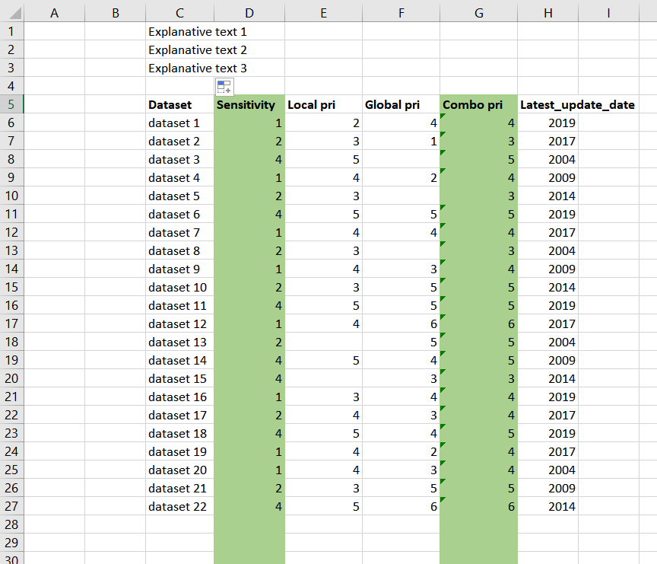

### 

### Appendix II - Processing figure

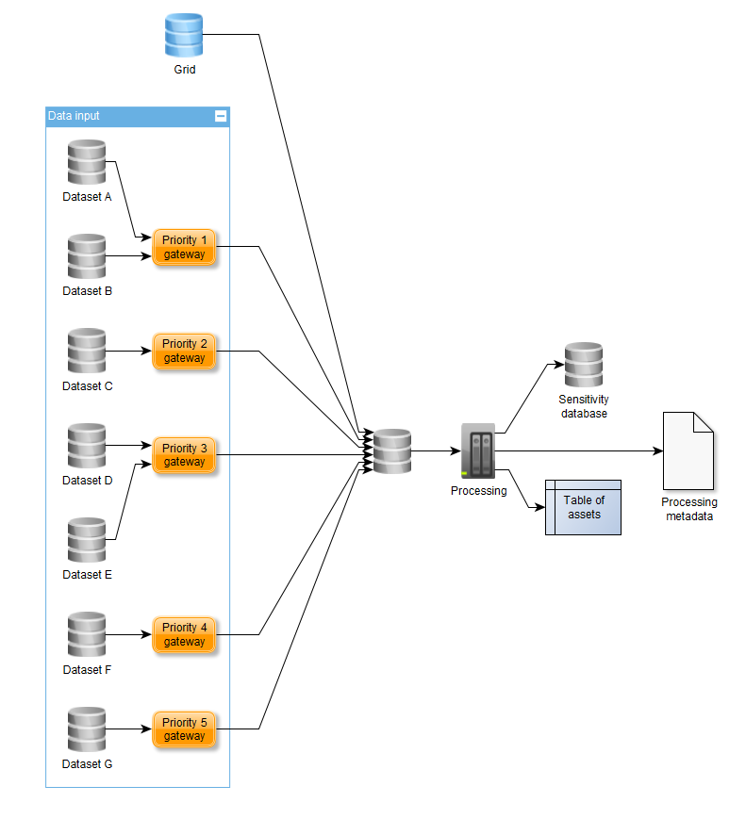

1. https://beredskap.kystverket.no/share/563790ed191a
2. FME from Safe Software. <https://www.safe.com/>
3. Geopackage format: <https://www.geopackage.org/>
4. <https://en.wikipedia.org/wiki/QDGC>