Wilderness analysis using SAWE

This wilderness analysis assumes that wilderness is any area with a distance of more than 1 km away from encroachments. The areas away from encroachments are further divided into the following categories:

|  |  |  |
| --- | --- | --- |
| ***Code*** | ***Name*** | ***Distance from encroachment*** |
| *w* | *wilderness* | *+5 kms* |
| *1* | *wilderness, (zone 1)* | *3-5 kms* |
| *2* | *wilderness (zone 2)* | *1-3 kms* |
| *n* | *near encroachment* | *0-1 kms* |

We can visualize the different categories this way:

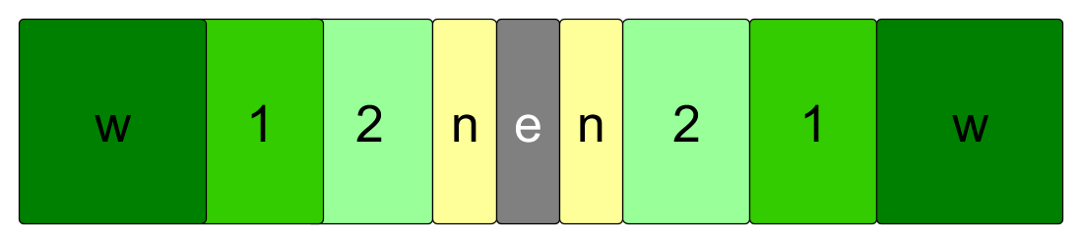

GIS tools like ArcGIS pro[1], QGIS[2] and others make it possible to do the calculations. A full calculation does however require many operations in sequence. This opens up for human errors.

Both ArcGIS and QGIS makes it possible to establish procedure sequencing systems named respectively model builder and graphical modeler. As of now SAWE only provides support for FME from Safe software.

**Processing**

The processing is done using the file wilderness_analysis.fmw available in this repository. The file can be downloaded. With relevant source files the calculation will give the user an analysis of Tanzania using OpenStreetMap data downloaded in shapefile format from Geofabrik.de[3].

**Using the FME procedure**

FME is commercial software. IT is unfortunate that the software does not have an entry level free version. They do however provide some free licenses for NGOs and others.

The easiest way to use the software is to do the following:

1. Clone this repository
2. Download the latest version of the OSM files from Geofabrik. Unzip them and place them in the folder sawe.git/data_in_osm/
3. Make sure the source files are linked up.
4. Disable/enable the relevant encroachment sources.
5. Run the workspace.

The full test data sets take around three hours with a decent laptop.

**Presenting the results**

A QGIS presentation of the data is available in the folder sawe.git/qgis/

1. https://pro.arcgis.com/en/pro-app/
2. https://www.qgis.org
3. https://download.geofabrik.de/africa/tanzania.html