Daniel Ivanov & Connor Lundberg

5/3/2017

TCSS 372 HW 4

Start of Program

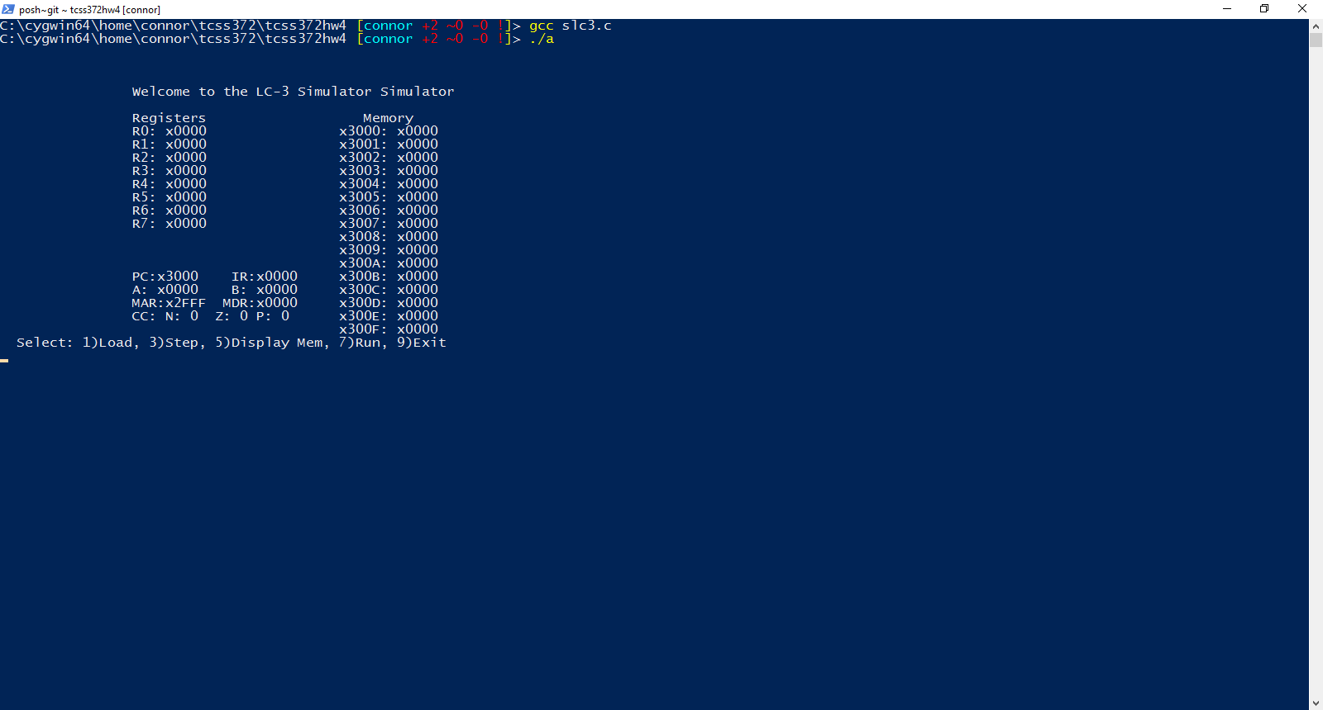

Load

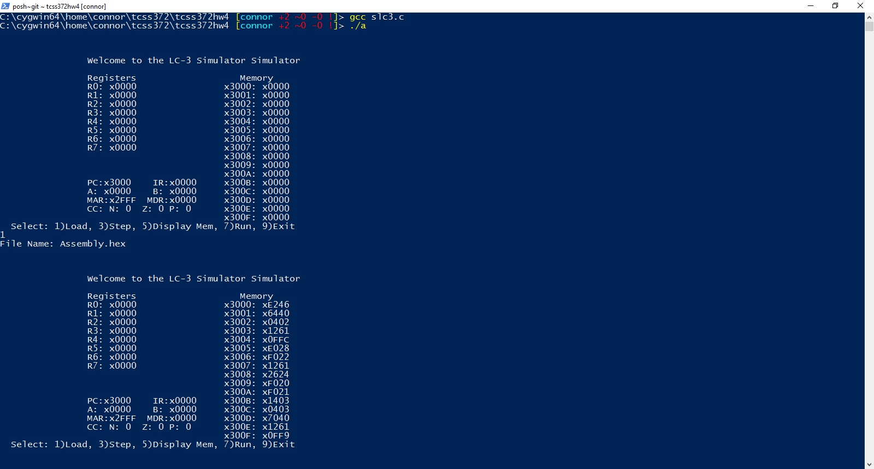

Display Memory

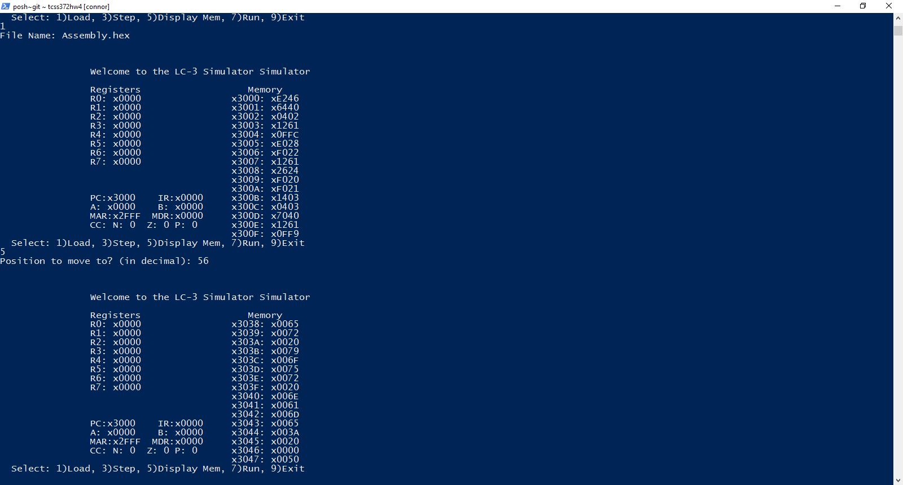

Run

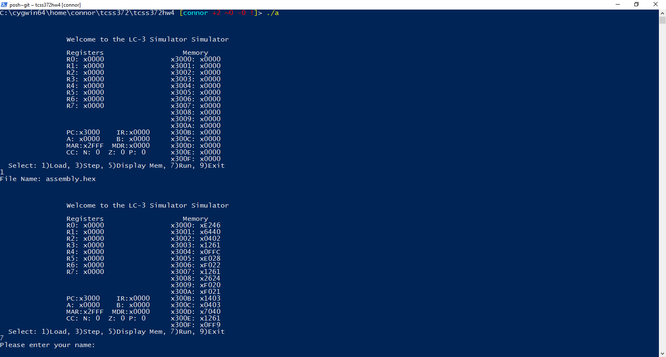

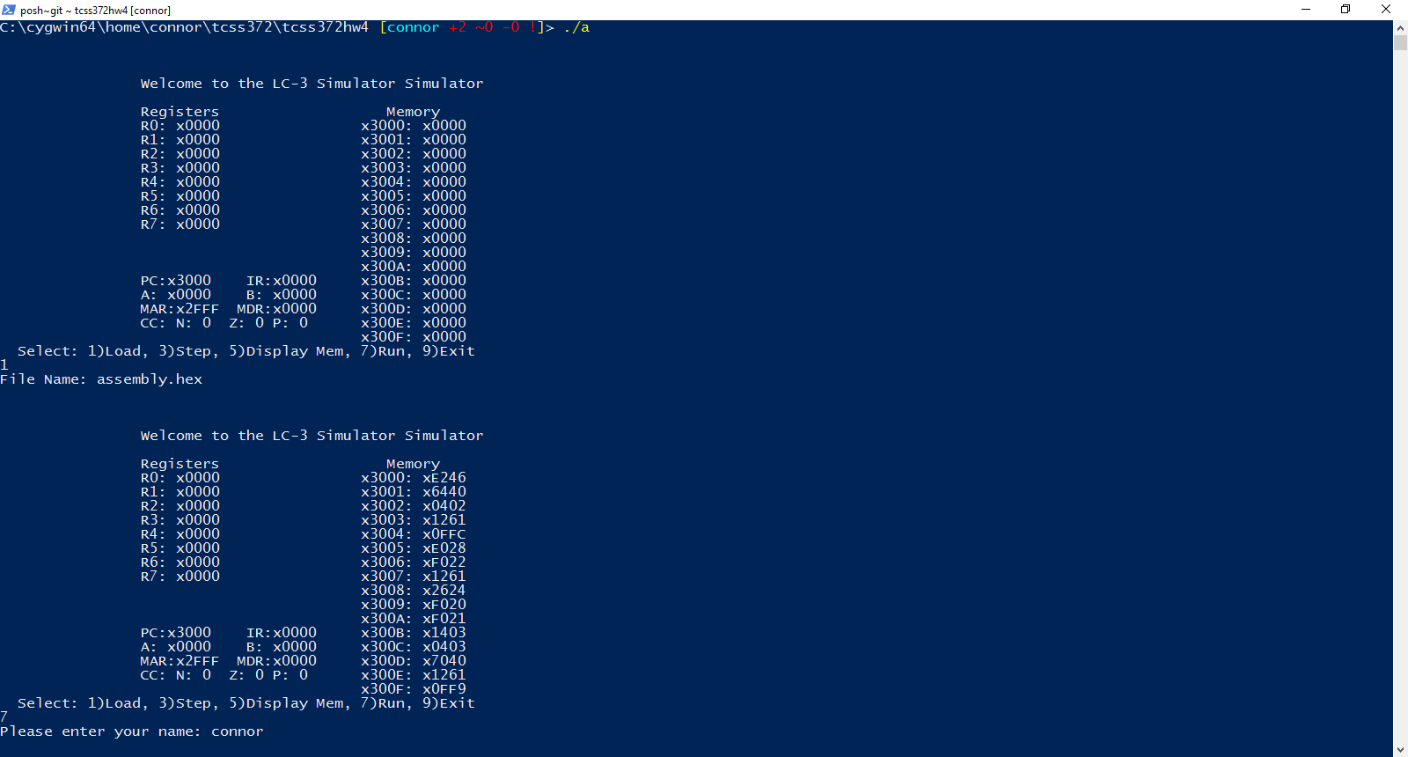

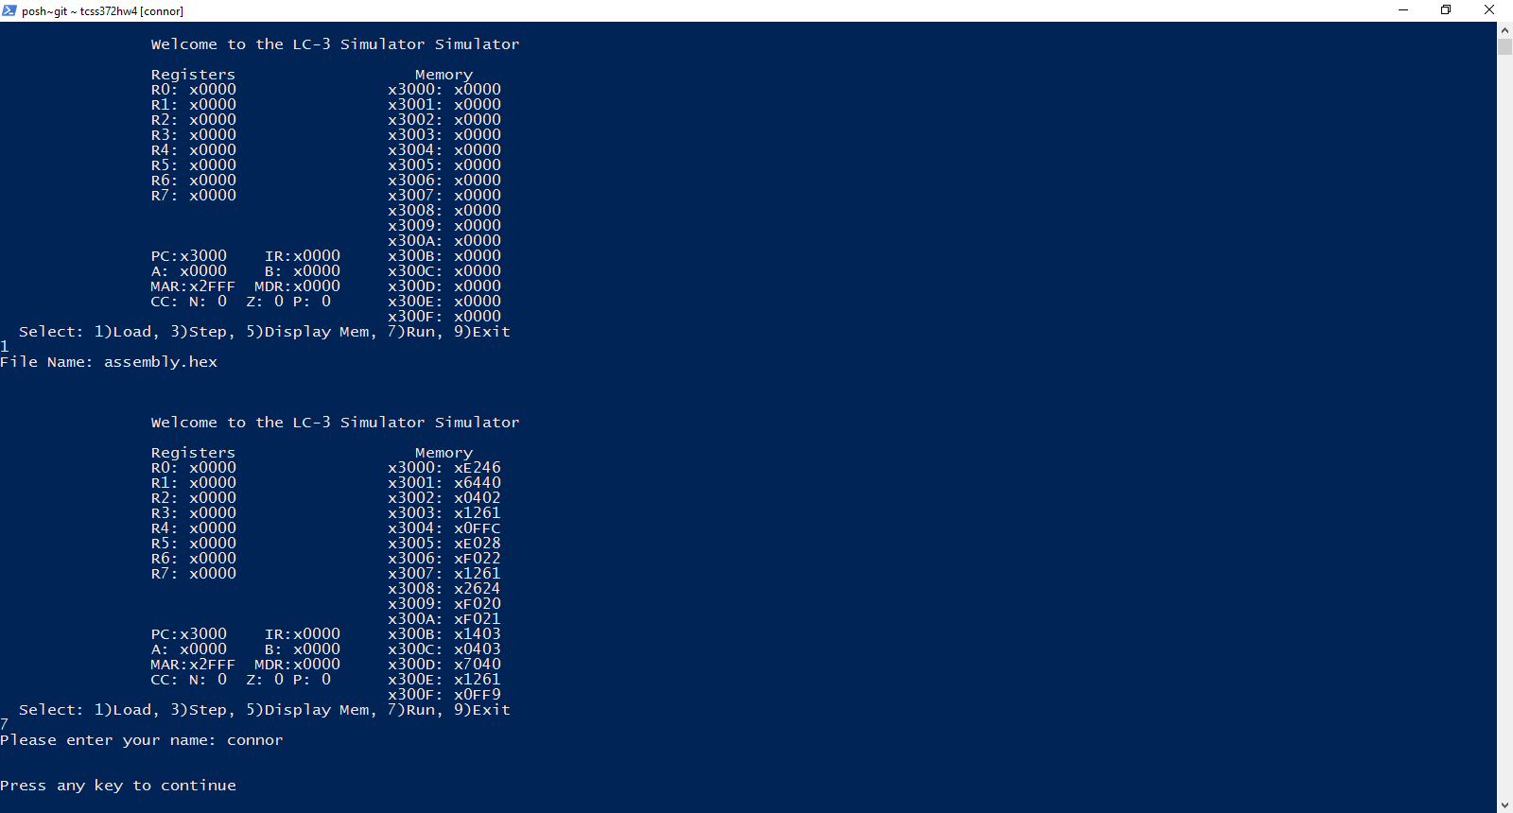

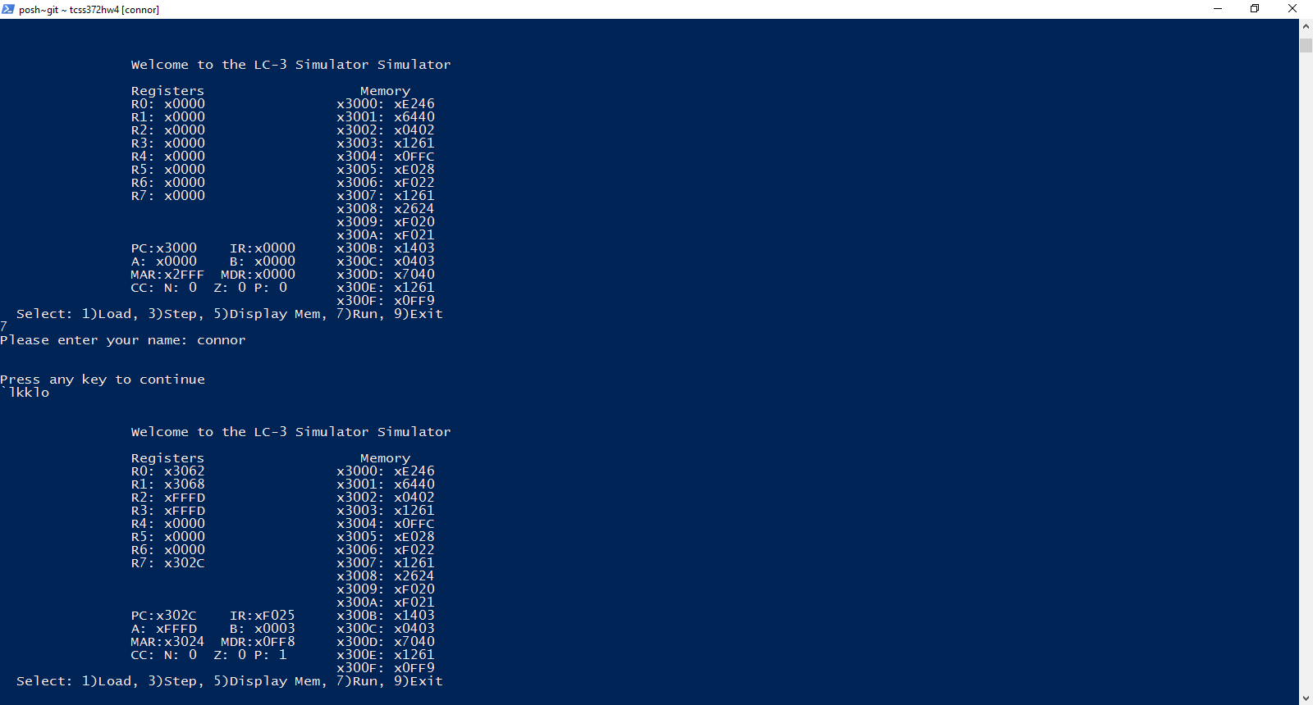

Step

For this I took a few screen shots showing the beginning of our program which will loop when it reaches x3004 to x3001.

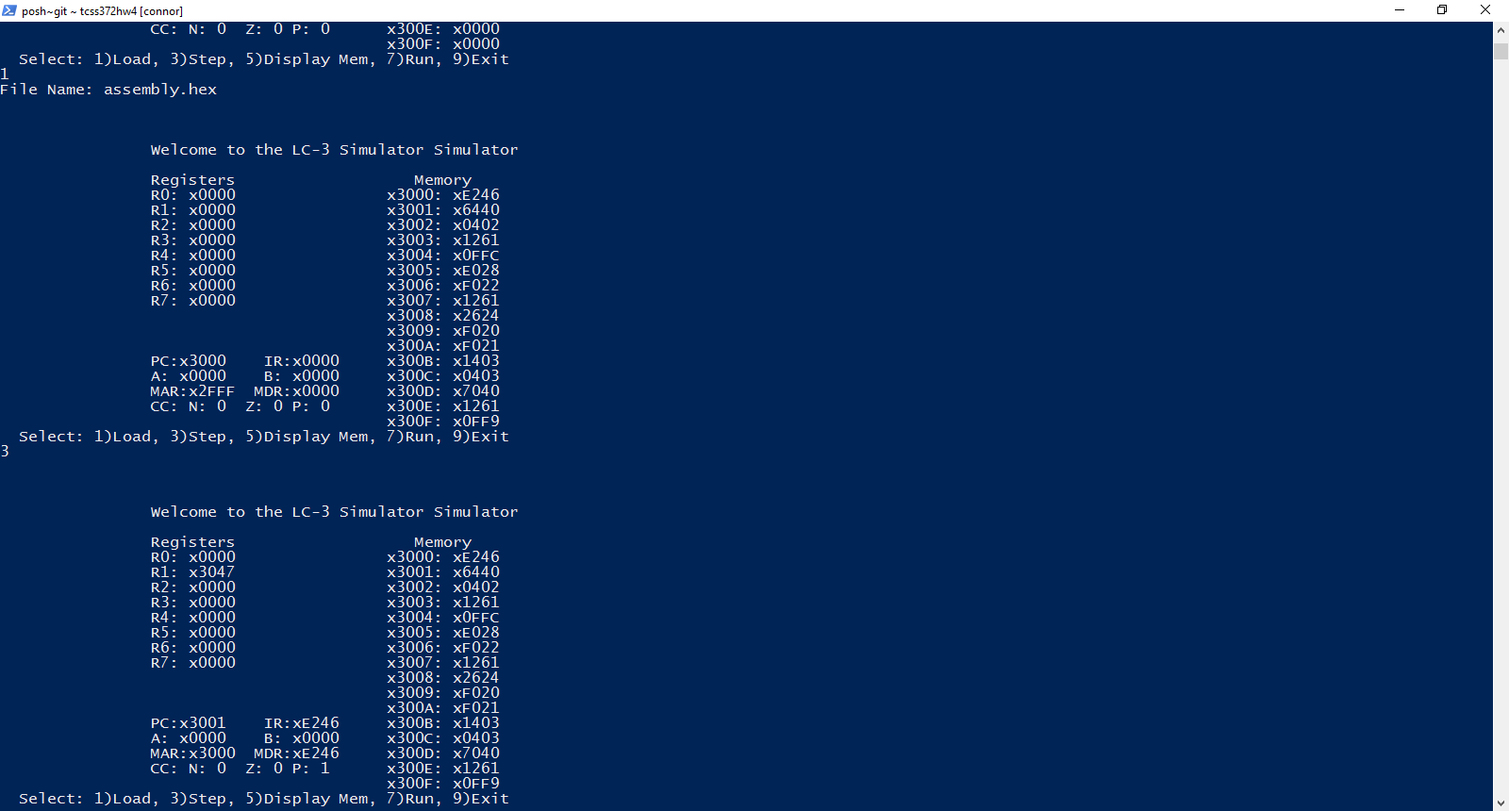

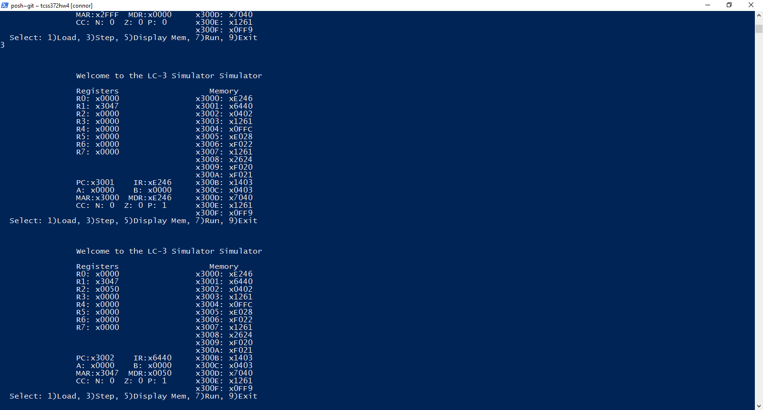

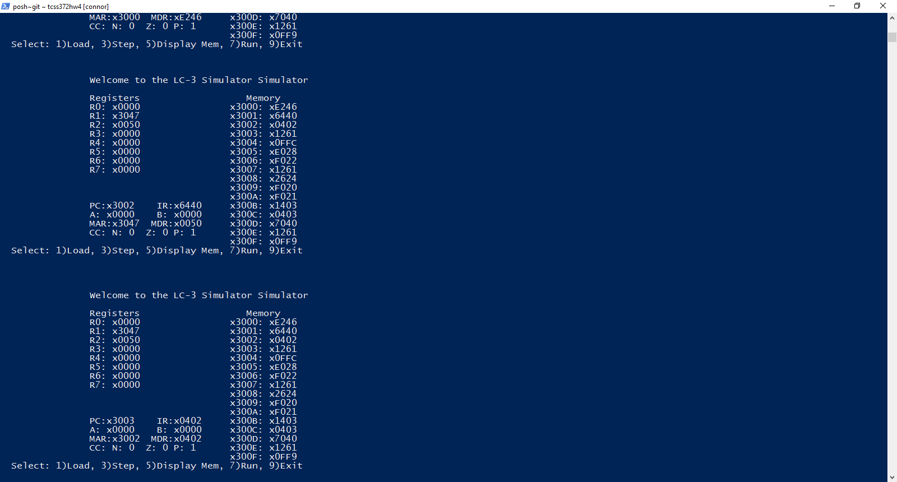

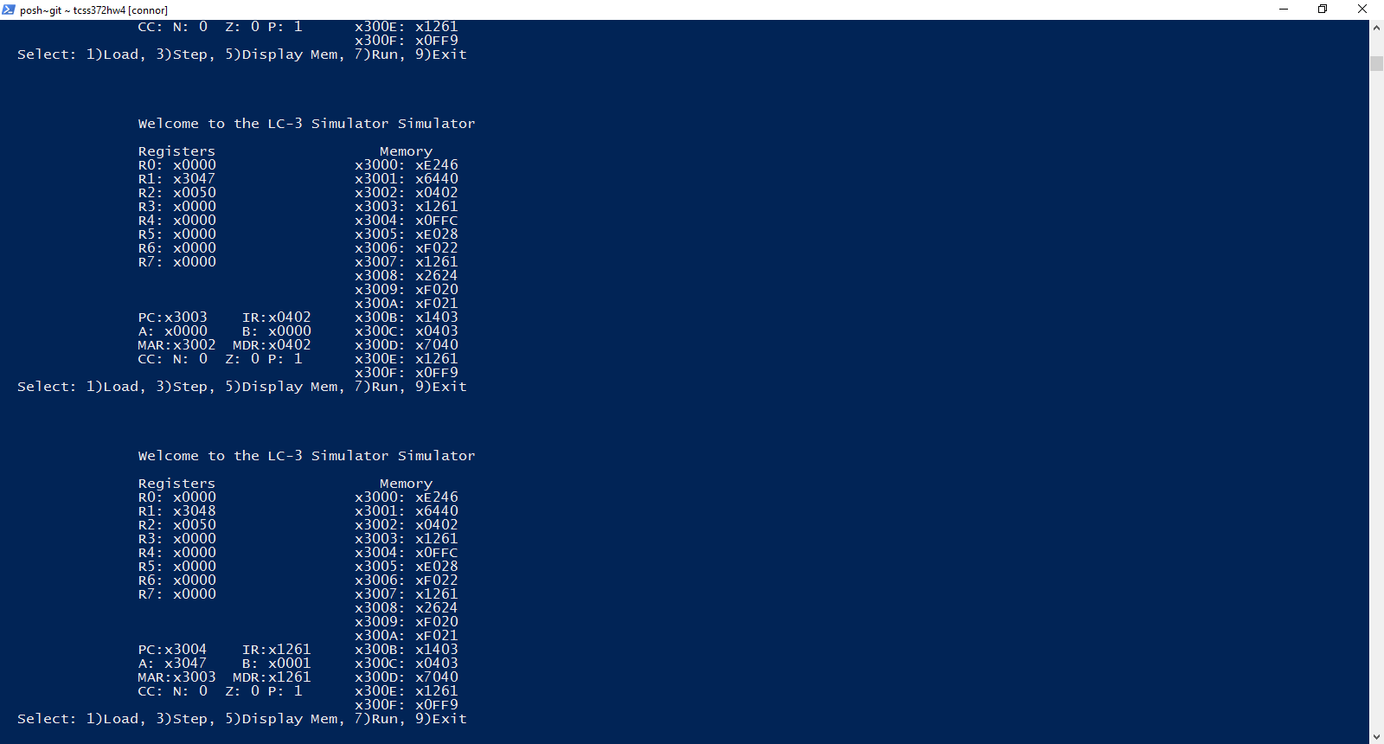

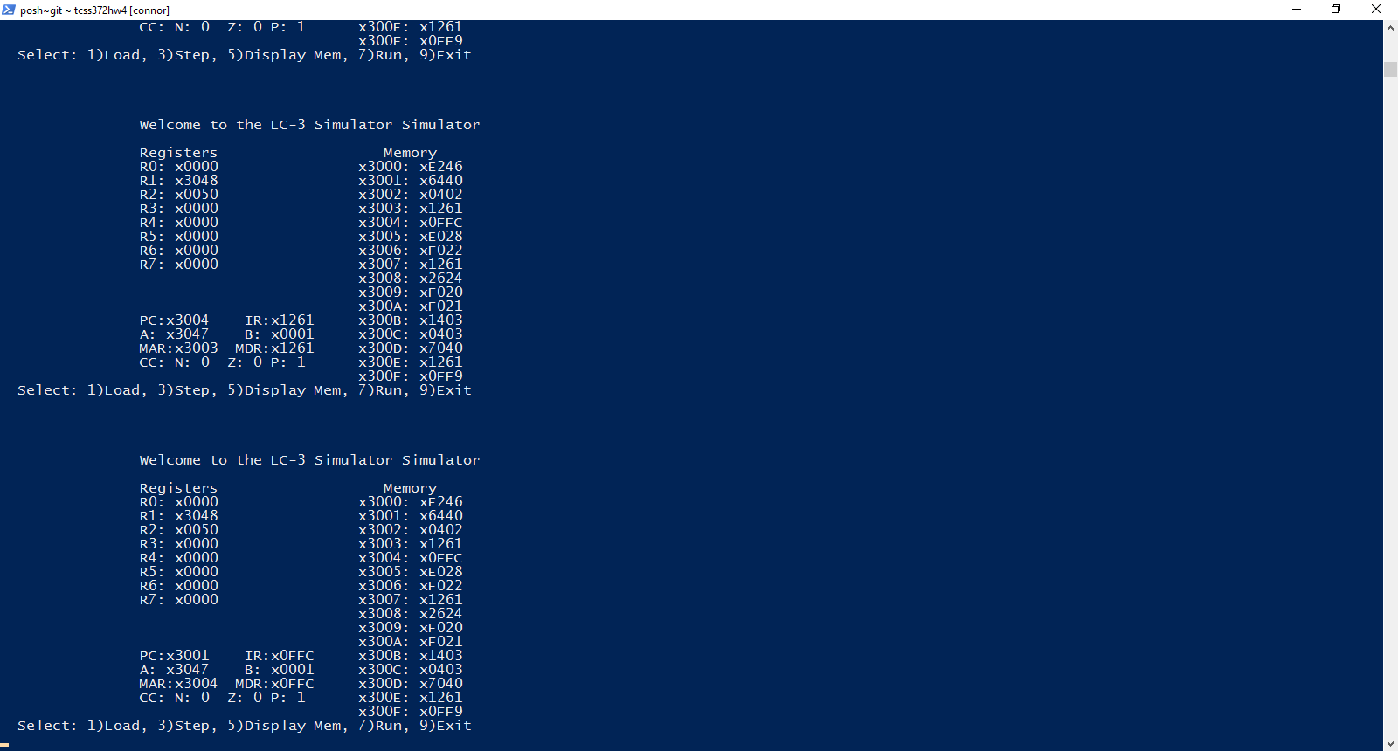

Exit

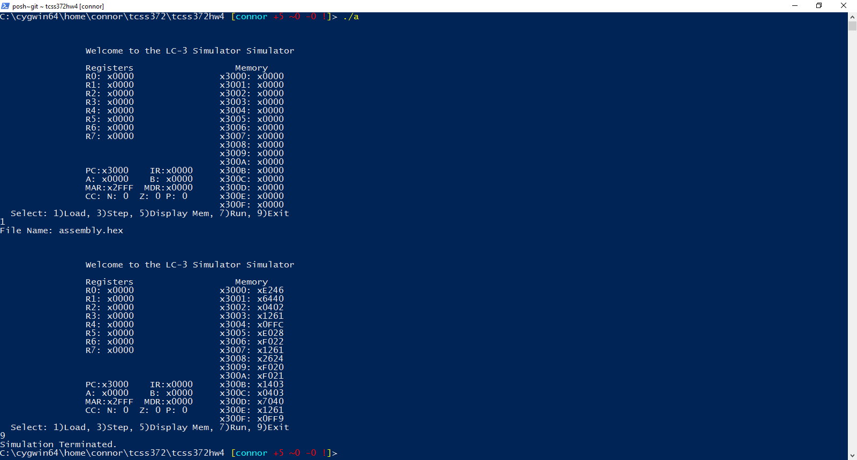

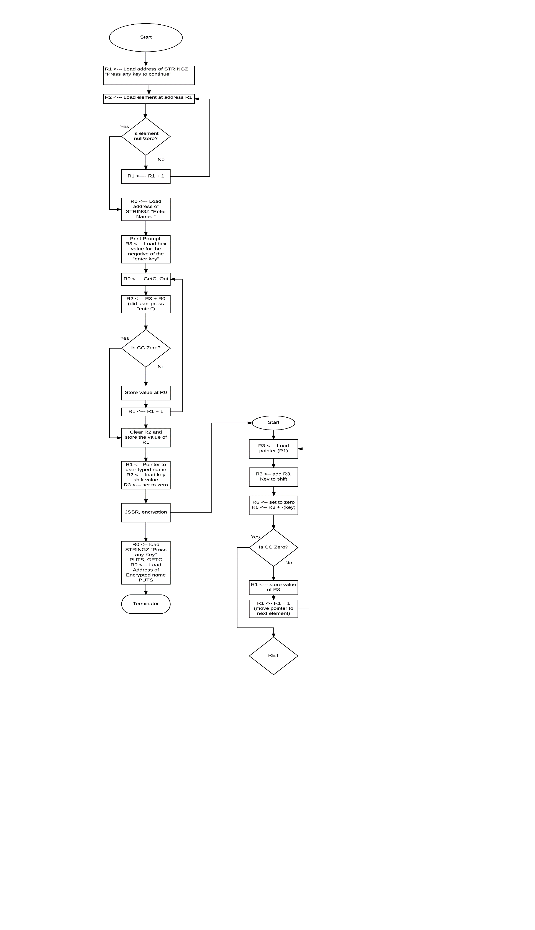Comparison in recoding:

Moving from Problem 3 to Problem 4, we realized we had a few key problems during early testing. At first, we were using my (Connor) code from Problem 3, but we soon realized the JMP and BR were not working correctly. Rather than go through and debug, we both agreed to use Daniel’s Problem 3. It took me (Connor) some time to understand how they were doing things (as I was updating the C while Daniel was making the Assembly program) but we were able to get it all working. For them, the biggest issue with their Problem 3 was their LD and ST, but that was a simple fix of the position in memory it was being used in. Besides that though, the only differences are those that were asked for this assignment. We also implemented an LDR and STR to get our program to work.

For the Diagram to the Left, it might be hard to see, but I used a high dpi, so you can easily zoom in and retain most of the detail.