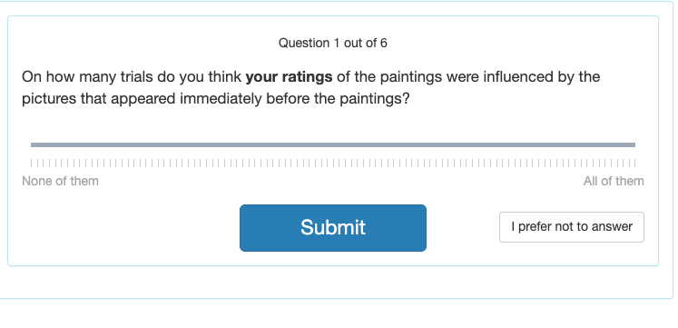
On how many trials do you think the other participant’s ratings of the paintings were influenced by the pictures that appeared immediately before the paintings?
slider
What strategy or strategies did you use to decide whether your own rating of the painting was influenced by the picture that appeared immediately before it?
[open ended]
What strategy or strategies did you use to decide whether the other participant’s rating of the painting was influenced by the picture that appeared immediately before it?
[open ended]

Did the strategy that you used for yourself and for the other participant differ from each other, or were they similar? How did they differ, or how were they similar to each other?
[open ended]
Is there anything else that you would like to tell us about your experience during this study?
[open ended]

You have completed the study!
When you click 'Continue', you will be debriefed on what the study was about.
You will also see the results of the Affect Misattribution Procedure (AMP) that you took.

Thank you for your participation. Our research depends on volunteers like you and we appreciate you spending time and effort on this experiment.
Your results for the Affect Misattribution Procedure (AMP) that you took are reported below:
After positive primes (real-life pictures), 0 of your responses were pleasant and 17 of your responses were unpleasant.
After negative primes (real-life pictures), 0 of your responses were pleasant and 17 of your responses were unpleasant.
Disclaimer
These results are not a definitive assessment of your implicit preference. The results may be influenced by variables related to the test (e.g., items used on the AMP) or the person (e.g., how tired you are). The results are provided for educational purposes only. Any single AMP is unlikely to predict behavior well for a specific individual. In the aggregate, the AMP can predict behavior such as discrimination in hiring and promotion, medical treatment, and decisions related to criminal justice.
1. What was this study about?
This study was concerned with how the implicit measure that you took, the Affect Misattribution Procedure (AMP), works. Specifically, we wanted to know whether people can become aware of the influence of the prime (the first, real-life image) on evaluations of the targets (the abstract paintings).
2. How was the study conducted?
In today’s study, you were asked to complete a modified Affect Misattribution Procedure (AMP). On the AMP, you judged computer-generated paintings while trying to ignore the items (clearly positive and clearly negative real-life images) that appeared before each painting. Research in the laboratory finds that it is difficult to ignore the distracting items and that they may influence judgments of the paintings. Specifically, if a person has a positive implicit attitude toward an object (e.g., a smiling baby or a pile of maggots), that person would rate the painting as pleasant more often than after an object that the person does not have positive implicit attitudes toward.
If you rated the paintings as pleasant more often after positive images than after negative images, then you would be said to have an implicit preference for positive over negative images. However, please keep in mind that this method for measuring implicit attitudes is still being actively researched. Therefore, your result is provided for educational purposes only.
3. What was the hypothesis?
Based on previous research we expected that participants would rate the abstract paintings as pleasant more often after positive than after negative primes. Moreover, we also expected that they would indicate that they were influenced by the primes more often when the prime and the response were congruent (e.g., a pleasant rating after a positive prime image) than when they were incongruent (e.g., an unpleasant rating after a positive prime image).
To be able to see what strategy participants use to make these decisions, you were also asked to make the same judgment for a past participant. We hypothesized that participants would follow a similar strategy here as for themselves: namely, they would compare the response (pleasant vs. unpleasant) and the type of prime (positive vs. negative). If participants are able to make these judgments in the same way for someone else as they are for themselves, this would indicate that the judgments are not based on so-called introspective awareness (i.e., knowing what’s going on in our own minds) but rather on a mental state inference (i.e., trying to use observations in the world to figure out what’s going on in other people’s minds).
4. Why is this study important?
This project is important because it explores the way in which one of the most widely used implicit measures works. It is important for us to understand these processes because without valid measures, we cannot arrive at valid conclusions about implicit bias.
5. References:
Mann, T. C., Cone, J., Heggeseth, B. & Ferguson, M. J. (2019). Updating implicit impressions: New evidence on intentionality and the affect misattribution procedure. Journal of Personality and Social Psychology, 116(3), 349–374. https://doi.org/10.1037/pspa0000146
Payne, B. K., Cheng, C. M., Govorun, O. & Stewart, B. D. (2005). An inkblot for attitudes: Affect misattribution as implicit measurement. Journal of Personality and Social Psychology, 89(3), 277–293. https://doi.org/10.1037/0022-3514.89.3.277
6. How to contact the researcher:
If you have unanswered questions about the task, please review background information on the IAT. If you have questions or concerns about your participation or payment, or want to request a summary of research findings, please contact the researcher: Benedek Kurdi, at benedek.kurdi@yale.edu. If you have general questions about the IAT, please check out the Frequently Asked Questions (FAQ) page.
7. Whom to contact about your rights as a participant in this research:
If you have questions about your rights as a research participant, or you have complaints about this research, you may call the Yale Institutional Review Boards at (203) 785-4688 or email hrpp@yale.edu.

