Computer Graphics ClassAssignment1-2022
2016026608 Kang Minji

- Which requirements I implemented.
- I manipulated the camera with mouse movement.
- The camera of my program initially looks at the target point (0, 0, 0).
- Orbit. The camera rotates around the target point by changing azimuth / elevation angles with the left button & drag.
- Pan. The camera and the target point move in left, right, up and down direction by translating both along u, v axis of the camera frame with the right button & drag.
- Zoom. The camera moves forward and backward by translating the camera along w axis of the camera frame with mouse wheel.
- The projection can be toggled between perspective projection(default) and orthogonal projection by pressing ‘v’ key.
- I drew a rectangular grid with lines on xz plane.

- A few screenshot images of my program. (A cubic is drawn for an effective explanation)
- initial state : origin target point, perspective projection
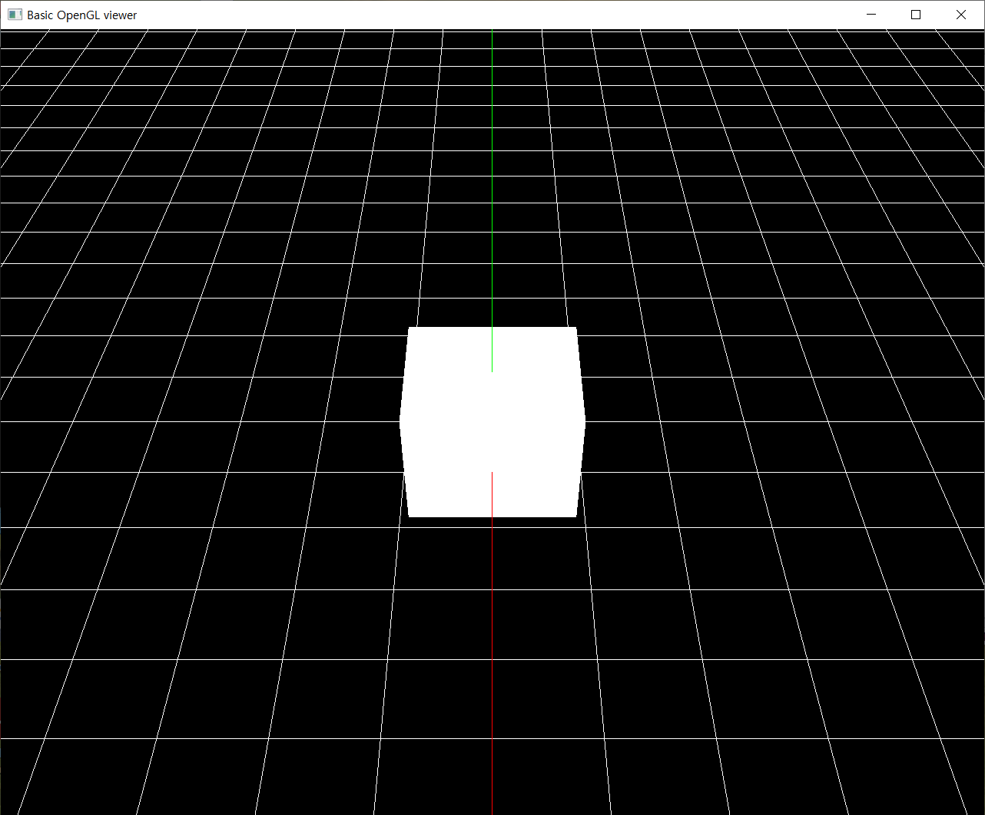
- orbit in perspective projection and orthogonal projection. (toggled by ‘v’)
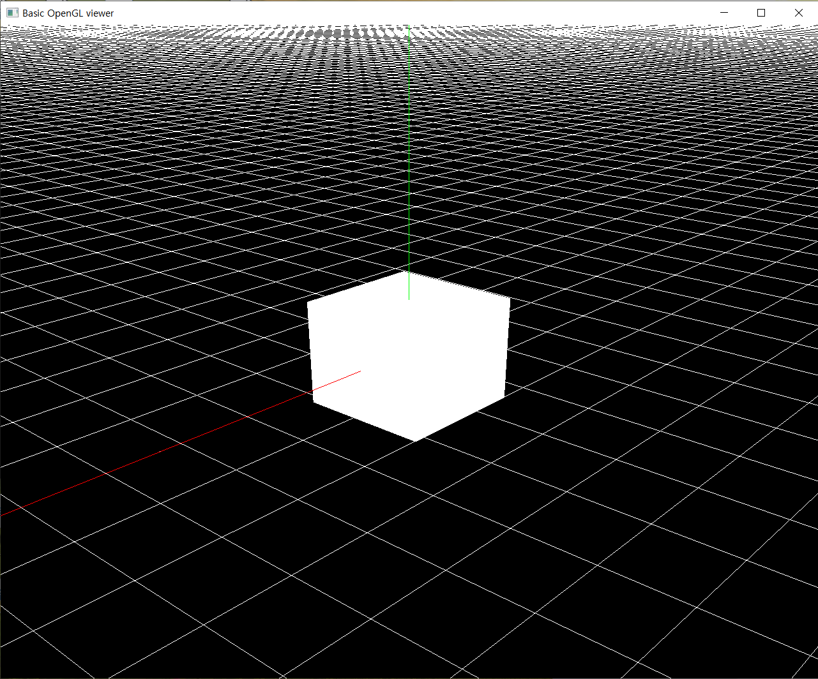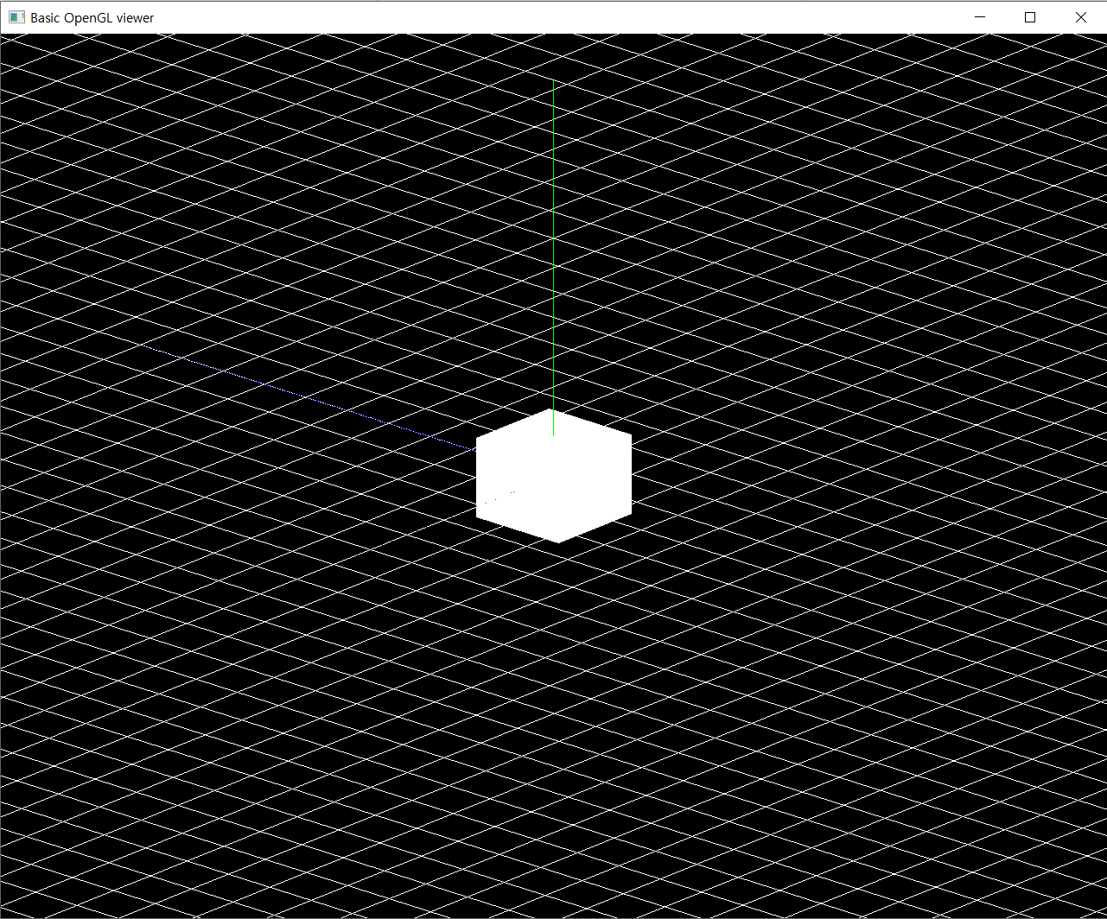
- pan in perspective projection and orthogonal projection. (toggled by ‘v’)
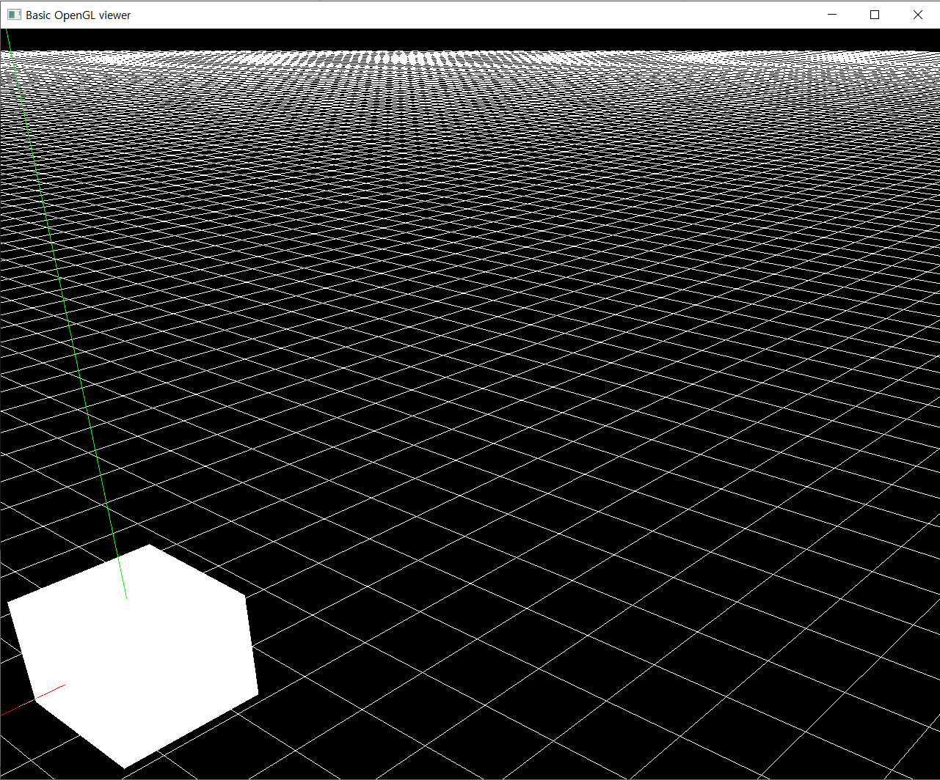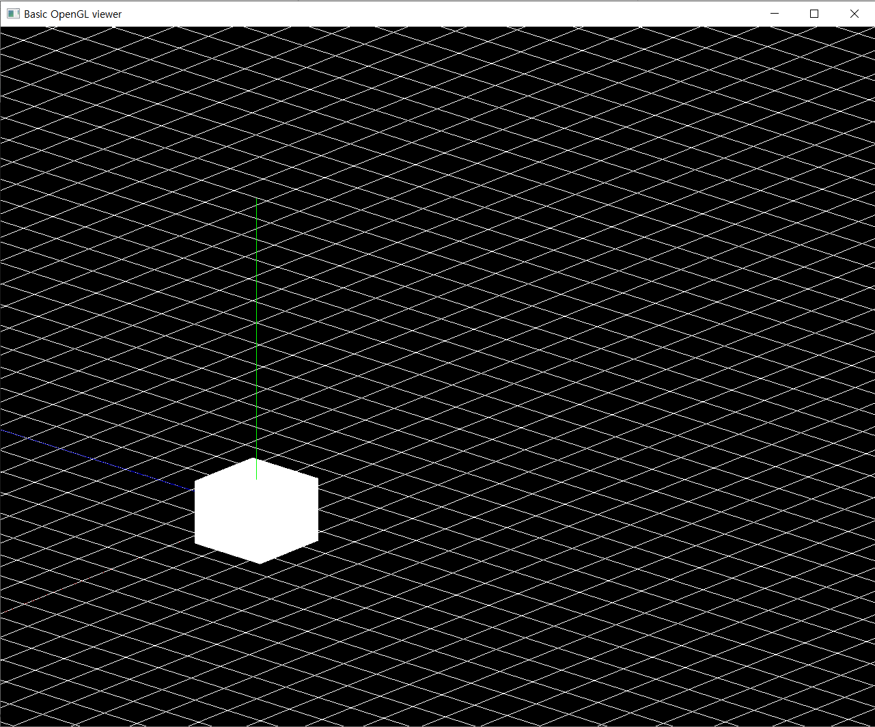
- zoom in perspective projection and orthogonal projection. (toggled by ‘v’)
- 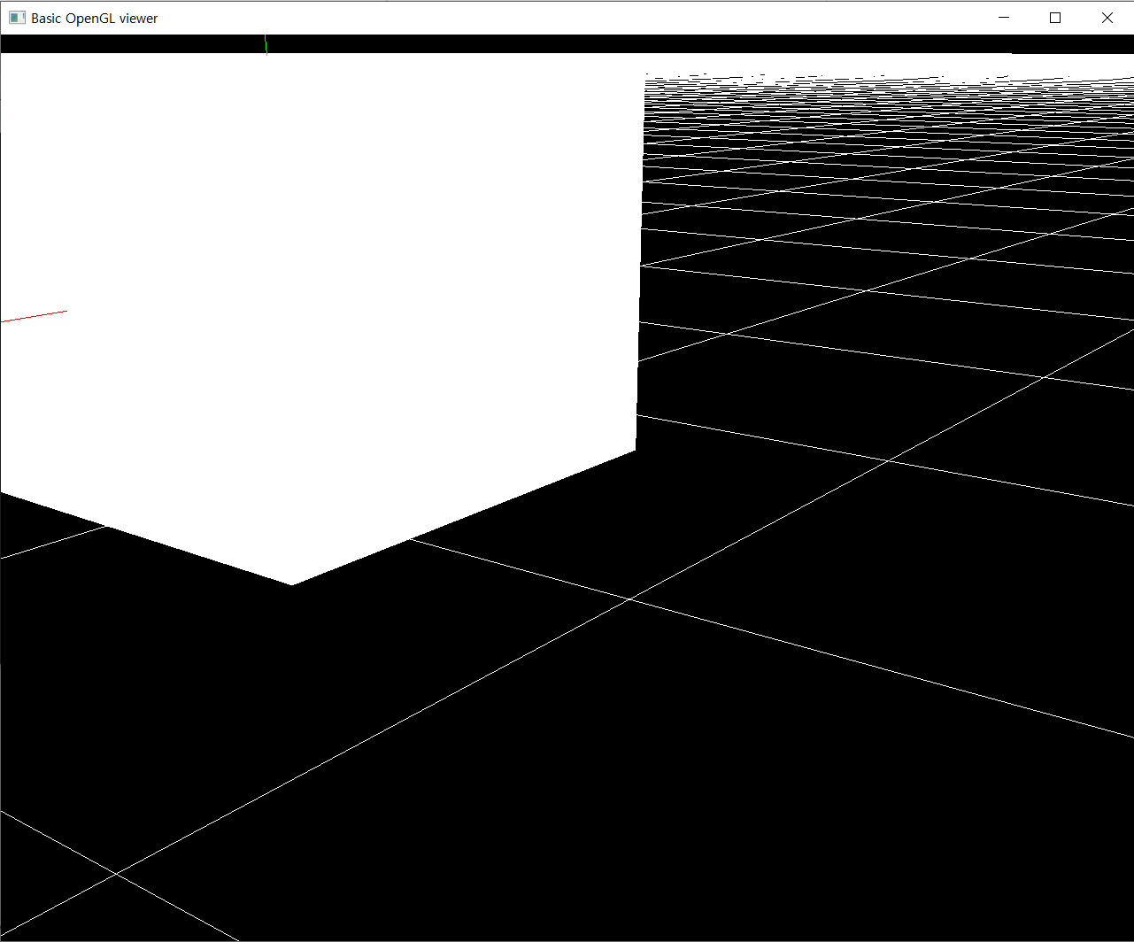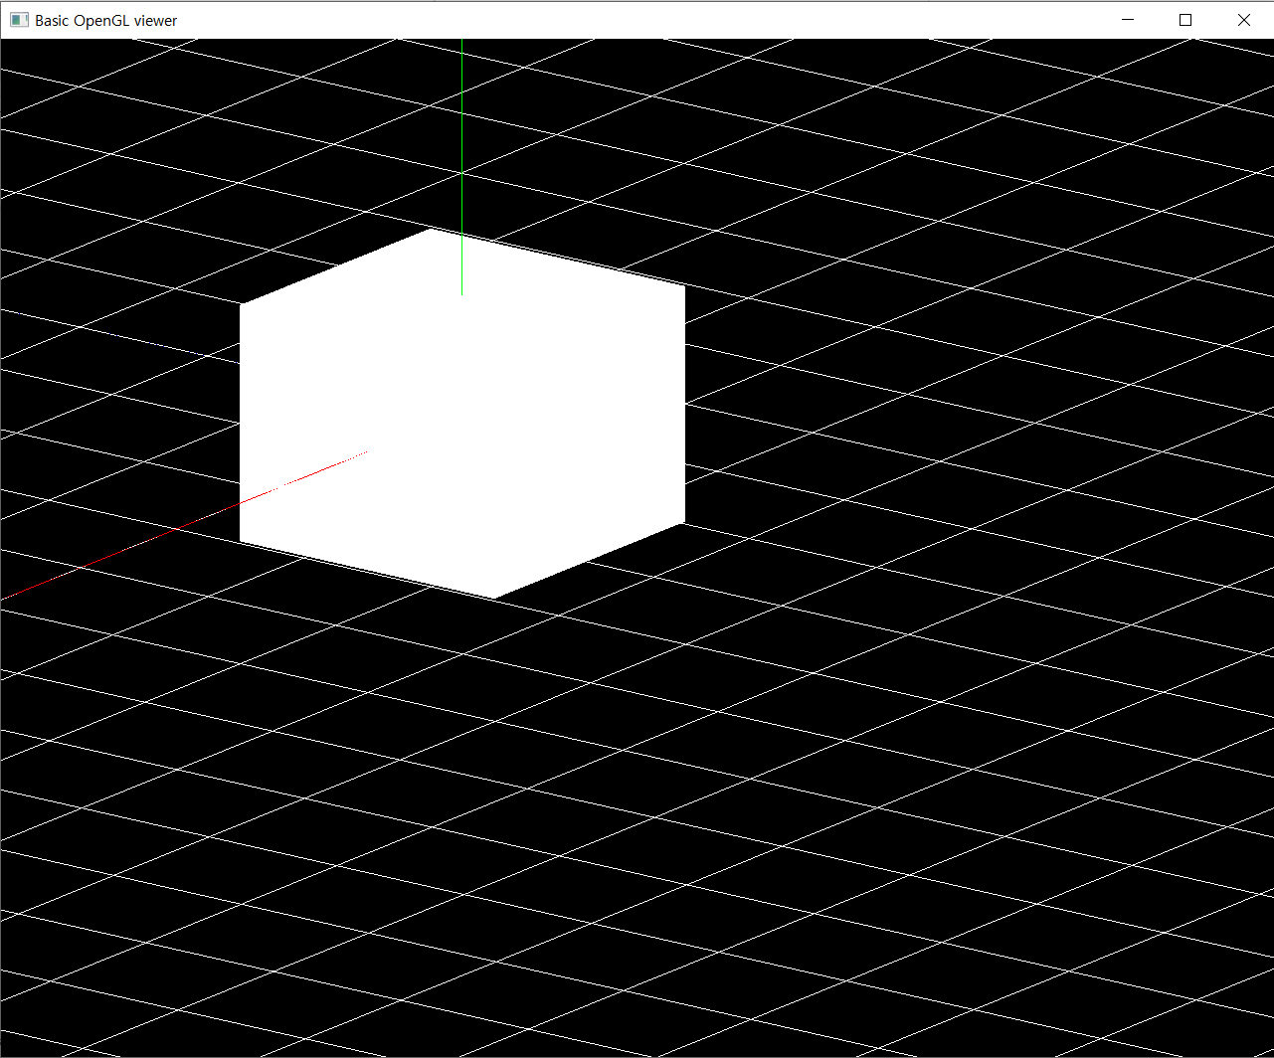

** I used two .py files for this assignment. One is the <camera.py> file which is Camera class file and the other is <main.py> file which contains callback, render and main function. You can import camera class in your main file by using ‘from camera import Camera’.

