CHAPTER 7
Homework 2
Zida Wu

A Deformation of the rod from t=0s to t=5s
- Position vs. time
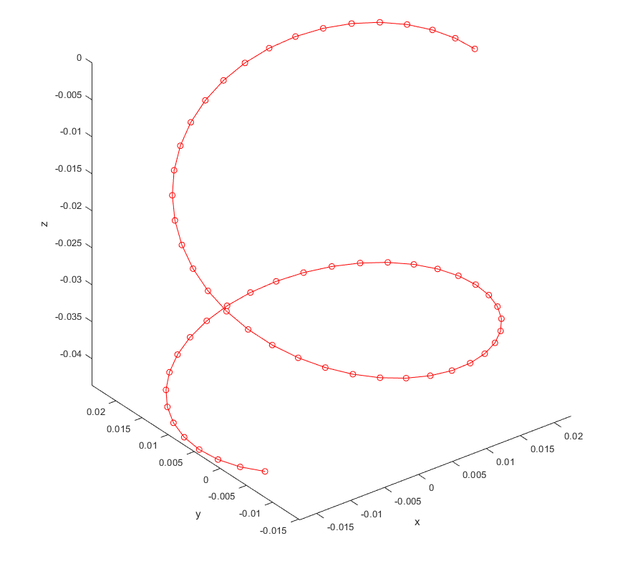
- Position vs. time
- Z-coordinate vs. time
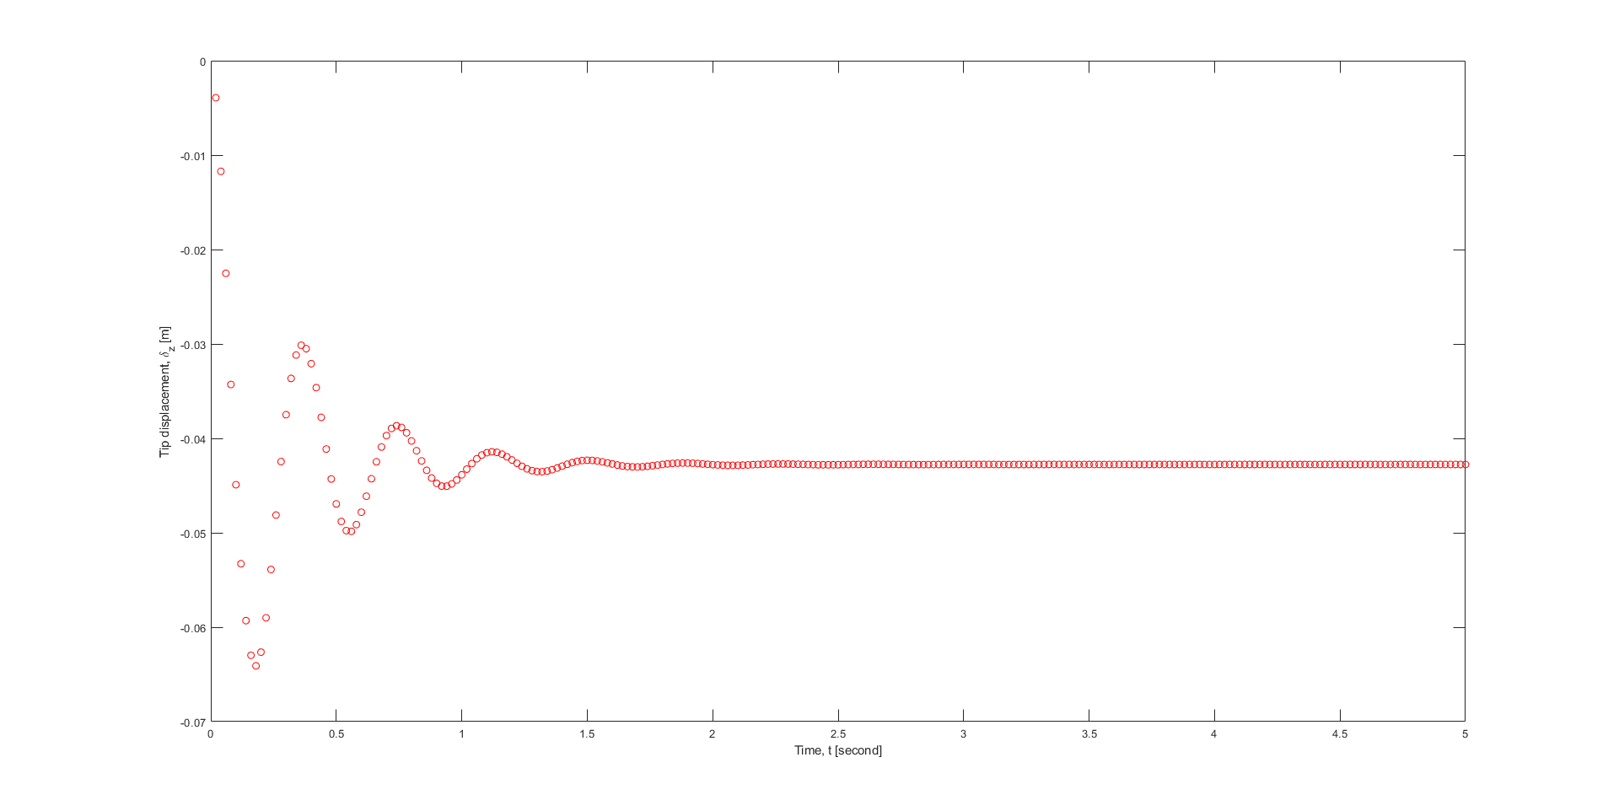
- Z-coordinate vs. time

 

