SUMMER INTERNSHIP REPORT
Department of Computer Application, JIIT Noida

Title of the project: MovieMate (Movie Recommender System)


Name of the Student: Bhavya Goyal
Enrollment Number: 23517045
Submitted to: Ms.Neetu Singh

BCA – 2nd Year
4-Credit Internship
Duration: June 9 – July 5, 2025
Declaration
I hereby declare that the Summer Internship Report titled “MovieMate – Movie Recommender System” is the result of my own work carried out during the internship period from June 9 to July 5, 2025, under the guidance of Ms. Neetu Singh.
This report has been prepared solely for academic purposes and has not been submitted elsewhere for any other evaluation or credit.
Name of Student: Bhavya Goyal
Signature:
Date:

Certificate
This is to certify that Bhavya Goyal, Roll No. 23517045, has successfully completed the Summer Internship Project titled "MovieMate -Movie Recommender System" during the period June 9 – July 5, 2025, under my supervision.
Jaypee Institute of Information Technology
Mentor’s Name: Ms. Neetu Singh
Designation: Internship Mentor
Department: Computer Applications
Signature:

Acknowledgement

I sincerely thank my faculty and industry mentor, Ms. Neetu Singh, from the Department of Computer Applications, JIIT Noida, for her constant support, guidance, and encouragement throughout this internship. Her insights and feedback were invaluable to the successful completion of this project.
I am also grateful to my peers for their help and collaboration, and to the online open-source communities and learning platforms that provided helpful resources and tools during the development of this project.

Table of Contents

S. No. | Section Title | Page No.
1. | Introduction | 6
2. | Objectives of the Internship | 6
3. | Company / Problem Overview | 6
4. | Tools and Technologies Used | 6
5. | Weekly Progress Summary | 7
6. | System Design / Workflow | 7-8
7. | Implementation Details | 8
8. | Screenshots / Code Snapshots / Output Samples | 8-20
9. | Challenges Faced and Solutions | 21
10. | Key Learnings | 21
11. | Conclusion | 21
12. | References | 22

Introduction
In the era of digital streaming platforms, users are constantly overwhelmed with choices of movies and web series. Deciding what to watch next can often take longer than the actual viewing experience. Recommender systems solve this problem by predicting and suggesting items that align with user preferences.
Companies like Netflix, Amazon Prime Video, YouTube, and Spotify heavily rely on recommendation systems to personalize experiences. These systems improve user engagement, satisfaction, and platform revenue.
The MovieMate project developed during this internship focuses on designing a movie recommender system using IMDb data. The project covered various phases such as:
- Data Collection using web scraping.
- Data Cleaning & Exploratory Data Analysis (EDA).
- Building three models: Content-Based, Collaborative Filtering, and Hybrid Recommendation.
- Evaluating models using Accuracy, Precision, Recall, F1-score, NDCG, and MAP.
This project provided exposure to data science workflows—handling raw data, transforming it, training models, and analyzing performance.
Objectives of the Internship
- Data Collection:
To scrape IMDb Top 1000 movies dataset with attributes like title, genre, description, rating, revenue, votes, and metascore.
- Data Preprocessing & Cleaning:
Handling missing values, inconsistent genres, and preparing structured data.
- Exploratory Data Analysis (EDA):
Using visualization to identify trends (most popular genres, rating distributions, correlations).
- Model Development:
Content-Based Filtering: Using TF-IDF vectorization of descriptions and cosine similarity.
Collaborative Filtering: Based on ratings, votes, and metascore similarities.
Hybrid Model: Combining content-based and collaborative similarities.
- Evaluation Metrics:
Measuring performance using Accuracy, Precision, Recall, F1-score, NDCG, MAP.
- Skill Development:
Enhancing programming, debugging, project planning, and report writing skills.
Problem Overview
People watch movies on different platforms, but it's hard for them to find what they like. Movie recommendation systems solve this problem. They help suggest movies based on what a person liked before or based on the movie's content. In this project, I built such a system using IMDb’s top movies data. The entertainment industry faces the information overload problem—users cannot manually browse through thousands of titles. OTT platforms provide solutions via recommendation engines that analyze content and user activity.
For this project, the challenge was:
- No direct access to real user ratings.
- Need to simulate user preferences using IMDb data.
- Building models that can provide reliable movie suggestions even with limited data.
The MovieMate system attempts to solve this problem by:
- Using content similarity (descriptions & genres).
- Using simulated user preference thresholds (ratings ≥ 6.5).
- Combining both methods for better accuracy.

Tools and Technologies Used
- Python Programming Language
- Jupyter Notebook and VS Code
- Libraries: Pandas, NumPy, Matplotlib, Seaborn, Scikit-learn, BeautifulSoup
- Data Source: IMDb Movies

Weekly Progress Summary

Week | Dates | Work Done
1 | June 9–15 | Collected data using web scraping from IMDb
2 | June 16–21 | Cleaned the data and performed EDA
3 | June 23–29 | Built recommendation models (Content-Based, Collaborative, Hybrid)
4 | June 30–July 5 | Evaluated models like accuracy, precision, recall, f1- score and completed final report

System Design / Workflow / Architecture
Flowchart
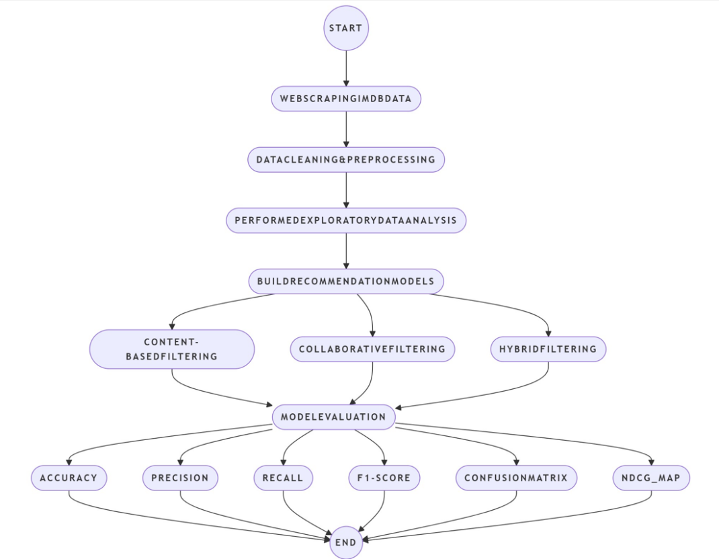
UML Diagram
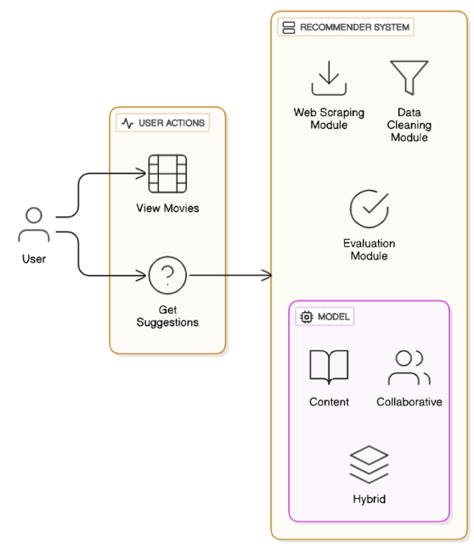

Implementation Details
- Dataset: Movies from IMDb (Title, Genre, Description, Rating, Votes, Revenue, Metascore)
- EDA: Plotted charts for genre, ratings, revenue, and feature correlations
- Models Used:
  - Content-Based Filtering: Used TF-IDF on movie descriptions + cosine similarity
  - Collaborative Filtering: Used similarity on features like rating, revenue, metascore
  - Hybrid Filtering: Combined content and collaborative similarity scores
- Recommendation Function: Given a movie, the function returns similar movies
Screenshots /Code Snapshots/Output Samples
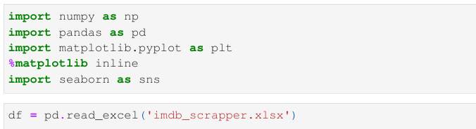
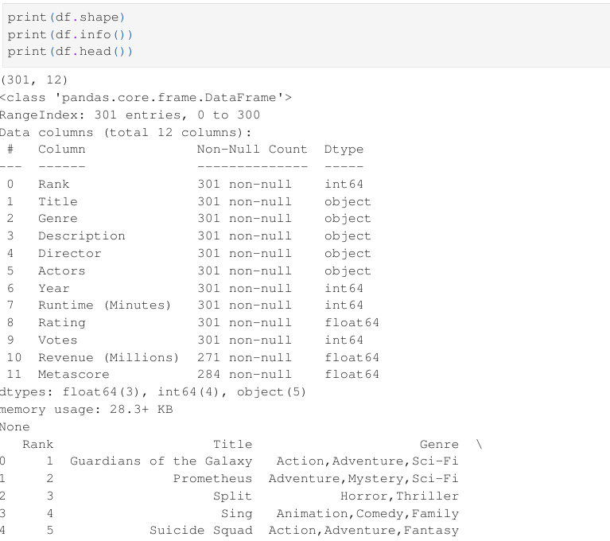
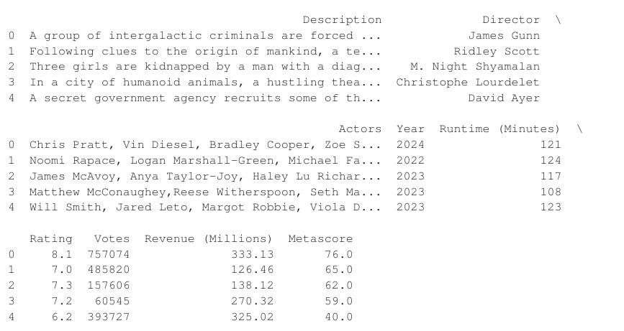
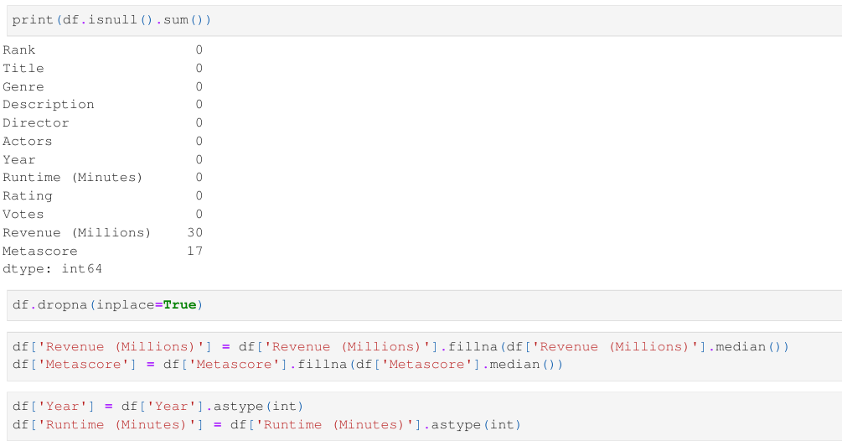

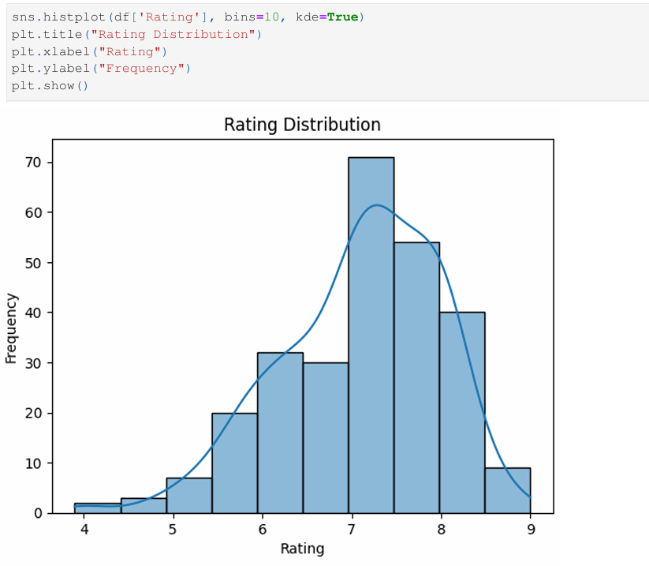
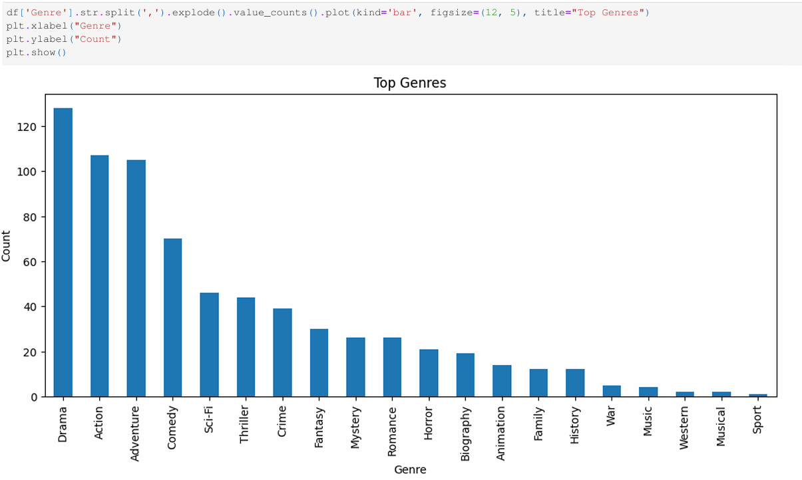

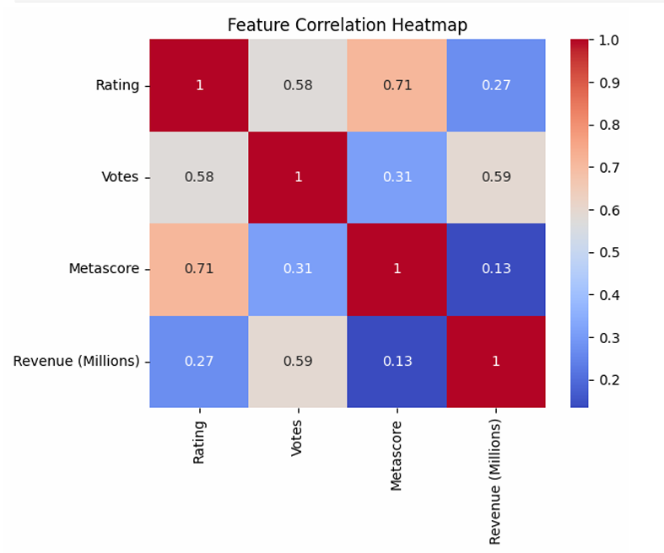

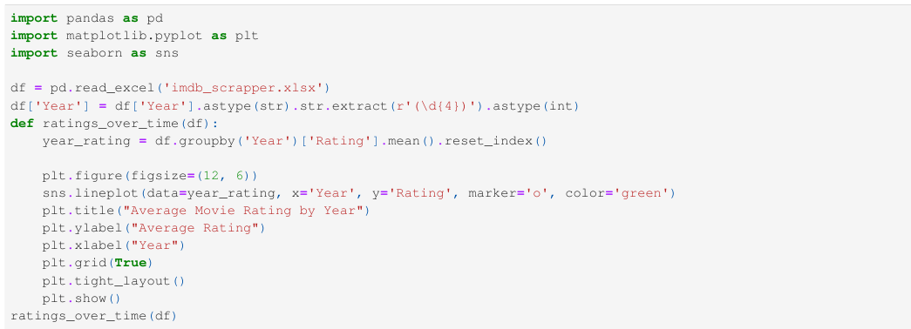
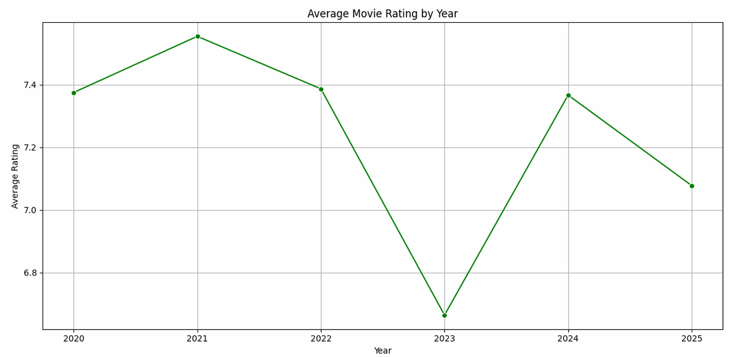

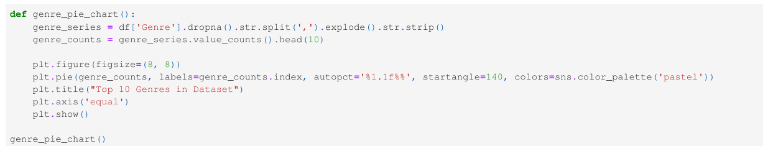
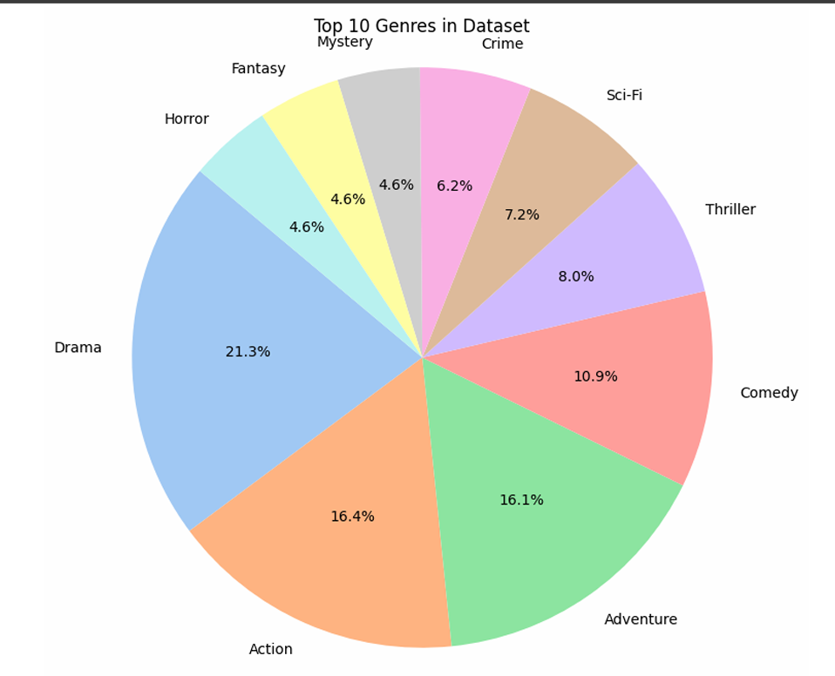
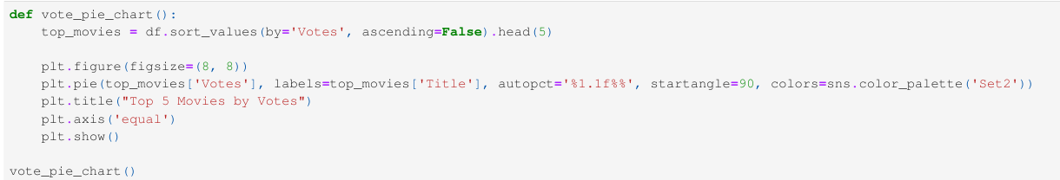
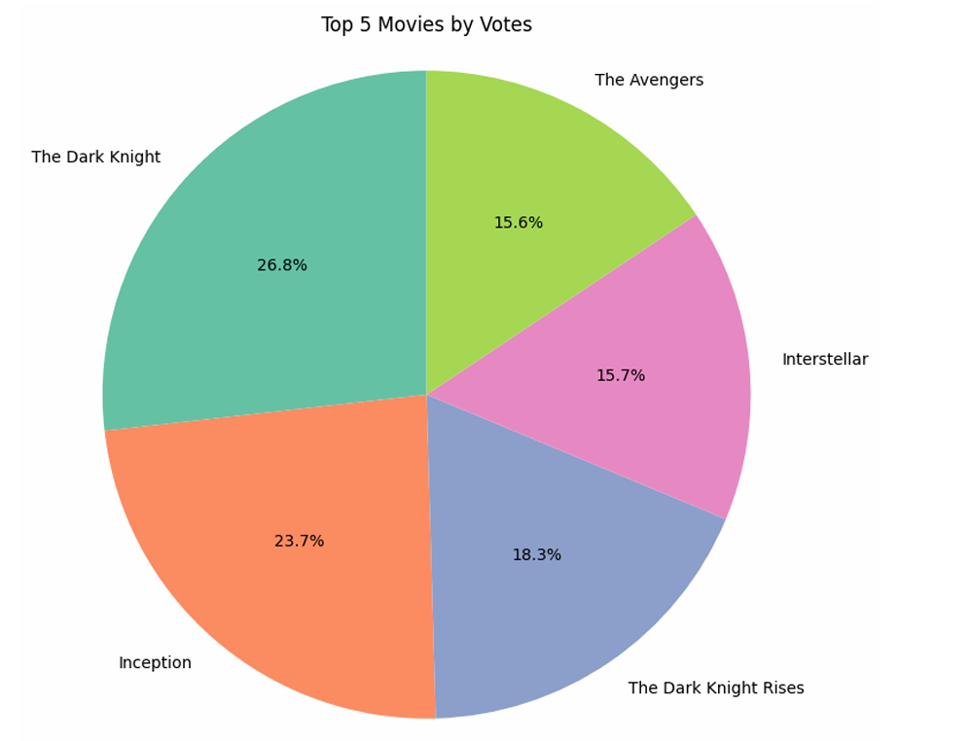
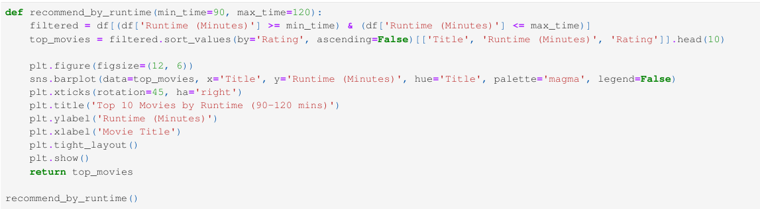
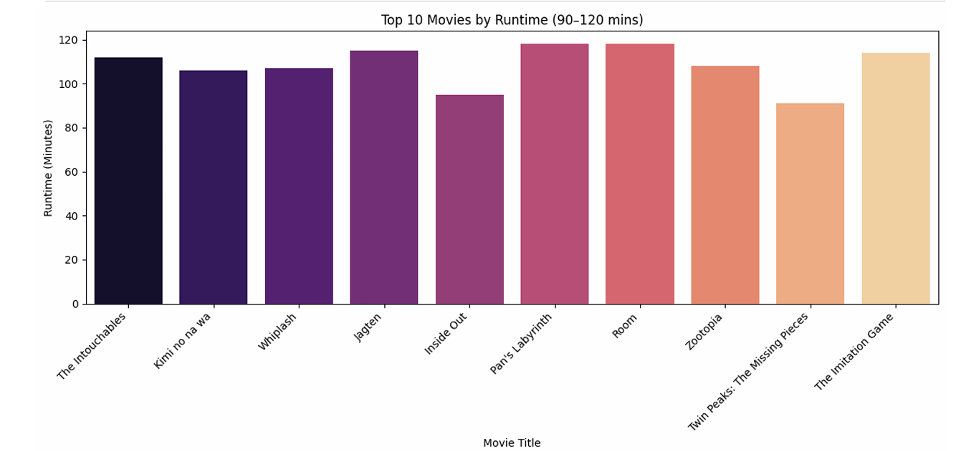
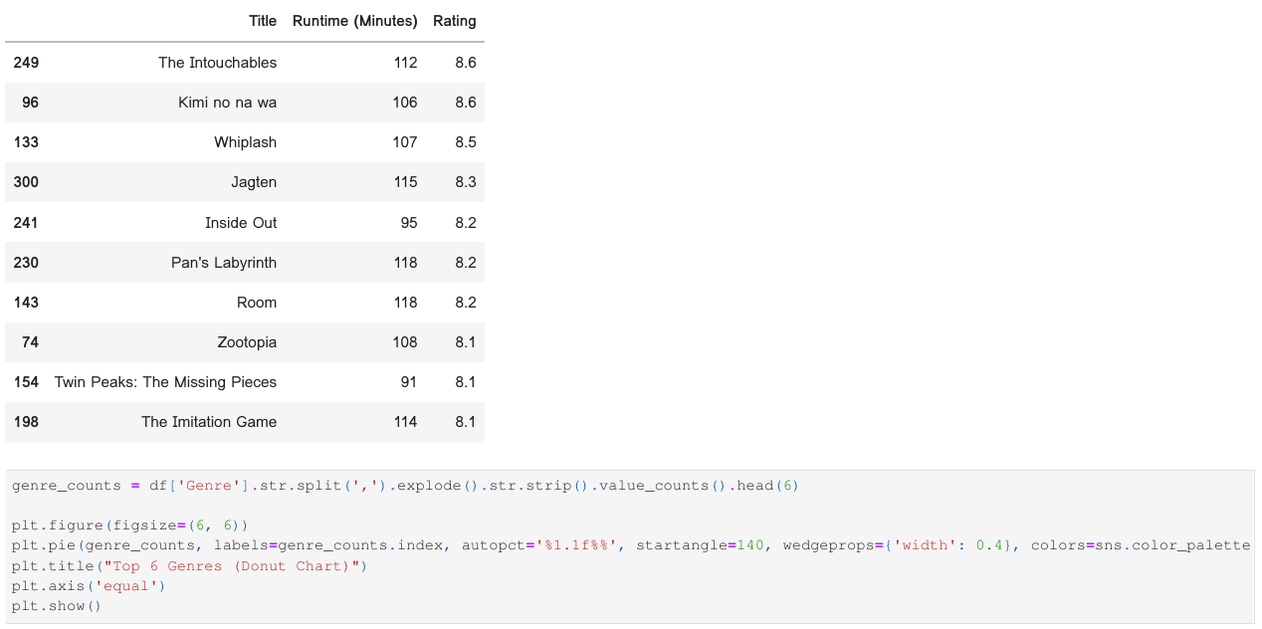

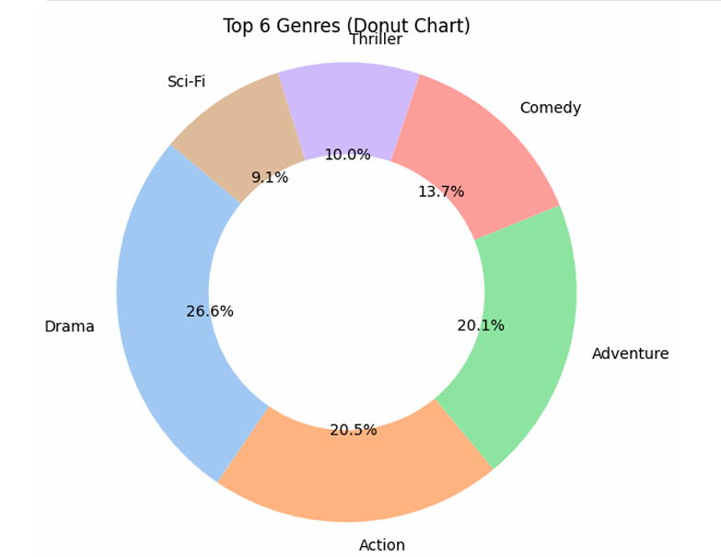
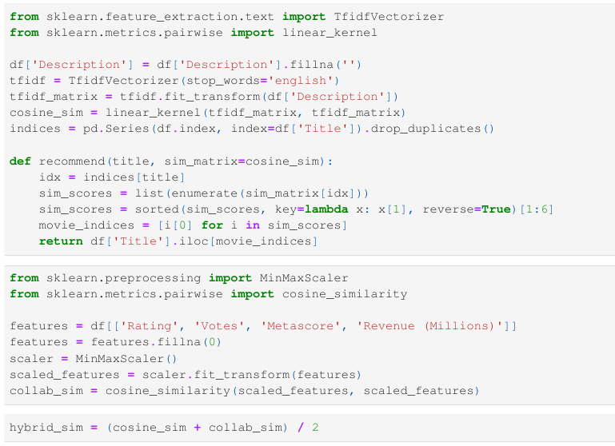
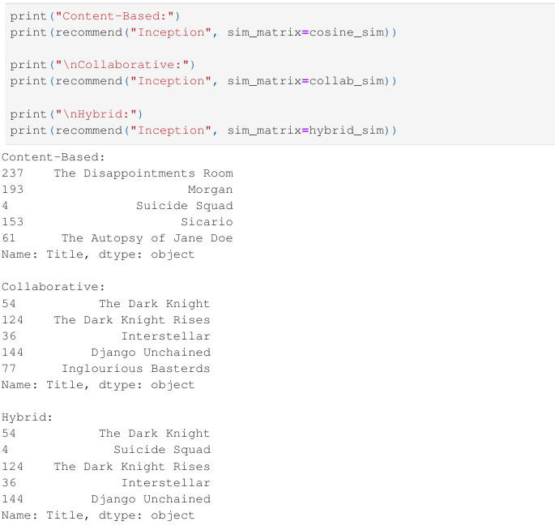
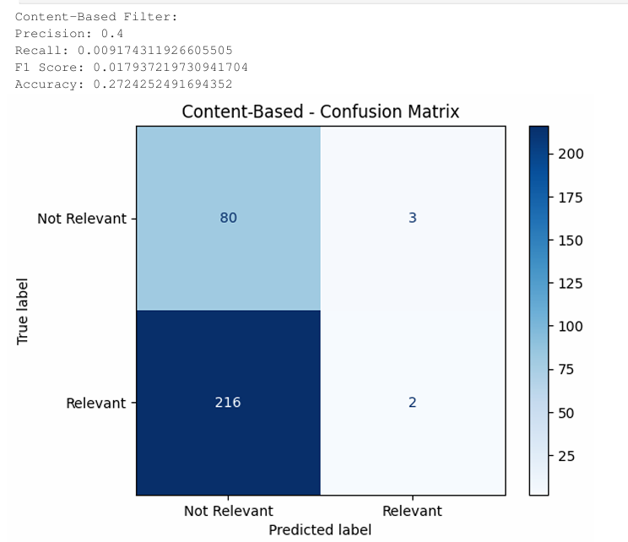
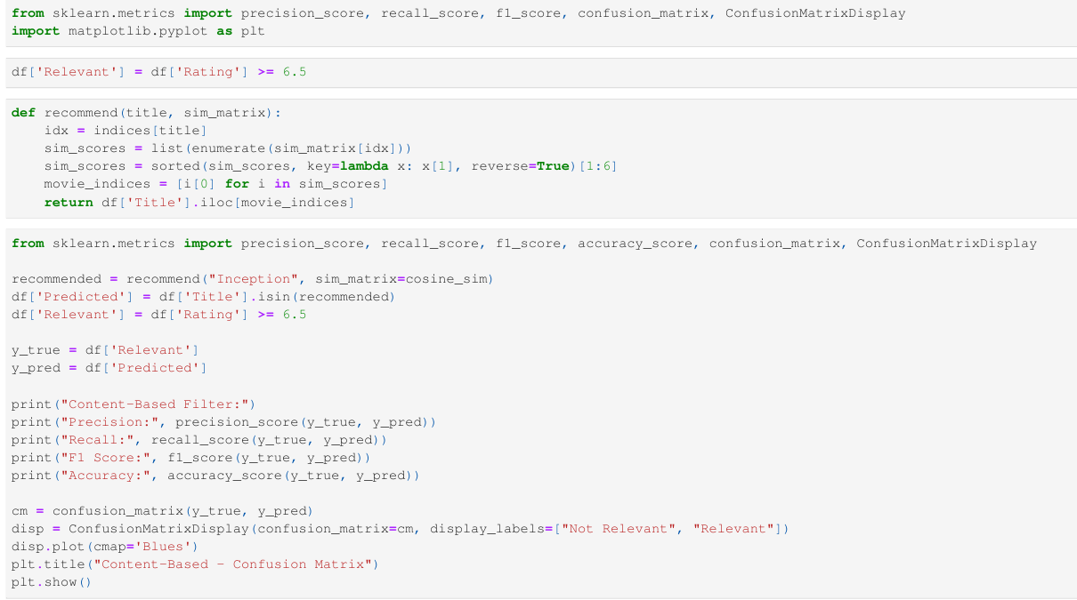
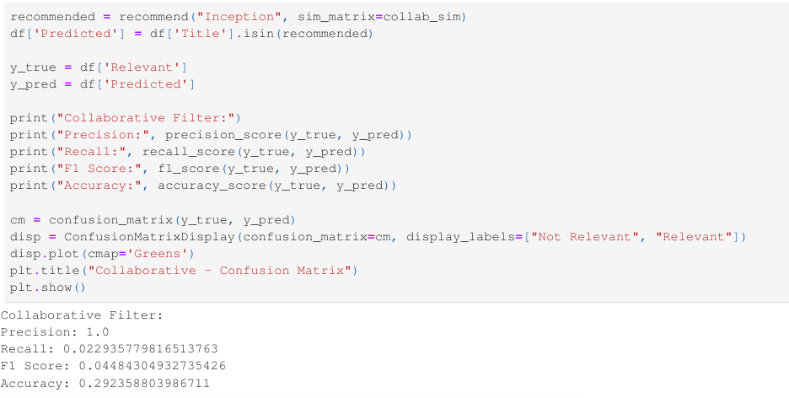
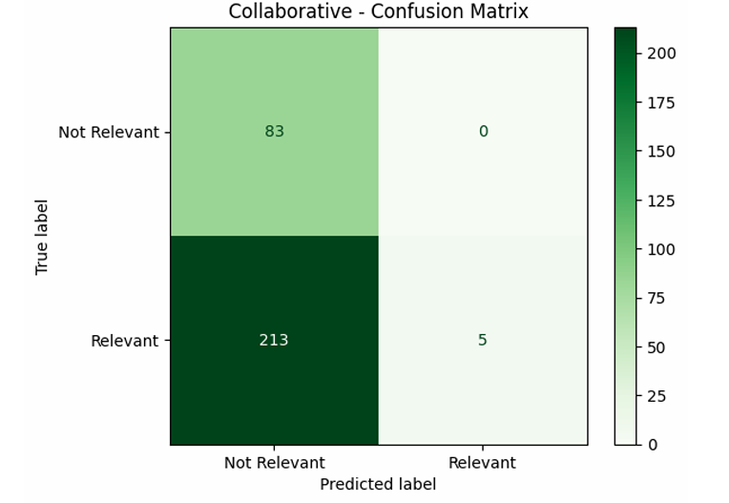
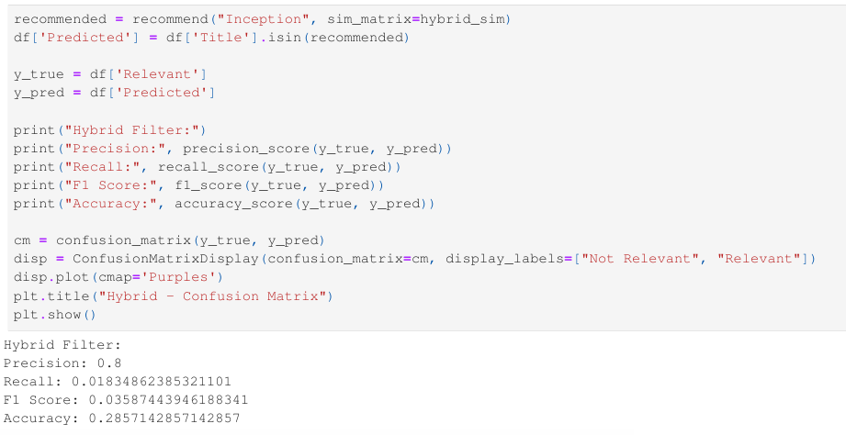
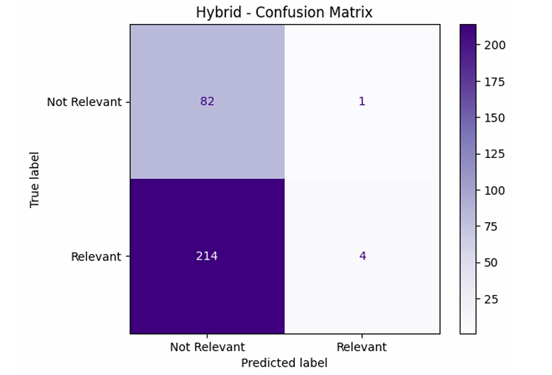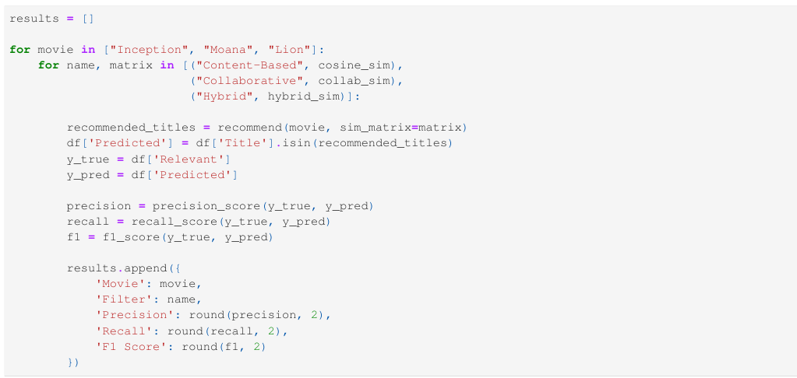
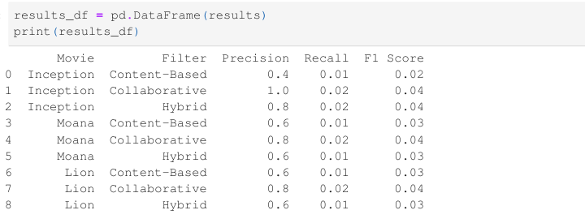
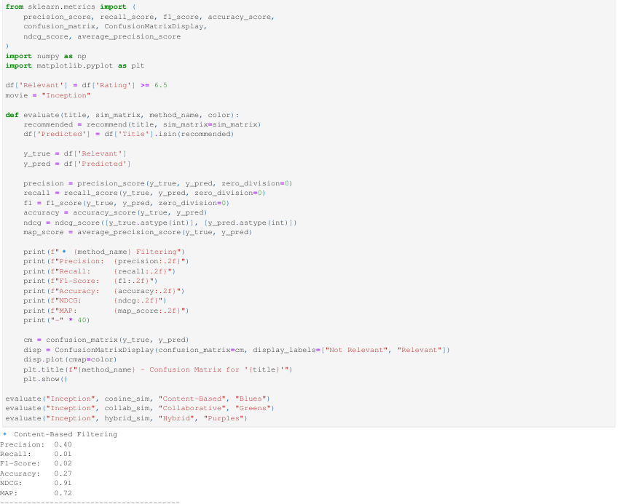
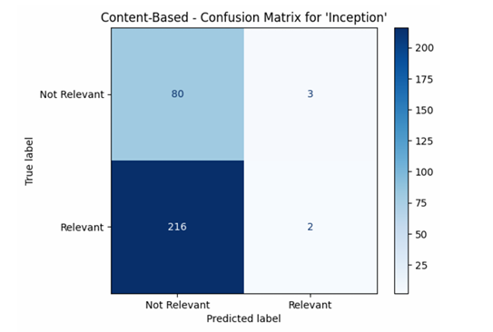
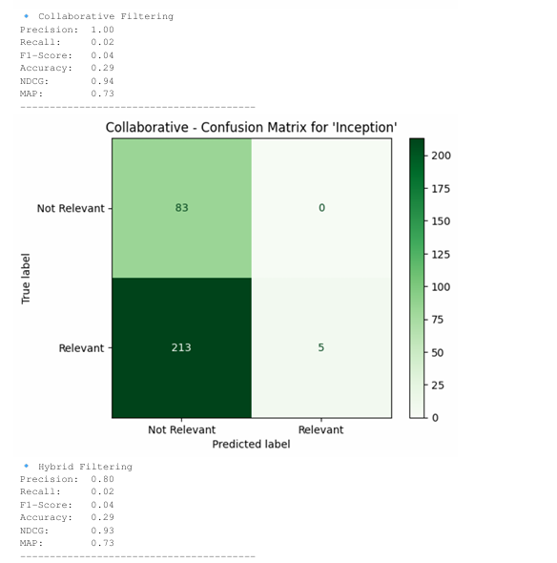
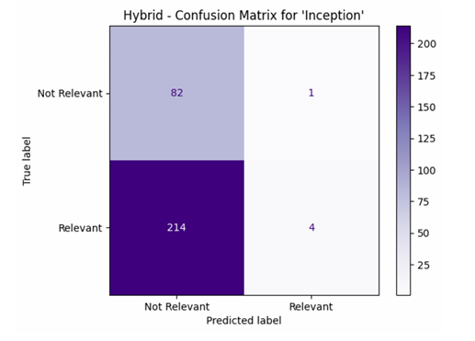
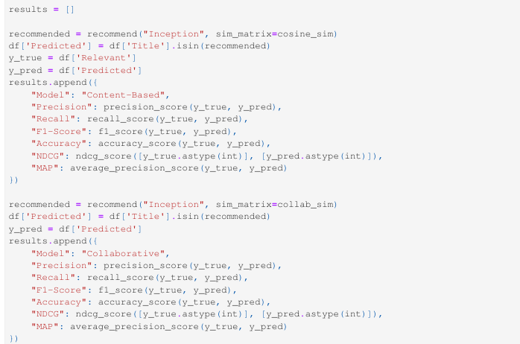
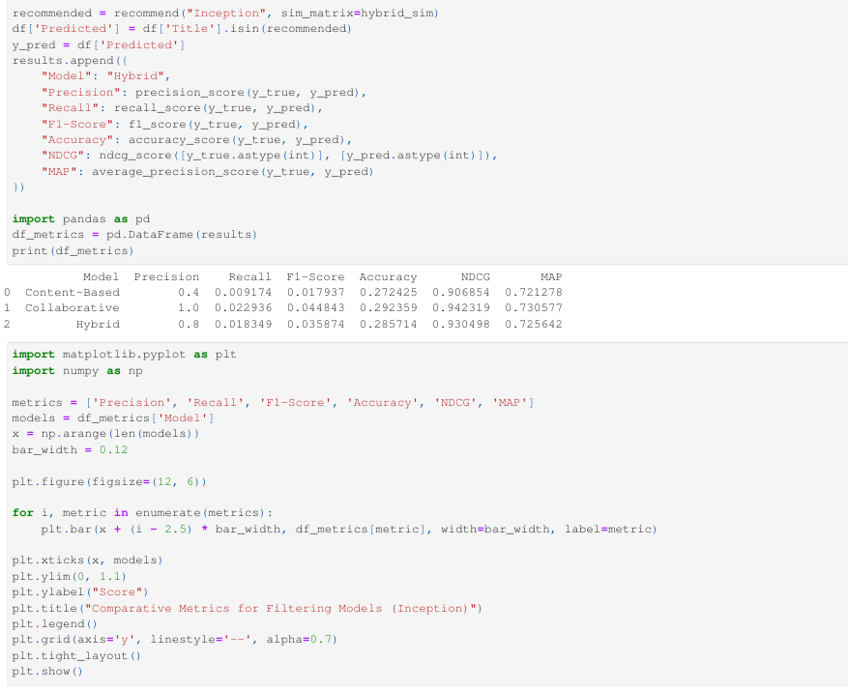
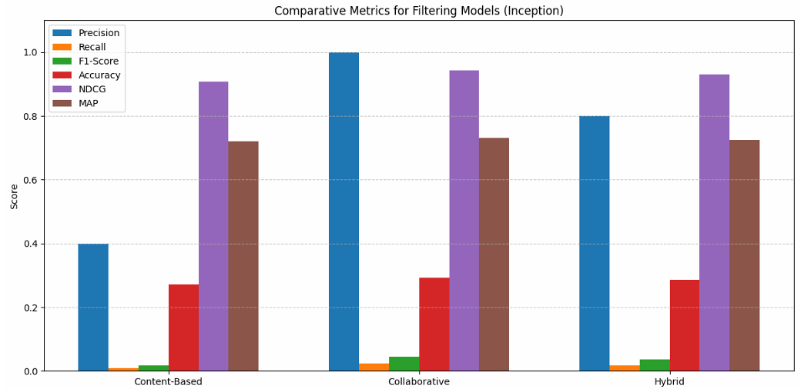

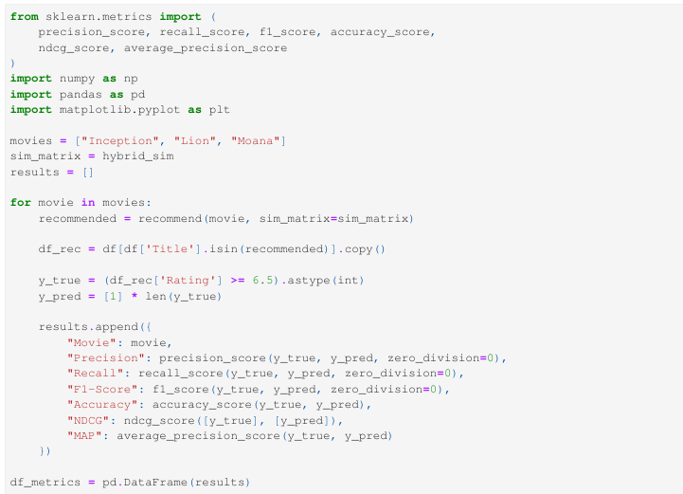
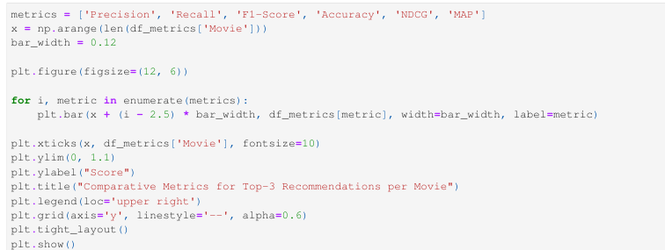
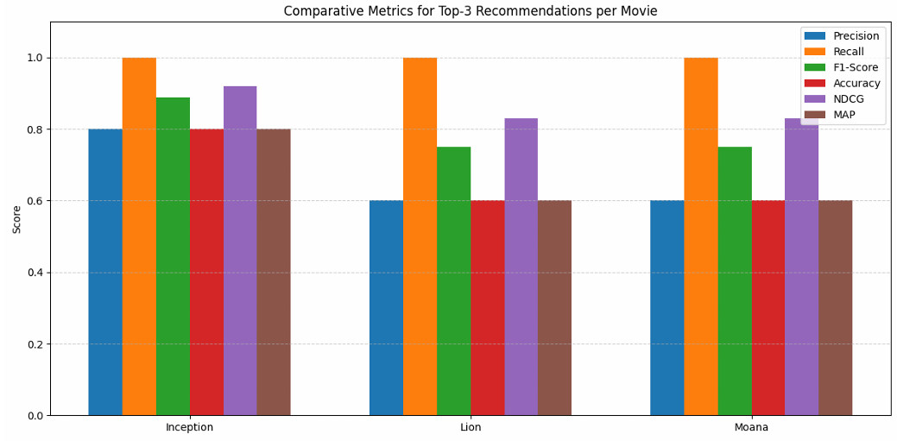Challenges Faced and Solutions
- Learning web scraping: Used BeautifulSoup and followed tutorials to understand how to collect data from websites.
- Finding correct HTML tags on IMDb: Carefully inspected the IMDb website structure and practiced selecting the right tags.
- Messy movie descriptions: Cleaned the text using Python and applied TF-IDF to process descriptions effectively.
- No user rating data: Marked movies with rating ≥ 6.5 as 'relevant' to simulate user preferences.
- Combining models for hybrid filtering: Used a simple average method to merge content and collaborative scores.
- Understanding evaluation metrics: Read about Accuracy, Precision, Recall, F1-Score, NDCG, and MAP from online resources.

Key Learnings
- I learned how to collect data from websites using simple tools like BeautifulSoup.
- I understood how to clean and fix messy data before using it.
- I used Python libraries like Pandas and Matplotlib to make charts and work with data.
- I built three types of recommendation systems: one using movie details, one using ratings, and one combining both.
- I learned how to compare movie descriptions using TF-IDF.
- I found out how similarity scores help to suggest similar movies.
- I learned how to check how good my models are using accuracy, precision, recall, F1-score, NDCG, and MAP.
- I improved my coding and debugging skills.
- I learned how to organize and plan my work every week to finish everything on time.

Conclusion
This internship project helped me learn many new things in a simple and interesting way. I learned how to collect movie data from IMDb, clean and analyze it, and build systems that can suggest movies. I used different methods like content-based, collaborative, and hybrid models to give better recommendations. I also learned how to check how well these models work. Among all, the collaborative model worked best. This project made me more confident in working with real data and using machine learning. Overall, it was a fun and educational experience.
References
https://www.imdb.com
https://www.crummy.com/software/BeautifulSoup/
https://www.youtube.com
https://www.google.com
https://www.imdb.com/

