Mill Daulagala

mill.daulagala@gmail.com

Problem Description.

* Build an application with 2 threads:
* The first thread will read sequentially through the attached XML files, from \Data\Computers, and place their contents on an internal queue.

A separate consumer thread will run concurrently with the first thread and will read from the internal queue, and render the XML to HTML in directory Data\Output using stylesheet “Computers.xsl” provided. Filename of rendered output can be any unique value.

Application Design.

Interface IHTMLGenerator

* It has 3 methods signatures.
* Those 3 methods help to load xml, transform xml to html and generate the html file.

class HTMLGenerator implements the IHTMLGenerator interface.

* TransformXmlToHtml method transform the xml to html using the xslt.
* StringReader reads the xmlStream and xsltStream.
* The [XslCompiledTransform](https://docs.microsoft.com/en-us/dotnet/api/system.xml.xsl.xslcompiledtransform) class is the Microsoft .NET Framework XSLT processor. This class is used to compile style sheets and execute XSLT transformations.
* Transform - the transform is executed by calling Transform method of the XslCompiledTransform class object. Transform method takes the XML document object and the XmlStringWriter objects as parameters. The second parameter of the Transform method is used to pass additional runtime arguments, it is left to null.
* GenerateHtml method created the html file.

class Program

* Main thread - The first thread will read sequentially through the attached XML files, from \Data\Computers, and place their contents on List.
* Parallel.ForEach loop- Parallel.ForEach loop runs upon multiple threads and processing takes place in a parallel way. Parallel.ForEach loop is not a basic feature of C# and it is available from C# 4.0 and above.
* separate consumer thread will run concurrently with the first thread and will read from the List, and render the XML to HTML in directory Data\Output using stylesheet “Computers.xsl” provided.
* Filename of the rendered html file is a unique value. I used Guid Generator.

How to run the application

1. Extract the .zip file to a folder.

2. Set the paths to following Resources according to the folder location.

* Computer.xslt
* /Data/Computers
* /Data/Output

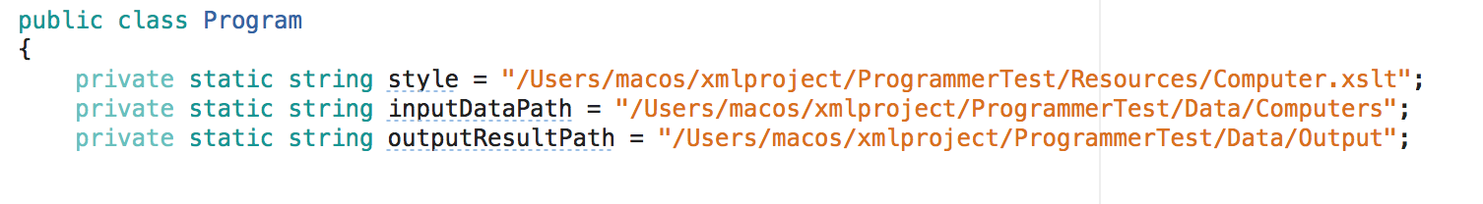

3. Place the Style.css inside the Output folder. Style.css does the styling for the html files.

4. Execute the Program.cs

5. The html files will be generated to the Data/Output folder with unique name.