
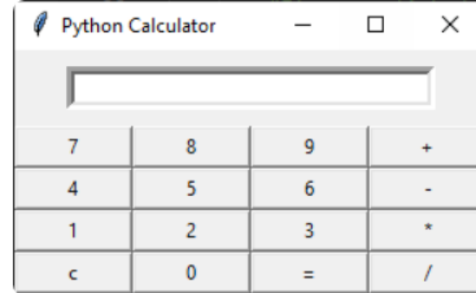
NextHikes IT Solutions
Project 2: Building Basic Calculator
Introduction
We hope there is a chance that you already know a Python-based calculator
program and are now eager to move into the realm of creating a Graphical User
Interface (GUI) for enhanced presentation and reusability. Tkinter library is the
Basic GUI toolkit for Python.
Project Overview
Before plunging into the code, let's take a moment to outline the nature of the
calculator we expect to construct, its functionalities, and its indispensable
components.
The expected GUI application should resemble the following features:

Outlined below are the essential features deemed indispensable for this
application:
●An equation display area (screen) to exhibit the mathematical expressions
and their respective results.
●Clickable buttons, each representing numerical values or mathematical
operations.
●Core mathematical operations functionality, encompassing addition,
subtraction, multiplication, and division.
●Seamless execution of mathematical calculations, yielding results (=),
coupled with the ability to clear the equation display (c).
Learning Outcome:
1. Core Python
2. tkinter Library
3 Visual Studio Code[IDE]
4. GitHub
5. Application development using Python programming language
Final Submission (1 month )
●Work on the Visual Studio Code and make a Python script for the
application, which will be saved in the Project 1 folder.
●Make a Small Presentation including all explanations of the project with
output.
●Link to your GitHub Account that should include your required code.

