**DATA MINING**

**Assignment 1**

25-04-2014

Group Members:

Santhosh Alladi (2011A7PS086H)

Surya Nikhil R (2011A7PS201H)

Manideep Illendula (2011C6PS662H)

Association Rule Mining

Objective:

The objective of this assignment is to pre-process a data set, do associative rule mining and then figuring out interesting rules which could be useful. In our assignment we used **bank data** set with the following attributes:

|  |  |
| --- | --- |
| **id** | a unique identification number |
| **age** | age of customer in years (numeric) |
| **sex** | MALE / FEMALE |
| **region** | inner_city/rural/suburban/town |
| **income** | income of customer (numeric) |
| **married** | is the customer married (YES/NO) |
| **children** | number of children (numeric) |
| **car** | does the customer own a car (YES/NO) |
| **save_acct** | does the customer have a saving account (YES/NO) |
| **current_acct** | does the customer have a current account (YES/NO) |
| **mortgage** | does the customer have a mortgage (YES/NO) |
| **pep** | did the customer buy a PEP (Personal Equity Plan) after the last mailing (YES/NO) |

Data set description:

As shown in the above table, the data set has 12 attributes. The unprocessed data set has 600 instances in total as shown in the attached file (bankData.arff). The following pre-processing steps are done for proper association rule mining-

* The id attribute has been removed, as it is of no importance.
* Then discretization is done:
* Under this first the children attribute is discretized to values 0,1,2 and 3 as this attribute takes only these 4 values.
* The age and income attributes are also discretized into 3 bins each.

The data set after all the pre-processing steps is in the attached file (bankDataFinal.arff).

The screen shot gives the visualization of the attribute data after the pre-processing of the dataset:

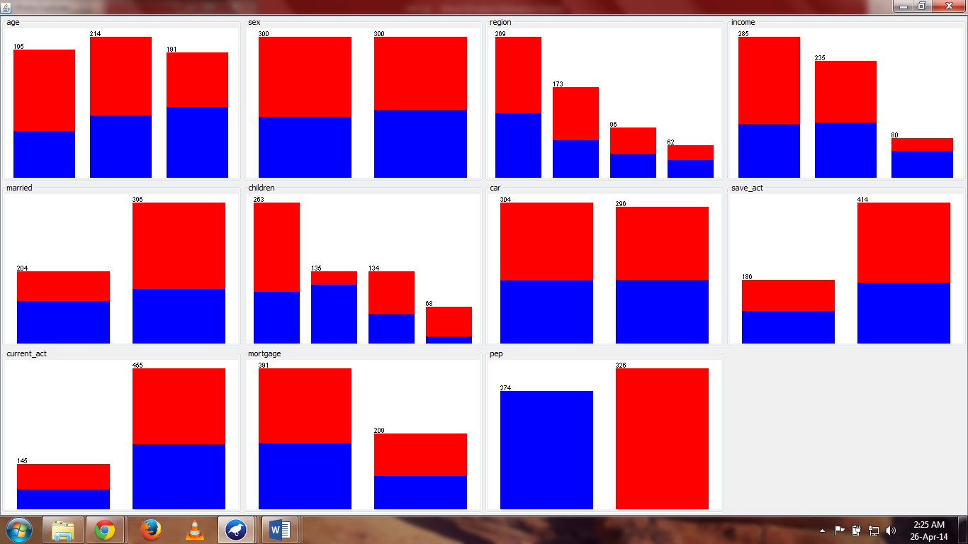

Rule Mining:

We did the rule mining using Apriori principle. Also, we have done rule mining using two metrics- confidence and lift. The screen shots show the values of the different parameters.

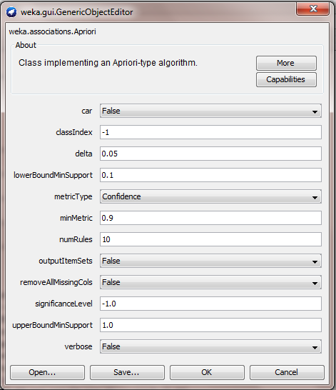

Parameters for confidence

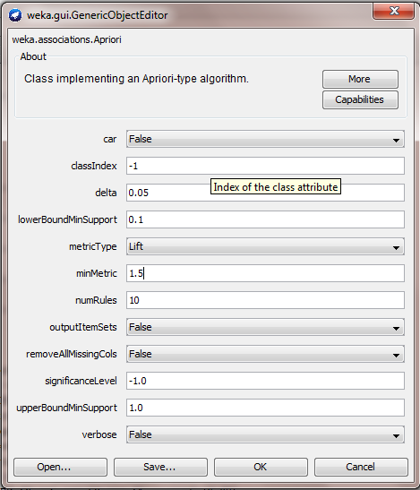

Parameters for lift

Resulting Rules:

After association rule mining the following are the 10 interesting rules.

1) Rules based on **confidence**:

1. income=43759_max 80 ==> save_act=YES 80 conf:(1)

2. age=52_max income=43759_max 76 ==> save_act=YES 76 conf:(1)

3. income=43759_max current_act=YES 63 ==> save_act=YES 63 conf:(1)

4. age=52_max income=43759_max current_act=YES 61 ==> save_act=YES 61 conf:(1)

5. children=0 save_act=YES mortgage=NO pep=NO 74 ==> married=YES 73 conf:(0.99)

6. sex=FEMALE children=0 mortgage=NO pep=NO 64 ==> married=YES 63 conf:(0.98)

7. children=0 current_act=YES mortgage=NO pep=NO 82 ==> married=YES 80 conf:(0.98)

8. children=0 mortgage=NO pep=NO 107 ==> married=YES 104 conf:(0.97)

9. income=43759_max current_act=YES 63 ==> age=52_max 61 conf:(0.97)

10. income=43759_max save_act=YES current_act=YES 63 ==> age=52_max 61 conf:(0.97)

2) Rules based on **lift**:

1. age=0_34 195 ==> income=0_24386 current_act=YES 138 conf:(0.71) < lift:(1.97)> lev:(0.11) [68] conv:(2.16)

2. income=0_24386 current_act=YES 215 ==> age=0_34 138 conf:(0.64) < lift:(1.97)> lev:(0.11) [68] conv:(1.86)

3. income=0_24386 285 ==> age=0_34 car=NO 100 conf:(0.35) < lift:(1.97)> lev:(0.08) [49] conv:(1.26)

4. age=0_34 car=NO 107 ==> income=0_24386 100 conf:(0.93) < lift:(1.97)> lev:(0.08) [49] conv:(7.02)

5. age=0_34 195 ==> income=0_24386 pep=NO 111 conf:(0.57) < lift:(1.94)> lev:(0.09) [53] conv:(1.62)

6. income=0_24386 pep=NO 176 ==> age=0_34 111 conf:(0.63) < lift:(1.94)> lev:(0.09) [53] conv:(1.8)

7. age=0_34 195 ==> income=0_24386 save_act=YES 106 conf:(0.54) < lift:(1.91)> lev:(0.08) [50] conv:(1.55)

8. income=0_24386 save_act=YES 171 ==> age=0_34 106 conf:(0.62) < lift:(1.91)> lev:(0.08) [50] conv:(1.75)

9. income=0_24386 285 ==> age=0_34 mortgage=NO 113 conf:(0.4) < lift:(1.9)> lev:(0.09) [53] conv:(1.3)

10. age=0_34 mortgage=NO 125 ==> income=0_24386 113 conf:(0.9) < lift:(1.9)> lev:(0.09) [53] conv:(5.05)

The text files containing the detailed result of the rule mining are attached along with this report (bankData_a*.txt).