Republic of the Philippines

**SOUTHERN LEYTE STATE UNIVERSITY-BONTOC**

San Ramon, Bontoc, Southern Leyte

Website: www.slsuonline.edu.ph

Telefax: (053) 382-3121; Email: slsubc@yahoo.com

**ACTIVITY**

**System Integration and Architecture**

*First Semester AY: 2020-2021*

|  |  |  |  |  |  |
| --- | --- | --- | --- | --- | --- |
| **Name:** | Millenium B. Miras | | | **Rating:** |  |
|  |  | |  | |  |
| **Course/Year/Section:** | | BSIT 3-A |  | |  |

ACTIVITY 1

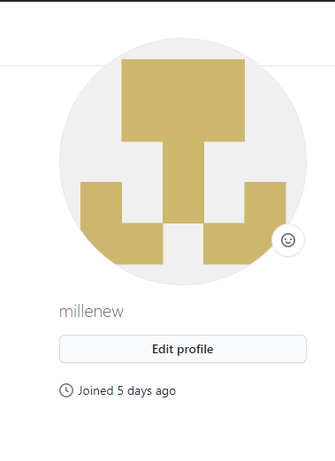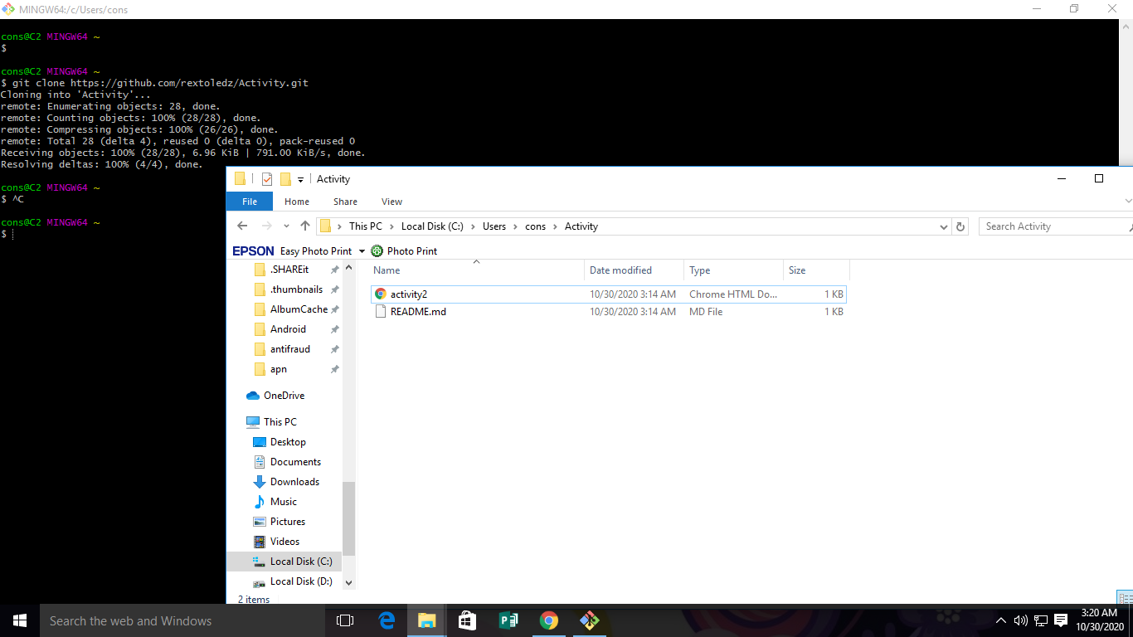

# ACTIVITY 2

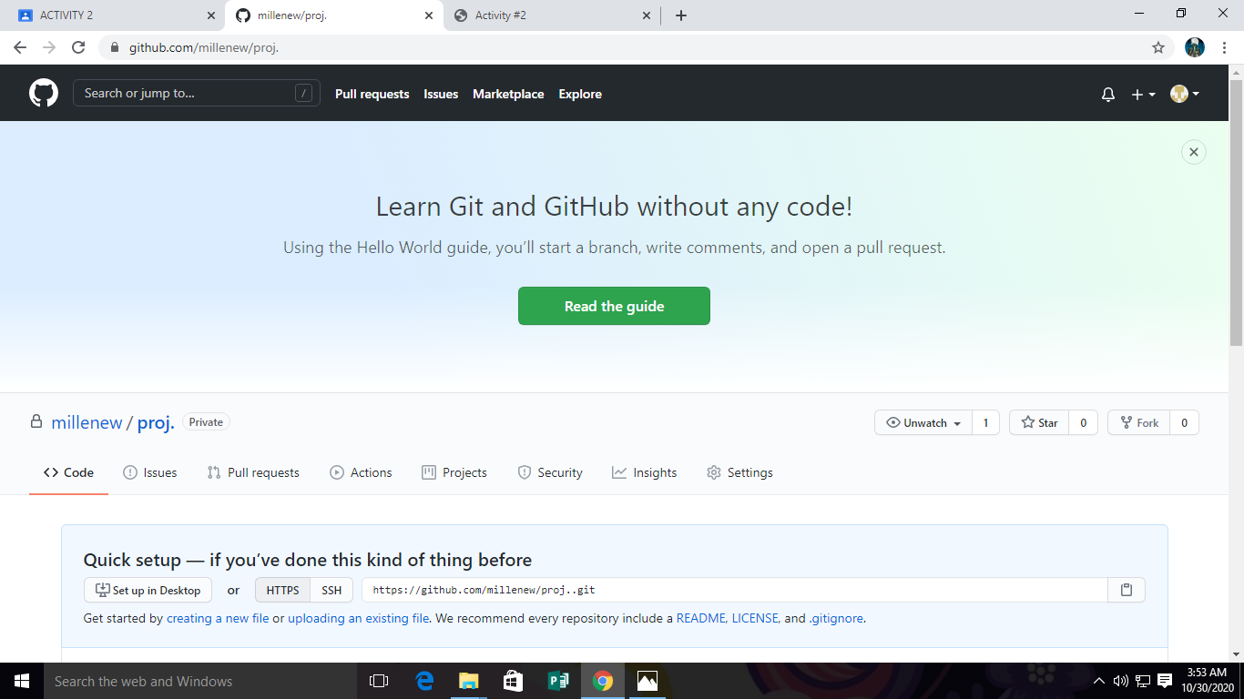

# ACTIVITY 3

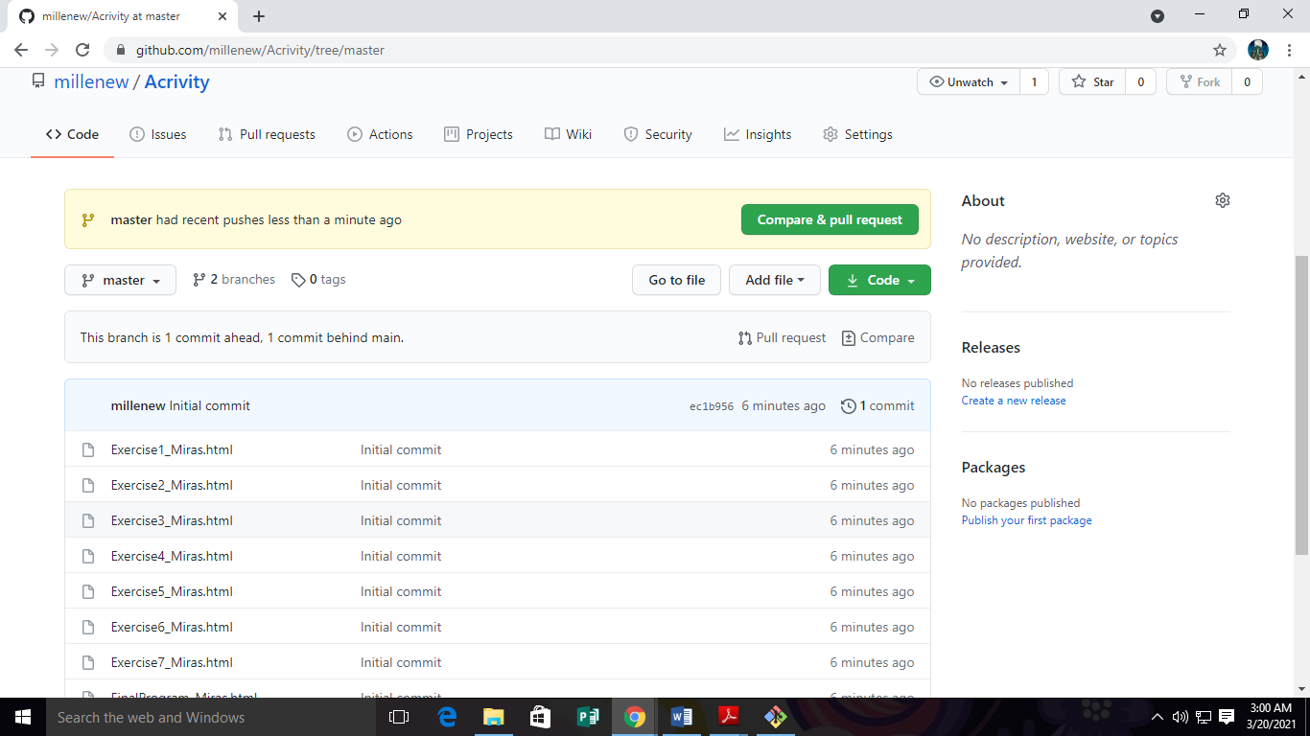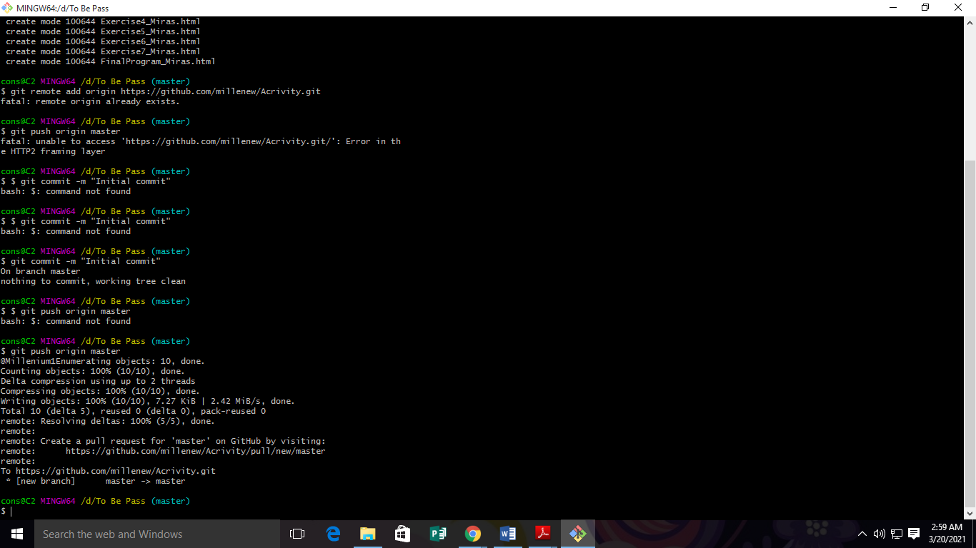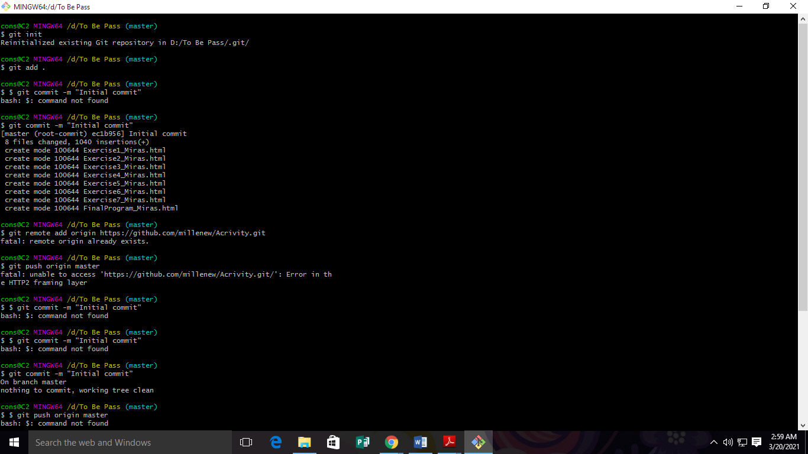

ACTIVITY 4

